Google Play Store Testing Setup

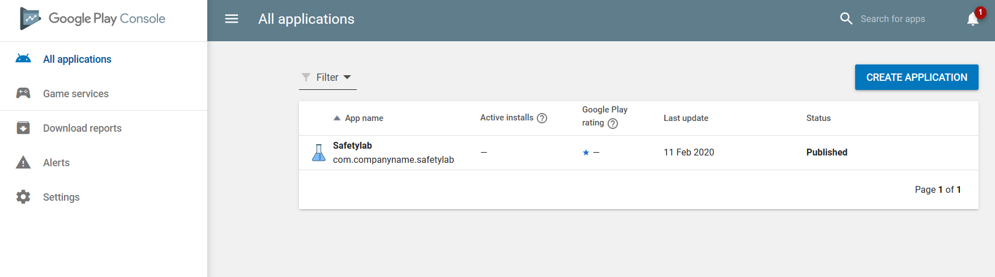

Click on Safetylab

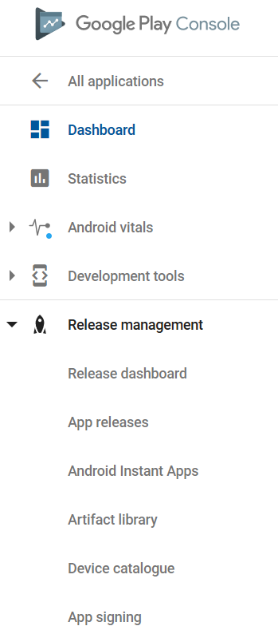

On the side of the webpage, run down to ‘Release Management’, click on ‘App Releases’

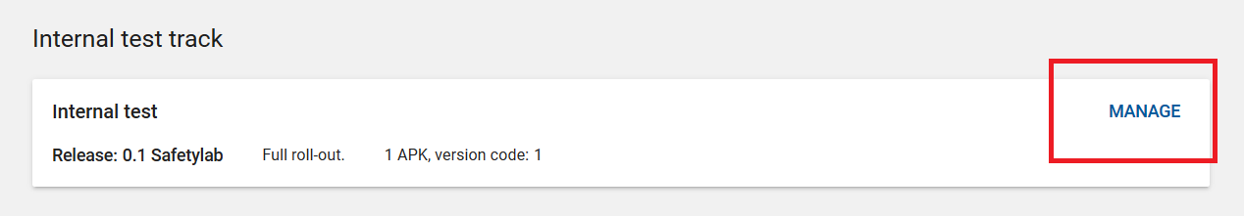

Scroll down to Internal Test Track and click manage.

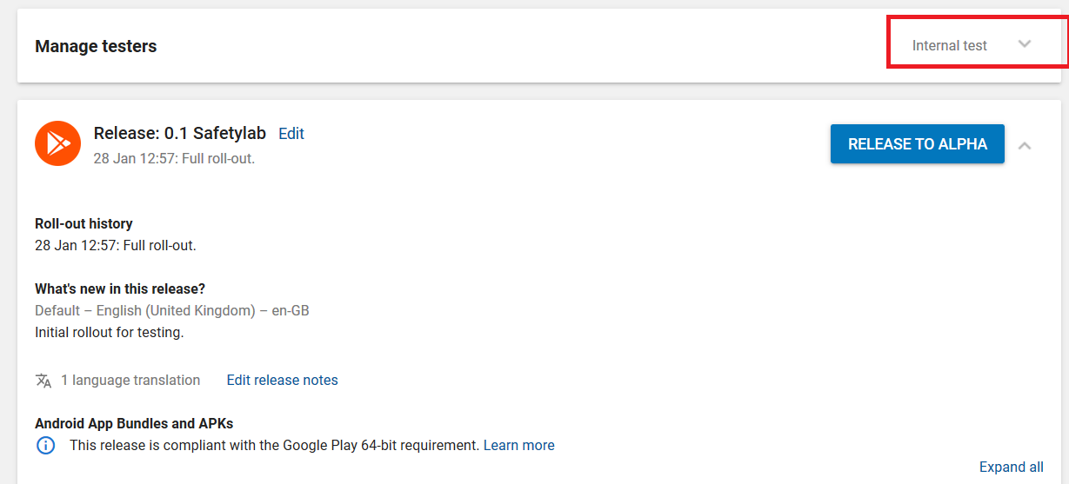

Manage Testers will have a little drop down box. Click it to bring down the list.

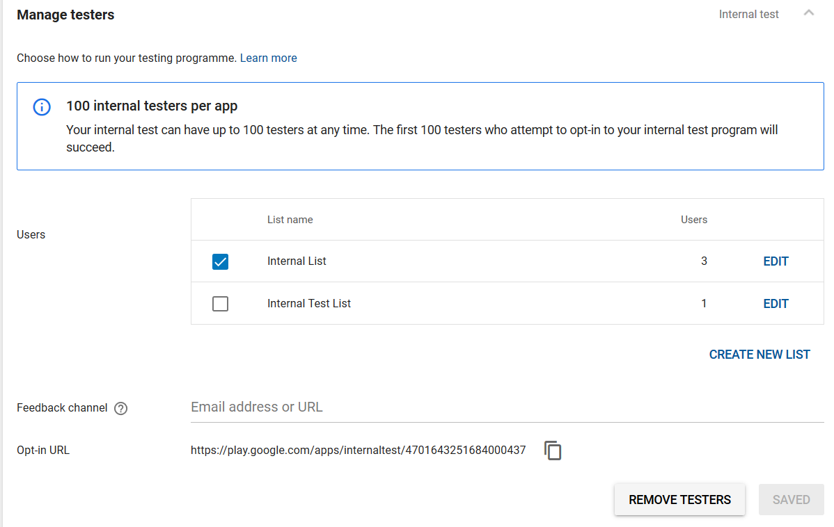

From here you can edit the lists you want for any users to opt-in. Users will need a gmail. You’ll have to send them the Opt-In URL at the bottom there as well to be able to download the app.

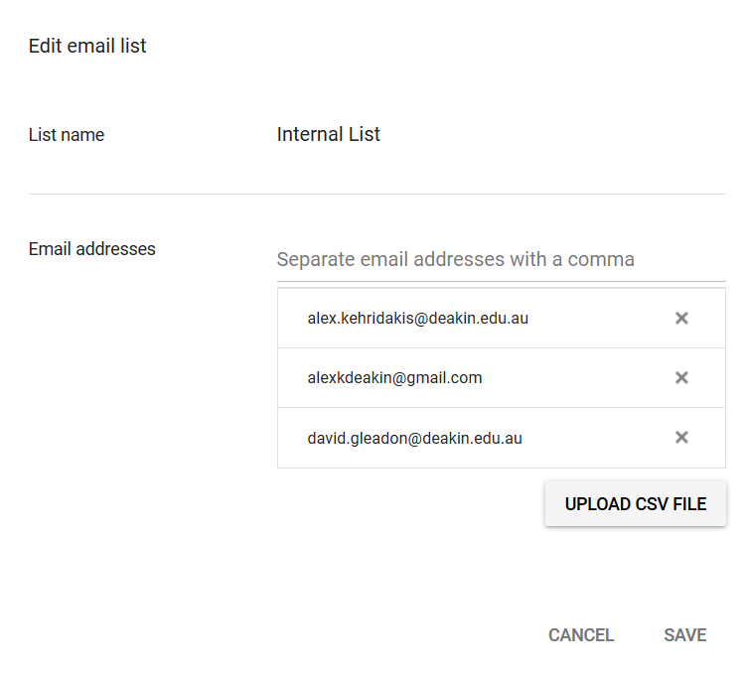

If you’re editing the opt-in user list, there’s also the option to upload a Microsoft Excel file instead, so you would just put in every email in a column and the site would handle the rest.