**Applicazioni per dispositivi mobili**

**course**

**a.y. 2018/2019**

**MusicPR**

**Design documentation**

|  |  |  |
| --- | --- | --- |
| **Team Members[1]** | | |
| **Name** | **Student Number** | **E-mail address** |
| **Marco Calabrese** | *231403* | *marco.calabrese2@student.univaq.it* |
| Albina Sela |  | *albinasela@icloud.com* |
| Pierluca Masiello | *238931* | *pierlucamasiello@hotmail.it* |
|  |  |  |
|  |  |  |

Strategy

# Product Overview

L'applicazione vuole offrire una piattaforma per pubblicizzare e vendere eventi musicali.

Gli utenti potranno reperire informazioni sugli eventi musicali nella loro zona, acquistare biglietti direttamente in app o lanciare una campagna di raccolta fondi per un evento che hanno intenzione di organizzare.

Ogni utente avrà un profilo con la storia degli eventi che ha organizzato che potranno essere recensiti dall’utente stesso e da altri anche aggiungendo foto.

[chat si chat no???? :’’’’’( ]

# Competitors

# User Research

Describe the NEEDS that you want to fill with your app

Describe the main GOALS your app allows users to achieve

# Personas

# 

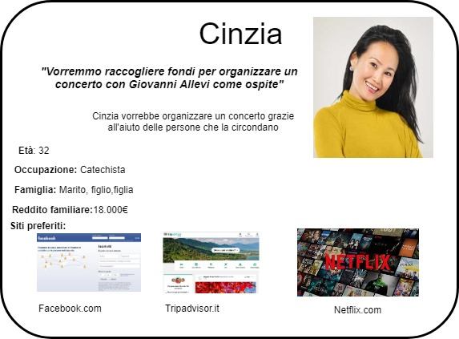

Scope

**Features**

Provide a list of all the features of your app.

**Scenarios**

It is a short, simple narrative describing how a persona might go about trying to fulfill one of those user needs. By imagining the process our users might go through, we can come up with potential requirements to help meet their needs.

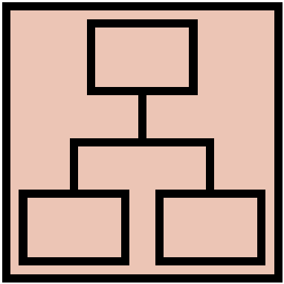Structure

# Navigation model

Navigation model of your app.

Description of its main parts and the relevant choices you made. For each view and for each main navigation flow you have to describe your design decisions and their main objectives.

# Data

Provide a class diagram representing all the contents you manage in your app. As a reference for class diagrams, use this: <http://it.wikipedia.org/wiki/Class_diagram>

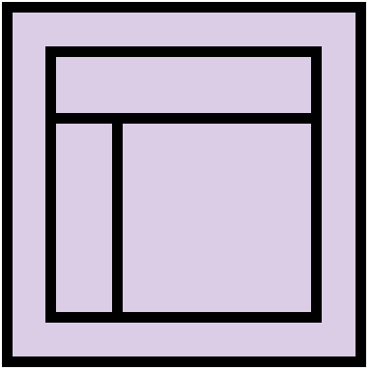Skeleton

Lo-Fi Wireframes of your app. In this phase you have to create a **complete wireframe** representing all the views described in the navigation model.

Description of the relevant choices you made about the user interaction and how information flows among views.

Surface

Provide an Hi-Fi Wireframes of a **single view** of your app. Please choose a representative view to show here.

Description of the relevant choices you made about the layout and color palette, fonts, icons, etc.

1.