Heart Disease Risk Prediction
End-to-End MLOps Pipeline

Course: AIMLCZG523 - Machine Learning Operations
Author: Adithya
Student ID: 2024AC05785
Repository: github.com/axle-bits/MLOP_Assignment_1

Contents

(Right-click → Update Field to refresh the table of contents.)

1. Overview & Setup
This project builds an end-to-end MLOps pipeline around a binary classifier that predicts heart disease risk from 13 clinical features in the UCI Cleveland dataset. The goal was to evidence every stage of a production ML lifecycle: reproducible data preparation, tracked experimentation, automated testing and CI/CD, containerised serving, Kubernetes deployment, and monitoring. Every non-trivial choice along the way is recorded and justified, not assumed.
The repository is organised around a stage-oriented layout that maps 1:1 onto CI/CD stages:
- ml/ - data download, preprocessing, feature engineering, training, and export
- api/ - FastAPI serving code and Pydantic schemas
- infra/ - Dockerfile and Kubernetes manifests
- tests/ - 39 pytest unit and integration tests
- notebooks/ - jupytext-paired EDA and model-comparison notebooks
- docs/ - decision log, report, and figures

Architecture overview:
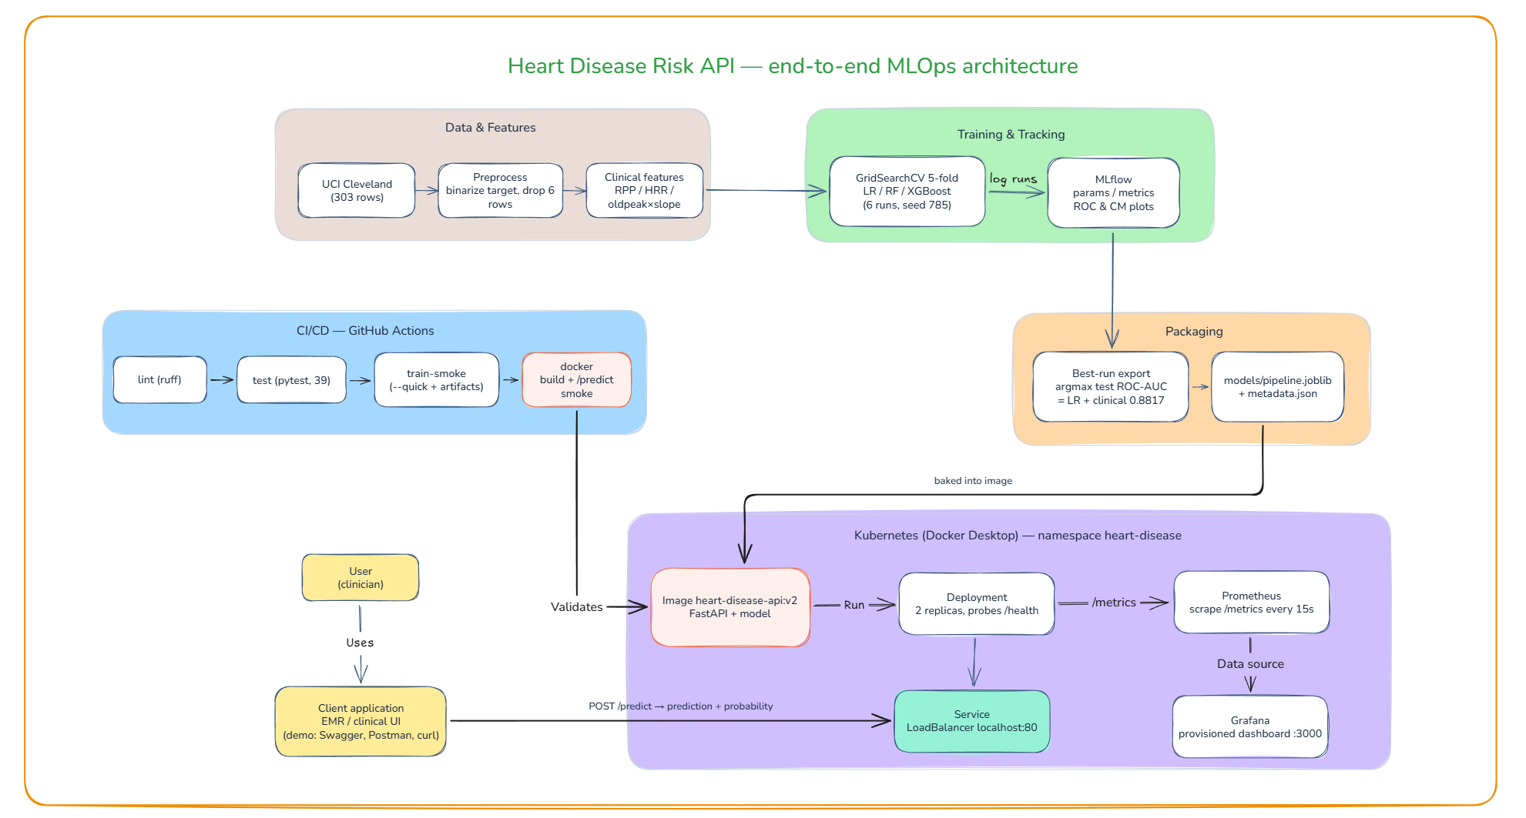
Figure 1 - System architecture

Quickstart
python -m venv .venv && .venv/Scripts/activate
pip install -r requirements.txt

Train and track experiments, then serve locally:
python -m ml.models.train
uvicorn api.main:app --reload --port 8000

Or run containerised and on Kubernetes:
docker build -t heart-disease-api -f infra/Dockerfile .
docker run -d -p 8000:8000 heart-disease-api
kubectl apply -f infra/k8s/

Run the test suite with pytest and the lint gate with ruff check . before touching anything else, to confirm the committed pipeline is clean. The remaining sections follow the same order as the assignment's nine tasks.

2. Data & EDA
The dataset is the classic Cleveland subset of the UCI Heart Disease repository, fetched programmatically via ucimlrepo (id=45). This returns exactly 303 rows × 13 features and matches the assignment's dataset link. The combined four-site dataset (~920 rows) was rejected because it is not what id=45 serves.
The raw multi-class target num (0–4, distribution 164/55/36/35/13) was binarised to 0 (no disease) vs 1 (disease present), the established 0-vs-rest convention. Six rows (2% of data) with missing ca (4 rows) or thal (2 rows) values were dropped rather than imputed - both are categorical clinical measurements where imputation would invent clinical facts. This leaves 297 rows with a class balance of 160 no-disease vs 137 disease cases.
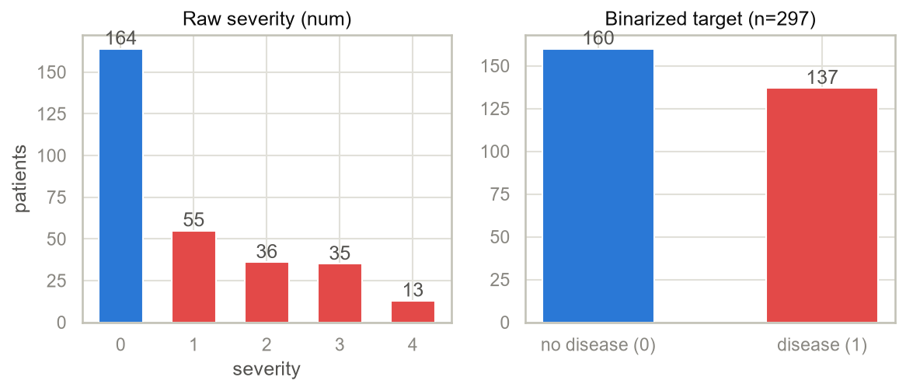
Figure 2 - Class balance (297 rows post-cleaning)
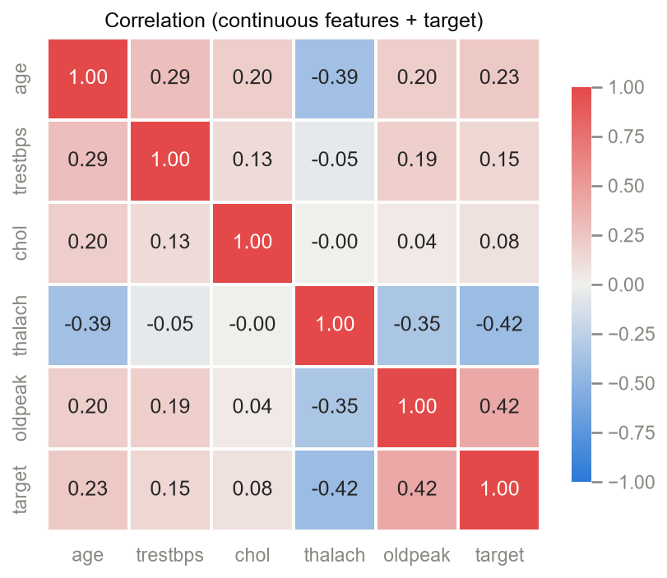
Figure 3 - Correlation heatmap (diverging blue–grey–red palette)
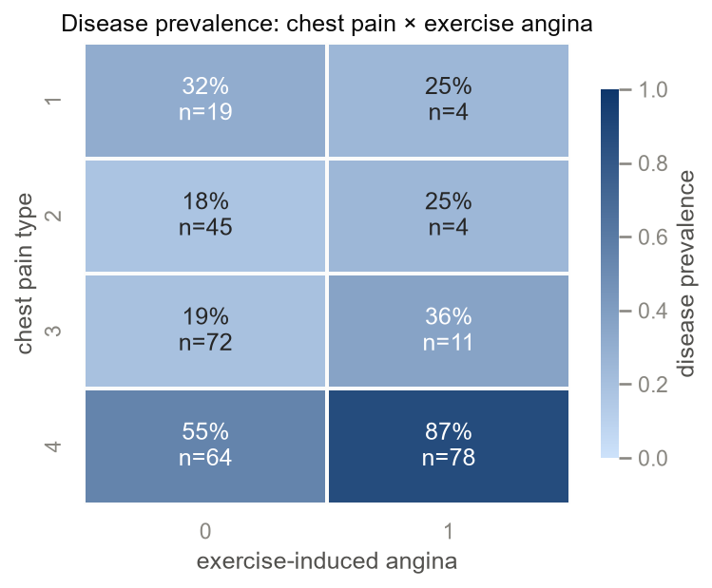
Figure 4 - Chest pain type × exercise angina prevalence heatmap
Key EDA findings: disease prevalence is higher in males (56%) vs females (26%). Patients with asymptomatic chest pain and exercise-induced angina show 87% prevalence - the strongest subgroup signal. ST-depression (oldpeak, r=+0.42) and maximum heart rate (thalach, r=−0.42) are the strongest continuous correlates of the target.
All figures use a fixed two-class palette (no-disease #2a78d6 blue, disease #e34948 red) validated colorblind-safe with a worst-pair ΔE well above the accessibility threshold.

3. Feature Engineering & Models

Derived Clinical Features
Three clinically motivated features are computed inside the scikit-learn Pipeline (via FunctionTransformer), not pre-computed into the cleaned CSV:
- Rate-pressure product: trestbps × thalach - index of myocardial oxygen demand
- Heart-rate reserve: 220 − age − thalach - unused chronotropic capacity
- oldpeak × slope interaction - ST-depression magnitude × slope pattern
Computing features inside the pipeline guarantees identical transformation at training and inference. A fourth candidate (pulse pressure) was rejected: the dataset carries only systolic BP (trestbps) with no diastolic column.

Preprocessing
The ColumnTransformer applies three strategies:
- StandardScaler → 5 continuous features + ca (ordinal vessel count 0–3) + 3 derived features
- OneHotEncoder(handle_unknown='ignore') → nominal categoricals: cp, restecg, slope, thal
- Passthrough → binary flags: sex, fbs, exang

Training Setup
Three model families (Logistic Regression, Random Forest, XGBoost) × 2 feature sets (raw / raw + clinical) = 6 tracked runs. Every run used GridSearchCV over StratifiedKFold (5 folds, shuffle=True), scoring ROC-AUC, tuned on an 80/20 stratified split. random_state=785 (derived from student ID 2024AC05785) is shared across all runs.

Results
Model | Features | CV ROC-AUC | Accuracy | Precision | Recall | F1 | Test ROC-AUC
Logistic Regression | Clinical | 92.0% ± 1.23 | 76.7% | 75.0% | 75.0% | 75.0% | ★ 88.2%
Logistic Regression | Raw | 92.0% ± 2.30 | 78.3% | 77.8% | 75.0% | 76.4% | 87.6%
Random Forest | Raw | 92.4% ± 1.49 | 78.3% | 75.9% | 78.6% | 77.2% | 85.8%
Random Forest | Clinical | 91.5% ± 2.06 | 76.7% | 79.2% | 67.9% | 73.1% | 84.9%
XGBoost | Clinical | 93.1% ± 1.15 | 68.3% | 65.5% | 67.9% | 66.7% | 84.2%
XGBoost | Raw | 92.4% ± 1.96 | 75.0% | 69.7% | 82.1% | 75.4% | 83.2%

KEY FINDING Winner: Logistic Regression + Clinical features - Test ROC-AUC 88.2%, CV 91.9% ± 1.2%. The clinical features helped LR (+0.6pp AUC) but slightly hurt Random Forest (−0.9pp AUC, −10.7pp recall). Tree ensembles already capture the interactions that the engineered features encode.

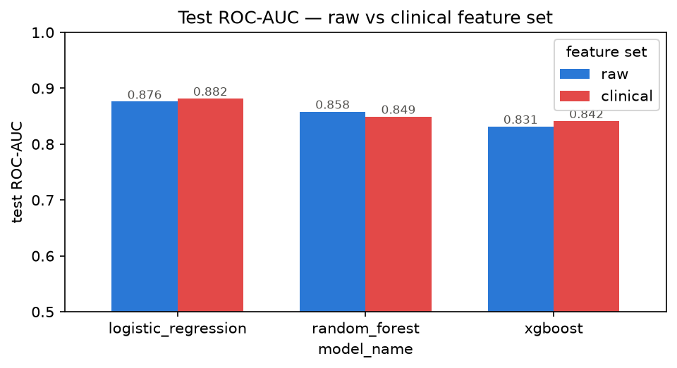
Figure 5 - Test ROC-AUC: raw vs clinical feature set per model

4. Experiment Tracking
All six runs are tracked with MLflow using a sqlite:///mlflow.db store for run metadata (params, metrics, tags) with artifacts under ./mlruns. Each run logs:
- Hyperparameters (best GridSearchCV params, seed, CV fold count, quick_mode flag)
- Seven metrics: CV mean/std ROC-AUC + test accuracy, precision, recall, F1, ROC-AUC
- Artifacts: ROC curve, confusion matrix, and feature-importance plots
- The fitted pipeline in MLflow model format (cloudpickle serialisation)
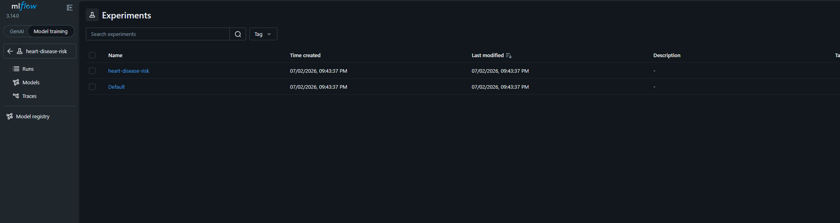
Figure 6 - MLflow experiment list
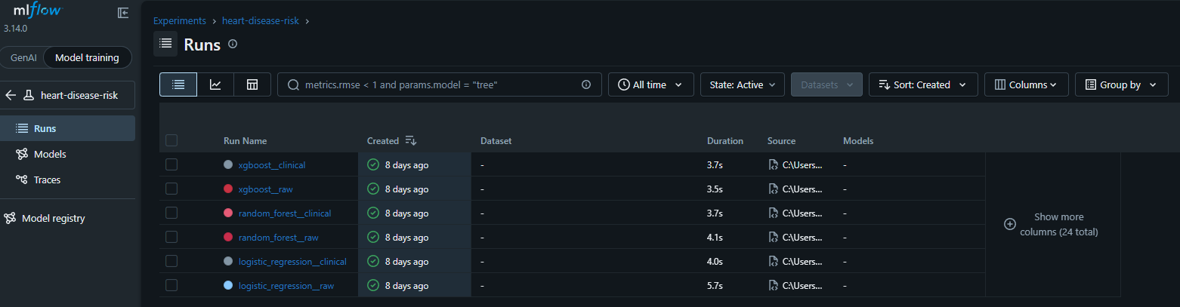
Figure 7 - All six runs in the MLflow runs table
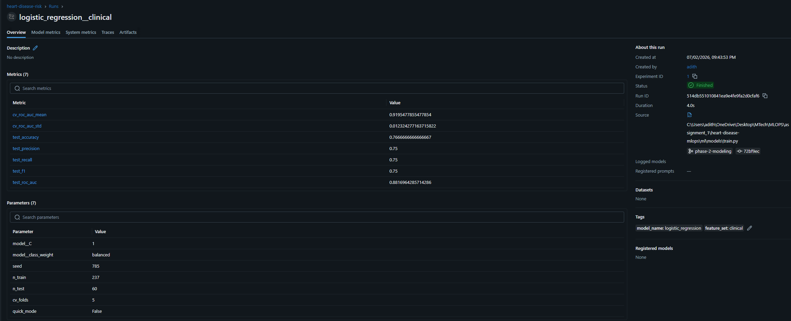
Figure 8 - Best run (LR/clinical) overview with all logged params and metrics
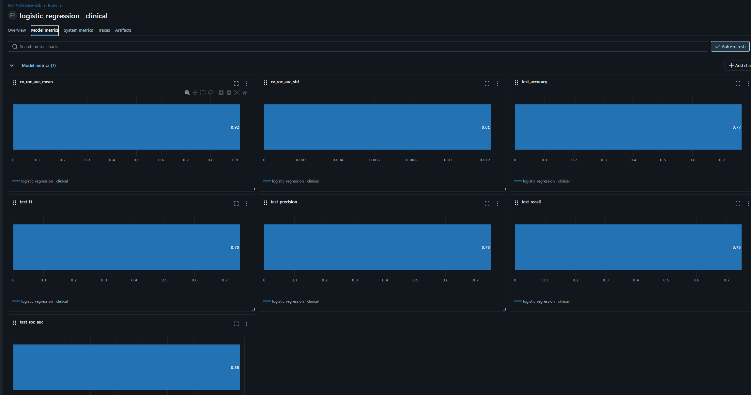
Figure 9 - Best run metric time-series charts
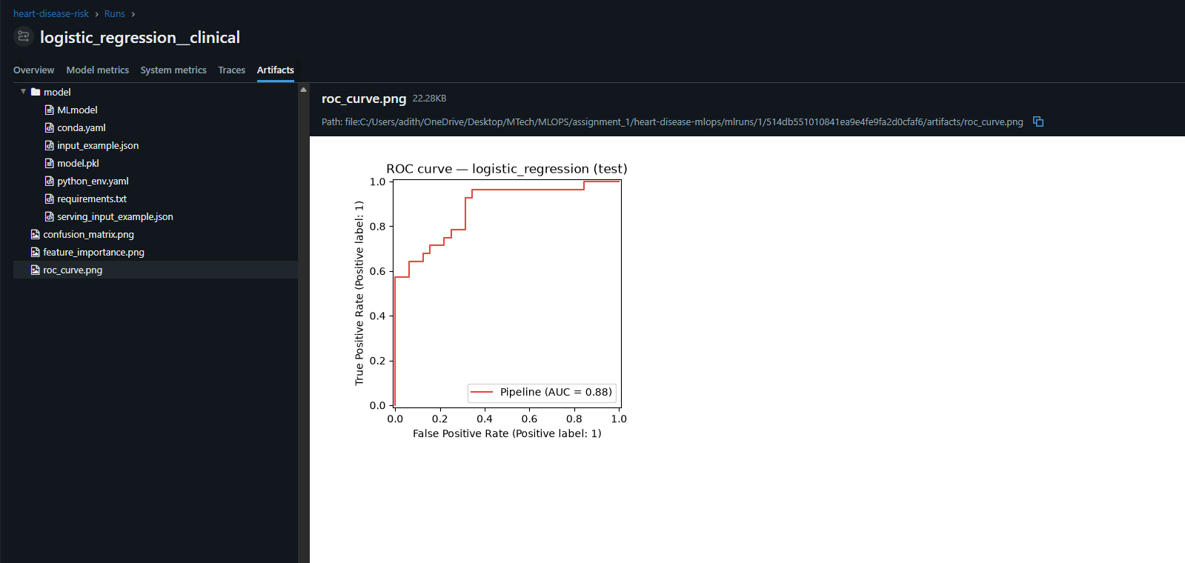
Figure 10 - ROC curve artifact (test split)
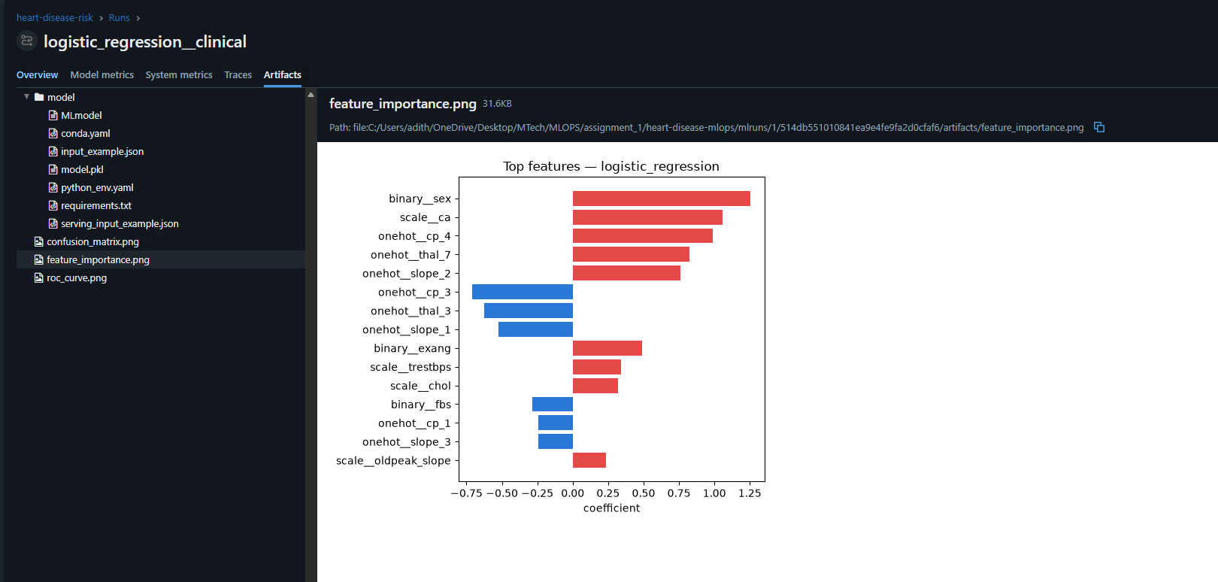
Figure 11 - Feature importance artifact: raw features dominate top ranks
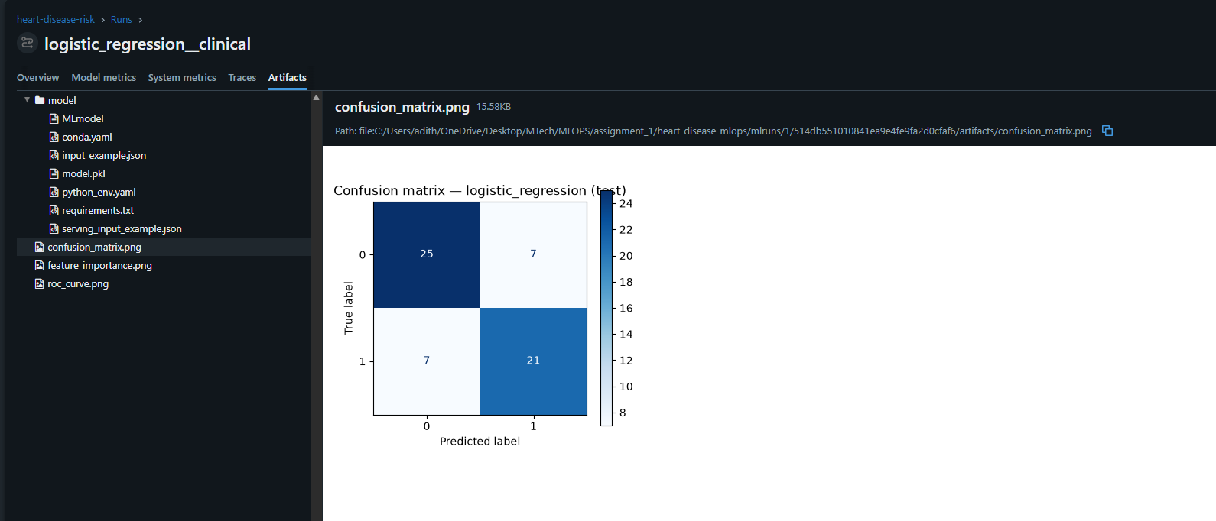
Figure 12 - Confusion matrix artifact (test split)

MLflow 3.14 Adaptations
Three deviations from a literal transcription of the assignment brief were required by the pinned MLflow 3.14.0:
- File store deprecation: MLflow 3.x raises on any file:// tracking URI unless MLFLOW_ALLOW_FILE_STORE=true is set. Fix: point at sqlite:///mlflow.db for metadata.
- log_model() changed: mlflow.sklearn.log_model() now records the model as a decoupled LoggedModel entity outside the run's artifact tree. Fix: save_model() to a temp dir + log_artifacts() to restore the classic runs:/<id>/model path.
- skops serialisation: the FunctionTransformer wrapping add_clinical_features is rejected as an 'untrusted type'. Fix: serialization_format=SERIALIZATION_FORMAT_CLOUDPICKLE.

5. Packaging & Reproducibility
The best run (argmax test ROC-AUC over full-grid runs) is exported by python -m ml.models.export to models/ in three formats:
- heart_disease_pipeline.joblib - canonical serving artifact; loads with scikit-learn + joblib only (no MLflow at inference time)
- model_metadata.json - source run ID, metrics, package versions, and input schema for provenance without the MLflow store
- mlflow_model/ - same pipeline in MLflow model format
All three are committed to git. A grader or fresh clone can serve the model without retraining. Pickle version-fragility is mitigated by pinned requirements and explicit package version recording in the metadata.
Reproducibility was verified, not assumed. Installing MLflow 3.14.0 forced pandas from 3.0.3 → 2.3.3 (MLflow declares Requires-Dist: pandas<3). This conflict was confirmed with pip install --dry-run and the full test suite was re-run against the downgraded pin before committing it.

6. CI/CD Pipeline
The GitHub Actions pipeline (.github/workflows/ci.yml) runs four jobs on every push and pull request. lint and test run in parallel; train-smoke and docker depend on test passing:
Job | Description
lint | ruff check . - pycodestyle errors (E), pyflakes (F), import order (I). Fails on any finding.
test | Full pytest suite (39 tests). JUnit XML uploaded as artifact even on failure (if: always()).
train-smoke | python -m ml.models.train --quick - all 6 model/feature combinations with quick grids. Training log + MLflow DB uploaded as artifacts.
docker | docker build + docker run + curl /health + curl /predict smoke test. Container must answer a real prediction request for the build to pass.

Python is pinned to 3.13 across all CI jobs because the committed model pickle was built under 3.13.11 - cross-minor-version unpickling is the most realistic breakage vector. The smoke job does not run export: pick_best() rejects quick-mode runs by design, and carving out a CI-only bypass would weaken that guarantee; export correctness is covered by unit tests in the test job.
To prove the gate is real, a deliberately broken commit was pushed. The test job fails, downstream jobs are skipped, and the failing assertion is visible in the logs.
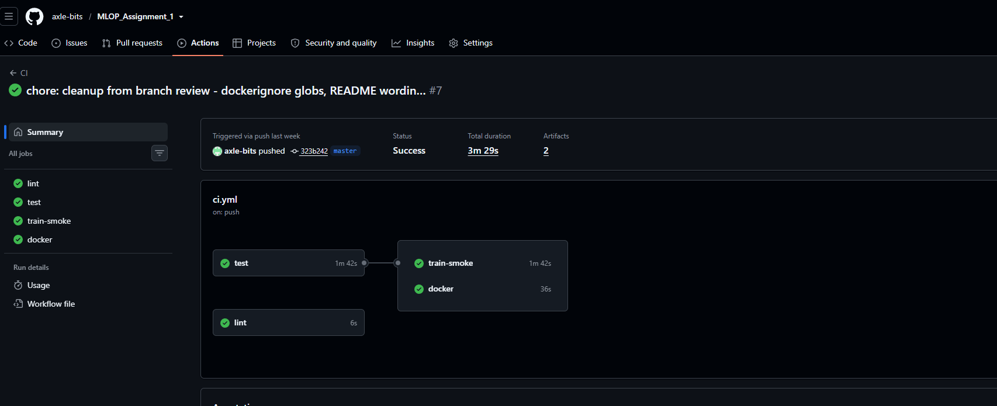
Figure 13 - Green CI run: all four jobs pass
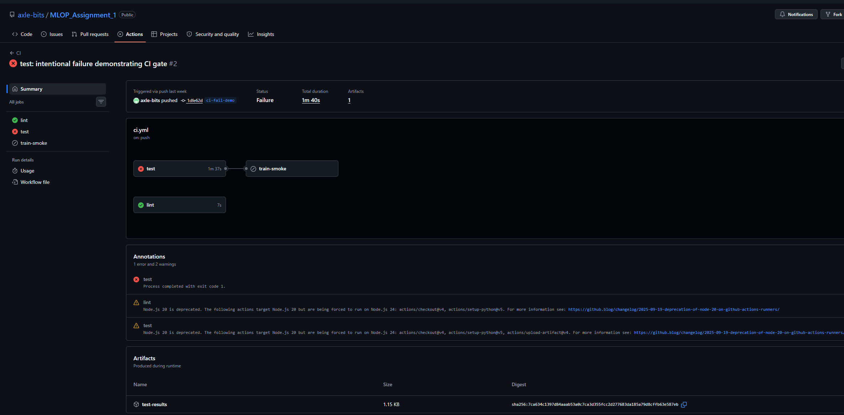
Figure 14 - Red CI run: test failure skips downstream jobs

7. Containerisation

Image Design
The serving image installs only api/requirements.txt - eight pins:
- fastapi==0.139.0
- uvicorn==0.49.0
- scikit-learn==1.9.0
- pandas==2.3.3
- numpy==2.5.0
- joblib==1.5.3
- prometheus_client==0.25.0
- prometheus-fastapi-instrumentator==8.0.2
MLflow, XGBoost, and the plotting stack are excluded - the exported joblib pipeline needs only scikit-learn, pandas, and the ml package at inference time. This roughly halves image size vs installing full training requirements and shrinks the attack surface.
Additional image properties:
- Base: python:3.13-slim (matches the pickle's build Python version)
- Non-root user (appuser) - principle of least privilege
- HEALTHCHECK against /health (30s interval, 3s timeout, 10s start-period)
- Dockerfile layers ordered: requirements → ml/ → models/ → api/ (cache-optimal)

Local Proof
The image was built and run with docker run -d -p 8000:8000 heart-disease-api. /health returned {"status":"ok","model_loaded":true} and a /predict call on the sample request returned probability 0.3326, confirmed against the container logs.
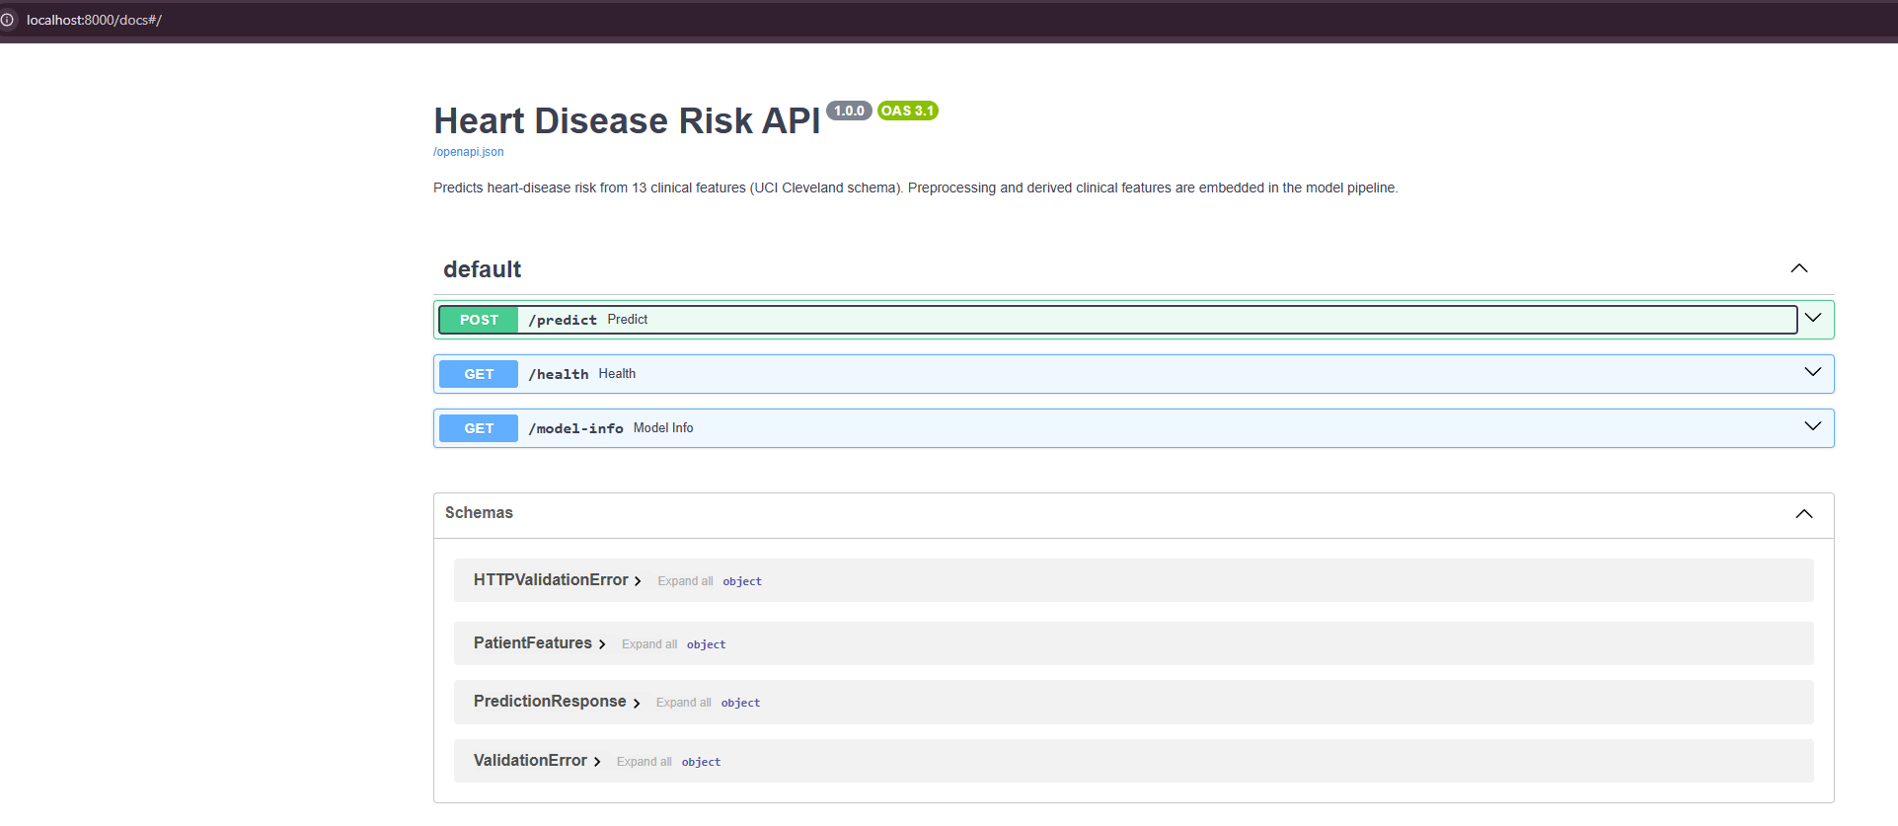
Figure 15 - Swagger UI served from the container

API Input Validation
The /predict schema enforces the UCI data dictionary strictly at the API boundary:
- Categorical codes as strict enums: cp ∈ {1,2,3,4}, thal ∈ {3,6,7}, ca ∈ {0,1,2,3}, sex/fbs/exang ∈ {0,1}
- Bounded continuous ranges: age [18,100], trestbps [80,220], chol [100,600], thalach [60,220], oldpeak [0,7]
- Invalid input → HTTP 422 Unprocessable Entity (never a silent wrong prediction)

8. Deployment

Platform Decision
The original target was AWS EKS. The available AWS account cannot create IAM roles and cannot expose public services (private VPC, private subnets only). eksctl provisions IAM roles via CloudFormation as part of cluster creation - EKS cluster creation fails under those guardrails. The deployment target was pivoted to Docker Desktop's built-in Kubernetes cluster, explicitly accepted by the assignment FAQ (Minikube/Docker Desktop with local access instructions in place of a public URL).

Kubernetes Manifests
Three manifest files under infra/k8s/ define the full stack:
- 00-namespace.yaml - isolated heart-disease namespace
- deployment.yaml - 2-replica Deployment; imagePullPolicy: IfNotPresent (local image store); readiness + liveness probes on /health; CPU 100m–500m, memory 256Mi–512Mi per pod
- service.yaml - LoadBalancer Service; port 80 → containerPort 8000

Verification
On a live 2-node cluster (desktop-control-plane + desktop-worker, v1.36.1): both nodes Ready, both pods Running with READY 1/1. curl /health and a /predict call both succeeded through the LoadBalancer. A rolling-restart demo issued six consecutive health-check requests during the restart - all returned 200 - confirming zero-downtime rollout.
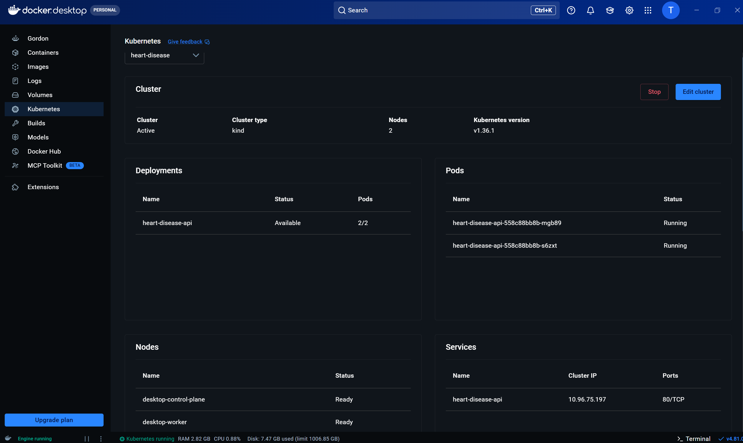
Figure 16 - Docker Desktop Kubernetes cluster dashboard
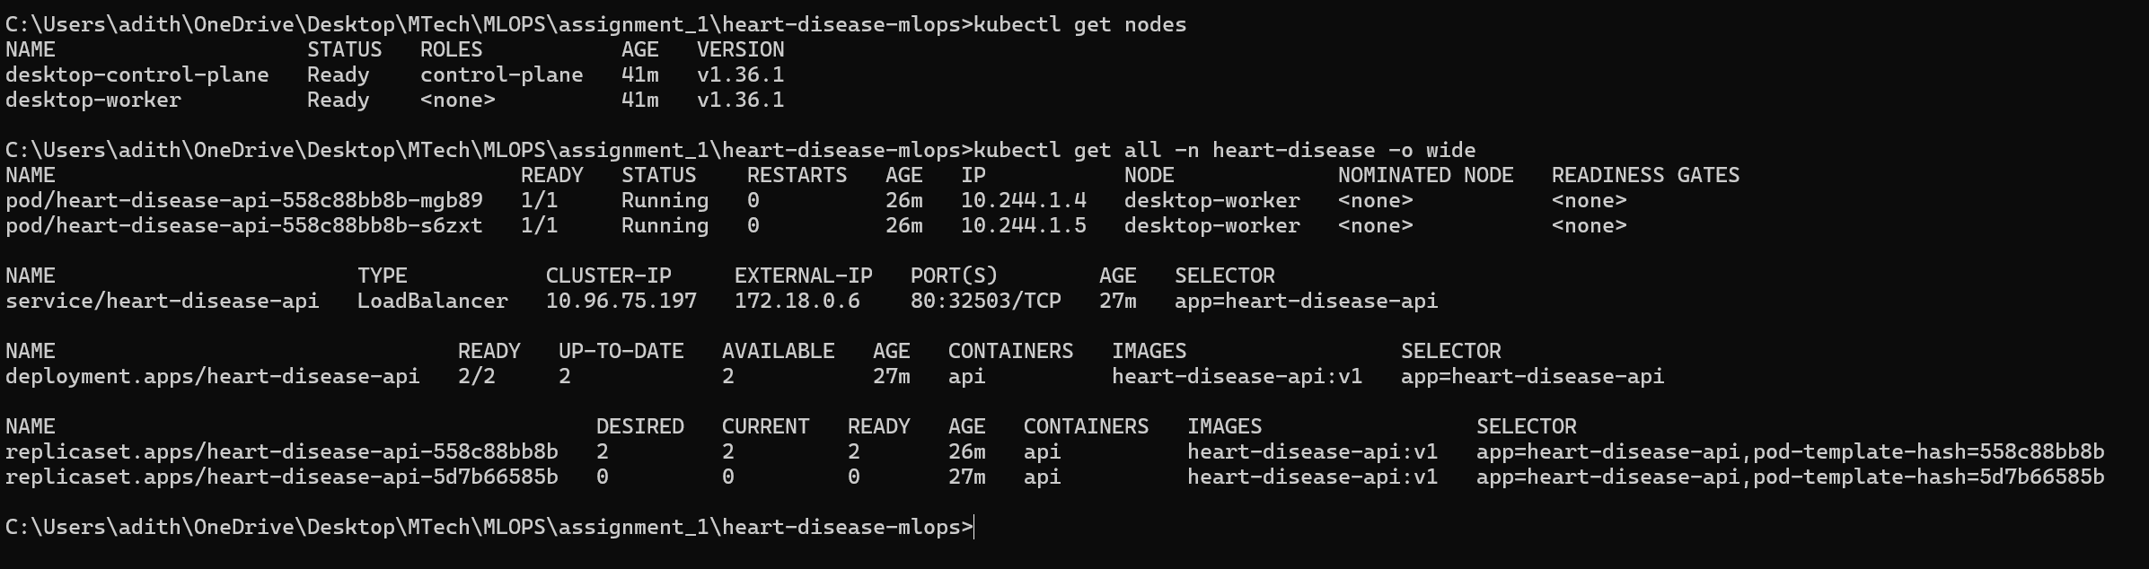
Figure 17 - kubectl get all -n heart-disease: 2 pods Running, LoadBalancer active
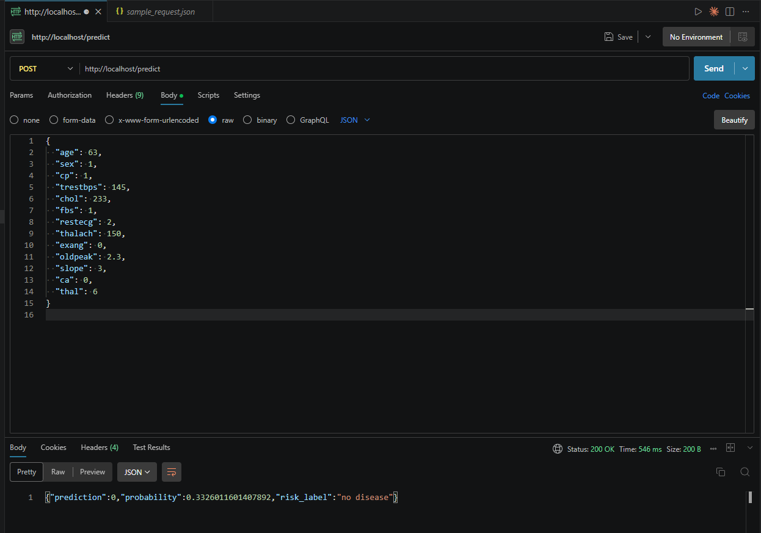
Figure 18 - Postman /predict response from the Kubernetes-served API
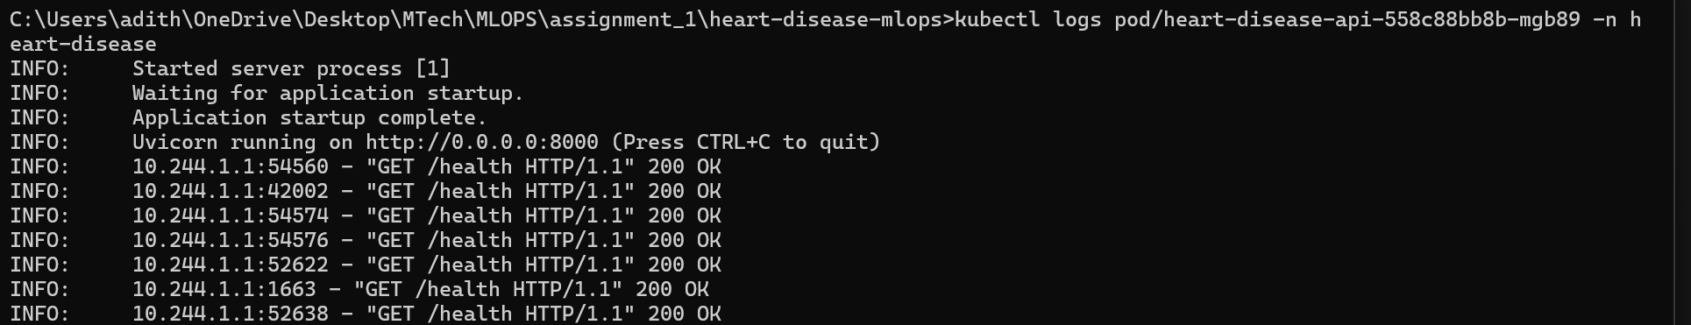
Figure 19 - Pod startup logs: model load + readiness probe hits
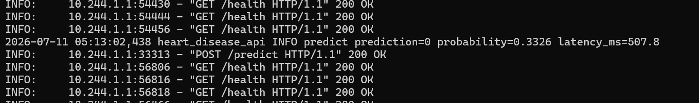
Figure 20 - Structured prediction log line: prediction, probability, latency_ms
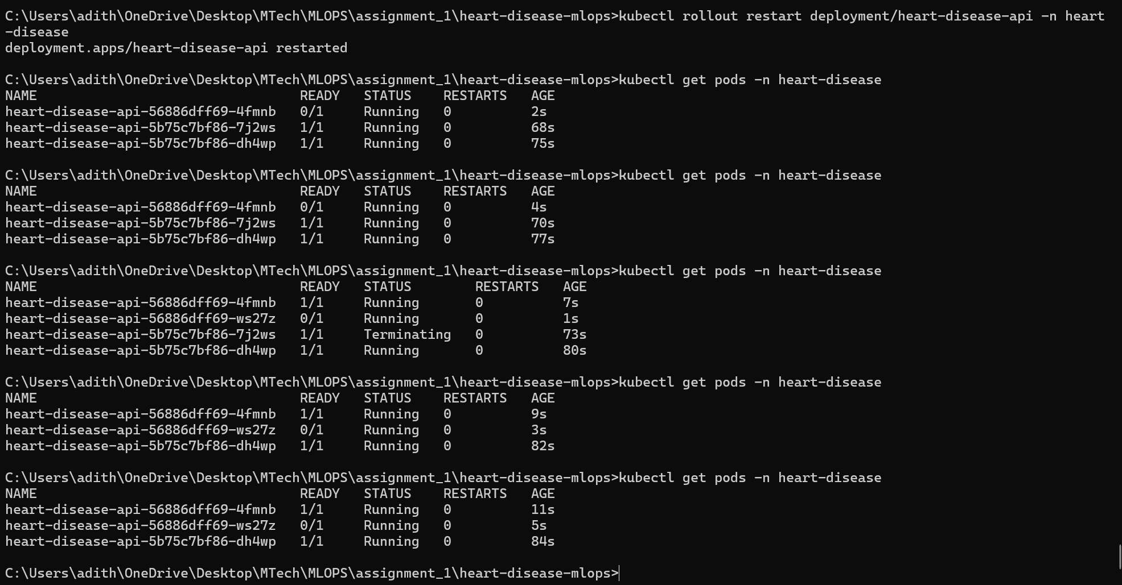
Figure 21 - Rolling restart: six consecutive /health 200 OK responses during pod replacement

9. Monitoring & Logging

Structured Logging
Every prediction request emits a structured application log line alongside uvicorn's own access log entry:
heart_disease_api INFO predict prediction=<0|1> probability=<p> latency_ms=<t>

This gives a human-readable audit trail with stable, greppable fields for every request.

Prometheus Metrics
The API exposes a /metrics endpoint via prometheus-fastapi-instrumentator, providing:
- Standard HTTP metrics: request rate, latency histogram (p50/p95), non-2xx rate
- Custom domain counter: heart_disease_predictions_total{risk_label} - incremented on every prediction

Grafana Dashboard
Prometheus and Grafana are deployed into the same namespace, fully provisioned from ConfigMaps with a single kubectl apply -f infra/k8s/monitoring/. The pre-built 'Heart Disease API' dashboard covers request rate, p50/p95 latency, non-2xx rate, and predictions by risk label - both services reachable via LoadBalancer on ports 9090 and 3000.
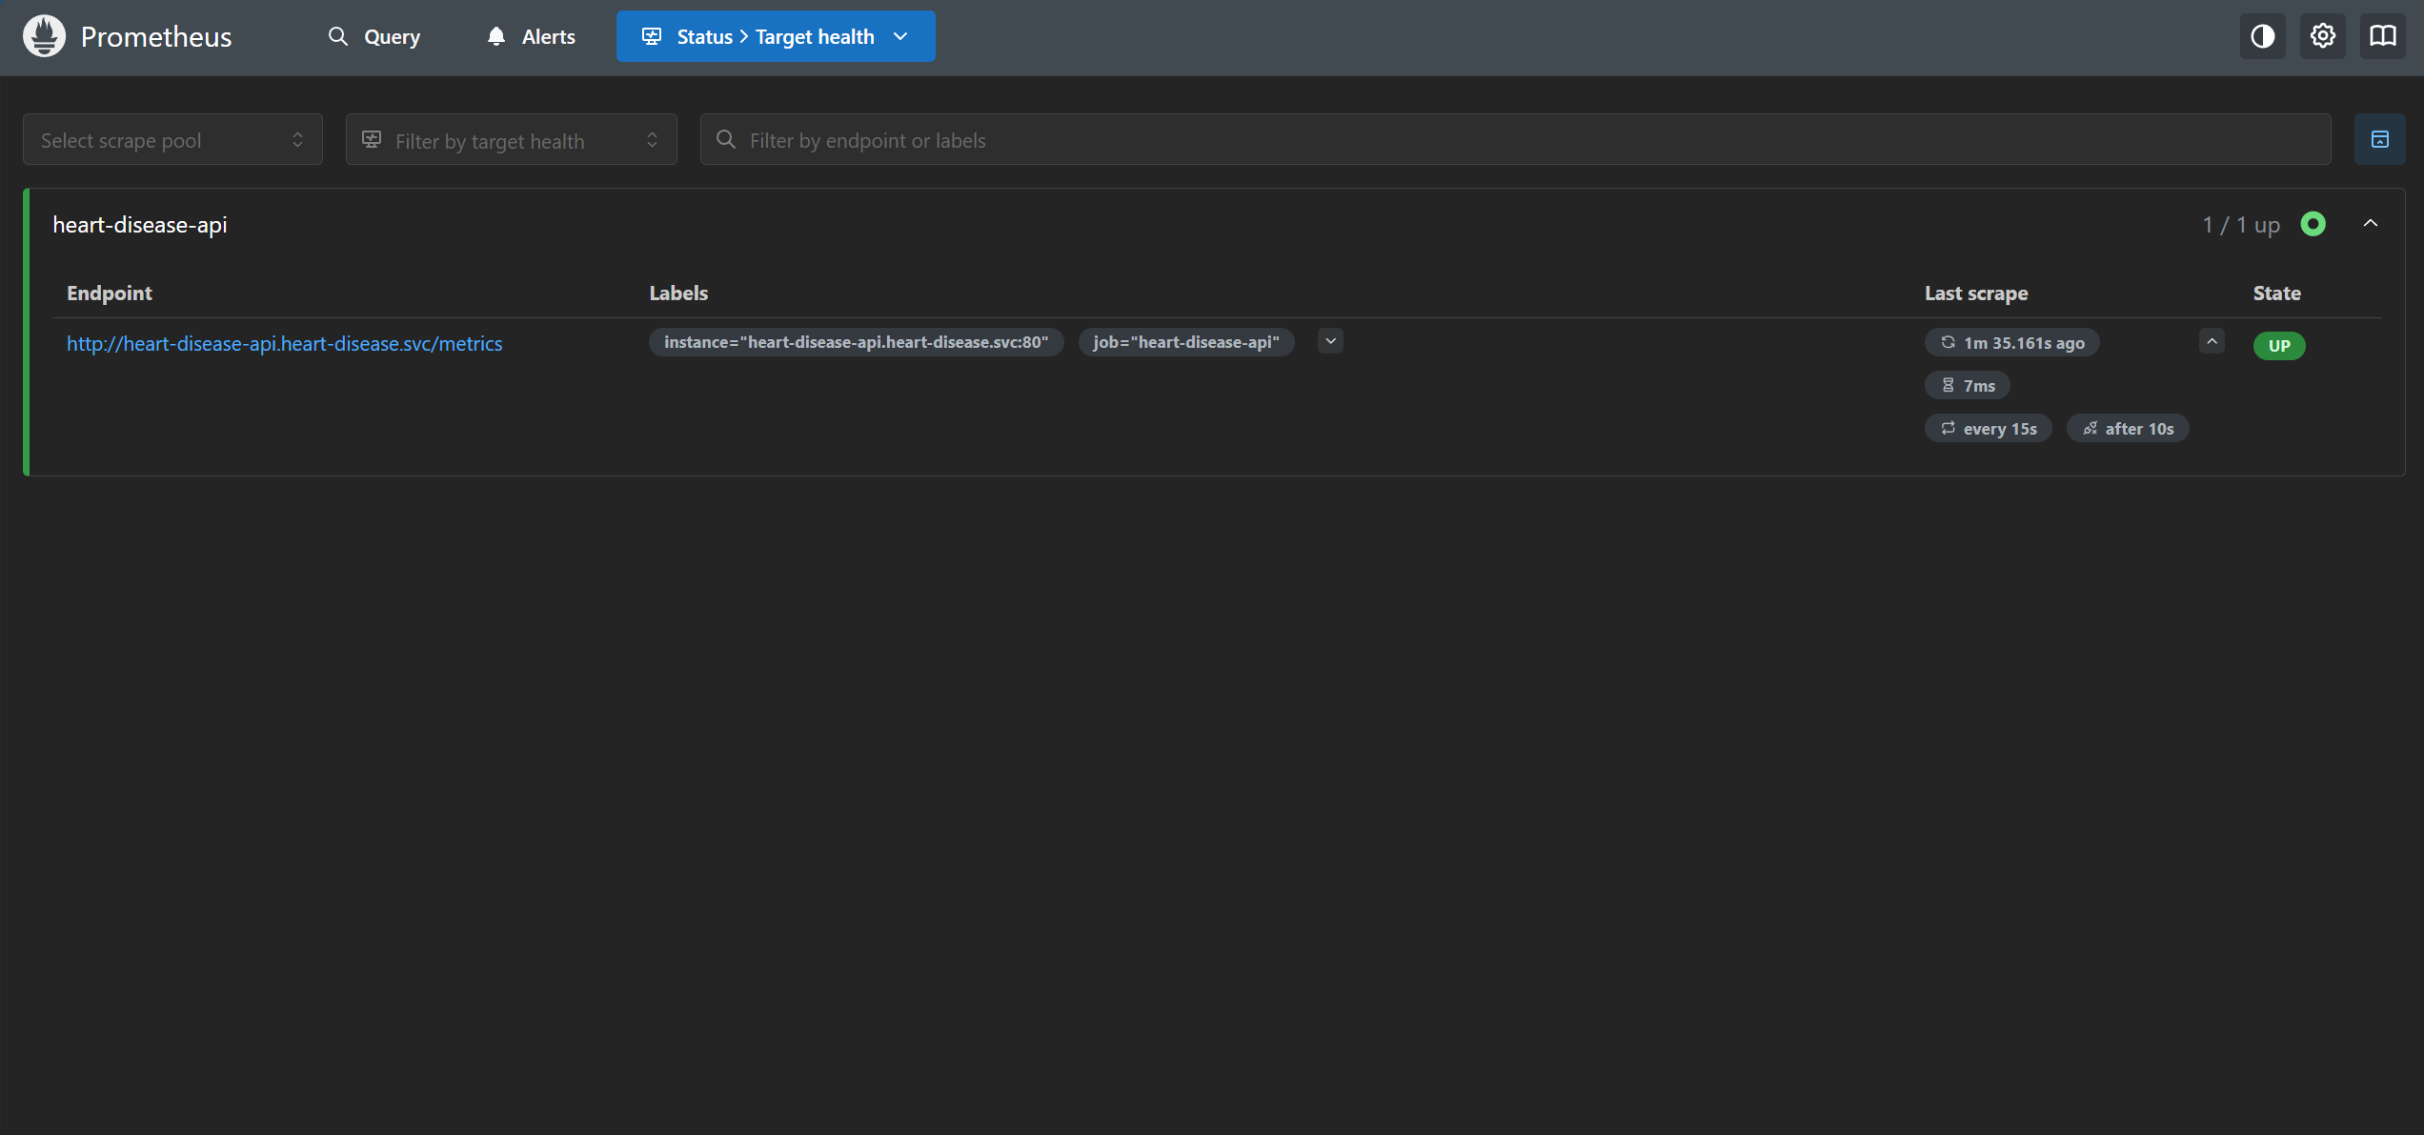
Figure 22 - Prometheus targets page: heart-disease-api scrape target UP
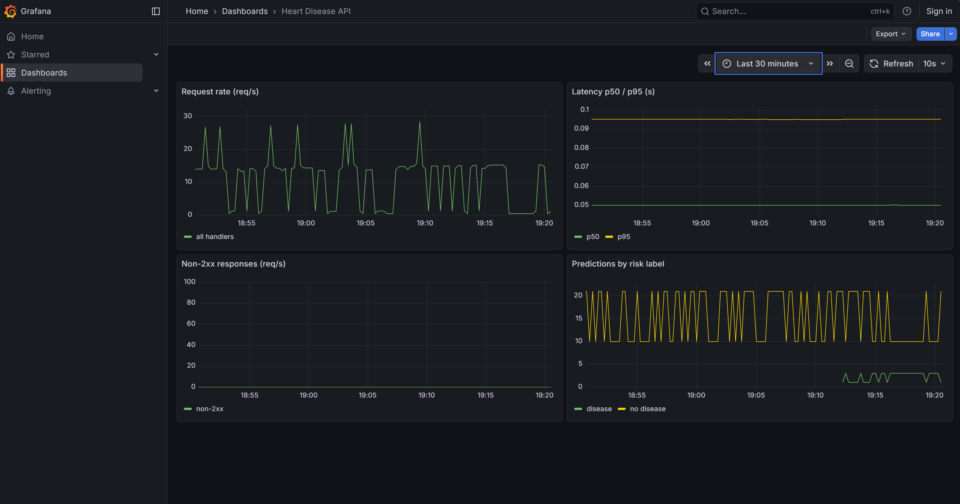
Figure 23 - Grafana 'Heart Disease API' dashboard with live traffic
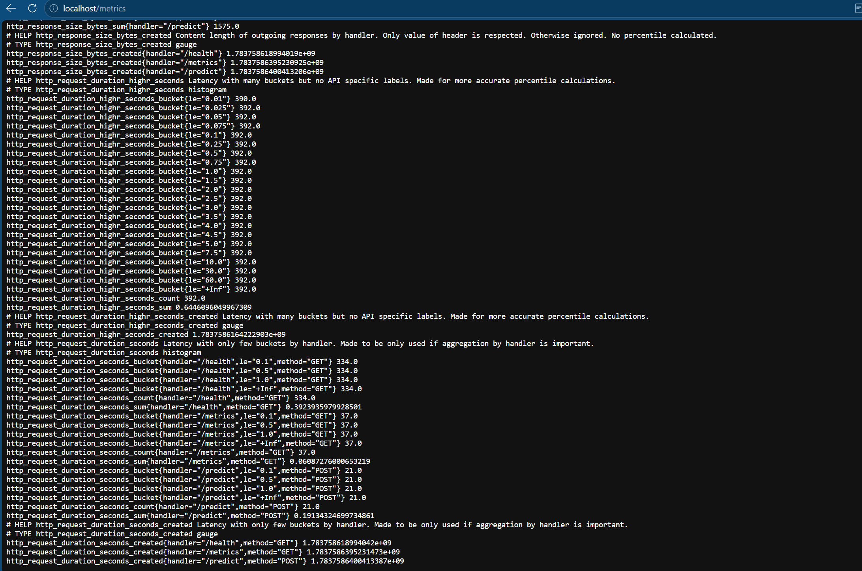
Figure 24 - /metrics endpoint in browser: Prometheus text format

Known Artefact: Counter Sawtooth
The Grafana 'predictions by class' panel shows a sawtooth pattern rather than a smooth monotonic line. Prometheus scrapes the API through its LoadBalancer Service, which alternates scrapes between the two pods. Each pod accumulates its own counter independently, so Prometheus sees alternating values from Pod A and Pod B. A headless Service (clusterIP: None) or per-pod Kubernetes service-discovery annotations would resolve this. This is documented expected demo behaviour, not a bug.

10. Conclusion

What Was Delivered
The pipeline demonstrates the full lifecycle requested by the assignment:
- Data fetched and cleaned reproducibly via a pip-installable download script
- Feature engineering embedded in a pipeline - identical transformation at training and inference
- Tracked multi-model comparison reporting honest, mixed results (clinical features helped LR, hurt Random Forest)
- Deterministic packaging - fresh clone serves without retraining
- CI/CD gate proven with both a green run and a deliberate red run
- Slim Docker image running as non-root with strict API input validation
- Kubernetes deployment chosen for a documented account constraint, not convenience
- Real Prometheus + Grafana monitoring stack wired end-to-end (not a stub endpoint)
- 39 unit tests covering data prep, feature engineering, export logic, and API behaviour

Trade-offs Accepted
- Local Kubernetes (Docker Desktop) instead of EKS - justified by IAM account restrictions, accepted by FAQ
- Ephemeral Prometheus/Grafana - no persistent volumes; metrics reset with pods (correct for a demo)
- Counter sawtooth in Grafana - documented known artefact of load-balanced scraping, not a bug
- Cloudpickle serialisation - required workaround for MLflow 3.x skops incompatibility with FunctionTransformer

Next Steps (If Production-Bound)
- Model Registry - promote the best run into MLflow's Model Registry once multiple models need lifecycle management
- Persistent monitoring - back Prometheus/Grafana on PersistentVolumeClaims; scrape each pod via a headless Service
- EKS revisit - re-attempt cloud deployment once the account IAM constraints are lifted
- Data drift detection - add a statistical drift monitor (e.g., Evidently) on incoming prediction feature distributions
Each of these is a natural, low-friction extension of decisions already made, not a rearchitecture. Everything is provisioned declaratively - the entire stack rebuilds from scratch with kubectl apply / kubectl delete in under two minutes.

