Heart Disease Risk Prediction — MLOps Assignment 01
Adithya (2024AC05785)
Table of Contents

Course: AIMLCZG523 — MLOps Repository: https://github.com/axle-bits/MLOP_Assignment_1

1. Overview & Setup
This project builds an end-to-end MLOps pipeline around a binary classifier that predicts heart disease risk from 13 clinical features in the UCI Cleveland dataset. The goal was not simply to fit a model but to evidence every stage of a production ML lifecycle: reproducible data preparation, tracked experimentation, automated testing and CI/CD, containerized serving, Kubernetes deployment, and monitoring — with every non-trivial choice recorded and justified along the way rather than assumed.
The system is organized around a stage-oriented repository layout — ml/ (data and model code), api/ (FastAPI service), infra/ (Docker and Kubernetes manifests), tests/, notebooks/, and docs/ — chosen to map 1:1 onto the CI/CD stages (lint, test, build) and to stay clearly distinct from the widely-copied cookiecutter-data-science template. Data flows from the UCI source through a cleaning step into a scikit-learn pipeline that performs feature engineering, scaling, and encoding; the trained pipeline is exported as a versioned artifact, wrapped in a FastAPI service, packaged into a Docker image, deployed to a local Kubernetes cluster, and observed through a Prometheus/Grafana stack. The architecture is summarized below.
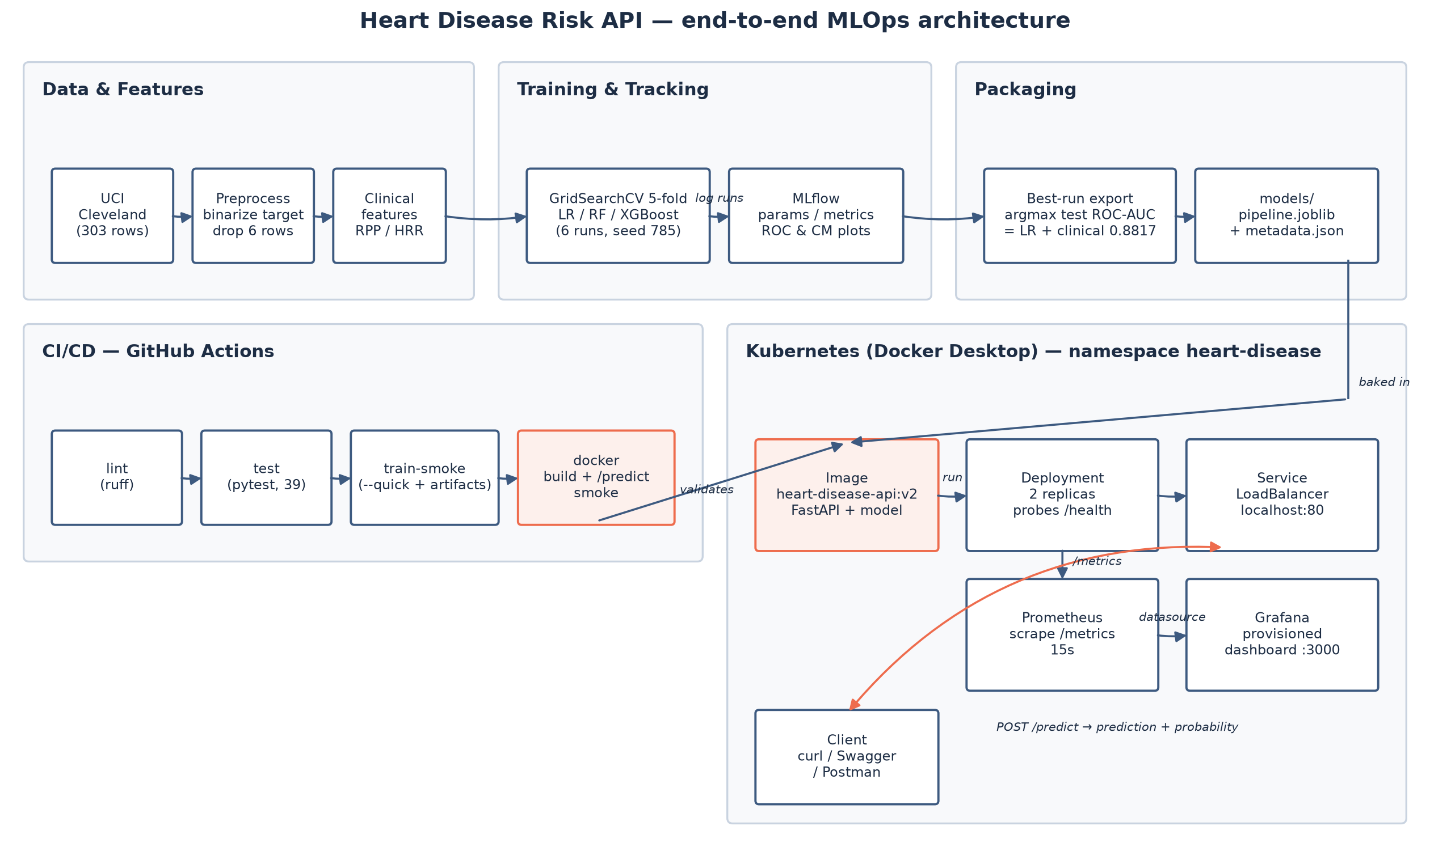
Architecture
Quickstart. Clone the repository, create a virtual environment, and install pinned dependencies:
python -m venv .venv && .venv/Scripts/activate
pip install -r requirements.txt
Train and track experiments, then serve locally:
python -m ml.models.train
uvicorn api.main:app --reload --port 8000
Or run containerized and on Kubernetes:
docker build -t heart-disease-api -f infra/Dockerfile .
docker run -d -p 8000:8000 heart-disease-api
kubectl apply -f infra/k8s/
Run the test suite before touching anything else — pytest — to confirm the data pipeline and packaging logic behave as committed; ruff check . runs the same lint gate CI enforces. The remaining sections follow the same order as the assignment’s nine tasks, from data through monitoring, and each closes with the trade-offs actually made rather than an idealized version of the pipeline.

2. Data & EDA
The dataset is the classic Cleveland subset of the UCI Heart Disease repository, fetched programmatically via ucimlrepo (id=45) rather than a manual CSV download, which was verified to return exactly 303 rows × 13 features and matches the assignment’s dataset link — the alternative combined four-site dataset (~920 rows) was rejected as not being what id=45 actually serves. The raw multi-class target num (0–4, distribution 164/55/36/35/13) was binarized to 0 (no disease) vs 1 (disease present), the established 0-vs-rest convention for this dataset and a binary classifier requirement from the assignment itself.
Six rows (2% of the data) with missing ca (4 rows) or thal (2 rows) values were dropped rather than imputed, since both are categorical clinical measurements (vessel count, thalassemia type) where imputation would invent clinical facts, and dropping sidesteps any train/test leakage question entirely. This leaves 297 rows with a class balance of 160 no-disease vs 137 disease cases — a mild imbalance, handled downstream by scoring on ROC-AUC.
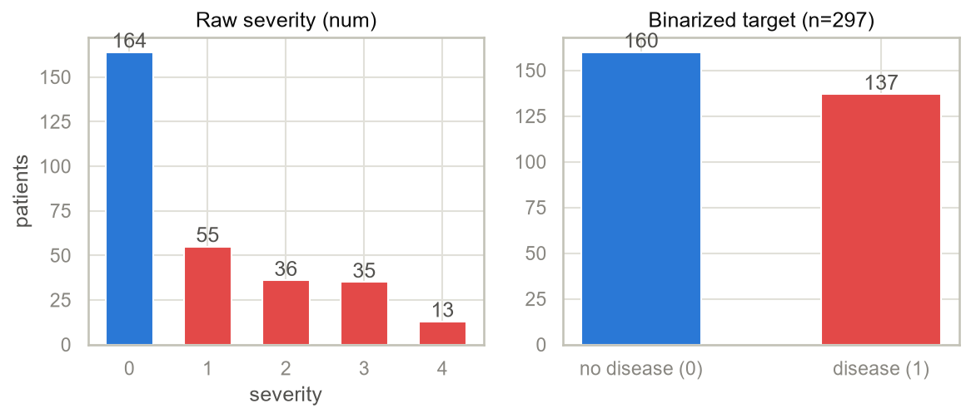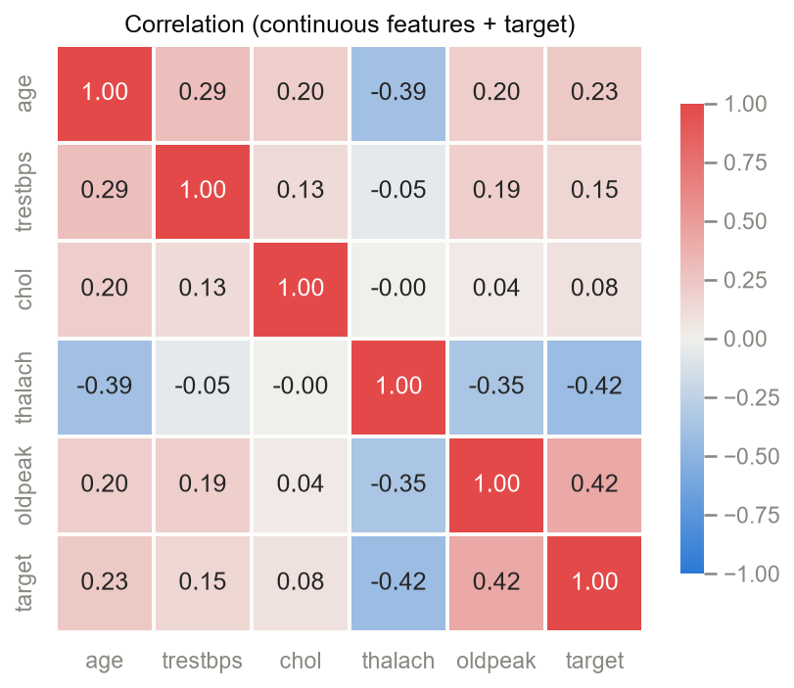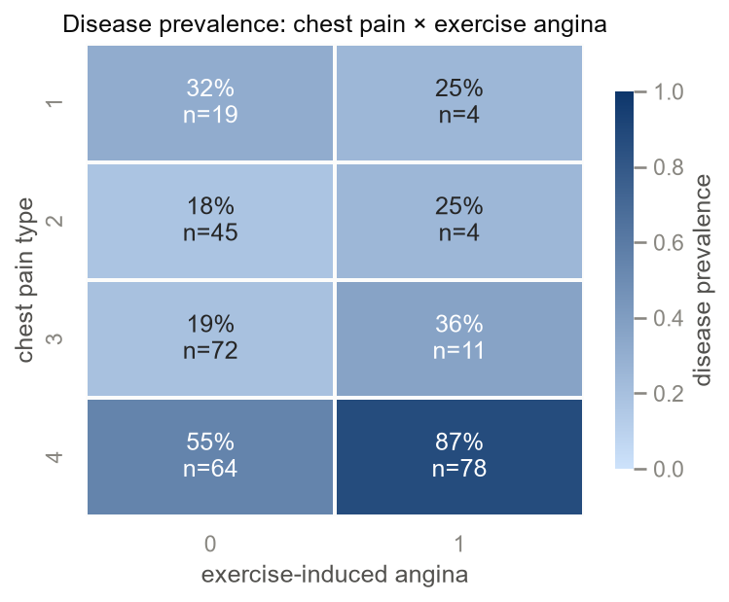
Exploratory analysis surfaced several clinically sensible patterns: disease prevalence is markedly higher in males (56%) than females (26%); patients reporting asymptomatic chest pain combined with exercise-induced angina show an 87% prevalence, the strongest subgroup signal in the data; and among continuous features, ST-depression (oldpeak, r=+0.42) and maximum heart rate achieved (thalach, r=−0.42) are the strongest linear correlates of the target. These findings motivated the derived clinical features introduced in the next section.
The figures themselves use a fixed two-class palette (no-disease blue #2a78d6, disease red #e34948, a diverging blue-gray-red scale for the correlation heatmap, and a single-hue blue ramp for prevalence heatmaps), validated colorblind-safe with a worst-pair contrast well above the accessibility threshold, rather than left to seaborn’s defaults — this keeps every chart in the notebook and the report visually consistent and legible.

3. Feature Engineering & Models
Three clinically motivated derived features — rate-pressure product (trestbps × thalach), heart-rate reserve (220 − age − thalach), and an oldpeak × slope interaction — were added inside the scikit-learn Pipeline itself (not pre-computed into the cleaned CSV), which guarantees an identical transformation at training and inference time. A fourth candidate, pulse pressure, was rejected outright: the dataset only carries systolic blood pressure (trestbps), with no diastolic column to pair it with.
Preprocessing applies StandardScaler to the five continuous features plus ca (treated numerically as an ordinal vessel count, not a nominal code) and the three derived features when enabled; OneHotEncoder with handle_unknown="ignore" to the genuinely nominal categoricals cp, restecg, slope, thal; and passthrough for the binary features sex, fbs, exang. This keeps dimensionality low on a 297-row dataset while protecting inference-time inputs from unseen category codes.
Three model families — Logistic Regression, Random Forest, and XGBoost — were each trained on two feature sets (raw vs. raw+clinical), giving six tracked runs. Every run used GridSearchCV over StratifiedKFold(5, shuffle=True), scoring ROC-AUC, tuned only on an 80/20 stratified train split with random_state=785 (a seed derived from the student ID) shared across all runs so that differences are attributable to model/features alone; the test split is touched exactly once per run to avoid selection leakage. Metrics logged include CV mean±std ROC-AUC plus held-out accuracy, precision, recall, F1, and ROC-AUC. GridSearchCV was preferred over RandomizedSearchCV because the six grids are small enough to enumerate exhaustively; nested cross-validation was judged more rigorous than necessary for 297 rows and harder to present clearly; and random_state=785 was chosen deliberately over the tutorial-universal seed 42 for originality, with no effect on the validity of the comparison since it is applied identically to every run. A third model family, XGBoost, was added beyond the assignment’s two-model minimum specifically to make this comparison richer.
model | features | cv_roc_auc | test_accuracy | test_precision | test_recall | test_f1 | test_roc_auc
logistic_regression | clinical | 0.9195 ± 0.0123 | 0.7667 | 0.7500 | 0.7500 | 0.7500 | 0.8817
logistic_regression | raw | 0.9198 ± 0.0230 | 0.7833 | 0.7778 | 0.7500 | 0.7636 | 0.8761
random_forest | raw | 0.9238 ± 0.0149 | 0.7833 | 0.7586 | 0.7857 | 0.7719 | 0.8583
random_forest | clinical | 0.9148 ± 0.0206 | 0.7667 | 0.7917 | 0.6786 | 0.7308 | 0.8493
xgboost | clinical | 0.9313 ± 0.0115 | 0.6833 | 0.6552 | 0.6786 | 0.6667 | 0.8415
xgboost | raw | 0.9242 ± 0.0196 | 0.7500 | 0.6970 | 0.8214 | 0.7541 | 0.8315
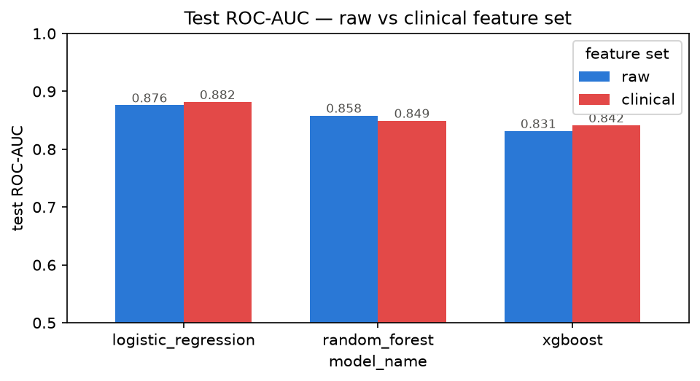
ROC-AUC by model
The winning configuration is Logistic Regression with the clinical feature set: test ROC-AUC 0.8817, CV 0.9195 ± 0.0123. The honest picture, however, is mixed rather than uniformly positive: the clinical features helped Logistic Regression (0.8817 vs 0.8761 raw) but slightly hurt Random Forest (0.8493 vs 0.8583 raw) — tree ensembles can already capture the interactions the derived features encode explicitly, so handing them a redundant, correlated copy of that signal did not pay off, and in RF’s case cost a little.

4. Experiment Tracking
All six runs are tracked with MLflow, using a sqlite:///mlflow.db store for run metadata (params, metrics, tags) with artifacts under ./mlruns. Each run logs its hyperparameters, seven metrics (CV mean/std ROC-AUC plus test accuracy, precision, recall, F1, ROC-AUC), the ROC curve, confusion matrix, and feature-importance plots as artifacts, and the fitted pipeline itself in MLflow’s model format. This gives a complete, comparable record across all 3-model × 2-feature-set combinations without re-running anything to answer “did the clinical features help.”
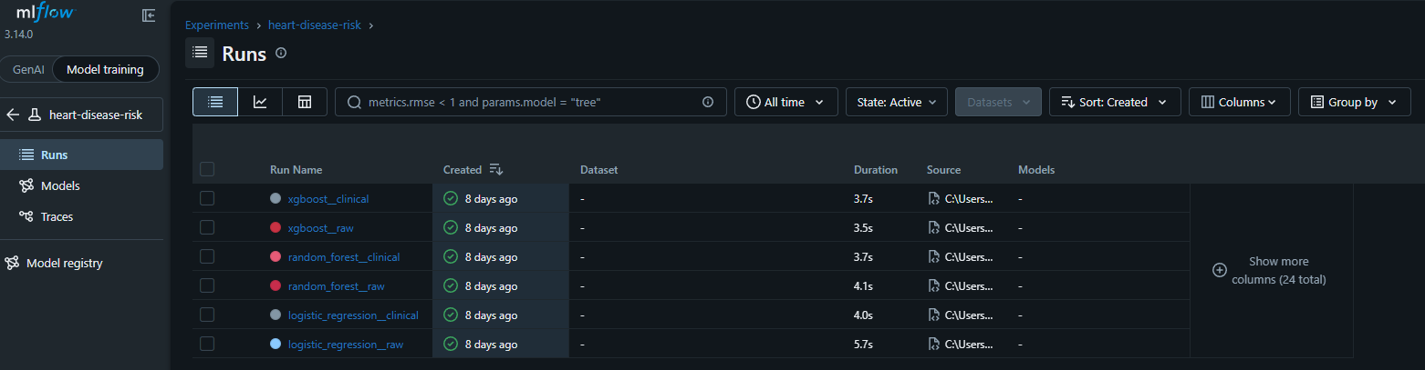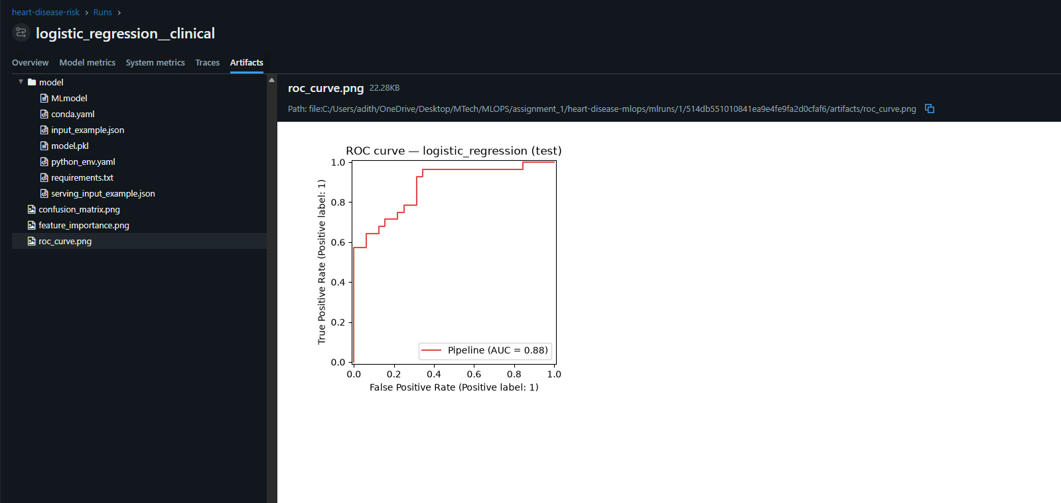
Getting there required adapting to genuine behavioral changes in the pinned MLflow 3.14.0 rather than the version the original brief assumed. MLflow 3.x now raises on any file:///./mlruns-only tracking URI unless MLFLOW_ALLOW_FILE_STORE=true is explicitly set, since the pure file store is in maintenance mode — the fix was to point the tracking URI at sqlite:///mlflow.db (metadata) with ./mlruns retained only as the artifact root, confirmed by inspecting which store actually held the six runs’ params and metrics. Separately, mlflow.sklearn.log_model() in 3.x now records the model as a decoupled “LoggedModel” that never appears under the run’s own artifact tree, and the model pipeline’s FunctionTransformer (wrapping the first-party clinical-feature function) is rejected by the new default skops serialization as an “untrusted type.” Both were resolved together by saving the model to a temp directory with serialization_format="cloudpickle" and uploading it as a run artifact explicitly — restoring the classic run-scoped model/ folder and keeping the custom transformer loadable, verified end-to-end by reloading each run’s model with mlflow.sklearn.load_model and calling .predict().

5. Packaging & Reproducibility
The best run — selected deterministically as the argmax of test ROC-AUC over the full-grid runs, which the fixed seed makes reproducible — is exported in two formats: models/heart_disease_pipeline.joblib, the canonical serving artifact loadable with scikit-learn and joblib alone (no MLflow dependency at inference time), and models/mlflow_model/, the same pipeline in MLflow’s own format for that deliverable. A companion model_metadata.json records the source run id, its metrics, package versions, and the expected input schema, so a fresh clone or a grader can verify provenance without access to the MLflow store. All three are committed to git alongside a fully pinned requirements.txt, so serving and the CI pipeline work from a clean checkout with no retraining required. Pickle version-fragility is mitigated by pinning dependency versions and recording them explicitly in the metadata file.
Reproducibility was also treated as something to verify, not assume: adding scikit-learn, xgboost, mlflow, and joblib to requirements.txt and re-freezing with exact == pins surfaced that installing MLflow forces pandas down from 3.0.3 to 2.3.3, because MLflow 3.14.0 declares Requires-Dist: pandas<3. Rather than leave that conflict implicit, it was confirmed directly (pip install --dry-run against the newer pandas raised ResolutionImpossible) and the full test suite was re-run against the downgraded pin before committing it, so the pinned set is a verified mutually-compatible combination rather than an assumed one.

6. CI/CD
The GitHub Actions pipeline (.github/workflows/ci.yml) runs four jobs on every push and pull request: lint (ruff check . — pycodestyle errors, pyflakes, import order) and test (the full pytest suite, JUnit results uploaded as an artifact even on failure) run in parallel, followed by train-smoke (python -m ml.models.train --quick, exercising all six model/feature combinations end-to-end with quick grids, log and tracking store uploaded as artifacts), and a docker build-validation job. Jobs carry timeouts and read-only permissions by default, and artifacts are uploaded on every run (if: always()) specifically so logs are available exactly when a run fails and they matter most. Linting runs a single tool, ruff, configured for pycodestyle errors, pyflakes, and import order with a 100-character line length; the smoke job deliberately does not run the export step, since the pipeline’s own pick_best logic rejects quick-mode runs by design, and carving out a CI-only bypass would weaken that guarantee rather than test it — export correctness is instead covered by unit tests in the test job. Python is pinned to 3.13 across CI and the serving image specifically because the committed model pickle was built under 3.13.11, and cross-minor-version unpickling is the most realistic way a pipeline like this actually breaks.
To demonstrate the gate is real rather than decorative, a deliberately broken commit was pushed to trigger a red run: lint/test/train-smoke fail fast and the pipeline reports failure, then the fix was pushed to restore a green run.
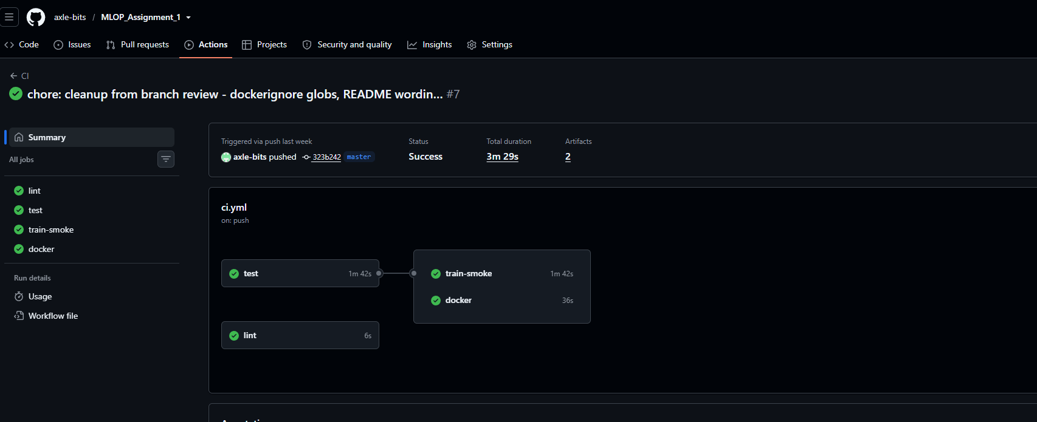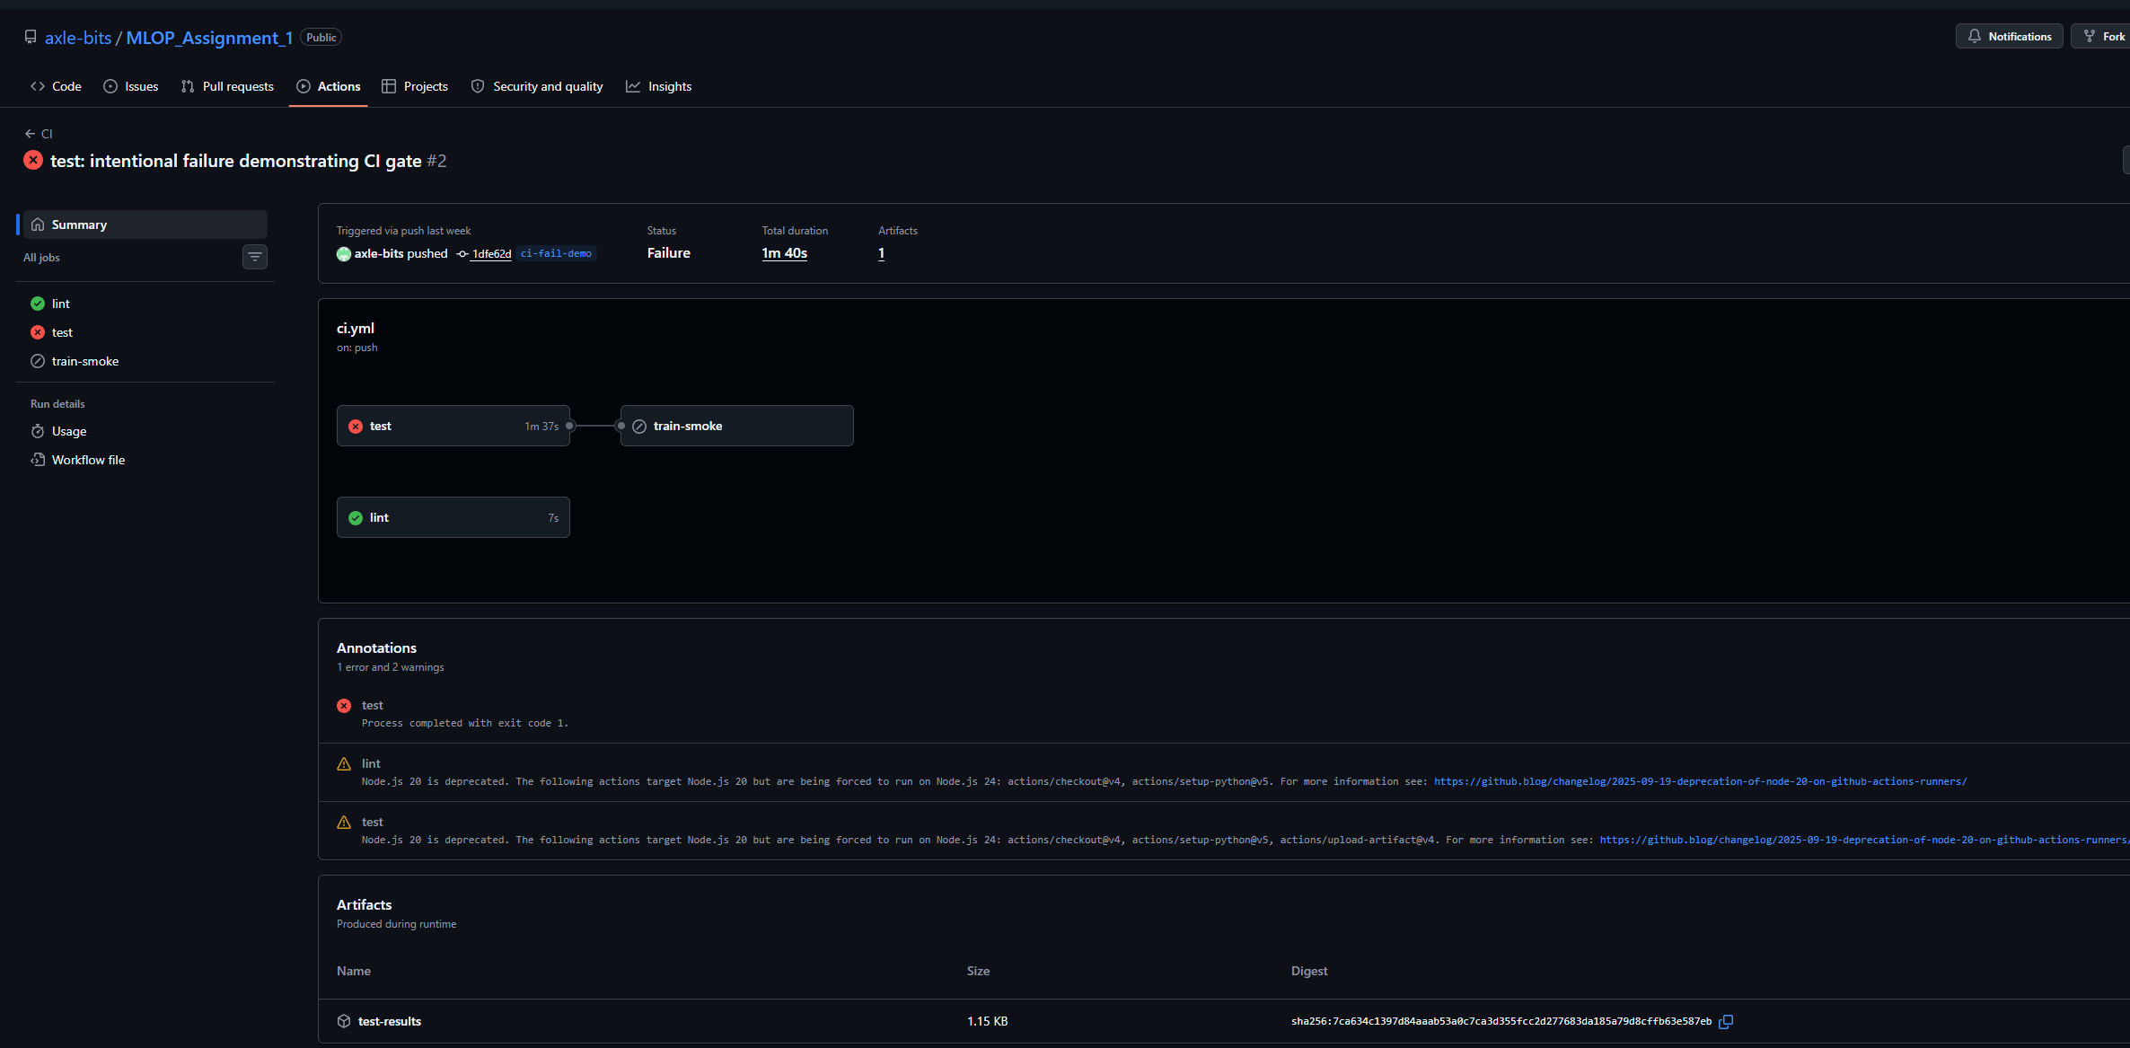

7. Containerization
The serving image installs only api/requirements.txt — FastAPI, uvicorn, scikit-learn, pandas, numpy, and joblib, eight pins mirrored from the root requirements.txt — and copies in ml/, models/, and api/; it deliberately excludes MLflow, XGBoost, and the plotting stack, since the exported joblib pipeline only needs scikit-learn, pandas, and the ml package at inference time. This roughly halves the image size relative to installing the full training requirements and shrinks the attack surface. The image runs as a non-root user on a python:3.13-slim base (matching the Python version the committed pickle was built under) with a HEALTHCHECK against /health.
Local proof: the image was built and run with docker run -d -p 8000:8000 heart-disease-api; /health returned {"status":"ok","model_loaded":true} and a /predict call against the sample request returned a prediction with probability 0.3326, both confirmed against the container’s own logs (full transcript in docs/figures/api/local_container_proof.md).
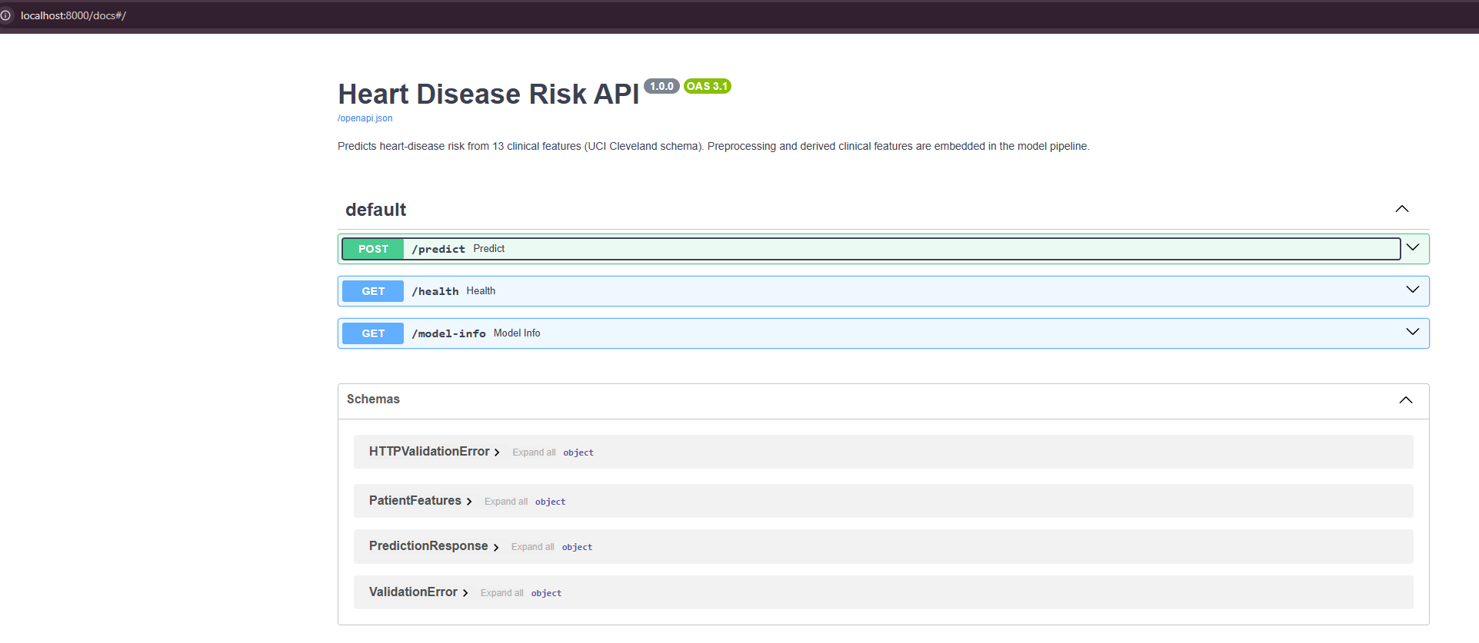
Swagger overview
The /predict schema itself enforces the UCI data dictionary strictly at the API boundary — enums for categorical codes (cp 1–4, thal {3,6,7}, ca 0–3, the various binary flags) and bounded ranges for continuous clinical values (age 18–100, resting blood pressure 80–220, cholesterol 100–600, max heart rate 60–220, oldpeak 0–7), rejecting anything outside those bounds with a structured 422 rather than accepting it. This is deliberately stricter than the pipeline itself needs to be: the fitted pipeline’s OneHotEncoder(handle_unknown="ignore") would silently zero-out an unrecognized category code and still return a prediction, which is tolerable for batch scoring but not for a clinical-facing endpoint, where silent garbage-in is worse than an explicit rejection. The pipeline’s own tolerance is kept as a second line of defense underneath the API-level validation.

8. Deployment
The deployment target was originally planned as AWS EKS with ECR as the registry. That plan changed on account-constraint grounds, not preference: the available AWS account cannot create IAM roles and cannot expose public services, being confined to a private VPC with only private subnets, and eksctl provisions IAM roles via CloudFormation as part of cluster creation — so EKS cluster creation fails outright under those guardrails. Rather than fight the account boundary, the deployment target was pivoted to Docker Desktop’s built-in Kubernetes cluster, a constraint-driven architecture decision explicitly accepted by the assignment FAQ (which allows Minikube/Docker Desktop and local access instructions in place of a public URL) and one that satisfies the rubric fully — Deployment and Service YAML, LoadBalancer exposure, verifiable endpoints — with zero account risk. Two alternatives were weighed and set aside: EKS against pre-existing IAM roles with an internal load balancer, whose feasibility could not be verified inside the restricted account (every step would have to be relayed through a SageMaker terminal with no direct visibility); and ECS in the account’s private subnets, which the account does permit but which produces a task-definition artifact rather than the Kubernetes Deployment/Service YAML the FAQ and rubric expect — a technically working answer to a different question.
The manifests define a heart-disease namespace, a 2-replica Deployment with readiness and liveness probes against /health (Kubernetes ignores the Dockerfile HEALTHCHECK, so the probes are the real gate — with the model loaded at import time, a pod with a broken artifact never becomes Ready), and a LoadBalancer Service mapping port 80 to the pods’ 8000. The image is consumed from the local Docker image store (imagePullPolicy: IfNotPresent), with no registry involved.
Verification on a live 2-node cluster (desktop-control-plane, desktop-worker, v1.36.1) confirmed both nodes Ready and both pods Running with READY 1/1; curl http://localhost/health and a /predict call both succeeded through the LoadBalancer Service. A rolling-restart demo (kubectl rollout restart) issued six consecutive health-check requests during the restart — all returned 200 — confirming zero-downtime rollout while both pods were replaced with fresh ones.
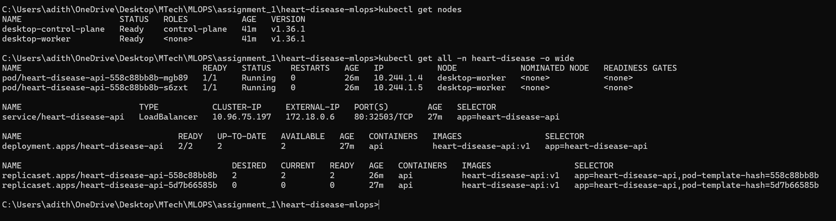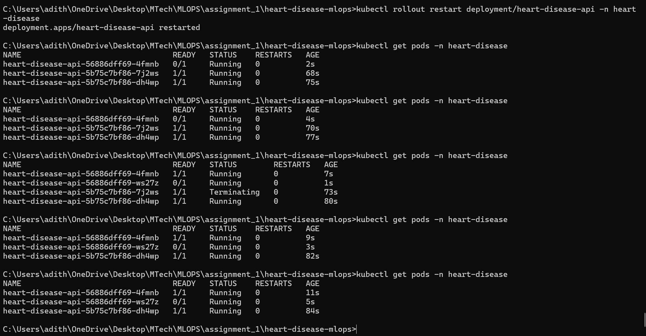

9. Monitoring & Logging
Every prediction request emits a structured application log line — heart_disease_api INFO predict prediction=<0|1> probability=<p> latency_ms=<t> — alongside uvicorn’s own access log entry for the same request, giving both a human-readable audit trail and a stable, greppable field format.
Beyond logging, the API exposes a /metrics endpoint via prometheus-fastapi-instrumentator (standard HTTP request-rate, latency, and status-code metrics) plus a custom domain counter, heart_disease_predictions_total{risk_label}, incremented on every prediction — surfacing ML-aware signal (the mix of predicted classes over time), not just HTTP plumbing. Prometheus and Grafana are deployed into the same namespace, fully provisioned from ConfigMaps with a single kubectl apply: Prometheus statically scrapes the API Service every 15s, and Grafana (anonymous viewer access) serves a pre-built “Heart Disease API” dashboard covering request rate, p50/p95 latency, non-2xx rate, and predictions by risk label — both reachable via their own LoadBalancer Services on 9090 and 3000. Live verification confirmed the Prometheus scrape target up, PromQL queries returning non-zero request-rate and prediction counts, and Grafana’s health and dashboard endpoints both healthy.
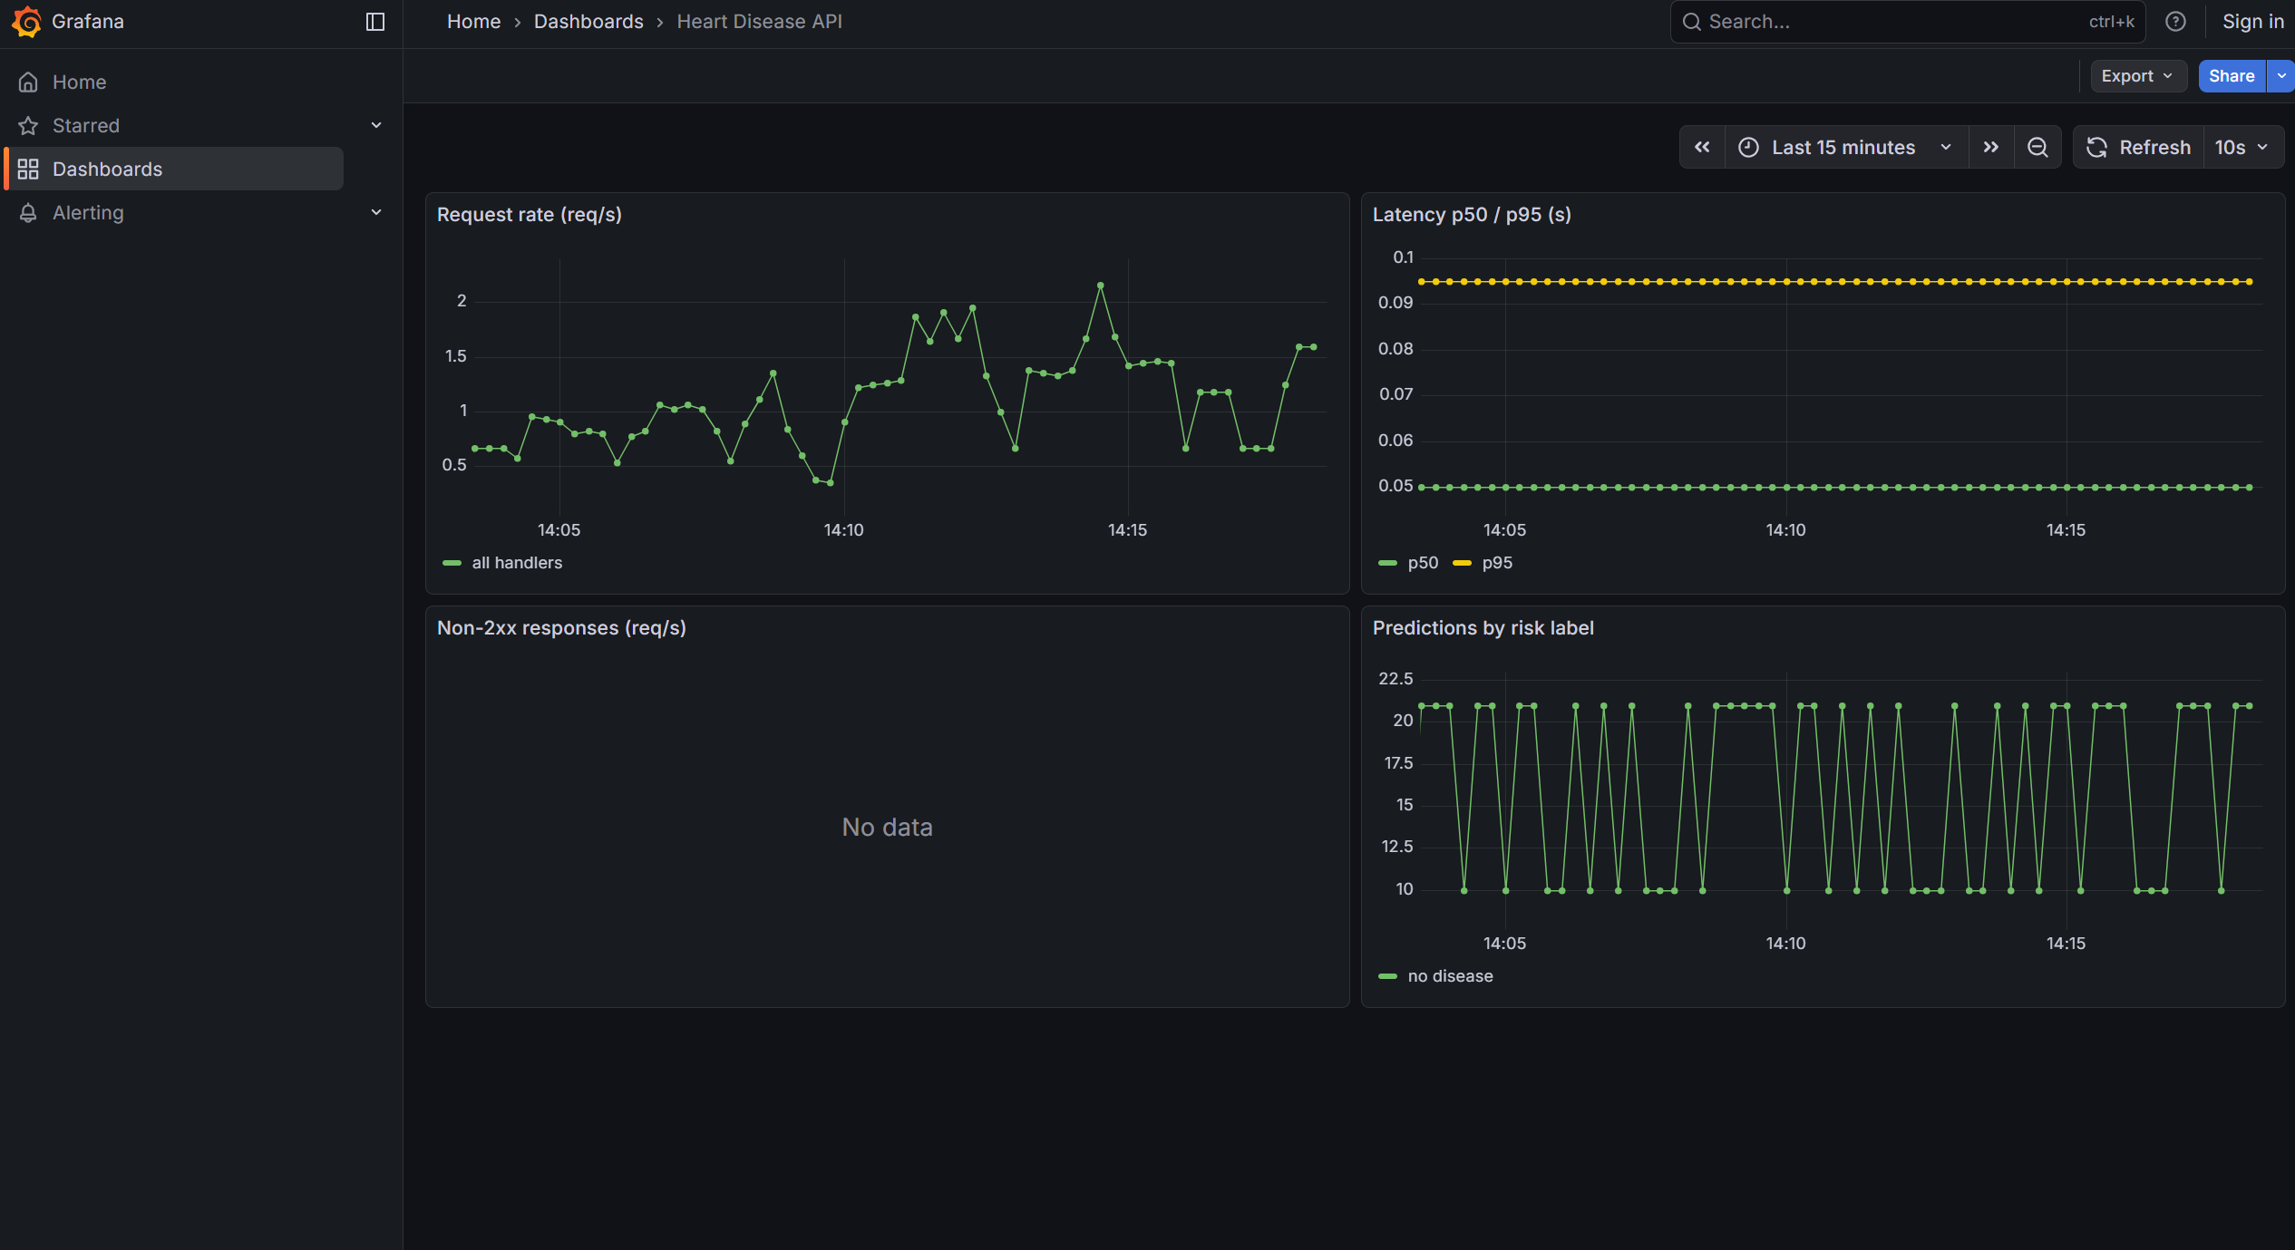
Grafana dashboard
One artifact of the setup is visible in the dashboard’s “predictions by class” panel: Prometheus reaches the API only through its Service, which load-balances each scrape between the two pods, so the counter it sees alternates between each pod’s independently-accumulated value rather than climbing monotonically — a visible sawtooth rather than a smooth line. A per-pod instance label (or scraping through a headless Service to reach each pod directly) would resolve this by letting Prometheus sum across pods instead of sampling one at a time; this is accepted here as expected demo behavior rather than a bug, and noted rather than silently left unexplained.
The monitoring stack, like the API deployment, is intentionally ephemeral: no persistent volumes are used, so metrics reset whenever pods restart. For a graded demo this is an acceptable, and arguably correct, trade-off — see the conclusion.

10. Conclusion
Taken together, the pipeline demonstrates the full lifecycle asked for by the assignment: a reproducibly fetched and cleaned dataset; feature engineering embedded in a pipeline rather than pre-computed; a tracked, multi-model comparison that reports honest, mixed results rather than a single flattering number; deterministic packaging that lets a fresh clone serve without retraining; a CI/CD gate proven with both a green and a red run; a slim, non-root container; a Kubernetes deployment whose target platform was chosen for a documented account constraint rather than convenience; and a monitoring stack wired into real Prometheus/Grafana rather than a stub JSON endpoint.
The ephemeral choices — no EKS cluster left running, no persistent volumes under Prometheus/Grafana, metrics that reset with the pods — are not shortcuts but cost-conscious practice: nothing here needs to survive a demo, and provisioning everything declaratively (namespace, Deployment, Service, and the monitoring ConfigMaps) means the entire stack can be torn down and rebuilt with a couple of kubectl apply/kubectl delete calls whenever it is needed again, which is the property that actually matters for a project graded once and not operated continuously.
If this pipeline were to continue past the assignment, the clearest next steps follow directly from the trade-offs already documented: promoting the tracked model into MLflow’s Model Registry once more than one model needs to be managed over time, moving the monitoring stack onto persistent storage and a per-pod scrape topology once metrics need to survive a restart, and revisiting EKS once the account constraints that forced the local-Kubernetes pivot are lifted. None of those are required to satisfy the current rubric, but each is a natural, low-friction extension of decisions already made rather than a rearchitecture.

