Proceeding Paper

RETHINKING ON-DEMAND IRRIGATION SYSTEMS USING IOT STAND-ALONE TECHNOLOGIES †

Giacomo Ferrarese1, Alessandro Pagano2, Davide Troiani1, Anna Ceni1, Axel I. Hutomo1, Nicola Fontana3, Gustavo Marini3, Stefano Mambretti1, Stefano Malavasi1

|  |
| --- |
| **Citation:** To be added by editorial staff during production.  Academic Editor: Firstname Lastname  Published: date **Copyright:** © 2024 by the authors. Submitted for possible open access publication under the terms and conditions of the Creative Commons Attribution (CC BY) license (https://creativecommons.org/licenses/by/4.0/). |

1 Politecnico di Milano, Milan, Italy; [giacomo.ferrarese@polimi.it](mailto:giacomo.ferrarese@polimi.it)

2 IRSA CNR, Bari, Italy; [alessandro.pagano@cnr.it](mailto:alessandro.pagano@cnr.it)

3 Università degli Studi del Sannio, Benevento, Italy; [fontana@unisannio.it](mailto:fontana@unisannio.it)

**\*** Correspondence: [giacomo.ferrarese@polimi.it](mailto:giacomo.ferrarese@polimi.it)

† Presented at the 3rd WDSA/CCWI Joint Conference, Ferrara, Italy, 1-4 July 2024.

**Abstract:** The integration of Internet of Things (IoT) technologies into pressurized irrigation water distribution networks holds significant potential for optimizing water utilization, especially given the escalating concerns about scarcity and increasing demand [1]. Nevertheless, within the irrigation domain, the utilization of specific technologies and management strategies based on IoT technologies is not yet as widespread as their well-established efficacy would suggest. The present work proposes a management strategy based on such technologies to enhance the sustainability of a case study network, using real operational data during the irrigation season.

**Keywords:** Pressurized irrigation networks; On-demand irrigation; Control valves; IoT

1. Introduction

The current and projected water demands can benefit from the incorporation of IoT tools for equitable distribution and efficient water usage. By leveraging these technologies, it becomes possible to monitor, manage, and allocate water resources effectively, mitigating scarcity concerns and promoting sustainable practices in water management. Moreover, there is an observed disparity between the inclination to employ these technologies at the farm management level [2] and their limited use at the distribution network management level. In this context the installation of two IoT technologies patented by the Politecnico di Milano is analyzed in the present paper with reference to a specific case study. The two technologies are the GreenValve System(GVS) [3] already used in civil water distribution systems and the Off-grid Automatic System (OAS) [4] that is under development. The two devices share the possibility of recovering energy from the flow regulation process to use it to add functionalities to the control node. Specifically, they can be actuated remotely and can collect and communicate pressure and flow data. In the following it is envisaged the installation of the devices in different points of interest of the network. The scope of the installation is to manage the pressure in the network and obtain, considering the whole irrigation season, a reduction of the average pressure in the pipelines allowing a consequent reduction of water losses in the network. The analysis also proposes the energetic balance of the devices during the irrigation season to evaluate the effectiveness of a real installation. In order to reproduce the irrigation season, real historical data from a water distribution consortium have been used.

2. Case study and methods

The case study used in the present work is the UFITA network, a scheme of the network is reported in Figure 1.a. The network is composed of three main branches, that withdraw water from a unique reservoir. Only Central and East areas are considered in the present work, mainly because in these areas the managers have available historical data about the use of water from each hydrant.

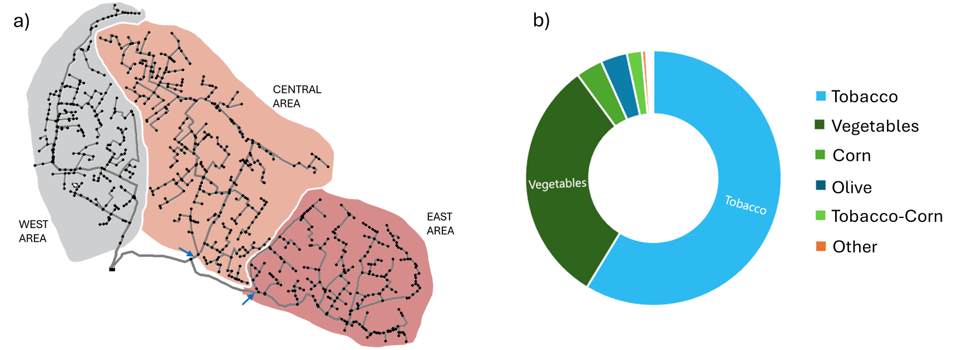

**Figure 1.** (a) Scheme of the complete network.. (b) Crops distribution in the Central and East areas.

The central and east branches are composed by 111 and 92 hydrants. Figure 1.b, reports the main crop varieties cultivated. Each hydrant of Central and East zones is equipped with a card reader to allow recording of water use. Using that data the irrigation season has been simulated realistically reproducing the behavior of the network. Figure 2.a reports the statistics of contemporary active hydrants during the season and Figure 2.b the pressure distribution of hydrants in the network is reported as a function of the several months of the season. As it can be seen the worse month is June where the number of contemporary hydrants reaches the maximum and the pressure at delivery nodes reaches the minimum.

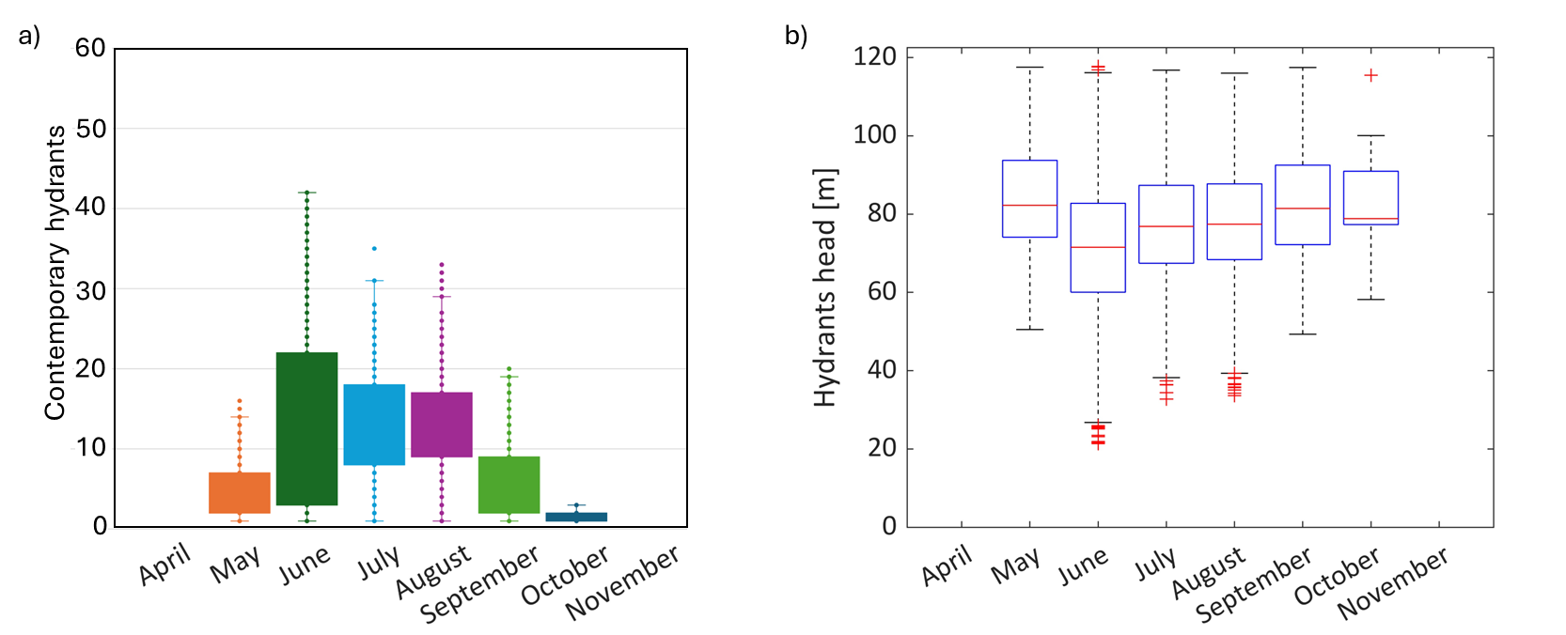

**Figure 2.** (a) Scheme of the complete network. Only Central and East areas are considered in the simulations. (b) Crops distribution in the Central and East areas.

As it can be seen by the pressure distribution of Figure 2.b a large surplus of pressure in all the areas considered occurs. Only few hydrants and in few specific configurations of active hydrants, suffer of a pressure below 25 meters when a limited deficit occurs. Due to the characteristics of the network and to the surplus of pressure the study is focused on the installation of two GVS in the main supply pipes for the central and east zones (indicated with yellow arrows in Figure 1.a) to minimize the pressure on the basis of the real demand of the network. To allow the real-time knowledge of network status it is proposed the installation of OAS in all the demand nodes of the network. The devices have been sized on the basis of the real hydraulic performances calculated after laboratory test on scaled models. Both devices can control the flow, reducing the pressure at a certain level, and can recover energy from the regulation process. The energy recovered can be used to collect and send data and to operate the device remotely, by the farmers and by the managers. The analysis provides an energy balance of each device to verify the effective possibility of recovering a sufficient amount of energy for its functioning during the whole season.

The analysis has been performed using the hydraulic solver Epanet (pressure driven analysis) and its toolkit for Matlab using a time step of half an hour on the entire season.

3. Results

Figure 3.a reports the pressure distribution at the hydrants before and after the application of the GVS. It can be seen that in each hydrant the pressure is kept above the limit of 20m, thus sufficiently above the functional limit for the correct usage of the hydrants. It is interesting to highlight that the average pressure at nodes in the network have been reduced by an average of 61% indicating a substantial potential for leakage reduction in the network with a resultant reduction of the total withdrawal.

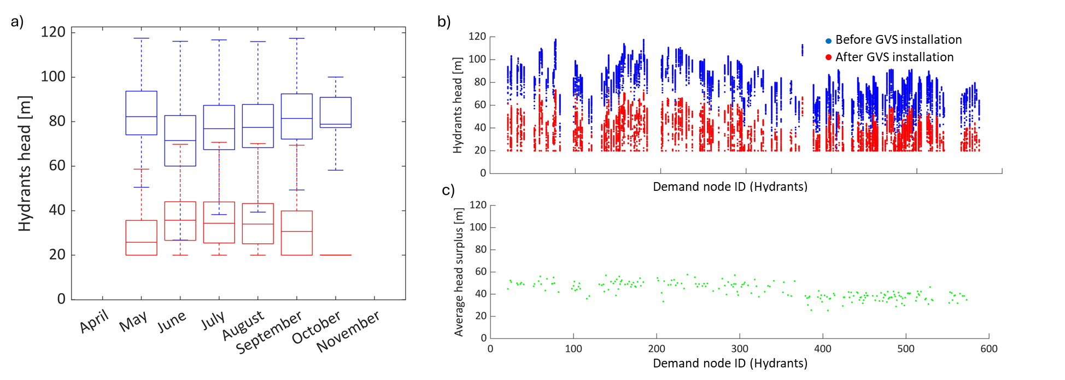

**Figure 3.** (a) Statistics of pressure at hydrants before and after the introduction of GVS. (b) Pressures at the hydrants before and after the introduction of the GVS. (c) Average head surplus at hydrants.

Finally, the new pressure distributions are used to evaluate the energy recovery with the OAS and GVS. The Figure 4.a reports the cumulative energy recovery capacity of the GVS in the two installation points and in Figure 4.b the cumulative energy recovered by the OAS.

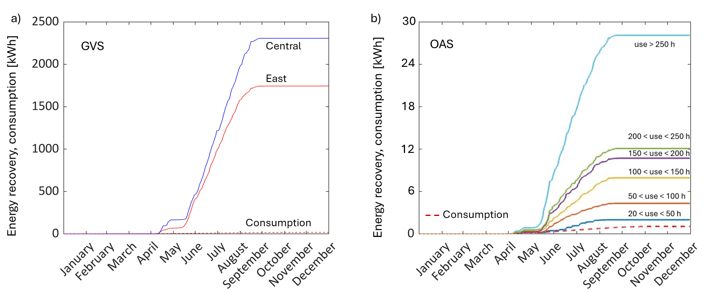

**Figure 4.** (a) Energy recovery with the two GVS. (b) Energy recovery of OAS system in the whole network.

In Figure 4.b the OAS are divided in classes on the basis of the number of activation hours to potentially evaluate a threshold of usage hours necessary to permit the device energetic sustainability. The energetic sustainability is guaranteed for all devices. Anyway the most critical period for device sustainability is the off-season period, where no energy is recovered, but a low but continuous consumption is present to allow signal reception.

4. Conclusions

The series of installed devices allows the implementation of new network management strategies, improving the operational conditions of the network itself without concerns for on-demand users. Using a study case with real data from the network it is proposed the installation of two devices the GVS and the OAS. Both are stand-alone devices thanks to the energy that can be recovered from the flow regulation process. The GVS is used to apply a pressure management strategy based on the real-time knowledge of active hydrants. The hydrant activation information is made available thanks to the proposed installation of the OAS at the hydrant nodes. It is calculated a reduction of the average pressure in the network of 61% gaining a proportional advantage on leakage reduction. Moreover, it is proved the energetic sustainability of the system by verifying the energetic balance of the several devices during the season.

This study emphasizes the potential of IoT methods in agricultural settings, emphasizing their pivotal role in optimizing irrigation networks and enhancing overall water management efficiency. An economic evaluation can be the next step for an exhaustive assessment of a field installation or for example the selection of OAS installation points on the basis of their criticality.

**Funding:** This study received funding from the European Union - Next-GenerationEU - National Recovery and Resilience Plan (NRRP) – MISSION 4 COMPONENT C2, INVESTIMENT N. 1.1, CALL PRIN 2022 D.D. 104 02-02-2022 – (Project 2022WLW9X8, Equality and Resilience of Agroecosystems through Smart water Management and USe - ERASMUS) CUP N. B53D23006510006.

**Acknowledgments:** authors would acknowledge the “Consorzio di bonifica dell’Ufita” in the persons of Elziario Grasso and Antonio Maria Grasso for their invaluable support during this research endeavor and for generously sharing their data.

**Author Contributions:** Conceptualization, G.F., S.Mal. and AP; methodology, G.F. and S.Mal.; software, D.T. and A.H.; validation, G.F., D.T. and A.H..; formal analysis, A.A.; investigation, A.C, D.T. and A.H..; resources, N.F. and G.M.; data curation, A.A.; writing—original draft preparation, G.F.; writing—review and editing, A.A.; visualization, D.T., A.H, and G.F.; supervision, S.Mal. and S.Mam; project administration, G.F, A.P. and N.F.; funding acquisition, G.F, A.P., and N.F. All authors have read and agreed to the published version of the manuscript. A.A. stands for All Authors.

**Institutional Review Board Statement:** Not applicable.

**Informed Consent Statement:** Not applicable.

**Data Availability Statement:** The data presented in this study are available on request from the corresponding author.

**Conflicts of Interest:** The authors declare no conflicts of interest.

References

1. Ramos, H.M.; Morani, M.C.; Carravetta, A.; Fecarrotta, O.; Adeyeye, K.; López-Jiménez, P.A. New Challenges towards Smart Systems’ Efficiency by Digital Twin in Water Distribution Networks. *Water*. **2022**, *14*, 1304-12.

2. Xu, J.; Gu, B.; Tian, G. Review of agricultural IoT technology. *Artificial Intelligence in Agriculture*. **2022**, *6*, 10–22.

3. Malavasi, S.; Rossi, M.M.A.; Ferrarese, G. GreenValve: hydrodynamics and applications of the control valve for energy harvesting. *Urban Water Journal*. **2016**, *15*, 200–9.

4. Ferrarese, G.; Pagano, A.; Fratino, U.; Malavasi, S. Improving Operation of Pressurized Irrigation Systems by an Off-grid Control Devices Network. *Water Resources Management*. **2021**, *35*, 2813-14, https://doi.org/10.1007/s11269-021-02869-5

**Disclaimer/Publisher’s Note:** The statements, opinions and data contained in all publications are solely those of the individual author(s) and contributor(s) and not of MDPI and/or the editor(s). MDPI and/or the editor(s) disclaim responsibility for any injury to people or property resulting from any ideas, methods, instructions or products referred to in the content.