Ammar Nahari AXN337

EECS 476 PS6

Github link: https://github.com/axn337/ammar_467_repository/tree/master/assignment_6
I faced many problems with my Gazebo simulator. It didn't function correctly for a long time, but when it did, the lidar sensor readings were not realistic. The image shows “rostopic echo /scan” where all the reading are constant and equal to 0.1 m. Due to this problem, the robot couldn't detect the obstacle so it didn't stop, and that's the reason I didn't submit a video.
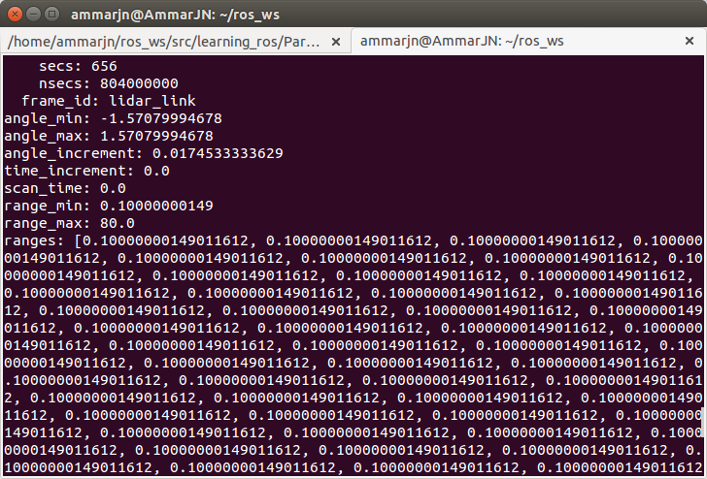
In pub_dest_state.cpp I did the following changes: Firstly, I added a call function to the lidar alarm. Then in estopServiceCallback, I subscribe to the lidar alarm code,and. added a condition that switch the e-stop trigger if the alarm is working
In the trajectory builder code, I edited the braking trajectory such that the speed decreases from speed_max to 0 in a distance of 0.5 meters .

