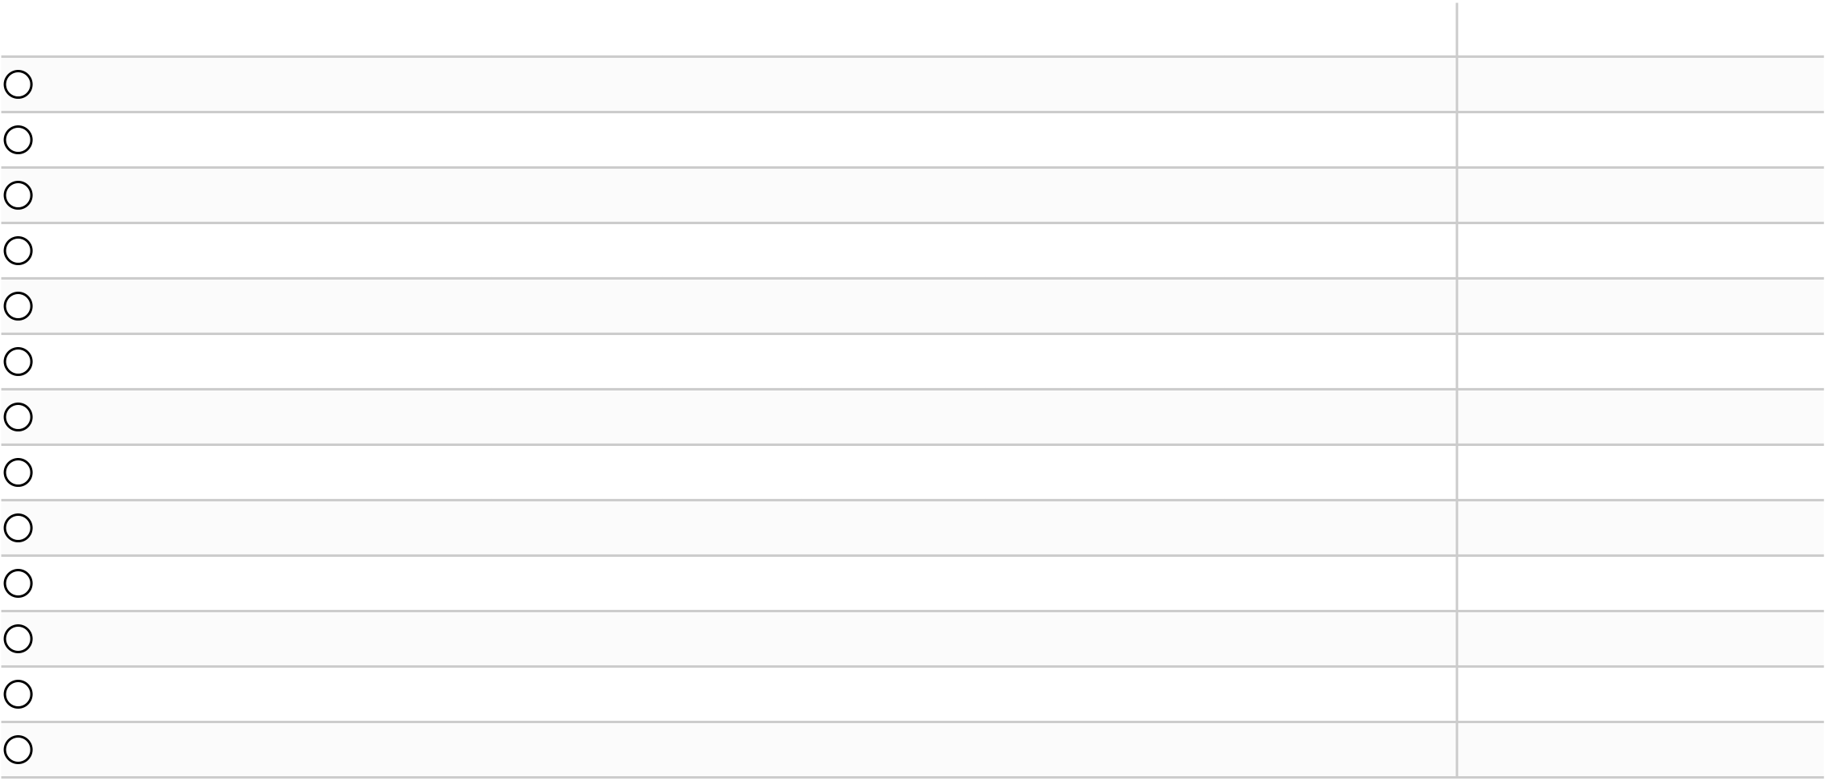

|  |  |  |  |  |  |  |  |  |  |  |  |  |  |  |  |  |  |  |  |  |  |  |  |  |  |  |  |  |  |  |
| --- | --- | --- | --- | --- | --- | --- | --- | --- | --- | --- | --- | --- | --- | --- | --- | --- | --- | --- | --- | --- | --- | --- | --- | --- | --- | --- | --- | --- | --- | --- |
|  | | MATCH REPORT  P L AY E R S TAT S | | | | | | | | Shots / |  | | | | | | | | | Boston College Eagles  Boston College Eagles 1 – 1 Syracuse Orange (28.10.2023) | | | | | | | | | | |
| Minutes | | | | | Actions / | | | | | Passes / | Crosses / | | Dribbles / | | | | | | Duels / | | Losses / | | Recoveries / | Touches in | | | Yellow / | | |
| Player | | played | Goals / xG | | Assists / xA | | | | successful | on target | accurate | accurate | | successful | | | | | | won | | own half | | opponent half | penalty area | | | Offsides | | Red cards |
| 11 | X. O'Neil | 80' | 1/0.07 | | 0/0.01 | | | 47/22 47% | | 3/1 33% | 13/7 54% | | 1/0 0% | 8/4 50% | | | | | | 20/8 40% | | 8/3 | 6/4 | | 1 | | | - | - | |
|  | M. Andrews | 103' | - | | - | | 58/30 52% | | | - | 22/12 55% | | 2/1 50% | 1/0 0% | | | | | | | 23/15 65% | 16/9 | 14/3 | | 1 | | | - | - | |
| 27 | M. Gundelach | 103' | - | | - | | 58/30 52% | | | - | 34/20 59% | | 1/0 0% | - | | | | | 14/8 57% | | | 14/10 | 14/0 | | - | | | - | - | |
|  | C. Williams | 46' | - | | - | | 27/14 52% | | | - | 16/11 69% | | 1/0 0% | - | | | | | 9/3 33% | | | 5/2 | 6/1 | | - | | | - | - | |
| 10 | A. Hughes | 103' | 0/0.09 | | 0/0.06 | | | 51/25 49% | | 2/0 0% | 19/14 74% | | 3/1 33% | 5/2 40% | | | | | | 26/9 35% | | 10/4 | 4/0 | | 1 | | | - | - | |
|  | M. Dos Santos | 98' | 0/0.03 | | 0/0.05 | | | 66/32 48% | | 1/0 0% | 18/10 56% | | 3/1 33% | 8/5 63% | | | | | | | 32/17 53% | 11/2 | 4/1 | | - | | | - | - | |
| 24 | T. Cargill | 103' | 0/0.06 | | - | | 56/30 54% | | | 1/0 0% | 23/14 61% | | 2/0 0% | 1/0 0% | | | | | | 22/8 36% | | 10/3 | 5/2 | | 2 | | | - | - | |
|  | J. Burkhardt | 103' | - | | - | | 72/36 50% | | | - | 40/28 70% | | - | - | | | | | 19/6 32% | | | 14/5 | 14/2 | | - | | | - | 1/0 | |
| 5 | A. Boadi | 94' | 0/0.05 | | - | | 71/27 38% | | | 2/0 0% | 17/11 65% | | 1/1 100% | | 3/1 33% | | | | | | 32/13 41% | 13/4 | 7/6 | | 2 | | | - | - | |
|  | D. Serafino | 103' | - | | - | | 56/21 38% | | | - | 9/7 78% | - | | 4/2 50% | | | | | | 23/11 48% | | 9/2 | 2/0 | | - | | | 2 | - | |
| 6 | S. White | 59' | 0/0.02 | | - | | 40/22 55% | | | 1/1 100% | 20/16 80% | | 1/0 0% | - | | | | | 10/5 50% | | | 6/1 | 11/4 | | - | | | - | 1/0 | |
|  | J. Dickens | 16' | - | | - | | 12/2 17% | | | - | 2/1 50% | - | | - | | | | | 5/1 20% | | | 2/0 | 1/0 | | - | | | - | - | |
| 3 | C. Bejar | 23' | - | | - | | 9/4 44% | | | - | 4/2 50% | - | | 1/1 100% | | | | | | | 4/2 50% | 5/3 | 2/0 | | - | | | - | - | |
| Duels | | | | | | | | | | Aerial duels / | Set pieces | | | | | | | | | | | | | | | | | | | |
| Minutes | | | | Defensive duels/ | | Offensive duels/ | | | | Loose ball duels / | | | Shots | | | Interceptions / | | | | | Sliding | Fouls / | | Free | | Direct | Corners | | |
| Player | | played | won | | won | | | | | won | won | | | blocked | | | | Clearances | | | | tackles / won | suffered | | kicks | | free kicks | served | | Throw-ins |
| 11 | X. O'Neil | 80' | 6/4 67% | | 14/4 29% | | | | | - | - | | | - | | 2/1 | | | | | | - | - | | 1 | 1 | | - | 6 | |
| 18 | M. Andrews | 103' | 11/9 82% | | 2/0 0% | | | | | 6/3 50% | 4/3 75% | | | 3 | | 10/3 | | | | | | - | 1/2 | | - | - | | - | 7 | |
| 27 | M. Gundelach | 103' | 4/3 75% | | - | | | | | 6/5 83% | 4/0 0% | | | - | | 5/7 | | | | | | - | 2/0 | | - | - | | - | - | |
| 25 | C. Williams | 46' | 3/1 33% | | 2/0 0% | | | | | 3/1 33% | 1/1 100% | | | - | | 2/2 | | | | | | - | - | | - | - | | - | 2 | |
| 10 | A. Hughes | 103' | 5/3 60% | | 18/5 28% | | | | | 1/0 0% | 2/1 50% | | | - | | 2/0 | | | | | | - | - | | - | - | | - | 7 | |
| 21 | M. Dos Santos | 98' | 8/6 75% | | 15/8 53% | | | | | 6/2 33% | 3/1 33% | | | - | | - | | | | | | - | 1/5 | | - | - | | 2 | - | |
| 24 | T. Cargill | 103' | 6/4 67% | | 11/2 18% | | | | | - | 5/2 40% | | | - | | 4/1 | | | | | | 3/2 67% | 0/2 | | 1 | - | | 4 | - | |
| 23 | J. Burkhardt | 103' | 10/4 40% | | 1/0 0% | | | | | 5/2 40% | 3/0 0% | | | - | | 10/4 | | | | | | 1/0 0% | 3/1 | | - | - | | - | - | |
| 5 | A. Boadi | 94' | 11/4 36% | | 12/5 42% | | | | | 6/3 50% | 3/1 33% | | | - | | 3/1 | | | | | | - | 5/3 | | - | - | | - | - | |
| 9 | D. Serafino | 103' | 4/3 75% | | 13/7 54% | | | | | 5/0 0% | 1/1 100% | | | - | | - | | | | | | - | 0/6 | | - | - | | - | 3 | |
| 6 | S. White | 59' | 4/3 75% | | 2/1 50% | | | | | 1/0 0% | 3/1 33% | | | - | | 11/1 | | | | | | 2/0 0% | 1/1 | | - | - | | - | - | |
| 20 | J. Dickens | 16' | - | | - | | | | | 4/1 25% | 1/0 0% | | | - | | - | | | | | | - | - | | - | - | | - | - | |
| 3 | C. Bejar | 23' | - | | 2/1 50% | | | | | 1/0 0% | 1/1 100% | | | - | | 1/0 | | | | | | 1/1 100% | 0/1 | | - | - | | - | 2 | |

6



|  |  |  |  |
| --- | --- | --- | --- |
|  | MATCH REPORT |  | Boston College Eagles |
| P L AY E R S TAT S |
| Boston College Eagles 1 – 1 Syracuse Orange (28.10.2023) |

Passing

|  |  |  |  |  |  |  |  |  |  |  |  |  |  |  |  |
| --- | --- | --- | --- | --- | --- | --- | --- | --- | --- | --- | --- | --- | --- | --- | --- |
| Player | | Minutes | Forward passes / | Back passes / | Lateral passes / | Short + medium | Long passes / | Progressive passes / | Passes to final | Through passes / | Deep | Key | Second / | Shot | Average pass |
| played | accurate | accurate | accurate | passes / accurate | accurate | accurate | third / accurate | accurate | completions | passes | third assists | assists | length |
| 11 | X. O'Neil | 80' | 7/3 43% | 2/2 100% | 1/1 100% | 12/7 58% | - | 2/0 0% | 2/2 100% | - | - | - | - | 1 | 21.3 |
|  | M. Andrews | 103' | 10/3 30% | 3/3 100% | 8/6 75% | 16/11 69% | 5/1 20% | 2/0 0% | 2/0 0% | - | - | - | - | - | 23.3 |
| 27 | M. Gundelach | 103' | 15/9 60% | 3/2 67% | 12/8 67% | 25/16 64% | 8/4 50% | 8/3 38% | 2/0 0% | 1/0 0% | - | - | - | - | 26.6 |
|  | C. Williams | 46' | 6/3 50% | 2/2 100% | 6/4 67% | 14/11 79% | 1/0 0% | 3/0 0% | 1/0 0% | - | - | - | - | - | 18.4 |
| 10 | A. Hughes | 103' | 6/3 50% | 8/8 100% | 4/2 50% | 14/12 86% | 2/1 50% | 7/4 57% | - | - | - | 1 | - | 1 | 20 |
|  | M. Dos Santos | 98' | 7/4 57% | 2/1 50% | 6/3 50% | 12/8 67% | 4/1 25% | 4/2 50% | 3/1 33% | 1/0 0% | - | - | - | 1 | 25.6 |
| 24 | T. Cargill | 103' | 8/4 50% | 5/5 100% | 6/4 67% | 19/14 74% | 2/0 0% | 4/0 0% | 3/1 33% | 1/0 0% | - | - | - | - | 22.5 |
|  | J. Burkhardt | 103' | 25/15 60% | 5/5 100% | 4/4 100% | 26/23 88% | 14/5 36% | 11/7 64% | 13/5 38% | 1/0 0% | - | - | - | - | 25.3 |
| 5 | A. Boadi | 94' | 5/0 0% | 3/3 100% | 6/5 83% | 15/10 67% | 1/0 0% | 2/0 0% | 3/1 33% | - | - | - | - | - | 18.8 |
|  | D. Serafino | 103' | 2/2 100% | 1/1 100% | 4/2 50% | 9/7 78% | - | - | 1/1 100% | - | - | - | - | - | 13.2 |
| 6 | S. White | 59' | 5/3 60% | 1/1 100% | 11/9 82% | 18/15 83% | 2/1 50% | 5/3 60% | 3/1 33% | - | 1 | - | - | - | 23.1 |
|  | J. Dickens | 16' | 1/0 0% | - | - | 2/1 50% | - | - | 1/0 0% | - | - | - | - | - | 3.9 |
| 3 | C. Bejar | 23' | 2/0 0% | 1/1 100% | - | 4/2 50% | - | 1/0 0% | - | - | - | - | - | - | 11.2 |

7

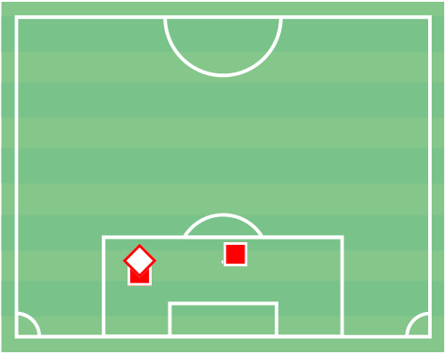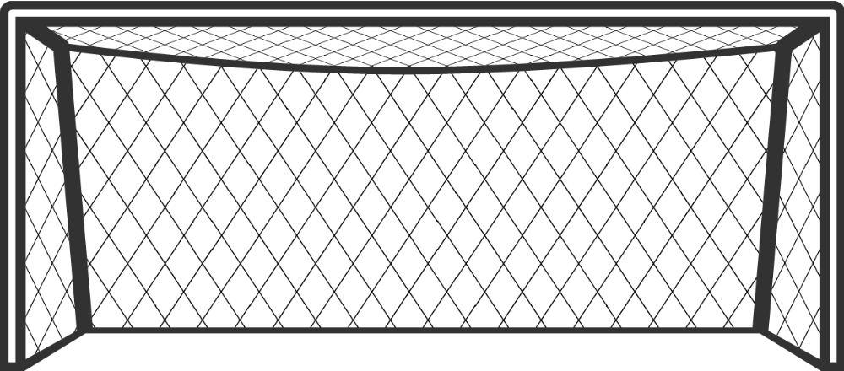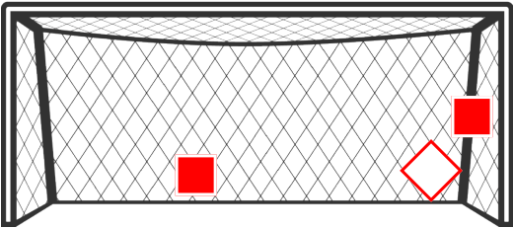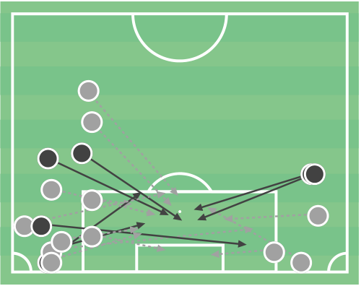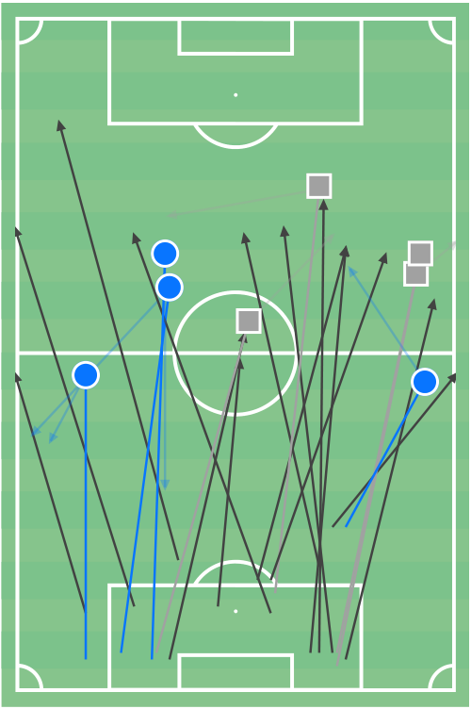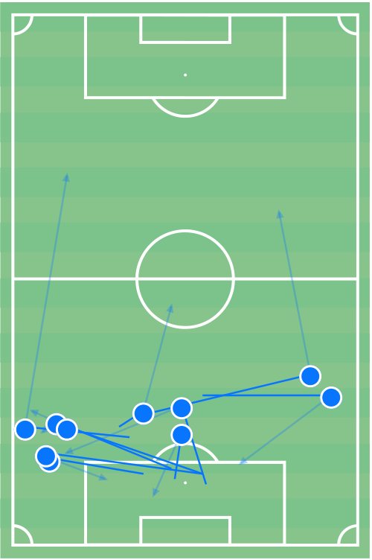

|  |  |  |  |
| --- | --- | --- | --- |
|  | MATCH REPORT |  | B. Klein |
| G O A L K E E P E R I N M AT C H |
| Boston College Eagles 1 – 1 Syracuse Orange (28.10.2023) |

Stats

|  |  |  |  |  |  |  |  |  |  |  |  |  |  |  |  |  |  |  |  |  |  |  |  |  |  |  |  |  |
| --- | --- | --- | --- | --- | --- | --- | --- | --- | --- | --- | --- | --- | --- | --- | --- | --- | --- | --- | --- | --- | --- | --- | --- | --- | --- | --- | --- | --- |
| |  | | --- | | Passes / accurate | | | | | | | Match | | | 1st half | | | 2nd half | | Saves | | | | | Match | | | 1st half | | | | 2nd half | |
| 32/18 56% | | | | | 18/9 50% | 14/9 64% | | 2 | | 1 | | | | | 1 | |
| Passes beyond own third / accurate | | | | | | 22/8 36% | | | | 12/3 25% | | 10/5 50% | | Reflex saves | | | | | 2 | | 1 | | | | | 1 | |
| |  | | --- | | Back passes to GK | | | | | | | 14 | 9 | | | | | 5 | | Conceded penalty goals / saved | | | | | 0/0 | | 0/0 | | | | | 0/0 | |
| Shots against | | | | | | 3 | 2 | | | | | 1 | | Aerial duels / won | | | | | 0 | | 0 | | | | | 0 | |
| Conceded goals | | | | | | 1 | 1 | | | | | 0 | | Exits | | | | | 1 | | 0 | | | | | 1 | |
| Shots against | | | | | | # | Player | | | | | Time | xCG | Crosses against | | | | | Opponent action | | | | | | | | |
|  |  |  | Save | | Reflex save |
| Goal |  | Claimed | | Defender action | | |
| SHOTS ON TARGET | | | | | | CROSSES MAP | | | | | # | Player | | | Time | | | | Outcome |
| 31 | | | 2 | | | 1 |  | L. Boselli | | | | 5' | 0.04 | 10 | | | | | 1 |  | J. Kocevski | | | | 17' | Defended | |
| 2 |  | L. Boselli | | | | 18' | 0.18 | 2 |  | M. Leveque | | | | 29' | Duel | |
| 3 |  | L. Boselli | | | | 54' | 0.08 | 3 |  | G. Mikina | | | 29' | | Offside | |
| 16 | | | | |
| 6 | 3 | | | | 4 |  | N. Edwards | | | | 47' | Shot | |
| 13 19 | | | | |
| 15 | 1 | | | | 5 |  | L. Boselli | | | 50' | | Defended | |
| 11 12 | 7 |  |  | 17 |
| 3 | | | | | | 5 | 9 |  | 6 |  | N. Singelmann 50' | | | | | Shot | |
| 18  2  14 |
|  |  |  | 7 |  | L. Boselli | | | 54' | | Defended | |
|  |  |  | 8 |  | N. Edwards | | | | 57' | Defended | |
|  |  |  | 9 |  | N. Edwards | | | | 65' | Defended | |
|  |  |  | 10 |  | J. Glenn | | | 68' | | Defended | |
| 2 | | | | 1 | |
|  | |  |  |  | 11 |  | J. Glenn | | | 70' | | Defended | |
|  | |  |  |  | 12 |  | J. Glenn | | | 79' | | Pass | |
|  | |  |  |  | 13 |  | N. Edwards | | | | 80' | Pass | |
|  | |  |  |  | 14 |  | J. Kocevski | | | | 81' | Defended | |
|  | |  |  |  | 15 |  | J. Kocevski | | | | 83' | Defended | |

+ 4

|  |  |  |  |  |  |  |  |  |  |  |  |  |  |  |  |  |
| --- | --- | --- | --- | --- | --- | --- | --- | --- | --- | --- | --- | --- | --- | --- | --- | --- |
| Passes beyond own third | | | | Unsuccessful | | Hand pass | |  | Passes inside own third | | | Unsuccessful | | Hand pass | |  |
|  | Successful | | Field player loss |  |  | Successful | Field player loss |  |
| PASSES MAP | | | |  | | ∑ | PASSES MAP | | |  | | ∑ |
| 9 | | | | |  | | --- | | Successful | | | 4 | 4 | 8 | |  | | --- | | Successful | | | 10 | 0 | 10 |
|  | D. Serafino | 2 | 2 | 4 |  | M. Gundelach | 3 | 0 | 3 |
|  | M. Dos Santos | 0 | 2 | 2 |  | J. Burkhardt | 3 | 0 | 3 |
|  | X. O'Neil | 1 | 0 | 1 |  | C. Williams | 2 | 0 | 2 |
| 9 | | 21 | |  | A. Boadi | 1 | 0 | 1 |  | M. Andrews | 1 | 0 | 1 |
| 5 | | 21 | |
| |  | | --- | | Unsuccessful | | | 14 |  | S. White | 1 | 0 | 1 |
| 9 | | | |
| 9 | | 11 | |  |  |  |

6

|  |  |  |  |  |
| --- | --- | --- | --- | --- |
| 23 | 25 23 | 27 | 27 | 18 |
| 27 |

23 25

8

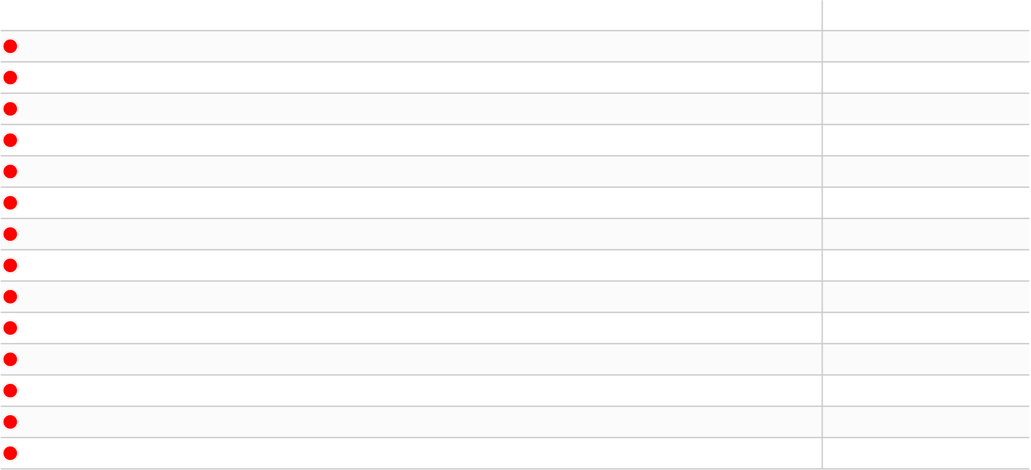

|  |  |  |  |  |  |  |  |  |  |  |  |  |  |  |  |  |  |  |  |  |  |  |  |  |  |  |  |  |  |  |
| --- | --- | --- | --- | --- | --- | --- | --- | --- | --- | --- | --- | --- | --- | --- | --- | --- | --- | --- | --- | --- | --- | --- | --- | --- | --- | --- | --- | --- | --- | --- |
|  | | MATCH REPORT  P L AY E R S TAT S | | | | | | | | | | | Shots / | Passes / | Crosses / |  | | | Syracuse Orange  Boston College Eagles 1 – 1 Syracuse Orange (28.10.2023) | | | | | | | | | | | |
| Minutes | | | Actions / | | | | | | | | | | Dribbles / | | Duels / | | Losses / | | | Recoveries / | | Touches in | | | Yellow / | | |
| Player | | played | Goals / xG | | Assists / xA | | | | | | | successful | on target | accurate | accurate | successful | | | won | own half | | | opponent half | | penalty area | | | Offsides | | Red cards |
| 33 | J. Belluz | 103' | - - | | | | | | | 59/44 75% | | | - | 36/31 86% | - | - | 16/11 69% | | | 6/4 | 12/2 | | | | - | | | - - | | |
|  | B. Sjöberg | 103' | 0/0.15 | - | | | | | | 64/41 64% | | | 1/0 0% | 34/27 79% | - | - | 14/9 64% | | | 12/7 | 14/3 | | | | 1 | | | - - | | |
| 22 | O. Oyegunie | 103' | 0/0.30 | - | | | | | | 70/38 54% | | | 1/0 0% | 45/30 67% | - | - | 12/7 58% | | | 22/11 | | 10/1 | | | 1 | | | - - | | |
|  | N. Edwards | 103' | - 0/0.05 | | | | | | | | 77/44 57% | | - | 36/25 69% | 5/2 40% | 8/5 63% | | 32/18 56% | | 16/8 | 7/4 | | | | 1 | | | - - | | |
| 7 | M. Leveque | 51' | - 0/0.15 | | | | | | | | 41/27 66% | | - | 24/20 83% | 1/1 100% | 1/0 0% | | 13/6 46% | | 4/0 | 7/4 | | | | - | | | - - | | |
|  | G. Mikina | 103' | - - | | | | | | | 70/50 71% | | | - | 39/34 87% | 1/0 0% | 2/1 50% | | 24/15 63% | | 10/4 | | 16/7 | | | 2 | | | - 1/0 | | |
| 11 | F. D'agostini | 70' | 0/0.08 | 0/0.31 | | | | | | | 50/31 62% | | 1/0 0% | 28/24 86% | - | 1/0 0% | | 16/6 38% | | 7/1 | 5/1 | | | | 5 | | | - - | | |
|  | J. Kocevski | 103' | - 1/0.60 | | | | | | | | 97/57 59% | | - | 58/41 71% | 5/1 20% | 4/4 100% | | | 25/13 52% | 18/3 | | 11/7 | | | 1 | | | 1 | - | |
| 10 | L. Boselli | 91' | 1/0.68 | - | | | | | | 65/29 45% | | | 6/3 50% | 25/14 56% | 3/0 0% | 2/1 50% | | 25/11 44% | | 17/3 | 3/3 | | | | 9 | | | 1 | - | |
|  | N. Kaloukian | 78' | 0/0.52 | 0/0.11 | | | | | | | 66/28 42% | | 3/0 0% | 23/14 61% | 2/0 0% | 2/1 50% | | 30/14 47% | | 11/2 | | - | | | 7 | | | 2 | - | |
| 99 | M. Suski | 11' | - - | | | | | | | 9/5 56% | | | - | 4/3 75% | - | 1/1 100% | | | 3/2 67% | 2/0 | 2/1 | | | | - | | | - - | | |
|  | J. Rauch | 26' | - - | | | | | | | 13/4 31% | | | - | 3/0 0% | 1/0 0% | - | 7/4 57% | | | 7/0 | | 1/1 | | | 2 | | | - - | | |
| 4 | N. Singelmann | 52' | 0/0.03 | 0/0.08 | | | | | | | 38/29 76% | | 1/0 0% | 22/21 95% | 1/1 100% | - | 9/7 78% | | | 3/1 | 5/2 | | | | 2 | | | - - | | |
|  | J. Glenn | 36' | - - | | | | | | | 22/12 55% | | | - | 12/8 67% | 4/1 25% | - | 5/3 60% | | | 6/1 | | 1/0 | | | - | | | - - | | |
| Duels | | | | | | | | | | | | | Aerial duels / | Loose ball duels / | | Set pieces | | | | | | | | | | | | | | |
| Minutes | | | Defensive duels/ | | | | | | Offensive duels/ | | | | Shots | Interceptions / | | | Sliding | Fouls / | | | | Free | | Direct | Corners | | |
| Player | | played | won | | | won | | | | | | | won | won | | blocked | Clearances | | | tackles / won | | | | suffered | kicks | | free kicks | served | | Throw-ins |
| 33 | J. Belluz | 103' | 7/5 71% | | | | 3/3 100% | | | | | | 3/2 67% | 3/1 33% | | - | 4/3 | | | - 2/2 | | | | | - | - | | - | 3 | |
| 19 | B. Sjöberg | 103' | 6/2 33% | | | | - | | | | | | 7/7 100% | 1/0 0% | | 1 | 15/8 | | | - 2/0 | | | | | - | - | | - | - | |
| 22 | O. Oyegunie | 103' | 6/3 50% | | | | 1/0 0% | | | | | | 4/3 75% | 1/1 100% | | 1 | 7/5 | | | - 2/0 | | | | | - | - | | - | 16 | |
| 18 | N. Edwards | 103' | 16/10 63% | | | | | 14/7 50% | | | | | 1/0 0% | 1/1 100% | | - | 5/1 | | | - 2/3 | | | | | - | - | | - | 6 | |
| 7 | M. Leveque | 51' | 7/4 57% | | | | 2/1 50% | | | | | | 2/1 50% | 2/0 0% | | - | 3/0 | | | - 1/1 | | | | | 1 | - | | - | - | |
| 5 | G. Mikina | 103' | 13/9 69% | | | | | 5/2 40% | | | | | 4/3 75% | 2/1 50% | | 1 | 5/1 | | | - 3/0 | | | | | - | - | | - | 1 | |
| 11 | F. D'agostini | 70' | 6/4 67% | | | | 6/0 0% | | | | | | 3/1 33% | 1/1 100% | | - | 2/1 | | | - - | | | | | - | - | | - | 1 | |
| 8 | J. Kocevski | 103' | 12/9 75% | | | | | 9/4 44% | | | | | 2/0 0% | 2/0 0% | | 1 | 1/1 | | | - 2/1 | | | | | 4 | - | | 2 | - | |
| 10 | L. Boselli | 91' | 2/2 100% | | | | 13/5 38% | | | | | | 5/3 60% | 5/1 20% | | - | 2/2 | | | - 1/1 | | | | | - | - | | - | - | |
| 32 | N. Kaloukian | 78' | 3/3 100% | | | | | 13/4 31% | | | | | 8/4 50% | 6/3 50% | | - | - | | | - 3/2 | | | | | - | - | | - | - | |
| 99 | M. Suski | 11' | 1/1 100% | | | | 2/1 50% | | | | | | - | - | | - | 1/0 | | | - - | | | | | - | - | | - | - | |
| 9 | J. Rauch | 26' | 3/3 100% | | | | | 2/0 0% | | | | | 1/1 100% | 1/0 0% | | - | - | | | - 1/0 | | | | | - | - | | - | - | |
| 4 | N. Singelmann | 52' | 5/4 80% | | | | 1/1 100% | | | | | | 1/0 0% | 2/2 100% | | - | 1/0 | | | - 2/1 | | | | | - | - | | - | - | |
| 23 | J. Glenn | 36' | 4/2 50% | | | | | - | | | | | - | 1/1 100% | | - | 2/2 | | | - 2/1 | | | | | - | - | | - | 3 | |

9