Milestone 4: Documentation

For milestone 4, I fixed many of the issues prevalent in milestone 3. I implemented the gate script logic correctly thanks to your help and after your pointers on the parameterized footsteps, I was able to enact it in my project as well. Because I could actually test it this time around, I worked on the parameters for the footsteps to make it actually mean something to the player based off how fast they are moving (with shift or what not). I rounded out the categories and created group buses in Unity. I then used these buses to create volume settings for my game through VCAs. Since I didn’t have any volume controls or anything, I spent the rest of my time implementing these volume settings and making my buses function properly. I also spent a lot of my time balancing out the sounds based off the mixer’s master bus loudness meter. Since this game is designed primarily for desktop usage, but could also be mobile, I struck a middle ground between -23LUFs and -29LUFs like so. I also made sure to equalize volumes so that the peak would never be higher than 0db; if I recall correctly the volume was peaked at -1.

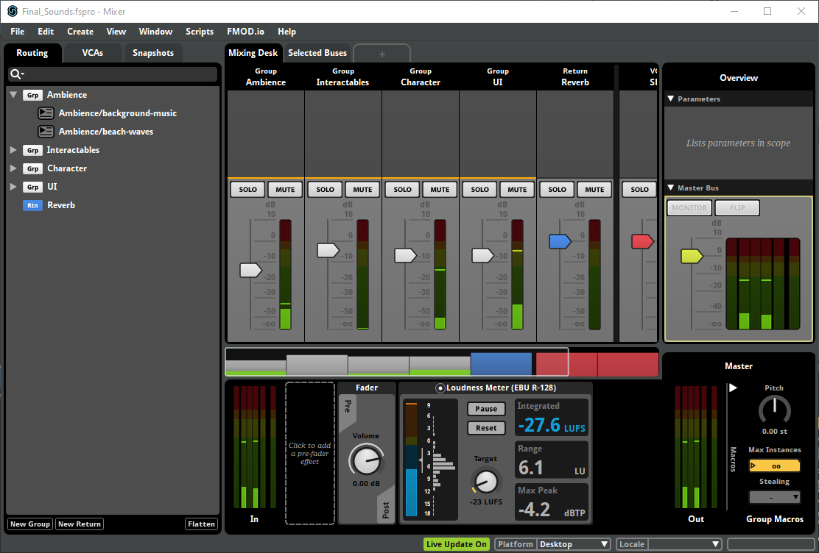

I’m not sure if you’ll come across this issue running my game, but sometimes the prefabs go missing during run time. I have no idea what is causing it but I used the same prefab and sprite settings like the other parts of my game so I don’t know. As always, run the game from StartMenu scene to get a full glimpse of it. Down below I attached screenshots of what this issue looks like.



The ‘100%’ is supposed to be there. Also, sometimes the buttons go missing, but you can still hover / click them. It’s a very weird bug that I couldn’t figure out the cause for.

