T3N Agent Build Challenge - Submission Draft
Undo-First Agent | prepared for import into a public Google Doc
Status: draft only. This document has not been submitted.

Project
Undo-First Agent - No action without an undo plan.
Undo-First Agent is a small, dependency-free safety layer for capable agents. It turns a vague request into a bounded change proposal, shows the blast radius and rollback path, requires approval for the exact scope, runs a synthetic local execution, and produces an audit receipt that can be rolled back.

Links
Public repository: Open GitHub repository
Public demo: Open public demo
Published T3N sandbox agent card: Open published agent card
T3N agent DID: did:t3n:313ce6ecc4809d44b0596f90e2cb9dadf19009e2

What is built
The demo presents three reusable synthetic scenarios: shared-folder cleanup, customer-record correction, and subscription audit. For each scenario the agent:
- translates natural language into explicit operations;
- shows scope, data touched, risk, expiry, and undo coverage;
- keeps destructive actions off by default;
- blocks execution until the user approves the exact plan;
- creates an execution receipt;
- restores the synthetic baseline with one-click rollback.

T3N and WebMCP fit
The T3N sandbox identity is registered and the public agent card is published. The card describes the narrow undo-first-plan capability and points to the public demo. The browser demo exposes six narrow WebMCP tools when a model context is available:
- inspect_action_request
- build_undo_plan
- simulate_blast_radius
- approve_reversible_action
- rollback_last_action
- prepare_action_receipt
The demo remains intentionally honest: it uses synthetic local data and performs no real filesystem, CRM, subscription, messaging, or financial action. A production provider adapter would be added behind the same plan, approval, receipt, and rollback contract.

Maintenance and handover
The project has no runtime dependency for the browser demo and can be hosted as static files. A maintainer can extend it by adding a provider adapter that implements inspection, snapshotting, staged operations, approved commit, and rollback. The approval gate must remain in place for every mutating operation, and every new action must document its reverse operation.
Preferred continuation: keep the current static demo public and add one read-only T3N-backed inspection followed by one staged/draft operation. Do not begin with irreversible deletion, external messaging, or money movement.

Validation evidence
- Public demo loaded successfully.
- Plan generation showed bounded operations, six affected items, eight touched files, 100% undo coverage, and a 24-hour expiry.
- The approval button remained disabled until I reviewed it was checked.
- Approval produced COMPLETED LOCALLY and an action receipt.
- Rollback produced ROLLED BACK and restored eight files with zero review items.
- No API key or personal data is stored in the repository.

Screenshot evidence
These captures show the same synthetic local demo at the three key points of the trust loop: review before approval, completed execution with a receipt, and one-click rollback.
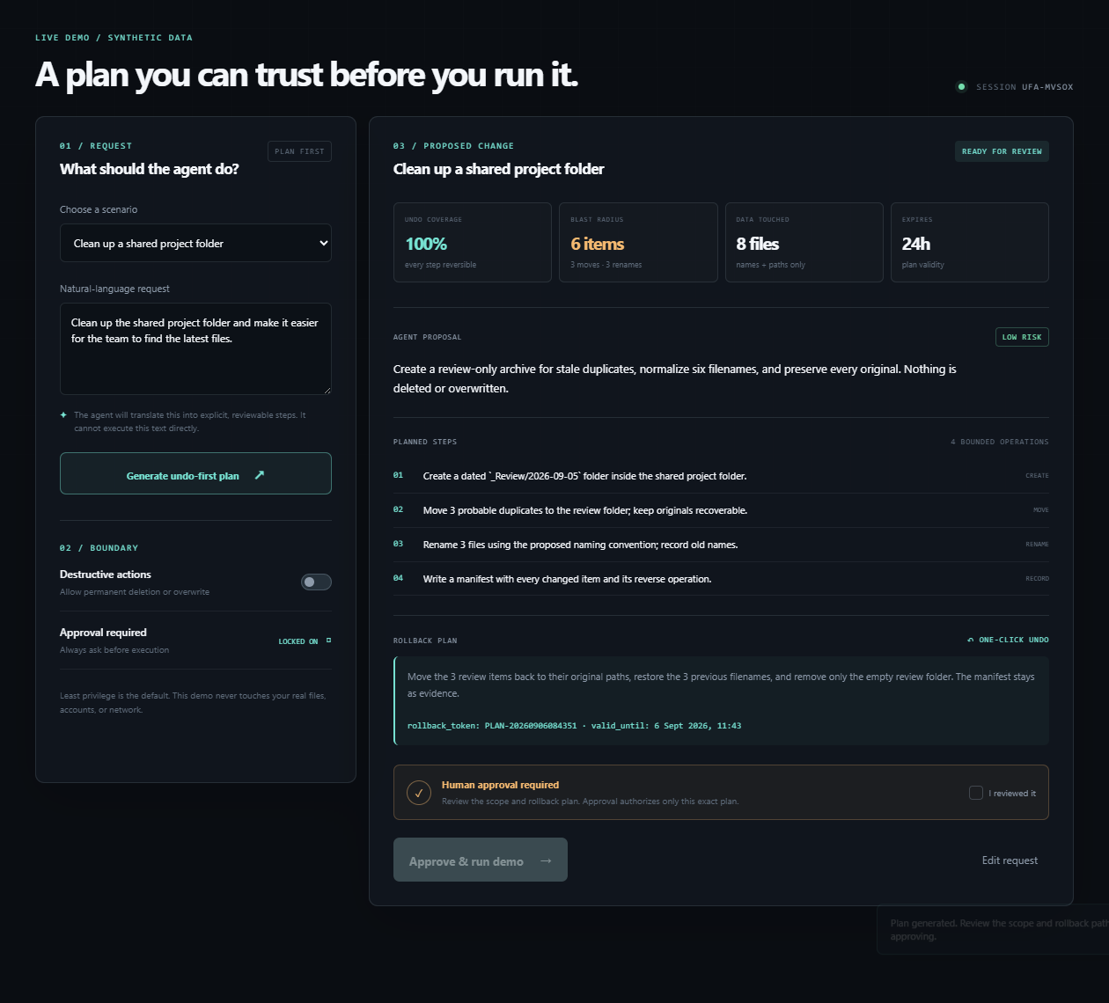
Figure 1. Bounded plan ready for review; approval remains locked until the exact scope is reviewed.
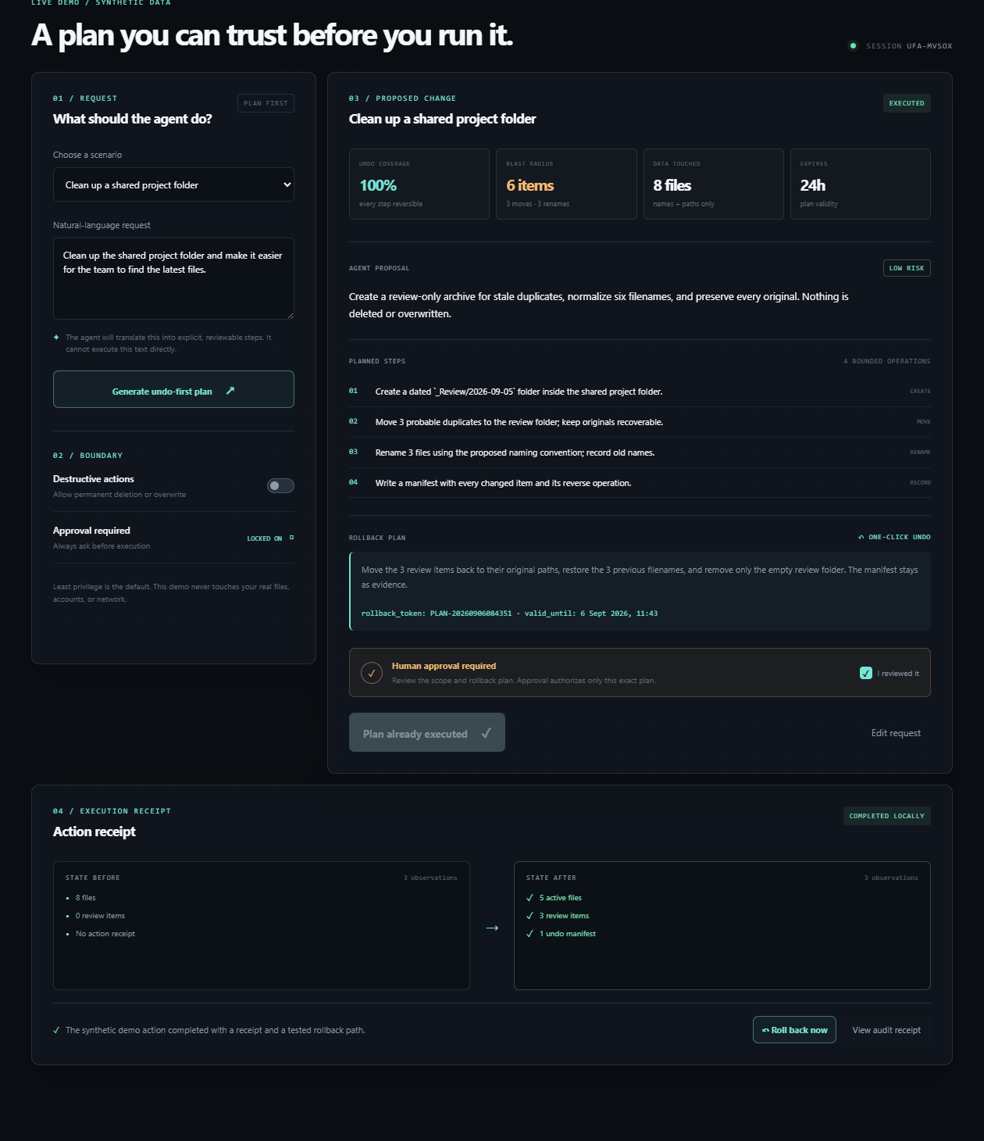
Figure 2. Approved synthetic action completed locally with an auditable receipt and rollback control.
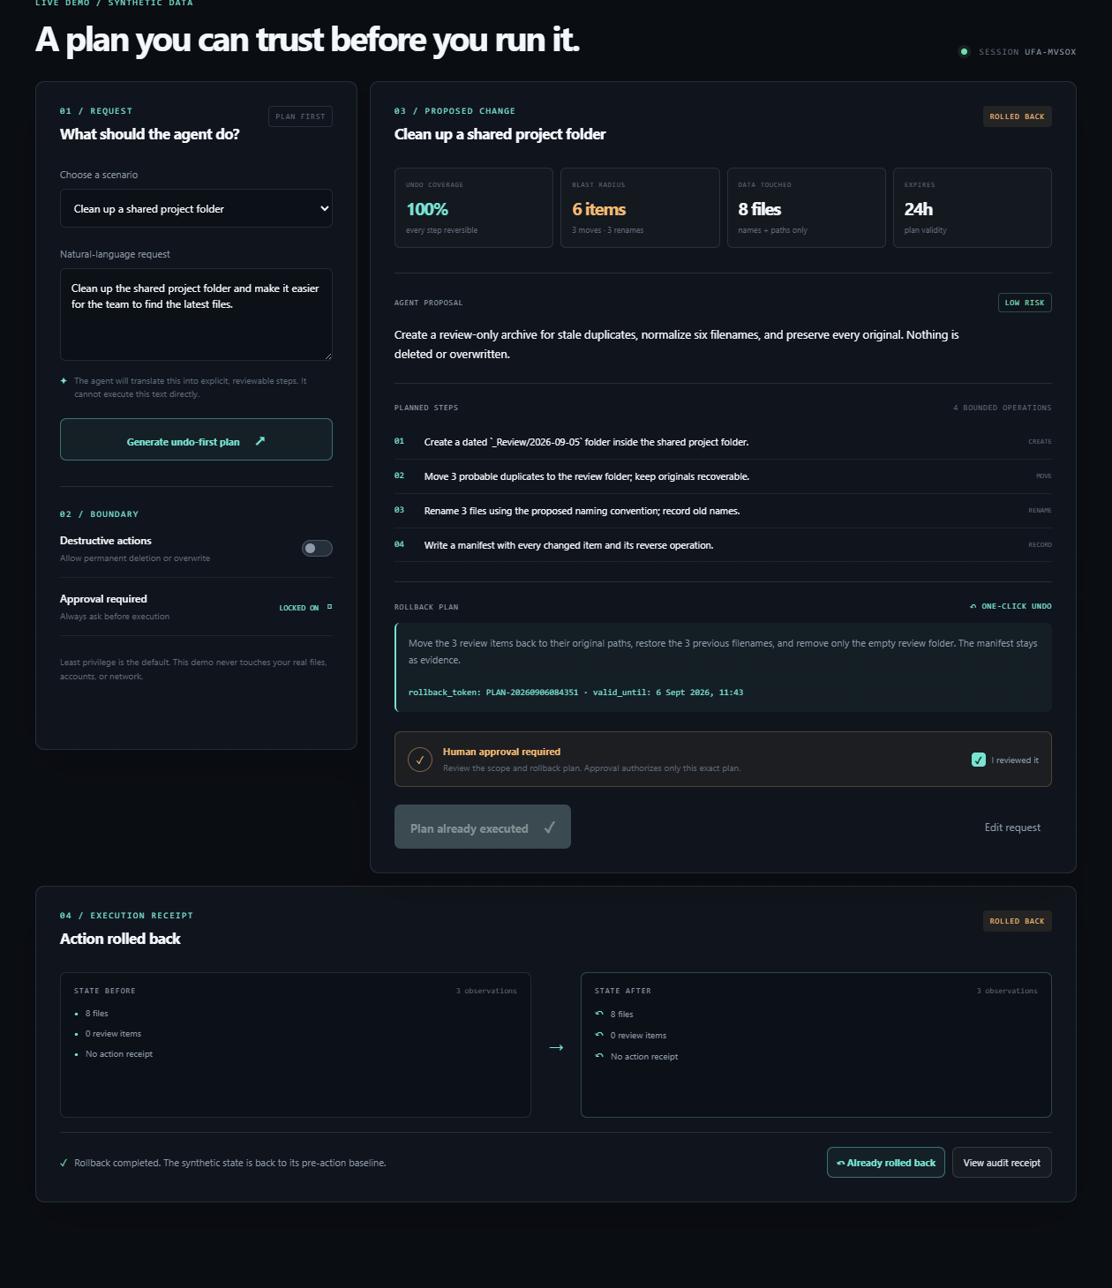
Figure 3. Rollback completed; the synthetic baseline is restored and the receipt remains available.

Bugs encountered and resolved
- The sandbox trust manifest was incomplete, so the connector uses the SDK's explicit unsafe trust option only for T3N_ENV=sandbox; production still requires a signed manifest.
- The SDK returns DID wrapper objects in some calls. The registration helper now normalizes those values to primitive DID strings before passing them to the contract or saving state.
- The registration helper now uses the SDK's official structured createAgent call rather than serializing the complete contract input as a string.

Submission checklist
- Public GitHub repository - complete
- Public static demo - complete
- T3N sandbox agent registered - complete
- T3N agent card published - complete
- Documentation and maintenance notes - complete
- Known bugs and fixes documented - complete
- Add screenshots to this Google Doc - pending
- Review the final submission in Superteam Earn - pending
- Press Submit Now - pending

Important boundary
The final Google Doc creation, screenshot upload, and Submit Now action are still pending human review. No API key is included in this document.

