Quick start with eCos 3.0
on Blackfin BF609 processors

Version 0.1.0

Author
Pavel Azizov

Date
12 March 2014

Description
The document describes quick start approach for eCos 3.0 on AX-SOM-BF609 development board

Target audience
Managers and technical experts

File name
Quick_start_with_eCos3_0_on_Blackfin_
BF609_processors.doc

Document History

Version
Version | Date | Author | Comment
0.1.0 | 12-March-2014 | Pavel Azizov | Initial version of the document

Review and Approvals
Version | Reviewed Date | Reviewed by | APPROVED DATE | Approved BY

Contents

1 Document History 2
1.1 Version 2
1.2 Review and Approvals 2
2 Contents 3
3 Introduction 4
4 General information on eCos 5
5 Preparing development environment on Linux hosts: 5
6 Building eCos libraries and tests 5
7 Creating new eCos configuration 8
8 Debugging eCos application in Eclipse 10
9 Building and running RedBoot 14

Introduction

Described eCos 3.0 port is developed to support AX-SOM-BF609 System-on-Module.
The port is intended to be built on Linux hosts.

Supported features:
1. Blackfin Core features (HAL);
2. Clock generation unit features (CGU);
3. System crossbars features (SCB);
4. Core timer (TMR) for eCOS 3.0 OS timer;
5. System event controller (SEC) features;
6. Dynamic memory controller (DMC);
7. General-purpose Ports (PORT);
8. Debug UART driver;
9. TWI (I²C) driver;
10. SPI driver;
11. Ethernet driver.

Hardware abstraction layer is located in /ecos-ax-som-bf609/packages/hal/bfin/ directory.
Ethernet , I²C, SPI and drivers are located in corresponding subdirectories (eth/bfin/, i2c/bfin/, spi/bfin/) in
/ecos-ax-som-bf609/packages/devs/ directory.
It includes following subdirectories:
arch – basic Blackfin architecture support. Contains initialization code, context switching, cache control.
bf60x – general purpose Port control macros, System Crossbar control macros.
adibf609 – contains MMU initialization code, pinmux setting, memory layout files (*.ldi files), dubug UART support.

For evaluation purposes eCos configuration file is supplied:
ax_som_bf609_kernel.ecc – for building basic eCos tests.
In order to support debugging in Eclipse via JTAG, ax_som_bf609_gdb_init_script.txt startup script is supplied.

General information on eCos

Main eCos information source: http://ecos.sourceware.org/

Recommended readings:
- Book “Embedded Software Development with eCos” http://www.informit.com/content/downloads/perens/0130354732.pdf
- Official eCos 3.0 documentation
http://ecos.sourceware.org/docs-3.0/

Examples for building eCos libraries and tests are provided in chapters 12.4, 12.6 of “Embedded Software Development with eCos” book.

Preparing development environment on Linux hosts:

- Install basic eCos repository and eCos Configuration Tool
Follow the guide:
http://ecos.sourceware.org/getstart.html
While installing do not select any toolchain, because you will use the separate toolchain for Blackfin processors.
Default repository will be created at path /home/user/ecos/ecos-3.0/

- Download eCos repository for AX-SOM-BF609
https://github.com/axonim/ecos-ax-som-bf609
Put the repository to /home/user/ecos/ecos-ax-som-bf609 directory.

- Download GNU Toolchain for ADI's Blackfin processors
Select toolchain for building standalone applications (bfin-elf target). The latest version at the of the document creation moment is 2013R1
http://sourceforge.net/projects/adi-toolchain/
Unpack the toolchain to /home/user/ecos/gnutools/bfin-elf directory

- Install Eclipse with CDT add-on.

Building eCos libraries and tests

- eCos Configuration Tool (configtool) is the main instrument for creating necessary eCos configuration.
Run eCos Configuration Tool (downloaded with eCos installation script to /home/user/ecos/ecos-3.0/tools/bin/ path).
Detailed setup for each eCos component is performed in Configuration Tool main window (Fig. 1):

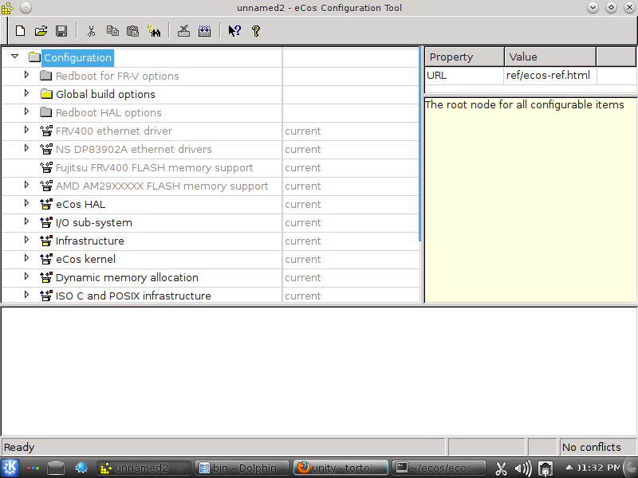
Fugure 1 – eCos Configuration Tool main window

- Set path to bfin-elf toolchain (/bfin-elf/bin):
Tools->Path->Build Tools…
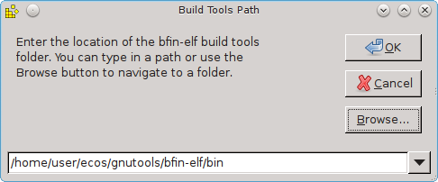
Figure 2 – Build Tools selection window
- Set path to Linux utilities (/bin):
Tools->Path->User Tools…
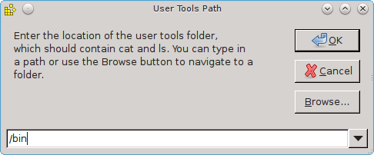
Figure 3 – User Tools selection window

- Set path to AM335x eCos repository (/ecos-ax-som-bf609):
Build->Repository…
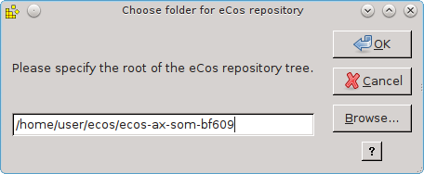
Figure 4 – eCos repository selection window

- Building test configuration
Open supplied bf609_kernel.ecc file from /ecos-ax-som-bf609/target/ directory with File->Open.

Then select Build->Generate build tree to prepare eCos building.

Option Build->Library builds eCos libraries to /target/bf609_kernel_install/lib/ directory.
Option Build->Tests builds eCos libraries (if not previously build) and then builds eCos tests to /target/bf609_kernel_install/tests/ directory.

Creating new eCos configuration

- Creating new configuration file
File->New
Build->Templates…
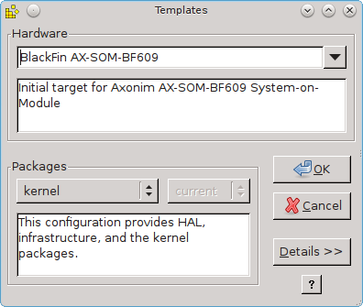
Figure 5 – Create new configuration file from template

Hardware – select hardware platform (hardware-dependent set of components).
Packages – select predefined hardware-independent set of components.

- Change selected components list
Build->Packages…
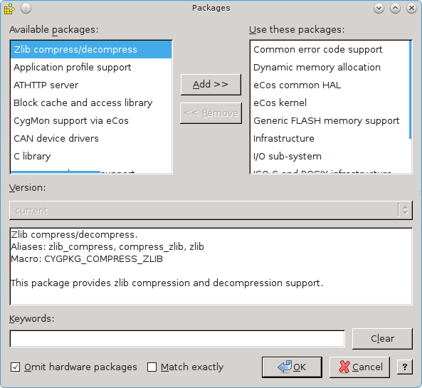
Figure 6 – Edit selecsed packages list

You can add/remove only hardware-independent components.

Save the configuration and select Build->Generate build tree.
Now you can build eCos libraries and tests in abovementioned manner (chapter 6).

Debugging eCos application in Eclipse

After installing Eclipse and CDT you should install GDB Hardware Debugging support plug-in.
Select:
Help -> Install New Software…
search for the plug-in and install it.
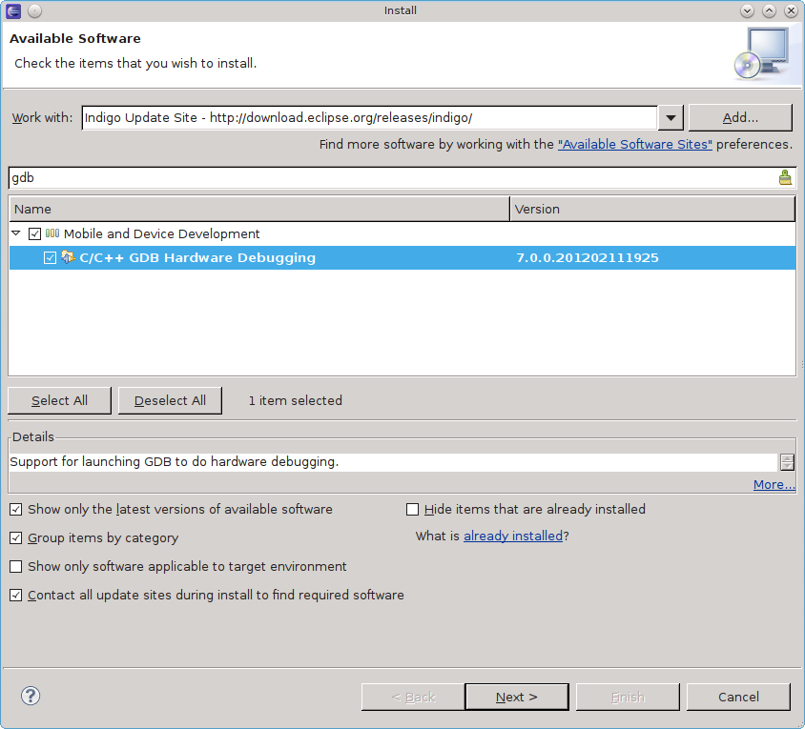

In order to debug your application, you should import the built executable file.
Select:
File -> Import…
C/C++ -> C/C++ Executable
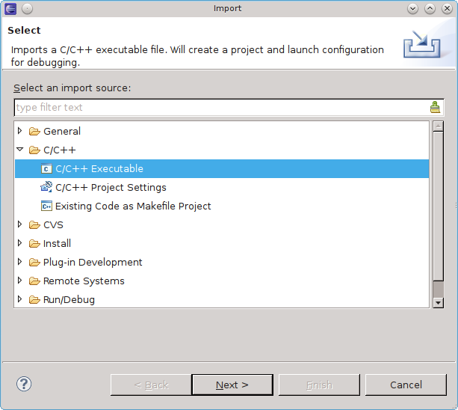
Select GNU Elf Parser.
Select built executable (for example, one of the built eCos tests).

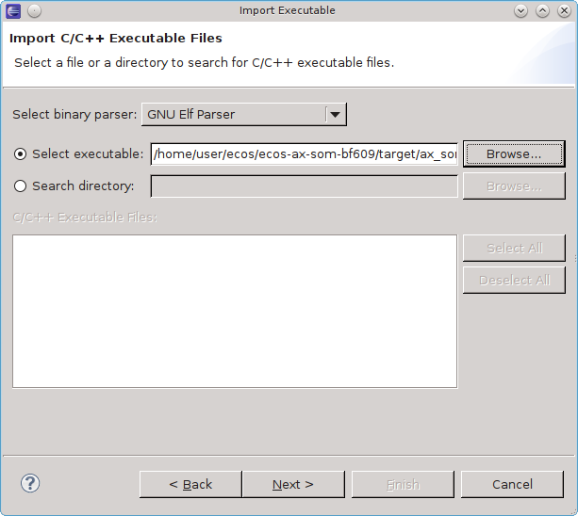

Check “Create a Launch Configuration” option and select “GDB Hardware Debugging”
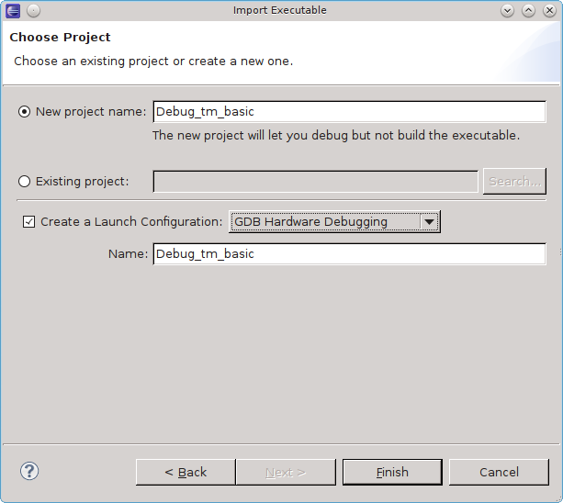
Setup the debug configuration

Debugger tab:
select path to bfin-elf-gdb debugger from downloaded Blackfin GNU toolchain;
set port number to 2000.
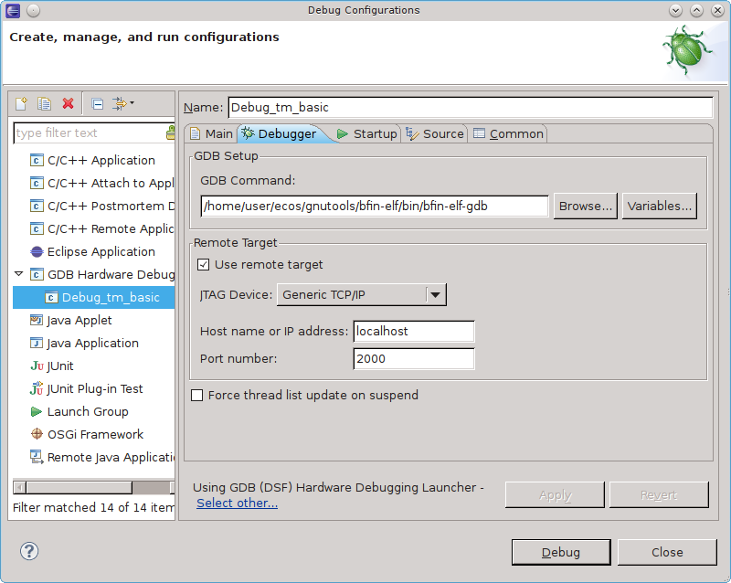

Startup tab:
Input supplied startup script for GDB (from ax_som_bf609_gdb_init_script.txt file)

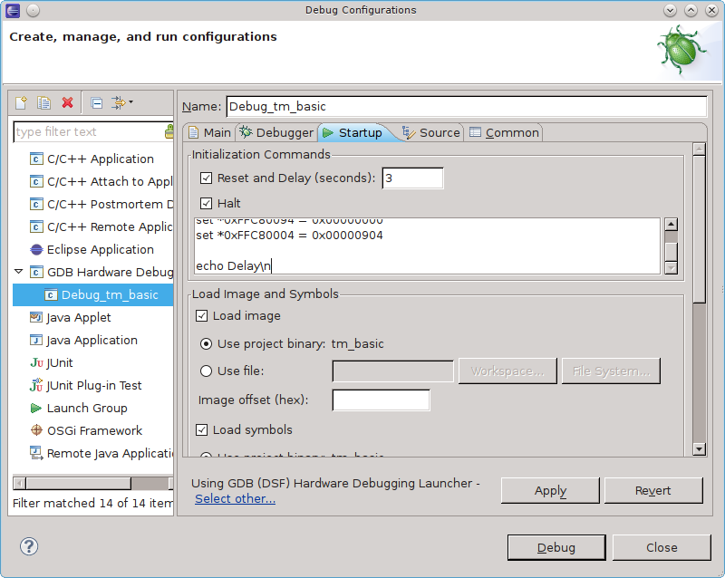
Connect to target with JTAG in-circuit emulator (for example, gnICE).

Creating gnICE emulator from FT2232H chip is described here:
http://elinux.org/Flameman/blackfin-avr-jtag

Run bfin-gdbproxy from downloaded GNU toolchain (/bfin-elf/bin/ directory).
It should find the target and wait connrction from GDB:
user@ubuntu:~/ecos/gnutools/bfin-elf/bin$ ./bfin-gdbproxy

Remote proxy for GDB, v0.7.2, Copyright (C) 1999 Quality Quorum Inc.
MSP430 adaption Copyright (C) 2002 Chris Liechti and Steve Underwood
Blackfin adaption Copyright (C) 2008 Analog Devices, Inc.

GDBproxy comes with ABSOLUTELY NO WARRANTY; for details
use `--warranty' option. This is Open Source software. You are
welcome to redistribute it under certain conditions. Use the
'--copying' option for details.

Found USB cable: gnICE
Connected to libftdi driver.
IR length: 5
Chain length: 1
Device Id: 00010010100000000100000011001011 (0x128040CB)
Manufacturer: Analog Devices, Inc. (0x0CB)
Part(0): SDU (0x2804)
Stepping: 1
Filename: ./../share/urjtag/analog/sdu/sdu
warning: bfin: no board selected, 3 parts are detected
warning: bfin: parts: [BF609 BF609] SDU
notice: bfin: jc: waiting on TCP port 2001
notice: bfin: jc: (you must connect GDB before using jtag console)
notice: bfin-gdbproxy: waiting on TCP port 2000

Now you can Debug the application with Eclipse.

Building and running RedBoot

