**Reporting with**

**BIRT and Xpert.Ivy**

Titel: Reporting with BIRT and Xpert.Ivy  
User Guide for installation and usage

Thema / Projekt: Ivy-BIRT Extension

Autor: – Soreco International

Datum: 24. November 2010

DOC: Version 2.0

**Tracking**

|  |  |  |  |
| --- | --- | --- | --- |
| **Wann** | **Was** | **Wer** | **Version** |
| 17.02.2010 | First Base Version of the document | Markus Demolsky | 1.0 |
| 18.11.2010 | Update to version 4.1.2   * New Process Elements in palette Create Report with Database and Create Report with XML Input | Markus Demolsky | 2.0 |

Introduction 3

Requirements 4

BIRT Designer 4

BIRT Runtime 4

Ivy-BIRT Plugin 4

BIRT Runtime 5

BIRT Plugin and Ivy Designer 6

Plugin installation 6

BIRT Process palette 8

BIRT and Ivy Databases 10

BIRT Plugin and Ivy Server 11

Plugin installation 11

BIRT Runtime JARs 11

Ivy Extensions 11

Sample project 13

# Introduction

Process applications often deal with report generation during process execution. Such reports are usually project specific and must be created for each project with the individual project data and structure. When using Xpert.Ivy as business process management platform, users/developers can make their own choice of the used reporting tool. This document focus on the BIRT plugin, an eclipse based reporting tool.

BIRT is an open source Eclipse-based reporting system that integrates with your Java/J2EE application to produce compelling reports. BIRT provides core reporting features such as report layout, data access and scripting.

Note, that this document is no BIRT Introduction. Users/Developers reading this document must have fundamental knowledge about BIRT.

Useful links to BIRT:

* <http://www.eclipse.org/birt/>
* <http://www.birt-exchange.org/#newest>
* <http://birtworld.blogspot.com/>

Good Books about BIRT:

* Practical Data Analysis and Reporting with BIRT
* BIRT: A field Guide to Reporting

# Requirements

PLEASE NOTE THAT THE CURRENT BIRT PLUGIN ONLY SUPPORTS BIRT VERSION 2.5.x

### BIRT Designer

The BIRT Designer is a seperate Eclipse instance that can be downloaded from the follwing link: <http://download.eclipse.org/birt/downloads/index2.5.2.php>. Please follow the installation instructions on the Eclipse BIRT Homepage: <http://www.eclipse.org/birt/phoenix/build/>

The BIRT Designer is used to design and test reports at design time.

### Ivy-BIRT Plugin

In order to integrate BIRT reports in your process applications, you need the Ivy-BIRT Plugin component. The installation instructions are described in the next section.

### BIRT Runtime

In order to create/render reports at runtime during process execution you need the BIRT Runtime. Again, please not that the current plugin only supports the BIRT Runtime 2.5.x, otherwise runtime exceptions will occur during report rendering.

You can download the BIRT runtime from the link below: <http://download.eclipse.org/birt/downloads/index2.5.2.php> Look for the area „Runtime“, to download the runtime components.

**IMPORTANT! The BIRT Version of the designer and the BIRT runtime must be the same, otherwise runtime exceptions will occur during report rendering.**

# BIRT Runtime

After downloading the BIRT Runtime and unpack the ZIP file. The unpacked folder structure contains a folder named *“ReportEngine”*. This folder contains the necessary runtime components for Ivy. Therefore you can copy the *“ReportEngine”* folder in a suitable place, or keep the folder alive in the upacked folder structure. A usual location for the *“ReportEngine”* folder is the XpertIvyDesigner folder.

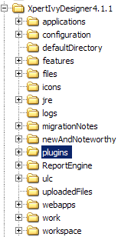

If you have more than one Ivy instances on your computer, it makes sense to place the Report Engine in a global folder and all Ivy instances use this Report Engine (will be described later).

# BIRT Plugin and Ivy Designer

### Plugin installation

The Ivy-BIRT Plugin will be deployed as single JAR file:

ch.ivyteam.ivy.extension.birt_4.1.2.jar

First of all close your Xpert.Ivy Designer and copy the JAR file in the plugins folder of your designer, as illustrated below:



The next step ist to inform the Plugin about your ReportEngine (the folder “ReportEngine”). Such settings will be done in the confirmation file birt.properties, that is also distributed with the BIRT Plugin and must be copied in the **configuration/extensions** folder.

You can also create the birt.properties file by your own and save it in the mentioned location. The properties file contains a set of settings:

|  |  |  |
| --- | --- | --- |
| Property | Required | Description/Example |
| engineHome | YES | Path to your report engine folder. If the report engine folder is located in the designer, the path can be set relativ, otherwise absolute.  Example  engineHome=ReportEngine |
| designRepository | NO | Global design repository where all your BIRT designs are located. The path of this repository must be absolute. |

If no birt.properties file exist, an error is thrown when the Xpert.Ivy Designer is started.

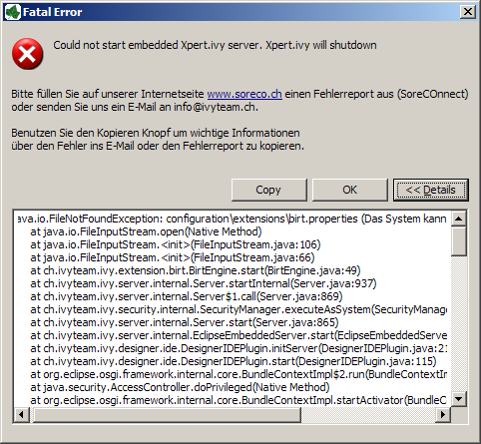

### BIRT Process palette

The plugin provides a seperate process palette, called BIRT.

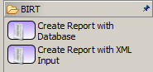

The current plugin version (4.1.2) provides two process elements, one dealing with Database and one dealing with XML Input.

Create Report with Database

Use this element if your report is connected with a database also used in your process application. (see also next section BIRT and Ivy databases)

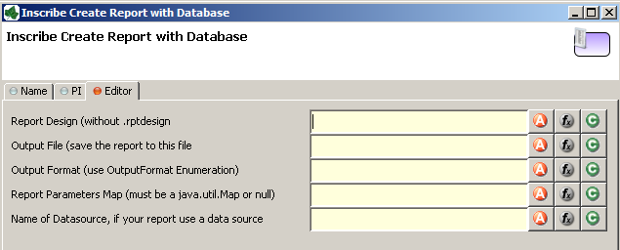

|  |  |  |
| --- | --- | --- |
| Property | Required | Description/Example |
| Report Design | YES | The report design that should be used to render the report. If you have defined a global design repository in your BIRT properties only the name with the relative path is required, e.g.: myCategory/myReport  If no global design repository is defined, the absolute path of the report design must be provided. (e.g. use global variables for that scenario, that points to the folder) |
| Output File | YES | Save the generated report tot he provided **Ivy File object**. The file object can be temporary or persistent. Look Ivy Designer help for more information about Ivy File.  **IMPORTANT**! In the current version is a little restriction. You must create the file and name a process step before and pass the created file to the plugin. |
| Output Format | YES | One oft he supported Outputformats:   * PDF * HTML * DOC (Word)   The output format must be a type of ch.ivyteam.ivy.extension.birt.OutputFormat  Therefore you can also decide at runtime, which output format should used |
| Report Parameter Map | YES | A map of parameterst hat the report uses. If no parameters should be passed, provide null |
| Datasource | YES | Name oft he Ivy Database from the Database repository. |

Create Report with XML Input

Use this element if your report needs a XML content as input.

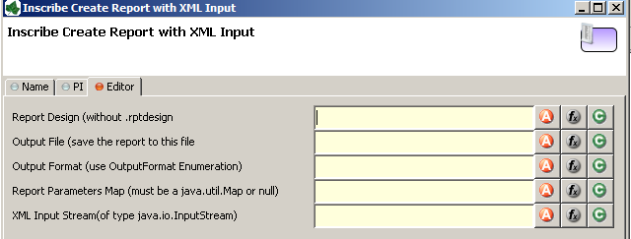

|  |  |  |
| --- | --- | --- |
| Property | Required | Description |
| Report Design | YES | Same as Create Report with Database |
| Output File | YES | Same as Create Report with Database |
| Output Format | YES | Same as Create Report with Database |
| Report Parameter Map | YES | Same as Create Report with Database |
| XML Input String | YES | Pass the XML Input Stream. If your XML is a String than use the ByteArrayInputStream, e.g.  new java.io.ByteArrayInputStream(  in.reportXmlContent.getBytes("UTF-8")) |

### BIRT and Ivy Databases

The only possibility to provide dynamic database connection strings in BIRT is o define named JDBC parameters in the report design as illustrated below:

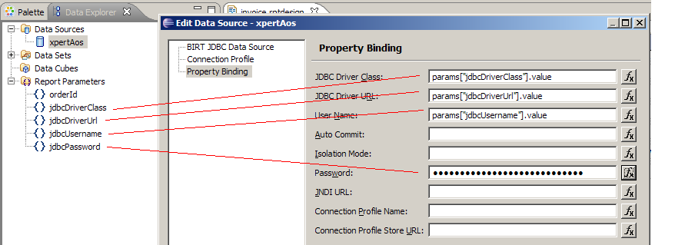

The name of the parameters must match the given pattern, because Ivy automatically fills this parameter with the selected Ivy Database (depending on the selected environment) provided in the process element. Again, the name of the parameters must be the same as in the table:

|  |  |  |
| --- | --- | --- |
| Parameter | Required | Description |
| jdbcDriverClass | YES | Database driver class |
| jdbcDriverUrl | YES | JDBC Url |
| jdbcUsername | YES | Username |
| jdbcPassword | YES | Password |

All database drivers (e.g. mysql) used in the report must be placed in the JDBC folder of the Report Engine.

ReportEngine\plugins\org.eclipse.birt.report.data.oda.jdbc_2.5.0.v20090605\drivers

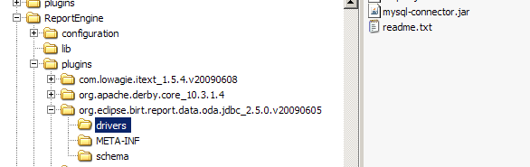

# BIRT Plugin and Ivy Server

### Plugin installation

Copy the distributed BIRT JAR-File

ch.ivyteam.ivy.extension.birt_4.1.2.jar

in the folder **lib/shared**.

### BIRT Runtime JARs

Additional to the BIRT JAR-file the Ivy Server needs the BIRT Runtime libs, that must be copied in **lib/shared** of the Ivy Server. You can find the BIRT Runtime jars in ReportEngine/lib.

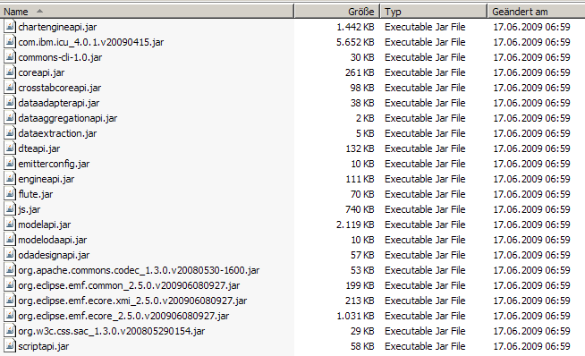

### Ivy Extensions

The Ivy server must be explicit informed about the BIRT plugin. This can be don in the configuration file **/configuration/extensions/ivy.extension**.

Copy the following section in the ivy.extension file.

<extensionPoint interface="ch.ivyteam.ivy.server.IServerExtension" bundle="ch.ivyteam.ivy.extension.birt">

<extension bundle="ch.ivyteam.ivy.extension.birt" class="ch.ivyteam.ivy.extension.birt.BirtEngine"/>

</extensionPoint>

<extensionPoint interface="ch.ivyteam.ivy.java.IIvyProjectClassPathExtension" bundle="ch.ivyteam.ivy.extension.birt">

<extension bundle="ch.ivyteam.ivy.extension.birt" class="ch.ivyteam.ivy.extension.birt.BirtProjectClassPathExtension"/>

</extensionPoint>

<extensionPoint interface="ch.ivyteam.ivy.designer.process.ui.IIvyProcessPaletteExtension" bundle="ch.ivyteam.ivy.extension.birt">

<extension bundle="ch.ivyteam.ivy.extension.birt" class="ch.ivyteam.ivy.extension.birt.process.element.BirtProcessPalette"/>

</extensionPoint>

<extensionPoint interface="ch.ivyteam.ivy.process.element.IExtensibleStandardProcessElementExtension" bundle="ch.ivyteam.ivy.extension.birt">

<extension bundle="ch.ivyteam.ivy.extension.birt" class="ch.ivyteam.ivy.extension.birt.process.element.BirtProcessElements"/>

</extensionPoint>

<extensionPoint interface="ch.ivyteam.ivy.designer.process.ui.IProcessElementUiInformationExtension" bundle="ch.ivyteam.ivy.extension.birt">

<extension bundle="ch.ivyteam.ivy.extension.birt" class="ch.ivyteam.ivy.extension.birt.process.element.BirtProcessElementUiInformation"/>

</extensionPoint>

# Sample project

The sample project provides a simple process that generates a report:

* Report Design  
  The report contains two parameters, that are passed by the process. The report is located in /reports/Testreport.rptdesign of the Testproject.
* 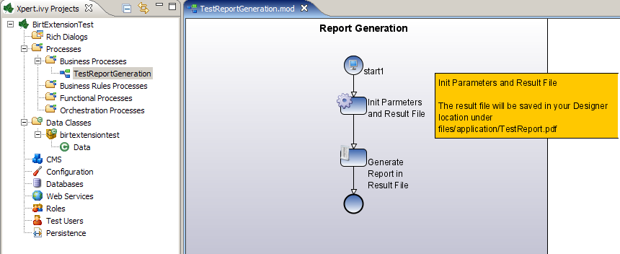Process   
  The first step in the process creates the name of the output file and fills the parameter values for the report. The second element is the BIRT element, that produce the report.