1. Enable WSL and install Docker Desktop

Enable WSL:

Open cmd as an administrator

图形用户界面, 文本, 应用程序, 电子邮件

AI 生成的内容可能不正确。

Type the following command and enter: wsl –install

文本

AI 生成的内容可能不正确。

文本

AI 生成的内容可能不正确。

This command installs the default WSL 2 (Windows Subsystem for Linux) and Ubuntu distributions. After the installation is complete, you need to restart your computer.

安装 Docker Desktop图形用户界面, 文本, 应用程序

AI 生成的内容可能不正确。

Install Gitea using Docker

1. In the directory you want to install (e.g. C:\Users\YourName\gitea), create a file called docker-compose.yml.

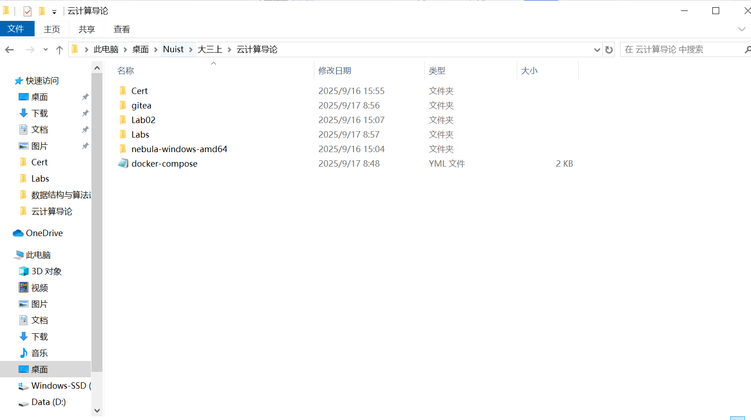

2. Open this file in an editor like Notepad or VSCode and copy the following into it. ​​

version: "3"

networks:

gitea:

external: false

services:

server:

image: gitea/gitea:latest

container_name: gitea

environment:

- USER_UID=1000

- USER_GID=1000

- GITEA__database__DB_TYPE=sqlite3

- GITEA__database__DB_HOST=db:3306

- GITEA__database__DB_NAME=gitea

- GITEA__database__DB_USER=gitea

- GITEA__database__DB_PASSWD=gitea

restart: always

networks:

- gitea

volumes:

- ./gitea_data:/data

- /etc/timezone:/etc/timezone:ro

- /etc/localtime:/etc/localtime:ro

ports:

- "3000:3000"

- "2222:22"

depends_on:

- db

db:

image: mysql:8

restart: always

environment:

- MYSQL_ROOT_PASSWORD=gitea

- MYSQL_USER=gitea

- MYSQL_PASSWORD=gitea

- MYSQL_DATABASE=gitea

networks:

- gitea

volumes:

- ./mysql_data:/var/lib/mysql3. Start Gitea:

In the directory where you just created the docker-compose.yml file, hold down the Shift key and right-click on an empty space and select Open PowerShell Window Here or Open Terminal Window Here ​​。

In the terminal that opens, run the following command:

docker compose up -d

This command automatically downloads the Gitea image and starts the container in the background.

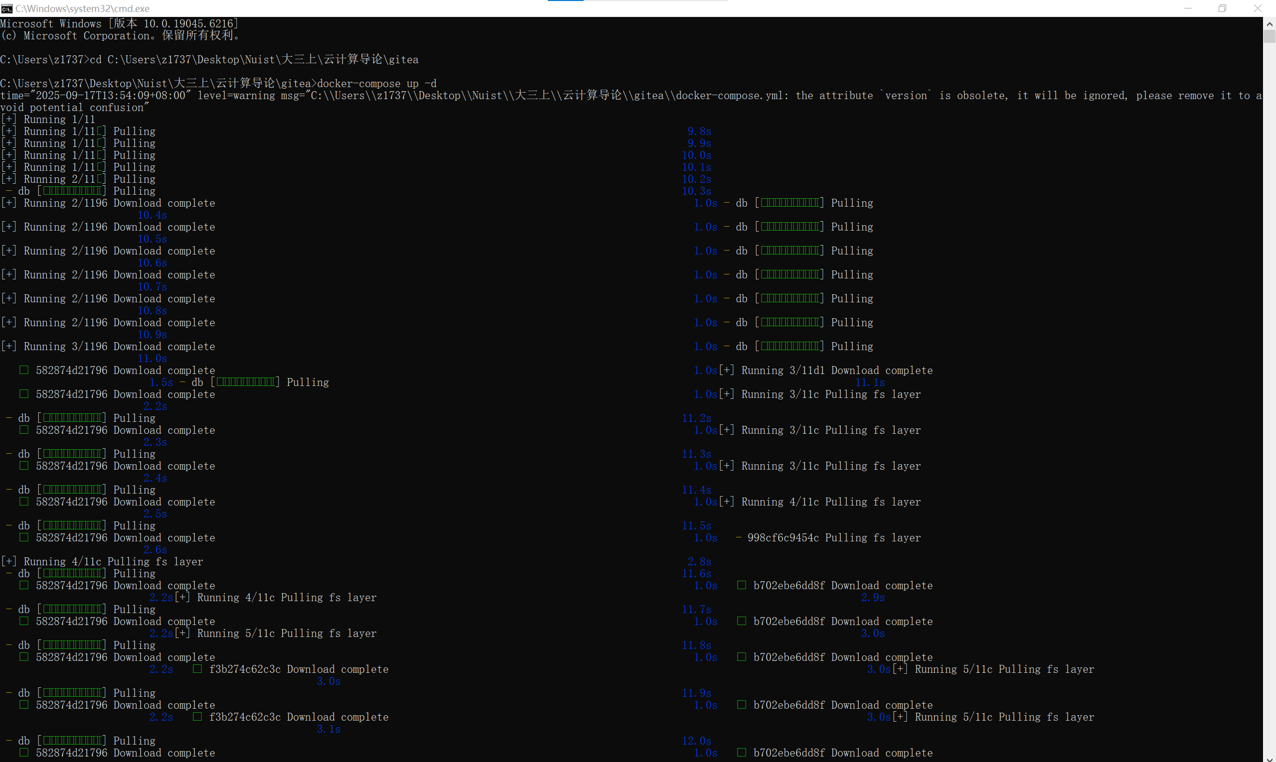

​​4. Complete the installation:

Open your browser and visit http://localhost:3000.

You'll see the Gitea's first installation setup page.

Database settings: Since we are using SQLite, most of the settings here have been automatically filled in, just keep them default.

The most important step: Replace the "SSH server domain" and "Gitea base URL" localhost in your machine IP address (e.g. 192.168.1.100), or you can keep localhost if you are only accessing locally. This is so that subsequent functions such as LFS can work correctly.

Set up an administrator account (username, password, email, etc.).

Click on "Install Gitea".

1. Does it support LFS? prove it.

Yes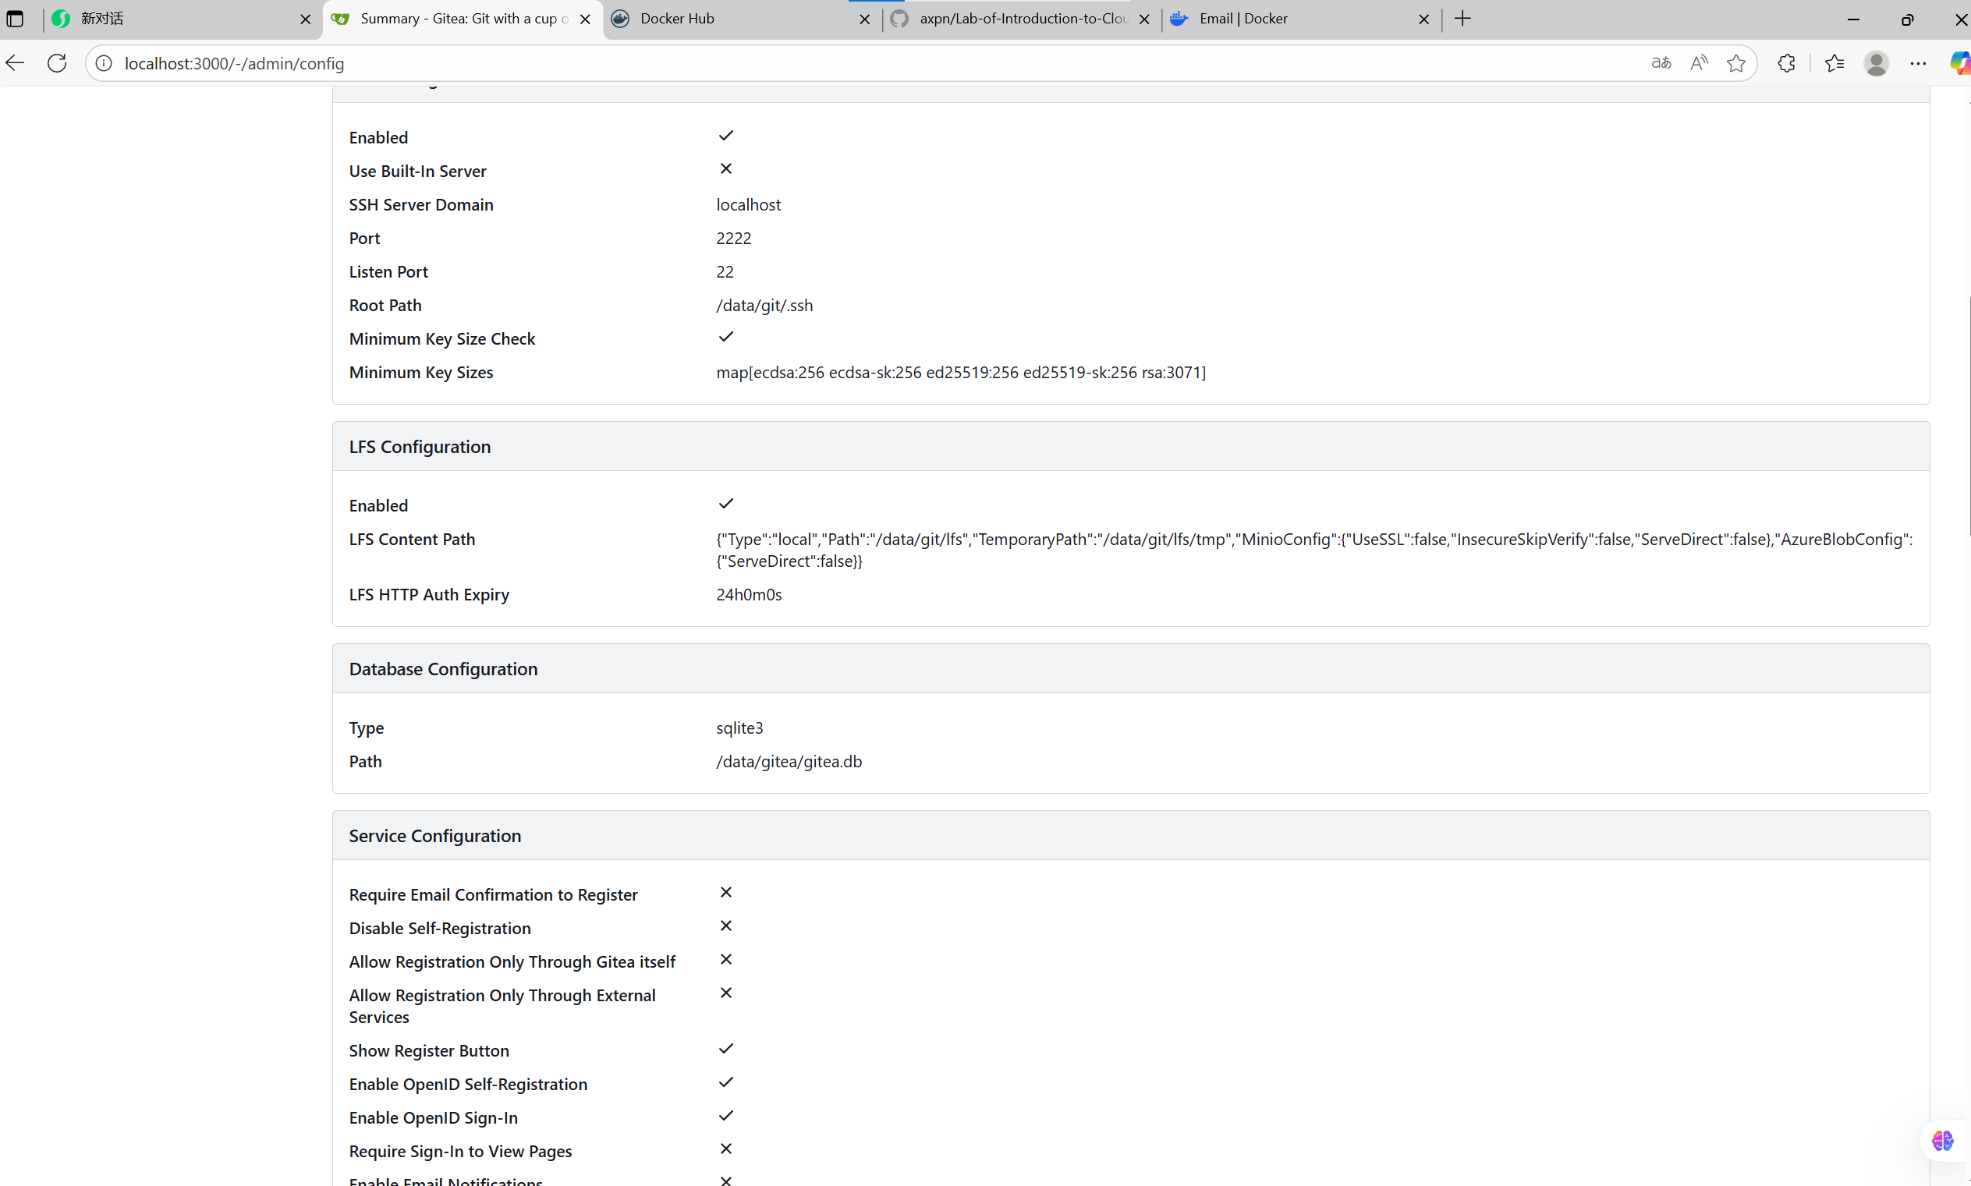

This proves that LFS functionality is built-in and configurable

1. Create a repo with a large file (1G+)

Click the "+" **icon on the Gitea homepage**  and select **"New Repository"**.

Click "Create Repository".

Follow the instructions on the page to configure Git on your local machine and initialize the new repository.

git init

git lfs install

git remote add origin http://localhost:3000/your_username/large-file-test.git

**Create a large file**. Since it is cumbersome to generate a real file of 1GB+, you can quickly create an empty file on Windows using the fsutil command to simulate:

fsutil file createNew fake_1g_file.dat 1073741824

(This command creates a padded file with a size of 1GB)

Track this big file and submit a push:

git lfs track "*.dat"

git add .gitattributes

git add fake_1g_file.dat

git commit -m "Add a 1GB+ large file via LFS"

git push origin main

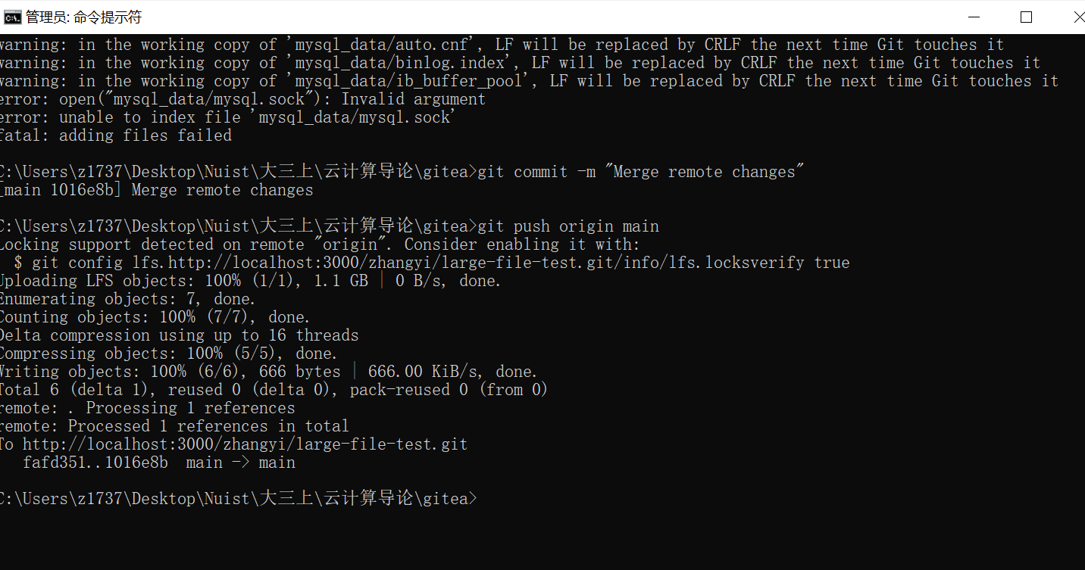

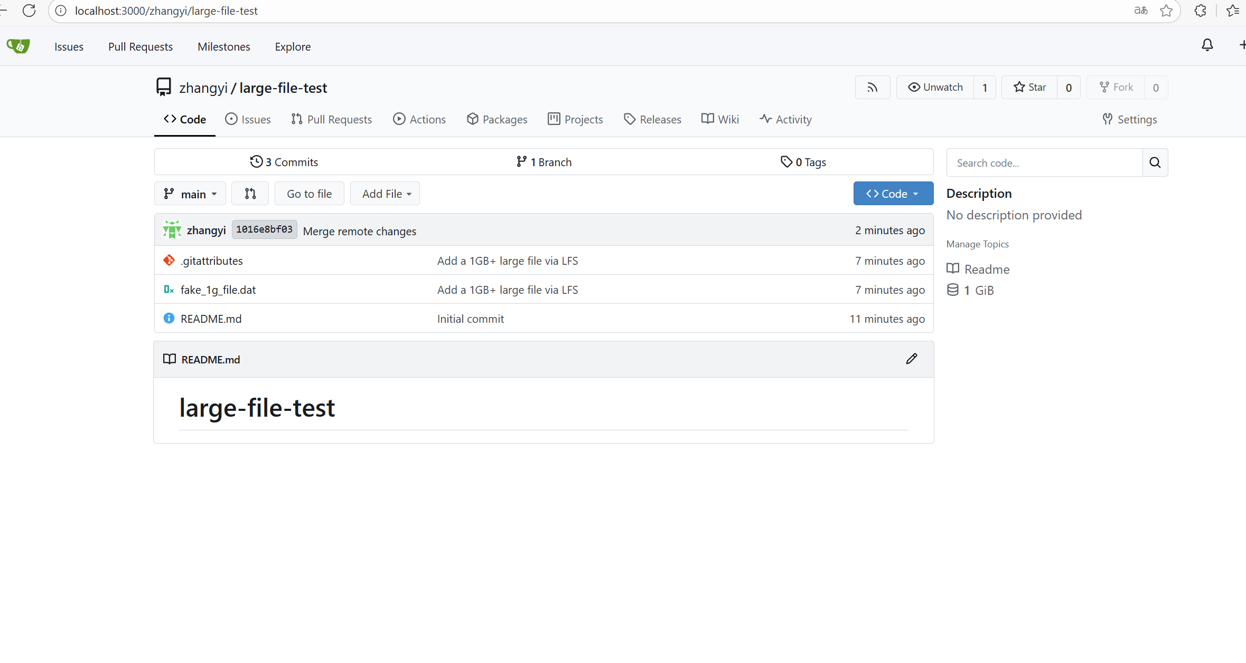

1. Create a repo for this module and commit your work to this repo.

Go back to Git Bash and switch to your repository's directory:

cd Lab04

Run the following command to add all new files to Git's staging area:

git add .

Submit the added file to your local repository with the commit information:

git commit -m "Add lab report and all required screenshots"

Finally, push the local commit to the remote Gitea server:

git push origin main

Finally, the results are attached

