**Traffic Shifting**

Precondition:

1. Istio is installed
2. The Bookinfo sample app is deployed
3. Make sure Gateway is installed
4. Route all traffic to reviews:v1:



1. Split traffic 50/50 between reviews:v1 and reviews:v3



Verify the virtual service: 文本

AI 生成的内容可能不正确。

1. Route 100% traffic to reviews:v3



**What happened**

Traffic shifting was done via Istio weighted routing, not by scaling deployments.

Both versions (v1 and v3) can scale independently.

Istio allows smooth version migration without downtime.

**Cleanup**

**文本

AI 生成的内容可能不正确。**

**Request Routing**

1. Route All Traffic to Version 1 (v1)
2. Apply VirtualService to route all traffic to v1:

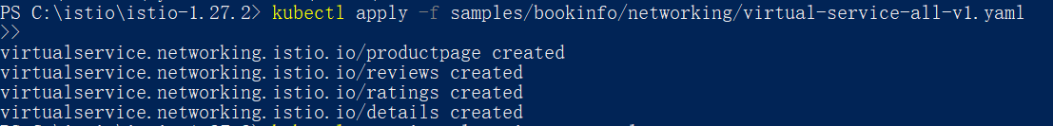

1. Check the routes:

文本

AI 生成的内容可能不正确。

1. Check subset definitions:

图片包含 文本

AI 生成的内容可能不正确。

1. Route Based on User Identity
2. Apply user-based routing rule:



1. Check the VirtualService:

文本

AI 生成的内容可能不正确。

Clean up

**Fault Injection**

1. Injecting an HTTP Delay Fault
2. Inject a 7-second delay for jason: 
3. Verify the VirtualService is applied correctly: 文本

   AI 生成的内容可能不正确。
4. Test the delay:

Open the /productpage and log in as jason.

1. Injecting an HTTP Abort Fault
2. Inject an HTTP 500 error for jason:



1. Verify the VirtualService:

文本

AI 生成的内容可能不正确。

Clean up