**X-Rays of My Soul: Ingmar Bergman**

*“I would therefore have to account for [my films’] sources, their roots and origins, and remove from their files the blurred X-rays of my soul.”* —*Ingmar Bergman*

Simone Peer, Marshall Raiskin, Patricia Sanabria, Kris Yeager

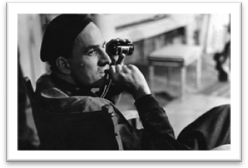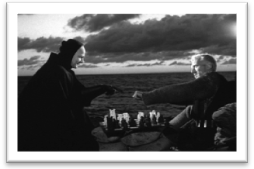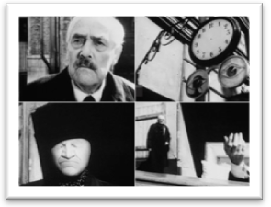

*Why should you care?*

Ingmar Bergman is one of cinema’s most celebrated directors and Sweden’s first auteur filmmaker. With a background in literature and theatre, Bergman executed complete creative control over his films, from scriptwriting to the final on-screen image. Bergman’s films were unique in their serious focus on internal human conflict, exploring psychological, philosophical, religious, and other deeply personal issues, rather than exploring external problems, as social realism and other film movements of that period did. His films have become iconic, celebrated as great cinematic achievements, and have provided inspiration for filmmakers of later generations. Bergman is the embodiment of a true auteur.

*Presentation outline:*

1. Ingmar Bergman: The “Demon Director”
2. Cinematic Style & Narrative Style
3. Dancing with Death: *The Seventh Seal* (1957)
4. In Dreams: *Wild Strawberries* (1957)
5. Key images
6. Bergman’s Legacy

“I think his films have eternal relevance, because they deal with the difficulty of personal relationships and lack of communication between people and religious aspirations and mortality, existential themes that will be relevant a thousand years from now. When many of the things that are successful and trendy today will have been long relegated to musty-looking antiques, his stuff will still be great.” —Woody Allen, *Time Magazine*, 2007