**ZAKO.AI Course**  
**Homework Assignment**

**Period:** August 2025 – December 2025  
**Teacher:** Mansurbek Abdullaev  
**Student:** Khasan Nasriddinov

# **ZAKO.AI | Homework Lesson 3: Data analysis – 1-3.**

Date: 2025.08.11

Tests:

1. Keltirilgan ikki ma’lumotning covariance ni turini to’g’:  
   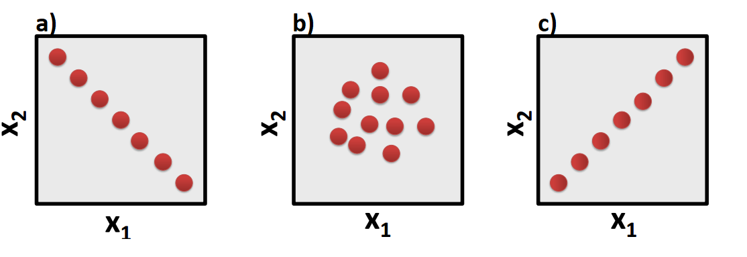  
   a) a- kuchli musbat covariance; b – kuchli manfiy covariance ; c – 0 kichik yoki teng;  
   b) a- kuchli manfiy covariance; b – kuchli musbat covariance; c – 0 kichik yoki teng;  
   **c) a- kuchli manfiy covariance; b – 0 kichik yoki teng; c – kuchli musbat covariance;**
2. To’gri ma’lumotning tanlang:

**a) Correlation – Nafaqat Chiziqlik bog’liqlikni; qolaversa bog;liqlikni darajasini miqdorini ham beradi;**  
b) Covariance – Chiziqlik va chiziqlik bo’lmagan bog’liqlikni ko’rsatib beradi;  
c) Correlation – (+∞) dan (-∞) gacha bo’ladi;

1. Range normalization Min-Max scaling orqali berilgab ma’lumotlarning normallashtirilgan to’g’ri variantni tanlang:

|  |  |  |
| --- | --- | --- |
| Ism | Oylik ($) | Tajriba (yil) |
| Anvar | 10 000 | 7 |
| Sardor | 8 000 | 5 |
| Jamshid | 5 000 | 1 |
| Xurshid | 20 000 | 20 |



|  |  |  |
| --- | --- | --- |
| Ism | Oylik ($) | Tajriba (yil) |
| Anvar | 0.33 | 0.316 |
| Sardor | 0.20 | 0.211 |
| Jamshid | 0.00 | 000 |
| Xurshid | 1.00 | 1 |

Javoblar keyingi betda.

Javoblar.

**(To’gri javoblar: 1c, 2a, 3b)**