GLYNN TUCKER CONSULTING ENGINEERS

AUTOCAD DRAFTING UTILITIES (GTLISP)

REFERENCE MANUAL

Errata
Every effort to ensure the documentation is current and no reference or syntactical errors exist has been taken. However, human error is present through-out all aspects of life, and yes, I'm human. If an error is identified, please contact us as soon as possible to have the issue rectified.

Understanding the Reference Documentation
This reference manual has been compiled in both the mind of the programmer and end user. There are portions to the documentation which serves no benefit to the user, however understanding of how a problematic routines works can assist the developer.

Function References
The function references listed within are split into individual modules or tool-sets (grouped by their functionality), and typically follow a specific format:
- FunctionName (Access Specifier) – The FunctionName is, as suggested, the calling name of the function being described. The access specifier depicts the extent of which the application, third party utilities or end users can access the method. There are two main categories:
  - Public or Unlisted – Indicates the function is usable and directly accessible by any user or other routines provided the code is loaded.
  - Private – The code will only be accessible by the function wrapping it preserving the concept of encapsulation. Hiding the inner workings of a function, ensuring stable extension. These functions cannot be called directly.

GTLISP Updating
As of version 0.0.11, the GTLISP utilities have an inbuilt update service which checks for a new version on each drawing load. If a newer version is available, the end user will be informed and given a choice to update. However, manual update is also possible by changing the packaged VLX file which AutoCAD loads.
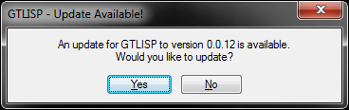Illustration 1: Update Dialog

Installation
The installation procedure for the GTLISP utilities is fairly straight forward:
- Open the desired version of AutoCAD.
- From the command line, type 'Appload'.
- Within the Appload dialog, use the file list to browse for the 'GTLISP.VLX' package.
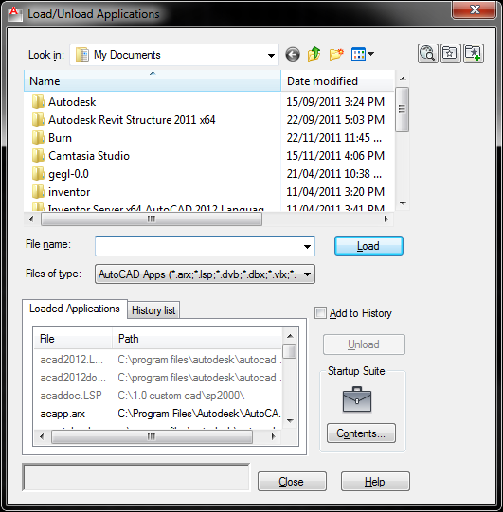Illustration 2: AutoCAD Appload Interface
- Select/Highlight the file and select Load then Close. Note, to have the utilities load on each instance of AutoCAD, add the 'GTLISP.VLX' package into the Startup Suite.
- If the load was successful, the GTLISP splash screen will be displayed.
- After clicking on continue, a browse dialog will be shown. Use the dialog to browse for the folder which contains the 'GTLISP.VLX' file. If the package is found, the file path will be added to the AutoCAD support directory. Note: It is advised that the GTLISP.VLX package is found within an AutoCAD support path.
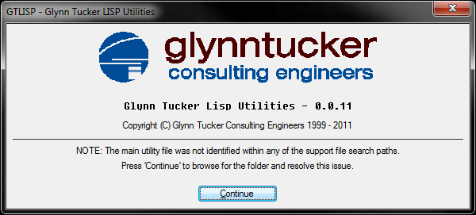Illustration 3: GTLISP Splash Screen
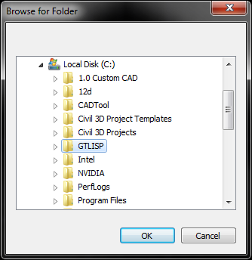Illustration 4: GTLISP Browse for Support Path

Custom Prompt Dialogs (GTDialogs)

DCL dialogs are a existing implementation of the AutoCAD platform and are supported on all release builds. The only issue found with dialogs are reuse-ability and file management, with the typical scenario of the dialog syntax file being deleted. All dialogs within GTLISP are generated into the temporary windows directory and deleted after use, ensuring the dialog always exists.

Splash

The splash dialog is a setup wizard designed to guide the user through setting up the GTLISP utilities for the first time. After selecting continue, the user will be asked to specify the location to the 'GTLISP.VLX' file which will ensure the utilities run as expected.
Usage:
- (gtdialogs:splash $information)

Where $information is a string of additional information to be displayed.
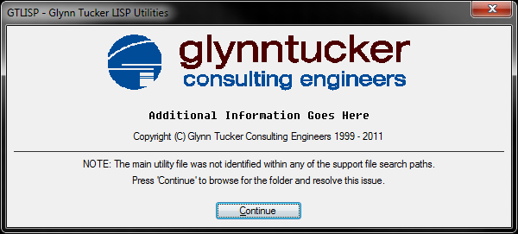

YesNo
The YesNo dialog prompts the user for a response to a simple yes/no question, returning either 'T' or 'nil' to the calling method.
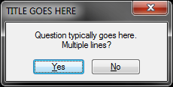Illustration 5: YesNo Dialog
Usage:
- (gtdialogs:yesno $title $question)
Where $title is the title of the dialog and $question is the question to be asked (multi-line through the use of the '\n' escape character).

GT Slab Tools

GTCogs

INI Config Parser & Generator (GTConfig)

    - [GENERAL]
    - BASEPATH=C:\GTLISP
    - PLOTPATH=X:\1.0-Drafting\2.0-Plot Configuration\3.0-GTLISP Plot Configurations
    - INITIALS=A.S.
    - DATEFORMAT=DD.MM.YY
    - ENABLE_TIMES=S
    - ENABLE_OVERLAY=T
    - [GENERAL_ARCHIVING]
    - FOLDER=Superseded\
    - DWGDETACH=x-sign-*
    - IMGDETACH=*
    - [DATABASE]
    - SERVER=database
    - DATABASE=glynntucker
    - EMPLOYEEID=58
    - [LOGGING]
    - #AVAILABLE LEVELS: 0=OFF, 1=DEBUG, 2=INFO, 3=WARNING, 4=ERROR, 5=FATAL, 6=ALL
    - LEVEL=6

Parse
Parses a specified INI structured configuration file into an associated list.

GetValue

HasSection

HasKey

SetValue

AddSection

Save

XML Parser (GTXML)
The XML parser was added into the GTLISP utilities as a method of downloading XML feeds from the Web as a way of 'Checking for Updates' or ensuring the VLX package was current.
Typically an XML document resembles the following syntax:
- <root>
    - <child>
      - <sub-child attribute=”attributeValue”></sub-child>
    - </child>
- </root>
The XML Parser requires an underlying Microsoft DOM (or object model) to successfully read the files, restricting the code functionality to Windows only AutoCAD editions.

GetAttributes (private)
Gets an associated list of attributes from any specified node within the XML document.
Usage:
- (gtxml:getattributes $node)
Where $node is an associated list of nodes.

GetChildNodes (private)
A recursive function which parses an XML node for any child nodes.
Usage:
- (gtxml:getchildnodes $node)
Where $node is the first XML node.

Read (public)
Parses an entire XML document into an associated list.
Usage:
- (setq $someVariable (gtxml:read $filename))
Where $filename is the URL or base file path to the XML document.

