



# Placement Empowerment Program

***Cloud Computing and DevOps Centre***

Task:

Use Cloud StorageCreate a storage bucket on your cloud

platform and upload/download files. Configure access permissions for the bucket.

Name: AXSHLIN SHARMIL S Department:CSE



# Introduction

Cloud storage provides a scalable, secure, and cost-effective solution for storing and managing data in the cloud. This Proof of Concept (POC) focuses on creating a cloud storage bucket, uploading and downloading files, and configuring access permissions to ensure data security and controlled accessibility.

In this POC, we will:

 Set up a cloud storage bucket on a cloud platform (AWS S3, Google Cloud Storage, or Azure Blob Storage).

 Upload and download files to and from the storage bucket.

 Configure access control policies to restrict or grant permissions based on security requirements.

This implementation demonstrates how cloud storage can be utilized for various applications, including backups, media hosting, and distributed data access.

# Overview

This Proof of Concept (POC) explores the implementation of cloud storage services to eﬃciently manage and control file storage, access, and retrieval. The objective is to demonstrate the capabilities of cloud storage solutions for handling data in a scalable and secure manner.

### Key Steps Involved:

#### Create a Cloud Storage Bucket

Choose a cloud provider (AWS S3, Google Cloud Storage, or Azure Blob Storage). Set up a new storage bucket with appropriate configurations.

#### Upload and Download Files

Use cloud CLI or SDKs to upload files to the bucket.

Retrieve or download files from the cloud storage for verification.

#### Configure Access Permissions

Define bucket-level access policies.

Set up public or private access controls as per security requirements. Implement IAM roles or ACLs to manage user permissions

# Objectives

1. Create a Cloud Storage Bucket
2. Enable File Upload and Download
3. Implement Access Control Mechanisms
4. Ensure Data Security and Integrity
5. Evaluate Performance and Scalability
6. Document and Analyze Findings

# Step-by-Step Overview

## Step 1:

### Navigate to the AWS Managment Console

In a Managment Console go to S3 and create a new bucket

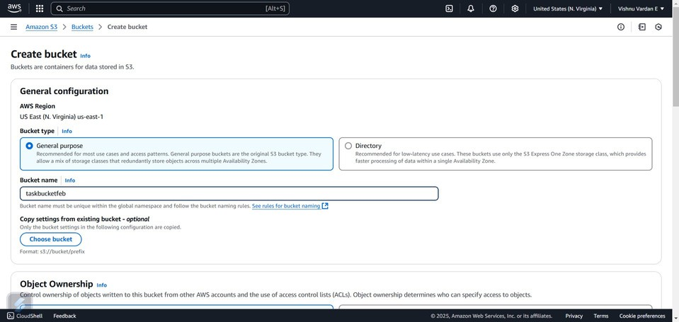

## Step 2:

Now Upload a file in the S3 bucket

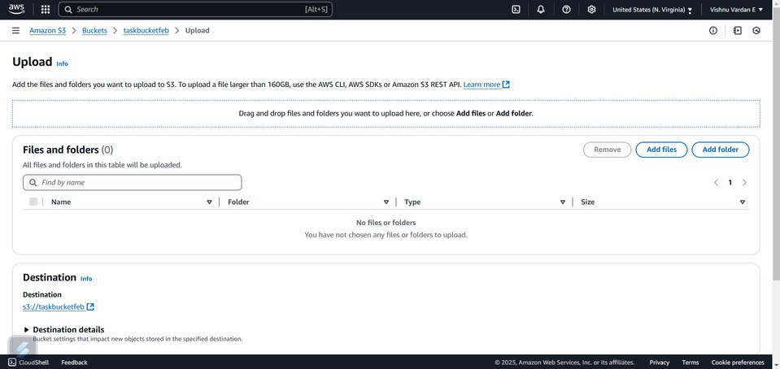

## Step 3:

Touch the bucket and navigate to the permission in top and enable the public access to the bucket then enter the given bucket policy in a edit bucket policy

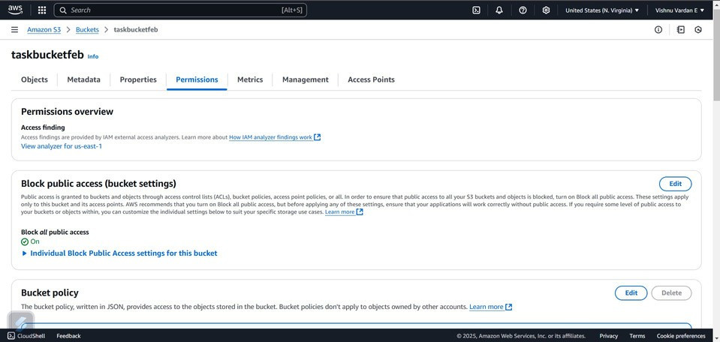

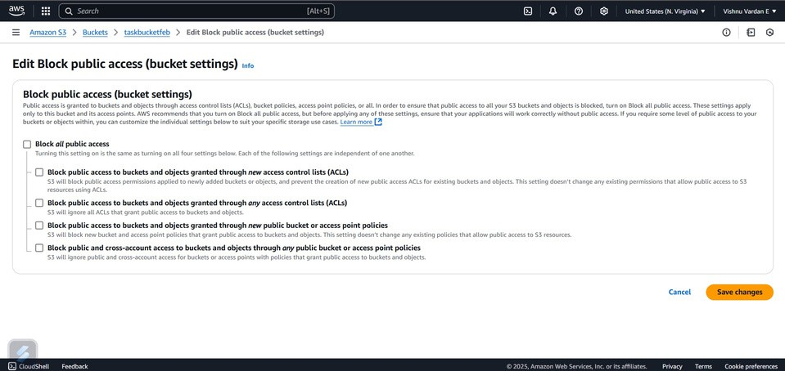

{

"Version": "2012-10-17",

"Statement": [

{

"Effect": "Allow",

"Principal": "*",

"Action": "s3:GetObject",

"Resource": "arn:aws:s3:::your-bucket-name/*"

}

]

}

## Step 4:

Then click on the save changes to the bucket policy



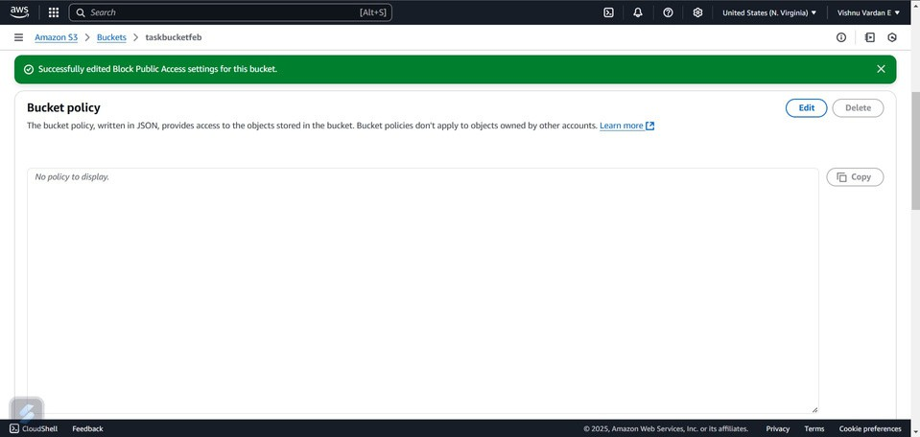

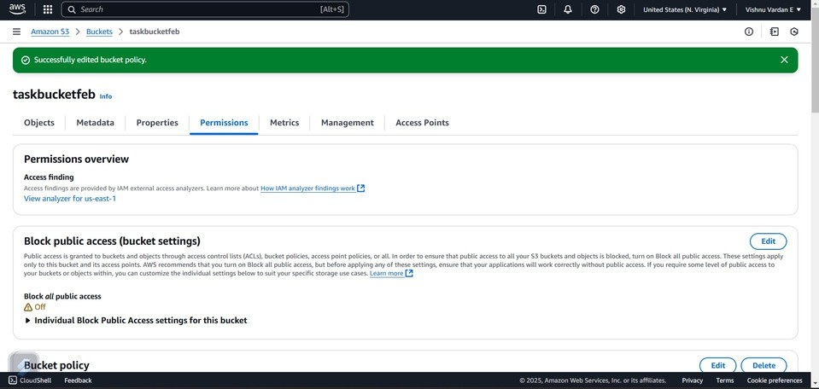

## Step 5:

Then finally navigate to the bucket and click on the copy url and then enter that address to the chrome

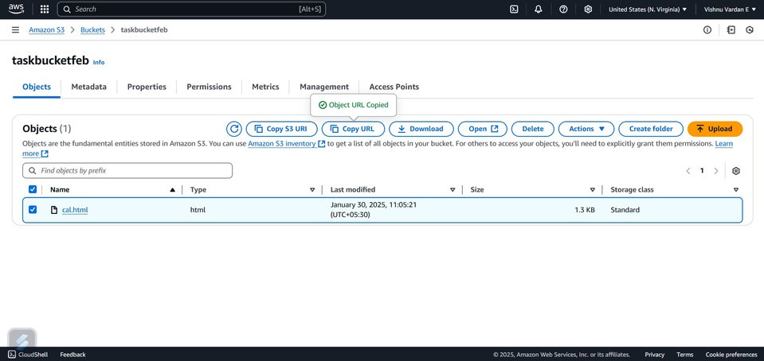

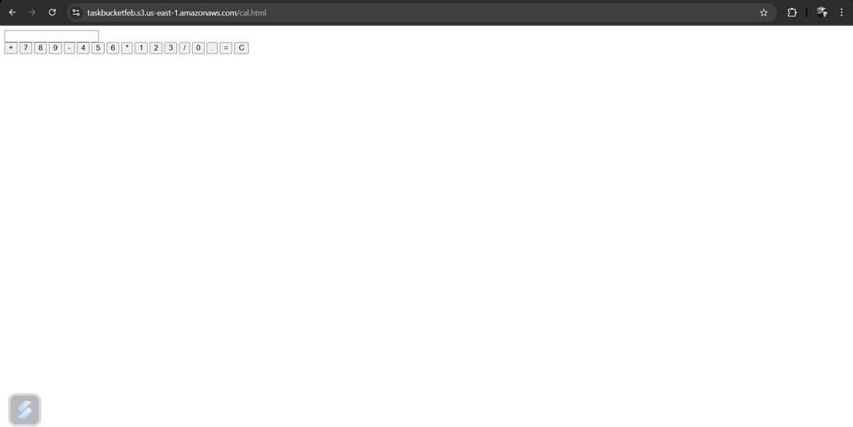

# Expected Outcomes:

 Successful creation of a cloud storage bucket.  Smooth file upload and retrieval process.

 Properly configured access control policies ensuring secure storage.

This POC provides a foundational understanding of cloud storage, making it

easier to integrate into applications for large-scale data handling, backups, and media hosting.