



# Placement Empowerment Program

***Cloud Computing and DevOps Centre***

Task:Set up a Virtual Machine in the Cloud

Name: AXSHLIN SHARMIL S Department: CSE



# Introduction

Introduction to Setting Up a Virtual Machine in the Cloud

A **Virtual Machine (VM)** in the cloud is a computing resource that runs on a cloud provider's infrastructure. It allows users to deploy applications, test environments, or run workloads without needing physical hardware.

This **Proof of Concept (PoC)** aims to guide you through the process of setting up a virtual machine on major cloud platforms like **Amazon Web Services (AWS), Microsoft Azure, or Google Cloud Platform (GCP)** using their **free-tier** offerings. The steps include:

1. **Creating a Cloud Account** – Sign up for a free-tier account on AWS, Azure, or GCP.
2. **Launching a Virtual Machine** – Choose an appropriate VM configuration and operating system.
3. **Connecting via SSH** – Securely access the VM using SSH from your local machine.

By the end of this PoC, you will have a running cloud-based VM that you can use for development, testing, or hosting applications.

# Overview

Step-by-Step Overview for Setting Up a Virtual Machine in the Cloud (PoC)

1: Create a Cloud Account

 Sign up for a free-tier accounton one of the major cloud providers:  AWS (Amazon Web Services) – [AWS Free Tier](https://aws.amazon.com/free/)

 Azure (Microsoft Azure) – [Azure Free Account](https://azure.microsoft.com/en-us/free/)

 GCP (Google Cloud Platform) – [Google Cloud Free Tier](https://cloud.google.com/free)

 Verify your email, phone number, and payment method (most providers require a credit card for verification but won’t charge for free-tier usage).

2: Access the Cloud Console

 Log in to the respective cloud console:

 AWS Console: [AWS Management Console](https://aws.amazon.com/console/)  Azure Portal: [Azure Portal](https://portal.azure.com/)

 Google Cloud Console: [Google Cloud Console](https://console.cloud.google.com/)

3: Launch a Virtual Machine (VM)

 Navigate to the Compute Servicessection:  AWS: EC2 (Elastic Compute Cloud)

 Azure: Virtual Machines

 GCP: Compute Engine

 Click on Create Instance / Launch VM  Configure the following settings:

 Choose OS (Ubuntu, Windows, CentOS, etc.)

 Select Machine Type (Free-tier eligible instance like AWS t2.micro, Azure B1s, or GCP e2-micro)

 Configure Network & Security (Ensure SSH is enabled)

 Create & Download SSH Key Pair (AWS & GCP) or set up username/password (Azure)

 Launch / Deploy the VM

4: Connect to the VM via SSH

 Once the VM is running, retrieve its public IP address

 Open a terminal (Linux/macOS) or use PuTTY (Windows)  Connect using SSH:

 ssh -i your-key.pem username@public-ip

 AWS: ssh -i key.pem ec2-user@public-ip  Azure: ssh username@public-ip

 GCP: ssh username@public-ip (or use Google Cloud Console SSH button)

5: Verify and Use Your VM

 Run basic commands to ensure the VM is working:  uname -a # Check system info

 df -h # Check disk usage  top # Monitor processes

 Install required packages or deploy an application as needed

# Step-by-Step Overview

## Step 1:

Navigate to the aws console and search ec2

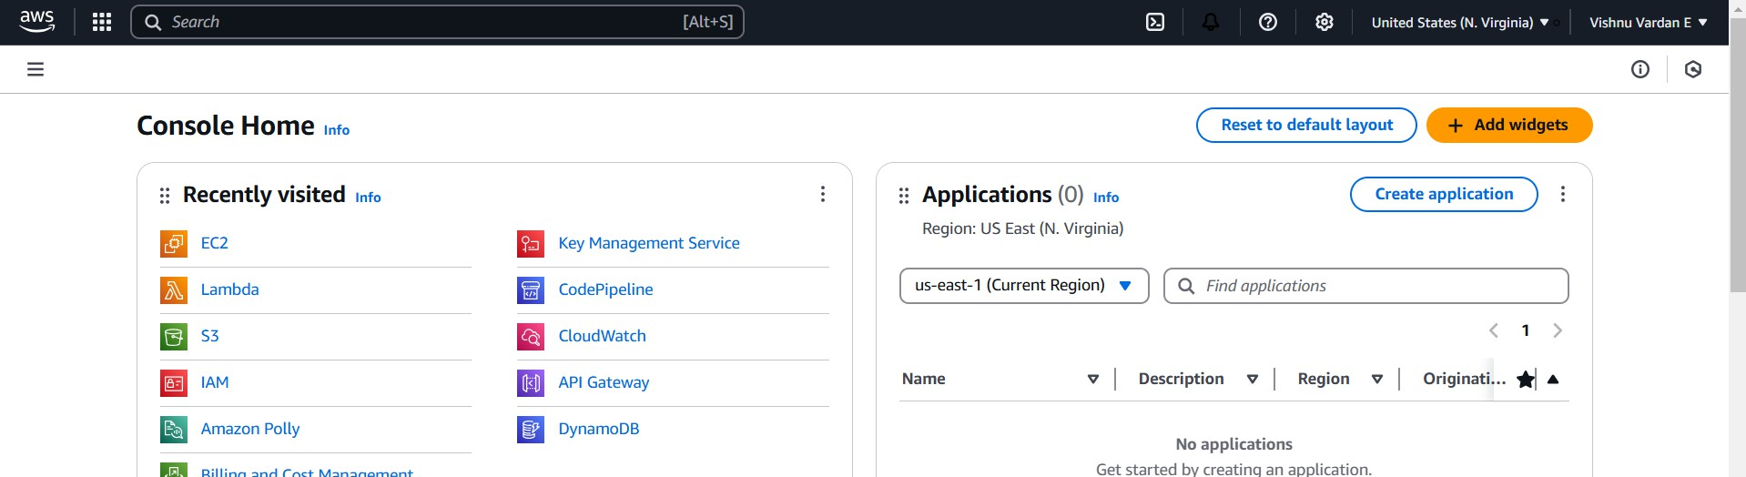

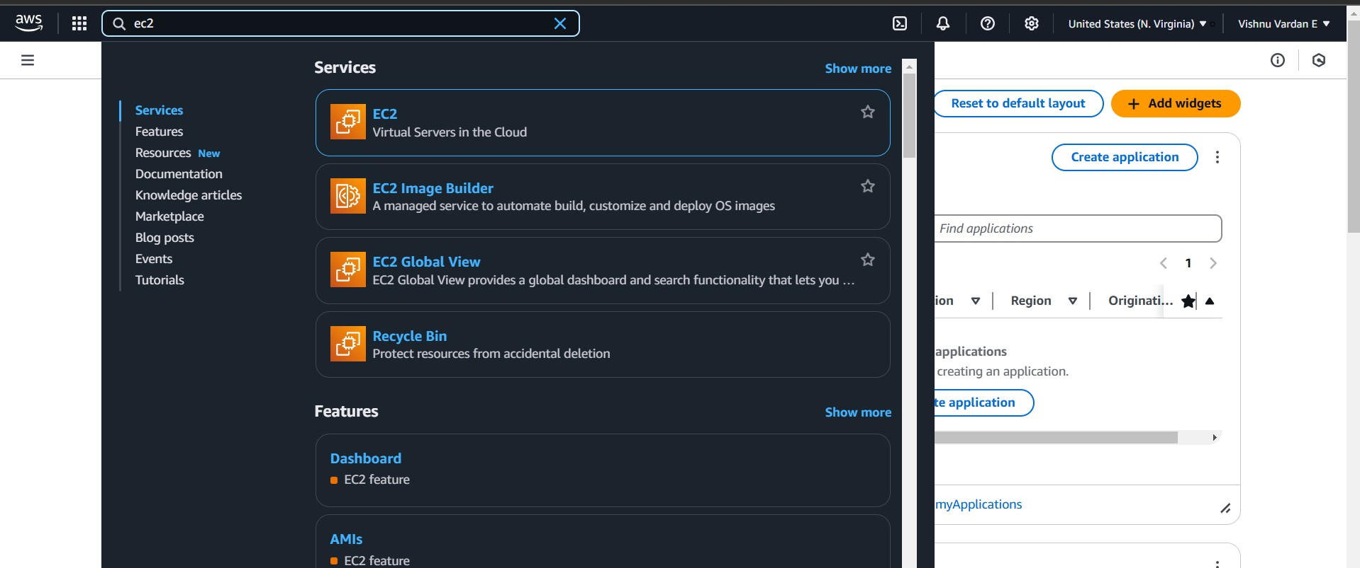

## Step 2

Now click the ec2 and launch an instance

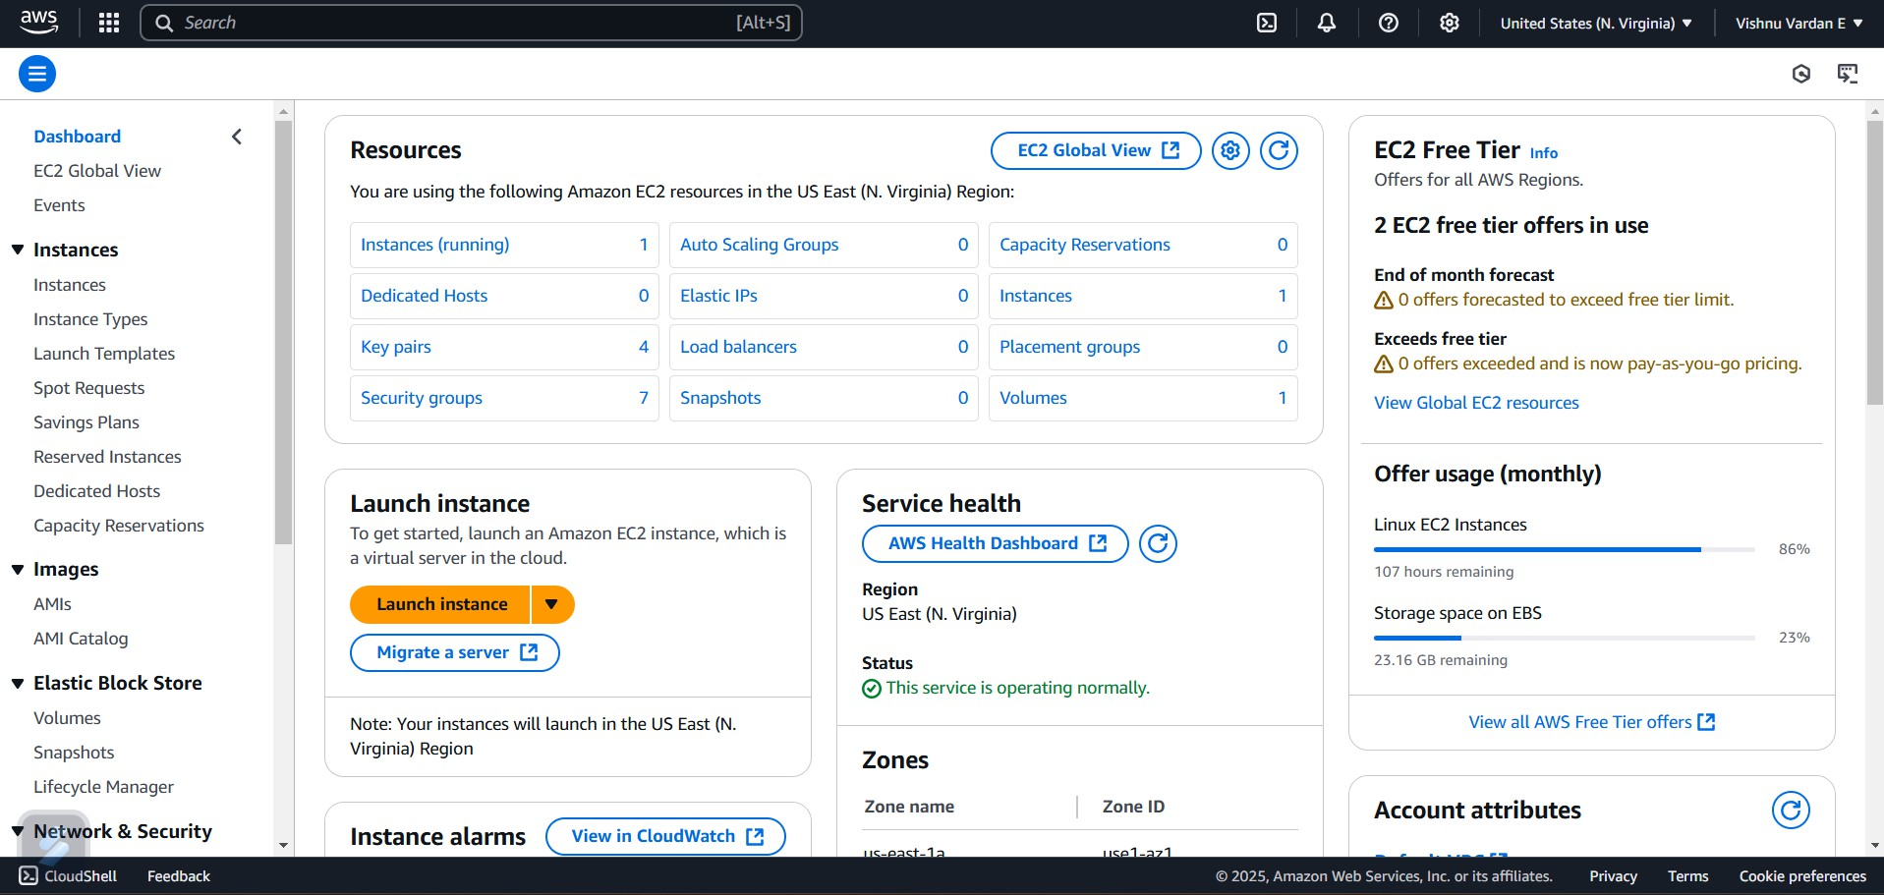

## Step 3:

Name the instance and create an new key pair name

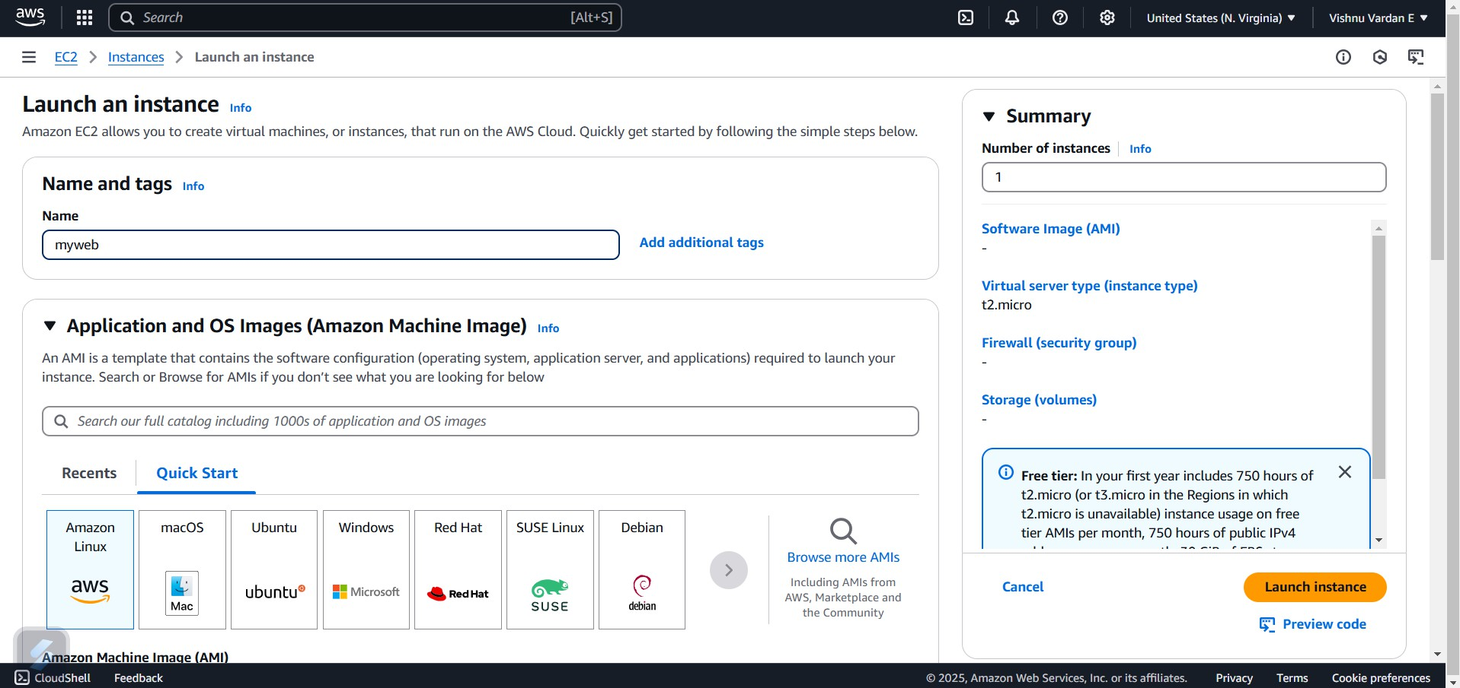

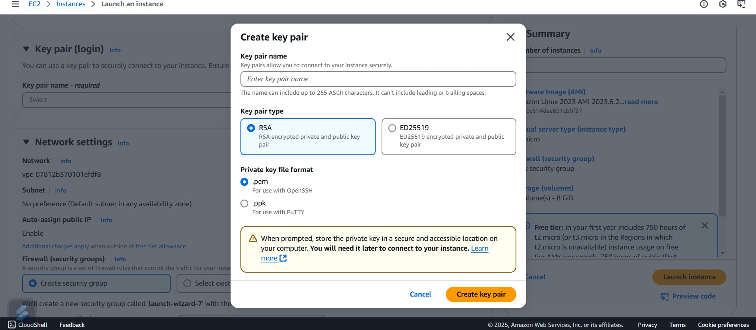

## Step 4:

Click to launch instance button and your instance has been launched

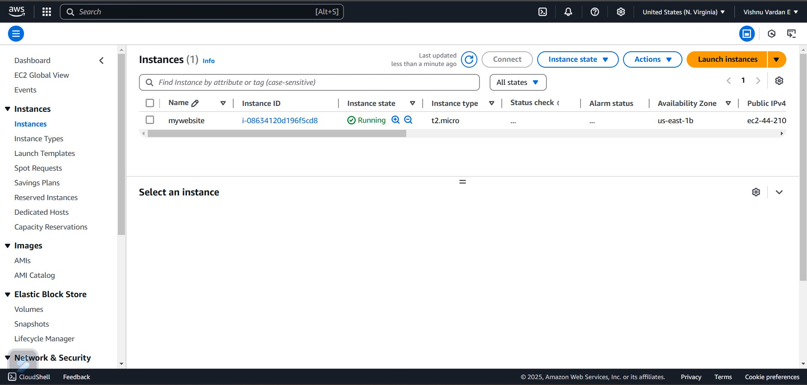

# Expected Outcome

After completing these steps, you will have a **fully functional cloud-based virtual machine** that can be accessed remotely. This VM can be used for **development, hosting applications, or running workloads**.