An art style is everything.

That seems a bit bold of a statement.

Well, and art style could make or break a game.

Fine.

It's all about that aesthetic. Speaking of which, we're gonna need a word doc for this one.

Huh?

Ok that feels a lot better

How did you do that?

Shhhh. I’m running the show today.

Fine.

Anyways, A E S T H E T I C is the key to a good consistent artstyle. The aesthetic is born of the thoughts feelings and emotions trying to be conveyed. So in order to develop a compelling and pleasing art style, we must first ask ourselves. What are we trying to convey?

Wait, when does Genre come into this?

Ok first ask what genre is it and then ask what are we trying to convey. It’s scifi btw.

Well, we want the game to be fun. We want the player to defeat robots and move cool and drift and stuff and we want to make them laugh, right?

RIGHT!! Now lets get some keywords from all of that ok:

FUN

HUMOROUS

COOL

Now, how do we convey these feelings through a scifi aesthetic?

Color and Shapes(and sound).

Sometimes things don’t have to look functional if they look cool.

Sometimes things don’t have to make sense if they are fun.

Sometimes things don’t have to blah blah blah blah humor.

Lets identify good guy shapes and bad guy shapes. As well as shapes for the environments

The good guys are friendly strong reliable relateable and cool.

The bad guys are unfriendly strong unrelateable but still cool.

Good guys will be characterized by round shapes, but since we also want to convey some element of coolness, they will have some amount of sharpness to them, but the sharpness cannot be too jarring to the overall feel

The bad guys will be characterized by hard shapes and sharp shapes. The less round the better, But There will still be an “even” coherence to them. 

The environment will be tricky. In order to juxtapose the player and the environment, the environments will share a similar feel the enemies in terms of shape and colors.

A flat look works for the characters, but the problem would be distinguishing them from the background. An outline would help but it would change the style in a drastic way.

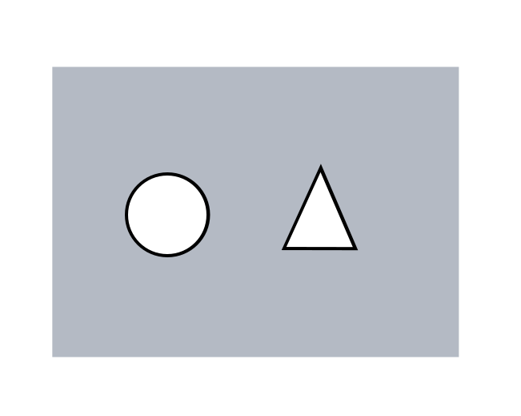

A Drop shadow seems to be a simple solution. With the drop shadow you will know that the player is above something as well as where they are, but it will also do well to keep the aesthetic consistent and appealing.

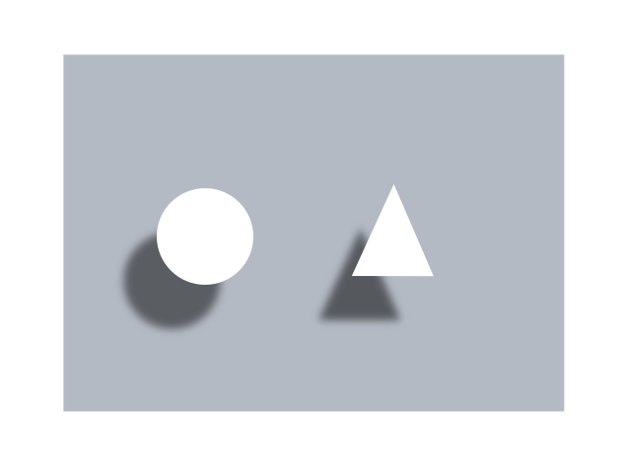

I believe a flat color palette will do well to suit this style we are developing, though I’d like to see how making certain objects brighter in hue will displace them from their surroundings specifically character eyes. Each robot will have a singular eye-like face. Sizes and colors will vary. It would make no sense to make their eyes look like a human retina. It would ruin the aesthetic. But we need the “Faces” if you will to be readable and distinguishable.

Now how will we use colors?

To set the tone, define the setting, make things apparent or distinguish things from one another

Which colors will we use?

Idk, how do we determine which colors we will use?

First we consult the budget. The budget states that time is money so the more time we waste the less budget we have for art.

Ok, since we are going for a flat scifi-themed aesthetic but our budget is hella limited. We need to hella simplify the color palette.

Ok, so how many colors should we use?

No more than 16.

That’s still a lot.

It seems like a lot, but believe when I say it will build up quickly, plus when we have to start reusing colors, you will thank me to high heaven.

First rule, NO PURE WHITE OR PURE BLACK.

Ok then let’s define our darkest hue and our lightest hue?



Are you sure you want to start here?

We can always change it later.

I have no idea where to go from here. At first I thought. I’ll just start deriving colors from these in the hopes that I can get a nice array to use from, but it felt so unnatural. But I’d rather not have a blank canvas and no starting choices. WE HAVE A LIMITED BUDGET! HOW DO WE PROCEED!!!???

Ok quit acting crazy. How about we dial back the 16 color thing. Instead of thinking of the game as a whole in terms of colors. Lets focus on levels with an even limited palette? Say 6 colors for the environment, 6 colors for the player and 6 colors for the enemies?

Each?

Each. Think of it like this. Do them one at a time while keeping the whole in mind.

Which should I start with first?

I’d say the environment. I would imagine the environment was there way before your player, not the other way around.

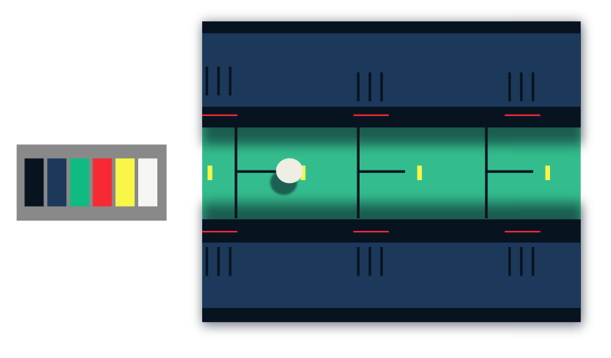

Figure . Environment Palette attempt one.

Things that worked were the dark blue, the blue, the red, the yellow, and the white. The green/teal was very contrasting which is good, but the contrast it gave created a strange feeling which was not one we were going for.