AnyEIS User Handbook
ABSTRACT
To address the need for efficient analysis of Electrochemical Impedance Spectroscopy (EIS) and Dielectric Spectroscopy (DS) data, the AnyEIS software was developed. This user guide introduces this comprehensive tool, which integrates data visualization, processing, simulation, and fitting functionalities. The software core comprises four key modules: The Plotting module enables intuitive visualization of EIS/DS experimental data; the Processing module provides preprocessing functions such as noise reduction; the Simulation module supports the flexible construction and simulation of electrochemical and dielectric models; and the Fitting module facilitates precise fitting analysis of model parameters. Through its integrated workflow, AnyEIS significantly enhances the efficiency and reliability of EIS/DS data interpretation. It provides researchers in materials science, biomedicine, and energy fields with a powerful technical support tool, effectively advancing related research.
KEY WORDS：AnyEIS; Electrochemical Impedance Spectroscopy (EIS); Dielectric Spectroscopy (DS); Data Fitting; Simulation Analysis
；

Table of Contents
目录
Table of Contents 1
Chapter 1 Introduction 1
1.1 Introduction 1
1.2 Core Functions and Applicable Scenarios 2
1.3. System requirements and compatibility 3
1.3.1 Operating System 3
1.3.2 Hardware configuration 3
1.3.3 Environment Configuration and Dependencies 3
1.3.4 Compatibility Description 4
1.4. Installation method 4
1.5 Copyright information 4
1.7 Quick Start 5
Chapter 2 System Function Settings 7
2.1 Introduction 7
2.2 Basic Setup 7
2.2.1 Basic Setup 7
Chapter 3 Plotting Module: Data Visualization 11
3.1 Overview of Module Functions 11
3.1.1 Applicable Scenarios 11
3.1.2 Description of Interface Layout 12
3.2 Data Loading and Basic Operations 13
3.2.1 File Operation Button Group 13
3.2.2 File Selection Control Area 13
3.2.3 Data File Information Table 14
3.3 Data Visualization and Chart Configuration 15
3.3.1 Plotting Area 15
3.3.2 Drawing Control Button Group 16
3.4 Data export and sharing 17
3.4.1 Data Output Control Area 17
3.5 Common Problems and Tips 17
Chapter 4 Processing: Data Processing 19
4.1 Overview of Module Functions 19
4.1.1 Applicable Scenarios 19
4.1.2 Interface Layout Description 20
4.2 Data Loading and Basic Operations 21
4.2.1 File Operation Button Group 21
4.2.2 File Selection Control Area 21
4.2.3 Data File Information Table 22
4.3 Data filtering 23
4.3.1 Filter and select control zones 23
4.4 Data Processing 25
4.3 Data Visualization and Chart Configuration 27
4.3.1 Plotting Area 27
4.3.2 Drawing Control Button Group 28
4.4 Data Export and Sharing 29
4.4.1 Data Output Control Area 29
4.5 Common Questions and Tips 29
Chapter 5 Simulation 31
5.1 Overview of Module Functions 31
5.1.1 Applicable Scenarios 31
5.1.2 Interface Layout Description 32
5.2 Data Loading and Basic Operations 33
5.2.1 Model Configuration 33
5.2.2 File operation button group 33
5.2.3 Setting Parameters 33
5.3 Data Visualization and Chart Configuration 37
5.3.1 Plotting Area 37
5.3.2 Drawing Control Button Group 38
5.4 Data Export and Sharing 39
5.4.1 Data Output Control Area 39
5.5 Common Issues and Tips 40
Chapter 6 Fitting Data 41
6.1 Overview of Module Functions 41
6.1.1 Applicable Scenarios 41
6.1.2 Interface Layout Description 42
6.2 Data Loading and Basic Operations 43
6.2.1 File Operation Button Group 43
6.2.2 File Selection Control Area 43
6.2.3 Data File Information Table 44
6.3 Data Entry and Analysis 45
6.4 Data Visualization and Chart Configuration 48
6.4.1 Plotting Area 49
6.4.2 Drawing Control Button Group 49
6.5 Algorithm Configuration 50
6.6 Data Export and Sharing 51
6.6.1 Data Output Control Area 51
6.7 Common Questions and Tips 51
Chapter 7 Principles of Mathematics and Physics 53
7.1 EIS 53
7.2 DS 53
7.3 Dielectric Sphere Shell Model 53
7.4 Dielectric Spectrum Model 53
7.5 Data Filtering 53
7.6 Data Fitting 53
References 54

Chapter 1 Introduction

1.1 Introduction
Electrochemical Impedance Spectroscopy (EIS) and Dielectric Spectroscopy (DS) are important techniques for studying the electrochemistry and dielectric properties of materials, widely used in materials science, biomedicine, and energy fields. AnyEIS software integrates comprehensive software tools for data visualization, processing, simulation, and fitting. It includes four major functional modules: data visualization, data processing, simulation, and fitting, which is able to efficiently complete experimental data display of EIS and DS, noise reduction, model simulation, and precise fitting analysis. It provides researchers with a powerful tool to meet the diverse needs of EIS and DS analysis, improve research efficiency, and drive advancements in related fields.
The main interface is shown in Figure 1. The main interface consists of three parts: the top title bar and the left menu bar. Bottom status bar. The top title bar is "AnyEIS - An EIS Research App based on Python”. At the center of the interface is the AnyEIS logo, composed of blue and orange graphics, with the words "AnyEIS" next to it.

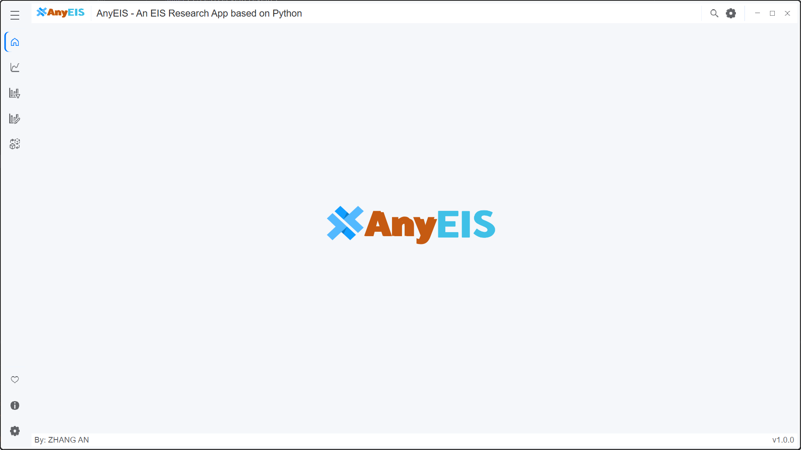
Figure 1: Main interface of AnyEIS

1.2 Core Functions and Applicable Scenarios
AnyEIS is an integrated analysis software specifically designed for EIS and DS studies, with core functions covering the entire experimental data processing process. The software achieves efficient collaboration through four major modules:
Plotting module: The plotting module provides multidimensional data visualization capabilities, supporting flexible drawing and dynamic interaction of professional graphs such as Nyquist plots, Boter plots, and Time order plots, helping users intuitively analyze material interface impedance properties and dielectric relaxation behavior.
Processing module: The Processing module integrates a suite of advanced data filtering and smoothing algorithms, allowing users to select the appropriate method based on data characteristics and analysis objectives. Available techniques include smoothing and noise reduction filters such as Savitzky-Golay, Median and so on for eliminating switch bounce; and calibration and calculation methods including System Calibration, Dielectric Material Method, Parallel Plate Capacitor, RF Impedance Calibration/Calculation, RF Dielectric Calculation, and the Three-Solution Method. By applying these targeted algorithms, the module effectively removes noise and anomalies from raw signals, significantly improving the signal-to-noise ratio.
Simulation module: The simulation module includes an equivalent circuit model and dielectric relaxation models (Debye, Cole-Cole, Cole-Davidson, Havriliak-Negami, etc.), supporting user-defined circuit topologies or dielectric distribution functions, quickly simulating theoretical impedance response characteristics under different working conditions to provide pre-research support for experimental design.
Fitting module: the fitting module uses intelligent optimization algorithms (such as genetic algorithms and the Levenberg-Marquardt method) to achieve multi-parameter synchronous fitting, accurately analyzing key parameters such as charge transfer resistance, double-layer capacitance, and dielectric loss peaks, significantly improving the performance evaluation accuracy of energy devices like fuel cells and supercapacitors.
This software is widely used in scenarios such as electrode interface characterization for lithium-ion batteries, biosensor impedance detection, and dielectric performance optimization of polymer materials. It provides cross-disciplinary solutions for materials scientists, electrochemical engineers, and biomedical researchers from basic research to industrial applications. Its highly integrated design effectively solves issues such as fragmented workflows in traditional analytical tools and poor model adaptability, making it an important tool platform for promoting new energy material development and the upgrade of bioelectrochemical diagnostic technologies.

1.3. System requirements and compatibility

1.3.1 Operating System
Only supports Windows 10 (64-bit) and above; make sure your system is updated to the latest patch.
Not yet compatible with Windows 7/8, Linux, or macOS systems.

1.3.2 Hardware configuration
Processor: Intel Core i5 or equivalent AMD processor (recommended clock speed≥ 2.4 GHz).
Memory: minimum 8 GB RAM (16 GB recommended to support large-scale data fitting and 3D visualization).
Storage space: At least 1 GB of available hard drive space (including dependencies and temporary files).
Monitor: Resolution ≥1920×1080, supports wide color gamut display (optimized rendering effects).

1.3.3 Environment Configuration and Dependencies
- Python environment: Python 3.8 or higher version required
- Anaconda 2025 release is recommended to simplify dependency management and avoid library conflicts.
- Third-party libraries:
  - Basic scientific computing: NumPy (>=1.24.0), SciPy (>=1.10.0)，
pandas (>=2.0.0), mpmath (>=1.3.0, for high-precision mathematical calculations) –
  - Data visualization: Matplotlib (>=3.7.0), schemdraw (>=0.18.0, for drawing equivalent circuit diagrams)
  - Numerical optimization: lmfit (>=1.2.0, for ECM and MT model parameter fitting)
  - Other tools: PySide6 (>=6.5.0, for building graphical user interfaces), xlsxwriter (>=3.1.0, for Excel data export)
- Development environment:
  - Supports debugging and functional module extension in mainstream IDEs such as Spyder or PyCharm.

1.3.4 Compatibility Description
a. Operating system compatibility
Windows 10/11: Tested and supports full functionality.
Other Windows versions: Not rigorously tested, possibly GUI display anomalies or dependency library conflicts.
Linux/macOS: Not compatible, not recommended to run directly. If cross-platform use is needed, it is recommended to deploy via virtual machines (such as VMware) or compatibility layers (such as Wine), but performance and stability cannot be guaranteed.
b. Hardware compatibility
Multi-core processor: Supports multithreaded acceleration; it is recommended to enable hyper-threading technology to optimize simulation and fitting efficiency.
Dedicated Graphics Card: Not required, but NVIDIA GPUs can enhance large-scale matrix computing performance (requires additional CUDA driver configuration).
c. Python environment compatibility
Only Python 3.8 and above are supported; errors may occur due to incomplete compatibility of the dependent library.
If using a non-Anaconda environment, you need to manually install compilation tools (such as Microsoft C++ Build Tools) to resolve some scientific computing package installation issues.
d. Peripherals and file formats
Data Input: Supports importing EIS/DS raw data in .csv, .txt, .xlsx formats (must comply with column header specifications).
Output compatibility: Charts can be exported as .png, .svg, .pdf, and fitted parameters support saving to .xlsx.

1.4. Installation method
Omitted

1.5 Copyright information
AnyEIS® Electrochemical Impedance Spectroscopy © System 2025 All rights reserved. This software is independently developed and maintained by the [Developer Name] team and is protected by the Regulations on the Protection of Computer Software and International Copyright Conventions. The core algorithm and graphical user interface (based on PySide6) are both original designs. Any form of code decompilation, commercial distribution, or modification is prohibited without written authorization.
License:
- Academic research and non-commercial use follow the MIT Open Source License, allowing free use while retaining the full copyright notice.
- Commercial applications require a commercial license; please contact Obtain Authorization Letter.
Disclaimer:
- Relied third-party libraries (such as NumPy 1.26.4, SciPy 1.13.0, etc.) follow their respective open-source licenses, and compatibility issues may cause software operation abnormalities [2];
- We are not responsible for data loss caused by system environment conflicts (such as Anaconda 2025 Multi-Library Version Management failure [1][2]) or cross-platform use (Linux/macOS).

The full license text can be found in the installation directory /LICENSE file. The final interpretation rights belong to the development team.

1.6 Quick Start
On the left side, there is a vertical menu bar containing five icons for navigating different functional modules. These icons stand for Home, Plotting, Processing, Simulation, and Fitting. The icons at the bottom are used to display themes, software information and settings.
Plotting: Click the icon to enter the data visualization module. This is the core area where users load, view, and explore their EIS or DS experimental data. It supports multiple chart types (such as Nyquist charts, Bode charts - modulus and phase, real - imaginary parts, etc.), allowing users to intuitively present and analyze raw or processed data.
Processing: Click this icon to enter the data processing module. This module provides tools for preprocessing and transforming experimental data. Key features include: Data Filter: Apply filters or algorithms to reduce noise in experimental data, improving data quality. It also includes processing of EIS and DS data. It also includes calibration of EIS data obtained from experiments.
Another distinctive feature is that it allows users to calculate dielectric spectroscopy (DS) data from electrochemical impedance spectroscopy (EIS) data based on a certain model, facilitating users to analyze the dielectric properties of materials using the same software. Select the calculation method in the Processing Data section, fill in the corresponding parameters, and after calculation, you can see the results before and after in the data visualization area on the right.

Simulation: Click this icon to enter the simulation module. Here, users can simulate and generate EIS or DS response curves based on theoretical models and preset parameters. Supported models include: EIS equivalent circuit models and dielectric relaxation models. This module helps users understand model behavior, predict experimental results, or provide initial reference curves for subsequent data fitting.
Fitting: Click this icon to enter the fitting module. This is the core part of data analysis. Users can fit experimental measurement data (from Plotting or Processing modules) onto various theoretical models, aiming to minimize the gap between model predictions and experimental data and optimize model parameters. Supported models are consistent with the Simulation module: EIS equivalent circuit models, Debye, Cole-Cole, Cole-Davidson, Havriliak-Negami, and other dielectric relaxation models.

Chapter 2 System Function Settings

2.1 Introduction
This chapter details how to personalize AnyEIS software to meet different user habits, work environment requirements, and specific analytical task requirements. Through system settings, users can optimize the software interface, adjust data processing behavior, manage software updates, and configure advanced options.

2.2 Basic Setup

2.2.1 Basic Setup
This module is designed to provide users with convenient system configuration access and necessary help support, ensuring users can quickly adapt to the software environment and resolve questions during use. The main menu contains the following core function entries:
a) Working Path
This option serves as the hub for data management. Clicking it allows entry into the detailed data path configuration interface (as described previously), enabling users to customize default storage and reading locations for various types of data, ensuring efficient and orderly file flow.
b) Language
Provides multi-language switching functionality. Users can freely switch between language packs such as Simplified Chinese and English according to personal habits or operating environments, eliminating language barriers and enhancing convenience for cross-border or cross-team usage.
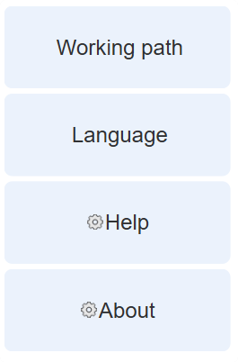
Figure 1: Main interface of AnyEIS

c) Help Documentation (Help)
• Feature Description: Built-in comprehensive user manual and operation guide.
• Instructions: Click this button to directly open the software's help documentation. The documentation covers full-process instructions from basic operations to advanced analysis, with illustrated examples. When users encounter confusion during data processing or chart plotting, they can quickly search for solutions through this feature without leaving the software environment to obtain technical support.
d) About Software (About)
• Feature Description: Displays software version information and copyright notices.
• Contents:
o Version Number: Shows the specific version of the currently installed software, allowing users to confirm whether an update is needed.
o Copyright Notice: Lists software copyright ownership and relevant legal statements.
o Contact Information: Provides contact channels for the development team or official website, facilitating users to report bugs or suggest improvements.

2.2.2 Appearance Settings
Offers light theme (bright and clear), dark theme (eye protection mode, reducing visual fatigue from prolonged use), and custom theme (optional, meeting personalized interface style needs). Users can flexibly choose according to scenarios or preferences to optimize visual experience.
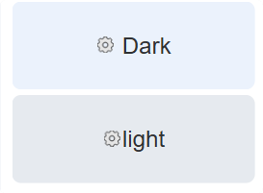
Figure 2 Appearance Settings

2.2.3 Data Path Management
a) Set Default Save/Open Location for Project Files
Through the "Data Paths" module, users can precisely configure default storage/read directories for three core data types:
Pending Data: Default storage path for data awaiting processing;
Reference Data: Default loading path for reference data;
Results Data: Default save path for analysis result data.
Clear path classification improves data management efficiency and prevents file confusion.
b) Chart Export Configuration
In the "Export Image" module, users can customize chart export formats (such as SVG vector graphics, compatible with professional typesetting tools) and resolution (DPI, default 100), ensuring exported charts meet clarity and compatibility requirements for different scenarios such as reports and papers.
c) User Preference Management
The "User Preferences" module supports exporting/importing preference settings: users can package current configurations (such as language, theme, paths, etc.) into configuration files for quick migration to other devices; they can also import configurations shared by others to achieve "one-click replication" of personalized environments, significantly simplifying configuration processes across multiple devices or users.
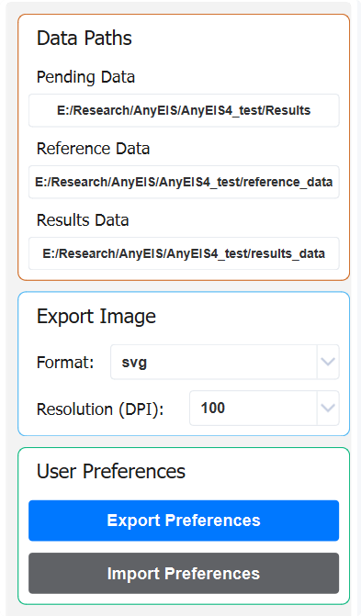
Figure 3 User Preference Management

Chapter 3 Plotting Module: Data Visualization

3.1 Overview of Module Functions
The plotting module, as shown in Figure 2, is the core interactive area for users to analyze EIS and DS experimental data. Users load experimental data files here and use its visualization capabilities for exploration and understanding. The core of this module is providing various standard chart types (such as Nyquist charts, Bode charts—modulus and phase, real part–imaginary part charts, etc.), enabling users to intuitively present raw or processed data. Users can deeply explore data details and identify features and patterns through interactive operations such as zooming and panning. This module supports data comparison, making it easier to verify the effectiveness of analysis steps. Ultimately, the generated clear and professional charts can be directly used for result presentation and reporting.

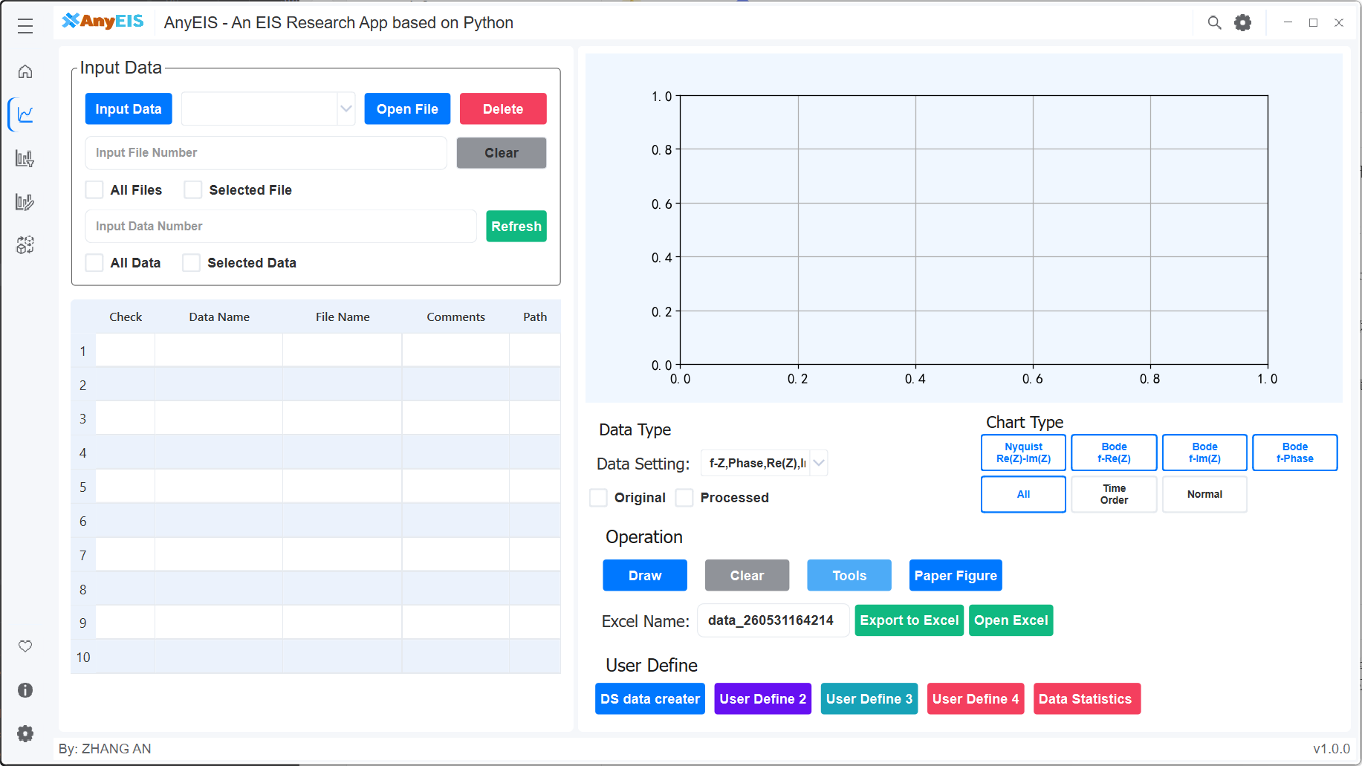
Figure 2 Interface of Plotting

3.1.1 Applicable Scenarios
The Plotting module, as shown in Figure 2, is the core interactive platform for users to analyze experimental data such as electrochemical impedance spectroscopy (EIS) or dielectric spectroscopy (DS). The core value of this module lies in its intuitive presentation and exploration capabilities, suitable for a variety of critical scenarios:
- Preliminary review and quality evaluation of experimental data: After loading raw data, users can immediately visualize it using various preset chart types such as Nyquist charts, Bode plots (analog values and phases), and real-part imaginary plots, quickly checking the overall trend, noise levels, outliers, and whether they meet the expected theoretical model (such as semicircles, lines, etc.), thereby making a preliminary judgment of experimental quality.
- In-depth exploration and pattern recognition: Users can interactively zoom and pan charts, focusing on specific frequency ranges or data regions to closely observe data details. By switching between different chart types (for example, observing the complex plane features of impedance on Nyquist plots, analyzing modulus decay and phase changes of frequency response on Bode plots), users can gain a more comprehensive understanding of the physicochemical processes contained in the data (such as charge transfer, diffusion, relaxation time distribution, etc.) and identify key features and potential patterns.
- Data comparison and verification before and after processing: After data preprocessing (such as smoothing, drift correction, outlier removal) or equivalent circuit fitting, users can visualize and overlay data before and after processing in the same chart or parallel chart.
- Result Display and Figure Generation: As the core display area, the module generates clear and professional charts (supporting annotations, legends, axis adjustments, etc.) that can be directly used in research reports, papers, presentations, or project documents to effectively convey experimental results and analytical conclusions to others.
- Teaching and Learning: For students or researchers learning EIS/DS principles and analytical methods, this module provides intuitive tools to help them connect abstract measurement data with theoretical models and physical phenomena, deepening their understanding.

3.1.2 Description of Interface Layout
The Plotting module is the core area for users to load, view, and analyze EIS or DS experimental data. The interface is clearly divided into left and right sections: the left side is the file management and data selection area, responsible for loading experimental data files and allowing users to select specific data points or channels; The right side is the data visualization and control area, dynamically displaying user-selected data (supporting various chart types such as Nyquist charts and Bode charts), and provides interactive tools such as zoom, panning, axis adjustment, and chart export functions, enabling users to intuitively and efficiently explore raw or processed data.

3.2 Data Loading and Basic Operations
Core features: Allows users to import and manage experimental data files, and may add comments, and select which data will be plotted.

3.2.1 File Operation Button Group
- Input Data button:
Function: This is the main entry point for importing files. Clicking this button opens a system file dialog that allows users to browse the local computer and upload one or more files containing EIS or DS experimental data. Supported file formats typically include common electrochemical data formats such as .txt, .csv, .xlsx, and .xls.

- Open File button:
Function: Clicking this button opens a system file dialog that allows users to open a file already existing in the software workspace or project. This is used for reloading data files that have been processed or saved before reloading.

- Delete File button:
Function: Removes selected data files from the software's current session or file list. This does not delete the original files on your computer's hard drive, but simply removes them from the current software interface and memory.
Figure 3 File Operation Button Group

3.2.2 File Selection Control Area
- All Files:
Function: Checking this option means selecting all currently loaded data files for drawing.

- Selected Files：
Function: Checking this option means selecting only specific files with the Selected checkbox clearly checked in the table below for drawing.

- File Number input:
Function: When the selection mode is Selected Files, this input box allows users to directly enter the numbers of one or more files (corresponding to row numbers or internal IDs in the table below) to quickly select specific files without manually checking them in the table. The input format may be a single number (e.g., 1), a comma-separated list (e.g., 1, 3, or a range (e.g., 1-3).

- Input Data Number:
Function: When the selection mode is Selected data, this input box allows users to directly enter the numbers of one or more files to quickly select specific data without manually checking them in the table. The input format may be a single number (e.g., 1), a comma-separated list (e.g., 1, 3, or a range (e.g., 1-3).

- All Data：
Function: Checking this option means selecting all currently loaded data for drawing.

- Selected Data:
Function: Checking this option means selecting only specific data with the Selected checkbox clearly checked in the table below for drawing.

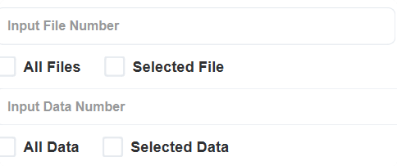
Figure 4 File Selection Control Area

3.2.3 Data File Information Table
Function: Lists all currently loaded data files and their key information in table form.

- Selected:
Function: When the user checks this line, it means selecting the file for drawing (effective when the top selection mode is Selected Files).

- Data Name:
Function: Displays the identifier or name of the dataset. This may be automatically generated by the software (such as based on file names) or user-defined (if the software supports renaming).

- Path:
Function: Displays the complete storage path of the data file on the computer.

- File Name:
Function: Displays the original name of the data file (with extension).

e) Comments:
Features: Allows users to add custom text annotations, labels, or metadata to the dataset (such as experimental conditions, sample numbers, notes, etc.). This is very useful for distinguishing and managing multiple similar datasets. Users can usually double-click within this cell to edit it.
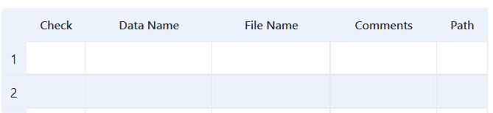
Figure 5 Data File Information Table

3.3 Data Visualization and Chart Configuration
Features: Displays user-selected EIS/DS data charts and provides tools to control chart display, interaction, and export.

3.3.1 Plotting Area
Function: This is the core visualization area of the interface. The initial state is blank. After selecting the data file and clicking the Draw button, the user's chosen EIS or DS data chart will be drawn here.
Display content: Depending on the data type and possible user configuration (possibly in the toolbar or settings), various standard graphs can be displayed:
EIS: Nyquist plot (-Z'' vs Z'), Bode plot (|Z| vs f, phase vs f), admittance plot, etc.
DS: Real part of complex permittivity (ε') vs frequency f, imaginary part of complex permittivity (ε'') vs frequency f, loss tangent (tan δ) vs frequency f, Cole-Cole plot (ε'' vs ε') and , etc.。
Features: Usually supports interactive operations such as zooming, panning, hovering data points to view values, legend display/hiding, etc.
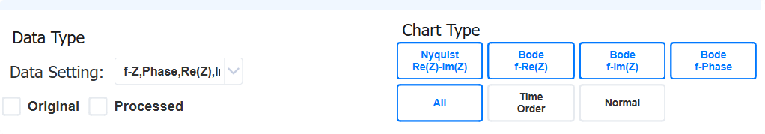
Figure 5 Plotting Area

3.3.2 Drawing Control Button Group
- Draw button:
Function: Core drawing command button. Based on the selected file (all files or selected files) in the left area and the current data type settings, generate or update the corresponding chart in the drawing area. If data or choices change, you need to click this button to refresh the view.

- Clear button:
Function: Clear all charts and graphic elements in the current drawing area to restore them to a blank state. This does not delete the file data loaded on the left side itself.

- Toolbar button：
Function: Clicking this button usually shows or hides a floating/embedded chart toolbar. This toolbar provides more precise control over drawing areas and typically includes:
        - Scaling: Rectangular zoom, X/Y axis zoom, restore original view.
        - Pan/Move: Drag the view.
        - Save Image: Save the current chart as an image file (PNG, JPG, SVG, PDF, etc.).
        - Copy image: Copy the chart to the clipboard.
        - Legend control: Show/hide legends, adjust their position.
        - Axis settings: adjust range, labels, scales, scale (linear/logarithmic).
        - Gridlines: Show/hide gridlines

- User Define 1, 2, 3, 4 button:
Features: These are reserved customizable function buttons. Software may allow users (or administrators/developers) to assign specific macros, scripts, or commonly used actions to these buttons. For example:
        - Quickly switch to a specific chart type (User Define 1 = Nyquist, User Define 2 = Bode Modulus)。
        - Apply preset chart styles/themes.
        - After performing specific data processing steps, the plot is drawn.
        - Call external scripts.
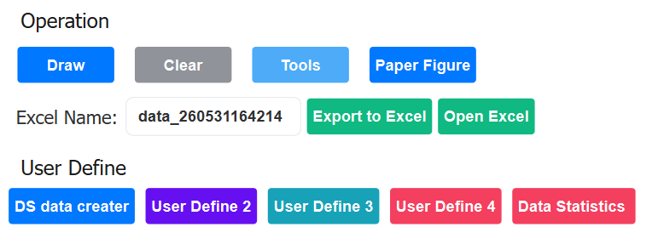
Figure 6 Drawing Control Button Group

3.4 Data export and sharing

3.4.1 Data Output Control Area
- Data type dropdown menu:
Function: Provides a dropdown list for users to select the type of data to export to Excel.
        - Origin Data: Exports the original experimental data loaded by the user via Input Data that has not been processed by the Processing module.
        - Processed Data: Export data processed by the Processing module (such as noise reduction, EIS->DS conversion).

- Excel Name Input Box:
Function: Allows users to specify a name for the Excel file they are about to export (excluding the .xlsx extension).

- Excel output button:
Function: Clicking this button will export and save the corresponding data as an Excel (.xlsx) file based on the user's selection (raw or processed data) from the data type dropdown menu and the selected file on the left (all files or selected files). The file will be saved to the user-specified location (usually a save dialog box will pop up).

3.5 Common Problems and Tips
The Plotting module interface focuses on "Select Data - > Draw Chart - > Export Data." Core process. The left area provides powerful file management and precise selection capabilities, while the right area is responsible for visually presenting selected data in rich chart form, along with plotting control, interaction, and export functions. Draw and Save to Excel are the key buttons connecting the left and right sides and triggering core operations. The Toolbar and User Define buttons enhance the interactivity and customizability of the charts. This layout clearly separates data input/selection from result output/control, enabling users to efficiently perform data visualization tasks.

Chapter 4 Processing: Data Processing

4.1 Overview of Module Functions
The Processing module is the core part for users to prepare and optimize experimental data for EIS and DS. Users perform preprocessing and transformation of the loaded experimental data here, laying the foundation for subsequent analysis and plotting. The core of this module is to provide data noise reduction functions, effectively reducing noise in experimental data by applying algorithms such as smoothing and filtering, significantly improving the signal-to-noise ratio and quality of the data. Users can eliminate disruptive factors through flexible preprocessing workflows, revealing the true characteristics and patterns within the data. This module typically supports data transformation operations, making the raw data better suited to specific analytical models or plotting requirements. Optimized high-quality data will significantly improve the reliability and accuracy of subsequent analysis steps.
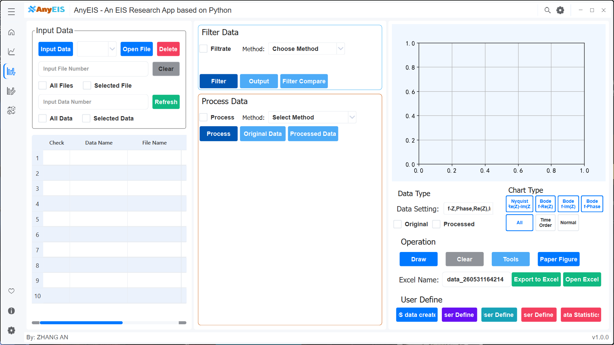
Figure 2 Processing interface

4.1.1 Applicable Scenarios
This module provides professional experimental data preprocessing capabilities suitable for the following key scenarios:
          - Raw data noise reduction and quality improvement: For noise introduced by instrument fluctuations or environmental interference in experiments such as EIS and DS, users can effectively suppress high-frequency noise or baseline drift through smoothing filtering (such as Savitzky-Golay), frequency-domain filtering (such as FFT filtering), or wavelet noise reduction techniques, significantly improving the data signal-to-noise ratio and providing a reliable data foundation for subsequent analysis.
          - Protection and enhancement of key features: During noise reduction, users need to finely adjust parameters (such as filter cutoff frequency, window size) to ensure core physicochemical features (like relaxation peaks in EIS and DS) are not excessively smoothed and weakened. This module supports real-time preview processing effects, helping users balance noise suppression with feature preservation.
          - Data format standardization and conversion: Users can perform unit conversions on raw data, coordinate transformations (such as logarithms of frequency log(f)), or data type reorganizations (such as extracting the real/imaginary parts of specific frequency intervals), so that the data format is uniformly adapted to subsequent analysis tools (such as equivalent circuit fitting and granularity distribution calculations).
          - Verification and optimization of preprocessing workflows: Users can overlay and compare data before and after processing for comparison visualization (such as comparing the semicircular shape before and after denoising in Nyquist charts), intuitively verifying whether denoising/conversion steps effectively correct outliers, eliminate baseline offsets, or introduce additional distortion, thereby iteratively optimizing processing parameters.
          - Batch preprocessing and process automation: For large amounts of repetitive datasets (such as time series measurements and multiple parallel experiments), users can define standardized processing flow templates (such as denoising first→ logarithmic conversion → final data clipping), enabling one-click batch processing, significantly improving data processing efficiency and consistency, and reducing manual errors.

4.1.2 Interface Layout Description
The Processing module is the core area for users to load, view, and analyze EIS or DS experimental data. The interface is clearly divided into left and right sections: the left side is the file management and data selection area, responsible for loading experimental data files and allowing users to select specific data points or channels; The right side is the data visualization and control area, dynamically displaying user-selected data (supporting various chart types such as Nyquist charts and Bode charts), and provides interactive tools such as zoom, panning, axis adjustment, and chart export functions, enabling users to intuitively and efficiently explore raw or processed data.

4.2 Data Loading and Basic Operations
Core features: Allows users to import and manage experimental data files, and may add comments), and select which data will be plotted.

4.2.1 File Operation Button Group
- Input Data button:
Function: This is the main entry point for importing files. Clicking this button opens a system file dialog that allows users to browse the local computer and upload one or more files containing EIS or DS experimental data. Supported file formats typically include common electrochemical data formats such as .txt, .csv, .xlsx, and .xls.

- Open File button:
Function: Clicking this button opens a system file dialog that allows users to open a file already existing in the software workspace or project. This is used for reloading data files that have been processed or saved before reloading.

- Delete File button:
Function: Removes selected data files from the software's current session or file list. This does not delete the original files on your computer's hard drive, but simply removes them from the current software interface and memory.
Figure 3 File Operation Button Group

4.2.2 File Selection Control Area
- All Files:
Function: Checking this option means selecting all currently loaded data files for drawing.

- Selected Files (选定文件)：
Function: Checking this option means selecting only specific files with the Selected checkbox clearly checked in the table below for drawing.

- File Number input:
Function: When the selection mode is Selected Files, this input box allows users to directly enter the numbers of one or more files (corresponding to row numbers or internal IDs in the table below) to quickly select specific files without manually checking them in the table. The input format may be a single number (e.g., 1), a comma-separated list (e.g., 1, 3, or a range (e.g., 1-3).

- Input Data Number:
Function: When the selection mode is Selected data, this input box allows users to directly enter the numbers of one or more files to quickly select specific data without manually checking them in the table. The input format may be a single number (e.g., 1), a comma-separated list (e.g., 1, 3, or a range (e.g., 1-3).

- All Data：
Function: Checking this option means selecting all currently loaded data for drawing.

- Selected Data:
Function: Checking this option means selecting only specific data with the Selected checkbox clearly checked in the table below for drawing.

Figure 4 File Selection Control Area

4.2.3 Data File Information Table
Function: Lists all currently loaded data files and their key information in table form.

- Selected:
Function: When the user checks this line, it means selecting the file for drawing (effective when the top selection mode is Selected Files).

- Data Name:
Function: Displays the identifier or name of the dataset. This may be automatically generated by the software (such as based on file names) or user-defined (if the software supports renaming).

- Path:
Function: Displays the complete storage path of the data file on the computer.

- File Name:
Function: Displays the original name of the data file (with extension).

e) Comments:
Features: Allows users to add custom text annotations, labels, or metadata to the dataset (such as experimental conditions, sample numbers, notes, etc.). This is very useful for distinguishing and managing multiple similar datasets. Users can usually double-click within this cell to edit it.
Figure 5 Data File Information Table

4.3 Data filtering
Preliminary noise filtering or smoothing is performed on selected raw data to improve data quality and prepare for more complex subsequent processing (such as conversion or the three-solution method).

4.3.1 Filter and select control zones
- Filter Method Selection：
Function: Provides a dropdown menu listing available data filtering or smoothing algorithms.
      - Common options may include:
        - Savitzky-Golay (Least Squares Polynomial Smoothing Filter): Performs a least squares polynomial fit within a local moving window and replaces the original data point with the fitted value. It effectively smooths noise while maximally preserving the original signal features, such as peak height and width.
        - Median: Replaces the current point with the median value of the data points within its neighboring window. It is highly effective at removing impulse noise (salt-and-pepper noise) and also maintains signal edges well.
        - Wiener (Wiener Filter - Adaptive Noise Reduction): An optimal filter based on the statistical properties of the signal and noise. It can adaptively adjust the filtering strength according to local signal characteristics to achieve the best noise reduction effect in the sense of minimizing the mean square error.
        - Butterworth: A filter designed in the frequency domain, renowned for its maximally flat magnitude frequency response in the passband. The low-pass type is used for smoothing and filtering out high-frequency noise; the high-pass type is used to extract rapid changes in the signal or for trend removal.
        - Cubic Spline: Approximates the data by fitting a piecewise cubic polynomial curve, which has continuous first and second derivatives at the connection points. This generates a very smooth curve that closely follows the data trend.
        - Arithmetic Average: Takes the direct arithmetic mean of a set of sampled values as the output. It is the most basic form of averaging filter, effective at suppressing periodic interference, but its smoothing speed and real-time performance are generally average.
        - Sliding Average: Forms a fixed-length queue with continuously sampled data. Each output is the arithmetic mean of this queue, where new data enters and the oldest data is removed. Suitable for smoothing real-time streaming data.
        - Median Average: First removes the maximum and minimum values (i.e., possible outliers) from the sampling window, then calculates the arithmetic mean of the remaining data. Combines certain resistance to impulse interference with smoothing effects.
        - Amplitude Limiting Average: Sets a reasonable amplitude variation limit. If the deviation between a new sample and the current valid value exceeds this limit, the sample is considered invalid and is replaced by the limit value for subsequent average calculation. Effective against large, sporadic impulse noise.
        - First Order Lag: Digitally implements the concept of a first-order inertial element (low-pass filter) from analog circuits. The output is a weighted sum of the current sample value and the last filtering result. Provides good smoothing for slowly changing signals.
        - Weighted Average: Assigns different weights (usually heavier for recent data) to samples at different times within the window, then performs a weighted average. By adjusting the weight distribution, the emphasis on new versus old data can be flexibly controlled.
        - Shake Off: Specifically designed to eliminate bounce or chatter in switch or digital signals. It confirms a valid signal by sampling continuously multiple times and judging if the state is stable, ensuring a stable, glitch-free output state.
        - Amplitude Limiting Shake Off: Adds amplitude limiting judgment to the shake-off logic. A state change is only confirmed when the signal change exceeds a set threshold and the state remains stable, resulting in stronger anti-interference capability.
        - (Possibly) User-Defined Filter.

- Parameters：
Function: Provides corresponding parameter input boxes based on the selected filtering method.

- Filter button:
Function: Core execution button. Based on the selected file, chosen filtering method, and parameters, the raw data is filtered and smoothed. The computed "filtered data" is usually stored internally and may trigger right-side chart updates (if configured as such) or provide new data sources for subsequent processing steps (such as "processing data" or plotting).

- Output button:
Function: Export the data processed by the filter operation (i.e., the filtered results) into the chart area on the right side and plot it (compare with the original data).

4.4 Data Processing
Perform core data transformations or specific analytical methods. This is a standard method in dielectric spectroscopy (DS) to eliminate electrode polarization effects. It calculates the complex dielectric constant of the sample itself by measuring the impedance of samples in three different concentrations of electrolytes.
- Process Method Selection:
The interface includes a drop-down menu that allows users to select from various processing algorithms, such as System Calibration (Open-Short-Load Three-Step Calibration), Dielectric Material Method (Dual-Reference Solution Dielectric Constant Calculation), Parallel Plate Capacitor (Parallel Plate Capacitance Method), RF Impedance Calibration (Transmission Line Impedance Calibration), RF Dielectric Calculation (Transmission Line Dielectric Constant Calculation), RF Impedance Calculation (Transmission Line Impedance Calculation), and Three-Solution Method (Three-Solution Reference Method), among others. The three-solution method is taken as an example for illustration.
This part of the function may be somewhat vague, such as recording or selecting data.
- Original Data input box: used to enter or automatically record the data of the original data measurement.
- Processed Data input box: used to enter or automatically record the current data of the three-solution method processing.
- Solution Configuration: The core part. Three types of electrolytes are defined by the three-solution method. Three independent solution option areas (usually labeled Solution 1, Solution 2, Solution 3).
- Reference Solution input box/selector: Specifies the reference data file corresponding to the solution. This should be the EIS data measured in the same sample at that specific concentration of electrolyte. Users need to specify the corresponding EIS data for each solution.
- Concentration input box: Enter the molar concentration (mol/L). The concentration should cover a range (usually low, medium, high).
- Temperature input box: Enter the temperature °C at the time of the EIS measurement. Temperature consistency is crucial for the accuracy of results.
- Open File button: Same function as before. Used to select and load the corresponding EIS data file for the solution. Clicking may bring up a file dialog where the user selects the EIS data file for the sample at the solution concentration. After loading, the file information should be associated with the solution configuration.
- Delete File button: Same function as before. Removes the EIS data file selected for this solution (do not delete the hard drive file).
- Process button:
Function: Core execution button. When all three solutions have correctly configured the corresponding EIS data files, concentration, and temperature, click this button. The software will perform the three-solution calculation method. The algorithm uses EIS data at three different concentrations (usually focusing on the low-frequency electrode-dominated impedance portion), mathematically eliminates electrode polarization contributions, and ultimately calculates the complex dielectric constant spectrum of the sample base material.
- Output button:
Function: Exports the complex dielectric spectrum data (DS data) calculated through Process operations (three-solution method).
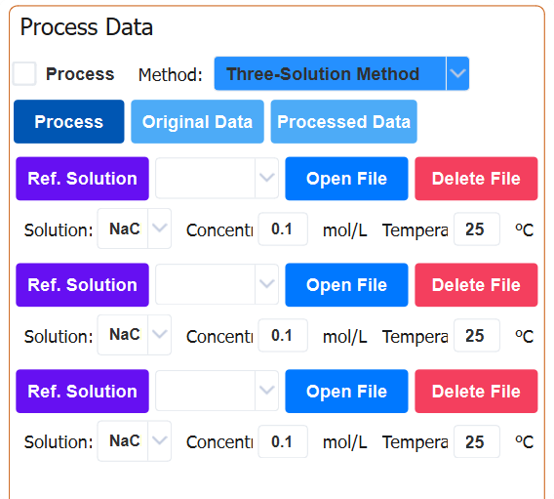
Figure 6 Data Processing

4.3 Data Visualization and Chart Configuration
Features: Displays user-selected EIS/DS data charts and provides tools to control chart display, interaction, and export.

4.3.1 Plotting Area
Function: This is the core visualization area of the interface. The initial state is blank. After selecting the data file and clicking the Draw button, the user's chosen EIS or DS data chart will be drawn here.
Display content: Depending on the data type and possible user configuration (possibly in the toolbar or settings), various standard graphs can be displayed:
EIS: Nyquist plot (-Z'' vs Z'), Bode plot (|Z| vs f, phase vs f), admittance plot, etc.
DS: Real part of complex permittivity (ε') vs frequency f, imaginary part of complex permittivity (ε'') vs frequency f, loss tangent (tan δ) vs frequency f, Cole-Cole plot (ε'' vs ε') and , etc.。
Features: Usually supports interactive operations such as zooming, panning, hovering data points to view values, legend display/hiding, etc.
Figure 5 Plotting Area

4.3.2 Drawing Control Button Group
- Draw button:
Function: Core drawing command button. Based on the selected file (all files or selected files) in the left area and the current data type settings, generate or update the corresponding chart in the drawing area. If data or choices change, you need to click this button to refresh the view.

- Clear button:
Function: Clear all charts and graphic elements in the current drawing area to restore them to a blank state. This does not delete the file data loaded on the left side itself.

- Toolbar button：
Function: Clicking this button usually shows or hides a floating/embedded chart toolbar. This toolbar provides more precise control over drawing areas and typically includes:
        - Scaling: Rectangular zoom, X/Y axis zoom, restore original view.
        - Pan/Move: Drag the view.
        - Save Image: Save the current chart as an image file (PNG, JPG, SVG, PDF, etc.).
        - Copy image: Copy the chart to the clipboard.
        - Legend control: Show/hide legends, adjust their position.
        - Axis settings: adjust range, labels, scales, scale (linear/logarithmic).
        - Gridlines: Show/hide gridlines

- User Define 1, 2, 3, 4 button:
Features: These are reserved customizable function buttons. Software may allow users (or administrators/developers) to assign specific macros, scripts, or commonly used actions to these buttons. For example:
        - Quickly switch to a specific chart type (User Define 1 = Nyquist, User Define 2 = Bode Modulus)。
        - Apply preset chart styles/themes.
        - After performing specific data processing steps, the plot is drawn.
        - Call external scripts.
Figure 6 Drawing Control Button Group

4.4 Data Export and Sharing

4.4.1 Data Output Control Area
- Data type dropdown menu:
Function: Provides a dropdown list for users to select the type of data to export to Excel.
        - Origin Data: Exports the original experimental data loaded by the user via Input Data that has not been processed by the Processing module.
        - Processed Data: Export data processed by the Processing module (such as noise reduction, EIS->DS conversion).

- Excel Name Input Box:
Function: Allows users to specify a name for the Excel file they are about to export (excluding the .xlsx extension).

- Excel Name Input Box:
Function: Clicking this button will export and save the corresponding data as an Excel (.xlsx) file based on the user's selection (raw or processed data) from the data type dropdown menu and the selected file on the left (all files or selected files). The file will be saved to the user-specified location (usually a save dialog box will pop up).

4.5 Common Questions and Tips
The Processing module interface focuses on "Select Data - >Filter data- > Processing data - > Draw Chart - > Export Data." Core process. The left area provides powerful file management and precise selection capabilities, The middle area is responsible for filtering or processing the data. while the right area is responsible for visually presenting selected data in rich chart form, along with plotting control, interaction, and export functions. Draw and Save to Excel are the key buttons connecting the left and right sides and triggering core operations. The Toolbar and User Define buttons enhance the interactivity and customizability of the charts. This layout clearly separates data input/selection from result output/control, enabling users to efficiently perform data visualization tasks.

Chapter 5 Simulation

5.1 Overview of Module Functions
The Simulation module is the core platform for users to conduct theoretical modeling of electrochemical impedance spectroscopy (EIS) or dielectric spectroscopy (DS). Users can conveniently generate simulation response curves based on preset physical models and parameters. The core of this module lies in providing robust theoretical model support, including classical EIS equivalent circuit models and dielectric relaxation models, thereby gaining insight into the electrical properties within materials. Users can understand the model's predictive behavior through simulation, pre-revise experimental results, or set an ideal initial reference curve for subsequent real-world data fitting. The generated simulation curves intuitively reflect the impact of parameter settings (such as resistance, capacitance, relaxation time, distribution parameters, etc.) on the spectrum characteristics.
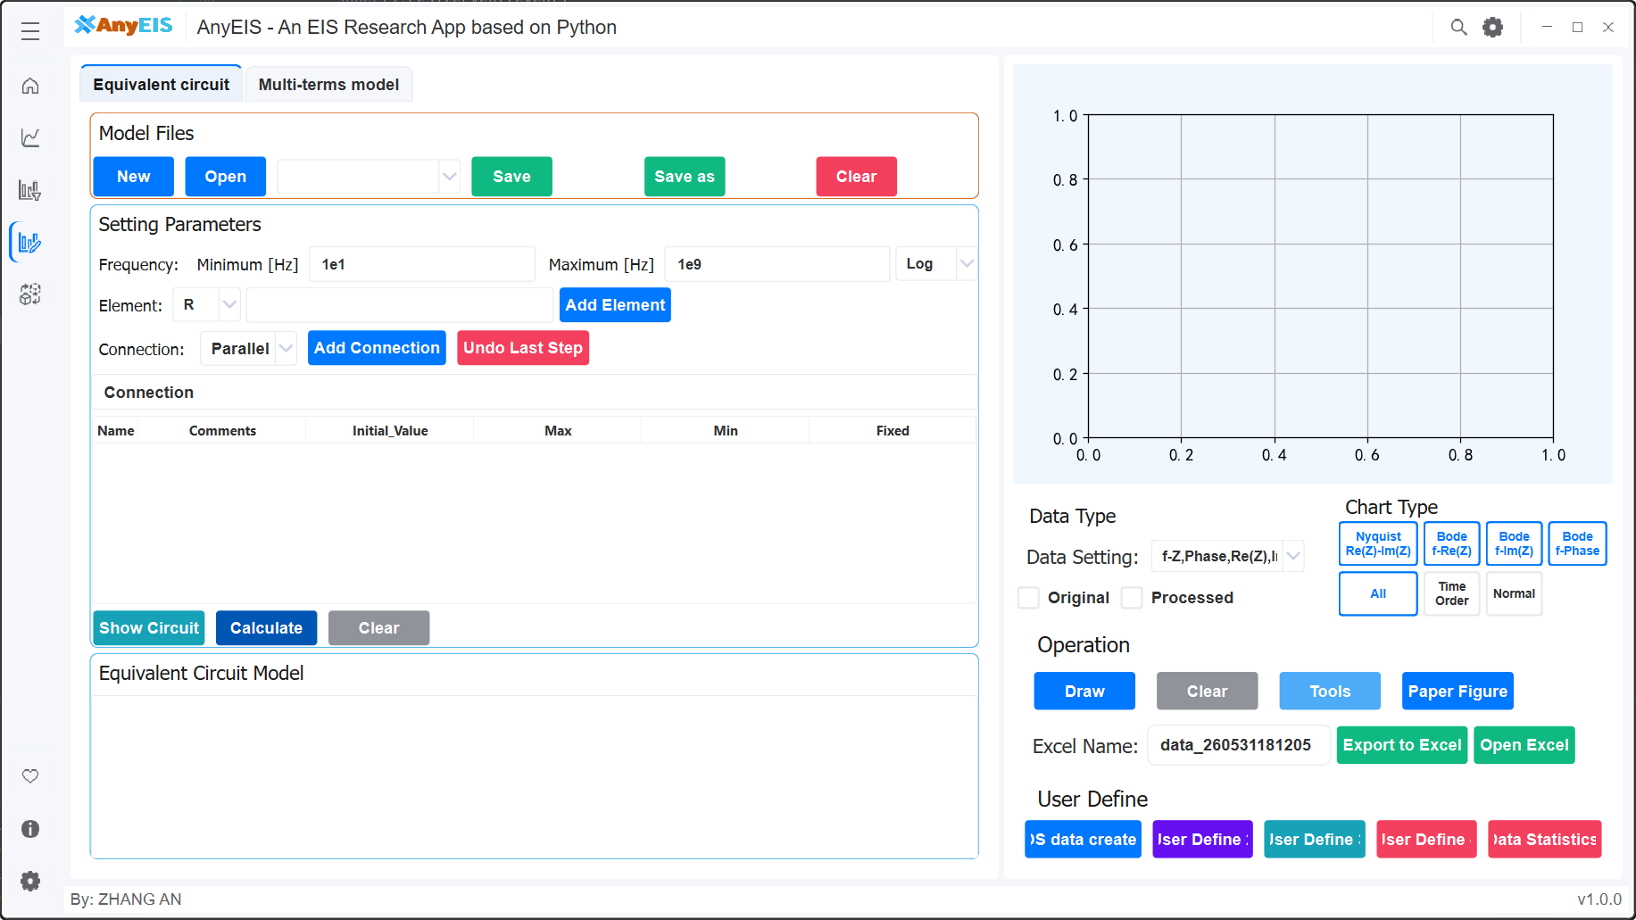
Figure 2 Simulation interface

5.1.1 Applicable Scenarios
The Simulation module (as shown in Figure 2) is the core interactive platform for users to analyze experimental data such as electrochemical impedance spectroscopy (EIS) or dynamic light scattering (DS). The core value of this module lies in its powerful intuitive presentation and exploration capabilities, suitable for a variety of critical scenarios:
- Theoretical model exploration and teaching assistance: Users can use this module to generate simulation curves based on equivalent circuits (such as R-CPE, Warburg) or dielectric relaxation models (such as Cole-Cole, Havriliak-Negami), intuitively demonstrating the impact of parameter changes on spectral features (such as relaxation peaks and phase angle inflections), accelerating understanding of complex electrochemistry/dielectric mechanics. Especially suitable for teaching demonstrations and theoretical validation.
- Pre-experiment prediction and scheme optimization: Rehearsing experimental results before actual measurements: By simulating the response of core-shell structures under specific parameters (interfacial capacitance, nuclear layer conductivity), or adjusting key variables such as relaxation time (τ) and distribution parameters (α), the optimal experimental conditions (such as frequency scanning range and measurement accuracy requirements) are used to help determine optimal experimental conditions (such as frequency scanning range and measurement accuracy requirements).
- Behavioral analysis of complex systems: provides theoretical references for multi-interface systems such as biological cells and composite materials; simulates the superposition effects of multiple relaxation processes (such as secondary relaxation peaks in dielectric spectra), distinguishes the contributions of different physical mechanisms (ionic polarization/interface polarization), and preliminarily identifies dominant controlling factors by comparing with experimental data.
- Initialization and validation of data fitting: generating high-precision theoretical curves as the "ideal frame of reference"; solving the problem of fitting divergence caused by noise interference in actual data, providing initial parameter benchmarks; By overlaying simulation and fitting results (such as dashed lines vs. solid lines), the reliability of the analysis process and model applicability were verified.

5.1.2 Interface Layout Description
The Simulation application interface is divided into left and right sections: the left side is the file and parameter settings area, where users can load and save model files, set frequency ranges and component parameters, manage connections, and operate on equivalent circuit models, dielectric models, spherical shell models, and more； On the right is the data visualization and control area, where users can dynamically view and analyze data. It supports various chart types, offers interactive tools such as zoom and panning, and allows exporting charts as Excel files. The entire interface design is simple and intuitive, making it easy for users to efficiently conduct EIS and DS studies.

5.2 Data Loading and Basic Operations
Core features: Allows users to import and manage experimental data files, and may add comments), and select the model category to fit.

5.2.1 Model Configuration
- Function: Select the base simulation model
- Options button:
a) Equivalent circuit model
    - Used for constructing circuit models (e.g., R-C parallel, Randle circuit, etc.)
    - Output: EIS spectra (Nyquist/Bode plots)
b) Multi-terms model (dielectric relaxation behavior model)
    - Used for simulating dielectric relaxation behavior (e.g., Debye, Cole-Cole models)
    - Output: DS spectra (ε' and ε'' frequency spectra)

5.2.2 File operation button group
- New button:
Function: Create a new model configuration file.

- Open button:
Function: Load a pre-saved model configuration file, automatically populating all parameters and circuit structure.

- Save button:
Function: Save the current model configuration (parameters + structure) as a file.
Save button:
- Save As button:
Function: Save the current model configuration (parameters + structure) as a file.
- Clear Model button
Function: Delete the current configuration file.

    - Setting Parameters
Function: Define the simulation scope and basic components
a) Equivalent circuit model
This module is used to define simulation parameters, build circuit topology, and execute the final impedance spectrum calculation.
1. Frequency Settings:
- Frequency Range Definition: Through the Minimum [Hz] and Maximum [Hz] input boxes, set the start and end frequency points for the simulation (e.g., 10^1 Hz to 10^9 Hz as shown in the figure).
- Distribution Type: The dropdown menu on the right (e.g., Log) is used to select the distribution mode for frequency sweep. Logarithmic scale is typically chosen to accommodate wideband simulation requirements, ensuring sufficient data point distribution in both low and high frequency bands.
2. Element & Connection Setup:
This area is the core interactive zone for circuit construction, supporting users to gradually build complex equivalent circuits.
- Element Addition:
  - Select Element: Choose basic circuit elements through the dropdown menu (e.g., R for resistor, or C, L, CPE, etc.).
  - Add Element: Click the button to add the selected element to the current editing list.
- Connection Logic:
  - Connection Method: Define the connection relationship between newly added elements and existing circuit parts through the dropdown menu. Parallel represents parallel connection, Series represents series connection option, "," indicates parallel relationship between the two elements before and after, and ")" indicates the end of parallel relationship.
  - Add Connection: Confirm and apply the above defined connection relationship to the circuit structure.
  - Undo Last Step: Provides undo function, allowing users to revert the previous operation and correct mistakenly added elements or wrong connections.
3. Parameter List and Management
The table area in the middle of the interface is used to manage the properties of all elements in the circuit in detail:
- Value Setting: Manually input Initial Value, or view the Fitted Value after fitting.
- Constraints: Set parameter boundaries through Max/Min, and lock specific parameters from fitting through the Fixed checkbox/
- Error Analysis: The Error [%] column displays the relative error of fitting results, assisting in evaluating model reliability.
4. Circuit Diagram Display Area
Displays the circuit topology in graphical form, intuitively presenting the symbolic connection relationships of resistors, capacitors, CPE (Constant Phase Element) and other elements, assisting users to quickly understand the circuit logic.
5. Bottom Functions
The bottom of the interface provides global operation buttons for visualization verification and core calculation:
- Show Circuit: Click to pop up or refresh the circuit diagram display area. Intuitively presents the current circuit topology in graphical form (symbolic connections of resistors, capacitors, etc.), helping users verify whether the built circuit logic is correct.
- Calculate: Start the simulation calculation engine. Generate impedance spectrum or dielectric spectrum data based on the set frequency range and circuit parameters.
- Clear: One-click clearing of all current settings, element lists and connection relationships, quickly resetting the entire working environment.
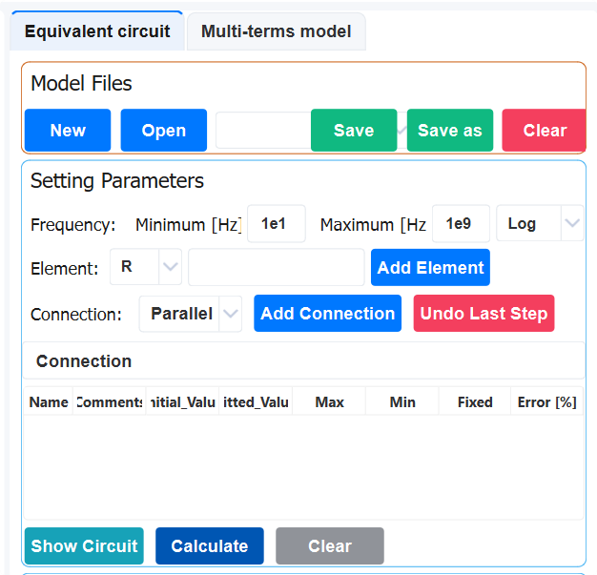

b) Multi-parameter/multi-shell models:
1. Frequency Settings
- Frequency Range Definition: Through the Minimum [Hz] and Maximum [Hz] input boxes, set the start and end frequency points for the simulation (e.g., in the figure, set from 10^1 Hz to 10^9 Hz).
- Distribution Type: The dropdown menu on the right (e.g., Log) is used to select the distribution mode for frequency sweeping. Logarithmic scale is typically chosen to accommodate wideband simulation requirements, ensuring sufficient data point distribution in both low and high frequency bands.

2. Advanced Physical Model Options
This area allows users to enable specific theoretical models or correction terms based on the actual physical properties of materials to improve simulation accuracy.
- Formalism (Formulation/Model Selection)
  - The dropdown menu is used to select the mathematical model describing dielectric response or impedance behavior.
  - When selecting Debye, Cole-Cole, or Havriliak-Negami models, the system will adopt the corresponding relaxation equations to fit or simulate data, corresponding to different assumptions of relaxation time distribution.
- Polarization
  - The checkbox is used to enable or disable polarization-related calculations.
When checked, the simulation will consider the effects of electrode polarization or interfacial polarization on the total impedance/dielectric spectrum, typically used to simulate non-ideal capacitive behavior or space charge accumulation effects appearing in the low-frequency range.
- DC Conductivity
  - The checkbox is used to introduce a DC conduction term into the model.
  - When checked, the system will add a pure resistance component in parallel to the equivalent circuit (or directly add a σ_dc/jωε_0 term to the formula), used to simulate leakage current or ionic conduction behavior of materials at the low-frequency limit, which is crucial for analyzing high-loss materials.

3. Component Operation Buttons
- Name: Can add names to Debye, Cole-Cole, Havriliak-Negami formula units.
- Add Term: Adds the selected Debye, Cole-Cole, Havriliak-Negami formula unit to the current model.
- Delete Element: Deletes the selected formula unit in the circuit.

4. Parameter Editing Table
In the table editing window, modify the core properties of components (such as resistance values, CPE exponent n values, capacitance values, etc.).
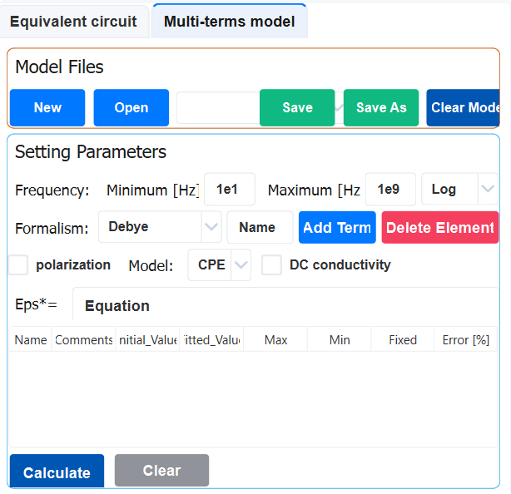

c) Core calculation button:
  - Simulate
    - Generate EIS/DS curves based on the current configuration
    - The results are displayed in real time in the chart area on the right
  - Calculate Parameters
    - Fit the simulation curve with the experimental data (data must be imported)
    - Output: R, C, t, α and other physical parameter values

5.3 Data Visualization and Chart Configuration
Features: Displays user-selected EIS/DS data charts and provides tools to control chart display, interaction, and export.

5.3.1 Plotting Area
Function: This is the core visualization area of the interface. The initial state is blank. After selecting the data file and clicking the Draw button, the user's chosen EIS or DS data chart will be drawn here.
Display content: Depending on the data type and possible user configuration (possibly in the toolbar or settings), various standard graphs can be displayed:
EIS: Nyquist plot (-Z'' vs Z'), Bode plot (|Z| vs f, phase vs f), admittance plot, etc.
DS: Real part of complex permittivity (ε') vs frequency f, imaginary part of complex permittivity (ε'') vs frequency f, loss tangent (tan δ) vs frequency f, Cole-Cole plot (ε'' vs ε') and , etc.。
Features: Usually supports interactive operations such as zooming, panning, hovering data points to view values, legend display/hiding, etc.
Figure 5 Plotting Area

5.3.2 Drawing Control Button Group
- Draw button:
Function: Core drawing command button. Based on the selected file (all files or selected files) in the left area and the current data type settings, generate or update the corresponding chart in the drawing area. If data or choices change, you need to click this button to refresh the view.

- Clear button:
Function: Clear all charts and graphic elements in the current drawing area to restore them to a blank state. This does not delete the file data loaded on the left side itself.

- Toolbar button：
Function: Clicking this button usually shows or hides a floating/embedded chart toolbar. This toolbar provides more precise control over drawing areas and typically includes:
        - Scaling: Rectangular zoom, X/Y axis zoom, restore original view.
        - Pan/Move: Drag the view.
        - Save Image: Save the current chart as an image file (PNG, JPG, SVG, PDF, etc.).
        - Copy image: Copy the chart to the clipboard.
        - Legend control: Show/hide legends, adjust their position.
        - Axis settings: adjust range, labels, scales, scale (linear/logarithmic).
        - Gridlines: Show/hide gridlines

- User Define 1, 2, 3, 4 button:
Features: These are reserved customizable function buttons. Software may allow users (or administrators/developers) to assign specific macros, scripts, or commonly used actions to these buttons. For example:
        - Quickly switch to a specific chart type (User Define 1 = Nyquist, User Define 2 = Bode Modulus)。
        - Apply preset chart styles/themes.
        - After performing specific data processing steps, the plot is drawn.
        - Call external scripts.
Figure 6 Drawing Control Button Group

5.4 Data Export and Sharing

5.4.1 Data Output Control Area
- Data type dropdown menu:
Function: Provides a dropdown list for users to select the type of data to export to Excel.
        - Origin Data: Exports the original experimental data loaded by the user via Input Data that has not been processed by the Processing module.
        - Processed Data: Export data processed by the Processing module (such as noise reduction, EIS->DS conversion).

- Excel Name Input Box:
Function: Allows users to specify a name for the Excel file they are about to export (excluding the .xlsx extension).

- Excel Name Input Box:
Function: Clicking this button will export and save the corresponding data as an Excel (.xlsx) file based on the user's selection (raw or processed data) from the data type dropdown menu and the selected file on the left (all files or selected files). The file will be saved to the user-specified location (usually a save dialog box will pop up).

5.5 Common Issues and Tips
The Simulation module interface focuses on "Select Data - > Draw Chart - > Export Data." Core process. The left area provides powerful file management and precise selection capabilities, while the right area is responsible for visually presenting selected data in rich chart form, along with plotting control, interaction, and export functions. Draw and Save to Excel are the key buttons connecting the left and right sides and triggering core operations. The Toolbar and User Define buttons enhance the interactivity and customizability of the charts. This layout clearly separates data input/selection from result output/control, enabling users to efficiently perform data visualization tasks.

Chapter 6 Fitting Data

6.1 Overview of Module Functions
The Fitting module serves as the core part of experimental data analysis. Users can fit measurement data from the Plotting or Processing modules into various theoretical models (including EIS equivalent circuits and dielectric relaxation models such as Debye, Cole-Cole, Cole-Davidson), and achieve precise parameter extraction through mathematical optimization algorithms to minimize differences between model predictions and experimental data. This module provides model library calls, automatic parameter tuning, statistical indicator evaluation (such as χ², R², residual analysis), and multi-model comparison functions. It supports visual overlay of fitted curves with raw data, enabling users to intuitively verify model applicability. Its output (optimized parameters, fitted equations, and professional charts) is directly related to physical mechanisms, thereby converting raw data into quantitative physical explanations and providing key theoretical support for electrochemical or dielectric system mechanism research. In short, the Fitting module bridges data and models through rigorous mathematical optimization, driving deep scientific analysis.

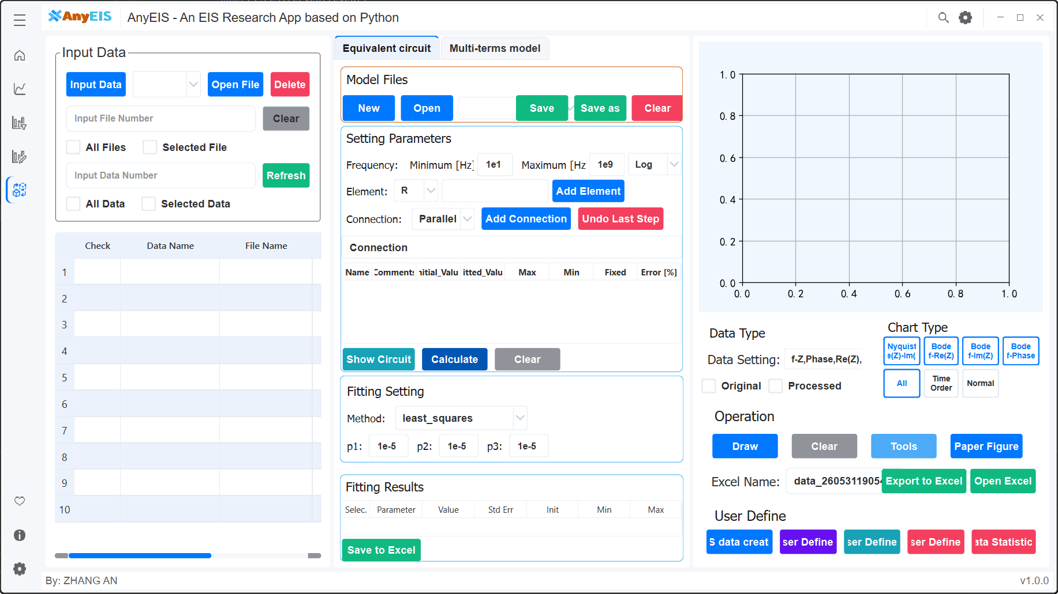
Figure 2 Fitting interface

6.1.1 Applicable Scenarios
The Fitting (Data Visualization) module (as shown in Figure 2) is the core interactive platform for users to analyze experimental data such as electrochemical impedance spectroscopy (EIS) or dynamic light scattering (DS). The core value of this module lies in its powerful intuitive presentation and exploration capabilities, suitable for a variety of critical scenarios:
- Precise extraction of electrochemical/dielectric parameters: The core value of this scenario lies in decoding the physical meaning of experimental data. Users can call built-in model libraries (such as EIS equivalent circuits, Cole-Cole dielectric models) to fit measured data (impedance spectra, dielectric spectra) from the Plotting or Processing modules into selected theoretical equations, and automatically tune parameters using mathematical optimization algorithms (such as least squares). Minimizing the difference between model predictions and measured values, optimizing the estimation and confidence intervals of key physical quantities such as final output resistance, capacitance, relaxation time (τ), and distribution parameters (α/β), thereby providing a quantitative physical basis for analyzing interfacial reaction kinetics, ion transport behavior, or molecular relaxation mechanisms.
- Objective verification and optimization of model applicability: This scenario aims to solve scientific decision-making problems under multi-model competition. When multiple candidate theoretical models exist (such as different equivalent circuit topologies or relaxation equations), users can use the module's multi-model comparison function to fit the same dataset in parallel to different models, quantitatively evaluate fit goodness using statistical indicators (χ², R², residual distribution), and intuitively identify system biases by visualizing the fitting curve with the original data; This process effectively excludes unsuitable models, filters out the theoretical framework closest to the physical essence, and provides reliable model support for mechanistic research.
- Mechanism identification of dominant mechanisms in complex systems: This scenario focuses on analyzing the contribution weight of multi-physical process coupling. For multi-interface/multi-relaxation systems such as biological cells and composite materials, users fit composite models containing multiple relaxation terms (such as multiple Cole-Colle term superpositions in dielectric spectra) to quantify characteristic parameters (relaxation intensity Δε, relaxation time τ) and their distribution characteristics by fitting composite models containing multiple relaxation terms (such as multiple Cole-Colle term superpositions in dielectric spectra). By analyzing parameter significance and correlation, dominant factors and secondary effects can be distinguished, revealing the controlling physical mechanisms of dynamic responses in complex systems.

6.1.2 Interface Layout Description
The interface layout in the Fitting (Data Visualization) module diagram is divided into left, center, and right sections, aiming to provide users with a comprehensive EIS (Electrochemical Impedance Spectrometry) research environment. The left section is used for model files and parameter settings, including file operations, parameter settings, and basic circuit model display. The middle section integrates input data management, chart display, fitting result viewing, and data export functions. Users can select data and dynamically display it through the chart area, while also supporting exporting data to Excel. The right section focuses on fitting settings, allowing users to select fitting methods and set related parameters. The entire design enables users to intuitively and efficiently explore and analyze EIS data.

6.2 Data Loading and Basic Operations
Core features: Allows users to import and manage experimental data files, and may add comments), and select which data will be plotted.

6.2.1 File Operation Button Group
- Input Data button:
Function: This is the main entry point for importing files. Clicking this button opens a system file dialog that allows users to browse the local computer and upload one or more files containing EIS or DS experimental data. Supported file formats typically include common electrochemical data formats such as .txt, .csv, .xlsx, and .xls.

- Open File button:
Function: Clicking this button opens a system file dialog that allows users to open a file already existing in the software workspace or project. This is usually used for reloading data files that have been processed or saved before reloading (if the software has project or session management). It may focus more on accessing datasets managed within the software than Input Data.

- Delete File button:
Function: Removes selected data files from the software's current session or file list. This usually does not delete the original files on your computer's hard drive, but simply removes them from the current software interface and memory.

6.2.2 File Selection Control Area
- All Files:
Function: Checking this option means selecting all currently loaded data files for drawing.

- Selected Files：
Function: Checking this option means selecting only specific files with the Selected checkbox clearly checked in the table below for drawing.

- File Number input box:
Function: When the selection mode is Selected Files, this input box allows users to directly enter the numbers of one or more files (corresponding to row numbers or internal IDs in the table below) to quickly select specific files without manually checking them in the table. The input format may be a single number (e.g., 1), a comma-separated list (e.g., 1, 3, or a range (e.g., 1-3)'.

6.2.3 Data File Information Table
Function: Lists all currently loaded data files and their key information in table form.

- Selected: A checkbox:
Function: When the user checks this line, it means selecting the file for drawing (effective when the top selection mode is Selected Files).

- Data Name:
Function: Displays the identifier or name of the dataset. This may be automatically generated by the software (such as based on file names) or user-defined (if the software supports renaming).

- Path:
Function: Displays the complete storage path of the data file on the computer.

- File Name :
Function: Displays the original name of the data file (with extension).

e) Comments (路径):
Features:Allows users to add custom text annotations, labels, or metadata to the dataset (such as experimental conditions, sample numbers, notes, etc.). This is very useful for distinguishing and managing multiple similar datasets. Users can usually double-click within this cell to edit it.
图5 Data File Information Table

6.3 Data Entry and Analysis
Function: Define the simulation scope and basic components
a) Equivalent circuit model
This module is used to define simulation parameters, build circuit topology, and execute the final impedance spectrum calculation.
1. Frequency Settings:
- Frequency Range Definition: Through the Minimum [Hz] and Maximum [Hz] input boxes, set the start and end frequency points for the simulation (e.g., 10^1 Hz to 10^9 Hz as shown in the figure).
- Distribution Type: The dropdown menu on the right (e.g., Log) is used to select the distribution mode for frequency sweep. Logarithmic scale is typically chosen to accommodate wideband simulation requirements, ensuring sufficient data point distribution in both low and high frequency bands.
2. Element & Connection Setup:
This area is the core interactive zone for circuit construction, supporting users to gradually build complex equivalent circuits.
- Element Addition:
  - Select Element: Choose basic circuit elements through the dropdown menu (e.g., R for resistor, or C, L, CPE, etc.).
  - Add Element: Click the button to add the selected element to the current editing list.
- Connection Logic:
  - Connection Method: Define the connection relationship between newly added elements and existing circuit parts through the dropdown menu. Parallel represents parallel connection, Series represents series connection option, "," indicates parallel relationship between the two elements before and after, and ")" indicates the end of parallel relationship.
  - Add Connection: Confirm and apply the above defined connection relationship to the circuit structure.
  - Undo Last Step: Provides undo function, allowing users to revert the previous operation and correct mistakenly added elements or wrong connections.
3. Parameter List and Management
The table area in the middle of the interface is used to manage the properties of all elements in the circuit in detail:
- Value Setting: Manually input Initial Value, or view the Fitted Value after fitting.
- Constraints: Set parameter boundaries through Max/Min, and lock specific parameters from fitting through the Fixed checkbox/
- Error Analysis: The Error [%] column displays the relative error of fitting results, assisting in evaluating model reliability.
4. Circuit Diagram Display Area
Displays the circuit topology in graphical form, intuitively presenting the symbolic connection relationships of resistors, capacitors, CPE (Constant Phase Element) and other elements, assisting users to quickly understand the circuit logic.
图5 Data File Information Table

5. Bottom Functions
The bottom of the interface provides global operation buttons for visualization verification and core calculation:
- Show Circuit: Click to pop up or refresh the circuit diagram display area. Intuitively presents the current circuit topology in graphical form (symbolic connections of resistors, capacitors, etc.), helping users verify whether the built circuit logic is correct.
- Calculate: Start the simulation calculation engine. Generate impedance spectrum or dielectric spectrum data based on the set frequency range and circuit parameters.
- Clear: One-click clearing of all current settings, element lists and connection relationships, quickly resetting the entire working environment.

b) Multi-parameter/multi-shell models:
1. Frequency Settings
- Frequency Range Definition: Through the Minimum [Hz] and Maximum [Hz] input boxes, set the start and end frequency points for the simulation (e.g., in the figure, set from 10^1 Hz to 10^9 Hz).
- Distribution Type: The dropdown menu on the right (e.g., Log) is used to select the distribution mode for frequency sweeping. Logarithmic scale is typically chosen to accommodate wideband simulation requirements, ensuring sufficient data point distribution in both low and high frequency bands.

2. Advanced Physical Model Options
This area allows users to enable specific theoretical models or correction terms based on the actual physical properties of materials to improve simulation accuracy.
- Formalism (Formulation/Model Selection)
  - The dropdown menu is used to select the mathematical model describing dielectric response or impedance behavior.
  - When selecting Debye, Cole-Cole, or Havriliak-Negami models, the system will adopt the corresponding relaxation equations to fit or simulate data, corresponding to different assumptions of relaxation time distribution.
- Polarization
  - The checkbox is used to enable or disable polarization-related calculations.
When checked, the simulation will consider the effects of electrode polarization or interfacial polarization on the total impedance/dielectric spectrum, typically used to simulate non-ideal capacitive behavior or space charge accumulation effects appearing in the low-frequency range.
- DC Conductivity
  - The checkbox is used to introduce a DC conduction term into the model.
  - When checked, the system will add a pure resistance component in parallel to the equivalent circuit (or directly add a σ_dc/jωε_0 term to the formula), used to simulate leakage current or ionic conduction behavior of materials at the low-frequency limit, which is crucial for analyzing high-loss materials.

3. Component Operation Buttons
- Name: Can add names to Debye, Cole-Cole, Havriliak-Negami formula units.
- Add Term: Adds the selected Debye, Cole-Cole, Havriliak-Negami formula unit to the current model.
- Delete Element: Deletes the selected formula unit in the circuit.

4. Parameter Editing Table
In the table editing window, modify the core properties of components (such as resistance values, CPE exponent n values, capacitance values, etc.).
图5 Data File Information Table

c) Core calculation button:
  - Simulate
    - Generate EIS/DS curves based on the current configuration
    - The results are displayed in real time in the chart area on the right
  - Calculate Parameters
    - Fit the simulation curve with the experimental data (data must be imported)
    - Output: R, C, t, α and other physical parameter values

6.4 Data Visualization and Chart Configuration
Features: Displays user-selected EIS/DS data charts and provides tools to control chart display, interaction, and export.

6.4.1 Plotting Area
Function: This is the core visualization area of the interface. The initial state is blank. After selecting the data file and clicking the Draw button, the user's chosen EIS or DS data chart will be drawn here.
Display content: Depending on the data type and possible user configuration (possibly in the toolbar or settings), various standard graphs can be displayed:
EIS: Nyquist plot (-Z'' vs Z'), Bode plot (|Z| vs f, phase vs f), admittance plot, etc.
DS: Real part of complex permittivity (ε') vs frequency f, imaginary part of complex permittivity (ε'') vs frequency f, loss tangent (tan δ) vs frequency f, Cole-Cole plot (ε'' vs ε') and , etc.。
Features: Usually supports interactive operations such as zooming, panning, hovering data points to view values, legend display/hiding, etc.
Figure 5 Plotting Area

6.4.2 Drawing Control Button Group
- Draw button:
Function: Core drawing command button. Based on the selected file (all files or selected files) in the left area and the current data type settings, generate or update the corresponding chart in the drawing area. If data or choices change, you need to click this button to refresh the view.

- Clear button:
Function: Clear all charts and graphic elements in the current drawing area to restore them to a blank state. This does not delete the file data loaded on the left side itself.

- Toolbar button：
Function: Clicking this button usually shows or hides a floating/embedded chart toolbar. This toolbar provides more precise control over drawing areas and typically includes:
        - Scaling: Rectangular zoom, X/Y axis zoom, restore original view.
        - Pan/Move: Drag the view.
        - Save Image: Save the current chart as an image file (PNG, JPG, SVG, PDF, etc.).
        - Copy image: Copy the chart to the clipboard.
        - Legend control: Show/hide legends, adjust their position.
        - Axis settings: adjust range, labels, scales, scale (linear/logarithmic).
        - Gridlines: Show/hide gridlines

- User Define 1, 2, 3, 4 button:
Features: These are reserved customizable function buttons. Software may allow users (or administrators/developers) to assign specific macros, scripts, or commonly used actions to these buttons. For example:
        - Quickly switch to a specific chart type (User Define 1 = Nyquist, User Define 2 = Bode Modulus)。
        - Apply preset chart styles/themes.
        - After performing specific data processing steps, the plot is drawn.
        - Call external scripts.
Figure 6 Drawing Control Button Group

6.5 Algorithm Configuration
Fit algorithm configuration
a) Algorithm Selector: The dropdown menu contains:
- least_squares - Least Squares Method
- nelder - Nelder-Mead Method
- lbfgsb - L-BFGS-B Algorithm
- differential_evolution - Differential Evolution Algorithm
- basinhopping - Basin-Hopping Algorithm
- powell - Powell's Method
- cg - Conjugate Gradient Method
- dual_annealing - Dual Annealing Algorithm
- bfgs - BFGS Algorithm
- ampgo - Adaptive Memory Programming for Global Optimization
The above algorithms come from lmfit and scipy, for specific explanations refer to the relevant help documentation
b) Parameter Settings:
Parameter settings refer to the relevant help documentation of lmfit and scipy

6.6 Data Export and Sharing

6.6.1 Data Output Control Area
- Data type dropdown menu:
Function: Provides a dropdown list for users to select the type of data to export to Excel.
        - Origin Data: Exports the original experimental data loaded by the user via Input Data that has not been processed by the Processing module.
        - Processed Data: Export data processed by the Processing module (such as noise reduction, EIS->DS conversion).

- Excel Name Input Box:
Function: Allows users to specify a name for the Excel file they are about to export (excluding the .xlsx extension).

- Excel Name Input Box:
Function: Clicking this button will export and save the corresponding data as an Excel (.xlsx) file based on the user's selection (raw or processed data) from the data type dropdown menu and the selected file on the left (all files or selected files). The file will be saved to the user-specified location (usually a save dialog box will pop up).

6.7 Common Questions and Tips
Core operational process
- Model Selection → 2 Import Data → 3 Build the model / set initial values → 4 Configuration algorithm → 5 Execution Fitting → 6 Key techniques for verifying exports
:
- Using Simulate pre-generated curves, the initial values are adjusted to approximate experimental data
- When residual diagrams show regular deviations, it indicates incorrect model selection
- Multi-shell models must ensure that core-shell parameters have clear physical significance
- Using genetic algorithms to avoid local optimals
Design advantages: Achieves a full-process closed-loop process of "data import→model construction→ parameter optimization→ and result verification," significantly improving efficiency in scenarios such as battery impedance analysis and dielectric property studies of biological cells.

Chapter 7 Principles of Mathematics and Physics
Introduces the relevant theoretical knowledge used in AnyEIS software, including mathematics, physics, electrochemistry, impedance spectroscopy, and dielectric spectroscopy.

7.1 EIS
Electrochemical Impedance Spectroscopy (EIS) is an important electrochemical testing technique that applies a small-amplitude sinusoidal wave potential (or current) perturbation to an electrochemical system, measures the system’s response, and thus obtains the impedance variation with frequency.
**Basic Principle - Apply a small-amplitude sinusoidal potential signal:
$$E(t)=E_{dc}+E_{ac}sin(ωt)$$
- Measure the corresponding current response:
$$I(t)=I_{dc}+I_{ac}sin(ωt-ϕ)$$
- Impedance is defined as a complex number:
$$Z(ω)=\frac{E_{ac}}{I_{ac}}e^{jϕ}=Z^{'}(ω)+jZ^{″}(ω)$$
where $ω=2πf$ is the angular frequency and $ϕ$ is the phase difference.
Main Applications:
- Corrosion mechanism research
- Battery performance evaluation
- Coating protective performance assessment
- Electrode process kinetics analysis
- Qualitative and quantitative substance analysis
Common Equivalent Circuit Elements:
- Resistor (R): represents ohmic impedance, impedance value is $Z_{R}=R$
- Capacitor (C): represents double-layer capacitance, impedance value is $Z_{C}=\frac{1}{jωC}$
- Inductor (L): represents inductive effect, impedance value is $Z_{L}=jωL$
- Constant Phase Element (CPE): represents non-ideal capacitance behavior, impedance value is $Z_{\text{CPE}}=\frac{1}{Q(jω)^{n}}$
- Warburg Element (W): represents diffusion impedance, impedance value is $Z_{W}=σ(1-j)ω^{-1/2}$
Typical Equivalent Circuit Models:
- Randles Circuit (with inductance correction):
$$Z=R_{s}+\frac{1}{\frac{1}{R_{ct}}+jωC_{dl}}$$
- Randles Circuit with Warburg Diffusion:
$$Z=R_{s}+\frac{1}{\frac{1}{R_{ct}}+jωC_{dl}+\frac{1}{Z_{W}}}$$
- Three-layer Parallel Model (commonly used for coating systems):
$$Z=R_{s}+{\left[\frac{1}{R_{pore}}+Z_{CPE}^{-1}+{\left(\frac{1}{R_{coat}}+Z_{tot}\right)}^{-1}\right]}^{-1}$$

7.2 DS
Dielectric Spectroscopy (DS) is a spectroscopic method for studying the dielectric properties of materials. By measuring the polarization response of materials under an electric field, it obtains the variation of dielectric constant and loss factor with frequency.
Basic Principle:
- Complex dielectric constant:
$$ε^{*}(ω)=ε^{'}(ω)-jε^{″}(ω)$$
- $ε^{'}$: stored energy (polarization capability)
- $ε^{″}$: loss energy (energy dissipation)
- Loss tangent:
$$tanδ(ω)=\frac{ε^{″}(ω)}{ε^{'}(ω)}$$
Main Applications:
- Polymer material molecular motion research
- Biological cell dielectric property analysis
- Food quality detection
- Ceramic material characterization
- Solution molecular interaction research
Relaxation Mechanisms:
- Electronic polarization (GHz~THz)
- Atomic/ionic polarization (MHz~GHz)
- Orientation polarization (Hz~MHz)
- Interfacial polarization (mHz~Hz)

7.3 Graphical Representation of Impedance Data
Impedance data is commonly represented in two graphical forms for intuitive analysis of electrochemical system characteristics.
Nyquist Plot:
Plot the real part $-Z^{'}(ω)$ of impedance on the horizontal axis and the imaginary part $Z^{″}(ω)$ on the vertical axis (or $-Z^{″}$), and draw the curve varying with frequency. From high frequency to low frequency, it usually presents characteristic semicircular arcs and straight line segments:
$$Z_{w}(ω)=σ(1-j)ω^{-1/2}=σω^{-1/2}-jσω^{-1/2}$$
The diameter of the high-frequency arc corresponds to the charge transfer resistance $R_{ct}$, and the intersection of the arc with the horizontal axis corresponds to the solution resistance $R_{s}$; the straight line in the low-frequency region corresponds to the diffusion characteristic of Warburg impedance.
Bode Plot:
Plot the logarithm of frequency $logf$ on the horizontal axis, and separately plot the impedance magnitude $|Z|$ and phase angle $ϕ$:
$$|Z(ω)|=\sqrt{Z^{'}(ω)^{2}+Z^{″}(ω)^{2}}$$
$$ϕ(ω)=arctan\left(\frac{Z^{″}(ω)}{Z^{'}(ω)}\right)$$
In the Bode plot, plateau areas or peaks correspond to specific relaxation processes, facilitating the identification of time constants.
Cole-Cole Plot (in Dielectric Spectroscopy):
Plot dielectric loss $ε^{″}$ on the vertical axis and stored dielectric constant $ε^{'}$ on the horizontal axis to draw a semicircle (Debye type) or flattened/stretched arc (Cole-Cole type, Havriliak-Negami type), which can be used to intuitively judge the nature of relaxation time distribution.

7.4 Dielectric Spectroscopy Models
Dielectric spectroscopy models are used to describe the relationship between material dielectric response and frequency changes. Common models include the Debye model, Cole-Cole model, Cole-Davidson model, and Havriliak-Negami model.
7.4.1 Debye Model
The simplest relaxation model, assuming a single relaxation time:
$$ε^{*}(ω)=ε_{∞}+\frac{ε_{s}-ε_{∞}}{1+jωτ}$$
where:
- $ε_{s}$: static dielectric constant (low frequency)
- $ε_{∞}$: high-frequency dielectric constant
- $τ$: relaxation time
7.4.2 Cole-Cole Model
Considering relaxation time distribution:
$$ε^{*}(ω)=ε_{∞}+\frac{ε_{s}-ε_{∞}}{1+(jωτ)^{α}}$$
where $0<α≤1$ represents the relaxation time distribution parameter.
7.4.3 Cole-Davidson Model
Asymmetric relaxation distribution:
$$ε^{*}(ω)=ε_{∞}+\frac{ε_{s}-ε_{∞}}{(1+jωτ)^{β}}$$
where $0<β≤1$.
7.4.4 Havriliak-Negami Model
Comprehensive model:
$$ε^{*}(ω)=ε_{∞}+\frac{ε_{s}-ε_{∞}}{(1+(jωτ)^{α})^{β}}$$
where $α$ and $β$ are distribution parameters.

7.5 Data Filtering
To be added in the future.

7.6 Data Fitting
Data fitting is the process of combining theoretical models with experimental data to determine model parameters, which is the core step in EIS and DS data analysis.
7.6.1 Fitting Objective
Minimize the objective function:
$$χ^{2}=\sum_{i=1}^{N}{{\left(\frac{Z_{\text{exp},i}-Z_{\text{mod},i}}{σ_{i}}\right)}^{2}}$$
where $Z_{\text{exp},i}$ is the experimental impedance, $Z_{\text{mod},i}$ is the model impedance, and $σ_{i}$ is the standard deviation.
7.6.2 Common Algorithms
- Nonlinear Least Squares: Most commonly used fitting method
- Levenberg-Marquardt Algorithm: Efficient nonlinear optimization algorithm
- Genetic Algorithm: Global optimization, suitable for multi-parameter complex models
- Bayesian Inference: Provides uncertainty estimation of parameters
7.6.3 Fitting Quality Evaluation
- Residual Analysis: Check the distribution of fitting errors
- Chi-square Test: Evaluate goodness of fit
- Parameter Correlation: Detect dependencies between parameters
- Confidence Interval: Evaluate parameter reliability
7.6.4 Equivalent Circuit Fitting
Common equivalent circuits:
- Simple charge transfer (Randles circuit): $R_{s}+(R_{ct}∥C_{dl})$
- Warburg diffusion: $Z_{W}=σ(1-j)ω^{-1/2}$
- Inductive effect: $Z_{L}=jωL$
where $R_{s}$ is solution resistance, $R_{ct}$ is charge transfer resistance, $C_{dl}$ is double-layer capacitance, $σ$ is Warburg coefficient, and $L$ is inductance. The impedance of the constant phase element (CPE) is:
$$Z_{\text{CPE}}=\frac{1}{Q(jω)^{n}}$$
where $Q$ is the CPE constant and $n$ is the dispersion index ($0≤n≤1$).
7.6.5 Impedance Data Validity Test (Kramers-Kronig Test)
The Kramers-Kronig relationship is an inherent constraint of the impedance of linear passive electrochemical systems, which can be used to test the validity of experimental data:
$$Z^{'}(ω)-Z_{∞}=\frac{2}{π}\int_{0}^{∞}{\frac{xZ^{″}(x)-ωZ^{'}(x)}{x^{2}-ω^{2}}}dx$$
$$Z^{″}(ω)=-\frac{2ω}{π}\int_{0}^{∞}{\frac{Z^{'}(x)-Z^{'}(ω)}{x^{2}-ω^{2}}}dx$$
where $Z_{∞}=\lim_{ω→∞}Z^{'}(ω)$. If the experimental data satisfies the K-K relationship, it indicates that the measurement system is stable and the data is reliable.

7.7 Maxwell-Wagner Interfacial Polarization
Maxwell-Wagner polarization (also called interfacial polarization) occurs in heterogeneous materials or multi-layer systems with different dielectric constants and conductivities. When an external electric field is applied to such systems, charge accumulates at the interfaces, forming a frequency-dependent polarization process.
Basic Principle:
In a multi-layer dielectric system, the complex dielectric constant of interfacial polarization can be described by the following form:
$$ε_{MW}^{*}(ω)=ε_{∞}+\frac{Δε_{MW}}{1+jωτ_{MW}}$$
where $Δε_{MW}$ is the Maxwell-Wagner polarization strength, and $τ_{MW}=\frac{ε_{0}ε_{r}}{σ}$ is the Maxwell-Wagner relaxation time, which depends on the dielectric constants and conductivities of the various layers.
Maxwell-Wagner Model for Multi-layer Systems:
For a system composed of $n$ layers of different materials, the effective complex dielectric constant is:
$$ε_{eff}^{*}=\frac{\sum_{k=1}^{n}{\frac{ε_{k}^{*}d_{k}}{S_{k}}}}{\sum_{k=1}^{n}{\frac{d_{k}}{S_{k}}}}$$
where $d_{k}$, $ε_{k}^{*}$, and $S_{k}$ are respectively the thickness, complex dielectric constant, and cross-sectional area of the $k$-th layer.
Application in Cell Impedance Measurement:
Cell membrane and cytoplasm have different electrical conductivities and dielectric constants, and the $β$ relaxation (interfacial polarization) is dominated by the Maxwell-Wagner effect between the cell membrane and cytoplasm:
$$σ_{cell}=σ_{cyto}⋅\frac{3ϕ(1-f)}{2+f}$$
where $ϕ$ is the cell volume fraction and $f$ is the membrane surface capacitance factor.

7.8 Electrode Systems and Measurement Configurations
7.8.1 Two-Electrode System vs Four-Electrode System
Two-Electrode System (2-Electrode):
The current application electrode and voltage measurement electrode are combined into one:
$$Z_{measured}=Z_{cell}+2Z_{electrode}$$
Suitable for high-frequency measurements or when sample impedance is much larger than electrode impedance.
Four-Electrode System (4-Electrode / Kelvin):
Uses four independent electrodes to separate the current path from the voltage measurement path:
$$Z_{measured}=Z_{cell}$$
This eliminates the influence of lead resistance and electrode-solution contact impedance, making it suitable for low-impedance samples and low-frequency high-precision measurements.
7.8.2 Potentiostatic Mode vs Galvanostatic Mode
Potentiostatic Mode (Potentiostat):
Controls the potential between the working electrode and the reference electrode, and measures the current response through the working electrode and counter electrode:
$$E_{wp}=E_{dc}+E_{ac}sin(ωt)$$
$$I(t)∝sin(ωt-ϕ)$$
$$Z(ω)=\frac{E_{ac}/A}{I_{ac}}e^{jϕ}$$
where $A$ is the electrode geometric area, used to calculate normalized impedance.
Galvanostatic Mode (Galvanostat):
Controls the current through the working electrode and measures the potential response between the working electrode and the reference electrode:
$$I(t)=I_{dc}+I_{ac}sin(ωt)$$
$$E(t)∝sin(ωt-ϕ)$$
$$Z(ω)=\frac{E_{ac}}{I_{ac}}e^{jϕ}$$
Galvanostatic mode is suitable for electrochemical systems with larger polarization.
7.8.3 Normalization of Impedance Data
To eliminate the influence of electrode area and cell constant, measured impedance is often normalized to volume resistance or specific resistance:
$$Z_{norm}=Z_{measured}⋅\frac{A}{d}$$
where $A$ is the electrode area and $d$ is the distance between the two plates (for plate electrodes), and $A/d$ is the electrode cell constant.
For disk electrodes, the cell constant is:
$$K_{cell}=\frac{d}{πr^{2}}$$
where $r$ is the electrode radius and $d$ is the electrode spacing.

7.9 Cole-Cole Plot Analysis in Dielectric Spectroscopy Measurement
Cole-Cole Plot (Cole-Cole Arc / Argand diagram):
Graphically displaying complex plane impedance data or dielectric data is a key tool for judging relaxation mechanisms and equivalent circuit models.
Feature Identification in EIS Nyquist Plots:
Feature | Physical Meaning
High-frequency intersection with real axis | Solution/ohmic resistance $R_{s}$
Diameter of high-frequency semicircular arc | Charge transfer resistance $R_{ct}$
Frequency at the top of the semicircular arc | $$ω_{max}=\frac{1}{R_{ct}C_{dl}}$$
Low-frequency line slope ≈ 45° | Warburg diffusion control
Low-frequency vertical straight line | Capacitive cutoff (pure capacitance)
Inductive loop (negative impedance arc) | Adsorption process or inductive effect
Cole-Cole Arc Analysis in DS:
- Debye type: Perfect semicircle, center on the real axis
- Cole-Cole type ($α<1$): Flattened arc, center below the real axis
- Cole-Davidson type ($β<1$): Asymmetric arc, raised from the high-frequency end of the real axis
- Havriliak-Negami type ($α,β$ both not equal to 1): General asymmetric flattened arc
Cole-Cole Radius Formula:
$$r_{CC}=\frac{ε_{s}-ε_{∞}}{2sin(πα/2)}$$
Center Angle:
$$ϕ_{center}=\frac{π(1-α)}{2}$$
where $α$ is the distribution parameter, and $α→1$ degenerates to the Debye semicircle.

7.10 Noise and Error Analysis in Frequency Domain Measurements
Signal-to-Noise Ratio (SNR):
SNR is a key indicator of impedance measurement quality:
$$SNR=20\log_{10}\left(\frac{|Z|}{σ_{Z}}\right) [\text{dB}]$$
where $σ_{Z}$ is the standard deviation of impedance measurement.
Frequency Selection Strategy:
In wide-frequency measurements, logarithmic frequency distribution is usually adopted to balance measurement accuracy across frequency bands:
$$f_{i}=f_{min}⋅{\left(\frac{f_{max}}{f_{min}}\right)}^{\frac{i}{N-1}}, i=0,1,…,N-1$$
Commonly used number of frequency points is $N=10∼50$ points/decade.
Integrated Noise:
For ADC quantization noise and background noise, the total noise-equivalent impedance is:
$$σ_{Z,total}=\sqrt{σ_{Z,quant}^{2}+σ_{Z,thermal}^{2}+σ_{Z,flicker}^{2}}$$
where:
- $σ_{Z,quant}=\frac{\sqrt{12}⋅LSB}{|Z|⋅2^{n}}$ is quantization noise
- $σ_{Z,thermal}=\frac{4k_{B}TR_{s}}{V_{in}}$ is thermal noise
- $σ_{Z,flicker}∝\frac{1}{f}$ is $1/f$ noise
Multi-point Averaging for Noise Reduction:
By performing $M$ repeated measurements at the same frequency and taking the average:
$$\overline{Z}=\frac{1}{M}\sum_{k=1}^{M}{Z_{k}}$$
$$σ_{\overline{Z}}=\frac{σ_{Z}}{\sqrt{M}}$$
i.e., noise power decreases linearly with the number of measurements.

7.11 Cole-Cole Plot Fitting Methods in Dielectric Spectroscopy
In dielectric spectroscopy data analysis, the fitting of Cole-Cole plots can directly extract model parameters from complex plane data.
Extracting Cole-Cole Parameters from Nyquist Data:
For the Cole-Cole model:
$$ε^{*}=ε^{'}-jε^{″}=ε_{∞}+\frac{ε_{s}-ε_{∞}}{1+(jωτ)^{α}}$$
Using complex plane parameter fitting, separate the real and imaginary parts:
$$ε^{'}(ω)=ε_{∞}+\frac{(ε_{s}-ε_{∞})(1+(ωτ)^{α}cos(πα/2))}{1+2(ωτ)^{α}cos(πα/2)+(ωτ)^{2α}}$$
$$ε^{″}(ω)=\frac{(ε_{s}-ε_{∞})(ωτ)^{α}sin(πα/2)}{1+2(ωτ)^{α}cos(πα/2)+(ωτ)^{2α}}$$
Nonlinear Least Squares Fitting Objective Function:
$$χ^{2}=\sum_{i=1}^{N}{w_{i}}\left[(ε_{exp,i}^{'}-ε_{mod,i}^{'})^{2}+(ε_{exp,i}^{″}-ε_{mod,i}^{″})^{2}\right]$$
where $w_{i}$ is the weight factor for each frequency point (usually taken as $w_{i}=1/σ_{i}^{2}$).
Weighted Residuals in Complex Plane:
$$Δε_{i}^{*}=(ε_{exp,i}^{'}-ε_{mod,i}^{'})+j(ε_{exp,i}^{″}-ε_{mod,i}^{″})$$
By adjusting $ε_{s}$, $ε_{∞}$, $τ$, and $α$ to make $∑|Δε_{i}^{*}|^{2}$ minimal.
Initial Parameter Estimation:
- $ε_{s}≈ε_{min}^{'}$ (real part value at lowest frequency)
- $ε_{∞}≈ε_{max}^{'}$ (real part value at highest frequency)
- $τ≈ω_{peak}^{-1}$ (reciprocal of peak frequency)
- $α≈2/π⋅arccos\left(\frac{(2ε_{peak}^{'}-ε_{s}-ε_{∞})}{ε_{s}-ε_{∞}}\right)$
where $ε_{peak}^{'}$ is the real part value at the vertex of the Cole-Cole arc.
Fitting Convergence Judgment:
When the relative parameter changes in two consecutive iterations satisfy the following conditions, the fitting is considered convergent:
$$\frac{|θ_{j}^{(k+1)}-θ_{j}^{(k)}|}{|θ_{j}^{(k)}|}<{10}^{-6}$$
or the objective function change satisfies:
$$\frac{|χ_{(k+1)}^{2}-χ_{(k)}^{2}|}{χ_{(k)}^{2}}<{10}^{-10}$$
where $θ_{j}$ is the $j$-th parameter to be fitted, and $k$ is the iteration number.

References

