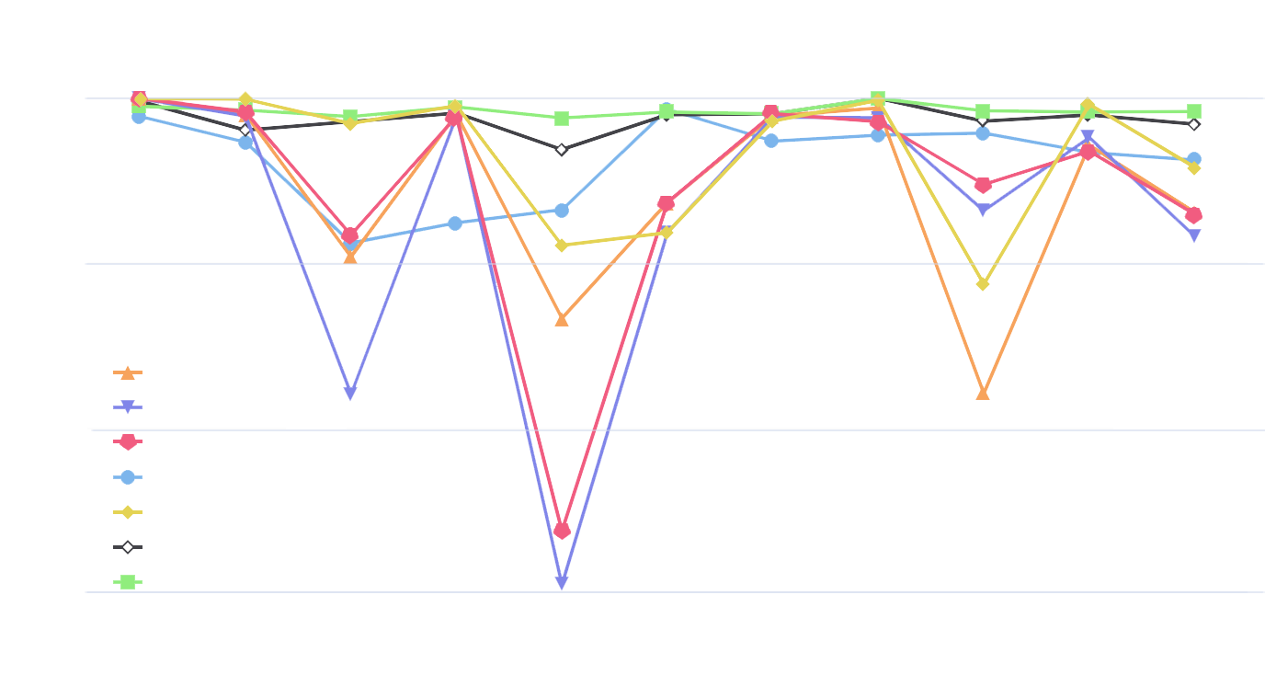

Accuracy

1

0.9

0.8

0.7

Cridex Geodo Hibot Miuref Neris Nsis Shifu Tinba Virut Zeus All

RF

DT

GBDT

CNN

HSTF

MT

VMT