**BLOCKCHAIN-BASED STORAGE FOR  
REAL ESTATE RECORDS**

*A Report*

*Submitted in partial fulfillment of the Requirements for the completion of*

*THEME BASED PROJECT*

## BACHELOR OF ENGINEERING

IN

## INFORMATION TECHNOLOGY

By

## SADHU ASHISH 1602-21-737-011

## PIYUSH BHUYAN 1602-21-737-014

## V.K.S SRINIVAS 1602-21-737-026

## Under the guidance of

## Mr. N. DAVID RAJU

## Assistant Professor



**Department of Information Technology**

**Vasavi College of Engineering (Autonomous)**

**ACCREDITED BY NAAC WITH 'A++' GRADE.**

**(Affiliated to Osmania University and Approved by AICTE)**

**Ibrahim Bagh, Hyderabad-31**

**2024**

**Vasavi College of Engineering (Autonomous)**

***ACCREDITED BY NAAC WITH 'A++' GRADE***

**(Affiliated to Osmania University and Approved by AICTE)**

**Ibrahim Bagh, Hyderabad-31**

**Department of Information Technology**



### DECLARATION BY CANDIDATES

We, **PIYUSH BHUYAN, SADHU ASHISH, V.K.S SRINIVAS,** bearing hall ticket number, **1602-21-737-014, 1602-21-737-011, 1602-21-737-026,** hereby declare that the project report entitled **”BLOCKCHAIN – BASED STORAGE FOR REAL ESTATE RECORDS”** under the guidance of Mr. N. David Raju, Assistant Professor, Department of Information Technology, Vasavi College of Engineering, Hyderabad, is submitted in partial fulfillment of the requirement for the completion of Theme-based project, VI semester, Bachelor of Engineering in Information Technology.

This is a record of bonafide work carried out by us and the results embodied in this project report have not been submitted to any other institutes.

## SADHU ASHISH

## 1602-21-737-011

## PIYUSH BHUYAN

## 1602-21-737-014

## V.K.S SRINIVAS

## 1602-21-737-026

**Vasavi College of Engineering (Autonomous)**

***ACCREDITED BY NAAC WITH 'A++' GRADE***

**(Affiliated to Osmania University and Approved by AICTE)**

**Ibrahim Bagh, Hyderabad-31**

**Department of Information Technology**

### BONAFIDE CERTIFICATE

This is to certify that the project entitled “**BLOCKCHAIN – BASED STORAGE FOR REAL ESTATE RECORDS**” being submitted by **SADHU ASHISH, PIYUSH BHUYAN, V.K.S SRINIVAS** bearing**, 1602-21-737-011, 1602-21-737-014, 1602-21-737-026,** in partial fulfillment of the requirements for the completion of Theme-based project of Bachelor of Engineering in Information Technology is a record of bonafide work carried out by them under my guidance.

|  |  |  |
| --- | --- | --- |
| **Mr. N. David Raju** | **External Examiner** | **Dr. K. Ram Mohan Rao** |
| **Assistant Professor** |  | **Professor, HOD IT** |
|  |  |  |

## ACKNOWLEDGEMENT

The satisfaction that accompanies the successful completion of the project would not have been possible without the kind support and help of many individuals. We would like to extend our sincere thanks to all of them.

It is with immense pleasure that we would like to take the opportunity to express our humble gratitude to **MR. N. DAVID RAJU, Assistant Professor, Information Technology** under whom we executed this project. His constant guidance and willingness to share their vast knowledge made us understand this project and its manifestations in great depth and helped us to complete the assigned tasks.

We are very much thankful to **Dr. K. Ram Mohan Rao, Professor and HOD, Information Technology,** for his kind support and for providing the necessary facilities to carry out the work.

We wish to convey our special thanks to Dr. S. V. Ramana**, Principal** of **Vasavi College of Engineering** for giving the required information in doing our project work. Not to forget, we thank all other faculty and non-teaching staff, and our friends who had directly or indirectly helped and supported me in completing our project in time.

We also express our sincere thanks to the Management for providing excellent facilities. Finally, we wish to convey our gratitude to our family who fostered all the facilities that we need.

**ABSTRACT**

The real estate industry is plagued by complex and often cumbersome record-keeping processes, which frequently lead to inefficiencies, inaccuracies, and disputes among stakeholders. Traditional methods of managing property records are prone to errors, fraud, and unauthorized alterations, compromising the integrity of data and eroding trust in the system. Blockchain technology has emerged as a potential solution to these challenges, offering a means to store data that is immutable, transparent, and decentralized. This project seeks to investigate the implementation of blockchain technology in the real estate sector, specifically for the purpose of storing property records.

The primary objective of this project is to explore how blockchain can be utilized solely for the storage aspect of real estate records, with a strong emphasis on enhancing transparency and security. By leveraging blockchain's distributed ledger technology, real estate records can be stored in a decentralized manner, which ensures that the data remains immutable and transparent. This decentralization significantly reduces the risk of data manipulation or loss, as records are not stored in a single location vulnerable to tampering or destruction.

Blockchain technology's inherent characteristics make it an ideal candidate for revolutionizing property record management. Each transaction or modification of a record is recorded on the blockchain in a secure, time-stamped, and unalterable manner, creating a verifiable and chronological history of ownership and changes. This level of transparency helps to build trust among stakeholders, as anyone with the necessary permissions can access and verify the records. Moreover, the decentralized nature of blockchain means that there is no single point of failure, enhancing the resilience and reliability of the system.

By implementing blockchain for the storage of property records, the real estate industry can move towards a more secure, efficient, and trustworthy system. This project aims to demonstrate that blockchain can address the current shortcomings in record-keeping, ultimately leading to a more streamlined and reliable real estate sector.

### 

**LIST OF FIGURES**

Fig 1.2. - Wear and Tear of Documents in Traditional System **2**

Fig 4.1.1 - Architecture Design of Blockchain-Based Storage for Real Estate Records **9**

Fig 4.1.2 - Use Case Diagram of Blockchain-Based Storage for Real Estate Records **10**

Fig 4.2.1.1 - 4.2.1.8 – Outputs **15**

Fig 4.2.1.9 - GitHub Directory Structure **18**

**LIST OF TABLES**

1. 4.1.2.1 - Use Case 1 **11**
2. 4.1.2.2 - Use Case 2  **11**
3. 4.1.2.3 - Use Case 3 **12**
4. 4.1.2.4 - Use Case 4 **12**
5. 4.1.2.5 - Use Case 5  **13**

### TABLE OF CONTENTS

|  |  |  |  |  |  |  |  |
| --- | --- | --- | --- | --- | --- | --- | --- |
| 1. INTRODUCTION | | | | 1 | | | |
| 1.1 Overview | | | | 1 | | |
| 1.2 Problem Statement | | | | 2 | | |
| 1.3 Motivation of theme & title | | | | 3 | | |
| 2. LITERATURE SURVEY | | | | 4 | | | |
| 3. EXISTING SYSTEM | | | | 7 | | | |
| 4. PROPOSED SOLUTION | | | | 8 | | | |
| 4.1. System Design | | | | 9 | | | |
| 4.1.1 Architecture Diagram | | | | 9 | | | |
| 4.1.2 Use-Case Diagram | | | | 10 | | | |
| 4.1.2.1 Use-case descriptions | | | | 11 | | | |
| 4.2 Functional Modules | | | | 14 | | | |
| 4.2.1 Screenshots & Pseudocode | | | | 14 | | | |
| 5. EXPERIMENTAL SETUP & IMPLEMENTATION | | | | 36 | | | |
| 5.1 System Specifications | | | | 36 | | | |
| 5.1.1 Hardware Requirements | | | | 36 | | | |
| 5.1.2 Software Requirements | | | | 36 | | | |
| 5.2 Methodology/Algorithm | | | | 37 | | | |
| 6. RESULTS | | | | 39 | | | |
| 7. CONCLUSION & FUTURE SCOPE | | | | 41 | | | |
| 8. REFERENCES | | | | 42 | | | |

**1. INTRODUCTION**

**1.1 Overview:**

Blockchain Technology has emerged as a game changer and has had a disruptive presence in the financial sector. Blockchain also aims to solve the issues associated with traditional record-keeping systems that are centralized and vulnerable to errors, duplication, and manipulation. These challenges in the traditional system of storage create issues in the appropriate identification of ownership leading to conflicts.

The origins of Blockchain technology can be traced back to the creation of Bitcoin, a digital currency introduced by Satoshi Nakamoto (a pseudonym) in 2008. Initially designed as a peer-to-peer electronic cash system, Bitcoin brought forth a fundamental change in digital transactions, mainly through its underlying Blockchain technology. This decentralized, transparent, and immutable ledger system quickly expanded beyond its original purpose, with applications in various sectors, especially finance and real estate.

Blockchain makes use of cryptographic techniques to ensure transaction security and protect sensitive data. Each transaction is encrypted and linked to previous ones, creating an unalterable record. This cryptographic security acts as a safeguard against fraud and unauthorized access.

The adoption of Blockchain technology in real estate has the potential to streamline processes, reduce paperwork, and lower transaction costs. Smart contracts, powered by blockchain, can automate and execute transactions without the need for intermediaries, further enhancing efficiency and reducing the risk of errors.

Blockchain technology holds immense promise for revolutionizing the real estate industry. Its decentralized, transparent, and secure nature has the potential to address longstanding challenges and create a more efficient, trustworthy, and accessible real estate market for all stakeholders involved.

**1.2 Problem Statement:**

In the realm of real estate management, the current landscape is fraught with inefficiencies, vulnerabilities, and a profound lack of transparency in record-keeping practices. Traditional storage methods are plagued by errors, redundancies, and exorbitant maintenance costs, while centralized systems remain susceptible to manipulation and cyber threats, undermining the integrity of property transactions. This persistent challenge underscores the critical need for a transformative solution.

Paper records present significant challenges in real estate management. Their tangible nature renders them susceptible to various risks, including damage, loss, or destruction. The ramifications of losing or damaging critical documents can be severe, resulting in disruptions and delays in transactions, particularly when time is limited.

Moreover, the existence of multiple physical copies of documents can compound the complexity of real estate transactions. Discrepancies between these copies frequently arise, leading to disputes among stakeholders. These disputes not only prolong the transaction process but also diminish trust and generate unnecessary friction between parties.

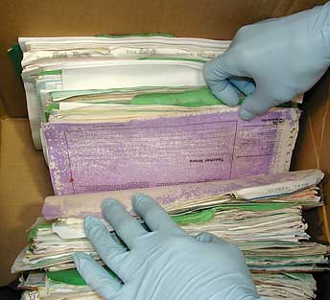 

Fig 1.2. Wear and Tear of Documents in Traditional System

The above pictures illustrate the challenges associated with the traditional/conventional system of real estate storage.

**1.3 Motivation to use Blockchain for Real Estate records storage:**

* *Enhanced Security*: Blockchain technology ensures records are tamper-proof and immutable, reducing the risk of fraud and manipulation.
* *Increased Transparency*: The decentralized nature of blockchain allows for transparent access to records, promoting trust among parties involved in real estate transactions.
* *Improved Efficiency*: By digitizing records and eliminating manual processes associated with paper-based systems, transactions can be streamlined, saving time and reducing administrative burdens.
* *Reduced Risk of Data Loss*: With digital storage on blockchain, there's less risk of documents being lost, damaged, or destroyed compared to physical copies.
* *Minimized Disputes*: Blockchain's transparency and accuracy help mitigate discrepancies between records, reducing the likelihood of disputes and delays in transactions.
* *Cost Savings*: Eliminating the need for physical storage and reducing administrative overhead associated with paper records can result in significant cost savings for real estate stakeholders.
* *Simplified Auditing and Compliance*: Blockchain's transparent ledger simplifies auditing processes and ensures compliance with regulatory requirements, providing a smoother experience for all parties involved.

**2. LITERATURE SURVEY**

Various methods have been proposed for implementing Blockchains and Real Estate storage systems built on those Blockchains, including different cryptography and encryption algorithms. Some of them are mentioned below,

In 1982, cryptographer **David Chaum et al [1]** proposed a blockchain-like protocol in his dissertation titled "Computer Systems Established, Maintained, and Trusted by Mutually Suspicious Groups." This early proposal, predating modern blockchain technology, provided a conceptual framework for decentralized systems. Chaum's innovative approach emphasized the importance of trustless systems in maintaining data integrity among groups with mutual suspicion. While distinct from contemporary blockchain implementations, Chaum's work paved the way for advancements in decentralized systems and cryptographic protocols, influencing the trajectory of modern technology.

In January 1991, **Stuart Haber and W. Scott Stornetta et al [2]** introduced a groundbreaking method for timestamping digital documents in their paper titled "How to time-stamp a digital document," published in the Journal of Cryptology. This seminal work laid the foundation for modern blockchain technology by presenting a novel approach to deter tampering and ensure the authenticity of digital records. By leveraging cryptographic techniques, they devised a method to create a sequential chain of blocks, each containing a timestamp and a cryptographic hash of the previous block. This innovative solution provided an immutable and verifiable ledger, pioneering the concept of decentralized trust in the digital realm. Haber and Stornetta's visionary contributions paved the way for the transformative impact of blockchain on digital security, transparency, and trust, shaping the landscape of modern technology.

In 2009, **Satoshi Nakamoto et al [3]** presented the original blockchain blueprint in the Bitcoin whitepaper. At its core lies the SHA-256 hashing algorithm, a critical cryptographic function that generates unique digital fingerprints for each block of transactions. This hashing algorithm ensures the integrity and security of data stored on the blockchain by creating a fixed-size output (256 bits) regardless of the input size. By employing SHA-256, Nakamoto's blockchain design fortifies the system against tampering and fraud, serving as the backbone for transaction verification. Transactions are bundled into blocks and linked together in a chain, with each block containing a hash of the previous block, thereby creating an immutable ledger.

In 2013, **Vitalik Buterin et al [4]** introduced Ethereum in the Ethereum whitepaper. At its core lies the Keccak-256 hashing algorithm, also known as SHA-3, a robust cryptographic function that surpasses SHA-256. Unlike its predecessor, Keccak-256 boasts enhanced resilience against cryptographic attacks, making it an ideal choice for securing blockchain data. This algorithm ensures the integrity and security of Ethereum's transactions by generating fixed-size outputs (256 bits) regardless of input size.

In 2018, **Haikel Magrahi et al [5]** introduced a novel approach to file notarization using blockchain technology. Magrahi highlights the increasing adoption of blockchain in various sectors and the need for decentralized solutions. However, existing blockchain-based storage systems lack effective management of document lifecycles and compliance with regulatory requirements. The NFB protocol bridges this gap by facilitating communication between a permissive blockchain and a secure, centralized archiving Document Management System. This approach enables users to archive, control, analyse, and validate transactions securely and confidentially while meeting regulatory compliance standards. Magrahi's protocol offers a promising solution for organizations seeking secure and compliant file notarization processes in the blockchain era.

In 2020, **Ankit Mittal et al [6]** presented a pioneering solution to the inefficiencies plaguing real estate management worldwide. Mittal addresses the challenges faced in real estate management, particularly in India, by proposing a blockchain-powered system. This system aims to streamline land registration processes, offering transparency, security, and efficiency. By utilizing a distributed permissioned blockchain, Mittal's system ensures secure transaction storage while minimizing the risk of hacking. Furthermore, the proposed system centralizes departmental operations while decentralizing data storage, offering a practical and comprehensive solution to the complexities of real estate management.

In 2024, **Mostafa Hassan et al [7]** addressed industry challenges such as opacity, fraud, and inefficiency by proposing the utilization of blockchain technology and NFTs. The "My Real Estate" system leverages blockchain and NFTs to enhance real estate transactions and ownership management. In Phase 1, the system integrates with the Ethereum blockchain network to ensure secure, automated transactions and immutable record-keeping through tools like MetaMask, Hardhat, and Solidity Smart Contracts. Phase 2 involves tokenizing properties into unique NFTs, enabling fractional ownership and enhancing liquidity. Additionally, this phase explores community-driven governance models for property management using NFTs. The goals of this approach include increasing transparency and trust, improving security, streamlining processes, reducing costs, and democratizing real estate investment. "My Real Estate" represents a significant step towards fostering trust, efficiency, and innovative ownership models in the traditional real estate landscape by integrating blockchain technology and NFTs.

**3. EXISTING SYSTEM**

In the realm of blockchain-based solutions for real estate, several marketplaces have emerged to facilitate property transactions and investment. Companies like Propy, Harbor, and Atlant offer platforms for buying, selling, and tokenizing real estate assets, enabling fractional ownership and increased liquidity. These platforms leverage blockchain technology to create digital tokens representing ownership stakes in real-world properties. Through tokenization, investors can purchase fractions of high-value properties, diversifying their portfolios and accessing assets previously out of reach.

However, while these platforms address aspects of property transactions and investment, there remains a gap in solutions for the safekeeping of real estate-related documents. Many existing solutions are still in their initial stages, primarily concentrating on transactional aspects rather than comprehensive document management. As the real estate industry progresses, there is an increasing demand for blockchain-based solutions that not only facilitate transactions but also offer secure and efficient storage and management of real estate documents. These solutions are expected to provide transparency, immutability, and accessibility to all stakeholders involved in the real estate ecosystem, ensuring smoother operations and heightened trust in the digital age of property management and transactions.

**4. PROPOSED SOLUTION**

The proposal involves developing a storage system for real estate records based on blockchain technology, aiming to enhance the efficiency and security of managing and safeguarding these vital documents. By leveraging blockchain's unique features, this system ensures the integrity and protection of real estate records, significantly reducing the risks inherent in traditional paper-based systems, such as fraud, errors, and unauthorized alterations.

Blockchain technology offers a decentralized and immutable ledger where each transaction is securely recorded, making it virtually impossible to tamper with or lose data. This ensures that all real estate records are accurate and reliable. Additionally, the system provides transparency, as each transaction is visible and verifiable by authorized parties, thereby fostering trust among stakeholders, including buyers, sellers, agents, and regulators.

Moreover, the accessibility of records is vastly improved, allowing stakeholders to access necessary documents quickly and efficiently, streamlining transactions and administrative processes. This transparency and ease of access not only expedite transactions but also enhance the overall trust and credibility within the real estate industry. Overall, the proposed blockchain-based storage system represents a significant advancement over traditional methods, offering a more secure, transparent, and efficient way to manage real estate records.

**4.1. System Design:**

**4.1.1. Architectural Design:**

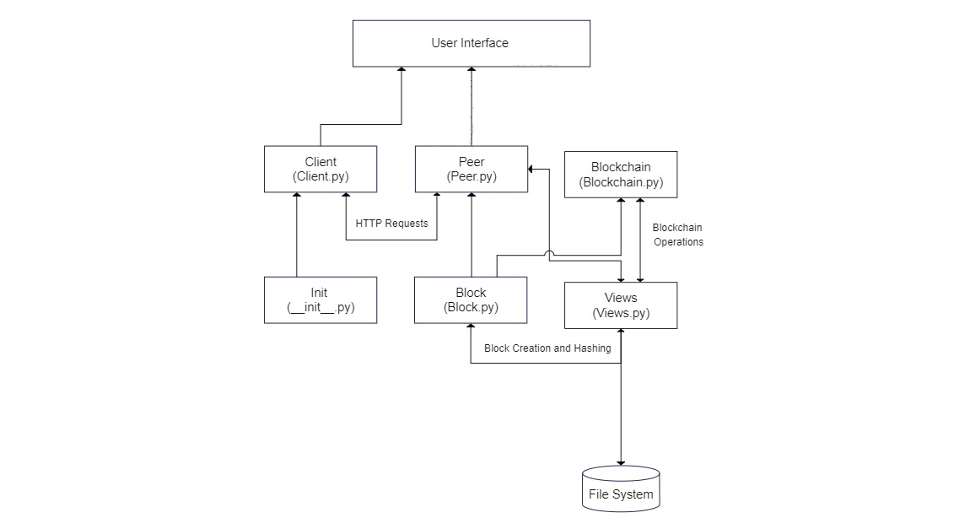

Fig 4.1.1. Architectural Design of Blockchain-Based Storage for Real Estate Records

**4.1.2. Use-Case Diagrams:**

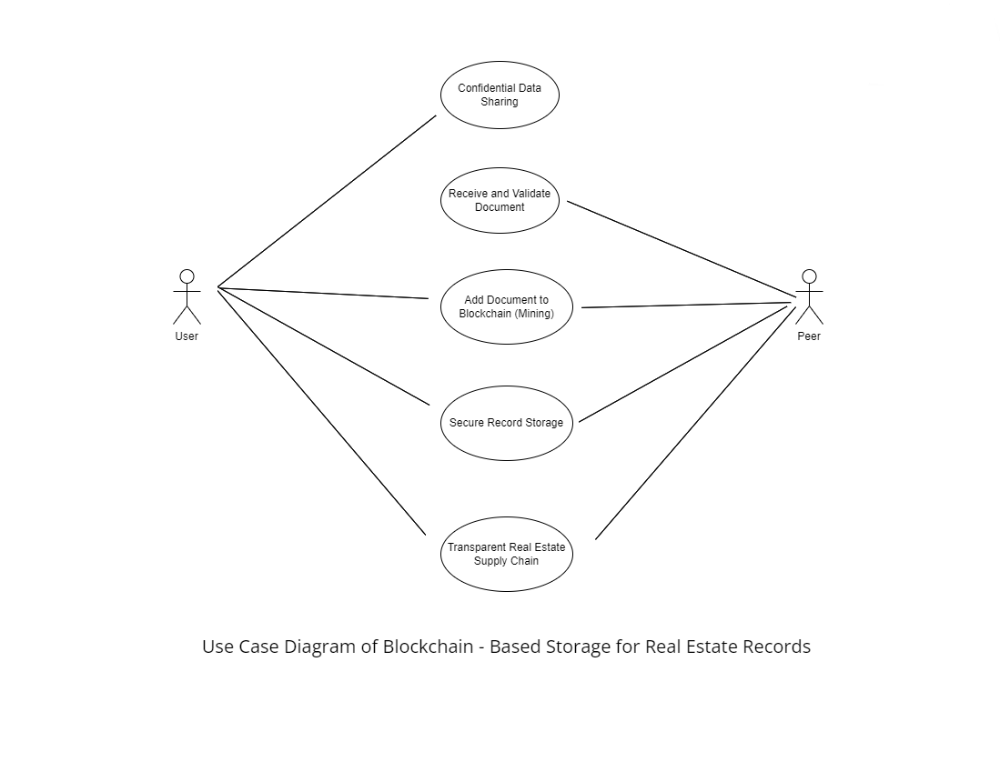

Fig 4.1.2 Use Case Diagram of Blockchain – Based Storage for Real Estate Records

**4.1.2.1 Use-Case Descriptions:**

**Use case ID:** UC01​

**Name:** Confidential Data Sharing​

**Actors:** User ​

**Description:** Users can securely access the decentralized storage platform and upload their documents by providing their names and IDs and requesting a mined block.

|  |  |
| --- | --- |
| User | Peer |
| 1. The User inputs their details to be shared. |  |
| 1. The User selects the document to be uploaded. |  |
| 1. The User submits the document and requests a mine. |  |

Table 4.1.2.1

**Use case ID:** UC02

**Name:** Receive and Validate Document​

**Actors:** Peer ​

**Description:** Peers receive and verify the authenticity of the received document

|  |  |
| --- | --- |
| User | Peer |
|  | 1. Peer listens for incoming real estate documents from users. |
|  | 1. Peer receives the submitted documents. |
|  | 1. Peer verifies the authenticity of the document. |

Table 4.1.2.2

**Use case ID:** UC03

**Name:** Add Document to Blockchain ​

**Actors:** Peer ​

**Description:** Peers add the document to the blockchain post verification.

|  |  |
| --- | --- |
| User | Peer |
|  | 1. Peer encrypts the received document after validation. |
|  | 1. Peer adds the encrypted document to the Blockchain for secure storage. |

Table 4.1.2.3

**Use case ID:** UC04

**Name:** Secure Records Storage ​

**Actors:** User, Peer ​

**Description:** Real estate firms and property owners can securely store and manage property records ensuring the integrity and accessibility of crucial information while protecting against data loss or unauthorized modifications.​

|  |  |
| --- | --- |
| User | Peer |
| 1. The User uploads real estate documents to the system for storage. |  |
| 1. The User ensures documents are securely stored within the blockchain network. |  |
|  | 1. Peer receives the submitted real estate document. |
|  | 1. Peer adds the validated document to the blockchain for secure storage. |
|  | 1. Peer confirms successful document upload. |

Table 4.1.2.4

**Use case ID:** UC05

**Name:** Transparent Real Estate Supply Chain ​

**Actors:** User, Peer ​

**Description:** Stakeholders in the real estate industry, such as developers, contractors, suppliers, and regulatory authorities, can share relevant documents and information related to property development projects, ensuring transparency, accountability, and compliance with regulatory standards throughout the supply chain, from land acquisition to construction and occupancy.​

|  |  |
| --- | --- |
| User | Peer |
|  | 1. Peer retrieves real estate records from the blockchain. |
|  | 1. Peer provides real estate records from the blockchain to users. |
| 1. The user accesses the blockchain to view real estate transactions and records. | . |
| 1. User verifies the authenticity and transparency of real estate transactions within the supply chain. |  |

Table 4.1.2.5

**4.2. Functional Modules:**

**4.2.1. Screenshots and Code:**

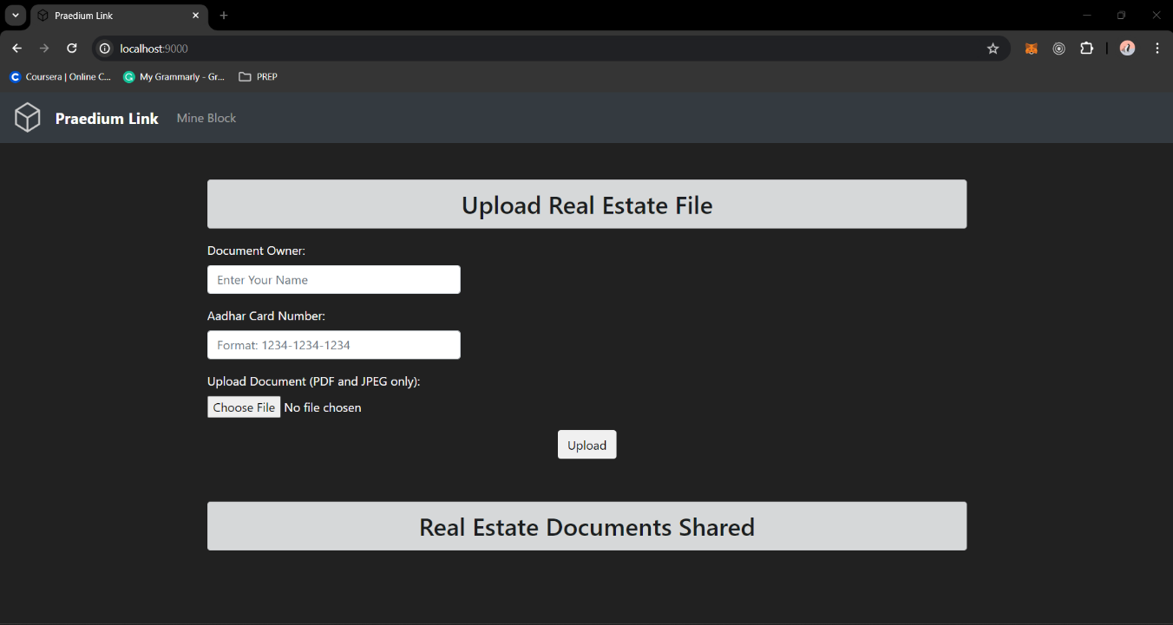

Fig 4.2.1.1 – Home Page

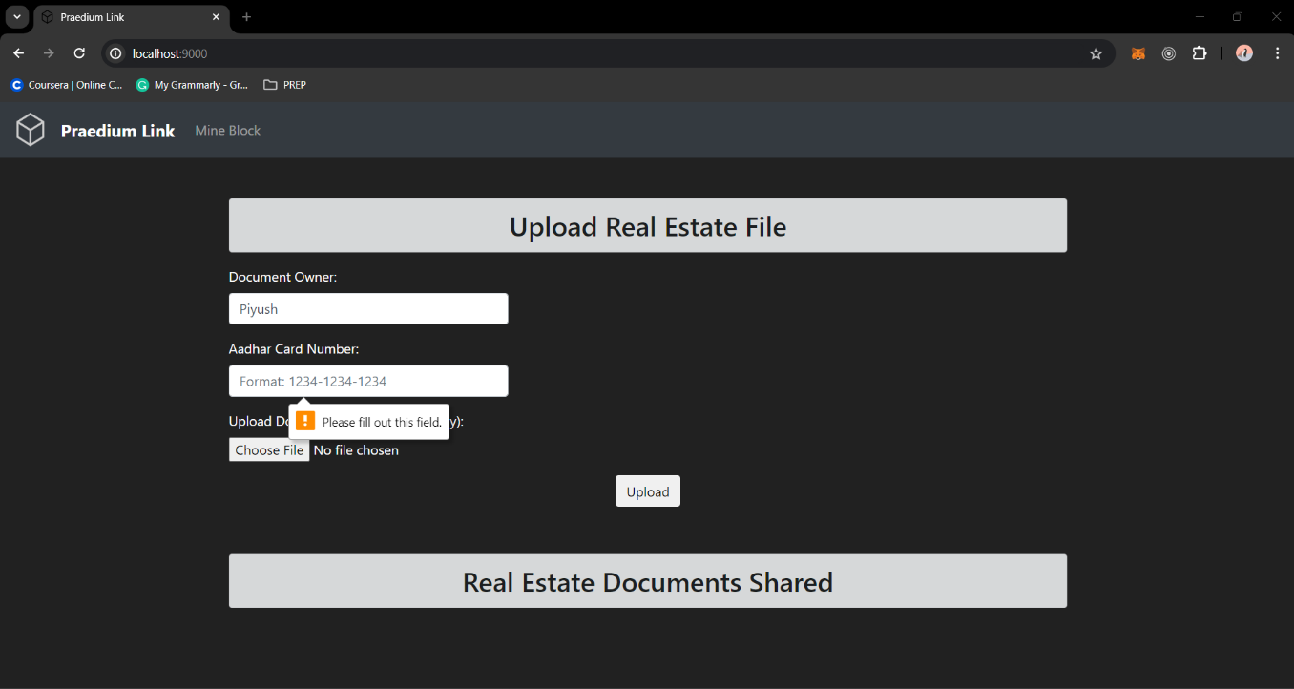

Fig 4.2.1.2 – Error when Upload button is pressed without entering the details

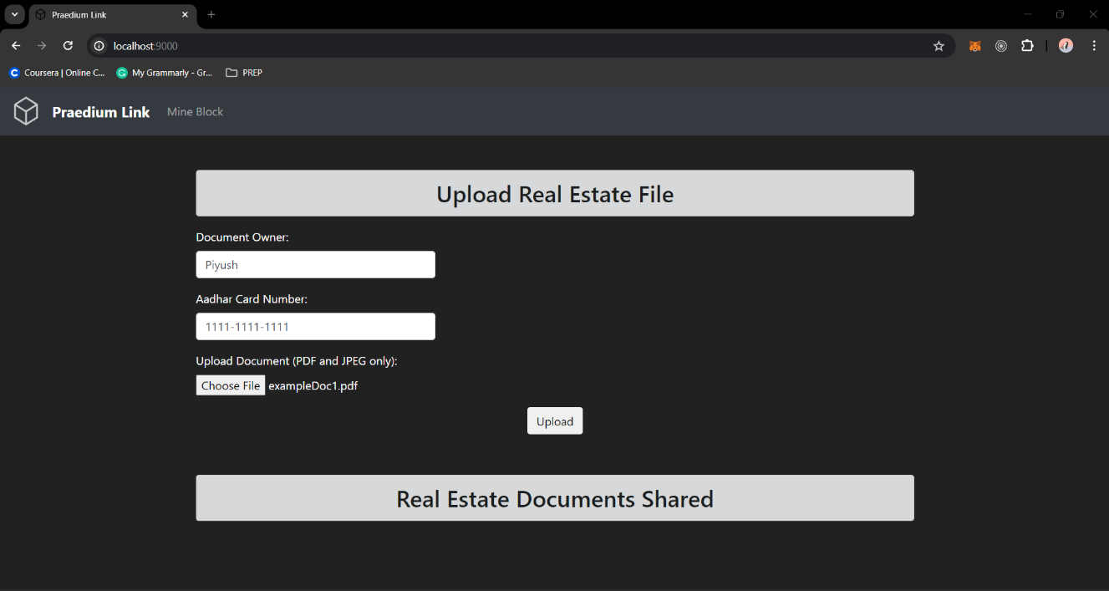

Fig 4.2.1.3 – Entering all the required details and uploaded the document

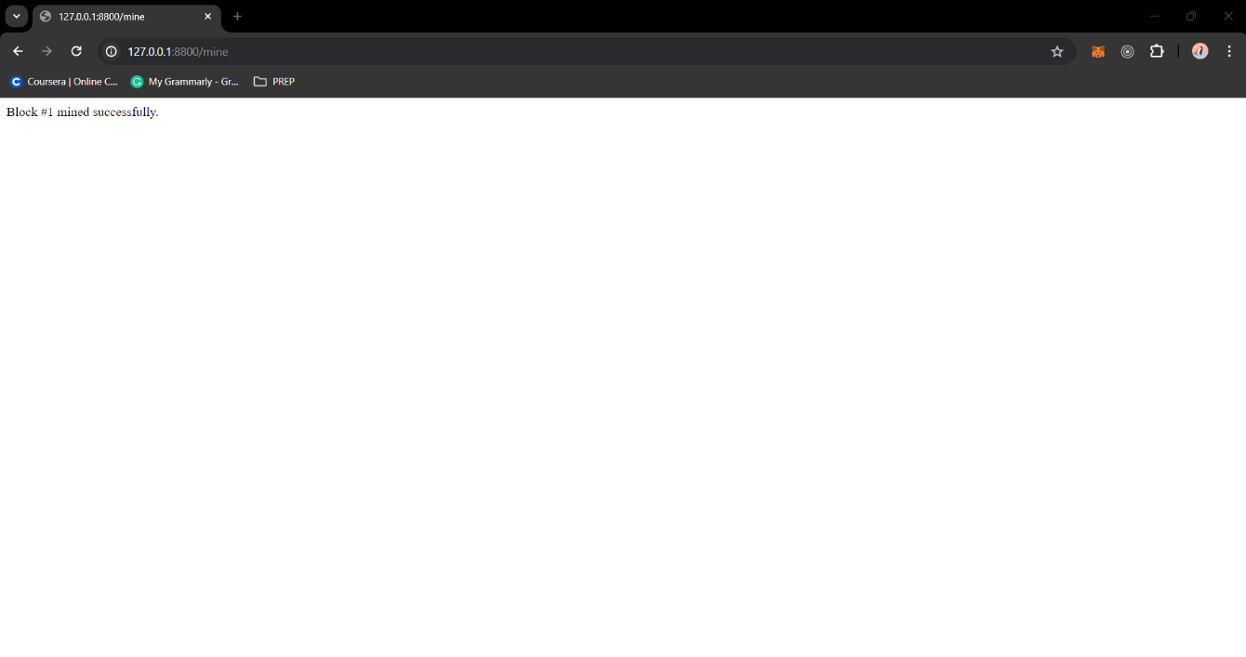

Fig 4.2.1.4 – After pressing the Mine Block in Navbar

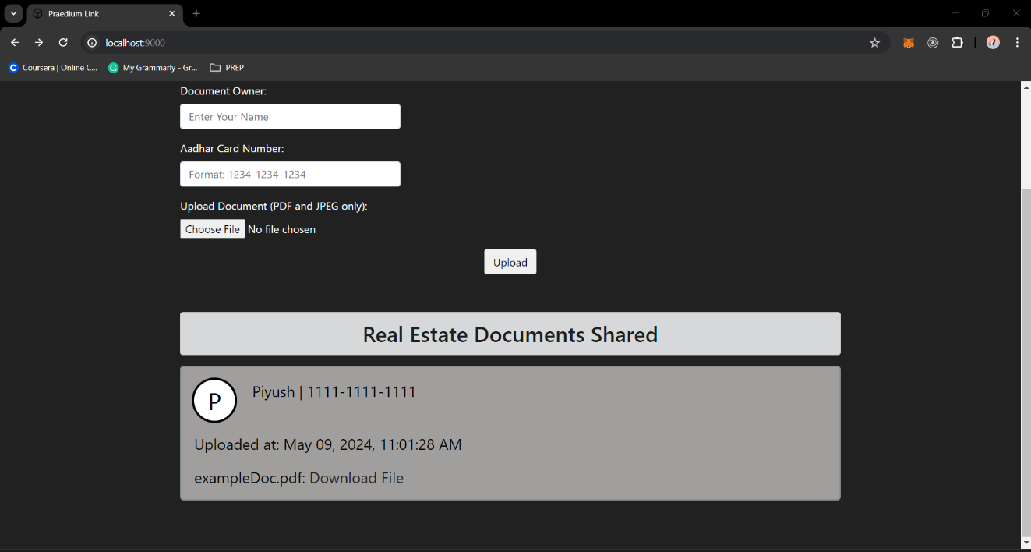

Fig 4.2.1.5 – Document successfully loaded into the blockchain

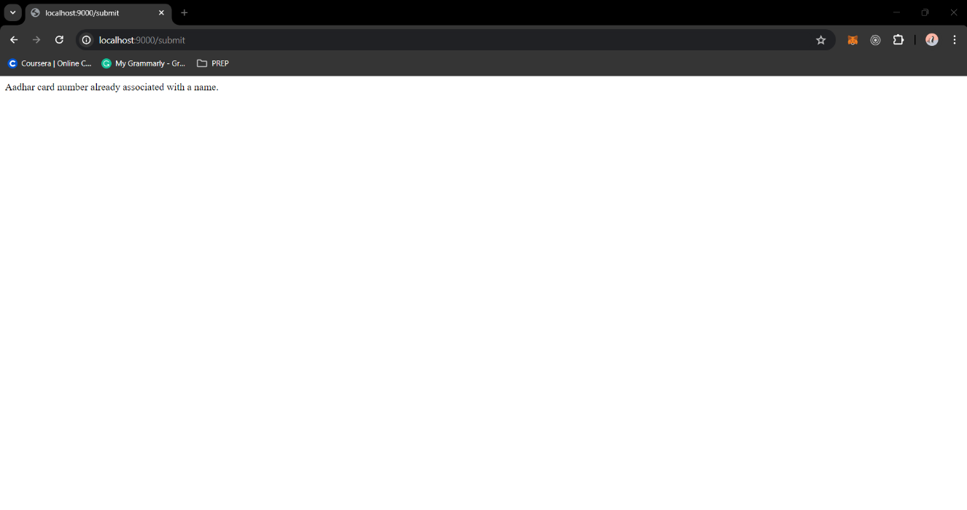

Fig 4.2.1.6 – Error when different user tries with a Aadhar Number which was already used

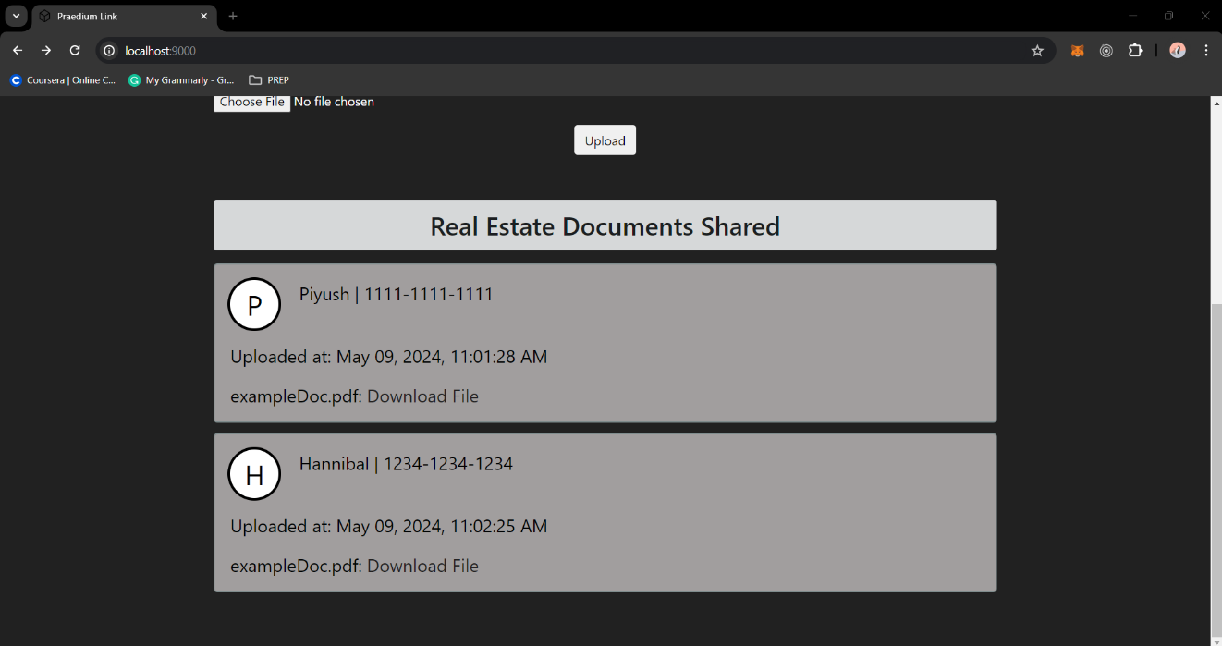

Fig 4.2.1.7 – Different users uploading their documents

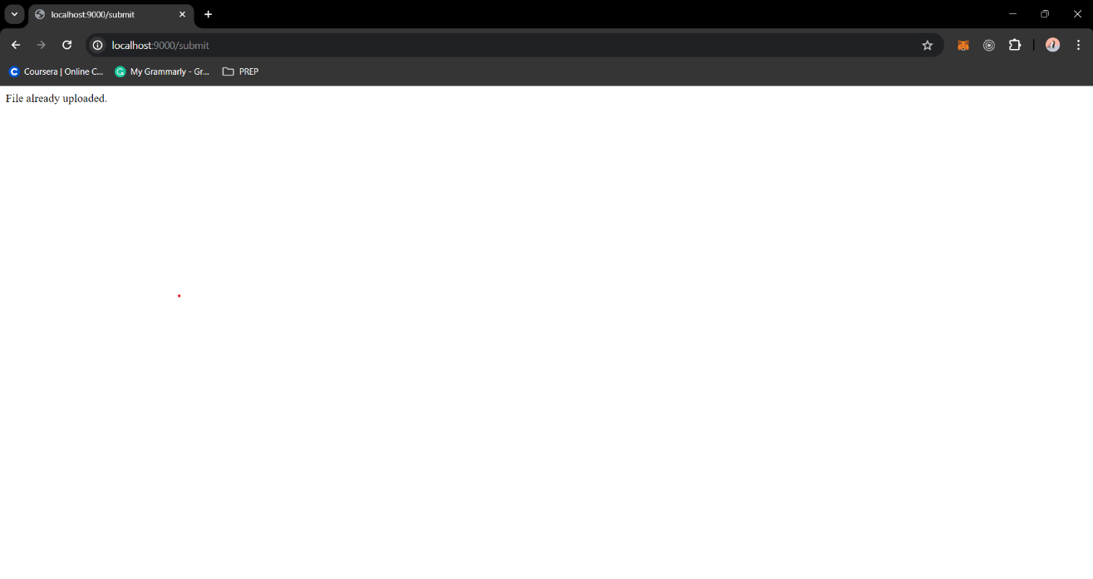

Fig 4.2.1.8 – Error when different user tries to upload a file which is already present in the blockchain

**Directory Structure:**

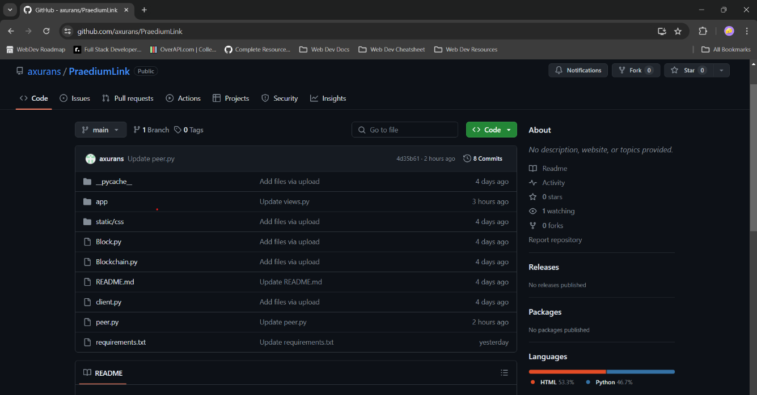

Fig 4.2.1.9: Directory Strucuture

GitHub Link: <https://github.com/axurans/PraediumLink>

**base.html**

<!DOCTYPE html>

<html lang="en">

<head>

<!-- Required meta tags -->

<meta charset="utf-8">

<meta name="viewport" content="width=device-width, initial-scale=1, shrink-to-fit=no">

<!-- Bootstrap CSS -->

<link rel="stylesheet" href="https://maxcdn.bootstrapcdn.com/bootstrap/4.0.0/css/bootstrap.min.css" integrity="sha384-Gn5384xqQ1aoWXA+058RXPxPg6fy4IWvTNh0E263XmFcJlSAwiGgFAW/dAiS6JXm" crossorigin="anonymous">

<link rel="stylesheet" type="text/css" href="{{ url_for('static', filename='css/bootstrap.css')}}">

<link rel="icon" href="https://cdn-icons-png.flaticon.com/512/142/142309.png" type="image/x-icon">

<title>Praedium Link</title>

<style>

/* Additional CSS for centering and cosmetics */

.center-heading {

text-align: center;

margin-top: 50px;

margin-bottom: 30px;

}

.navbar-nav .nav-item .nav-link:hover {

color: rgb(255, 255, 255); /* Change color to blue on hover */

}

.navbar-text:hover {

color: grey;

}

</style>

</head>

<body style="background-color: rgba(0, 0, 0, 0.871); color: white; padding-bottom: 60px;">

<nav class="navbar navbar-expand-lg navbar-dark bg-dark">

<a class="navbar-brand" href="#">

<img src="https://cdn-icons-png.flaticon.com/512/142/142309.png" width="40" height="40" style="background: transparent; filter: invert(80%)">

</a>

<a class="navbar-brand" href="#" style="font-weight: bold;">Praedium Link</a>

<button class="navbar-toggler" type="button" data-toggle="collapse" data-target="#navbarSupportedContent" aria-controls="navbarSupportedContent" aria-expanded="false" aria-label="Toggle navigation">

<span class="navbar-toggler-icon"></span>

</button>

<div class="collapse navbar-collapse" id="navbarSupportedContent">

<ul class="navbar-nav mr-auto">

<li class="nav-item">

<a class="nav-link" href="{{ node_address }}/mine">Mine Block</a>

</li>

</ul>

<!-- <span class="navbar-text">

<a href="https://github.com/axurans/" style="text-decoration:none; "> Made by Piyush Bhuyan </a>

</span> -->

</div>

</nav>

{% with messages = get_flashed_messages() %} {% if messages %} {% for message in messages %}

<li>{{ message }}</li>

{% endfor %} {% endif %} {% endwith %} {% block content %}{% endblock %}

<script src="https://code.jquery.com/jquery-3.2.1.slim.min.js" integrity="sha384-KJ3o2DKtIkvYIK3UENzmM7KCkRr/rE9/Qpg6aAZGJwFDMVNA/GpGFF93hXpG5KkN" crossorigin="anonymous"></script>

<script src="https://cdnjs.cloudflare.com/ajax/libs/popper.js/1.12.9/umd/popper.min.js" integrity="sha384-ApNbgh9B+Y1QKtv3Rn7W3mgPxhU9K/ScQsAP7hUibX39j7fakFPskvXusvfa0b4Q" crossorigin="anonymous"></script>

<script src="https://maxcdn.bootstrapcdn.com/bootstrap/4.0.0/js/bootstrap.min.js" integrity="sha384-JZR6Spejh4U02d8jOt6vLEHfe/JQGiRRSQQxSfFWpi1MquVdAyjUar5+76PVCmYl" crossorigin="anonymous"></script>

</body>

</html>

**index.html**

{% extends "base.html" %} {% block content %}

<style type="text/css">

.navbar-item:hover {

background-color: #ffffff;

}

.left {

float: left;

}

.right {

float: right;

}

/* Title, subtitle, and horizontal line. */

.title {

margin-top: 9rem;

text-align: center;

line-height: 1.6rem;

}

.title-text {

font-family: "Courier New", Courier, monospace;

font-size: 5rem;

}

.subtitle-text {

font-size: 2.9rem;

}

.hr {

border-style: solid;

border-width: 0.08rem;

border-color: #8d7f7f;

width: 55rem;

}

/* Buttons, post text area, name input, and body styling. */

.content {

min-height: 100%;

height: 100%;

}

.btn:hover {

background-color: #2aadc1;

cursor: pointer;

}

.post-textarea,

.name-input {

font-family: "Courier New", Courier, monospace;

font-size: 1.8rem;

padding: 1.2rem;

border-radius: 0.4rem;

border-width: 0.1rem;

border-style: solid;

border-color: #000303;

}

.request_tx {

margin: 2.5rem 2.5rem 14rem 2.5rem;

}

/* Post boxes styling */

.post_box {

background: rgb(235, 235, 235);

padding: 1.2rem 0 0 1.2rem;

margin-top: 0;

margin-bottom: 0.8rem;

border: 0.1rem solid #7f8c8d;

border-radius: 5px;

}

.post_box-header {

padding-bottom: 1.2rem;

font-size: 1.4rem;

}

.post_box-avatar {

width: 3.8rem;

height: 3.8rem;

border-radius: 50%;

display: flex;

justify-content: center;

align-items: center;

color: white;

font-size: 2.2rem;

float: left;

margin-right: 1.6rem;

border: 0.1rem solid #fff;

box-shadow: 0 0 0 0.2rem #f00;

}

.post_box-avatar::after {

content: "";

display: block;

}

.post_box-name {

font-weight: bold;

}

.post_box-subtitle {

color: #777;

}

.post_box-body {

margin-top: 1.6rem;

margin-bottom: 0.8rem;

font-size: 1.4rem;

}

.post_box-options {

float: right;

}

.option-btn {

background: #f8f8f8;

border: none;

color: #502c2c;

padding: 0.7rem;

cursor: pointer;

font-size: 1.4rem;

margin-left: 0.2rem;

margin-right: 0.2rem;

outline: none;

height: 4.2rem;

}

</style>

<div class="container-fluid">

<div class="row mt-5">

<div class="col-md-8 offset-md-2">

<h2 class="text-center alert alert-dark">Upload Real Estate File</h2>

<!-- Upload form -->

<form action="/submit" method="POST" enctype="multipart/form-data">

<div class="form-group">

<label for="name">Document Owner:</label>

<input

type="text"

class="form-control col-md-4"

name="user"

id="name"

placeholder="Enter Your Name"

required

/>

</div>

<div class="form-group">

<label for="aadhar">Aadhar Card Number:</label>

<input

type="text"

class="form-control col-md-4"

name="aadhar"

id="aadhar"

placeholder="Format: 1234-1234-1234"

pattern="\d{4}-\d{4}-\d{4}"

title="Please enter in the format 1234-5678-9123"

required

/>

</div>

<!-- Hidden timestamp field -->

<input type="hidden" id="timestamp" name="timestamp" value="" />

<div class="form-group">

<label for="fileUpld">Upload Document (PDF and JPEG only):</label>

<br />

<input

type="file"

id="fileUpld"

name="v_file"

accept="application/pdf,image/jpeg"

required

/>

</div>

<div class="text-center">

<!-- Centered button -->

<button

type="submit"

class="btn btn-default mb-2"

onclick="setTimestamp()"

>

Upload

</button>

</div>

</form>

</div>

</div>

<div class="row mt-5">

<div class="col-md-8 offset-md-2">

<h2 class="text-center alert alert-dark">Real Estate Documents Shared</h2>

<!-- Display shared documents -->

{% for post in request_tx %}

<div

class="post_box"

style="

color: #000303;

background-color: rgba(195, 192, 192, 0.79);

border-radius: 5px;

"

>

<div class="post_box-header">

<div

style="

background: rgb(255, 255, 255) none repeat scroll 0% 0%;

box-shadow: rgb(0, 0, 0) 0 0 0 0.2rem;

color: black;

"

class="post_box-avatar"

>

{{post.user[0]}}

</div>

<div class="name-header" style="color: black">

{{post.user}} | {{post.aadhar}}

</div>

</div>

<div>

<div class="post_box-body">

<p>Uploaded at: {{ post.timestamp }}</p>

<p>

{{post.v_file}}:

<a

href="{{url_for('download_file', variable=post.v_file)}}"

style="color: rgb(34, 33, 33)"

>Download File</a

>

</p>

</div>

</div>

</div>

{% endfor %}

</div>

</div>

</div>

<script>

function setTimestamp() {

var timestampInput = document.getElementById("timestamp");

var timestampValue = new Date().toISOString();

// Format the timestamp

var date = new Date(timestampValue);

var options = {

year: "numeric",

month: "short",

day: "2-digit",

hour: "2-digit",

minute: "2-digit",

second: "2-digit",

timeZone: "Asia/Kolkata", // Convert to IST

};

var formattedTimestamp = date.toLocaleString("en-US", options);

// Set the value of the timestamp input field

timestampInput.value = formattedTimestamp;

}

</script>

{% endblock %}

**__init__.py**

from flask import Flask

app = Flask(__name__)

from app import views

**views.py**

import json

import os

import requests

from flask import render_template, redirect, request, send_file

from werkzeug.utils import secure_filename

from app import app

from timeit import default_timer as timer

requestTx = []

files = {}

aadhar_name_mapping = {}

UPLOAD_FOLDER = "app/static/Uploads"

app.config['UPLOAD_FOLDER'] = UPLOAD_FOLDER

ADDR = "http://127.0.0.1:8800"

def getTxReq():

global requestTx

chainAddr = "{0}/chain".format(ADDR)

resp = requests.get(chainAddr)

if resp.status_code == 200:

content = []

chain = json.loads(resp.content.decode())

for block in chain["chain"]:

for trans in block["transactions"]:

trans["index"] = block["index"]

trans["hash"] = block["prevHash"]

content.append(trans)

requestTx = sorted(content, key=lambda k: k["hash"], reverse=True)

@app.route("/")

def index():

getTxReq()

return render_template("index.html", title="RealEstateFileStorage", subtitle="A Blockchain Real Estate File Storage", node_address=ADDR, request_tx=requestTx)

@app.route("/submit", methods=["POST"])

def submit():

start = timer()

user = request.form["user"]

aadhar = request.form["aadhar"]

timestamp = request.form["timestamp"]

upFile = request.files["v_file"]

# Check if Aadhar card number or name has already been submitted

if aadhar in aadhar_name_mapping:

return "Aadhar card number already associated with a name."

if user in aadhar_name_mapping.values():

return "Name already associated with an Aadhar card number."

aadhar_name_mapping[aadhar] = user

upFile.save(os.path.join("app/static/Uploads/", secure_filename(upFile.filename)))

files[upFile.filename] = os.path.join(app.root_path, "static", "Uploads", upFile.filename)

file_states = os.stat(files[upFile.filename]).st_size

post_object = {

"user": user,

"aadhar": aadhar,

"timestamp": timestamp,

"v_file": upFile.filename,

"fileData": str(upFile.stream.read()),

"fileSize": file_states

}

address = "{0}/newTransaction".format(ADDR)

requests.post(address, json=post_object)

end = timer()

print(end - start)

return redirect("/")

@app.route("/submit/<string:variable>", methods=["GET"])

def download_file(variable):

p = files[variable]

return send_file(p, as_attachment=True)

**Block.py**

from hashlib import sha256i

class Block:

def __init__(self, index, transactions, prevHash):

self.index = index

self.transactions = transactions

self.prevHash = prevHash

self.nonce = 0

def genHash(self):

allDataCombined = str(self.index) + str(self.nonce) + self.prevHash + str(self.transactions)

return sha256(allDataCombined.encode()).hexdigest()

def addT(self, t):

self.transactions.append(t)

**Blockchain.py**

import random

from Block import Block

class Blockchain:

difficulty = 3

def __init__(self):

self.pending = []

self.chain = []

genBlock = Block(0, [], "0")

genBlock.hash = genBlock.genHash()

self.chain.append(genBlock)

def addBlock(self, block, hashl):

prevHash = self.lastBlock().hash

if (prevHash == block.prevHash and self.isValid(block, hashl)):

block.hash = hashl

self.chain.append(block)

return True

else:

return False

def mine(self):

if(len(self.pending) > 0):

lastBlock = self.lastBlock()

newBlock = Block(lastBlock.index + 1,self.pending,lastBlock.hash)

hashl = self.p_o_w(newBlock)

self.addBlock(newBlock, hashl)

self.pending = []

return newBlock.index

else:

return False

def p_o_w(self, block):

block.nonce = 0

getHash = block.genHash()

while not getHash.startswith("0" * Blockchain.difficulty):

block.nonce = random.randint(0,99999999)

getHash = block.genHash()

return getHash

def addPending(self, transaction):

self.pending.append(transaction)

def checkValidity(this, chain):

result = True

prevHash = "0"

for block in chain:

blockHash = block.hash

if this.isValid(block, block.hash) and prevHash == block.prevHash:

block.hash = blockHash

prevHash = blockHash

else:

result = False

return result

def isValid(cls, block, blockHash):

if(blockHash.startswith("0" * Blockchain.difficulty)):

if(block.genHash() == blockHash):

return True

else:

return False

else:

return False

def lastBlock(self):

return self.chain[-1]

**client.py**

from app import app

app.run(host = 'localhost', port = '9000',debug=True)

**peer.py**

import json

from Blockchain import Blockchain

from Block import Block

from flask import Flask, request

app = Flask(__name__)

blockchain = Blockchain()

peers = []

@app.route("/newTransaction", methods=["POST"])

def newTransaction():

fileData = request.get_json()

requiredFields = ["user","aadhar", "v_file", "fileData", "fileSize"]

for field in requiredFields:

if not fileData.get(field):

return "Transaction does not have valid fields!", 404

blockchain.addPending(fileData)

return "Success", 201

@app.route("/chain", methods=["GET"])

def getChain():

chain = []

for block in blockchain.chain:

chain.append(block.__dict__)

print("Chain Length: {0}".format(len(chain)))

return json.dumps({"length" : len(chain), "chain" : chain})

@app.route("/mine", methods=["GET"])

def mineUncofirmed():

result = blockchain.mine()

if result:

return "Block #{0} mined successfully.".format(result)

else:

return "No pending transactions."

@app.route("/pending_tx")

def getPending():

return json.dumps(blockchain.pending)

@app.route("/addBlock", methods=["POST"])

def validateAndAdd():

blockData = request.get_json()

block = Block(blockData["index"],blockData["transactions"],blockData["prevHash"])

hashl = blockData["hash"]

added = blockchain.addBlock(block, hashl)

if not added:

return "The Block was discarded by the node.", 400

return "The block was added to the chain.", 201

app.run(port=8800, debug=True)

**5. EXPERIMENTAL SETUP & IMPLEMENTATION**

|  |  |
| --- | --- |
| 5.1 System Specifications |  |
| 5.1.1 Hardware RequirementsMinimum:Any modern desktop or laptop computer.Processor: Intel Core i3, AMD Ryzen 3 or equivalent.RAM: 4 GB.Storage: SSD for faster performance and ample free disk space.Recommended:Any modern desktop or laptop computer.Processor: Intel Core i5, equivalent or higher.RAM: 8 GB RAM or higher.Storage: SSD for faster performance and ample free disk space. |
| 5.1.2 Software Requirements |
| Minimum:Operating System: Windows 10, macOS 10.12, Ubuntu 18.04 LTSBrowser: Google Chrome, Mozilla Firefox, SafariBackend: Python 3.7, Flask 3.0.3, Requests 2.31.0, Werkzeug 2.3.8, NumPy 1.26.4Recommended:Operating System: Windows 11, macOS 14.4.1, Ubuntu 24.04 LTSBrowser: Google Chrome, Mozilla Firefox, SafariBackend: Python 3.12, Flask 3.0.3, Requests 2.31.0, Werkzeug 2.3.8, NumPy 1.26.45.2 Methodology/Algorithm: |  |

The methodology employed in the development of the blockchain-based real estate storage system revolves around the fundamental principles of blockchain technology, decentralized peer-to-peer networking, and cryptographic hashing. At its core, the system leverages a custom-built blockchain implemented in Python, adhering to the principles of transparency, immutability, and decentralization.

The algorithmic workflow begins with the creation of individual blocks using the ‘Block’ class, each block encapsulating a set of real estate transactions along with metadata such as index, previous hash, and nonce. A nonce (number used once) is a 32-bit arbitrary number that is included in a block along with other transaction data. The nonce is an essential component of the proof-of-work algorithm, which is used to mine new blocks and secure the blockchain network.

Central to the integrity of the blockchain is the cryptographic hashing algorithm SHA-256, utilized for generating the unique hash of each block. This algorithm ensures the immutability of data by producing a fixed-size hash value that is computationally infeasible to reverse-engineer, thereby safeguarding the integrity of real estate documents stored on the blockchain.

The ‘Blockchain’ class orchestrates the management of the blockchain, facilitating operations such as adding new blocks, mining new blocks through Proof-of-Work, and validating the integrity of the chain. Proof-of-Work (PoW) is a consensus mechanism used in blockchain networks to achieve agreement on the validity of transactions and the addition of new blocks to the blockchain. It is a key component of many blockchain protocols, and is designed to prevent attacks such as double-spending and ensure the security and integrity of the network.

Mining involves solving a computationally intensive cryptographic puzzle to find a nonce that results in a hash value meeting a predefined difficulty level, ensuring the security and decentralization of the network.

Peer-to-peer communication is facilitated through the Flask framework, with each node in the network capable of receiving and broadcasting transactions, mining new blocks, and synchronizing the blockchain with other nodes. This decentralized architecture eliminates the need for a central authority, empowering users to securely store and

transact real estate documents without intermediaries.

In summary, the methodology and algorithm employed in the blockchain-based real estate storage system encapsulate the principles of blockchain technology, cryptographic hashing with SHA-256, and decentralized peer-to-peer networking, culminating in a secure, transparent, and immutable platform for real estate document storage and transactions.

**6. RESULTS**

**1. Implementation of Blockchain-Based Real Estate Storage System**

The primary outcome of this project is the successful implementation of a blockchain-based real estate storage system. The system enables users to securely store and access real estate documents on a decentralized blockchain network. Through the utilization of cryptographic hashing, peer-to-peer communication, and consensus mechanisms, the system ensures the integrity, transparency, and immutability of stored documents.

**2. Functionality and Features**

Key features of the implemented system include:

* *Document Upload*: Users can upload real estate documents to the system, which are then securely stored on the blockchain.
* *Blockchain Management*: The system manages the blockchain, including adding new blocks, mining new blocks through proof-of-work, and validating the integrity of the chain.
* *Secure Storage*: Real estate documents are stored securely on the blockchain using cryptographic hashing (SHA-256), ensuring data integrity and immutability.
* *Transparency*: The blockchain provides transparency by allowing users to view all transactions and document history recorded on the chain.

**3. Performance Evaluation**

Performance evaluation of the system includes:

* *Scalability*: The system demonstrates scalability by efficiently handling a growing number of transactions and users on the network.
* *Security*: Through the utilization of cryptographic hashing and consensus mechanisms, the system ensures robust security against tampering and unauthorized access.
* *Reliability*: The system operates reliably, with minimal downtime and high availability, ensuring continuous access to stored documents.
* Enhanced user authentication and access control mechanisms.
* Implementation of data analytics tools for real-time insights into document usage and trends.

**7. CONCLUSION & FUTURE SCOPE**

In conclusion, the development and implementation of the blockchain-based real estate storage system represent a significant advancement in the field of real estate document management. Through the utilization of blockchain technology, cryptographic hashing, and decentralized peer-to-peer networking, the system provides a secure, transparent, and immutable platform for storing and accessing real estate documents.

The future scope of the blockchain-based real estate storage system includes:

* *Enhanced Functionality*: Integration of advanced features such as smart contracts for automated real estate transactions, digital signatures for document authentication, and version control mechanisms for document revision tracking.
* *Scalability Improvements*: Optimization of the system architecture and protocols to enhance scalability and accommodate a larger number of transactions and users on the network.
* *Interoperability*: Exploration of interoperability with other blockchain networks and real estate platforms to facilitate seamless data exchange and interoperability.
* *Regulatory Compliance*: Implementation of regulatory compliance mechanisms to ensure adherence to legal and regulatory requirements in the real estate industry, including data privacy and security regulations.
* *Research and Innovation*: Continued research and innovation in blockchain technology, cryptography, and decentralized systems to further advance the capabilities and applicability of the system in real-world scenarios.

**8. REFERENCES**

[1] D.L. Chaum, Computer Systems Established, Maintained, And Trusted by Mutually Suspicious Groups, Feb 1979

[2] Stuart Haber, W. Scott Stornetta, How to time-stamp a digital document, January 1991

[3] Satoshi Nakamoto, Bitcoin: A Peer-to-Peer Electronic Cash System, October 2008

[4] Vitalik Buterin, Ethereum Whitepaper, 2014

[5] Haikel Magrahi, Nouha Omrane, Olivier Senot, Rakia Jaziri, NFB: A Protocol for Notarizing Files over the Blockchain, April 2018

[6] Ankit Mittal, Bhavyansh Sharma, Pinku Ranjan, Real Estate Management System based on Blockchain, November 2020

[7] Mostafa Hassan, Mahmoud Raafat, Hesham Mansour, My Real Estate: Revolutionizing Real Estate Transactions and Ownership Management with Blockchain and NFTs, March 2024