**HW3**

**TODO#1-1: Load skybox cubemap texture:** 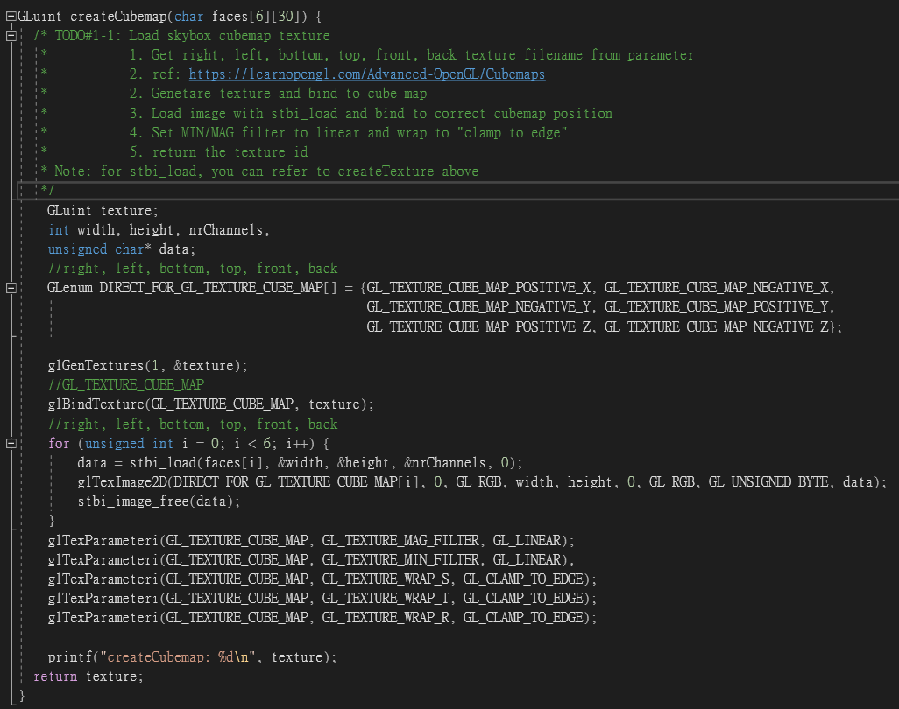

參數設定

Skybox的方向面的參數

Skybox的各方向面的讀檔

**TODO#1-1: Add skybox mode:**

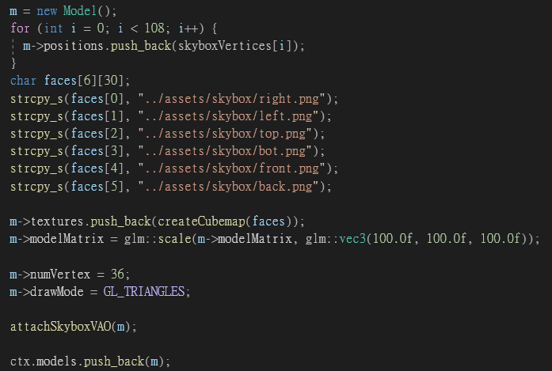

給材質檔案位置

給點座標

**TODO#1-2: Render skybox with shader:**

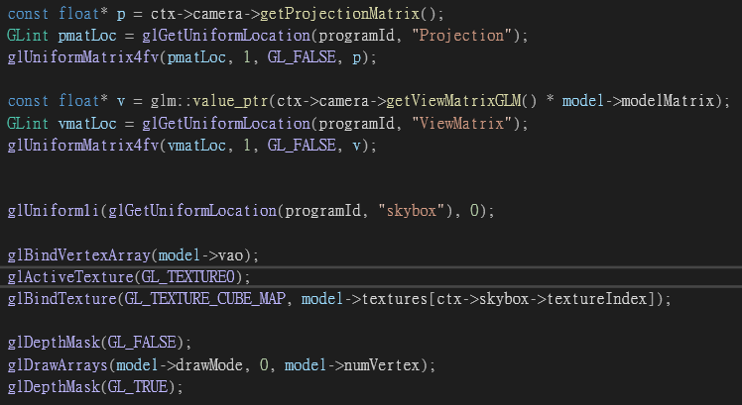

畫skybox

Bind & Active Texture

將變數傳給shader

**TODO#1-2: vertex shader / fragment shader**

vertex shader

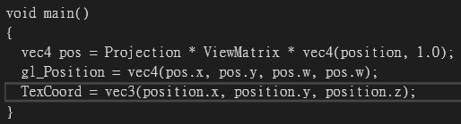

計算gl_Position

傳TexCoord到fragment shader

fragment shader

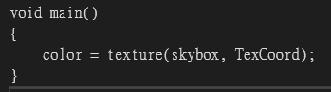

取得材質color

**TODO#2-1 Generate frame buffer and depth map for shadow program**

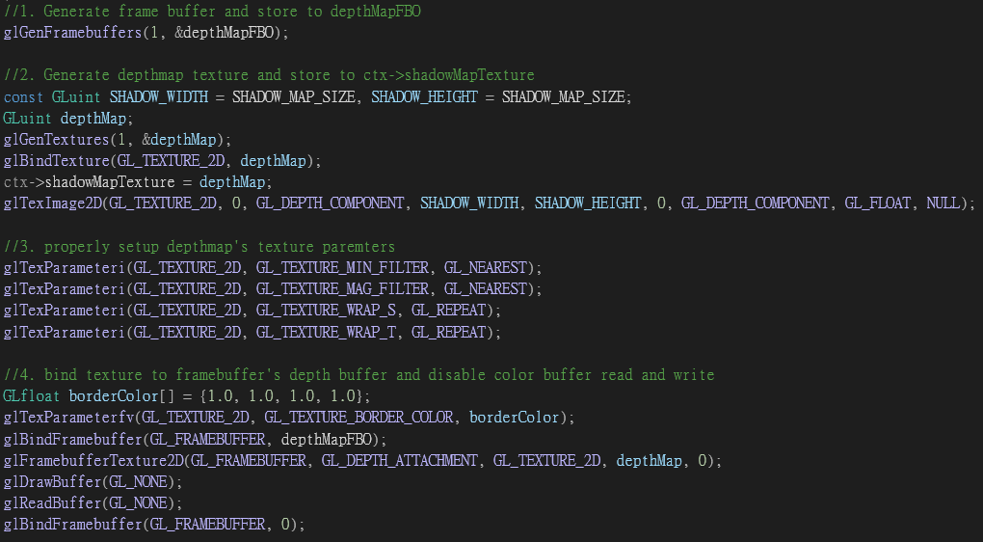

bind texture to framebuffer's depth buffer and disable color buffer read and write

Generate depthmap texture and store to ctx->shadowMapTexture

Generate frame buffer and store to depthMapFBO

**TODO#2-2: Render depth map with shader**

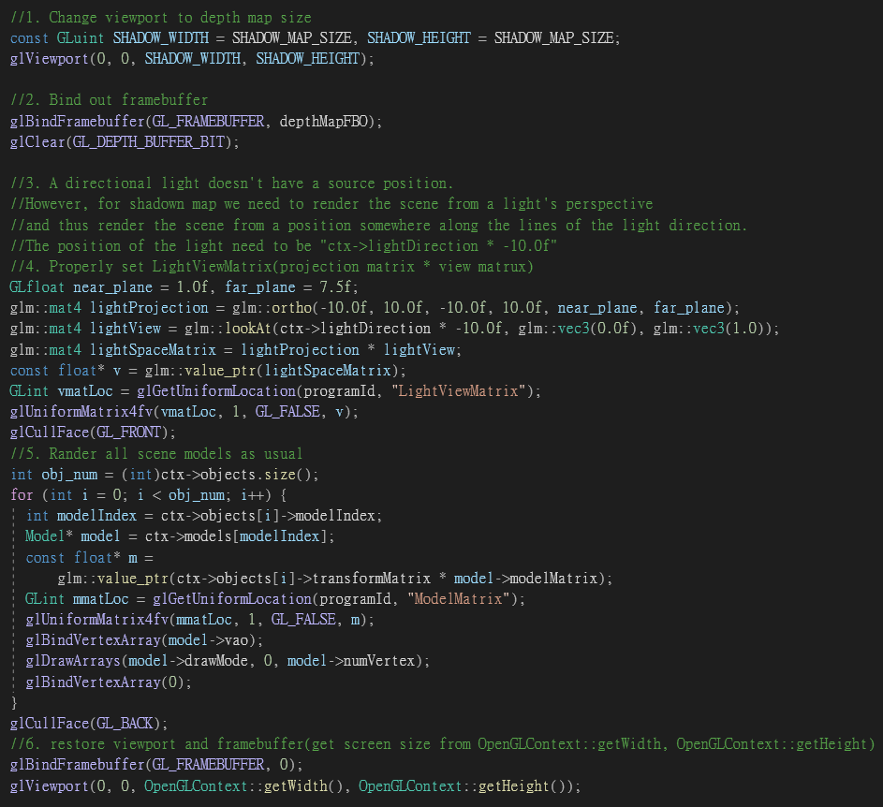

restore viewport and framebuffer(get screen size from OpenGLContext::getWidth, OpenGLContext::getHeight)

Render all scene models as usual

Properly set LightViewMatrix(projection matrix * view matrux)

Bind out framebuffer

Change viewport to depth map size

**TODO#2-3: Render scene with shadow mapping**

* Copy from LightProgram

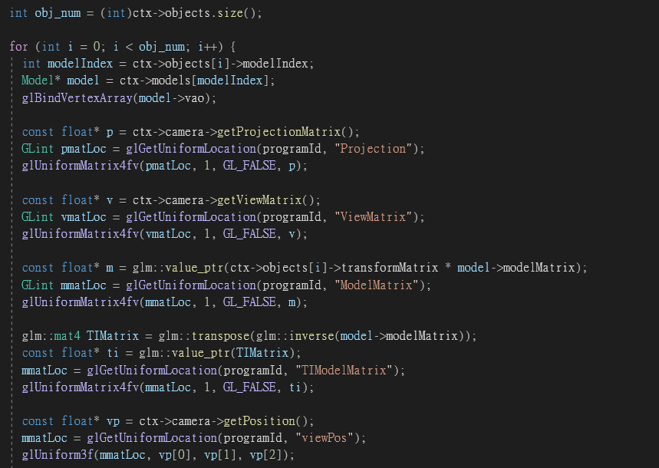

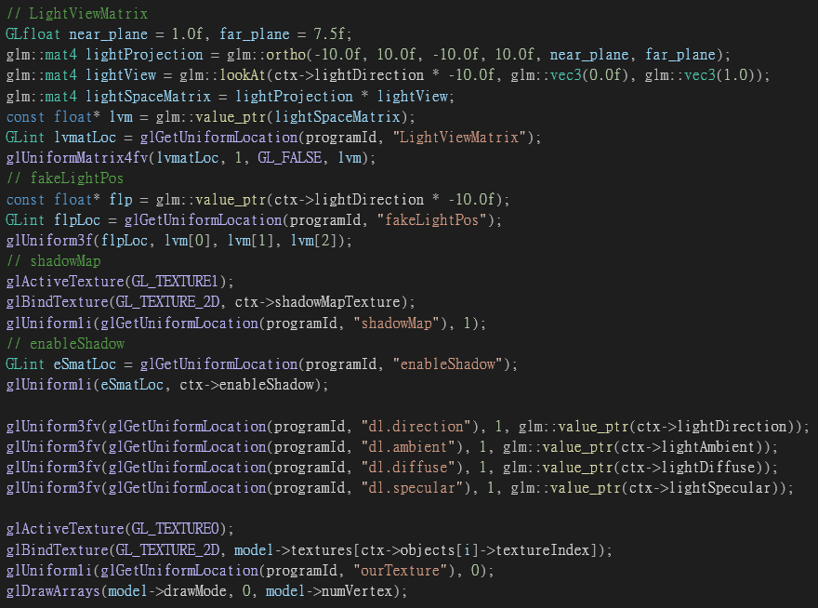

Pass LightViewMatrix, fakeLightPos, shadowMap, enableShadow to shader program

**TODO#2-4: shadow-enabled shader with single direct light**

vertex shader

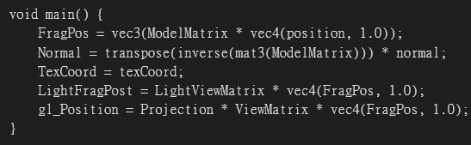

fragment shader: 計算是否在陰影裡

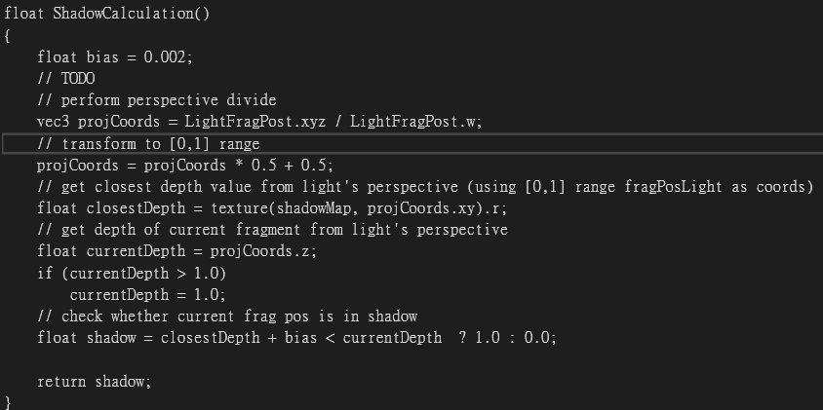

**TODO#3-1: Generate Framebuffer and VAO/VBO for filter**

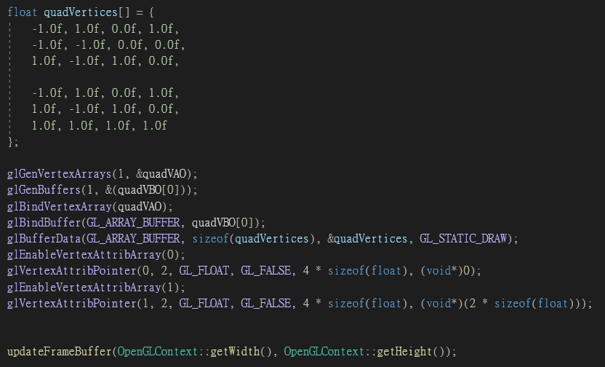

設定VAO/VBO

並傳位置到shader

設定quadVertices

**TODO#3-1: generate color/depth buffer for frame buffer**

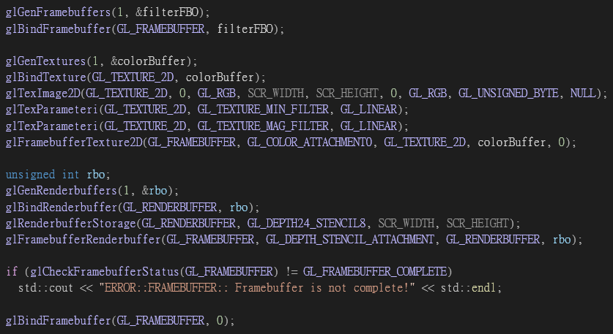

Generate/Bind a render buffer inad store in rboDepth

Set Render buffer size to SCR_WIDTH*SCR_HEIGHT

Attach colorBuffer and rboDepth to filterFBO

Generate color buffer texture and store in colorBuffer

Set texture size to SCR_WIDTH*SCR_HEIGHT

Set MIN/MAG filter to linear

**TODO#3-1: pass VAO, enableEdgeDetection, eanbleGrayscale, colorBuffer to shader and render**

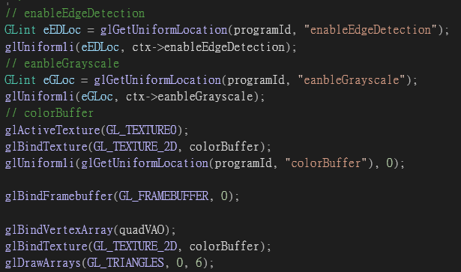

render

pass VAO, enableEdgeDetection, eanbleGrayscale, colorBuffer to shader

**TODO#3-2: apply filter to color**

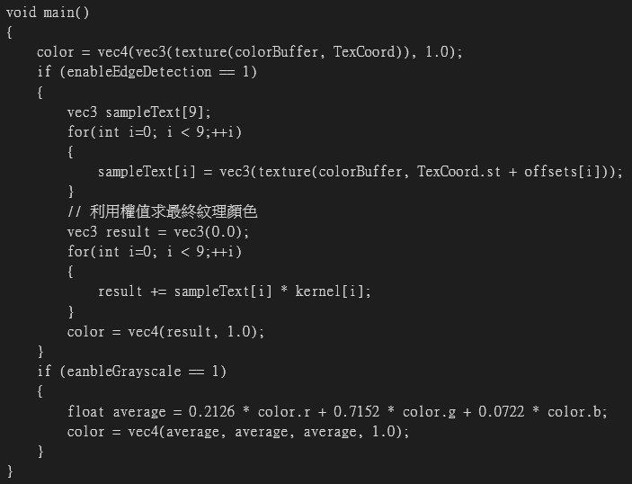

灰階運算

邊緣運算

**Problems you encountered**

* Task2的shadow與shadowLight區分不清楚，誤以為在shadow就要畫出陰影

**BONUS:**

使用按鍵H&J調整Gamma做Gamma Correction

P.S 調到過曝可以找到星星(?)

