Прошлое задание

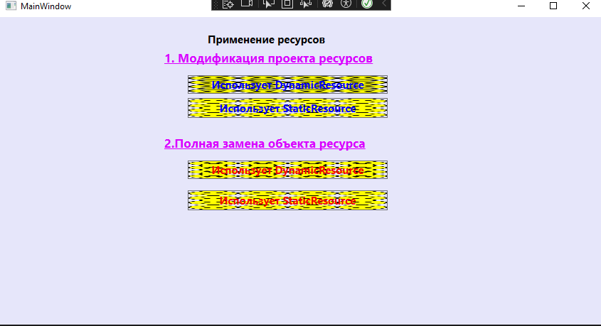

<TextBlock Margin="292,21,330,388" Text="Применение ресурсов" FontWeight="Bold" FontSize="15" />

<TextBlock Text="1. Модификация проекта ресурсов" Margin="231,46,269,352" FontWeight="Bold" FontSize="17" Foreground="#FFDA00FF" TextDecorations="Underline"/>

<Button Content="Использует DynamicResource" FontWeight="Bold" Foreground="#FF0400F3" Margin="264,82,302,325" FontSize="15" Background="{DynamicResource 1}"/>

<Button Content="Использует StaticResource" FontWeight="Bold" Foreground="#FF0400F3" Margin="264,114,302,291" FontSize="15" Background="{StaticResource 2}"/>

<TextBlock Text="2.Полная замена объекта ресурса" Margin="231,166,269,232" FontWeight="Bold" FontSize="17" Foreground="#FFDA00FF" TextDecorations="Underline"/>

<Button Content="Использует DynamicResource" FontWeight="Bold" Foreground="#FFF30700" Margin="264,202,302,205" FontSize="15" Background="{DynamicResource 2}" />

<Button Content="Использует StaticResource" FontWeight="Bold" Foreground="#FFF30700" Margin="264,244,302,161" FontSize="15" Background="{StaticResource 2}"/>

<ImageBrush x:Key="1" ImageSource="C:\Users\kizil\source\repos\WpfApp2\WpfApp2\Images\FACE02.ICO" Viewport="0,0,0.25,0.25" TileMode="FlipXY"></ImageBrush>

<ImageBrush x:Key="2" ImageSource="C:\Users\kizil\source\repos\WpfApp2\WpfApp2\Images\FACE04.ICO" Viewport="0,0,0.25,0.25" TileMode="FlipXY"></ImageBrush>

<SolidColorBrush x:Key="MainWindow" Color="Lavender" ></SolidColorBrush>

1.

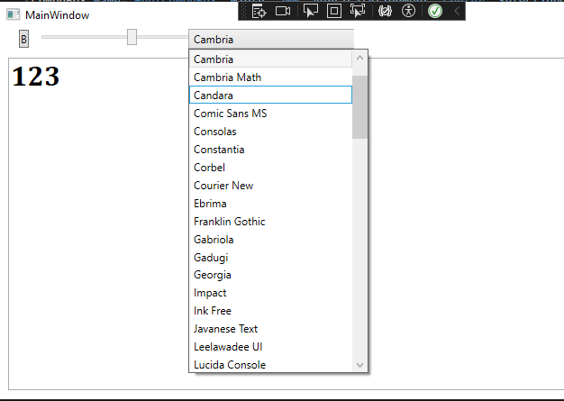

<Grid>

<Grid Grid.Row="0" >

<Slider Name="Slider" Minimum="10" Maximum="50" Value="20" ValueChanged="Slider_ValueChanged" Margin="55,10,605,382"/>

<ComboBox Name="ComboBox" Width="200" VerticalAlignment="Top" SelectionChanged="ComboBox_SelectionChanged" Margin="213,9,387,0"/>

</Grid>

<TextBox Name="textBox" AcceptsReturn="True" Margin="10,48,42,235"/>

<Button Content="B" HorizontalAlignment="Left" VerticalAlignment="Top" Margin="22,10,0,0" Click="Button_Click"/>

</Grid>

public MainWindow()

{

InitializeComponent();

LoadSystemFonts();

}

private void Slider_ValueChanged(object sender, RoutedPropertyChangedEventArgs<double> e)

{

if (textBox != null)

{

textBox.FontSize = e.NewValue;

}

}

private void LoadSystemFonts()

{

foreach (FontFamily fontFamily in Fonts.SystemFontFamilies)

{

ComboBoxItem item = new ComboBoxItem();

item.Content = fontFamily.Source;

ComboBox.Items.Add(item);

}

}

private void ComboBox_SelectionChanged(object sender, SelectionChangedEventArgs e)

{

if (ComboBox != null && ComboBox.SelectedItem != null && textBox != null)

{

string selectedFont = (ComboBox.SelectedItem as ComboBoxItem).Content.ToString();

textBox.FontFamily = new FontFamily(selectedFont);

}

}

private void Button_Click(object sender, RoutedEventArgs e)

{

if (textBox.FontWeight == FontWeights.Normal)

{

textBox.FontWeight = FontWeights.Bold;

}

else

{

textBox.FontWeight = FontWeights.Normal;

}

}

}

}

2.  
  
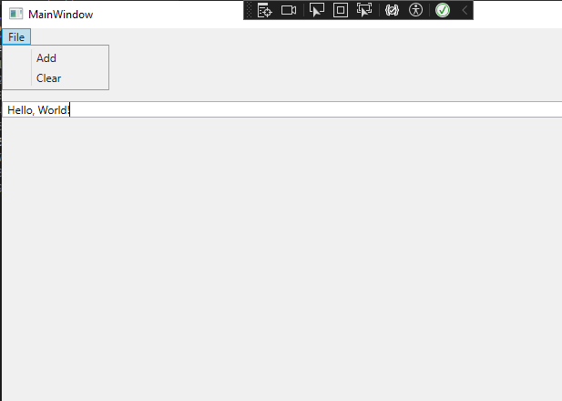

<Menu>

<MenuItem Header="File">

<MenuItem Header="Add" Click="MenuItem_Click"/>

<MenuItem Header="Clear" Click="MenuItem_Click_1"/>

</MenuItem>

</Menu>

<RichTextBox Name="rich" HorizontalAlignment="Center" VerticalAlignment="Top" Margin="0,80,0,0"/>

private void MenuItem_Click(object sender, RoutedEventArgs e)

{

rich.AppendText("Hello, World!\n");

}

private void MenuItem_Click_1(object sender, RoutedEventArgs e)

{

rich.Document.Blocks.Clear();}