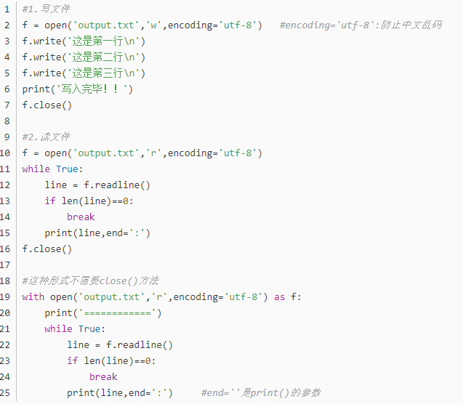

https://blog.csdn.net/weixin_42079187/article/details/80458377