

1. a cache hit returns the saved data to the requester ***(Check values highlighted in green)***

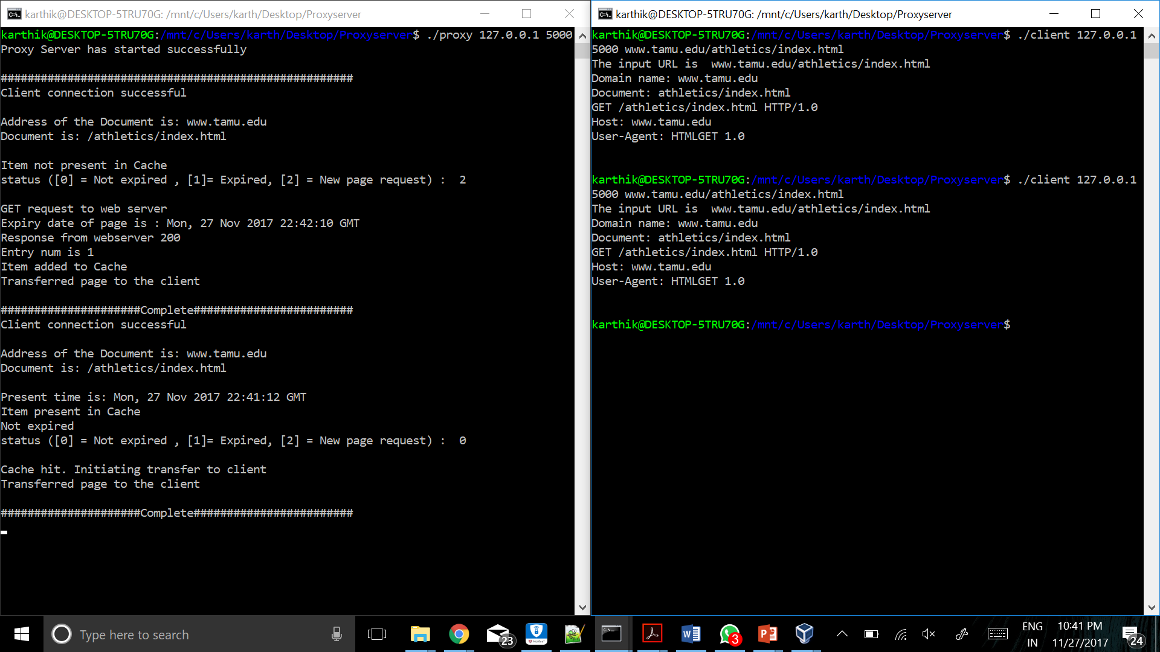



(2) a request that is not in the cache is proxied, saved in the cache, and returned to the requester ***(Check values highlighted in green)***

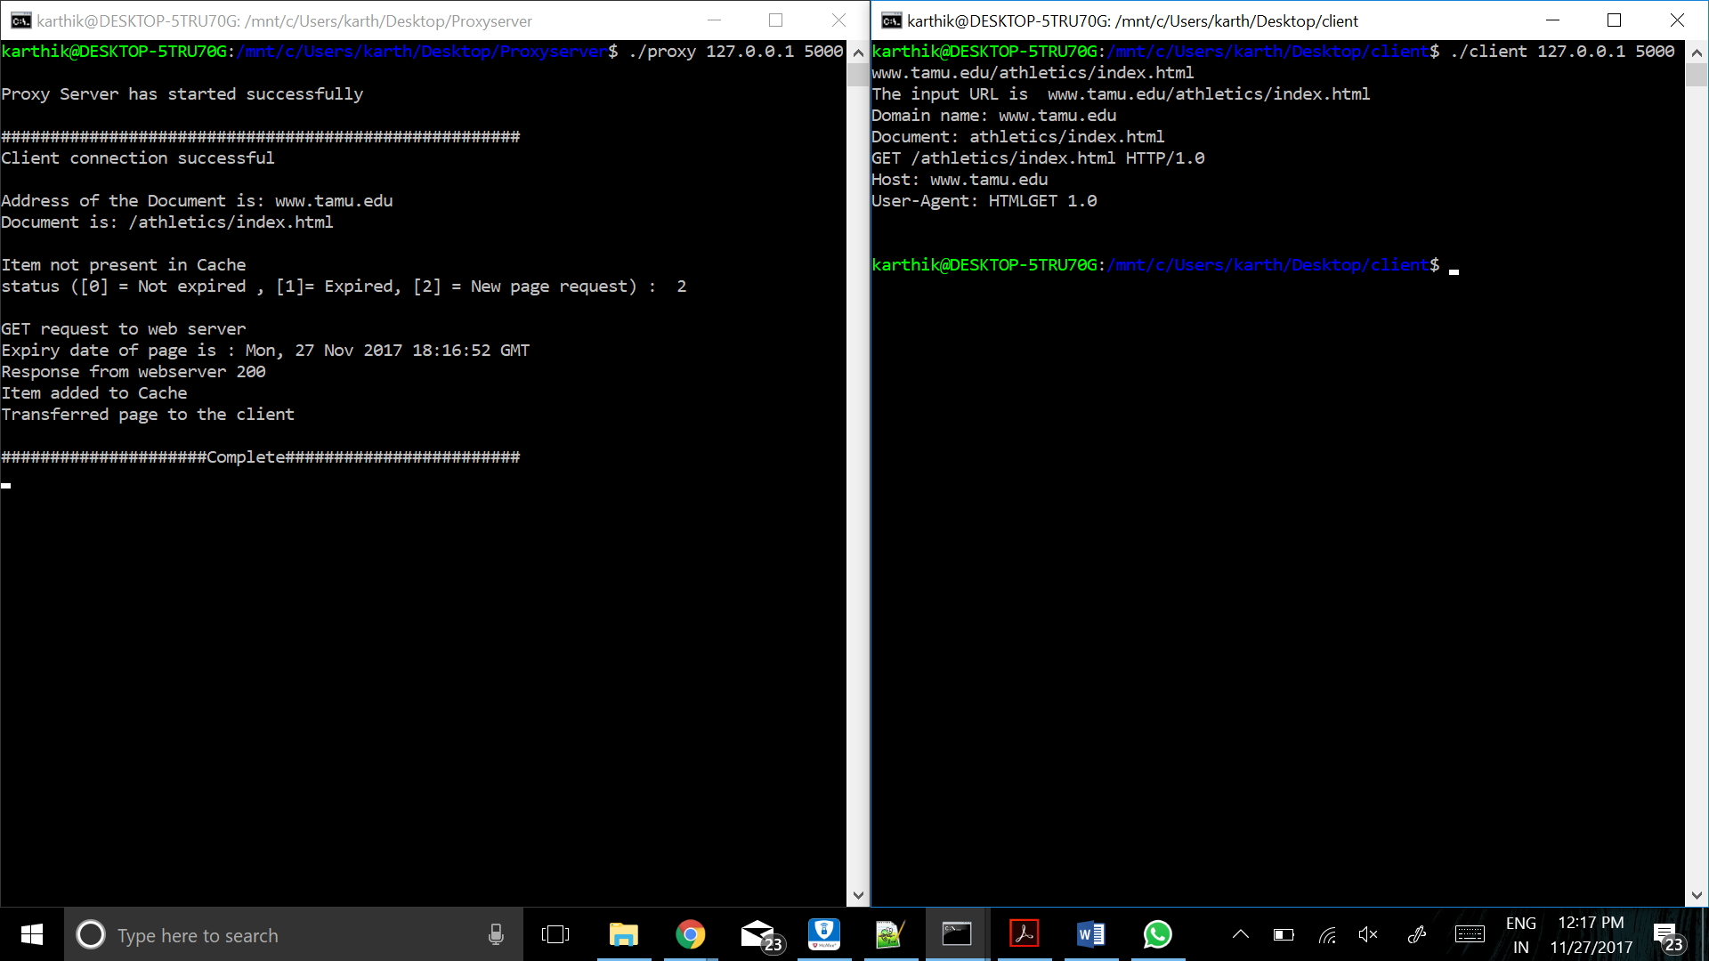



(3) a cache miss with 10 items already in the cache is proxied, saved in the LRU location in cache, and the data is returned to the requester ***(Check values highlighted in light blue)***

Cache Entry 0 : admissions/index.html

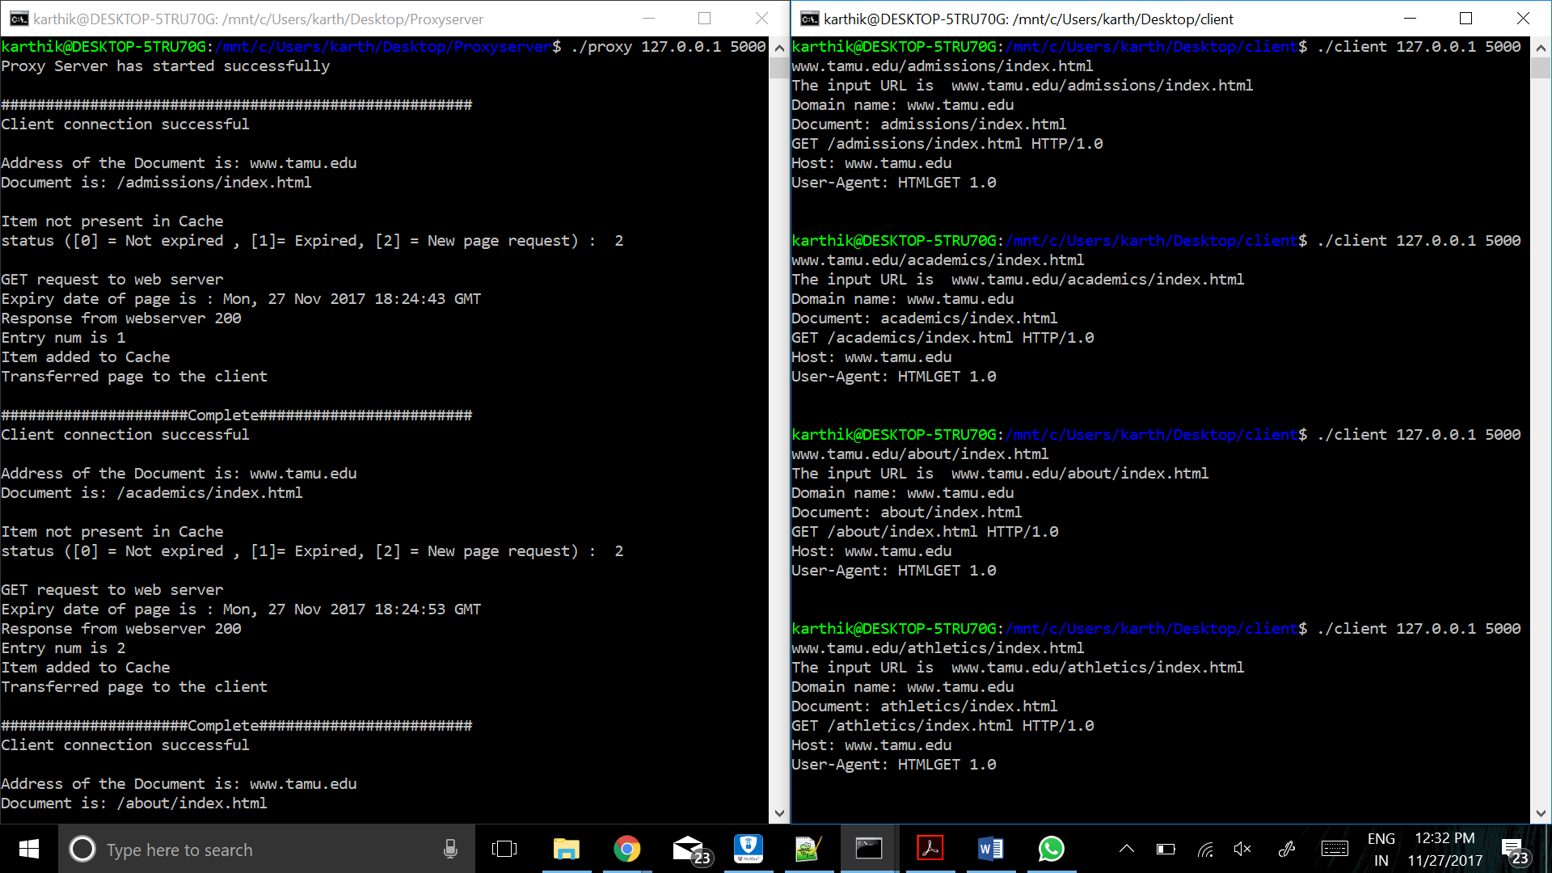



11th Entry to Cache (student-life/index.html) ->Evicts Entry 0

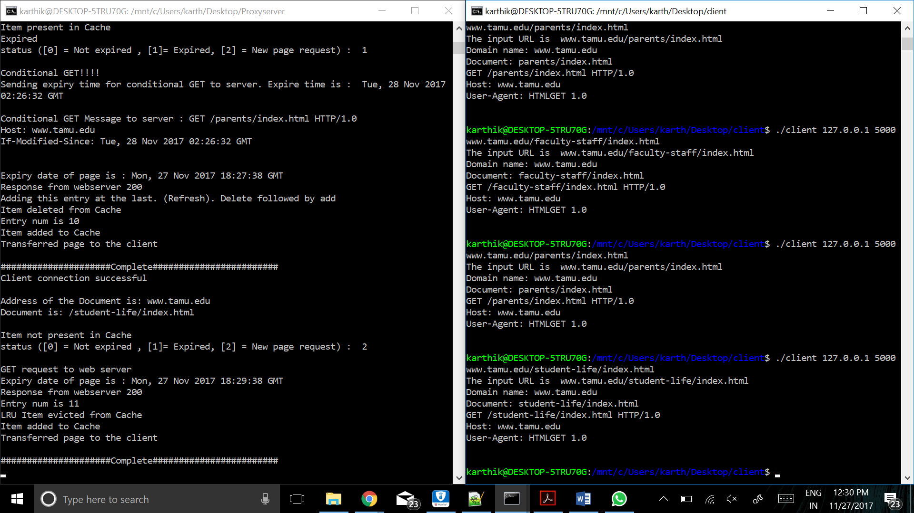



Now Cache Entry 0 (admissions/index.html) accessed again. It is not present in cache now. Added as the last entry



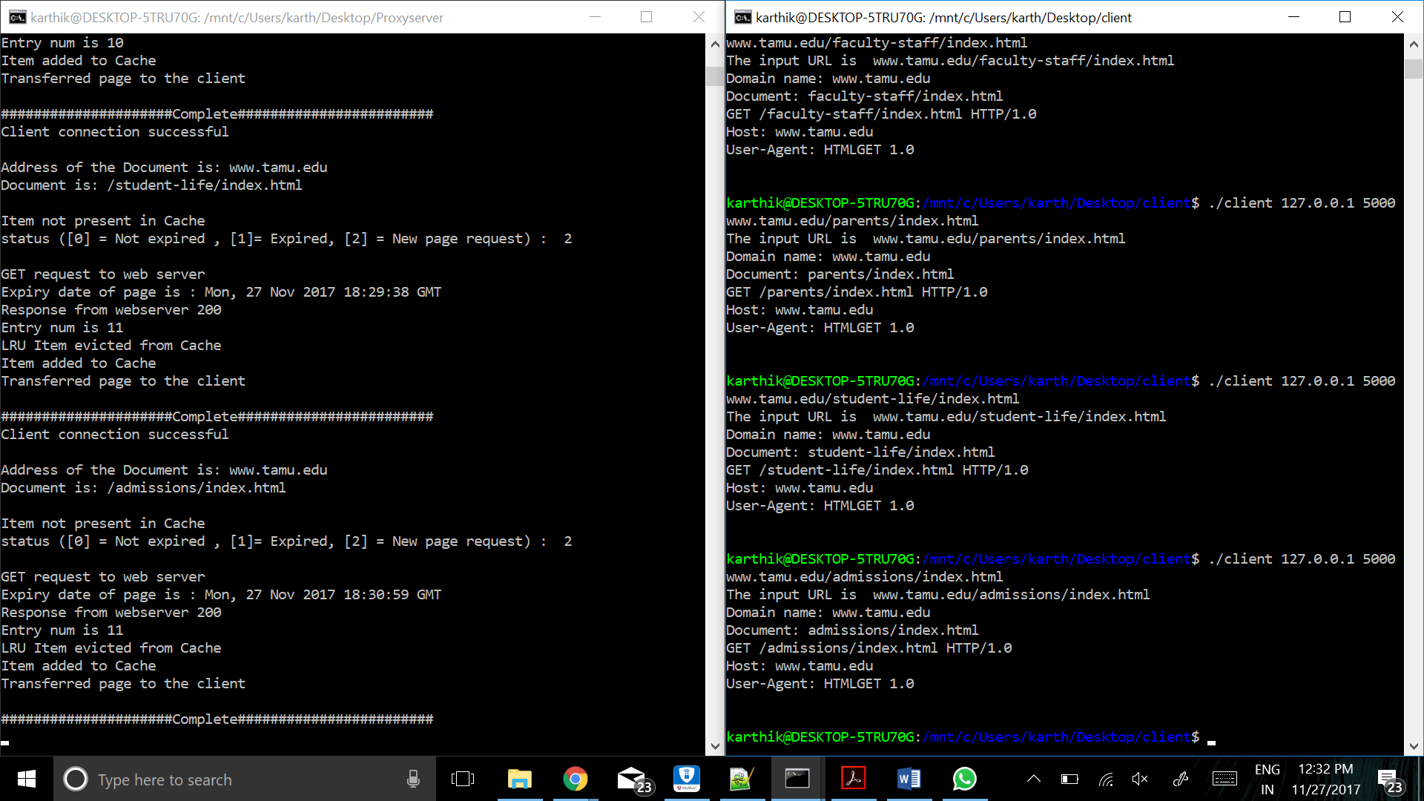



(4) a stale Expires header in the cache is accessed, the cache entry is replaced with a fresh copy, and the fresh data is delivered to the requester ***(Check values highlighted in light blue)***

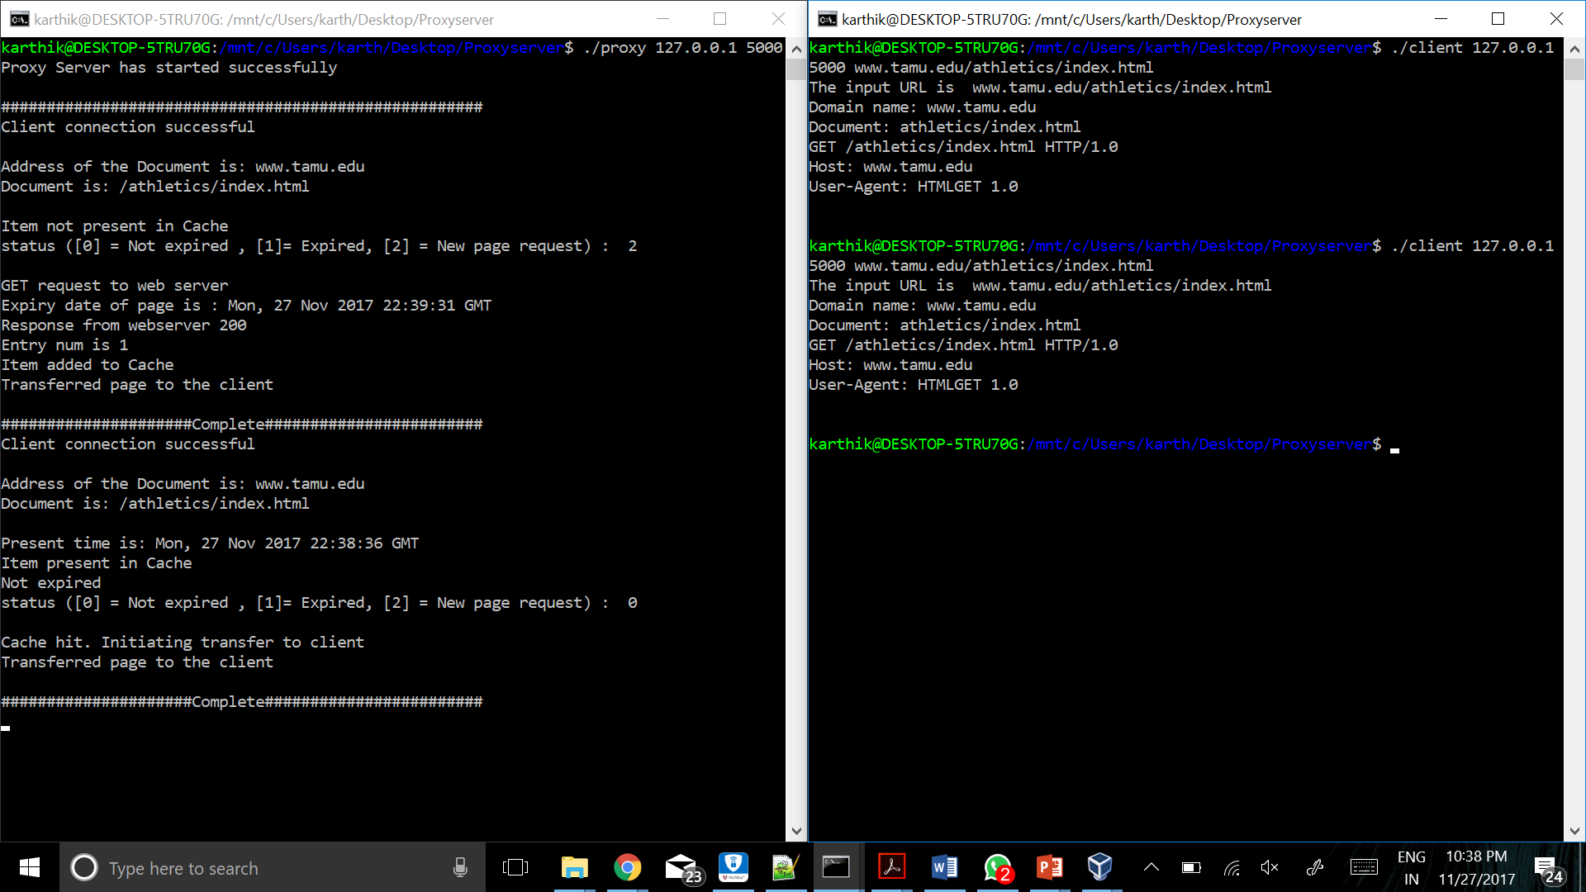

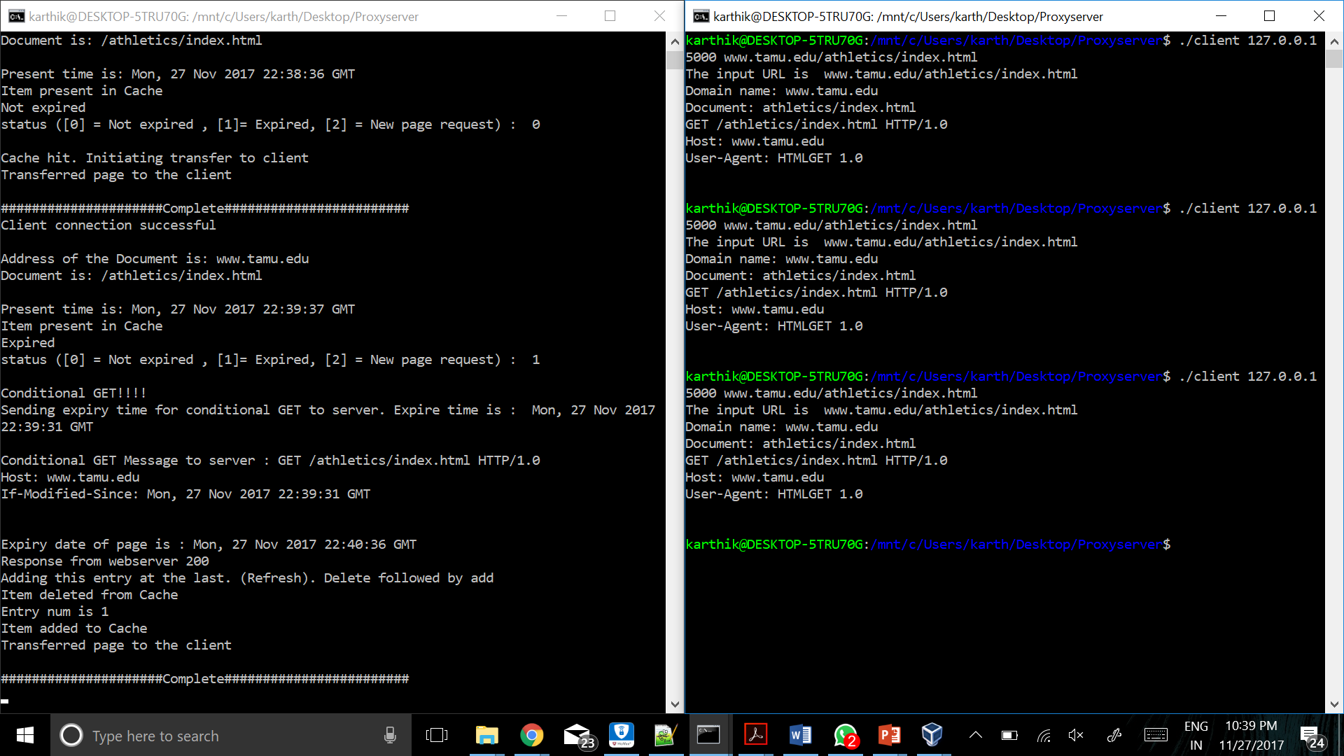



(5) a stale entry in the cache without an Expires header is determined based on the last Web server access time and last modification time, the stale cache entry is replaced with fresh data, and the fresh data is delivered to the requester

***(Check values highlighted in light blue)***

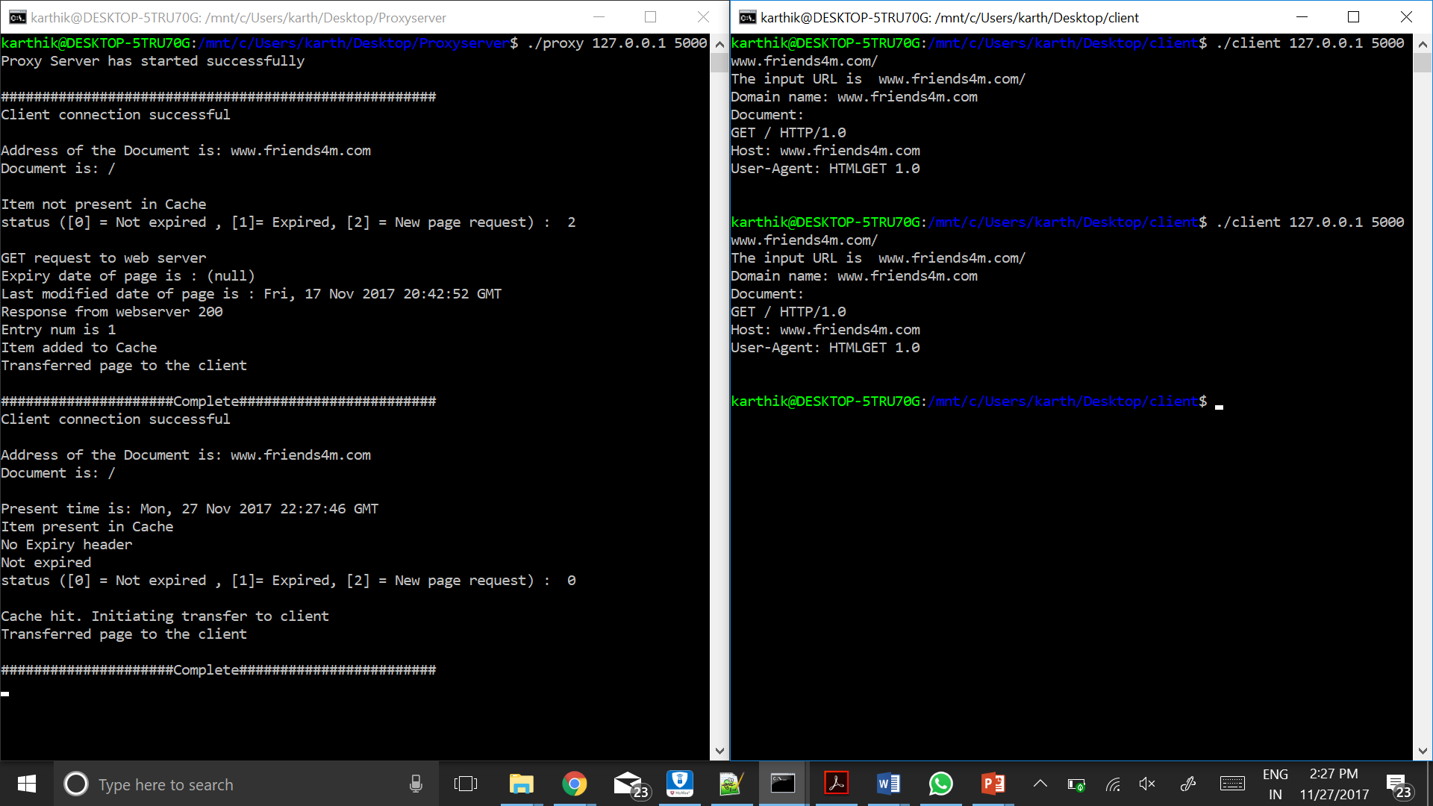

Expires header missing.

Last modified is within a month (Present time : Nov 27 22:27:46 GMT and Last modified is 17 Nov 2017 20:42:52 GMT) and we have immediately accessed it (Last accessed within a day), so it is not expired, **So Conditional GET not triggered**.

(6) a cache entry without an Expires header that has been previously accessed from the Web server in the last 24 hours and was last modified more than one month ago is returned to the requester

***(Check values highlighted in light blue)***

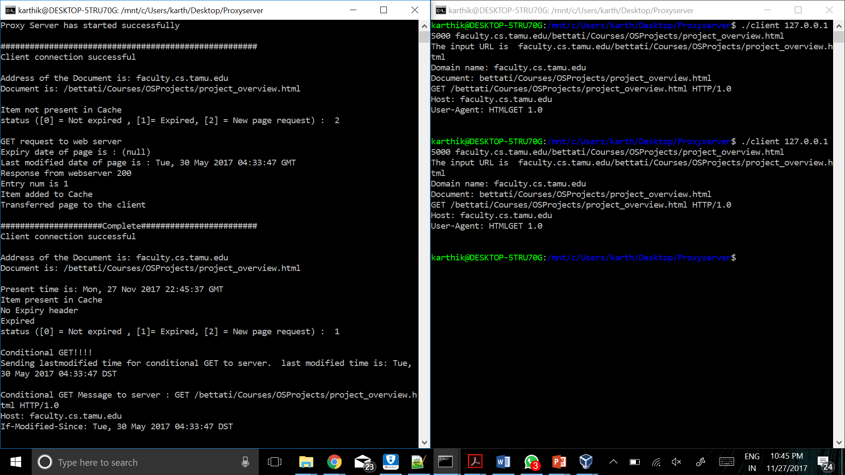



Expires header missing.

Last modified is beyond a month (Present time : Nov 27 22:27:46 GMT and Last modified is 30 May 2017 04:33:47 GMT) and we have immediately accessed it (Last accessed within a day), so it is expired and **Conditional GET triggered**.

A conditional GET (304 response) or HEAD request has been received and would have resulted in a 200 OK response if it were not for the fact that the condition evaluated to false. In other words, there is no need for the server to transfer a representation of the target resource because the request indicates that the client, which made the request conditional, already has a valid representation; the server is therefore redirecting the client to make use of that stored representation as if it were the payload of a 200 OK response.

(7) three clients can simultaneously access the proxy server and get the correct data

