Test Cases for TCP Echo Server and Client, ECEN 602 Network Programming Assignment 1

Test Case 1 : Start server, start one client and send a message from the client.(The line of text is terminated by a newline.)

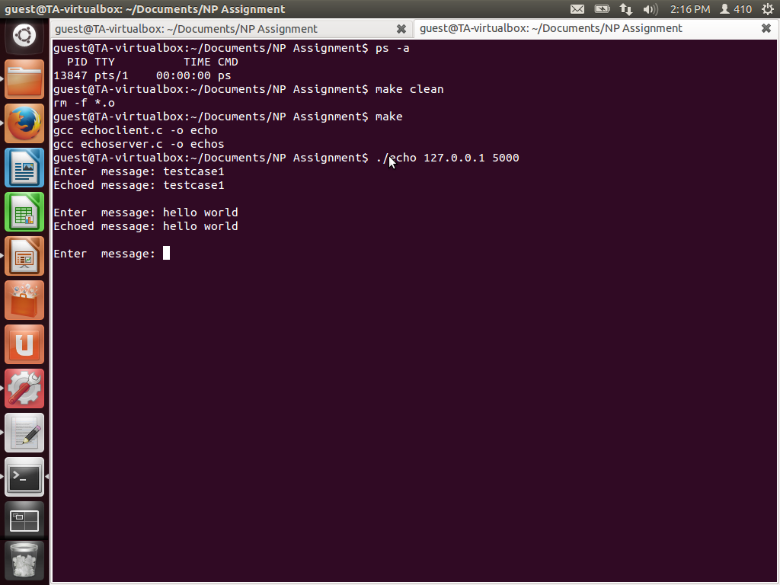

Client

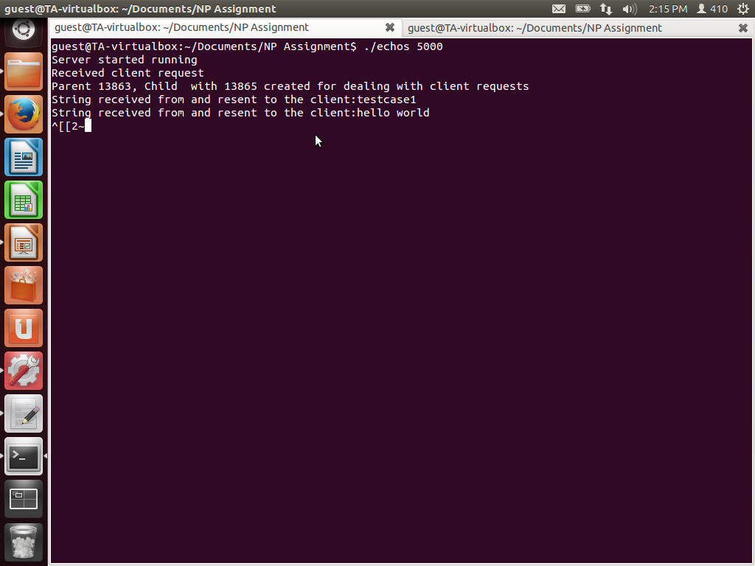

Server

The server responds back/ echoes back the same message to the client.

Test Case 2: line of text the maximum line of length without a newline

Buffer size is considered 6 for this test case.

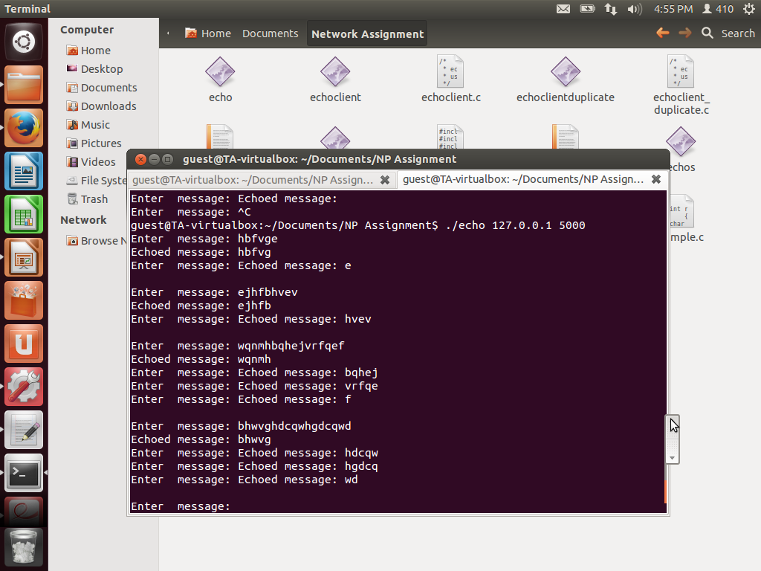

Test Case 3: line with no characters and EOF

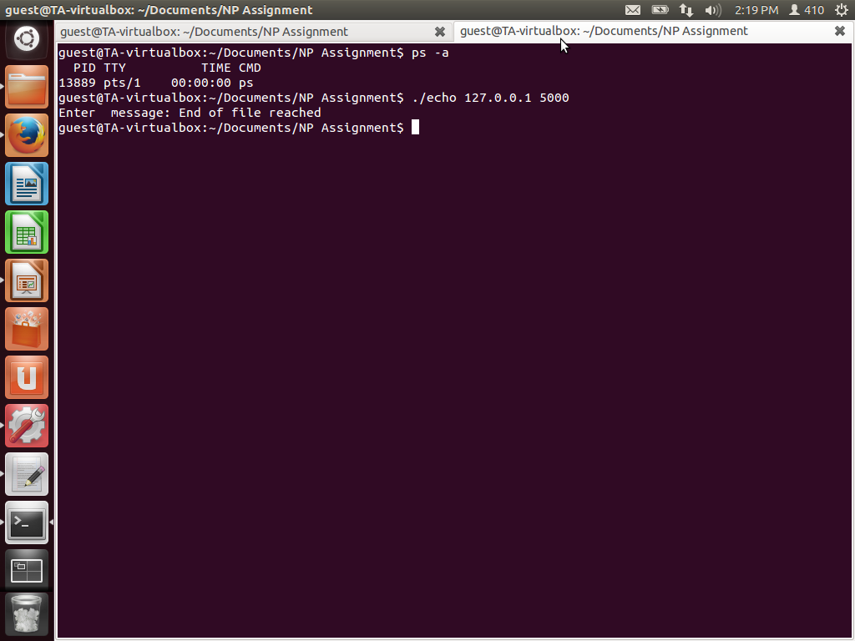

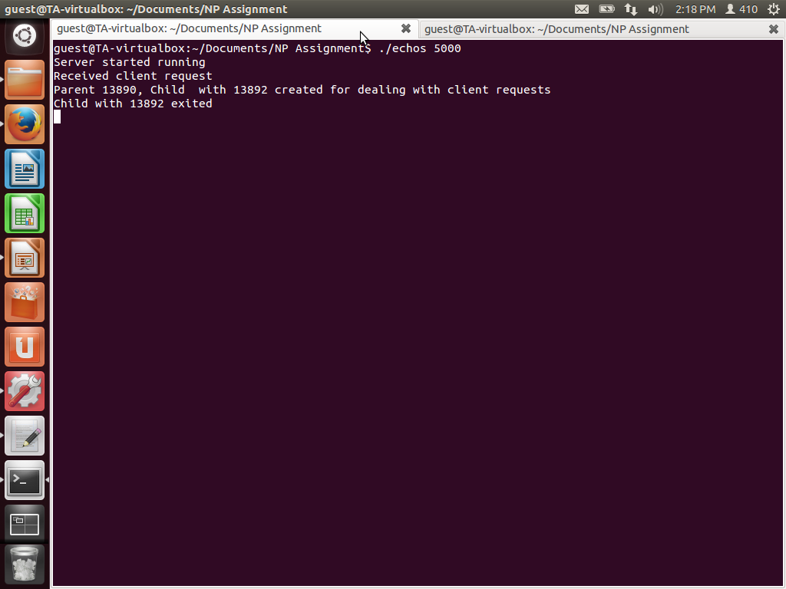

Test Case 4:client terminated after entering the text

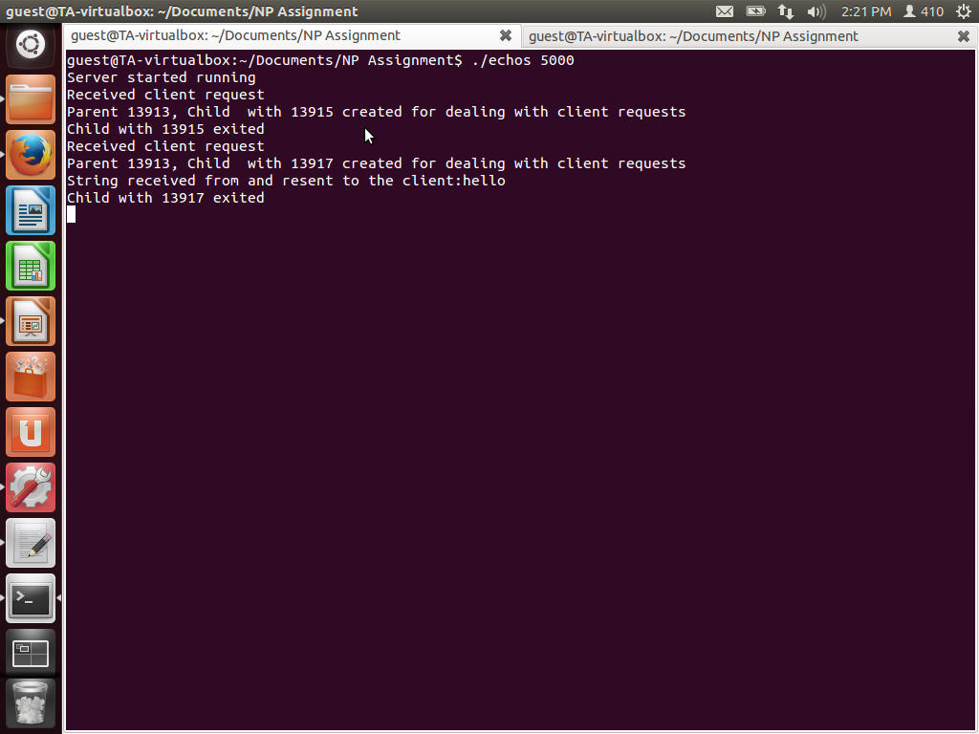

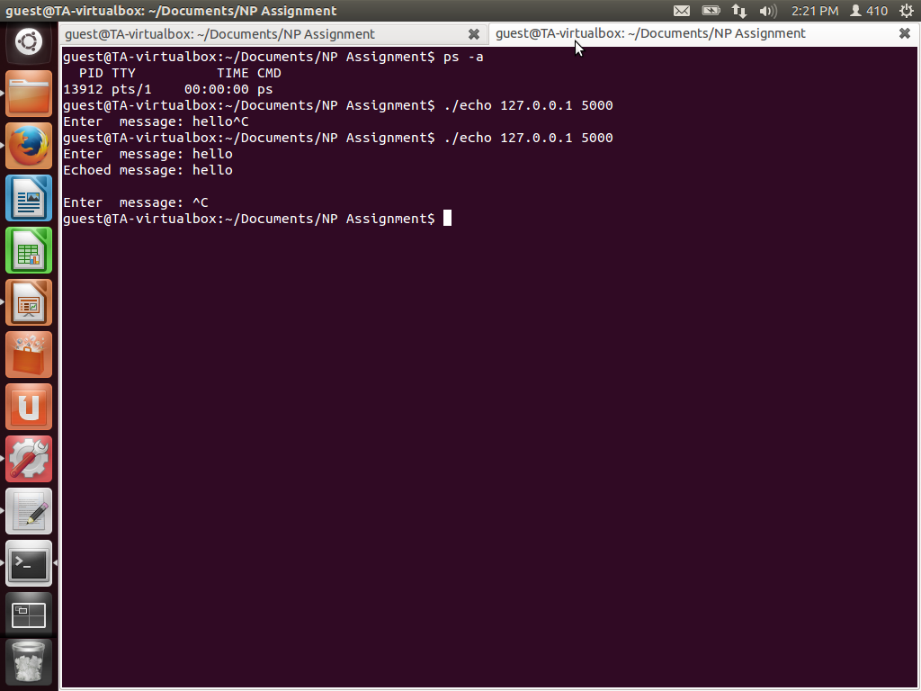

Test Case 5: Three clients connected to the server

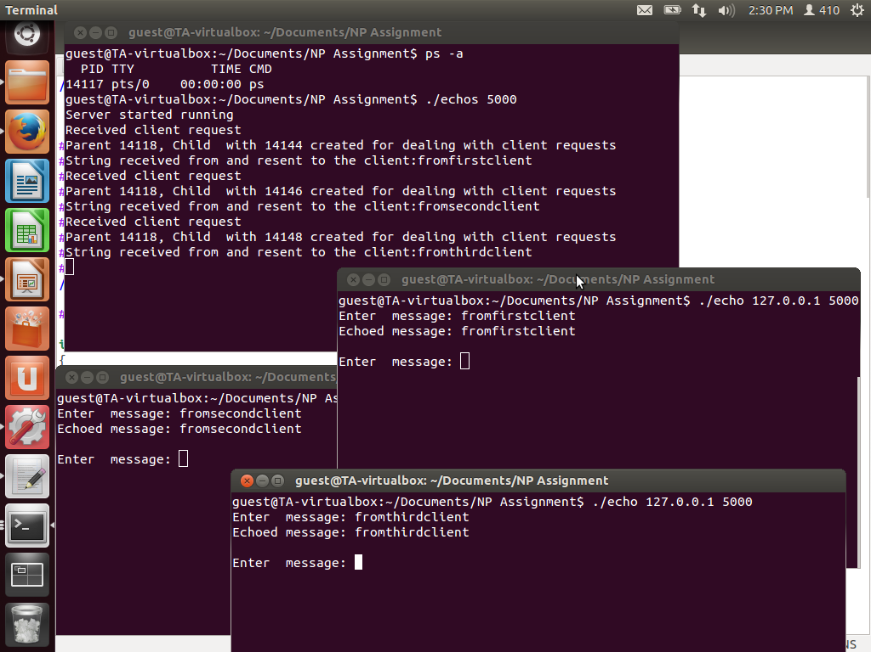

Test Case 6: Start client without the server

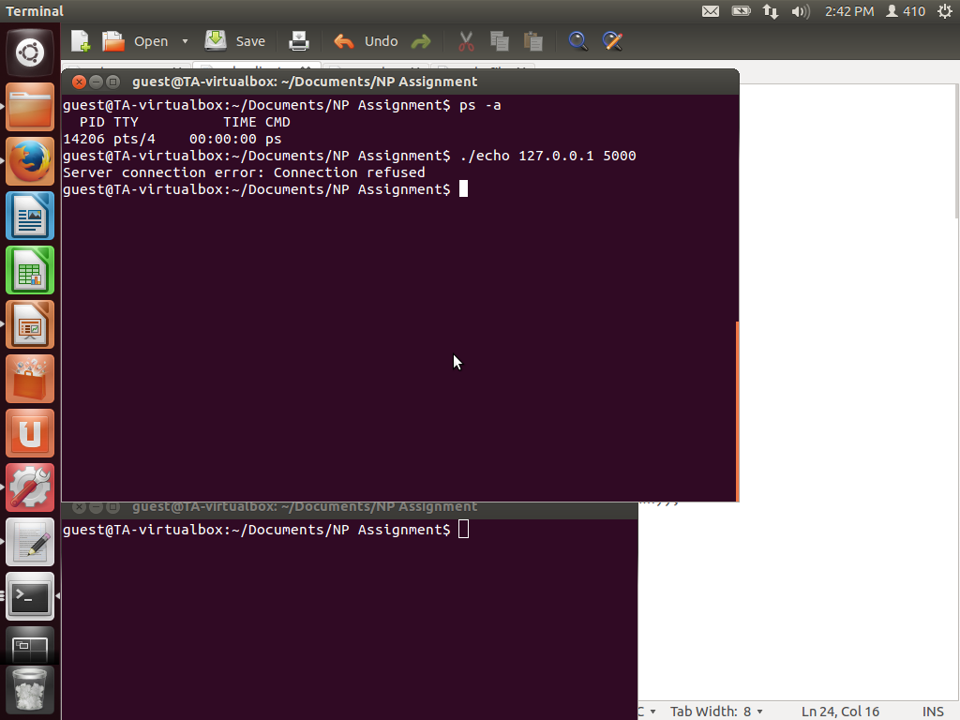

Connection refused