Surecom KPI Parsing Tool

This readme file contains instructions for:

* Installing the prerequisites in order to use to tool
* Installing the tool to a local PC
* Using the tool

# Install the prerequisites

In order to use this tool, you need to install the following:

* Python 3.9.2 or newer ([link](https://www.python.org/downloads/release/python-392/))
* Microsoft Excel 2013 or newer
* gitBash for Windows (optional) ([link](https://git-scm.com/download/win))

# Install the tool

You have two options of getting the source code: either using git commands or download it as a zip file and extract it locally. If you are familiar with git, the repository is located here:

<https://github.com/axydias/Surecom_KPI> (if you don’t have access, let me know to grant access to your account)

## Download the code using zip file

Use the “code” button and select Download ZIP option, as you see below:

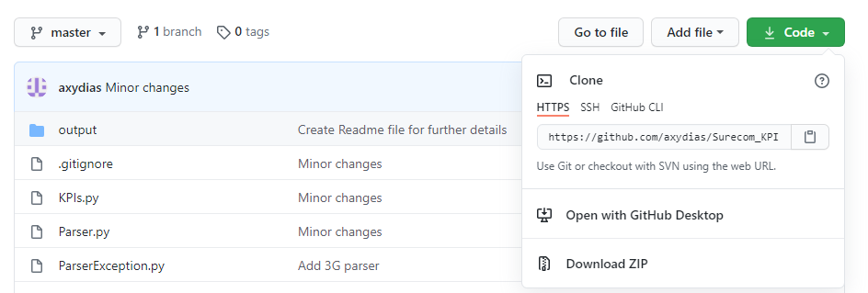

Extract the zip file and it’s ready.

# Use the tool

1. Put all the FMT files that you need to be parsed in a single directory, i.e. input
2. Open command promt from windows
3. Change to the directory, in which the above zip file (with the source code) is extracted.
4. Run: python.exe main.py “<full path of the folder input directory>”

Example: C:\Surecom_KPI>python main.py "C:\Surecom_KPI\input"

The expected output is like:

Program started

Files to be processed:

['VF B1A F0 UMTS.FMT', 'VF B1A F1 UMTS .FMT', 'VF B1A F2 UMTS.FMT', 'VF B1A F3 UMTS.FMT', 'VF B1B F0 UMTS.FMT', 'VF B3 F0 UMTS.FMT', 'VF B3 F2 UMTS.FMT', 'VF B3 F4 UMTS.FMT', 'VF B3 F6 UMTS.FMT', 'VF B3 MEZZ UMTS.FMT', 'VF B4 F0 UMTS.FMT', 'VF B4 F2 UMTS.FMT', 'VF B4 F4 UMTS.FMT', 'VF B4 F6 UMTS .FMT', 'VF B4 F8 UMTS.FMT', 'VF BMT Car pk UMTS.FMT', 'VF BMT CONF UMTS.FMT']

Reading input file C:\Surecom_KPI\input\VF B1A F0 UMTS.FMT

Parsing completed

Writing results to 'C:\Surecom_KPI\output\VF B1A F0 UMTS.csv'

Reading input file C:\Surecom_KPI\input\VF B1A F1 UMTS .FMT

Parsing completed

Writing results to 'C:\Surecom_KPI\output\VF B1A F1 UMTS .csv'

Reading input file C:\Surecom_KPI\input\VF B1A F2 UMTS.FMT

Parsing completed

Writing results to 'C:\Surecom_KPI\output\VF B1A F2 UMTS.csv'

Reading input file C:\Surecom_KPI\input\VF B1A F3 UMTS.FMT

Parsing completed

Writing results to 'C:\Surecom_KPI\output\VF B1A F3 UMTS.csv'

Reading input file C:\Surecom_KPI\input\VF B1B F0 UMTS.FMT

Parsing completed

Writing results to 'C:\Surecom_KPI\output\VF B1B F0 UMTS.csv'

Reading input file C:\Surecom_KPI\input\VF B3 F0 UMTS.FMT

Parsing completed

Writing results to 'C:\Surecom_KPI\output\VF B3 F0 UMTS.csv'

Reading input file C:\Surecom_KPI\input\VF B3 F2 UMTS.FMT

Parsing completed

Writing results to 'C:\Surecom_KPI\output\VF B3 F2 UMTS.csv'

Reading input file C:\Surecom_KPI\input\VF B3 F4 UMTS.FMT

Parsing completed

Writing results to 'C:\Surecom_KPI\output\VF B3 F4 UMTS.csv'

Reading input file C:\Surecom_KPI\input\VF B3 F6 UMTS.FMT

Parsing completed

Writing results to 'C:\Surecom_KPI\output\VF B3 F6 UMTS.csv'

Reading input file C:\Surecom_KPI\input\VF B3 MEZZ UMTS.FMT

Parsing completed

Writing results to 'C:\Surecom_KPI\output\VF B3 MEZZ UMTS.csv'

Reading input file C:\Surecom_KPI\input\VF B4 F0 UMTS.FMT

Parsing completed

Writing results to 'C:\Surecom_KPI\output\VF B4 F0 UMTS.csv'

Reading input file C:\Surecom_KPI\input\VF B4 F2 UMTS.FMT

Parsing completed

Writing results to 'C:\Surecom_KPI\output\VF B4 F2 UMTS.csv'

Reading input file C:\Surecom_KPI\input\VF B4 F4 UMTS.FMT

Parsing completed

Writing results to 'C:\Surecom_KPI\output\VF B4 F4 UMTS.csv'

Reading input file C:\Surecom_KPI\input\VF B4 F6 UMTS .FMT

Parsing completed

Writing results to 'C:\Surecom_KPI\output\VF B4 F6 UMTS .csv'

Reading input file C:\Surecom_KPI\input\VF B4 F8 UMTS.FMT

Parsing completed

Writing results to 'C:\Surecom_KPI\output\VF B4 F8 UMTS.csv'

Reading input file C:\Surecom_KPI\input\VF BMT Car pk UMTS.FMT

Parsing completed

Writing results to 'C:\Surecom_KPI\output\VF BMT Car pk UMTS.csv'

Reading input file C:\Surecom_KPI\input\VF BMT CONF UMTS.FMT

Parsing completed

Writing results to 'C:\Surecom_KPI\output\VF BMT CONF UMTS.csv'

Program ended with success

For every single FMT file, a respective csv file is created, using the same name but different suffix.

If you open a csv file with excel, you should see the values in different columns, like:

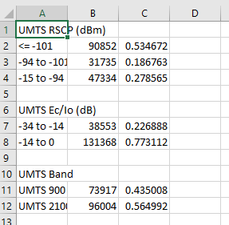

In case you don’t see them like this, you can change the SEPARATOR variable, inside file Settings.py from SEPARATOR = ';' to SEPARATOR = ',' and re-run step 4.

1. You can open the template.xlsx file, which is located on the output directory. This file has 2 sheets, as shown in the picture below. Paste the contents of a csv into Input3G tab of the excel and then switch to Output3G tab. The results will be updated instantly and are ready to be used.

