|  |  |
| --- | --- |
| HILADO, Xyleen C. | November 30,2019 |
| 2-ECE-B | Experiment 9 |

PROBLEM 1

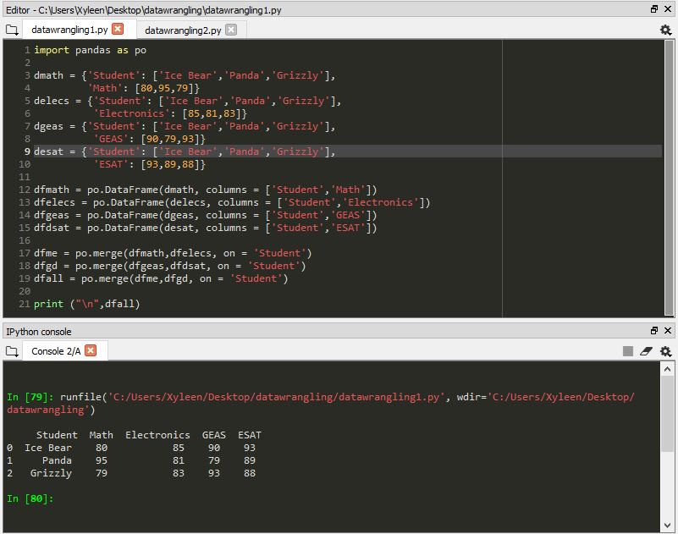

PROBLEM 2

