MARS使用手册

MARS是MIPS汇编语言的模拟机，由密苏里州立大学开发，其下载地址是www.cs.missouristate.edu/MARS。 目前最新版本为4.5。
下面我们将分三个部分介绍MARS。

第一部分：MARS的基本使用

我们将根据示例程序Fibonacci.asm----用于计算斐波那契序列，来具体演示MARS的操作步骤。
- 双击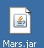，启动MARS程序。
- 点击菜单File…Open或者双击打开工具栏按钮，打开Fibonacci.asm程序。（所有的工具栏按钮都具有相应的菜单项，在后续的具体操作中我们将尽可能地使用工具栏按钮。
- 双击工具栏按钮，汇编该程序。
- 熟悉程序初始数据在内存中的位置和具体的数值。单击复选框，在“10进制显示”和“16进制显示”之间进行切换。
  - 长度为19的数组fibs被初始化为0，其内存地址为0x10010000 … 0x10010048。
  - 变量size的内存地址为0x1001004c，其值为19.
  - 地址0x10010050 … 0x1001006c中存放着一些非空的ASCII串。
- 使用“Settings”菜单配置MARS的显示内容。
- 观察寄存器显示窗口，这里显示了32个通用MIPS寄存器的内容。寄存器显示窗口里的另外两个标签页显示了浮点运算寄存器(Coproc 1)和(Coproc 0)，暂时可以不看。
- 使用滑动条来改变运行速度，便于观察汇编程序的执行过程，而不是瞬间运行完毕。
- 选择程序运行方式：
  - ：直接运行程序：通过黄色高亮部分来观察程序的运行，并在数据段显示窗口Data Segment display中观察斐波那契序列数值的变化。如下图中黄色和蓝色部分。
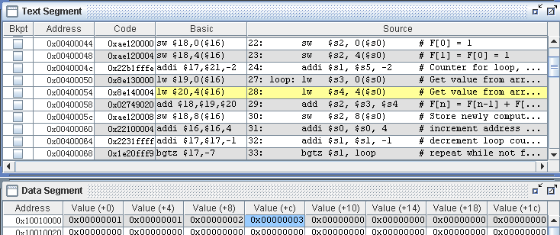
  - ：重置程序为初始值。
  - ：单步执行程序，和（单步回退程序）功能相反。

- 在输入输出窗口中观察程序的输出，如下图所示：
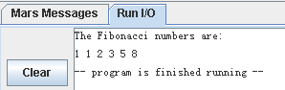
- 修改某个内存地址中的内容。（修改寄存器的内容类似）
  - 在输出结果子程序的第一条指令前添加断点，即勾中该指令的复选框。
  - 单击和，重新运行程序后，程序将在断点处停止运行。
  - 双击存储菲波那契序列 某个内存位置，该单元将高亮显示，并接受键盘输入。输入一个数值，按回车键结束输入，如下图所示，内存地址0x10010008中现在存放的数据是0x00000024。
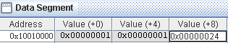
  - 单击，从断点处继续执行程序。程序的输出将会包含刚才输入的数值，而不是原来的菲波那契数。
- 单击，查看帮助文件，熟悉MIPS指令、伪指令、directives和syscalls。
- 修改程序，使得 程序运行时提示用户输入菲波那契序列的长度。
  - 选择Edition标签页，返回程序编辑界面。
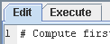
  - MIPS注释符号是#。一行中#后面的所有符号都是注释内容。
  - 去掉第12行到第19行代码的注释标志，这几行用于提示用户输入 菲波那契序列的长度，允许输入的长度范围为2-19（主要是受32位数的大小限制）。
  - 查找帮助文件，找出执行读入整数功能的syscall指令的参数值。
- 重新运行程序，观察结果值。

Part 2 : MARS Tools

You may have noticed that MARS has a Tools menu. The capabilities provided through this menu really catapult MARS into a different league of computer science educational software.

We call each of the items in the Tools menu a MARS Tool. A MARS Tool is best described as a pop-up application that observes MIPS memory and/or register activity during MIPS program execution then communicates that activity to the tool user to serve a particular purpose. This is best seen by example.

MARS Tools Activity 1 : Running the Data Cache Simulator tool

- Close any MIPS programs you are currently using.

- Open the program row-major.asm from the Examples folder. This program will traverse a 16 by 16 element integer matrix in row-major order, assigning elements the values 0 through 255 in order. It performs the following algorithm:
for (row = 0; row < 16; row++)
for (col = 0; col < 16; col++)
data[row][col] = value++;

- Assemble the program.

- From the Tools menu, select Data Cache Simulator. A new frame will appear in the middle of the screen.

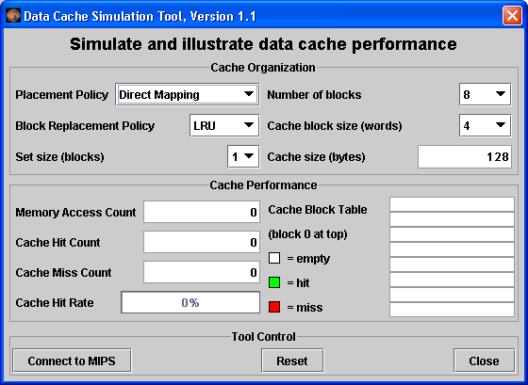
This is a MARS Tool that will simulate the use and performance of cache memory when the underlying MIPS program executes. Notice its three major sections:
  - Cache Organization: You can use the combo boxes to specify how the cache will be configured for this run. Feel free to explore the different settings, but the default is fine for now.
  - Cache Performance: With each memory access during program execution, the simulator will determine whether or not that access can be satisfied from cache and update the performance display accordingly.
  - Tool Control: These buttons perform generic control functions as described by their labels.

- Click the tool's Connect to MIPS button. This causes the tool to register as an observer of MIPS memory and thus respond during program execution.

- Back in MARS, adjust the Run Speed slider to 30 instructions per second. It is located at the right side of the toolbar. This slows execution so you can watch the Cache Performance animation.
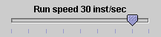

- In MARS, run the program using the Run toolbar button , the menu item or keyboard shortcut. Watch the Cache Performance animate as it is updated with every access to MIPS memory.

- What was the final cache hit rate? _____________. With each miss, a block of 4 words are written into the cache. In a row-major traversal, matrix elements are accessed in the same order they are stored in memory. Thus each cache miss is followed by 3 hits as the next 3 elements are found in the same cache block. This is followed by another miss when Direct Mapping maps to the next cache block, and the patterns repeats itself. So 3 of every 4 memory accesses will be resolved in cache.

- Given that explanation, what do you predict the hit rate will be if the block size is increased from 4 words to 8 words? ______________. Decreased from 4 words to 2 words? ___________.

- Verify your predictions by modifying the block size and re-running the program from step 7.
NOTE: when you modify the Cache Organization, the performance values are automatically reset (you can always use the tool's Reset button).
NOTE: You have to reset the MIPS program before you can re-run it.
NOTE: Feel free to adjust the Run Speed slider to maximum speed anytime you want.

- Repeat steps 2 through 10 for program column-major.asm from the Examples folder. This program will traverse a 16 by 16 element integer matrix in column-major order, assigning elements the values 0 through 255 in order. It performs the following algorithm:
for (col = 0; col < 16; col++)
for (row = 0; row < 16; row++)
data[row][col] = value++;
NOTE: You can leave the Cache Simulator in place, move it out of the way, or close it. It will not interfere with the actions needed to open, assemble, or run this new program and will remain connected to MIPS memory. If you do not close the tool, then skip steps 4 and 5.

- What was the cache performance for this program? ____________. The problem is the memory locations are now accessed not sequentially as before, but each access is 16 words beyond the previous one (circularly). With the settings we've used, no two consecutive memory accesses occur in the same block so every access is a miss.

- Change the block size to 16. Note this will reset the tool.

- Create a second instance of the Cache Simulator by once again selecting Data Cache Simulator from the Tools menu. Adjust the two frames so you can view both at the same time. Connect the new tool instance to MIPS, change its block size to 16 and change its number of blocks to 16.

- Re-run the program. What is the cache performance of the original tool instance? ____________. Block size 16 didn't help because there was still only one access to each block, the initial miss, before that block was replaced with a new one. What is the cache performance of the second tool instance? ____________. At this point, the entire matrix will fit into cache and so once a block is read in it is never replaced. Only the first access to a block results in a miss.

In what courses might an exercise like this one be useful for your students? I have used a variation on this exercise as a student exercise in Operating Systems, and for a lecture illustration of the cache concept in Otterbein's CS 0 course, "The Scope of Computer Science".

MARS Tools Activity 2 : Running the Cache Simulator as a stand-alone

- In command mode, traverse to the directory containing Mars.jar and enter the command:
java -classpath Mars.jar mars.tools.CacheSimulator

- The cache simulator tool is launched. Its Tool Control section is replaced by Application Control, which contains additional controls for loading, assembling and running MIPS programs. It uses MARS' MIPS assembler and runtime simulator in the background to control MIPS execution.
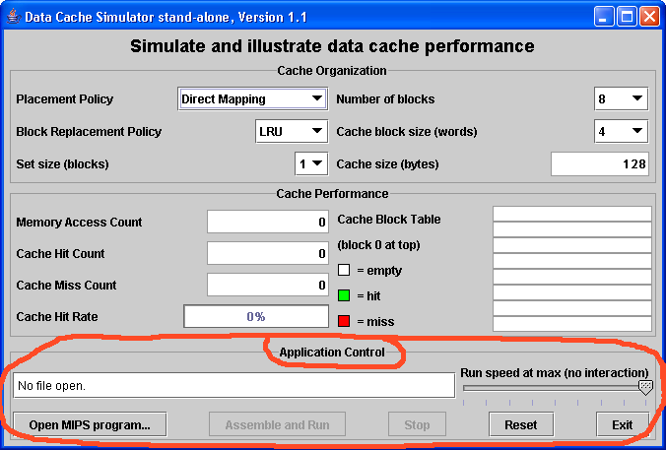

- Click the Open MIPS program button and a File Open dialog will pop up. Browse to and select a MIPS program to run. Select row_major.asm again if you wish.

- The Assemble and Run button is now enabled. Click it to assemble and run the program. The animation will be very rapid.

- Use the Run Speed slider to adjust the running speed, click the Reset button then click Assemble and Run again. While the program is running, the Stop button is enabled. Program status is updated in the single line text field.

We plan to implement a small MARS Tool Suite application to simplify the selection and launching of tools such as the Cache Simulator that are capable of running outside the MARS integrated development environment.
MARS Tools Activity 3 : The Memory Reference Visualization tool

- Open the program row-major.asm from the Examples folder if it is not already open.
- Assemble the program.

- From the Tools menu, select Memory Reference Visualization. A new frame will appear in the middle of the screen.

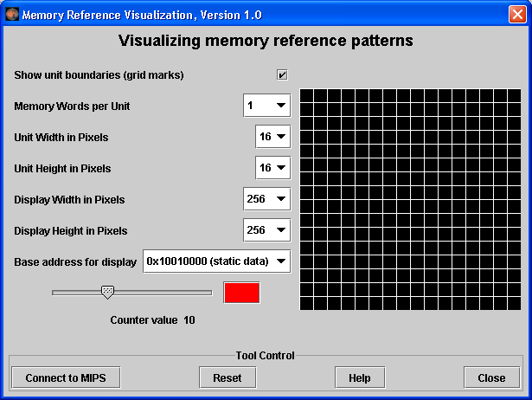

This tool will paint a grid unit each time the corresponding MIPS memory word is referenced. The base address, the first static data segment (.data directive) word, corresponds to the upper-left grid unit. Address correspondence continues in row-major order (left to right, then next row down).

The color depends on the number of times the word has been referenced. Black is 0, blue is 1, green is 2, yellow is 3 and 4, orange is 5 through 9, red is 10 or higher. View the scale using the tool’s slider control. You can change the color (but not the reference count) by clicking on the color patch.

- Click the tool's Connect to MIPS button. This causes the tool to register as an observer of MIPS memory and thus respond during program execution.

- Back in MARS, adjust the Run Speed slider to 30 instructions per second.
- Run the program. Watch the tool animate as it is updated with every access to MIPS memory. Feel free to stop the program at any time.

- Hopefully you observed that the animation sequence corresponded to the expected memory access sequence of the row-major.asm program. If you have trouble seeing the blue, reset the tool, move the slider to position 1, change the color to something brighter, and re-run.

- Repeat steps 2 through 7, for column-major.asm. You should observe that the animation sequence corresponded to the expected memory access sequence of this program.

- Repeat again for fibonacci.asm to observe the animated pattern of memory references. Adjust the run speed and re-run if necessary.

- (Optional) Create a new instance of the Data Cache Simulator. Move the two frames around so you can see both. Connect the cache simulator to MIPS and reset the Memory Reference Visualization. Re-run the program. This exercise illustrates that two different tools can be used simultaneously.

The Memory Reference Visualization tool could be useful in an operating systems course to illustrate spatial and temporal locality and memory reference patterns in general.

Part 3 : Extending MARS Capabilities

Our session today is not long enough for interactive activities in this area, but we’ll provide you with enough detail that you can pursue them on your own if you desire.

Abstract

MARS can be customized and extended in four different ways: (1) writing new MARS Tools, (2) writing new MIPS system calls, (3) writing new MIPS pseudo-instructions, and (4) writing new MIPS basic instructions. Techniques for all four are described here.

You have the ability to extend and customize certain MARS capabilities to make it more useful in your courses. This document describes four different techniques for extending MARS capabilities:

- Ability to write MARS Tools for inclusion in the Tools menu and stand-alone use.

- Ability to define and add new system calls for subsequent use by MIPS programs.

- Ability to customize the instruction set by adding, removing or modifying pseudo (macro) instruction specifications.

- Ability to customize the basic instruction set by adding, removing or modifying basic instruction specifications.

These procedures apply to MARS 3.2.1, released January 2007. Some may be streamlined in future releases.

The ability to define and plug in new MARS Tools will be used to develop new learning aids for students in a variety of computer science courses and provide micro-worlds for assembly language students to target in their projects. Through those tools it is possible to deeply engage students in both settings.

The ability to modify the set of system calls, basic instructions, and pseudo-instructions can be used to define a complete instruction set for an alternative RISC architecture. MARS was not designed with this in mind however, so support is uneven. For example, instruction syntax analysis and code generation is driven by the example and template provided with each instruction, whereas lexical analysis such as the recognition of register names is embedded in program logic and cannot easily be modified. A customized instruction set has to use MIPS conventions for labeling, register naming, and so forth. Hopefully MARS can be refactored in future releases to facilitate its use for alternative instruction sets.
1. Writing your own MARS Tool and plugging it into MARS

Abstract

If you think MARS Tools like the Cache Simulator are cool then why not develop your own? There are two different ways to do so: (1) write a class that implements the MarsTool interface and is launched from the Tools menu in MARS, or (2) write a class that extends the AbstractMarsToolAndApplication class and runs either from the Tools menu or as a free-standing application. You can also write a free-standing application that uses the Mars API.

This section describes two different techniques for developing your own MARS Tool.

- Write a class that implements the mars.tools.MarsTool interface and keep it in the mars.tools package. It will automatically be added to the Tools menu the next time MARS is run and launched when its menu item is selected.

- Write a class that extends mars.tools.AbstractMarsToolAndApplication and keep it in the mars.tools package. It will automatically be added to the Tools menu the next time MARS is run and launched when its menu item is selected. It can also be launched from outside MARS as a free-standing Java application that uses the Mars API to control the assembly and execution of MIPS programs.

It is also possible to write your own application from scratch using the Mars API. This should be considered only for very specialized applications and should be undertaken with great care. The AbstractMarsToolAndApplication class provides full support for assembling and running MIPS programs in the background and is the preferred approach.

MyTool implements MarsTool approach

- Extract the MARS distribution from its JAR file. The JAR file does not have an outermost folder to contain everything, so you'll want to create one and extract it into that folder.

- Develop your class in the mars.tools package (mars/tools folder).

- Your class must implement the MarsTool interface, which is in that package. This has only two methods: String getName() to return the name to be displayed in its Tools menu item, and void action() which is invoked when that menu item is selected by the MARS user. These will assure its inclusion in the Tools menu when MARS is launched.

- The user interface should be based on the javax.swing.JDialog class. The tool interacts with simulated MIPS memory and registers through the mars.mips.hardware.Memory and mars.mips.hardware.Register classes, both of which extend java.util.Observable. The Memory class provides several addObserver() methods that permit an Observer to register for selected memory addresses or ranges. Javadoc-produced documentation is available in the doc folder of the MARS distribution.

- After successful compilation, MARS will automatically include the new tool in its Tools menu.

MyTool extends AbstractMarsToolAndApplication approach

A better alternative is to extend the AbstractMarsToolAndApplication class, which is also in the mars.tools package. By doing so, you get the following elements:
- ability to run either from the Tools menu or as a free-standing application
- basic user interface JDialog with Tool Control section (for tools)
- basic user interface JFrame with Application Control section (for applications)
- basic user interface layout (BorderLayout) and rendering algorithm
- basic MIPS memory and register observer capabilities

  - Extract the MARS distribution from its JAR file if you have not already done so.

  - Develop your class in the mars.tools package (mars/tools folder).

  - Your class must extend the AbstractMarsToolAndApplication abstract class, which is in that package. Nineteen of the 21 methods in this class have default implementations.

  - Define at least the two abstract methods: String getName() to return the tool’s display name, and JComponent buildMainDisplayArea() to construct the central area of the tool’s graphical user interface. It will automatically be placed in the CENTER of a BorderLayout, with title information to its NORTH and tool control buttons to its SOUTH. Several addAsObserver() methods are available for registering as a memory and/or register observer.

  - Override additional methods as desired. Some do nothing by default.
  - After successful compilation, MARS will automatically include the new tool in its Tools menu.
  - To run it as a stand-alone application, you either need to add a main() to create the tool object and call its go() method or write a short external application to do the same.

For a better idea of the GUI elements that come with this abstract class, launch MARS and select Introduction to Tools from the Tools menu.

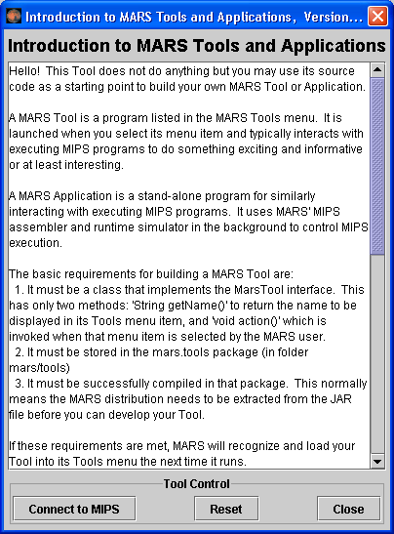 | By extending the provided abstract class AbstractMarsToolAndApplication, you get everything in this figure except the scrolled JTextArea displayed in the center.  You build the main user interface of your tool by defining the inherited abstract buildMainDisplayArea() method. This method returns a JComponent that will automatically be displayed in the center of the default BorderLayout.  Javadoc-produced documentation of the AbstractMarsToolAndApplication class is available in the doc folder of the MARS distribution.  Source code files for the MARS Tools are included together with their bytecode files in the mars/tools folder. Feel free to refer to them. All MARS source files, including tools, are included in the src folder.

If you develop a nifty MARS Tool, feel free to send it to us and with your permission we'll post it on the MARS web site for others to use!

2. Writing a system call (syscall) and plugging it into MARS

Abstract

MIPS System calls are functions that interface with the operating system to perform I/O and related operations. They are accessible to MIPS assembly programs through service numbers and the syscall instruction. MARS provides the 17 system calls documented in Computer Organization and Design Third Edition, but you can develop and add your own by writing a class that implements the Syscall interface or extends the AbstractSyscall class.

MIPS system calls perform operating system functions and input/output operations in particular. A system call is used in MIPS assembly by loading its identifier (an integer) into register $v0, loading any required arguments into registers as specified by the call's protocol, then issuing the syscall instruction.

MARS supports the MIPS system call specifications given in Appendix A of Patterson and Hennessy's Computer Organization and Design Third Edition. This appendix is freely available on the web at http://www.cs.wisc.edu/~larus/HP_AppA.pdf. MARS provides all 17 of the system calls specified there.

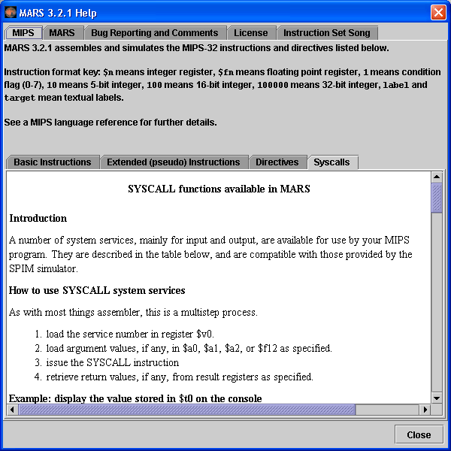
MySystemCall implements Syscall approach

- Extract the MARS distribution from its JAR file, if you have not done so.

- Develop your class in the mars.mips.instructions.syscalls package (mars/mips/instructions/syscalls folder).

- Your class must implement the Syscall interface, which is in that package. This has four methods: String getName() to return an assigned name for this service, setNumber() and getNumber() to set and get its associated service number, and simulate() to simulate the execution of the system call at MIPS runtime.

- After your class compiles successfully, it will be automatically plugged in and available to MIPS programs the next time you launch MARS.

MySystemCall extends AbstractSyscall approach

- Extract the MARS distribution from its JAR file, if you have not done so.

- Develop your class in the mars.mips.instructions.syscalls package (mars/mips/instructions/syscalls folder).

- Your class must extend the AbstractSyscall class, which is in that package. It provides a constructor and defines the three Syscall getter and setter methods. The simulate() method is abstract so you must define that yourself.

- After your class compiles successfully, it will be automatically plugged in and available to MIPS programs the next time you launch MARS.

Additional Information

Implementation of the simulate() method may require access to one or more simulated MIPS memory and register objects. The pertinent classes are mars.mips.hardware.Memory and mars.mips.hardware.RegisterFile. Also study the source code of existing system calls. Source code files for the 17 MARS system calls are located in the src folder. Follow the folder hierarchy mars/mips/instructions/syscalls.

The MARS distribution includes a text file Syscall.properties which you can edit to override any system service number assigned in a constructor. This allows you to change number assignments without re-compiling any Java source files.

The Syscalls help page is static at this time so it will not reflect any additional system calls or renumbering.

If you develop a nifty system call, please send it to us and with your permission we'll post it on the MARS web site for others to access!

We have had philosophical discussions concerning the development of additional system calls and so far have resisted doing so. On one hand, it would be very useful to have a small library of handy functions such as random number generators available through the syscall mechanism. On the other hand, such functions are not considered operating system operations that would be performed in kernel mode and it would be misleading to infer such status. Let us know what you think!

3. Modifying the set of pseudo (extended, macro) instructions

Abstract

To define a new pseudo-instruction, edit the PseudoOps.txt file included in the MARS distribution. The instruction specification is one line long and consists of a tab-separated list containing an example usage of the instruction followed by the one or more basic instructions that the assembler will expand it to. Use specification language symbols to control the substitution of program statement operands into the generated basic instruction(s).

The MIPS instruction set includes a large number of pseudo-instructions. These are instructions that follow MIPS instruction syntax specifications but are not directly supported by the MIPS architecture. They are instead expanded into a sequence of one or more basic instructions by the assembler. For this reason they are sometimes called macro instructions.

The classic example of a pseudo-instruction is la, or load address. Here's an example:
la $t0, number
where number is the label for a data item. A corresponding MIPS machine instruction would have to include the operation code, the 5 bit register number and the 32 bit address. But since machine instructions are only 32 bits long, this is not possible. It requires two instructions.

Pseudo-instructions are provided entirely for the programmer's convenience, and MARS includes an assembler setting that will disallow their use.

To modify the pseudo-instruction set, follow this process:

- Extract the MARS distribution from its JAR file if you have not already done so.
- Edit PseudoOps.txt appropriately. Each pseudo-instruction and its macro expansion are specified on one line in this file. Details below.

- Launch MARS and test your instruction.

Here's an example specification, for the absolute value instruction abs

abs $1,$2 addu RG1,$0,RG2 bgez RG2,2 sub RG1,$0,RG2

1
2
3
4

- Example instruction use. This instruction takes two register operands. The $1 and $2 represent generic registers and are used only to generate a token sequence for syntax analysis. There is no relationship between register references in the example instruction (item 1) and register references in the macro expansions (items 3 and 4)!
- Each item in the specification must be separated by a single TAB character. Only the first one is pointed out but there is also a TAB between each of the remaining items.
- The first instruction of the macro expansion. RG1 is a formal parameter that will be replaced by the actual first register operand of the statement being assembled. RG2 is similarly replaced by the actual second register operand of the statement being assembled.
- Second and third instructions of the macro expansion. Perform similar substitutions.

Statement to assemble | Macro expansion
abs $t3, $t4 | addu $t3, $0, $t4  bgez $t4, 2  sub $t3, $0, $t4

This example uses the simple substitutions RG1 and RG2. Other macro substitution symbols are more complex, such as VL2P3 which means to substitute the low order 16 bits of the 32 bit value in source operand 2 after adding 3 to it (used in the expansion of certain unaligned loads and stores).

The macro substitution language is described in detail in the file itself.

If you add any pseudo-instructions, they will automatically be included in the instruction list produced by the Help feature's Extended (pseudo) Instructions subtab. If the instruction specification ends with a comment on the same line (# is the comment marker, just like in MIPS), that comment will be included in the list along with the example instruction use.
4. Modifying the set of Basic Instructions

Abstract

It is possible to modify the basic instruction set recognized by MARS. This requires you to edit and re-compile the mars.mips.instructions.InstructionSet class. The specification of a basic instruction includes four components: (1) an example of instruction use, (2) the instruction format – R, I, or J, (3) a template for generating the 32 bit machine code from a program statement, and (4) a method to simulate the execution of that program statement.

This is the one type of MARS extension that requires re-compilation of a standard MARS source file. Specifications for the MIPS basic instruction set are contained in the mars.mips.instructions.InstructionSet class. Each specification follows the same format. Here is an example, for the and instruction that performs logical AND.

instructionList.add(new BasicInstruction(

"and $1,$2,$3", 1. example use

BasicInstructionFormat.R_FORMAT, 2. instruction format

"000000ssssstttttfffff00000100100", 3. machine code template

new SimulationCode() 4. execution simulator
{
public void simulate(ProgramStatement statement)
{
int[] operands = statement.getOperands();
RegisterFile.updateRegister(
operands[0],
RegisterFile.getValue(operands[1]) &
RegisterFile.getValue(operands[2]) );
}
}
));

The BasicInstruction constructor takes four parameters, annotated on the example:

- Example instruction use. This instruction takes three register operands. The $1, $2 and $3 represent generic registers and are used only to generate a token sequence for syntax analysis.
- MIPS instruction format. MIPS defines the R-format (works with registers), I-format (works with immediate value), and J-format (jump instruction). MARS defines a second version of the I-format called I-branch-format when the immediate value is used in a branch instruction.

- Machine code template. This String of length 32 consists of the characters 0, 1, f, s, and t. When the MIPS program statement syntactically matches this instruction, the 32 bit machine code instruction is constructed by substituting low order bits from the first operand for f, low order bits from the second operand for s and low order bits from the third operand for t. The result is converted to 32 bit binary. This example has register numbers which are 5 bits because MIPS32 defines 32 integer registers.

- Constructs the object whose simulate() method will be called to simulate the execution of the program statement at MIPS runtime. The object is constructed from an anonymous subclass of the SimulationCode class defined right here. The simulate() method receives information about the program statement as a parameter and manipulates MIPS registers and/or memory to carry out the instruction.

To modify the basic instruction set, follow this process:

- Extract the MARS distribution from its JAR file if you have not already done so.
- Copy InstructionSet.java from the src/mars/mips/instructions folder into the mars/mips/instructions folder.
- Make a backup copy of InstructionSet.java for safe keeping.

- Edit InstructionSet.java appropriately. Implementation of the simulate() method will likely require access to one or more simulated MIPS memory and/or register objects. The pertinent classes are mars.mips.hardware.Memory and mars.mips.hardware.RegisterFile. Javadoc-generated documentation for all MARS classes is provided in the distribution's doc folder. Also study the source code of existing instructions.

- Compile InstructionSet.java and test your instruction.

NOTE: This technique applies to MARS release 3.2.1. It is possible that the technique for specifying basic instructions will change in a future release of MARS. If so, it would be converted to a technique similar to that now used for system calls.

