# Analysis of a scientific article

## Identification of the students:

|  |  |
| --- | --- |
| Names of the students | 1. Jonas Bertels |
|  | 2. Yoshi Vermeire |
|  | 3. |

## Identification of the article:

|  |  |
| --- | --- |
| Title of the article | Available Power Gain, Noise Figure, and Noise Measure of Two-Ports and Their Graphical Representations |
| Author(s) | H. Fukui |
| Journal  (title, year, volume, edition, pp.) | IEEE Transactions On Circuit Theory, 1966, volume CT-13, No. 2, page 137 |

## Declaration

The analysis submitted is original work, in which we (I) do not use the ideas or wording of anyone else without proper referencing or quoting. We (I) have read the guidelines of the Faculty of Engineering Science and are (am) applying these guidelines (<https://eng.kuleuven.be/en/study/plagiarism>). We are (I am) aware of the sanctions that may result from plagiarism or any other irregularity as defined in the article 84 to 86 of the examination regulations of the KU Leuven (<https://www.kuleuven.be/education/regulations/2018/#art84>).

## Analysis of the content of the article:

### What is in your own words the main message of the article (≠ abstract)?

The available power gain, noise figure, and noise measure can all be plotted on the Smith chart of the (reflection coefficient of the) source admittance because they all the depend on this source impedance. Plotting it on the Smith Chart allows us to better understand these figures of merit.

Take for instance the available power gain Ga. When we plot this (rectangular)

On the other hand, when we plot this (Smith Chart)

### 2. Which are the basic assumptions on which this article relies? (This can have different formats: e.g. a model that has been used and of which one assumes it is sufficiently accurate for the purpose, or the assumption that only linear effects are important in an active circuit, or the assumption that a new type of circuit should always be better than previous ones,…).

It uses the following expression for the available power gain using a procedure described by Linvill and Gibbons in their book *Transistors and Active circuits*:



Using some Berkely Lecture notes (Niknejad, 2005), we can derive it as follows:

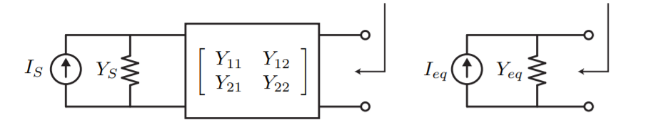

$$Power at the source = \frac{{\left|I_{S}\right|}^{2}}{8*Re\left\{Y_{S}\right\}}$$

$$Power at the load = \frac{{\left|I_{eq}\right|}^{2}}{8*Re\left\{Y_{eq}\right\}}$$

$$Y_{eq}=Y_{22} - \frac{Y_{21}Y_{12}}{Y_{11}+Y_{S}}$$

$$I_{eq} = \frac{Y_{21}}{Y_{11}+Y_{S}}I_{S}$$

Using this, we can calculate $G_{A}=\frac{Power at the load}{Power at the source}$

$$G_{S}=Re\left\{Y_{S}\right\} and g_{22}=Re\left\{Y_{22}\right\}$$

$$G_{A}=\frac{{\left|Y_{21}\right|}^{2}G_{S}}{{\left|Y_{11}+Y_{S}\right|}^{2}(g_{22}-Re\left\{ \frac{Y_{21}Y_{12}}{Y_{11}+Y_{S}}\right\})}$$

This simplifies to the same result as found in the article.

### 3. Reformulate in your own words the fundamental reasoning that is made in the article.

### 4. Do you agree with the content and conclusions of the article? Why? (You may check some of the mathematics to come to your decision.)

### 5. Where and how can the content of this article be applied following you? (You may mention applications indicated in the paper, but also try to come up with your own ideas.)

### 6. Are there any terms (definitions), or other background information, that you needed to look up in order to understand the article? If yes, explain.

* Paper refers to original paper of Rothe and Dalke “Theory of Noisy fourpoles”, which was found and from which we got the following figure describing the noise figure on a rectangular coordinate system.
* 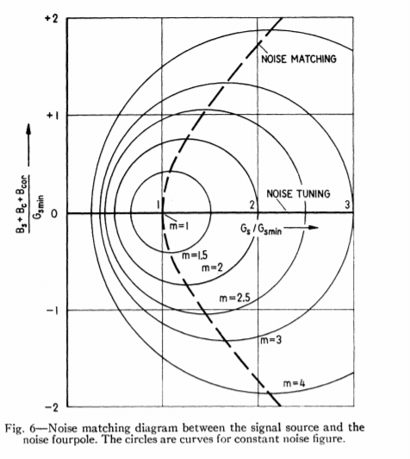

## Analysis of the format of the article:

### 1. Is the article written a sufficiently clear language?

### 2. Are the graphs sufficiently clear?

### 3. Do the captions to the figures and tables contain sufficient information in order to understand them (and possibly reconstruct them)?

### 4. What is the importance / the function of the references to which this article refers? Which reference is the crucial one (explain)? (Add this reference in pdf to your analysis)

### Bibliography

<http://rfic.eecs.berkeley.edu/~niknejad/ee142_fa05lects/pdf/lect4.pdf>