Initial problems with the thing we built

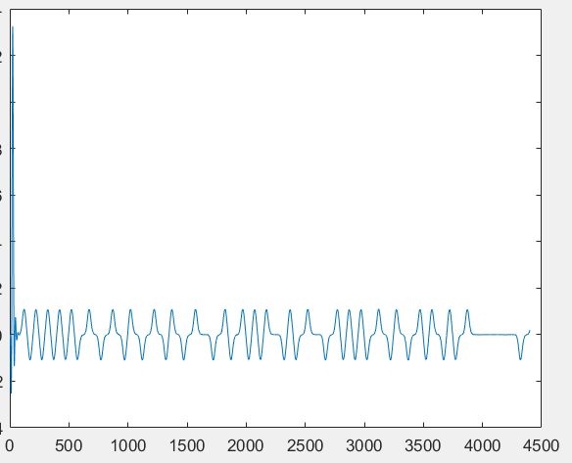

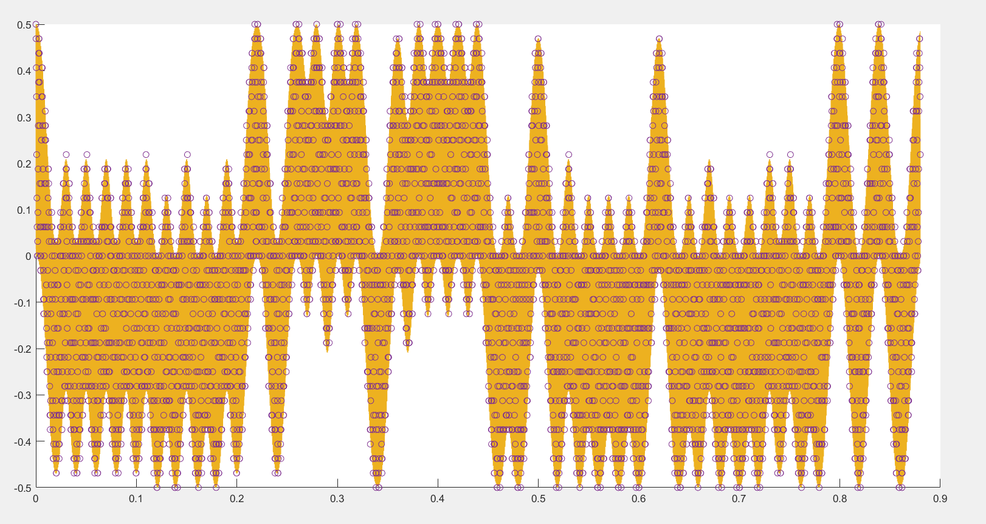

As you can see, at this point the in phase is still very accurate, but it does have it’s own problems with the fact that the data it is taken from have a high frequency component. Digital data should be low passed to remove the high frequency that is in it due to downsampled

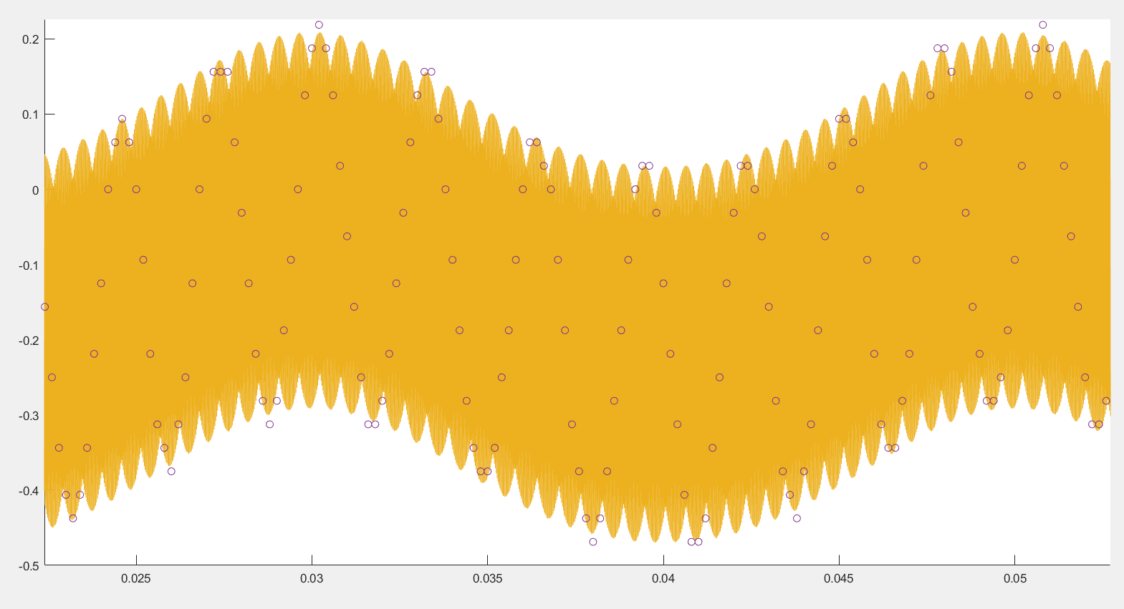

After the filter, the matlab looks fine, while the digital looks extremely poor (and also seemingly larger than should be)

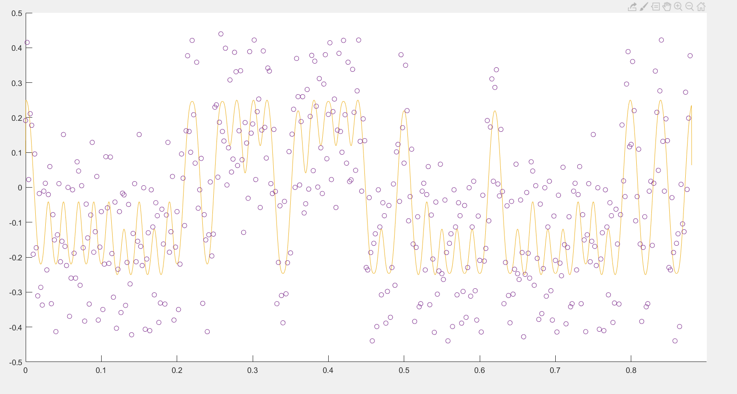

This is the actual problem:

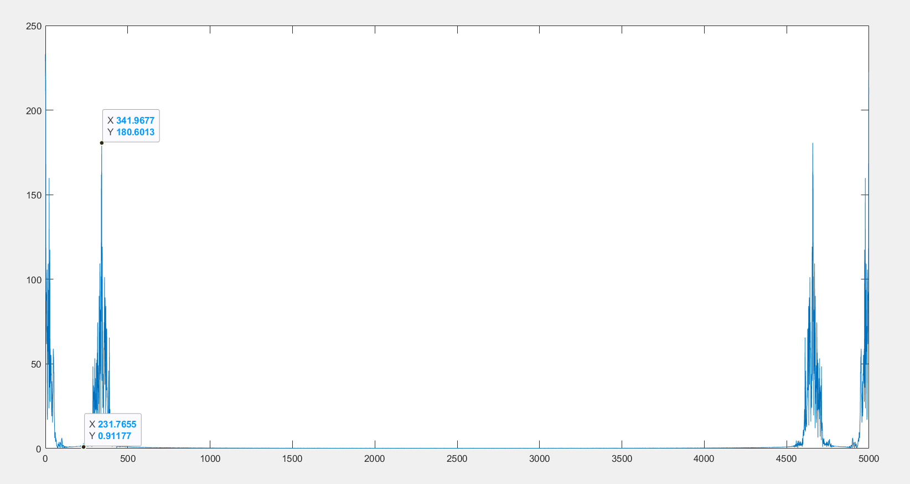

So we need an order 8 filter that can deal with removing everything from 250 onwards, in other words, everything from 0.1pi (or 250 Hz with pi being 2500) onwards, but not affecting 0.04pi (100Hz)

We do this using the minimum square (and some weights, which I figured out after an hour):

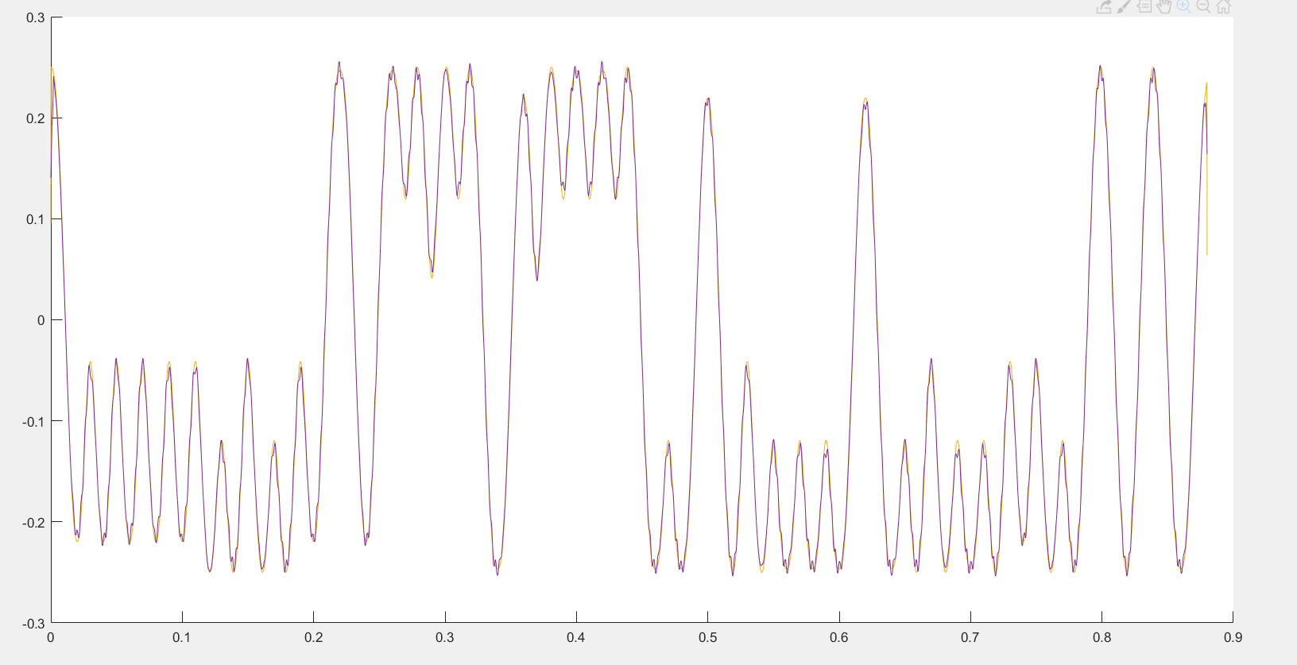

… and the problem is solved. Doing this in hardware will require a new implementation, but as this one will be rather simple, it’s fine