Report Digital design P&D electronics

# The TA’s case:

Firstly, the SNR you receive from the main model doesn’t necessarily have the SNR that you placed requested in the specifications, because it is changed to take into account the oversampling done during the generation in analog. Our SNR before the IQ downmixer is therefore 10 (loss of 30dB, due to this change) . Demodulation brings it up to 25 dB.

## Signal in: no noise:

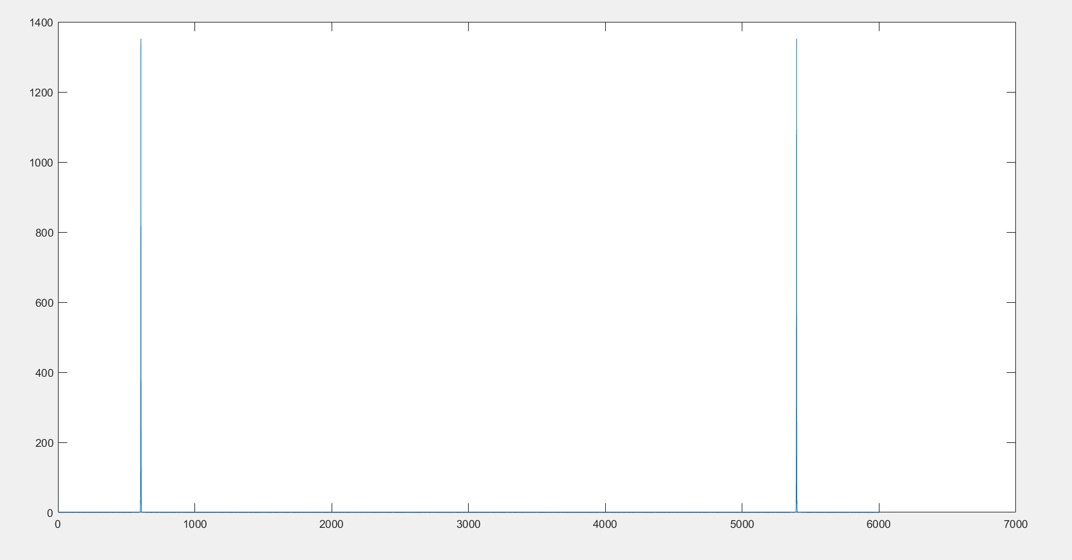

## Signal in: no noise: frequency plot of angle

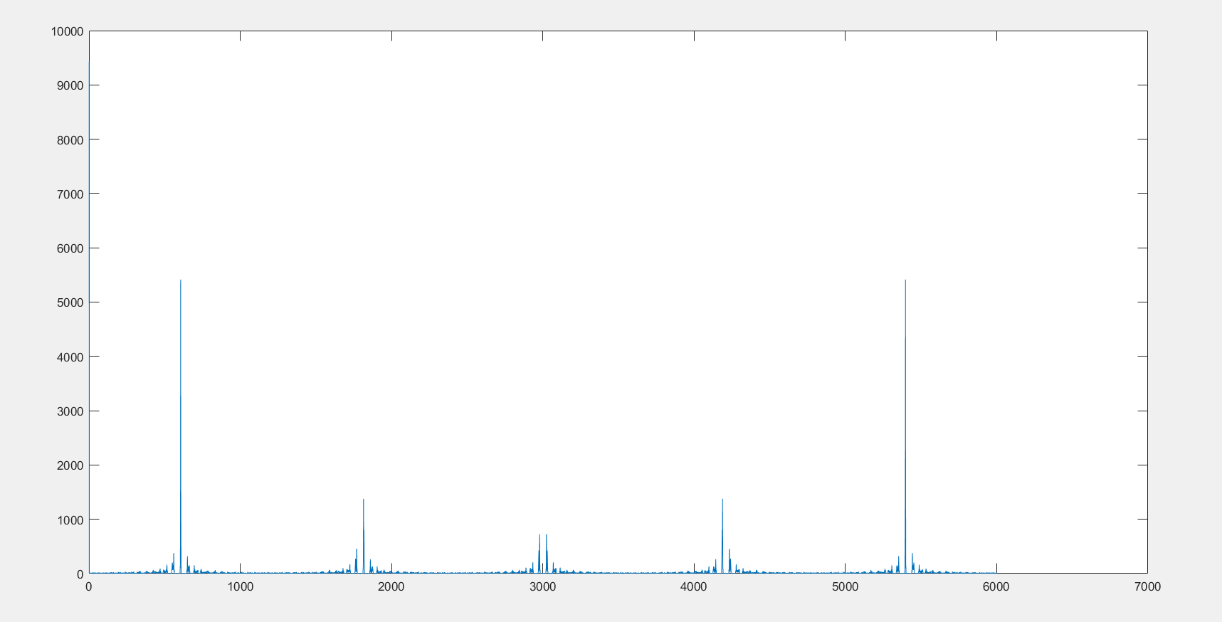

The explanation is that we have taken the angle of the signal (which in this case is equal to Real{ exp(2pi*omegaC} * exp{some upwards or downwards sloping function}) The angle of a real signal will be either pi or 0, so the result will be a very crude approximation of our actual signal. Luckily, we don’t apply our downconverter on the angle but on the whole signal, so the frequency plot of the angle is irrelevant.

## Signal after downconversion (frequency plot)

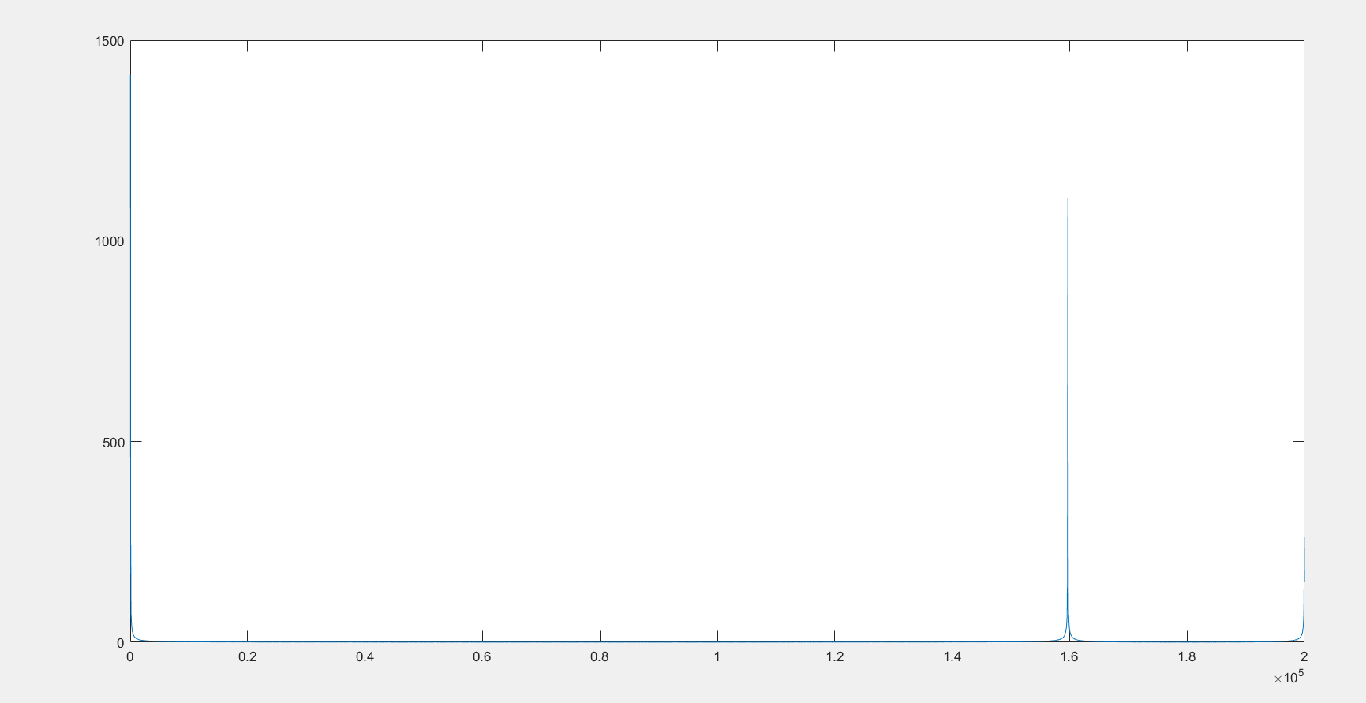

## Signal after filtering: frequency:

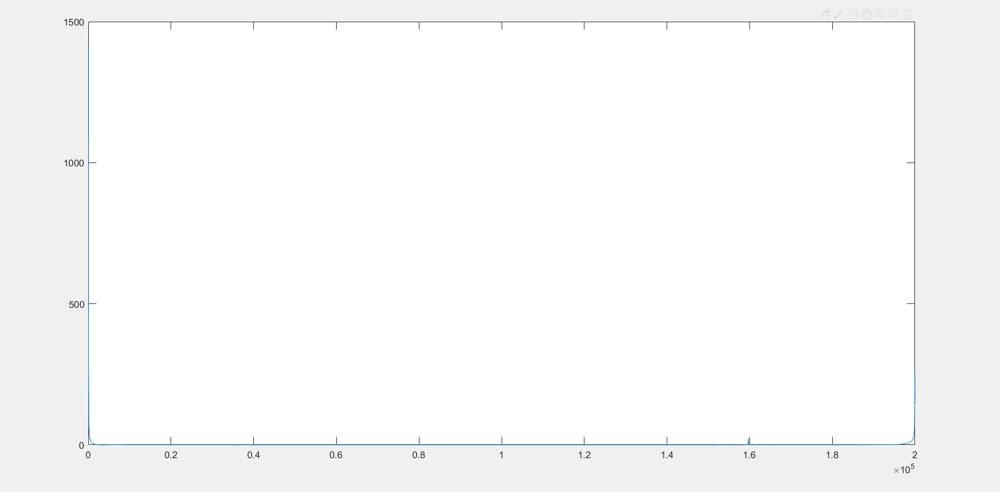

As one can see, there is still a (faint) component at -40 kHz (160 kHz) that isn’t filtered away, but the low pass filter does a good enough job at removing all the unwanted components.

## Signal at output: without quantization noise (this plots the angle of the aforementioned signal)

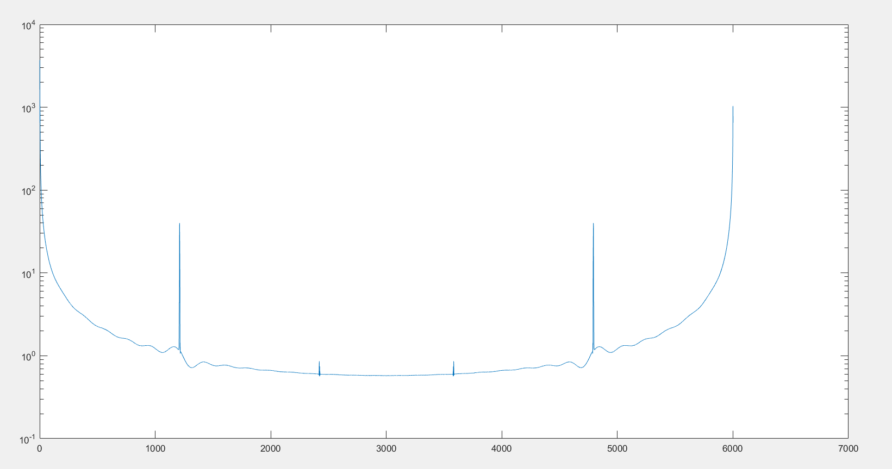

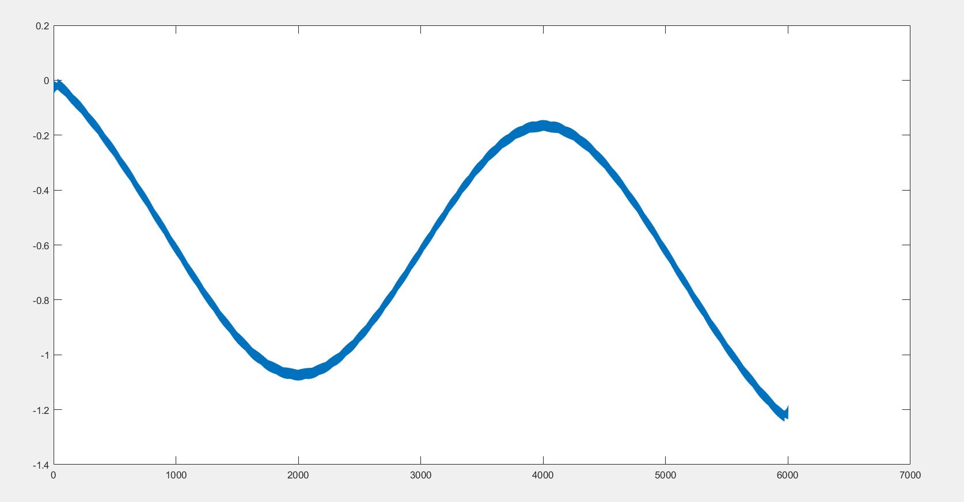

## Signal at output: with quantization noise

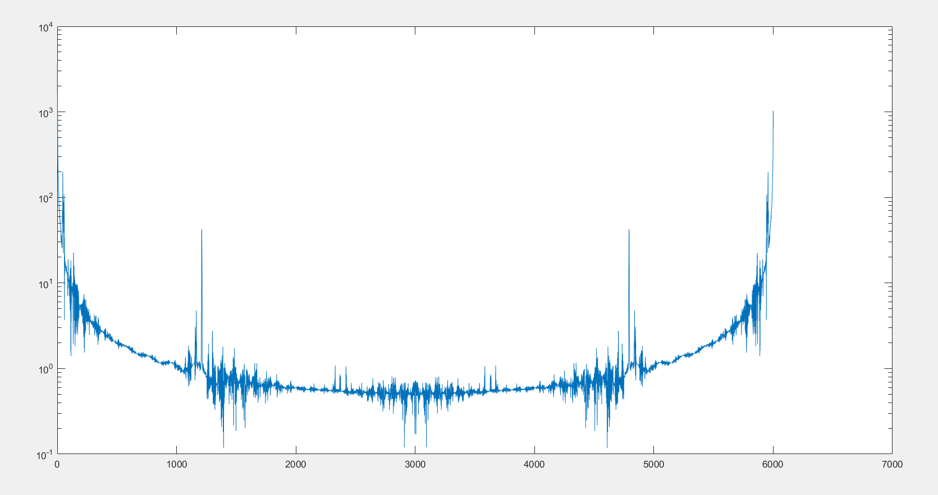

# Ultrasimple improvement: 20 1’s instead of 2 convolution

The frequencies are now properly surpressed, and we actually get what we wanted: a look at how the pulses look, which we can then compare with our matched filter to determine how we should make our matched filter.

