

OrganicLink: A Computer-Vision Marketplace for Irish Organic Producers with Automated Produce Quality Grading

LK489 - Master of Engineering in Computer Vision and Artificial Intelligence

Final Project Report

Aashrith Sai Yamsani
25287419

Elfed Lewis

<Submission Date>

Abstract
Organic food producers in Ireland continue to face challenges in connecting directly with buyers, despite growing consumer demand for locally produced organic food. These challenges vary across different sectors. A large quantity of vegetables is lost each year because produce that does not meet cosmetic standards often has no market. Organic meat producers can also get hit with financial losses, especially when premium products are processed and then sold as ordinary, conventional meat. During interviews conducted as part of this project, organic dairy farmers also described situations where milk produced beyond their contracted volume could not easily be sold. Although these problems appear different, but they have a shared underlying reason. When buyers purchase remotely, they have limited trust in the quality of goods they can’t inspect in person. This makes direct trade more difficult than it should be.
OrganicLink was developed to address this problem by providing a web-based marketplace where organic farmers and buyers can trade directly, with computer vision used to assess the quality of produce from photographs. The main contribution of the project is the dual-inspection variance protocol, which provides a way of checking quality during a transaction. The produce is assessed at two points: when the farmer prepares it for dispatch and when it reaches the buyer. The results from these two inspections are then compared to determine whether there has been a significant change in quality. If the difference exceeds a predefined tolerance, the system automatically flags the transaction for review, and it also temporarily holds payment until the quality mismatch has been sorted out.
The whole idea is to cut down on having to trust subjective statements from either side, because the comparison is done objectively using the same grading model at both points along the supply chain. To support this process, a ResNet18 convolutional neural network using transfer learning was trained through a two-phase strategy to identify produce type and assess quality. In addition, a two-stage detection and grading pipeline was developed to analyse photographs containing multiple produce items by detecting each item before grading it individually.

Declaration
This final report is presented in part fulfilment of the requirements for the LK473/LK480/LK489 Master of Engineering in Computer Vision and Artificial Intelligence Masters Project.
It is entirely my own work and has not been submitted to any other University or Higher Education Institution or for any other academic award within the University of Limerick.
Where there has been made use of work of other people it has been fully acknowledged and referenced.

Name | AASHRITH SAI YAMSANI
Signature | AASHRITH SAI YAMSANI
Date | 16/08/2026

Acknowledgement
I would like to express my sincere gratitude to my supervisors, Dr. Elfed Lewis, Dr. Annmarie Ryan, and Dr. Ciaran Eising, for their guidance, support, and encouragement throughout this project. Their insight and feedback were invaluable in shaping both the direction and the execution of this work.
I am also grateful to the Digital Futures Lab at the University of Limerick, where this project originated, for providing the stakeholder context and the foundation on which OrganicLink was built.
My thanks go to Joe Kelleher, organic dairy specialist at Teagasc, whose consultation was instrumental in refining the focus of this project toward a genuine, evidenced need within the Irish organic sector.
Finally, I would like to thank my family and friends for their continued support and patience throughout my studies.

Table of Contents
Abstract ii
Declaration iii
Acknowledgement iv
Table of Contents v
List of Figures viii
List of Tables ix
Chapter 1: Introduction - 1 -
1.1 Overview - 1 -
1.2 Motivation for the project - 1 -
1.2.1 How the problem was identified and refined - 3 -
1.2.2 The Core problem: trust in remote transactions - 4 -
1.2.3 The proposed solution - 4 -
1.3 Project aims and objectives - 5 -
1.4 Report outline - 6 -
1.5 Conclusion - 7 -
Chapter 2: Literature review - 9 -
2.1 Overview - 9 -
2.2 The organic market-access problem in Ireland - 9 -
2.2.1 Cosmetic rejection and vegetable market access - 9 -
2.2.2 Leakage in the organic meat sector - 10 -
2.2.3 Refinement of the project focus - 10 -
2.3 Existing direct-trade food platforms - 11 -
2.4 Computer Vision for produce quality assessment - 12 -
2.4.1 Reported accuracies for produce grading - 13 -
2.5 Object detection for multi-item grading - 15 -
2.6 The gap addressed by this project - 15 -
2.7 Conclusion - 16 -
Chapter 3: Analytical background - 17 -
3.1 Overview - 17 -
3.2 Image Classification and Supervised Learning - 17 -
3.3 Convolutional Neural Networks - 18 -
3.4 The ResNet architecture - 18 -
3.5 Transfer Learning - 19 -
3.6 Multi-head architecture - 20 -
3.7 Object Detection - 21 -
3.8 Hybrid neural and classical scoring - 21 -
3.9 Perceptual hashing for dataset quality - 22 -
3.10 Evaluation metrics - 22 -
3.11 Conclusion - 23 -
Chapter 4: Specification and design - 24 -
4.1 Overview - 24 -
4.2 Requirements - 24 -
4.2.1 Functional requirements - 24 -
4.2.2 Non-functional requirements - 25 -
4.3 System architecture - 25 -
4.4 Computer-vision grading design - 27 -
4.4.1 The Multi-Head Classifier - 27 -
4.4.2 Hybrid Scoring - 28 -
4.4.3 The two-stage bulk-grading pipeline - 29 -
4.5 The dual-inspection variance protocol - 30 -
4.6 Design boundaries: what is and is not graded automatically - 31 -
4.7 Traceability design - 32 -
4.8 Data Model - 32 -
4.9 Conclusion - 32 -
Chapter 5: Implementation - 33 -
5.1 Overview - 33 -
5.2 Technologies and tools - 33 -
5.3 Backend and API implementation - 33 -
5.4 Frontend Implementation - 35 -
5.5 Computer Vision implementation - 36 -
5.5.1 Model Training - 37 -
5.5.2 Dataset quality and deduplication - 37 -
5.5.3 Hybrid Scoring implementation - 38 -
5.6 The two-stage bulk grading pipeline - 39 -
5.7 The dual-inspection protocol and supporting features - 40 -
5.8 Conclusion - 42 -
Chapter 6: Results and discussion - 43 -
6.1 Overview - 43 -
6.2 Overall grading accuracy - 43 -
6.3 Per-product performance - 44 -
6.4 Dataset quality and honesty of the results - 47 -
6.5 The two-stage bulk-grading pipeline - 48 -
6.6 The dual-inspection protocol - 48 -
6.7 Limitations - 49 -
6.8 Discussion - 50 -
6.9 Conclusion - 50 -
Chapter 7: Conclusions and future work - 52 -
7.1 Overview - 52 -
7.2 Summary of the project - 52 -
7.3 Achievement of objectives - 52 -
7.4 Contributions - 53 -
7.5 Future work - 53 -
7.6 Concluding remarks - 54 -
References - 55 -

List of Figures
Figure 1 - Multi-head ResNet-18 model for product and defect classification. - 20 -
Figure 2 - End to End workflow of the system, from uploading photo to grading - 26 -
Figure 3 - OrganicLink three-tier system architecture - 26 -
Figure 4 - The two-stage bulk-grading pipeline - 29 -
Figure 5 - The dual-inspection variance protocol. - 30 -
Figure 6 - Farmer accounts are held pending until an administrator approves the organic certificate. - 34 -
Figure 7 - The buyer marketplace, with filtering by produce type, county, grade and distance. - 35 -
Figure 8 - The produce-listing form, including the bulk-mode toggle and multi-angle photo guidance. - 36 -
Figure 9 - Single-item quality grading - a tomato graded A (94.7/100) with colour-metric breakdown. - 38 -
Figure 10 - The whole-image product-match check rejecting a banana photo when tomato was selected. - 39 -
Figure 11 - The admin portal, a variance-flagged order with dispatch and delivery grades side by side. - 40 -
Figure 12 - The traceability passport - QR code, verified farm of origin, organic certification, and the full listing/dispatch/delivery inspection history. - 41 -
Figure 13 - Product-classification confusion matrix on the held-out test set. - 44 -
Figure 14 - Test F1-score against training-data volume, showing accuracy tracks data availability. - 44 -
Figure 15 - Per-product test F1-scores, from 88.5% (capsicum) to 99.2% (banana). - 45 -
Figure 16 - Near-duplicate contamination in the two-dataset training set - 47 -

List of Tables
Table 1 — Representative reported accuracies for produce grading[5] - 14 -
Table 2 - Per-product data volume and test performance - 46 -

Introduction

Overview
Ireland has seen steady growth in demand for organic food over the past decade, driven by consumer interest in locally produced, sustainable, and traceable food. Government policy has actively encouraged this trend, with a national target to bring a significantly larger share of Irish farmland under organic production by the end of the decade. Yet while both demand and production are rising, the link between the farmer producing organic food and the buyer eager to purchase it remains fragile and inefficient. Often, fresh food that is in high demand fails to reach the market. This issue isn't caused by demand or quality; instead, it stems from a lack of connection and trust.
This report presents OrganicLink, an online marketplace that connects Irish organic farmers directly with buyers and uses computer vision to provide an objective, automated assessment of produce quality from photographs. Its central purpose is to make direct trade between distant parties more trustworthy, so that produce can move from producer to buyer without the loss of value that currently occurs at several points in the chain. The principal technical contribution is a dual-inspection variance protocol, which grades produce at both dispatch and delivery and automatically detects quality disputes when the two assessments differ beyond a defined tolerance.
This chapter introduces the project. Section 1.2 sets out the motivation, including the evidence for the problem and the way the project's focus evolved during its early stages. Section 1.3 states the aim and objectives. Section 1.4 outlines the structure of the remainder of the report, and Section 1.5 concludes the chapter.

Motivation for the project
The challenges faced by organic producers in accessing buyers vary across sectors, and each sector experiences the problem in a different way. Understanding these differences is important because they influence the requirements of any proposed solution. Cosmetic requirements are an important factor, with vegetables and fruits that do not meet expectations for size, shape or appearance being rejected by conventional retailers despite remaining suitable for consumption.
Environmental Protection Agency research estimated that 122,395 tonnes of vegetables were lost or wasted at the primary-production stage in Ireland each year, highlighting the scale of the problem. Without a suitable alternative buyer, this produce may be used as animal feed or dumped back in the soil. In this situation, the main problem is not that the produce is unusable, but that the farmer has no suitable route to market.
The organic meat sector presents a different outcome, the consequences are primarily economic. Limited connections between organic livestock farmers and specialised processors or buyers can lead to organically produced animals being processed through conventional channels. The Department of Agriculture, Food and the Marine has reported that a considerable proportion of organic lamb and cattle is processed conventionally. Although the production process has met organic requirements, may not receive the price premium normally associated with organic products. In this case, the loss occurs through the supply chain as reduced economic value rather than through physical food waste.
A similar market-access issue occurs in the dairy sector. During interviews carried out for this project, cases were identified where organic dairy farmers had difficulty finding buyers for milk produced above their contracted volumes. This suggests that the same basic problem can occur in different forms across the vegetable and meat sectors: produce is available and potential demand may exist, but there is no reliable mechanism for connecting the producer with an appropriate buyer.
Looking across the three sectors, the problem appears in different forms. Vegetable can be left unsold because it does not meet cosmetic requirements, organic meat can lose its premium when processed conventionally, and surplus organic milk may lack an accessible buyer. These differences are important, but all three point to the need for more reliable connections between producers and suitable buyers. In remote transactions, the inability of buyers to physically inspect produce introduces uncertainty regarding quality and condition. This uncertainty can weaken trust between the parties and represents an important barrier to direct trade.

How the problem was identified and refined
The focus of this project was shaped by an earlier phase of work and by primary consultation with a sector expert, and it is useful to record how the direction was reached.
The project originally began as a concept focused specifically on the organic dairy sector. The idea was a cooperatively governed digital platform that would aggregate the fragmented supply of Ireland's small organic dairy farmers so that their collective volume could justify investment in value-added processing, such as butter and cheese, and so that farmers could be paid on the quality of their milk rather than a flat rate per litre. This concept rested on a single central assumption: that aggregating supply through coordination would make value-added processing economically viable for processors who currently overlook the organic sector.
Consultation with Joe Kelleher, an organic dairy specialist at Teagasc, challenged that assumption directly . The national organic dairy sector was described as very small and fragmented on the order of eighty organic dairy farmers nationally, served by only a handful of processors handling organic milk with the result that the organic milk pool is simply too small to justify value-added processing investment at present. Consequently, the overall volume of organic milk was considered insufficient to support investment in value-added processing at the current scale. More effective coordination could improve how the existing supply is organised, but it could not address the underlying limitation of insufficient market volume.
As a result, the project underwent a deliberate change in scope. Instead of continuing with a dairy-specific aggregation model based on an assumption that was not supported by the consultation, the project was broadened to address a more widely observed issue across the organic sector. The revised concept focused on a broader problem evident across the organic sector: producers may have difficulty establishing reliable connections with suitable buyers, particularly where direct transactions take place across geographical distances. In these circumstances, uncertainty surrounding the condition and quality of produce can further weaken trust between the parties. OrganicLink was subsequently developed around this broader market-access and trust problem, with the evolution of the concept examined in greater detail in Chapter 2.

The Core problem: trust in remote transactions
The main problem addressed by this project is the lack of trust that can arise when produce is bought and sold without direct physical inspection.
When a buyer and seller are in the same place, quality assessment is simple: the buyer looks at the produce, handles it and decides. When they are not - when a restaurant in one county wishes to buy directly from a farm in another, or a buyer commits to produce before it is dispatched - this direct inspection is impossible. The buyer must instead rely on the seller's description, which the seller has every incentive to present favourably. This creates two distinct difficulties.
The first is the difficulty of assessing quality before purchase. A buyer who cannot see the produce has no objective basis on which to judge itPhotographs can provide some information about quality, but they are still selected by the seller and judged by the buyer. There is no common standard that both parties can use to make the assessment.
A further problem can arise after delivery, particularly when the condition of the produce has changed during transportation, making it difficult to determine whether a reduction in quality occurred before or during transitThe buyer may consider the produce to have arrived in poor condition, while the seller may believe that it was in good condition when it was dispatched. Both parties may have valid reasons for their claims, particularly where the condition of the produce has changed between dispatch and delivery. Without some form of independent evidence, it is difficult to determine when the change occurred. This can make quality disputes difficult to resolve and may discourage direct trading.
For this reason, the main technical challenge addressed by the project is to provide a consistent way of identifying changes in produce quality during a transaction. OrganicLink therefore focuses not only on assessing produce quality, but also on providing a basis for comparing its condition at different stages of the transaction.

The proposed solution
OrganicLink addresses this trust gap by bringing together a direct-trade marketplace, automated computer-vision quality assessment and a method for comparing produce quality at different stages of a transaction. Together, these features provide a more consistent basis for dealing with disagreements about the condition of the produce.
The marketplace allows verified organic farmers to list their produce for sale, while buyers can browse listings, negotiate transaction terms and place orders. Unlike a standard marketplace, quality assessment is included as part of the transaction. The computer-vision model analyses photographs of the produce to identify its type and assess its quality according to a predefined grading scale. This gives both parties a consistent quality measure rather than relying only on the descriptions given by the buyer or seller.
The main contribution is the dual-inspection variance protocol. Instead of assessing the produce at only one point, the system performs two inspections during the transaction. The first is carried out when the farmer prepares the order for dispatch, and the second when the buyer receives it. Both assessments use the same grading model, allowing the results to be compared directly. Where the difference remains within the defined tolerance, the transaction continues normally. If the difference is within the defined tolerance, the transaction continues as normal. If it exceeds the tolerance, the transaction is flagged and payment is temporarily held while the issue is addressed. Using the same assessment method at both stages gives the two parties a common basis for comparison and reduces reliance on their individual accounts of the produce's condition.
The grading system also supports photographs containing several produce items. A two-stage pipeline first detects the individual items in the image and then sends each detected item to the grading model. The individual results can then be combined to give an overall assessment of a batch, such as a tray or basket of produce.

Project aims and objectives
The main aim of this project is to develop and evaluate a web-based marketplace that enables direct trade between Irish organic producers and buyers located remotely . The proposed system incorporates computer vision to provide consistent produce-quality assessment and an automated mechanism for identifying significant changes in quality between dispatch and delivery.
The project addresses this aim through six objectives:
- To investigate the market-access and trading barriers experienced by Irish organic producers, using published research and primary interviews to establish a clear and evidence-based understanding of the problem.
- To design and implement a marketplace that supports the main stages of direct producer-to-buyer transactions, including verification, listing, browsing, ordering, negotiation and payment tracking.
- To develop a computer-vision approach capable of identifying produce and assessing its visual quality from photographic input.
- To develop and implement a dual-inspection variance protocol that compares quality assessments obtained at dispatch and delivery and identifies cases where the observed difference exceeds a predefined threshold.
- To extend the computer-vision approach from individual produce images to multi-item photographs through object detection followed by individual item grading.
- To evaluate the developed system through quantitative and functional testing, considering both the performance of the computer-vision components and the operation of the dual-inspection protocol, while identifying the limitations that affect its practical application.
The main contributions of the project are the development of the dual-inspection variance protocol for comparing produce quality at dispatch and delivery, the computer-vision-based produce-grading system and its evaluation on held-out data, and the two-stage pipeline for assessing multiple produce items within a single photograph. The project also contributes an evidence-based analysis of the barriers affecting direct trade within the Irish organic sector.

Report outline
The remainder of this report is organised into six chapters, each addressing a different stage of the project.
Chapter 2 – Literature Review examines the background to the project in greater detail. It discusses the development of the project from its original focus on the organic dairy sector, reviews the evidence relating to the market-access challenges faced by Irish organic producers, examines existing direct-trade platforms, and reviews relevant research on computer-vision-based produce quality assessment. The chapter concludes by identifying the research and development gap addressed by OrganicLink.
Chapter 3 – Analytical Background provides the theoretical and technical foundations required to understand the methods employed in the project. The chapter discusses image classification, convolutional neural networks, ResNet18, transfer learning, multi-head architectures, object detection, hybrid quality scoring, perceptual hashing and the metrics used to evaluate model performance
Chapter 4 – Specification and Design translates the identified problem into system requirements and a technical design. It describes the three-tier architecture of OrganicLink and the design of its computer-vision components. Attention is given to the two-stage bulk-grading pipeline and the dual-inspection variance protocol, as well as the design boundaries separating visually assessed quality from certification-based verification.
Chapter 5 – Implementation describes the development of the system and the technologies used. The chapter covers the backend and frontend, computer-vision model training and inference, dataset deduplication, hybrid scoring, the multi-item grading pipeline, the dual-inspection mechanism and supporting features such as invoicing, payment tracking and traceability.
Chapter 6 – Results and Discussion evaluates the implemented system against the objectives established earlier in the report. The chapter analyses the performance of the computer-vision model, differences between produce classes, dataset integrity and the behaviour of the bulk-grading pipeline. It also evaluates the dual-inspection protocol and discusses the practical limitations identified through testing.
Chapter 7 – Conclusions and Future Work brings together the findings from the project and assesses the overall outcome of the work. It considers the contributions made by OrganicLink, reflects on the extent to which the project objectives were achieved and identifies improvements and further research that could be pursued in future iterations.

Conclusion
This chapter has introduced the problem that motivates the project: Irish organic producers struggle to trade directly with buyers, and a key barrier is the absence of trust in remote transactions where produce cannot be inspected in person. It has described how the project's focus was refined, through evidence, from an original dairy-aggregation concept to a broader marketplace addressing trust in direct trade. It has introduced OrganicLink and its central contribution, the dual-inspection variance protocol, and stated the aim and objectives of the work. The following chapter reviews the relevant background and literature in detail, establishing the evidence for the problem and positioning the project in relation to existing work.

Literature review

Overview
This chapter reviews the background and existing work relevant to OrganicLink. It is organised around the three areas the project draws together. The first is the problem context: the barriers that prevent Irish organic producers from reaching buyers, and how the focus of this project was refined through evidence. The second is the landscape of existing direct-trade food platforms, which establishes what has already been built and where the gaps lie. The third is the body of work on computer vision for produce quality assessment, including the classification and object detection techniques on which the system's grading components are based. The chapter closes by drawing these strands together to identify the specific gap this project addresses.

The organic market-access problem in Ireland
Demand for organic food in Ireland has grown steadily, supported by national policy that aims to expand the area of land under organic production. However, growth in production and demand has not been matched by an efficient route connecting the two. Irish organic production is characterised by small, geographically dispersed farms that individually lack the scale, market connections and logistical support needed to reach buyers reliably. The result is that food which is fit for sale, and for which demand exists, frequently fails to reach a market. This is a problem of connection rather than of quality or demand, and it manifests differently across sectors.

Cosmetic rejection and vegetable market access
A substantial share of horticultural produce never reaches a buyer because it does not meet the cosmetic standards imposed by commercial buyers. Reporting on the Irish situation indicates that around 30% of fruit and vegetables are rejected by commercial buyers on the basis of self-imposed cosmetic standards, despite being perfectly edible[1]. This is reinforced at the level of overall food loss: research published by the Environmental Protection Agency reports that vegetable production is the single largest source of farm-level food loss in Ireland, at 122,398 tonnes annually, and attributes a significant part of this to the conditions in retailer contracts, with the average waste of some vegetables reaching around 40% [2]. For a producer without a committed buyer for produce that falls outside specification, this food typically ends up as animal feed or is left unharvested. The produce is not spoiled; it is unsold, and the barrier is access to a market willing to take it.

Leakage in the organic meat sector
The organic meat sector presents a different form of the same market-access problem. In this case, relatively little food is physically wasted; but producers can lose a significant part of the value associated with organic production. Many organic livestock farmers have limited access to organic processors and buyers, resulting in a significant share of organically reared animals entering conventional processing channels loses the price premium associated with organic certification. Estimates for 2022 tells that approximately 70% of organic lambs and 30% of organic cattle were processed through conventional channels[3]. Although these animals were produced to organic standards, their organic status is therefore not always reflected in the price received by producers. This indicates that the challenge extends beyond physical food waste to include the loss of added value arising from inadequate market integration within the organic supply chain. This phenomenon, described within the sector as "leakage," is attributed in part to the weak connections between producers, finishers, marts, processors and retailers, and the National Organic Strategy identifies the strengthening of these links, including through organic producer groups, as a key objective.

Refinement of the project focus
he direction of this project was shaped by an earlier design phase and by primary consultation. The project originally focused on the organic dairy sector, proposing a cooperative platform that would aggregate the fragmented supply of Ireland's small organic dairy farmers so that their collective volume could justify investment in value-added processing such as cheese and butter, and so that farmers could be paid on the quality of their milk rather than a flat rate. This concept rested on the assumption that coordination alone could make value-added processing viable. Consultation with Joe Kelleher, an organic dairy specialist at Teagasc, challenged this assumption directly . It was indicated that the national organic dairy sector is very small and fragmented , comprising on the order of eighty organic dairy farmers nationally, served by only a handful of processors handling organic milk and that the resulting milk pool is too small to justify value-added processing investment at present.
This is a problem that improved coordination alone cannot resolve: if the underlying volume is insufficient, aggregating it more efficiently still leaves the fundamental question of scale unaddressed. This insight prompted a deliberate reframing. Rather than a dairy-specific aggregation platform, the project shifted to address the broader and better-evidenced problem common across the organic sector - the weak, fragmented links between producers and the buyers who want their produce, and the absence of trust that makes direct trade between distant parties difficult. This reframed problem, evidenced by the cosmetic-rejection and leakage figures above, is what OrganicLink addresses.

Existing direct-trade food platforms
Direct-trade food marketplaces are not new, and reviewing them clarifies both the established value of the model and the specific gap this project fills.
Open Food Network is an open-source, not-for-profit marketplace platform that allows farmers and food producers to sell directly to customers, used by more than 2,500 enterprises across more than fifteen countries. It enables communities to create virtual farmers' markets, handling food-specific stock measures and allowing single payments to be distributed to multiple producers. Its emphasis is on removing the barrier to entry for community food enterprises and on transparent short supply chains.
NeighbourFood operates online farmers' markets on a click-and-collect model: customers order from a group of local producers during the week and collect their goods from a single nearby location. It is oriented toward local, community-scale distribution.
CrowdFarming is a European direct-to-consumer platform on which customers buy fruit, vegetables, olive oil and honey from named farms, and can even "adopt" a tree or plot and receive its harvest, shipping across some thirty countries. It emphasises a direct connection between consumer and named grower.
Beyond these community-oriented platforms, commercial ventures have targeted surplus and imperfect produce specifically. These demonstrate that a market for out-of-specification produce exists, but they typically rely on manual grading and human inspection to assess quality, and some have struggled with the economics of logistics when taking physical custody of stock.
What is common to these platforms is that they connect producers and buyers and, in doing so, address the market-access problem to a degree. What is absent is an automated, objective mechanism for verifying produce quality at the point of trade. Quality is either assumed, described by the seller, or assessed manually. None of the platforms reviewed currently offers automated produce grading through image analysis or quality verification at multiple stages of a transaction. OrganicLink addresses this gap by combining computer-vision technology with a dual-inspection protocol to provide more consistent quality assessment throughout the transaction process.

Computer Vision for produce quality assessment
Food quality assessment has traditionally depended on human sensory evaluation and laboratory testing. Although these methods can provide reliable results, they are often costly, time-consuming and influenced by the subjectivity of the assessor[4]. Computer vision provides an alternative approach by allowing produce to be assessed from images in a more consistent and non-destructive way. Its use in food quality assessment has expanded alongside improvements in imaging technology and machine learning.
Early computer-vision approaches to produce grading commonly used manually selected features, including shape, colour, texture and histograms, together with conventional machine-learning methods such as Support Vector Machines, Random Forests and k-Nearest Neighbours[4] These methods were useful, but their performance depended heavily on the quality of the features selected and could be affected by changes in lighting, background and image orientation.
The development of deep learning, particularly Convolutional Neural Networks (CNNs), has changed this approach by allowing relevant features to be learned directly from images. This has made it possible to detect defects, estimate ripeness and identify contamination without relying on manually designed features. Previous studies have reported strong results across different types of produce. For example, image-based systems have achieved approximately 95.5% accuracy in tomato grading, while colour- and shape-based methods have also produced high levels of accuracy for potatoes and mangoes[5]. Computer vision has since been applied to a wider range of food-quality tasks, including fruit and vegetable grading, meat and dairy inspection, and automated food-safety assessment[6].
Two aspects of this research are particularly relevant to the present project. The first is transfer learning, where a model that has already been trained on a large dataset is adapted to a more specific classification task. This can reduce the amount of labelled data needed for training[4]. OrganicLink follows this approach by adapting a ResNet18 model pre-trained on ImageNet for produce grading. The second issue is the effect of environmental conditions on image classification. Studies have shown that changes in lighting, shadows and occlusion can reduce grading accuracy, particularly when images are captured in uncontrolled, real-world settings[4]. This is relevant to OrganicLink because the reliability of its grading system is expected to depend partly on the quality and consistency of the photographs used.
The literature also records the specific difficulty of grading certain vegetables. Work on carrots, for instance, has required dedicated deep-learning and transfer-learning approaches to detect appearance defects: Xie et al[7]. applied five classical CNN architectures (DenseNet-121, ResNet-50, Inception-V3, VGG-16 and VGG-19) to identify defective carrots, and Deng et al[7] combined machine vision with deep learning for automatic carrot grading[6]. This reflects that some produce types are harder to grade reliably than common fruits — a pattern also observed in the present project, where root vegetables such as carrots proved more difficult to grade than well-represented fruits.

Reported accuracies for produce grading
The maturity of image-based produce grading is illustrated by the range of accuracies reported across the produce types relevant to this project. A survey of deep learning and machine vision in food processing[5] collates numerous results, summarised in Table 2.1. Previous work provides a useful reference point for evaluating the model, with image-based grading of common fruits and vegetables reaching accuracies in the mid-90% range or higher when tested under controlled conditions.This provides a basis for comparison with the results reported later in this study.

Produce | Method | Reported accuracy
Tomato | BPNN [8] | 99.31%
Tomato | Deep Stacked Sparse Auto-Encoders[9] | 95.5%
Apple | Relevance Vector Machine[10] | 95.63%
Apple | PLS-DA | 98%
Banana | SVM, YOLOv3 [5] | 96.4%
Strawberry | SVM [11] | 100%
Mango | SVR / MADM [12] | 87%
Potato | LDA | above 90%
Vegetables (general) | CNN | 97.29%

Table 1 — Representative reported accuracies for produce grading[5]

Several points from the literature are directly relevant to this study. First, the strongest results are generally reported for common fruits such as apples, tomatoes and strawberries, while lower results, such as 87% for mangoes, show that performance can vary between produce types. Second, transfer learning with ResNet architectures has been shown to be an effective approach when training data are limited. He et al[13] introduced the residual network architecture used in this study, while later research has reported high accuracy when applying ResNet-based models to agricultural imagery. Finally, many of these results were achieved under controlled imaging conditions, and performance can decline when images contain low lighting, noise or occlusion [6]. This limitation is particularly relevant to the real-world evaluation of the system developed in this study.

Object detection for multi-item grading
Image classification assigns one label to an entire image, making it suitable for photographs containing a single, clearly presented item. Produce is often photographed in groups, such as in trays or crates. In these cases, object detection is more appropriate because it identifies each individual item and provides both its class label and location within the image.
Single-stage detectors of the YOLO (You Only Look Once) family perform detection in one pass over the image and are well suited to detecting many objects efficiently, making them appropriate for real-time and multi-object settings. In the present project, a detector of this family is used specifically to locate individual produce items within a bulk photograph, after which each detected item is graded individually by the classification model. This separation of concerns detection to locate, classification to grade , allows each component to be used for the task it performs best, and forms the basis of the two-stage bulk-grading pipeline described in later chapters.

The gap addressed by this project
Drawing the strands together, the reviewed work establishes three points. First, the market access and trust problem facing Irish organic producers is real and evidenced, across vegetables (cosmetic rejection), meat (leakage) and, as a motivating origin, dairy. Second, direct-trade platforms exist and demonstrate the value of connecting producers with buyers, but they verify quality manually or not at all, and never at more than one point in a transaction. Third, computer vision can grade produce quality from images to a useful level of accuracy, using CNNs and transfer learning, though reliability depends on photographic conditions and varies by produce type.
The gap addressed by this project lies where these three areas come together. Existing platforms do not combine direct trading with automated image-based quality assessment and, importantly, a method for checking quality at both dispatch and delivery. OrganicLink brings these elements together to identify changes in quality during transit and provide an objective basis for resolving related disputes. It is this combination and in particular the dual inspection variance protocol that constitutes the novel contribution of OrganicLink, and the remainder of this report describes its design, implementation and evaluation.

Conclusion
This chapter has established the problem context, reviewed existing direct-trade platforms and surveyed the computer-vision techniques relevant to produce grading. It has shown that the market-access problem is well evidenced, that existing platforms do not provide automated multi-point quality verification, and that the computer-vision methods needed to provide it are mature but bounded by real-world conditions. The following chapter presents the analytical and technical background underpinning the methods used in this project.

.

Analytical background

Overview
This chapter presents the technical foundations on which the OrganicLink quality-assessment system is built. The system combines several established techniques from machine learning and computer vision, and this chapter explains each in turn so that the design and implementation described in later chapters can be understood in context.
The chapter begins with the general problem of image classification and the supervised learning framework within which the models operate. It then describes convolutional neural networks, the ResNet architecture used as the model backbone, and the principle of transfer learning that allows a network pre-trained on a large general dataset to be adapted efficiently to a specialised task. The multi-head architecture used to perform two classification tasks from a single network is then explained, followed by the object-detection approach used to locate individual items in photographs containing multiple pieces of produce. The chapter also describes the hybrid scoring scheme that combines the neural network's output with classical computer-vision measurements, the perceptual-hashing technique used to assess the quality of the training data, and finally the metrics used to evaluate the system.

Image Classification and Supervised Learning
Image classification is the task of assigning a label to an image from a fixed set of possible categories. In this project there are two such tasks: identifying which type of produce appears in an image, and assessing whether that produce is fresh or defective. Both are addressed through supervised learning, in which a model learns from a dataset of examples that have each been labelled with the correct answer.
Formally, given a training set of image–label pairs, the model learns a function that maps an input image to a predicted label. Learning proceeds by adjusting the model's internal parameters to minimise a loss function, which measures the difference between the model's predictions and the true labels. For classification tasks the standard choice is the cross-entropy loss, which for a single example is given by
L = − Σ yᵢ log(pᵢ)
where yᵢ denotes the target value for class i and pᵢ denotes the probability predicted for that class. For the correct class, yᵢ = 1, while it is zero for the other classes. Minimizing the cross-entropy loss therefore encourages the model to assign greater probability to the correct class.
The model parameters are updated during training using gradient descent. The gradients are calculated through backpropagation, and the parameters are adjusted in the direction that reduces the loss. By repeating this process across the training data allows the model to improve its classification performance.

Convolutional Neural Networks
Convolutional neural networks (CNNs) are widely used for extracting useful visual features from images[7]. Unlike fully connected networks, CNNs take advantage of the spatial structure of images by applying small learnable filters across different regions of the input. These filters learn to recognise local patterns such as edges, textures and shapes, which can occur at different positions within an image. This makes CNNs particularly suitable for image-recognition tasks.
The network learns these features progressively through multiple convolutional layers. Earlier layers tend to capture simpler visual properties, such as edges and colours, while deeper layers combine these into more complex patterns. For produce images, the learned representations can describe features such as the overall shape of an item, its surface characteristics and visible signs of deterioration.
Pooling is applied to reduce the spatial dimensions of the feature maps between convolutional stages. This decreases the amount of computation requirements and provides some tolerance to small changes in the position of features. ReLU activation functions introduce the non-linearity required for the network to learn complex relationships within the image data. Once the feature-extraction stages are completed, the resulting representation is passed to fully connected layers that generate the classification output.

The ResNet architecture
Making a CNN deeper can increase its representational capacity, but deeper networks can also become more difficult to train. In particular, adding layers beyond a certain point can cause training performance to stop improving or even deteriorate. ResNet was introduced to address this problem through residual connections[13].
A residual connection allows the input to a block to be passed directly to its output in addition to the transformation performed by the layers within the block. The block therefore learns a residual function rather than the complete transformation. This is represented by:
y = F(x) + x
where x is the input, F(x) is the learned residual transformation and y is the output. he direct connection also improves the flow of gradients through the network during training, making deeper architectures easier to optimise.
For OrganicLink, ResNet18 was selected as the backbone for the image-classification model. Its relatively compact architecture provides a useful balance between feature-learning capability and computational cost. This balance was particularly important in the context of the project, as model training and inference were conducted without dedicated GPU resources.

Transfer Learning
Deep CNNs generally require substantial amounts of labelled training data and computing resources when trained from the beginning. Transfer learning reduces this requirement by starting with a model that has already learned useful visual features from a large dataset. The model used in this project was pre-trained on ImageNet, which contains more than one million images across 1,000 categories [14]. The features learned during this initial training, particularly those in the earlier layers, can also be useful for a different image-classification problem.
The original classification layer was replaced with layers specific to the tasks required by OrganicLink. Training was then divided into two phases. Initially, the pre-trained layers were frozen and only the newly added layers were trained. This allowed the new classification components to adapt to the project dataset while retaining the existing visual features.
The second phase involved unfreezing the complete network and continuing training with a lower learning rate. his allowed the learned features to be adjusted gradually to the characteristics of the produce images. This two-stage approach shows a practical way to fine-tune the network when the project dataset is relatively small.

Multi-head architecture
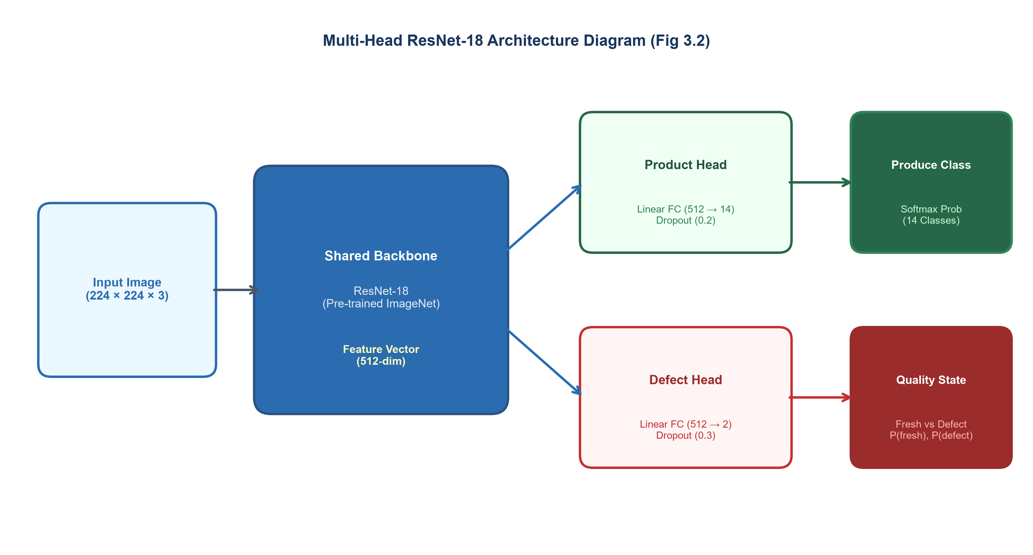
Figure 1 - Multi-head ResNet-18 model for product and defect classification.

The system must perform two related classification tasks on the same image: identifying the produce type and assessing its quality. Rather than training two entirely separate networks, these tasks share a single backbone in a multi-head, or multi-task, architecture.
In this design, the shared ResNet18 backbone extracts a single set of visual features from the input image. These features are then passed to two independent output heads: a product head, which classifies the produce type, and a defect head, which assesses quality. Sharing the backbone is efficient, because the low-level visual features useful for identifying produce are largely the same as those useful for assessing its condition, and it allows both tasks to benefit from the same feature representation. During training, the losses from both heads are combined, so that the shared backbone learns features that serve both tasks. The combined objective can be expressed as a weighted sum of the two task losses:
L_total = w_product · L_product + w_defect · L_defect
where the weights control the relative influence of each task. The quality assessment is treated as a binary classification between fresh and defective produce, with the probability of a defect obtained directly as
P(defect) = 1 − P(fresh)
Treating quality as a binary decision in this way avoids the ambiguity that arises when attempting to distinguish fine gradations of defect severity, for which consistent labelled data is difficult to obtain

Object Detection
Image classification assigns a single label to an entire image, which is appropriate when the image contains one clearly presented item. However, produce is often photographed in bulk for example a tray or crate containing many items. Assessing such images requires first locating each individual item, a task known as object detection.
Object detection differs from classification in that it produces, for each object found, both a class label and a bounding box giving the object's location in the image. This project uses a detector from the YOLO (You Only Look Once) family, which performs detection in a single pass over the image and is well suited to detecting many objects efficiently[15]. In the bulk-grading pipeline, the detector is used only to locate individual produce items. Its bounding boxes are then passed to the classification model, which grades each item separately. The detector’s predictions are not used for grading because the produce type is already specified in the seller’s listing. This separation allows the detector to concentrate on locating the individual items, while the classification model is responsible for assessing their quality.

Hybrid neural and classical scoring
The neural network provides the main quality assessment, while the final score also takes into account three classical computer-vision measurements using an 80:20 weighting. These additional measures provide directly measurable features of the produce's appearance and help support the model's prediction. Colour vibrancy is calculated from the mean saturation in the HSV colour space, colour uniformity is based on variation in hue, and surface defect coverage is estimated using adaptive thresholding to identify discoloured or damaged areas. The final score is calculated as:
Final score = 0.80 × neural quality score + 0.20 × classical appearance score
The neural network therefore remains the main component of the assessment, while the classical measures provide a smaller adjustment based on measurable visual characteristics. This approach combines the ability of the neural network to learn visual patterns with features that can be directly measured from the image.

Perceptual hashing for dataset quality
The reliability of any machine-learning evaluation depends on the quality of the underlying data, and on the separation between training and test data. Public produce datasets frequently contain near-duplicate images for example multiple photographs of the same physical item, or augmented copies of the same original image. If such duplicates are split across the training and test sets, the model may appear to perform well simply because it has effectively seen the test images before, a problem known as data leakage.
To assess this, the project uses perceptual hashing. Unlike a conventional hash, which changes completely with any alteration to a file, a perceptual hash produces a compact fingerprint of an image's visual content, such that visually similar images produce similar hashes[16] The similarity between two images can then be measured by the Hamming distance between their hashes the number of positions at which the two hashes differ. Images whose hashes fall within a small distance of one another are identified as near-duplicates. This technique allows the extent of duplication within the dataset to be quantified and enables a duplicate-aware split in which near-duplicate images are kept together, so that the evaluation reflects genuine generalisation rather than memorisation.

Evaluation metrics
Several metrics are used to evaluate the classification models. The most basic is accuracy, the proportion of examples classified correctly. Accuracy alone can be misleading when classes are imbalanced, however, since a model can achieve high accuracy simply by favouring the majority class. For this reason, precision, recall and the F1 score are also used.
For a given class, precision is the proportion of the model's predictions for that class which are correct, while recall is the proportion of actual members of that class which the model correctly identifies:
Precision = TP / (TP + FP) Recall = TP / (TP + FN)
where TP, FP and FN denote true positives, false positives and false negatives respectively. The F1-score combines precision and recall into a single measure using their harmonic mean. It therefore provides a balanced indication of classification performance:
F1 = 2 · (Precision · Recall) / (Precision + Recall)
Because the system must perform well across all produce classes, including those with fewer examples, the macro-averaged F1 score is reported. This averages the F1 score across all classes equally, regardless of how many examples each contains, so that strong performance on common classes cannot mask weak performance on rarer ones. The confusion matrix, which tabulates predicted against actual classes, is used to identify specifically which classes are confused with one another. Finally, and most importantly, all headline results are reported on a held-out test set a portion of the data set aside before training and never used for training or model selection, so that the reported figures reflect the model's ability to generalise to genuinely unseen images.

Conclusion
This chapter has described the technical foundations underlying the OrganicLink qualityassessment system: the supervised learning framework and cross-entropy objective; convolutional neural networks and the ResNet18 architecture with its residual connections; transfer learning and the two-phase training strategy; the multi-head design that performs produce identification and quality assessment from a shared backbone; the object-detection approach used for bulk photographs; the hybrid scheme that combines neural and classical measurements; perceptual hashing for assessing dataset quality; and the metrics used for evaluation. With these foundations established, the following chapter presents the specification and design of the system that applies them.

Specification and design

Overview
This chapter presents the specification and design of OrganicLink. It begins by setting out the requirements the system must satisfy, drawn from the problem analysis in the preceding chapters, distinguishing functional requirements (what the system must do) from non-functional requirements (the qualities it must exhibit).
The chapter then presents the overall platform architecture and explains the design of its main components. These include the computer-vision grading system, the two-stage bulk-grading pipeline, the dual-inspection variance protocol, and the traceability mechanism. It also explains the design boundaries that determine which products can be graded automatically and which require other forms of verification. These boundaries are intentional design choices rather than limitations of the system. The chapter concludes by describing the data model that supports the platform.

Requirements
The system requirements are based on the problem the project aims to address: supporting trustworthy direct trade between organic farmers and remote buyers.

Functional requirements
The system must support several core requirements. Farmers must be able to register, upload their organic certificate and complete administrator verification before they can sell produce. Once verified, they must be able to create produce listings and upload photographs for automated quality assessment. Buyers must be able to browse and filter available listings, view the assigned quality grades and place orders. The system must also allow buyers and farmers to negotiate the price, quantity and delivery arrangements.
The platform must assess produce quality from photographs by identifying the product type and classifying its condition as either fresh or defective. It must support inspections at both dispatch and delivery, allowing the produce to be graded at each stage. The two grades must then be compared, with the transaction flagged for review when the difference exceeds the defined tolerance. Once a transaction is completed, the system must generate an invoice, record the payment status and allow both the buyer and farmer to provide ratings.Finally, the platform must maintain an audit trail of significant actions and provide traceability information for each transaction.

Non-functional requirements
Beyond these functional requirements, the system also needs to meet a number of practical requirements. The privacy of farmers must be protected, mainly by keeping their exact location out of sight until the moment a transaction is properly completed. The platform must also provide secure user authentication and ensure that users can only perform actions appropriate to their roles. Quality review should be finished within a reasonable timeframe , so it doesn’t end up interrupting usual platform use.
The system should also give consistent results, especially when they compare the quality noted at dispatch with the quality noted at delivery, because that comparison ends up acting as the foundation for the dispute process. Another important requirement is that the system should not present its predictions as more certain than they are. Finally, automated grading should be used only on features that can reasonably be evaluated from a picture or image. Where a quality attribute cannot be reliably determined visually, the system should not attempt to make a definitive judgement.

System architecture
OrganicLink uses a conventional three-tier architecture, with the system divided into the presentation, application and data layers. This structure keeps the user interface, application logic and data storage separate. The presentation tier is implemented as a single-page React application through which farmers, buyers and administrators interact with the platform.
The application layer is built using FastAPI and contains the main logic required by the platform. It manages users and listings, handles the order process, performs the dual-inspection comparison, generates invoices and maintains the audit trail. The computer-vision functionality is also handled at this level. Images are therefore processed on the server, with the same models being used for grading requests. PostgreSQL is used as the data layer and stores information relating to users, listings, orders, inspections, ratings and audit records.
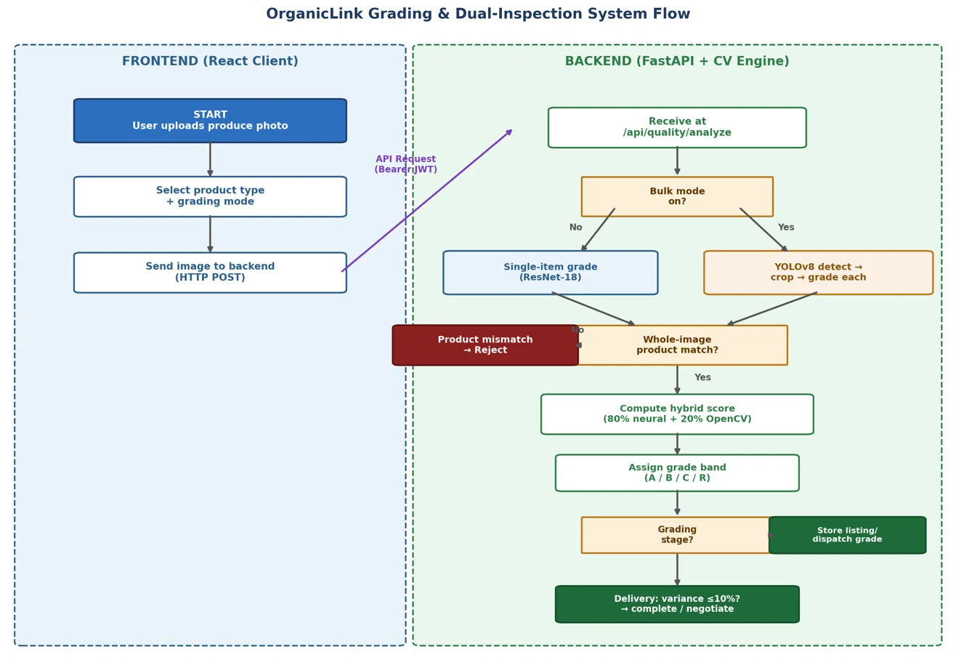
Figure 2 - End to End workflow of the system, from uploading photo to grading
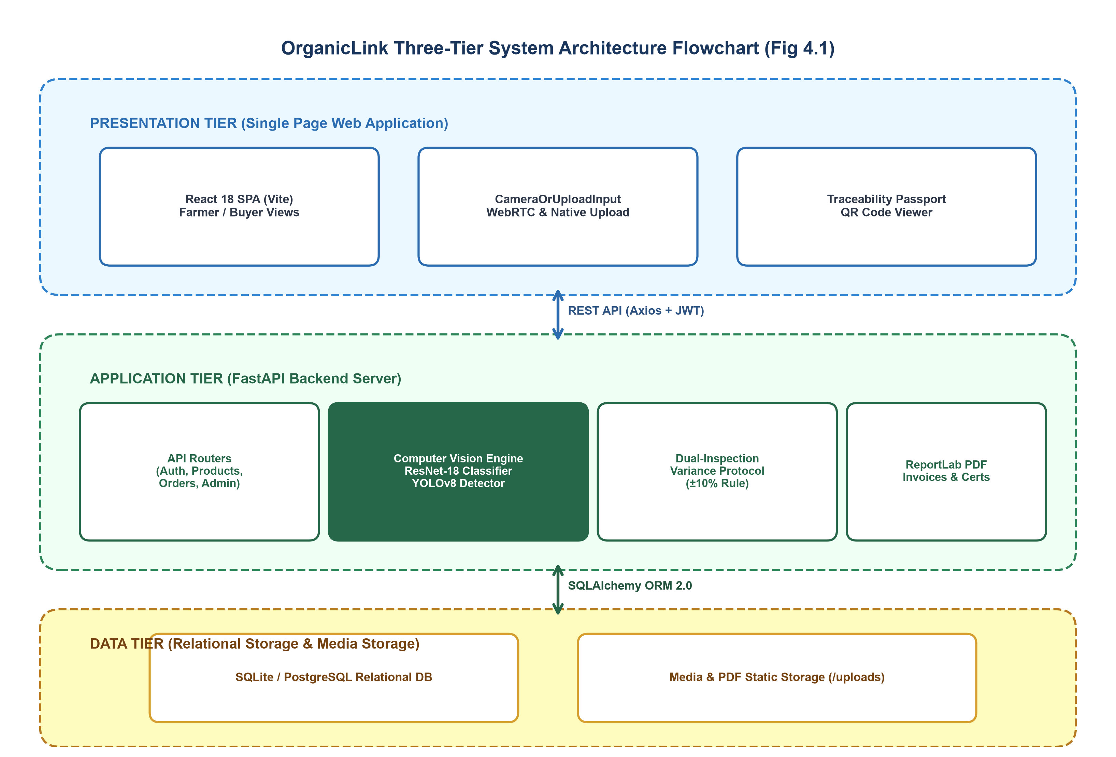
Figure 3 - OrganicLink three-tier system architecture
.
Python was used for the application layer because the computer-vision components were developed using PyTorch and OpenCV. Keeping these components within the same environment as the application logic avoids the need for a separate model-serving service. Authentication is handled using JSON Web Tokens (JWT), while Docker is used to provide a consistent environment for running the system.
The separation between the layers also means that the computer-vision models are kept behind the API. So the frontend just submits an image and gets back the resulting grading inormation, without needing to know anything about the models inside. This also makes it easier to swap out or retrain the underlying models later, without having to touch the rest of the system.

Computer-vision grading design
The grading system is the main computer vision component of OrganicLink. Its design is based on the two tasks it needs to perform : recognizing the type of produce and determining its quality. The system must also handle both scenarios: individual produce images and photographs showing several items together.

The Multi-Head Classifier
Rather than using separate models for product identification and quality assessment, OrganicLink uses a single model with two output heads. As described in Chapter 3, the backbone is a ResNet18 model pre-trained on ImageNet, which extracts the main visual features from the input image. After that , the extracted features go into the product head for figuring out the kind of produce, and they also go into the defect head which estimates its quality level. This arrangement makes sense because the two tasks rely on many of the same visual characteristics, so the features learned for identifying the produce can also help with assessing its condition.
The system classifies produce into two quality categories: fresh and defective. This was a deliberate choice made after considering a three-class approach consisting of fresh, minor defect and major defect. While the three-class model could provide more detail, the available dataset did not contain enough consistent examples of minor defects to train this category reliably. The distinction between minor and major defects also made the predictions less consistent. For this reason, the final system uses the simpler fresh-versus-defective classification. The defect probability is derived from the predicted fresh probability, giving a more reliable and easier-to-interpret quality assessment.

Hybrid Scoring
The quality grade is based mainly on the neural network prediction, which contributes 80% of the final score. The remaining 20% comes from three image measurements calculated using OpenCV. Mean saturation is used to represent colour vibrancy, variation in hue is used to indicate colour uniformity, and adaptive thresholding is used to estimate the area affected by visible surface defects. These measurements provide additional information about the appearance of the produce without replacing the neural network's prediction. The combined result is converted to a score between 0 and 100 and then presented as an A, B, C or R grade.

The two-stage bulk-grading pipeline
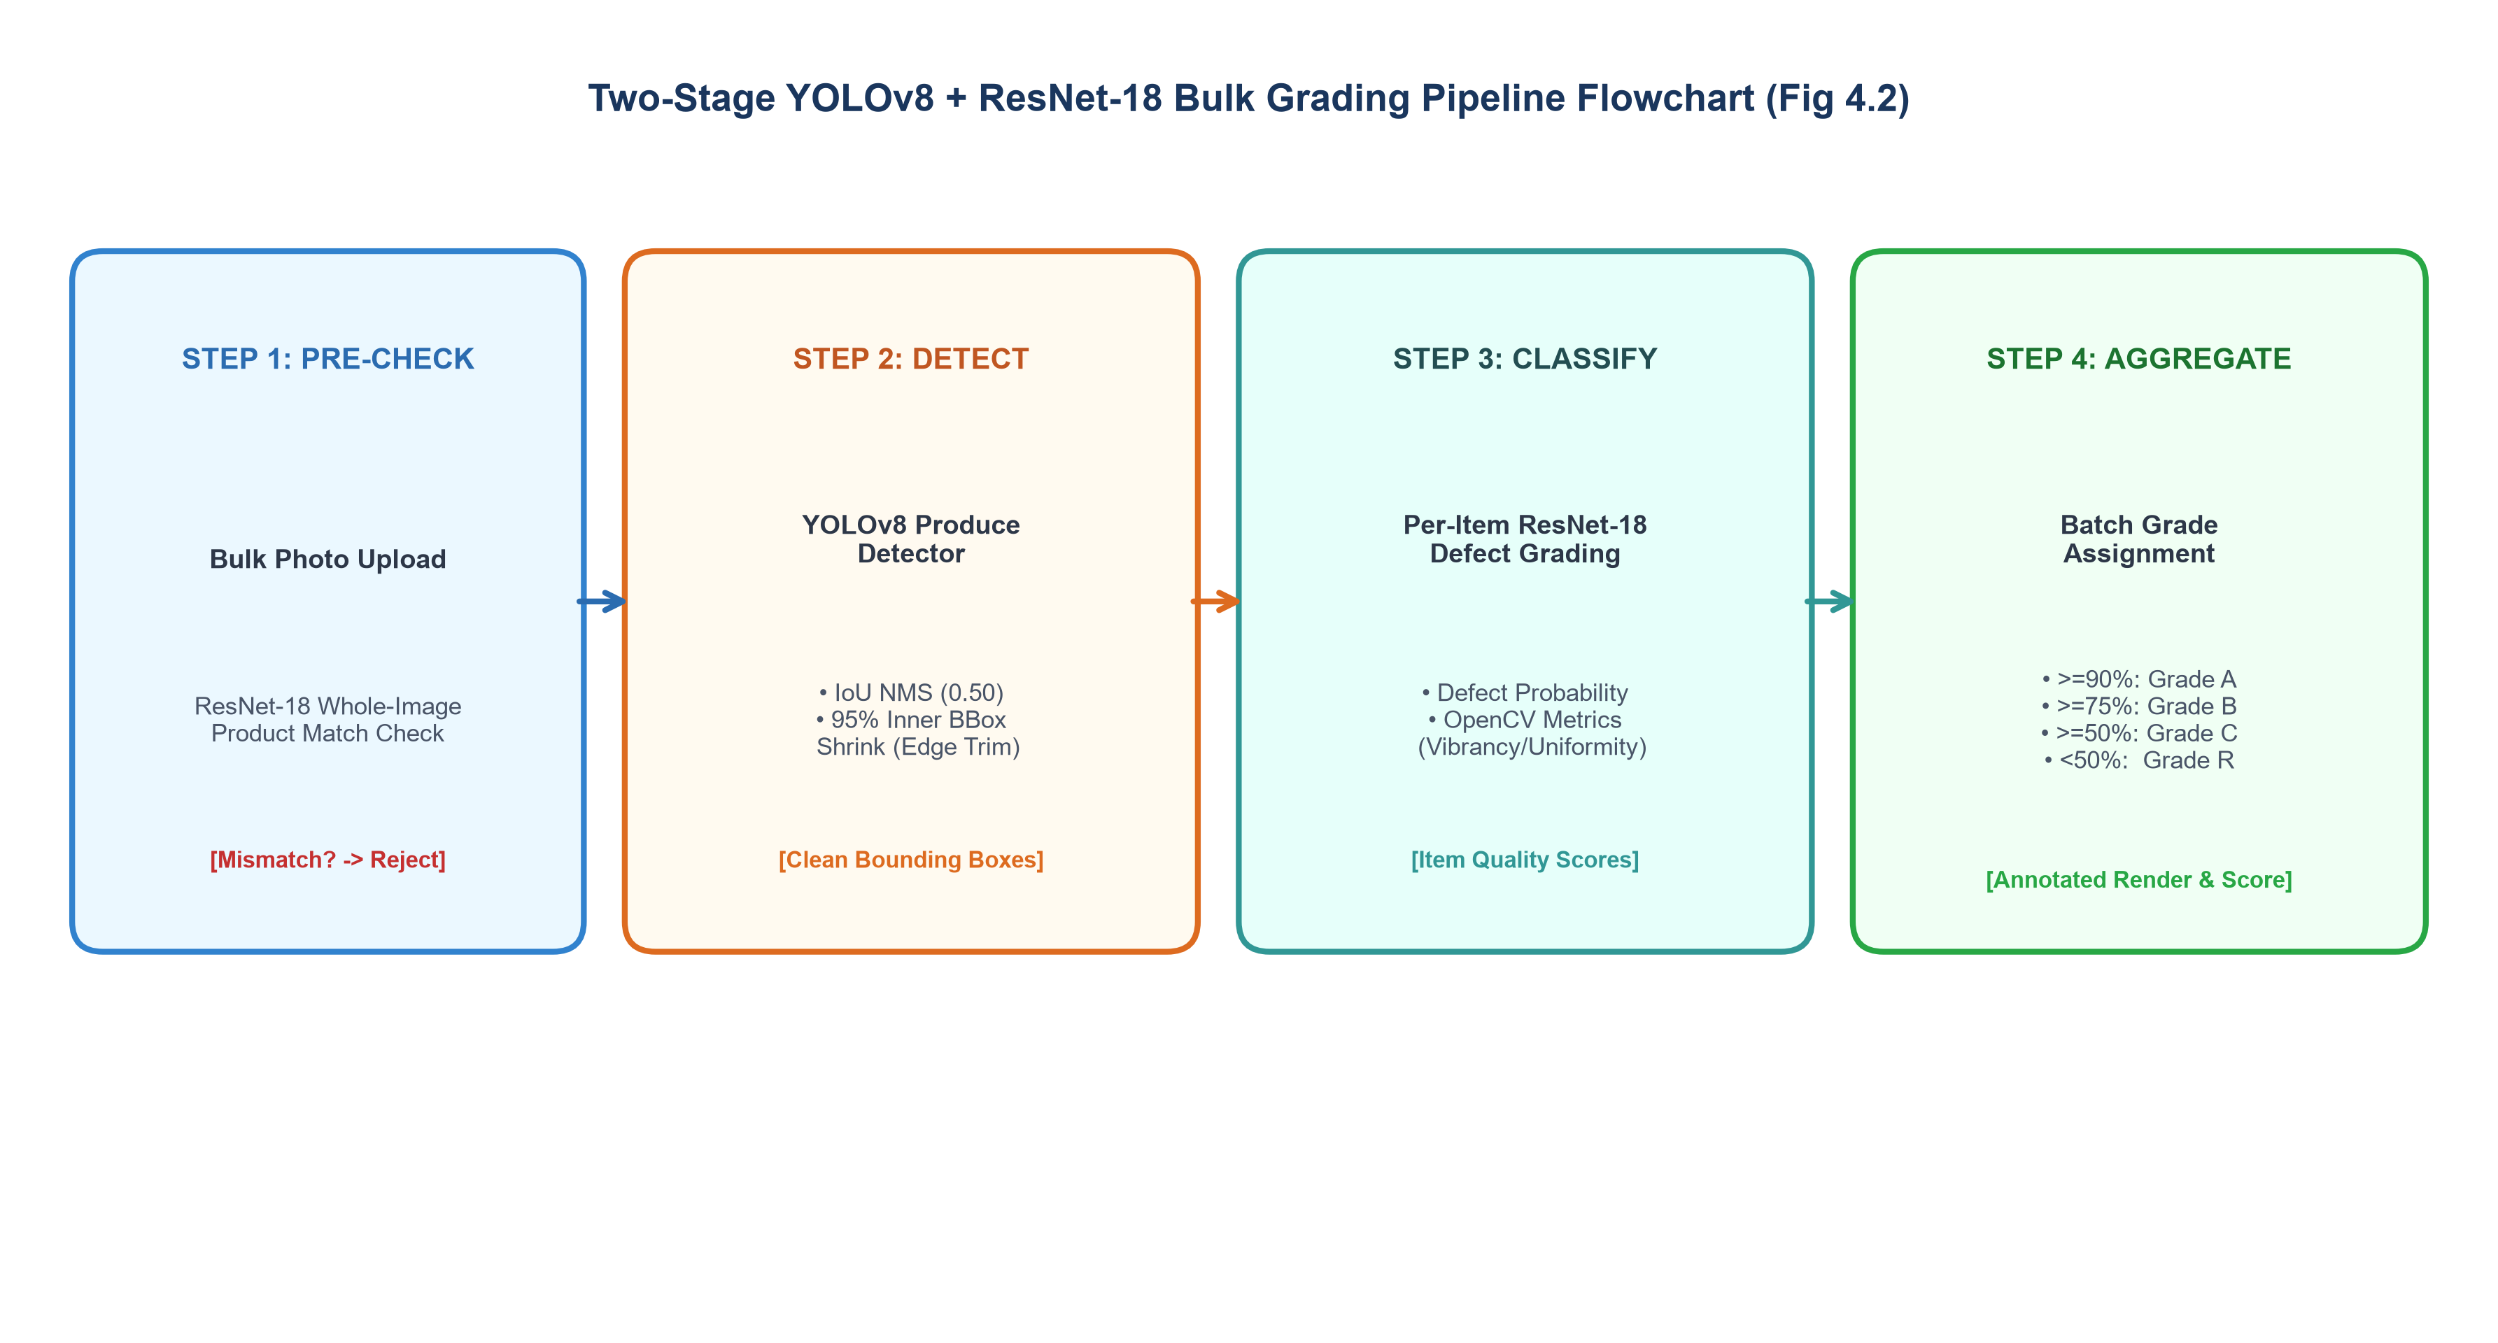
Figure 4 - The two-stage bulk-grading pipeline
.
The main classification model is intended to assess one produce item at a time, so a separate process is needed when several items appear in the same photograph. OrganicLink handles these images using a two-stage detection and grading pipeline. First, a YOLOv8-based object detector identifies the individual produce items and places a bounding box around each one. Each detected region is then cropped and passed to the multi-head classifier for quality assessment. After all detected items have been graded, the individual results are combined to produce a batch-level result, including the number of items detected, the proportion classified as fresh or defective, and the overall batch grade.
A number of choices were made to make this process more reliable. The detector is used only to locate the items and its predicted class is not used for the final grading. This is because the produce type is already known from the listing. Each detected bounding box is also reduced to its central region before being passed to the classifier. This reduces the amount of neighbouring produce included in the crop and gives the classifier a more focused view of the item being assessed.A confidence threshold and non-maximum suppression are applied so that only cleanly detected, non-overlapping items are graded, preventing unreliable crops from distorting the batch result. Product-consistency is checked at the level of the whole image rather than per crop, because whole-image identification is more reliable than identification of small, cluttered crops.

The dual-inspection variance protocol
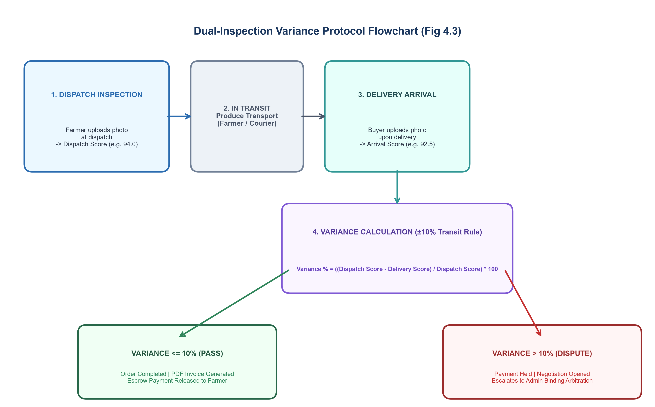
Figure 5 - The dual-inspection variance protocol.

The dual-inspection variance protocol is the central design contribution of the project and directly addresses the trust problem identified in Chapter 1.
The protocol grades produce at two points in a transaction. When the farmer prepares an order for dispatch, the produce is photographed and graded, producing a dispatch grade. When the buyer receives the order, it is photographed and graded again, producing a delivery grade. Because the same model is applied in the same way at both points, the two grades are directly comparable and neither depends on the subjective judgement of either party.
The two grades are then compared. If the difference between them lies within a defined tolerance, the transaction is considered consistent and proceeds normally to invoicing and payment.
If the difference between the two quality assessments is greater than the defined tolerance, the transaction is flagged because this suggests that the quality of the produce may have changed during transit. A flagged transaction does not immediately become a formal dispute. Instead, the system first gives the buyer and farmer an opportunity to negotiate a resolution. For example, the buyer may choose to accept the produce at a reduced price to account for the change in quality. Payment remains on hold during this stage. If an agreement cannot be reached, the transaction is passed to an administrator for formal dispute review.
The reason for using negotiation first is that a change in quality does not necessarily mean that the buyer will reject the produce. An agreed price adjustment may be a more suitable solution in some cases. The two quality assessments also give both parties a common reference when discussing the issue, rather than relying only on their individual descriptions of what happened. The protocol therefore provides evidence of the change in quality between dispatch and delivery and uses this evidence to support the resolution process.

Design boundaries: what is and is not graded automatically
The system does not attempt to grade every product using computer vision. This was a deliberate design choice based on what can realistically be determined from visual information. Computer-vision grading is applied only where quality can be assessed from an image, mainly for fruit and vegetables, where freshness and visible defects can be identified. But for goods where quality can’t be reliably judged from a photograph the design intentionally skips automated grading. Milk, for example, depends on properties that are not visible in an image and is therefore not CV-graded; instead, such products are supported through certification and administrative verification. Similarly, meat is handled as a certification based product, rather than one that is CV-graded ,because its safety and overall quality depends on how it’s treated and stored and a photo can’t really capture that.
The system also distinguishes between assessing product quality and verifying organic status. This cannot be reliably determined through computer vision because organically produced and conventionally produced items may have the same visual appearance. An organic tomato, for example, cannot be visually distinguished from a conventional tomato using computer vision alone. The platform therefore uses the farmer's organic certificate and administrative verification to establish organic status, rather than relying on the quality-assessment model. The computer-vision system only assesses visible quality and does not claim to identify organic produce. This keeps quality assessment and organic-status verification as two separate parts of the platform: quality is assessed from the image, while organic status is confirmed through certification.

Traceability design
To support traceability across the platform, each listing and transaction is linked to information that can be accessed through a QR code. Scanning the code opens the record associated with the produce, including the farmer's verified organic certification, the farm where the produce was grown, and the available quality-inspection history. Where both inspections have been completed, the record also includes the grades recorded at dispatch and delivery. This gives the buyer or end consumer a way to check the origin of the produce and review its quality history after the purchase. The QR code uses information already stored within the system, so it provides access to the existing record without requiring a separate process for collecting traceability data.

Data Model
The database schema is organised around the entities the system manages. A user record holds account and role information and, for farmers, the organic-certificate reference and verification status. A listing record represents produce offered for sale, linked to the farmer who created it and to the quality inspection produced when it was listed. An order record represents a transaction between a buyer and a listing, and carries the state of the order through its lifecycle.
Inspection records store the results of quality grading, including the dispatch and delivery inspections that the dual-inspection protocol compares. Rating records capture the mutual feedback between parties after a transaction, and audit records provide an insert-only log of significant actions. This structure keeps the quality-inspection data central to the dual inspection protocol as first-class records that can be compared, displayed and traced.

Conclusion
This chapter has set out the requirements of the system and described its design: a three-tier architecture with server-side computer-vision grading; a multi-head classifier with hybrid scoring; a two-stage pipeline for bulk photographs; the dual-inspection variance protocol with its negotiation-first resolution; the deliberate boundary separating visually gradable quality from certification-verified provenance; a traceability mechanism; and the data model underpinning it all. The following chapter describes how this design was implemented

Implementation

Overview
This chapter describes how the design presented in Chapter 4 was implemented. It covers the technologies used, the implementation of the backend and its API, the frontend, the computervision components, the two-stage bulk-grading pipeline, the dual-inspection protocol, and the supporting features such as invoicing, traceability and the audit trail. Rather than reproducing source code in full, the chapter explains the significant implementation decisions and the practical challenges encountered, since these are more informative than the code itself. Where a challenge was encountered and resolved during development, it is described, because the resolution of these issues formed a substantial part of the engineering effort.

Technologies and tools
The completed system consists of a full-stack web application. Python and FastAPI were used for the backend because of their performance, built-in API documentation and suitability for running the machine-learning components within the same application. The frontend was developed with React. PostgreSQL was used as the relational database, with the backend accessing the stored data through an object-relational mapper.
The computer-vision components were implemented using PyTorch, which provided the ResNet18 architecture and the training and inference machinery, and OpenCV, which provided the classical image-processing operations used in the hybrid scoring and in image handling. The bulk-grading component was implemented using a YOLOv8 object-detection model. PDF invoices were generated using ReportLab, while JSON Web Tokens were used to handle user authentication. Docker was used to containerise the application so that it could run consistently across different environments. The machine-learning models and application components were integrated and tested as part of the overall system to ensure that the individual components worked correctly together.

Backend and API implementation

Figure 6 - Farmer accounts are held pending until an administrator approves the organic certificate.

The backend is organized around a REST API, with endpoints organised according to the main resources they handle, including users and authentication, listings, orders, quality inspections, payments, ratings and administration. Requests are authenticated using JSON Web Tokens and each endpoint enforces those role based restrictions that are set out in the design, for example, only verified farmers can create listings and only the buyer tied to an order can submit its delivery inspection.
The most substantial piece of backend logic is the order lifecycle, which moves an order through a defined sequence of stages, starting with creation and continuing through negotiation, acceptance, dispatch, delivery and inspection comparison, before ending in either completion or dispute. This was implemented as an explicit state machine so that each stage can only move to a valid next state. This was particularly important because an earlier version allowed the quality check to be bypassed when the dispatch inspection was copied to the order too early. As a result, the delivery inspection could effectively be compared against the wrong information. This was corrected by ensuring that the dispatch and delivery inspections are stored separately and only compared at the appropriate stages of the order lifecycle. Concurrent updates were also handled to prevent two updates to the same order from leaving it in an inconsistent state.
Several issues were found during testing and were corrected as the system was developed. These included a field-name mismatch that stopped farm photographs from being displayed, handling cases where a listed product could not be graded using computer vision, correcting API routes that were no longer consistent between the frontend and backend, and making sure that database changes were saved correctly after quality inspections. The affected functions were tested through the complete workflow after each correction to confirm that they worked as expected.

Frontend Implementation
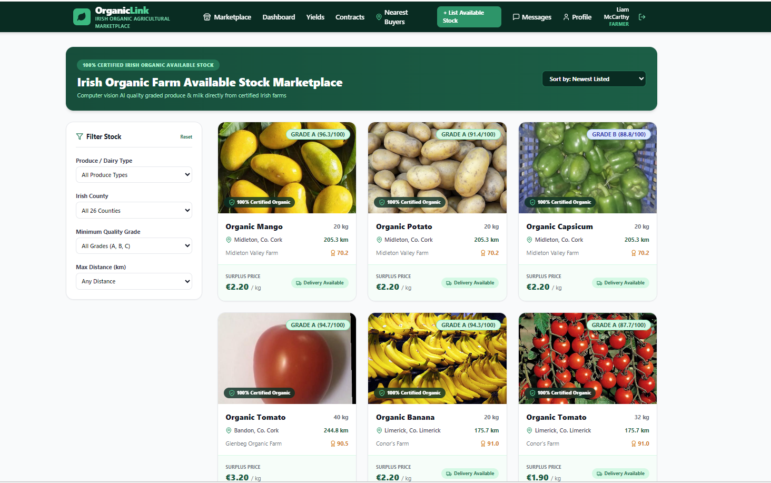
Figure 7 - The buyer marketplace, with filtering by produce type, county, grade and distance.

Different user roles are provided with their own interfaces within the frontend. Farmers can manage their own profiles and organic certificates, create listings of the produce with photographs and view the quality grading result, and manage orders that are received from buyers. Buyers can browse and filter the marketplace, place and negotiate orders, and submit the images for delivery inspections. Administrators can verify farmer certificates and review disputes that have been escalated when the issues cannot be resolved between the two parties.
Privacy was also considered in the implementation of the platform. The farmer's precise location is stored as an Eircode but is private from the public marketplace. Listings display only the town, with the full Eircode becoming visible to the buyer after completion of the transaction. This allows the location to be used for delivery or collection without exposing it unnecessarily during the buying process. The behavior was implemented across both the API and frontend to ensure that the precise location remained hidden before completion and was displayed only at the appropriate stage.

Computer Vision implementation

Figure 8 - The produce-listing form, including the bulk-mode toggle and multi-angle photo guidance.

The computer-vision grading component was implemented as an inference engine within the backend. The trained multi-head model is loaded once and reused for subsequent requests, avoiding the need to reload the model for each image. Before inference, each image goes through the required preprocessing steps. The engine then returns the predicted product type, quality assessment, confidence values and the derived quality score as a structured result.

Model Training
The multi-head model was trained using an ImageNet-pretrained ResNet18 and the two-phase transfer-learning approach described in Chapter 3. In the first phase, the ResNet18 layers were kept frozen while the newly added classification heads were trained. The network was then unfrozen and the full model was fine-tuned using a lower learning rate. To deal with differences in the number of examples between classes, class weights were applied to the loss according to class frequency. A maximum weight was applied to prevent very rare classes from having a disproportionate effect on training. During development, an important problem was identified when the number of product classes was expanded. The product head then failed to learn effectively, with accuracy falling to almost zero, while the quality head continued to train normally.
Investigation showed this was not a fundamental problem but a lossweighting instability caused by uncapped class weights combined with an over-weighted quality loss. Capping the class weights, balancing the two heads, and removing label smoothing resolved it, and the product head then trained correctly. A single-batch diagnostic was added to test the product head before running the complete training process. This provided an early indication of whether the head was learning as expected and helped identify this type of problem sooner.

Dataset quality and deduplication
The training data required particular attention during the computer-vision development. The public produce datasets contained many images that were very similar to one another, with near-duplicates making up 34.7% of the combined training data. To identify these images, a deduplication step based on perceptual hashing was implemented. Each image was converted into a perceptual hash, and images with a small Hamming distance between their hashes were identified as near-duplicates and placed into the same group. Rather than deleting duplicates, a grouped split was constructed in which every group of near-duplicates was assigned entirely to either the training or the validation side, so that no image could have a near-identical counterpart on the opposite side of the split. This ensured that the evaluation measured genuine generalisation rather than recognition of images effectively seen during training. A third public dataset was also assessed for inclusion, but perceptual-hash analysis showed that incorporating it would raise near-duplicate contamination to 61.8%, indicating it consisted largely of imagery already represented; it was therefore excluded from the final model. This deduplication was performed before training, so that the reported accuracy figures were leakage-free from the outset.

Hybrid Scoring implementation
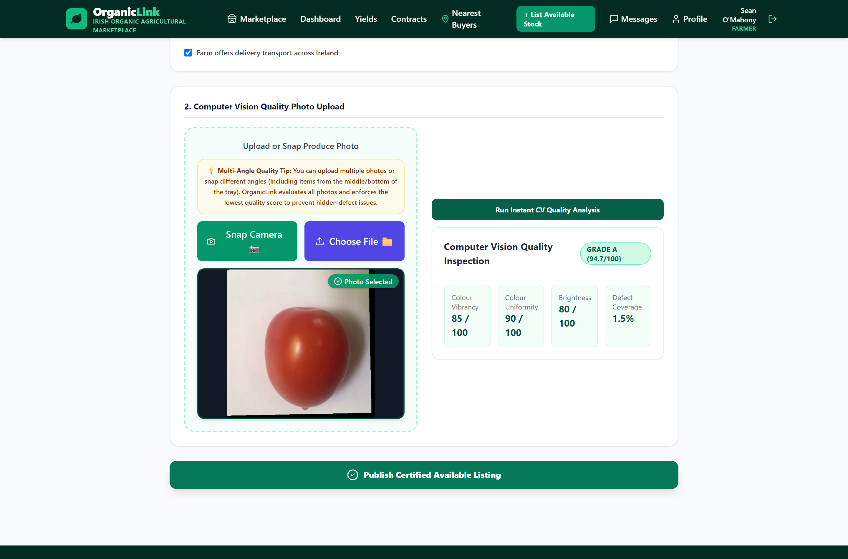
Figure 9 - Single-item quality grading - a tomato graded A (94.7/100) with colour-metric breakdown.

The final quality score was implemented as the weighted combination of the neural output and the classical measurements described in Chapter 4. The classical measurements like colour vibrancy, colour uniformity and defect coverage were computed with OpenCV in the hue saturation value colour space, and combined with the neural quality score in an 80:20 ratio. The score was then mapped to a letter grade for presentation. Because the class count of the deployed model must match the label list used at inference, the inference engine was implemented to detect the model's output dimensions when loading and select the matching class list automatically, preventing the label-mismatch errors that can otherwise arise when switching between models with different numbers of classes.

The two-stage bulk grading pipeline
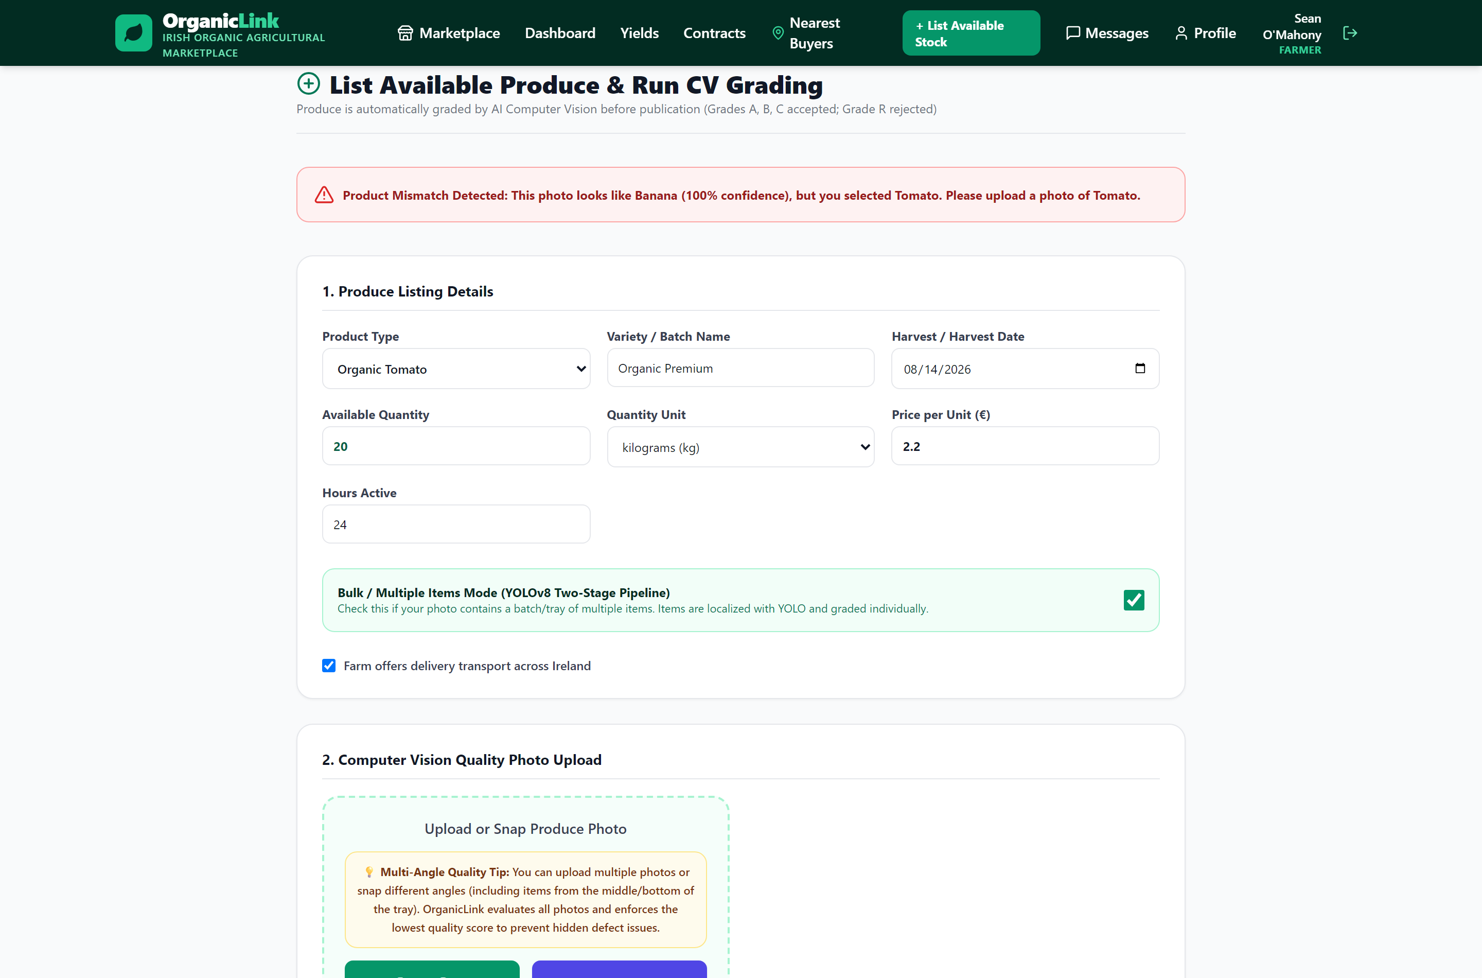
Figure 10 - The whole-image product-match check rejecting a banana photo when tomato was selected.

The bulk-grading pipeline was implemented in two stages, as designed. The first stage runs the YOLOv8 detector on the uploaded photograph to obtain bounding boxes for the individual items. A general-purpose detector proved inadequate for this , it did not reliably recognise the produce so a produce-oriented detector was used; only its bounding boxes are used, and its own class labels are discarded, since the product type is already known from the listing.
The second stage crops each detected box, reduces it to its central region to avoid capturing neighbouring items, and passes it to the multi-head classifier for grading. A confidence threshold and non-maximum suppression are applied so that only cleanly detected items are graded. The individual results are then aggregated into a batch result: the total number of items graded, the counts and proportions fresh and defective, and an overall batch grade.
Two implementation issues in this pipeline are worth recording. First, an early version inadvertently used the detector's ripeness labels in place of the classifier's quality assessment, so that produce was reported as acceptable regardless of its actual condition; correcting this ensured that every crop was graded by the quality classifier and that the reported defect proportions were computed from real results. Second, product-mismatch checking was moved from the level of individual crops to the level of the whole image, because small cropped regions were unreliable to identify a cropped banana, for instance, could be misidentified as a visually similar item whereas identifying the product from the whole image was dependable. With this change, a whole-image check reliably rejects a photograph whose contents do not match the selected product, while per-item grading proceeds using the known product type.

The dual-inspection protocol and supporting features
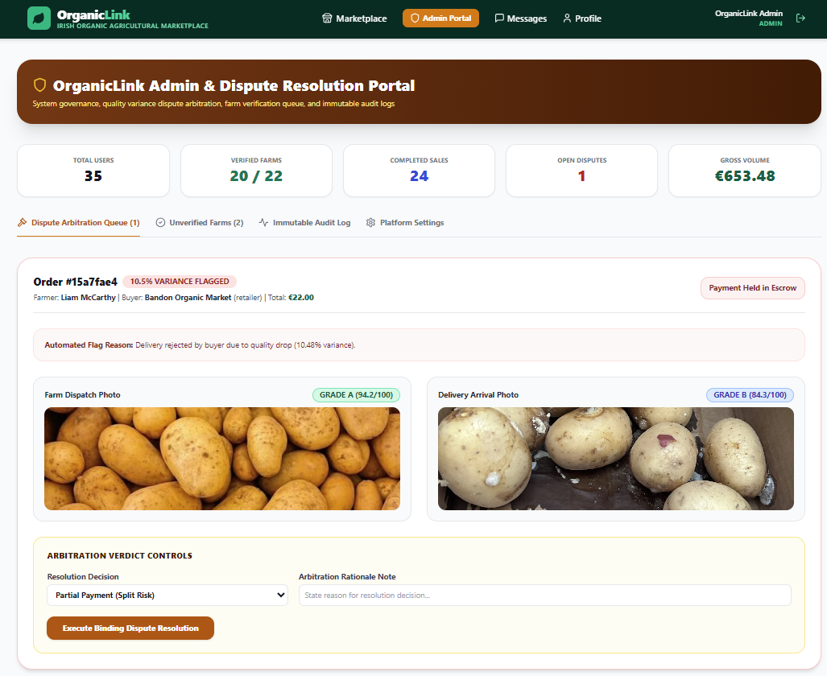
Figure 11 - The admin portal, a variance-flagged order with dispatch and delivery grades side by side.

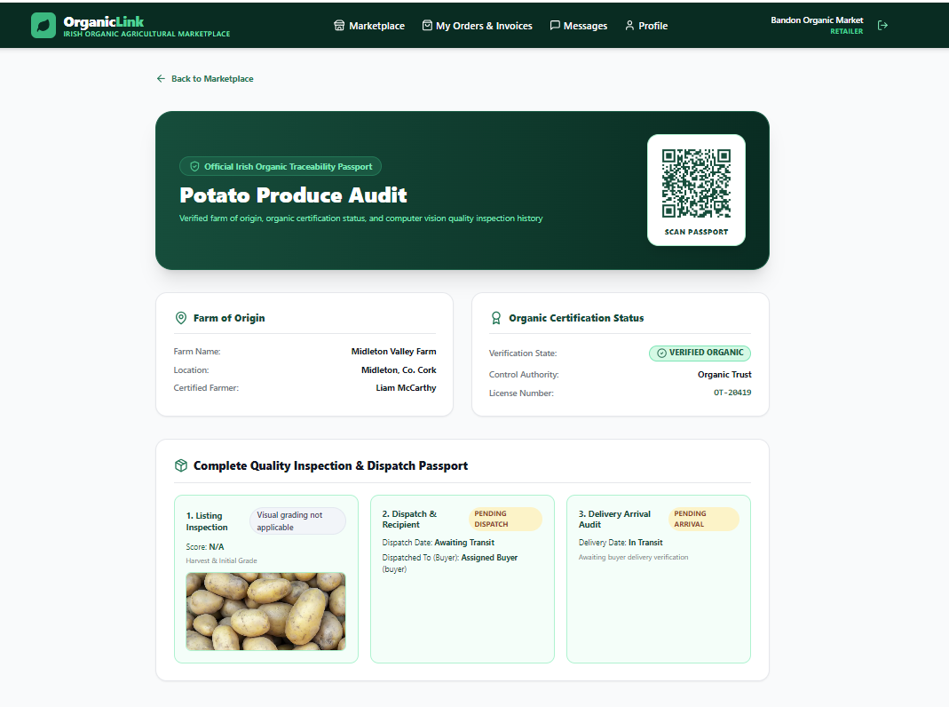
Figure 12 - The traceability passport - QR code, verified farm of origin, organic certification, and the full listing/dispatch/delivery inspection history.

The dual-inspection protocol was implemented within the order lifecycle. When an order is dispatched, the farmer's photograph is graded and stored as the dispatch inspection; when it is delivered, the buyer's photograph is graded and stored as the delivery inspection. The two are then compared, and if their variance exceeds the tolerance, the order is flagged and payment held, opening the negotiation step; only on failure of negotiation is the order escalated to a formal dispute for administrator review.
Supporting features were implemented to complete the transaction flow. Invoices are generated as PDF documents on completion, incorporating the dispatch and delivery grades and their variance. Payment status is tracked through an explicit two-step process representing the buyer marking payment as sent and the farmer marking it as received; no real financial processing is performed, as this was outside the scope of the project. Ratings allow each party to record feedback after a transaction. An insert-only audit log records significant actions, providing a tamper-evident record. Finally, traceability information is made available through a QR code that links to the produce's record, drawing together its certification, origin and inspection history

Conclusion
This chapter has described the implementation of the system: the backend and its orderlifecycle state machine, the role-specific frontend with its privacy handling, the computer-vision inference engine and the training, deduplication and scoring work behind it, the two-stage bulkgrading pipeline, and the dual-inspection protocol with its supporting features. The implementation focused on the main design decisions and the practical issues that arose during development. Several of these required significant work to resolve, including the instability in product-head training, removal of duplicate data from the dataset, correction of the quality gate, and fixes to the bulk-grading pipeline. The next chapter evaluates the resulting system and presents the results of this work.

Results and discussion

Overview
This chapter presents the evaluation of the system and discusses what the results demonstrate. The evaluation focuses mainly on the computer-vision components, as these form the technical core of the project and provide the clearest scope for quantitative evaluation. It reports the overall accuracy of the grading model on a held-out test set, examines performance on a per-product basis, and presents the analysis of dataset quality that underpins the honesty of these figures. It then discusses the behaviour of the two-stage bulk-grading pipeline and the dual-inspection protocol, and closes with a frank account of the system's limitations. Throughout, the emphasis is on reporting results honestly, including where performance is weaker, since an accurate understanding of the system's boundaries is itself a contribution

Overall grading accuracy
The multi-head grading model was evaluated on a held-out test set , a portion of the data set aside before training and used neither for training nor for model selection ,so that the reported figures reflect the model's ability to generalise to unseen images rather than its ability to recall training data. On this held-out test set, the model achieved 96.8% accuracy in identifying produce type and 98.3% accuracy in assessing quality (fresh versus defective). These figures sit within the range reported in the literature for image-based produce grading (Chapter 2), where common produce is routinely graded at accuracies in the mid-nineties and above under controlled conditions. The high quality accuracy in particular reflects that the binary fresh-versus-defective distinction is a comparatively well-defined visual task, whereas product identification across many visually similar classes is inherently harder, which is consistent with the slightly lower product accuracy.
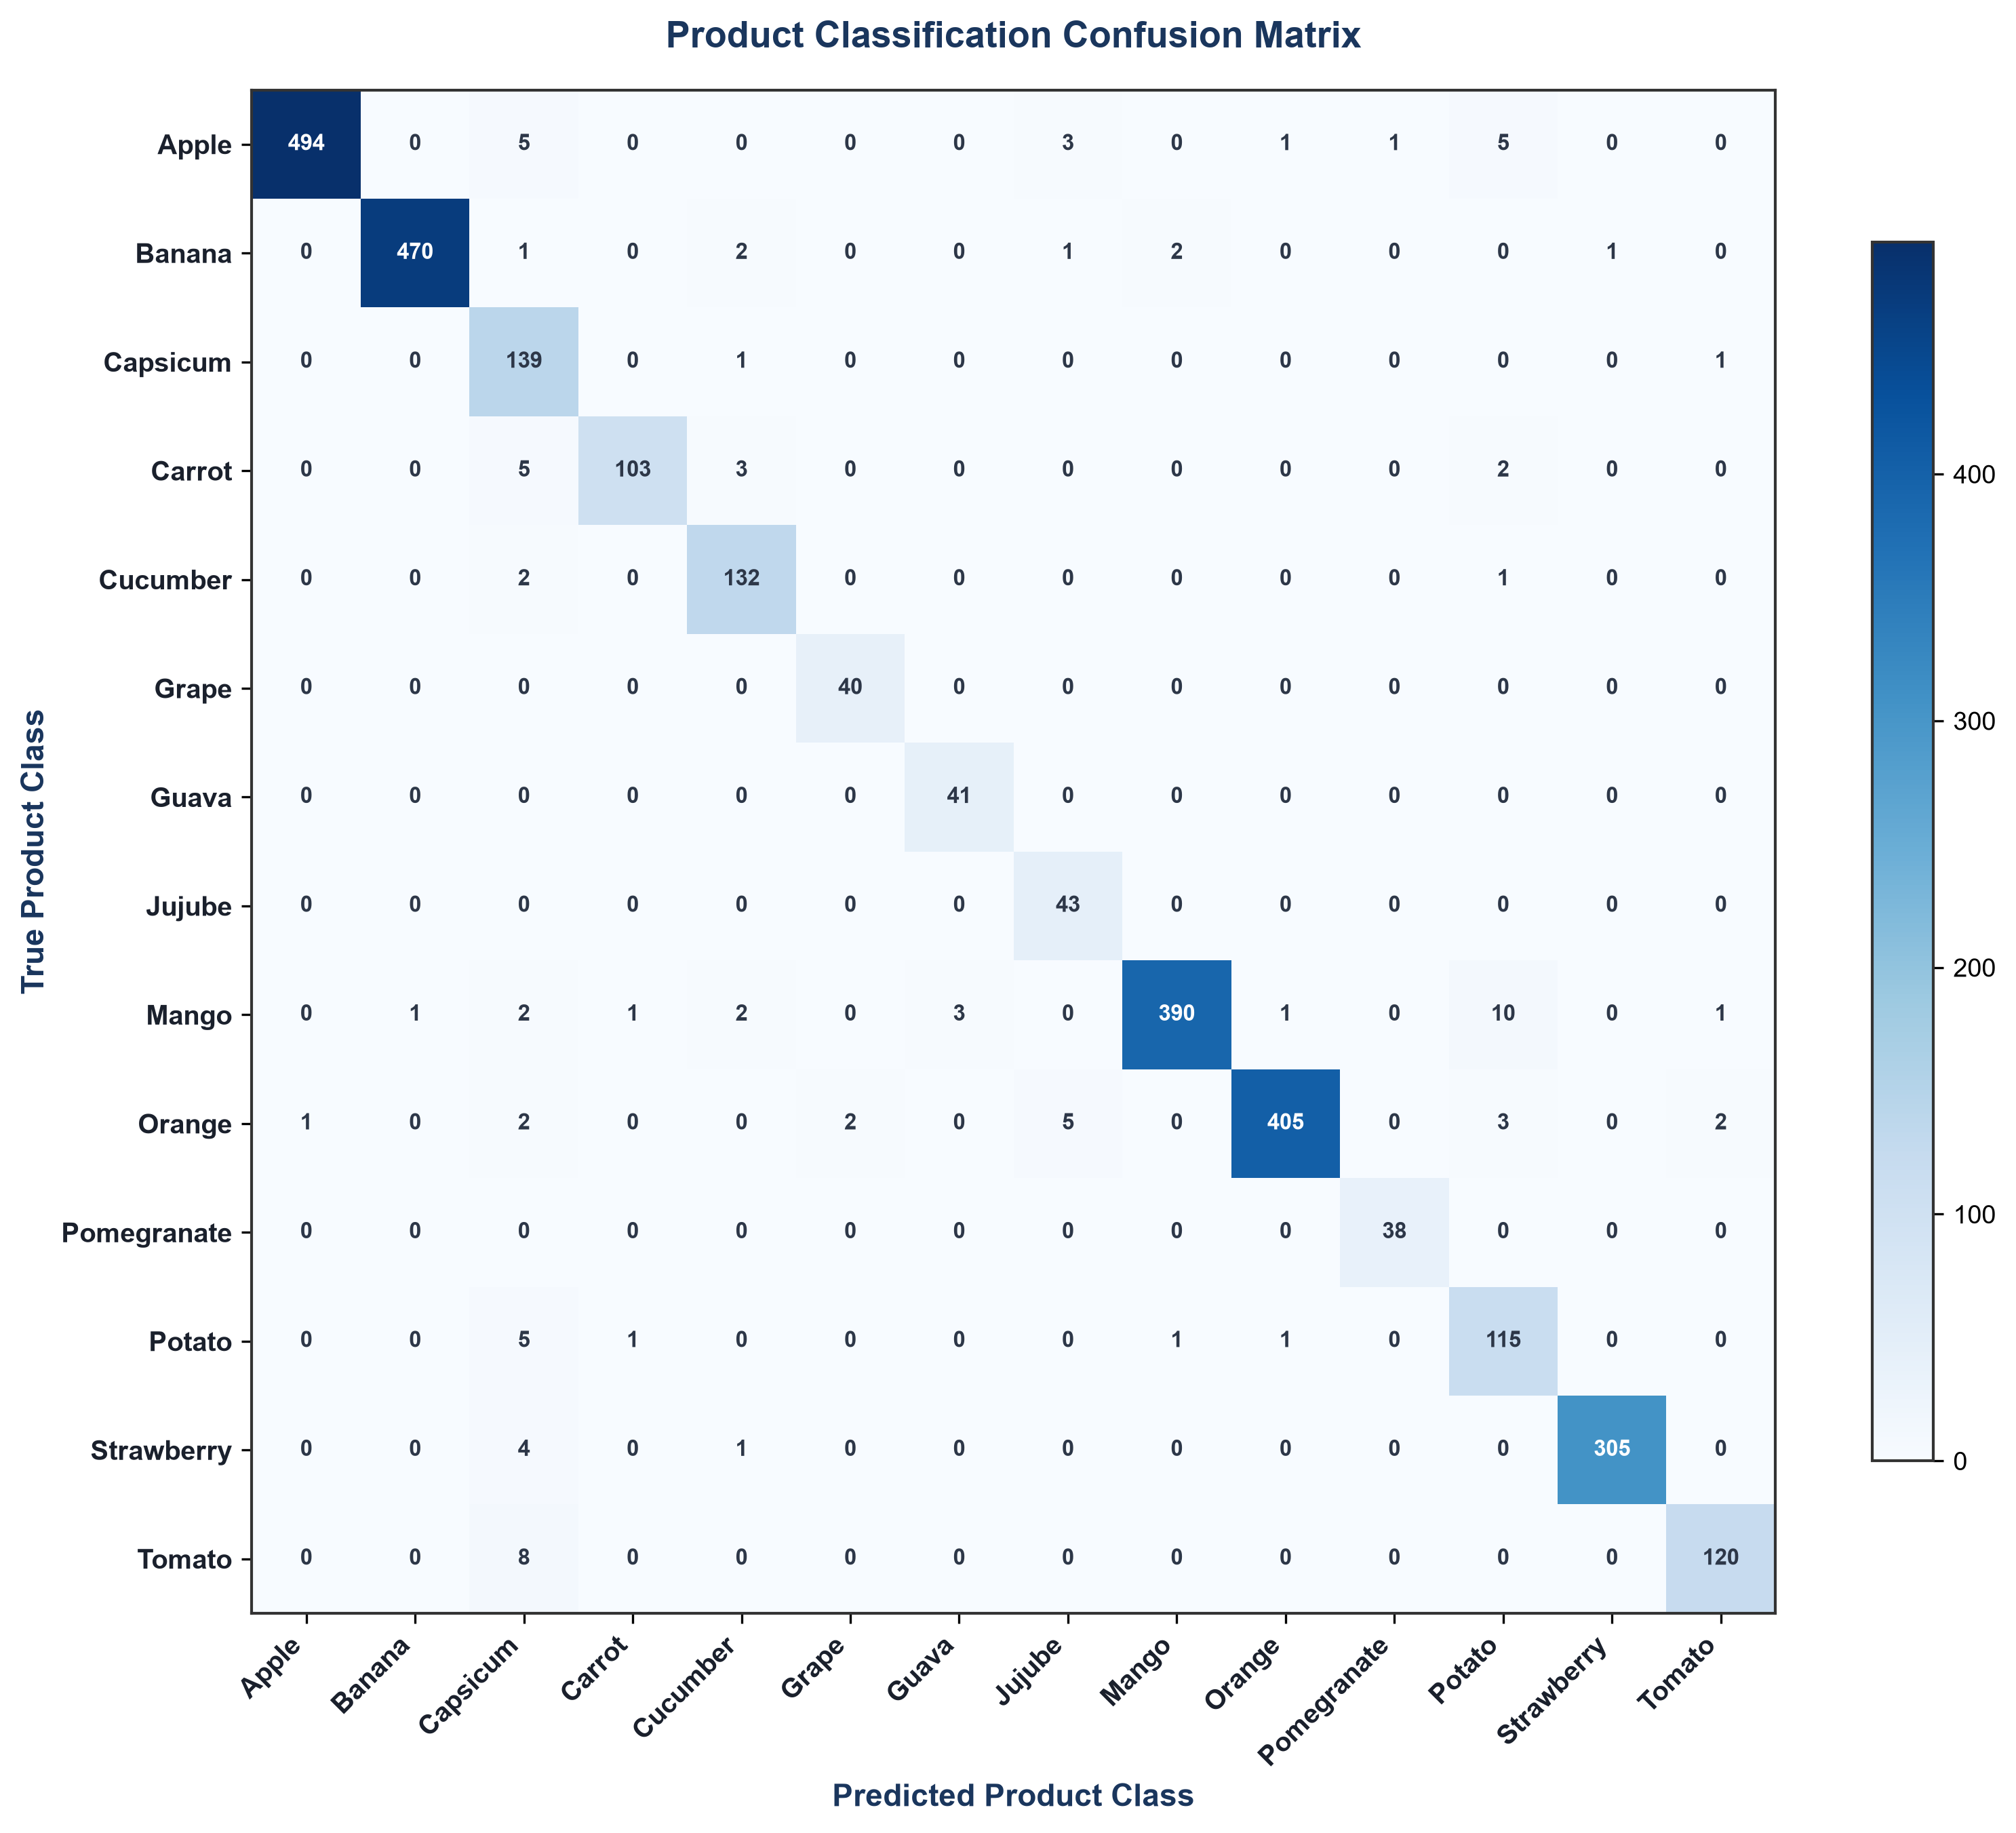
Figure 13 - Product-classification confusion matrix on the held-out test set.

Per-product performance
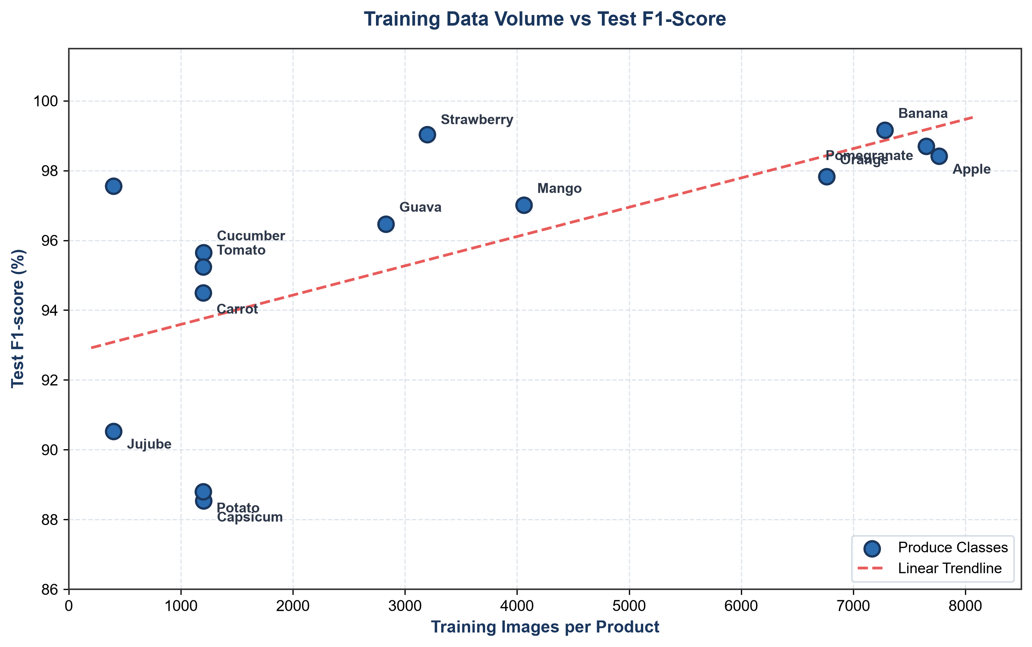
Figure 14 - Test F1-score against training-data volume, showing accuracy tracks data availability.

To examine differences in performance between individual classes, the model was evaluated separately for each product rather than relying only on the overall accuracy. Table 6.1 reports the number of training images, evaluation samples and test F1-score for each product. F1-score provides a more useful measure in this case because it considers both precision and recall, particularly where the number of available samples is not the same across all classes.
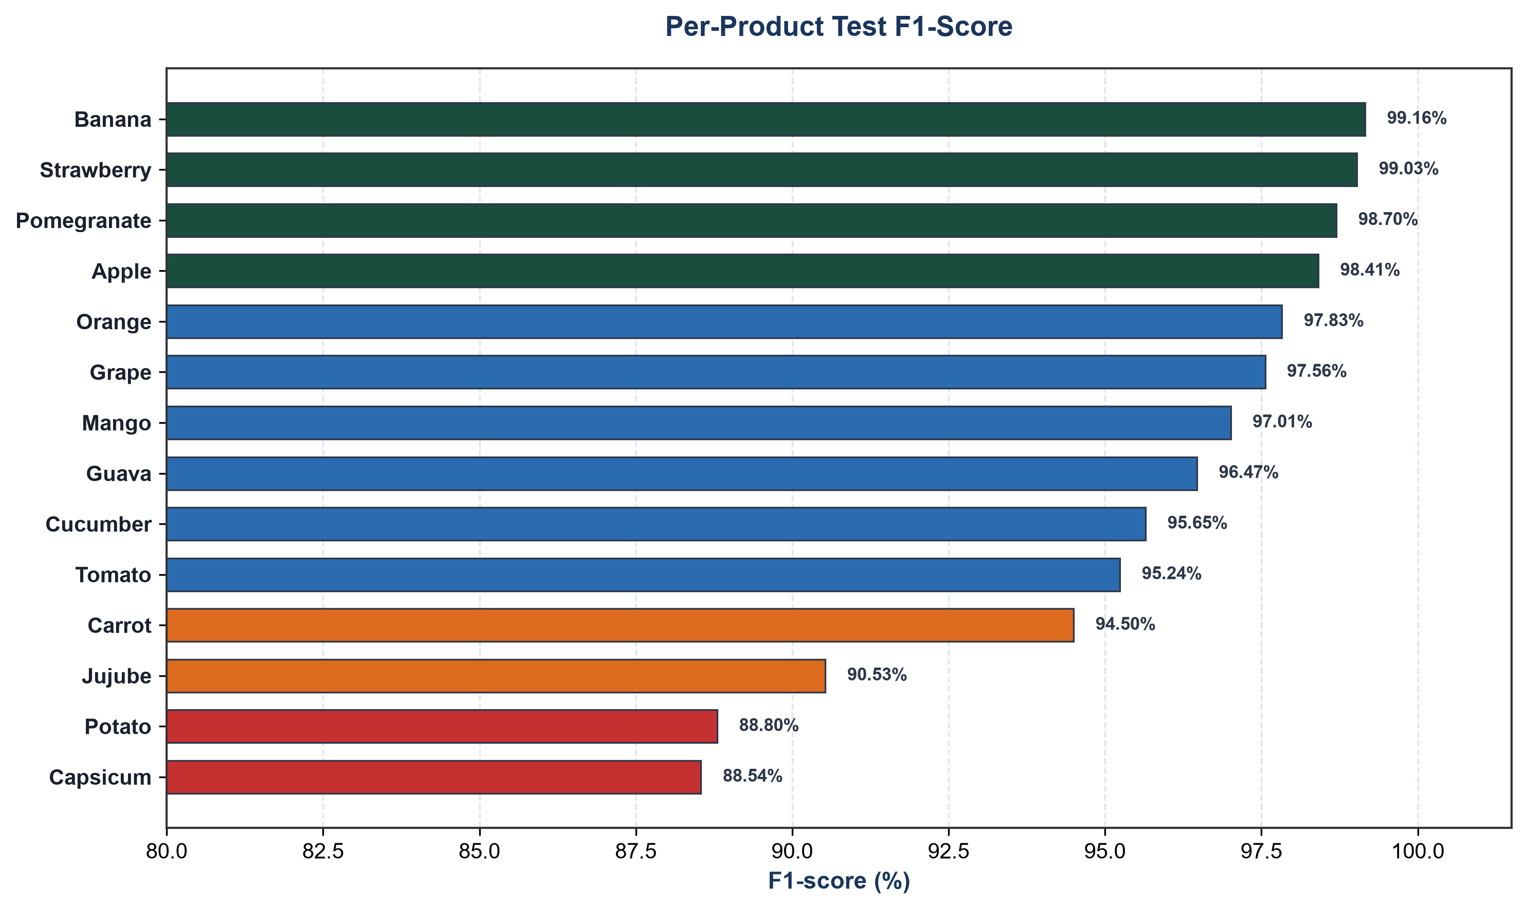
Figure 15 - Per-product test F1-scores, from 88.5% (capsicum) to 99.2% (banana).

The results show some clear differences between the products. Banana (99.16%), strawberry (99.03%), pomegranate (98.70%) and apple (98.41%) achieved the highest F1-scores, and these classes were also among the better represented in the training data. The rounder and more visually distinctive fruits performed particularly well. In general, performance appears to be related to both the amount and variety of training data available. Capsicum (88.54%) and potato (88.80%), which produced the lowest scores, had comparatively less data and were also more visually similar to other classes. These results are consistent with the observation in the literature that the size and quality of the dataset can have a substantial effect on produce-grading performance.[5].

Product | Training images | Evaluation samples | Test F1-score
Apple | 7,766 | 1,497 | 98.41%
Pomegranate | 7,652 | 106 | 98.70%
Banana | 7,281 | 1,348 | 99.16%
Orange | 6,761 | 1,194 | 97.83%
Mango | 4,060 | 1,137 | 97.01%
Strawberry | 3,199 | 875 | 99.03%
Guava | 2,829 | 97 | 96.47%
Capsicum | 1,202 | 341 | 88.54%
Cucumber | 1,201 | 342 | 95.65%
Tomato | 1,199 | 336 | 95.24%
Potato | 1,198 | 352 | 88.80%
Carrot | 1,198 | 349 | 94.50%
Jujube | 400 | 130 | 90.53%
Grape | 400 | 97 | 97.56%
Table 2 - Per-product data volume and test performance

The carrot results are particularly useful in interpreting the model's performance. Carrot achieved an F1-score of 94.50% on the held-out test set, but photographs of carrots taken outside the dataset were less consistently graded in practice. This difference suggests that the conditions represented in the test data do not fully reflect those encountered in photographs taken during normal use. The dataset images are generally more consistent, whereas real photographs can vary in factors such as presentation and image conditions. This limitation is considered further below. The result also shows why a strong test-set score should not be taken as evidence that a model will perform equally well in every real-world situation.

Dataset quality and honesty of the results
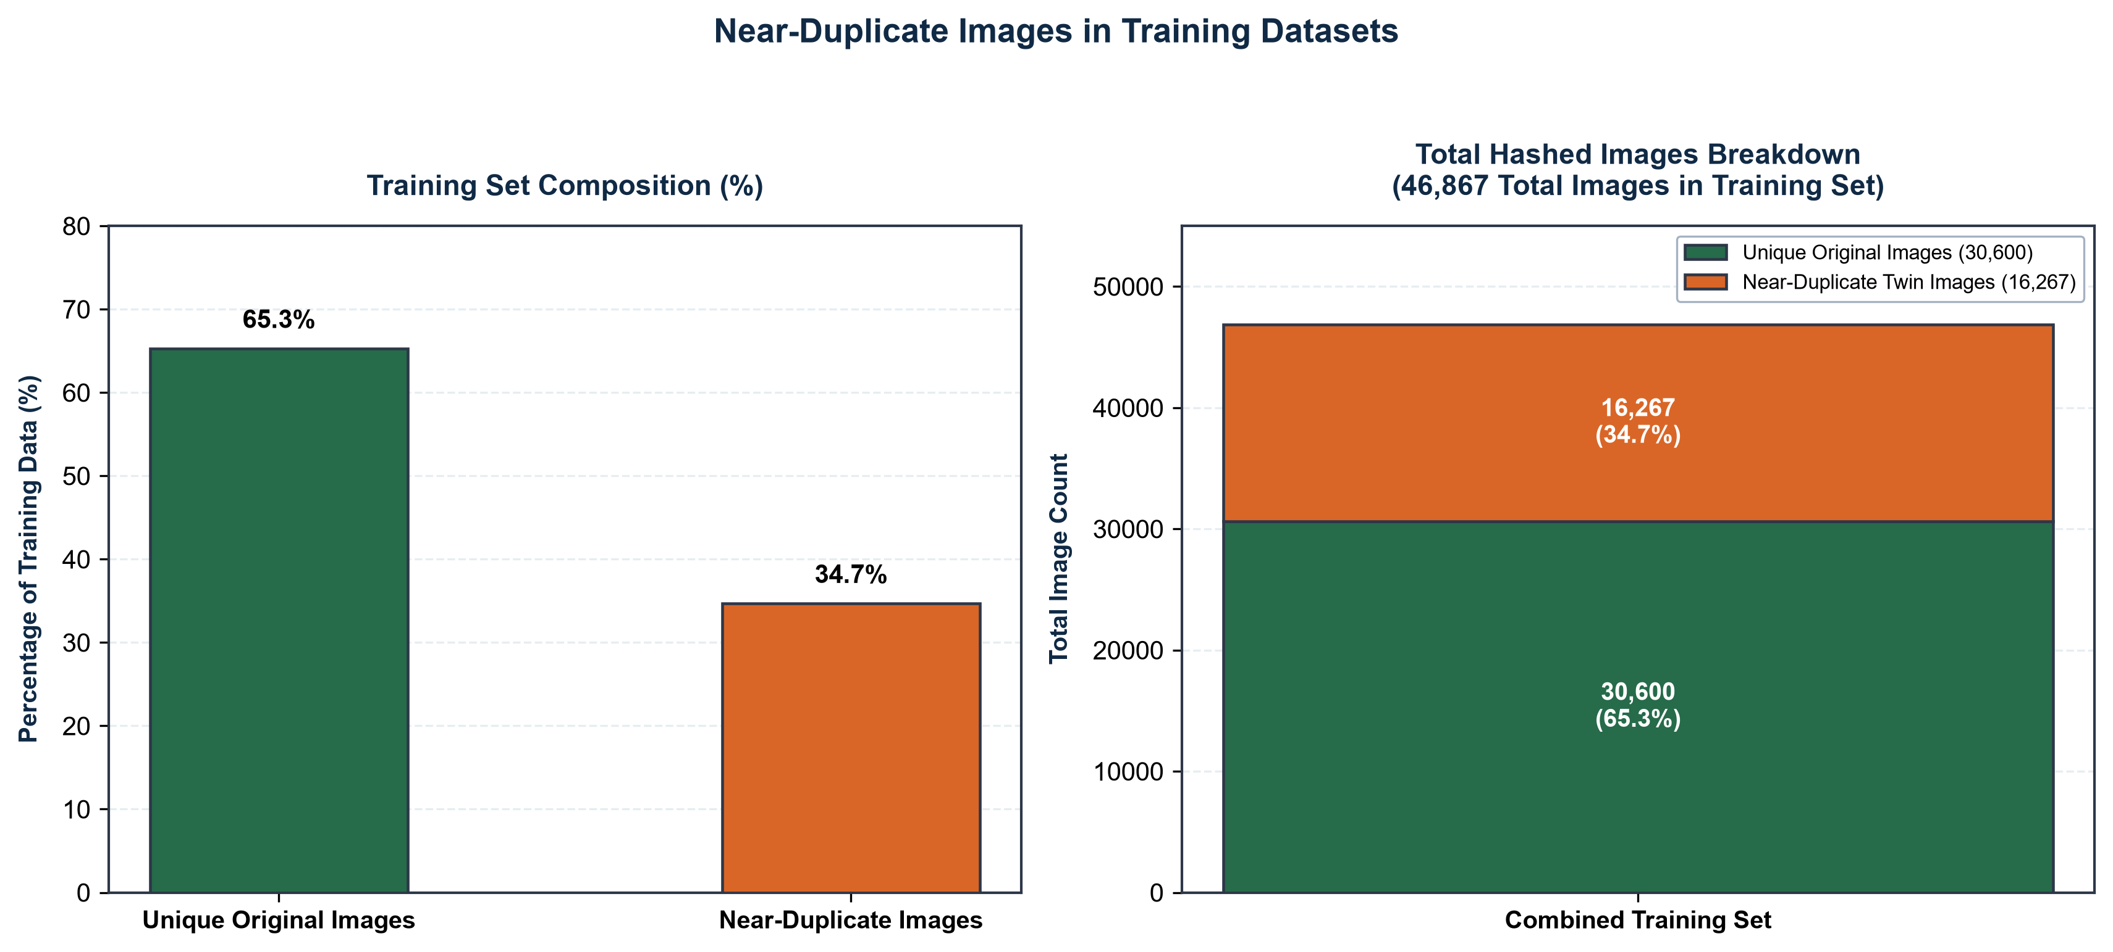
Figure 16 - Near-duplicate contamination in the two-dataset training set

A headline accuracy figure is only as trustworthy as the data on which it is measured, and a specific and instructive finding of this project concerns the integrity of the training data.
Public produce datasets frequently contain near-duplicate images: multiple photographs of the same item, resized or lightly altered copies, and augmented versions of the same original. If such near-duplicates are distributed across the training and test sets, the model can appear highly accurate simply because it has effectively seen the test images during training - a phenomenon known as data leakage, which inflates reported accuracy.
To investigate this, the datasets were analysed using perceptual hashing, which assigns visually similar images similar fingerprints, with similarity measured by the Hamming distance between fingerprints. The analysis found that a substantial proportion of the imagery consisted of near-duplicates: 34.7% of the combined training set ( 16,267 of 46,867 images ) had at least one near-duplicate, comprising thousands of duplicate groups. This is a striking level of duplication, and had it not been controlled for, it would have rendered a conventional random train/test split unreliable.
To address this, the data was divided using a grouped split in which every group of near-duplicate images was assigned entirely to one side of the train/test boundary, guaranteeing that no test image had a near-identical counterpart in training. Crucially, when the model was evaluated on this leakage-free basis, its accuracy remained high, close to the figures reported above. This is an important result in its own right: it demonstrates that the model's performance derives from genuine learning of produce features rather than from memorising duplicated images. Had accuracy collapsed on the deduplicated split, it would have indicated memorisation; that it held confirms genuine generalisation.
This deduplication analysis, and the honest reporting of its effect, is one of the project's more valuable contributions. The checking of datasets for near-duplicate contamination is frequently omitted in comparable work, and the finding that public produce datasets can contain such high levels of duplication is a caution of general relevance to image-based grading.

The two-stage bulk-grading pipeline
The bulk-grading pipeline was evaluated on photographs containing multiple produce items (the interface for which is shown in Figure 5.3). On a controlled test a tray of produce containing a deliberately included defective item the pipeline correctly detected the individual items, graded each, and identified the defective one, flagging it while grading the sound items as fresh and reporting an accurate proportion of the batch as defective. On a further controlled case, a basket of items in which one was clearly spoiled, the pipeline correctly reported the batch as predominantly fresh with the single defective item identified, rather than condemning the whole batch the behaviour intended by the design, and a demonstrable improvement over single-image grading of the same photograph, which unfairly graded the entire basket as defective on account of the one spoiled item.
The pipeline's performance is, however, bounded by the difficulty of detection on densely packed produce. On loosely arranged or moderately dense photographs, detection is clean and grading is reliable. On very densely packed piles, where items overlap heavily, the detector produces overlapping and imperfect bounding boxes, and the resulting crops can be contaminated by neighbouring items, leading to occasional misgrading. The confidence threshold and central-cropping mitigate this by grading only cleanly detected items, but they do not eliminate it. This is a genuine limitation of the two-stage approach and is discussed below.

The dual-inspection protocol
The dual-inspection variance protocol was evaluated by comparing dispatch and delivery inspections across the tolerance threshold. Where the delivery grade was consistent with the dispatch grade, within the defined tolerance, the transaction completed normally. Where the delivery grade indicated a drop in quality beyond the tolerance simulated by comparing a photograph of sound produce at dispatch against a photograph of poorer produce at delivery the protocol correctly detected the variance, flagged the transaction and held payment, opening the negotiation step rather than immediately closing the order as a dispute. These results show that the protocol operates as intended. It can distinguish between deliveries where the quality remains consistent and those where a significant reduction occurs, while providing a defined process for dealing with the difference.
The importance of this result is not primarily numerical. Rather, the protocol provides an automated way of identifying potential quality loss during transit and gives both parties evidence that can be used when resolving the issue. In this respect, the protocol represents the main contribution of the project, beyond the classification accuracy achieved by the computer-vision model.

Limitations
The evaluation tells several limitations, which are stated openly because understanding them is part of understanding the system.
First, grading is most reliable on clear photographs of single, well-presented items, and degrades on very densely packed produce, where overlapping items produce contaminated crops. Fully addressing this would require instance segmentation, which delineates each item precisely rather than with a rectangular box, and is identified as future work.
Second, performance varies by product, and some products notably certain vegetables such as carrots, and visually similar or under-represented classes such as capsicum and potato grade less reliably than well-represented fruits. This is a data-availability limitation rather than a flaw in the approach; the remedy is more and better-balanced training data for these classes.
Third, the model can confuse visually similar produce. Products that are round and red such as apples and tomatoes are occasionally confused with one another, because they share the visual features on which the classifier relies. This particularly affects the product-consistency check, and for this reason the product identification is treated as an assistive warning rather than an authority, with the farmer's declared product taken as the source of truth.
Fourth, there is a gap between test-set and real-world performance, exemplified by carrots, arising from the difference between the clean images of public datasets and the more variable conditions of real photographs. Reliability depends on reasonable photographic conditions, and adverse lighting, cluttered backgrounds or unusual angles reduce accuracy.
Finally, the system's scope is deliberately bounded. It grades quality, which is visually determinable, but not organic provenance, which is not; provenance is established by certification. Certificate verification is, moreover, a point-in-time check, and ongoing assurance would require periodic re-verification and integration with the certifying authority a matter beyond the scope of this prototype.

Discussion
Overall, the results provide support for the main objectives of the project, while also showing the limitations of the current system. The grading model achieved high accuracy on the held-out test set, and the deduplication analysis gave further confidence that this performance was not caused by near-duplicate images in the training and test data. The bulk-grading pipeline allowed the system to assess photographs containing several items, although closely packed produce remains more difficult to detect and grade. The dual-inspection protocol also operated as intended, providing an objective comparison of quality between dispatch and delivery.
The results should not, however, be taken as evidence that the system can work reliably under all conditions. It is a prototype designed mainly for clear photographs of produce that can be assessed visually. Performance can be affected when the images or arrangements fall outside these conditions. These limitations are important when considering the results and help define the current scope of the system. The next chapter concludes the report and discusses possible directions for future work.

Conclusion
This chapter evaluated the developed system, with particular emphasis on the computer-vision components. On the held-out test set, the model achieved 96.8% accuracy for product identification and 98.3% for quality assessment. Per-product performance was examined in addition to the overall results, including the relationship between performance and the amount of training data available. The dataset was also analysed for near-duplicate images, and the resulting findings provided evidence that the measured performance was not primarily caused by data duplication. The bulk-grading pipeline and dual-inspection protocol were evaluated and found to operate according to their intended design. The limitations identified during the evaluation were also discussed. The next chapter presents the overall conclusions and future work.

Conclusions and future work

Overview
This chapter concludes the report and reviews what was achieved during the project. It summarises the problem that the project addressed, considers the extent to which the objectives were met, and outlines the main contributions of the work. The final section also discusses possible improvements and areas for future work based on the limitations found during evaluation.

Summary of the project
This project focused on the difficulty faced by Irish organic producers in reaching buyers directly. One of the main issues identified was the lack of trust that can arise when the buyer and farmer are unable to inspect the produce together. The project initially focused on the organic dairy sector but was later broadened following consultation and further investigation, leading to a wider focus on the connection between producers and buyers and the problem of verifying quality remotely.
In response to this problem, OrganicLink was designed and implemented as a web-based marketplace for direct trade between organic farmers and buyers. Computer vision is used to assess produce quality from photographs. The main feature developed as part of the project is the dual-inspection variance protocol, where produce is graded at dispatch and again at delivery. The two assessments are then compared, and the transaction is flagged if the change in quality exceeds the defined tolerance. The system also supports grading for both individual and multiple produce items. Where organic status cannot be established visually, it is verified through certification. Traceability information is also made available through QR codes.

Achievement of objectives
The objectives outlined in Chapter 1 were largely achieved during the project. The barriers affecting Irish organic producers were investigated using published research and primary interviews, providing the basis for an evidence-based definition of the problem. The marketplace was implemented with the main functions needed to support direct trading, including producer verification, listings, browsing, ordering, negotiation and payment tracking.
The computer-vision model achieved 96.8% accuracy in produce identification and 98.3% in quality assessment on the held-out test set. The dual-inspection protocol was implemented and successfully flagged transactions where the difference between the two quality assessments exceeded the defined tolerance. The grading system was also extended to photographs containing multiple produce items through a two-stage detection and grading process. The completed system was then evaluated, including checks for dataset leakage, and the limitations identified during the evaluation were documented.

Contributions
The project makes several contributions. The principal one is the dual-inspection variance protocol, which provides an objective and automatic mechanism for verifying produce quality across a transaction and for detecting degradation in transit — a form of quality assurance and dispute resolution that existing direct-trade platforms do not provide. A second contribution is the honest evaluation of the grading model, including the discovery that a large proportion of the underlying public datasets consisted of near-duplicate images, and the demonstration, through a leakage-free grouped split, that the model's accuracy reflects genuine learning rather than memorisation. A third is the two-stage bulk-grading pipeline, which extends grading from single items to photographs of many items and was shown to grade a batch fairly rather than condemning it for a single defective item. Underpinning these is an evidenced analysis of the market-access and leakage problems facing Irish organic producers, grounding the technical work in a real and documented need.

Future work
The evaluation identified several limitations, each of which suggests a direction for future work.
The most technically significant is the difficulty of grading densely packed produce, where overlapping items produce contaminated crops. The natural next step is to replace rectangular bounding boxes with instance segmentation, which delineates the precise outline of each item, allowing clean per-item grading even in dense arrangements.
A second direction concerns the products that grade less reliably certain vegetables and visually similar or under-represented classes. Because this is fundamentally a data-availability limitation, the remedy is to collect more and better-balanced training data for these products, ideally including images taken under real-world conditions rather than only curated dataset images, which would also narrow the observed gap between test-set and real-world performance.
A third direction is to strengthen the assurance of organic provenance. Certificate verification is presently a point-in-time check; a fuller system would support periodic re-verification and integration with the certifying authority's records, so that a producer's organic status is confirmed on an ongoing basis rather than once at registration.
Further work could extend the platform to the products currently handled only by certification notably meat building out the certification-based listing path for these, and could develop the traceability feature into a fuller provenance record accessible to end consumers. Finally, deploying the system with real users would allow evaluation of its effectiveness in practice, beyond the controlled testing reported here.

Concluding remarks
The project started with a focus on a specific problem in Irish organic dairy and was later broadened to examine the wider issue of trust in remote direct trade. The work shows that computer vision can be used as part of this process to provide an objective assessment of produce quality, provided that it is applied only where quality can be judged from an image. The dual-inspection approach is particularly important because it allows the quality of the produce to be compared at dispatch and delivery rather than relying only on the accounts of the buyer and farmer. The final system provides a working prototype of this approach, while the evaluation identifies both its strengths and its limitations. The work therefore provides a useful starting point for further development and testing in a real trading environment.

References

[1] I. Examiner. "About 30% of fruit and vegetables in Ireland are rejected by commercial buyers due to cosmetic standards." https://www.irishexaminer.com/news/arid-41840586.html#:~:text=About%2030%25%20of%20fruit%20and%20vegetables%20in%20Ireland%20are%20rejected%20by%20commercial%20buyers%20due%20to%20self%2Dimposed%20cosmetic%20standards. (accessed 15/08/2026.
[2] J. O. C. Attard, Tracey, "Food Loss and Waste from Farming, Fishing and Aquaculture in Ireland," Environmental Protection Agency, 2022. [Online]. Available: https://www.epa.ie/publications/research/waste/Research_Report_410.pdf
[3] Agriland. "Why boosting consumer demand for organics is important." https://www.agriland.ie/farming-news/why-boosting-consumer-demand-for-organics-is-important/#:~:text=Leakage%20continues%20to%20be%20a%20challenge%20for%20the%20organic%20livestock%20sector%2C%20particularly%20sheep.%20Estimates%20for%202022%20suggest%20that%2070%25%20of%20organic%20lambs%20and%2030%25%20of%20organic%20cattle%20are%20processed%20as%20conventional. (accessed 15/08/2026.
[4] K. Shehzad, U. Ali, and A. Munir, "Computer Vision for Food Quality Assessment: Advances and Challenges," Global Journal of Machine Learning and Computing, vol. 1, pp. 76–92, 02/19 2025, doi: 10.70445/gjmlc.1.1.2025.76-92.
[5] L. Zhu, P. Spachos, E. Pensini, and K. N. Plataniotis, "Deep learning and machine vision for food processing: A survey," Current Research in Food Science, vol. 4, pp. 233–249, 2021/01/01/ 2021, doi: https://doi.org/10.1016/j.crfs.2021.03.009.
[6] Z. Xiao, J. Wang, L. Han, S. Guo, and Q. Cui, "Application of Machine Vision System in Food Detection," (in English), Frontiers in Nutrition, Mini Review vol. Volume 9 - 2022, 2022–May–11 2022, doi: 10.3389/fnut.2022.888245.
[7] A. Kamilaris and F. Prenafeta Boldú, "Deep Learning in Agriculture: A Survey," Computers and Electronics in Agriculture, vol. 147, 04/01 2018, doi: 10.1016/j.compag.2018.02.016.
[8] P. Wan, A. Toudeshki, H. Tan, and R. Ehsani, "A methodology for fresh tomato maturity detection using computer vision," Computers and Electronics in Agriculture, vol. 146, pp. 43–50, 03/01 2018, doi: 10.1016/j.compag.2018.01.011.
[9] m. Iraji, "Comparison between soft computing methods for tomato quality grading using machine vision," Journal of Food Measurement and Characterization, vol. 13, 03/01 2019, doi: 10.1007/s11694-018-9913-2.
[10] K. He, X. Zhang, S. Ren, and J. Sun, "Deep Residual Learning for Image Recognition," in 2016 IEEE Conference on Computer Vision and Pattern Recognition (CVPR), 27–30 June 2016 2016, pp. 770–778, doi: 10.1109/CVPR.2016.90.
[11] X. Liu, "A Food Safety Detection System Based on Computer Vision Technology," in 2024 International Conference on Advances in Electrical Engineering and Computer Applications (AEECA), 16–18 Aug. 2024 2024, pp. 441–447, doi: 10.1109/AEECA62331.2024.00083.
[12] J. Blasco, N. Aleixos, and E. Molto, "Machine Vision System for Automatic Quality Grading of Fruit," Biosystems Engineering, vol. 85, pp. 415–423, 08/01 2003, doi: 10.1016/S1537-5110(03)00088-6.
[13] M. Amit et al., "IJFANS INTERNATIONAL JOURNAL OF FOOD AND NUTRITIONAL SCIENCES Computer Vision in Food Quality Control: Applications and Innovations," vol. 11, p. 2022, 01/01 2022.
[14] J. Deng, W. Dong, R. Socher, L.-J. Li, K. Li, and F.-F. Li, ImageNet: a Large-Scale Hierarchical Image Database. 2009, pp. 248–255.
[15] J. Redmon, S. Divvala, R. Girshick, and A. Farhadi, "You Only Look Once: Unified, Real-Time Object Detection," in 2016 IEEE Conference on Computer Vision and Pattern Recognition (CVPR), 27–30 June 2016 2016, pp. 779–788, doi: 10.1109/CVPR.2016.91.
[16] C. Zauner, "Implementation and Benchmarking of Perceptual Image Hash Functions," 2010.

Appendix 1: Code listing

Discuss the inclusion of datasheets and code listings, etc., with your supervisor,
Appendix to start on odd number page.

Appendix 2: Weekly progress reports

Replace this text with Weekly progress reports (for the complete project). Appendix to start on odd number page.

