المشروع : موقع شراء الكترونى للمنتجات المصنوعة اليدوية

الفرقة : التالتة

قسم : نظم المعلومات

اسماء طالبات الفريق :-

- دعاء ابراهيم محمد سيكشن 2

- اية ابوالعلا سيكشن 1

- دعاء سعدالدين يسن احمد سيكشن 2

project scope

The project is a site for handmade products. Through this site you can display your own made products for sale accompanied by the price next to them. You can also see what others have offered and communicate with them to buy

__________________________________________________

project risk

1. product could be delivered to the wrong recipient.

2- With the inception of the site, people may doubt its integrity, and consequently they are afraid that they will share important data with it, such as the visa card number.

3- Someone may use our site name to carry out criminal operations

4- There is a whole range of security threats out there to beware of, including malware, phishing attacks, hacking and spam mail you know no site is safe from attack.

(To defend against these threats, we will make sure that we update our platform's operating system regularly, and use a strong SSL (Secure Sockets Layer)).

5- You deal with computers and people, especially women, who love to see the product with their eyes and touch it with their hands

6- A different product comes due to a mistake in the data base, for example

7- Delays in remote locations may make the customer feel bored

_________________________________________________________________________________

8- How to change project network based on number of programmers in team and number of machines?

When the number of programmers and the number of machines change, the number of days of each task (which depends on programmers or machines) will change and consequently, a change will occur for each of the ES,EF,LS, and LF of tasks.

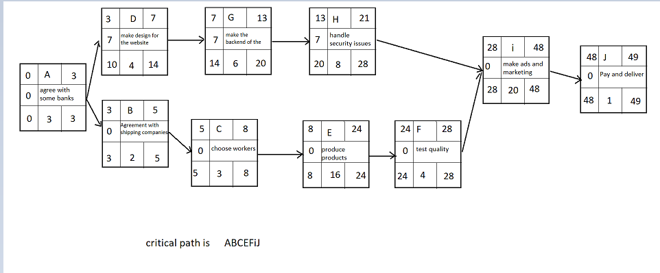

Critical path is ABCEFij