The Islamic University of Gaza  Faculty of Information Technology  Department of Computer Science |  | Fall Semester 2025–2026  Multimedia Programming I  Instructor: Aya N. Alharazin
What Is Programming?
is the process of giving instructions to a computer so it can do what you want.
What Are Programming Languages?
A programming language is a special language that we use to tell the computer what to do.
Computers do not understand Arabic or English — they only understand binary (0s and 1s).
So we use programming languages as a bridge to communicate with the computer in a way that is easier for humans.
What Is a Program?
A program is a set of instructions written by a programmer to make the computer do something.
Examples of programs:
- Calculator app
- WhatsApp
- Instagram
Types of Programming Languages
- High-Level Language
A high-level programming language is a language that is easy for humans to read, write, and understand.
It is close to human language and far from machine language (0s and 1s) like java , c++ , python .
- Low-Level Languages
Languages that are close to the machine (computer hardware).
We will use python Programming language .

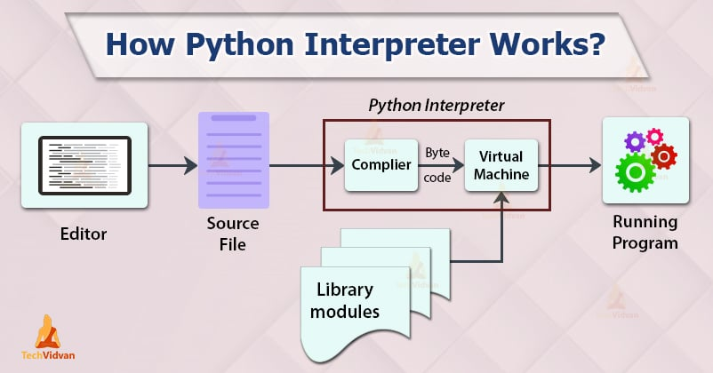

What Is the Python Interpreter?
The Python Interpreter is the program that reads your Python code and runs it.
The interpreter performs 3 main tasks:
  - Reads Your Source Code (.py)
  - Compiles It Into Bytecode
  - Sends the Bytecode to the PVM
What Is an IDE?
An IDE is an application where you write, run, and test your code—all in one place.

