Start app Page (logo)





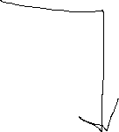

Sign in Page

Register/sign up Page

# After Register 🡪 Register Steps :

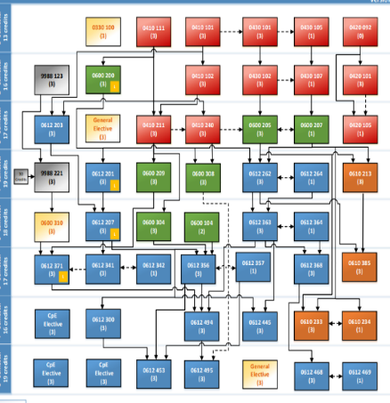

BOOK MARK:

LATES SAVED FILES

BOOK

مرشد

Rate Your Course :

Your comunisties :

Welcome msg

HOME EXPLOER CHAT



# After sign in or finishing Register Steps :

Next

Skip

Next

Finish

Join community

Select professor for each course . its okay if u forget the them

I

Select course u entered before or currently taking

Join

Join



Join

Join

Join

Join

HOME PAGE

CHAT PAGE

EXPLOER PAGE

SERCH BAR

RECOMMENDED FOR YOU :

EXPLORE COMUNITES :

Join

Join

Join

Join

HOME EXPLOER CHAT

HOME EXPLOER CHAT



Gg



HOME Exploer + CHAT Commuities

Post Resources

PAGES:

COURSE DETAIL

COMMUNITY DETAIL

PROFILE me

ACCOUNT OTHER USER

CHAT DETAIL

BOOKMARK list

OFFICEHOIRE DETAIL

AWARD?

ERR DIGREM?

DESIGN IDEAS?

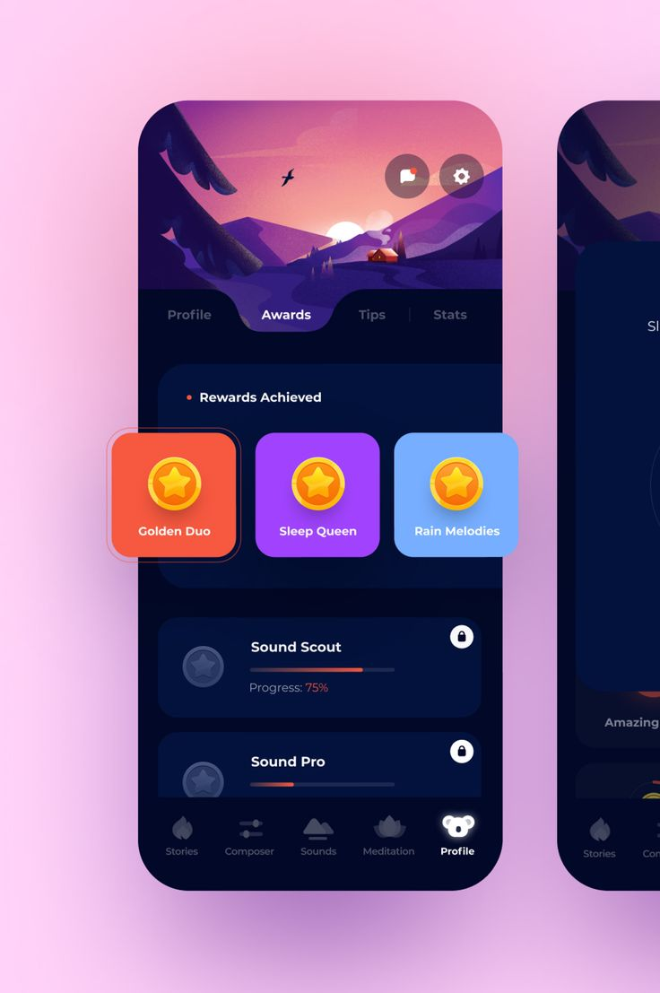



profile awards uplodes BookMark

Background image

HOME EXPLOER CHAT

Basd on that we can do account

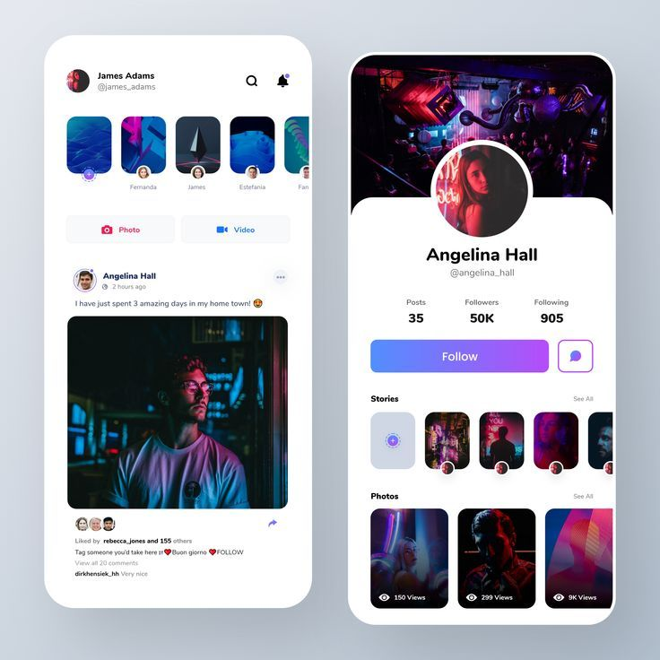

Awards:

Corses:

Msg icon

Follow

number number number

Followers Following Comunites

Background image



