🧾
Intelligent Automation of Invoice Processing
Final Mini-Project — Modeling, Automation & AI Workflow
Department: Finance — Accounts Payable
Scope: Design, workflow modeling (AS-IS / TO-BE), automation & AI integration,
KPI justification, technical & financial feasibility, ROI

Executive Summary
A mid-sized company receives around 1,000 supplier invoices per month, submitted as emailed PDFs or scanned documents. Invoice processing is currently handled almost entirely by hand, which is slow, repetitive and error-prone. This project designs an intelligent automation workflow that combines OCR, an AI extraction/analysis layer, and rule-based routing, while keeping a human in the loop for decisions that require judgment (validation of significant amounts, correction of anomalies).
The proposed solution reduces average processing time per invoice from 12 minutes to 4 minutes (-66.7%), cuts the error rate from 5% to 1% (-80%), and is estimated to generate a net annual benefit of about 38,000 TND against an initial investment of 4,500 TND — a first-year ROI of roughly 744% and a payback period of about 1.4 months. All figures below are simulation hypotheses to be validated with a real pilot before full-scale rollout.

1. Project Scenario

1.1 Company Context
The organization is a mid-sized company that receives approximately 1,000 supplier invoices per month, in varied formats (PDF sent by email, scanned paper documents). Today, the process is manual end-to-end: an accountant opens each document, reads the key fields, keys them into the system, checks amounts and supplier details, requests approval when required, then records and archives the invoice. This consumes significant staff time and introduces data-entry errors.

1.2 Department & Team
Department: Finance Department → Accounts Payable Service.
The team combines human actors (accountant, financial manager, IT) with software actors (the AI extraction engine and the workflow orchestrator), coordinated through a shared automated workflow.
Actors and Responsibilities
Actor | Responsibility
Supplier | Sends the invoice (by email or as a scanned document).
Accounts Payable Accountant | Verifies and processes invoices; validates invoices below the approval threshold; handles flagged anomalies.
Financial Manager | Approves invoices above the financial threshold (> 2,000 TND) and reviews escalated exceptions.
IT / Systems Team | Maintains the platform, the OCR/AI pipeline, the workflow engine and system integrations.
AI System (OCR + LLM) | Extracts and structures invoice data, and performs first-pass consistency analysis.
Workflow Engine (n8n) | Orchestrates the end-to-end process and routes each invoice to the right actor or automated step.

1.3 Objective
Design a system that reduces manual work as much as possible while preserving human validation for decisions that carry financial or business risk.

1.4 Business Rule (Routing Logic)
- Invoice amount ≤ 2,000 TND → validated by the accountant.
- Invoice amount > 2,000 TND → additional validation required from the Financial Manager.
- Inconsistent or incomplete information (amount mismatch, unknown supplier, suspected duplicate) → routed to manual control, regardless of amount.

1.5 Invoice Fields Captured
For every invoice, the system must retrieve: invoice number, invoice date, supplier name, supplier ID, net amount (excl. tax), VAT, gross amount (incl. tax), due date, purchase-order reference, and bank details where required.

2. Current Process — AS-IS Modeling
Before designing the automated solution, the existing (fully manual) process is modeled as-is. This baseline is what the KPIs and the ROI calculation are measured against.
Current Task Sequence
- Supplier sends the invoice.
- Accounts Payable receives it (by email or physical mail).
- The accountant opens and reads the PDF or scanned document.
- Data is keyed manually into the accounting system.
- Amounts and supplier information are checked manually.
- If information is inconsistent, a correction is requested from the supplier.
- Once compliant, the invoice is validated by the accountant or, above the threshold, escalated to the Financial Manager.
- The invoice is recorded in the system.
- The invoice is archived.
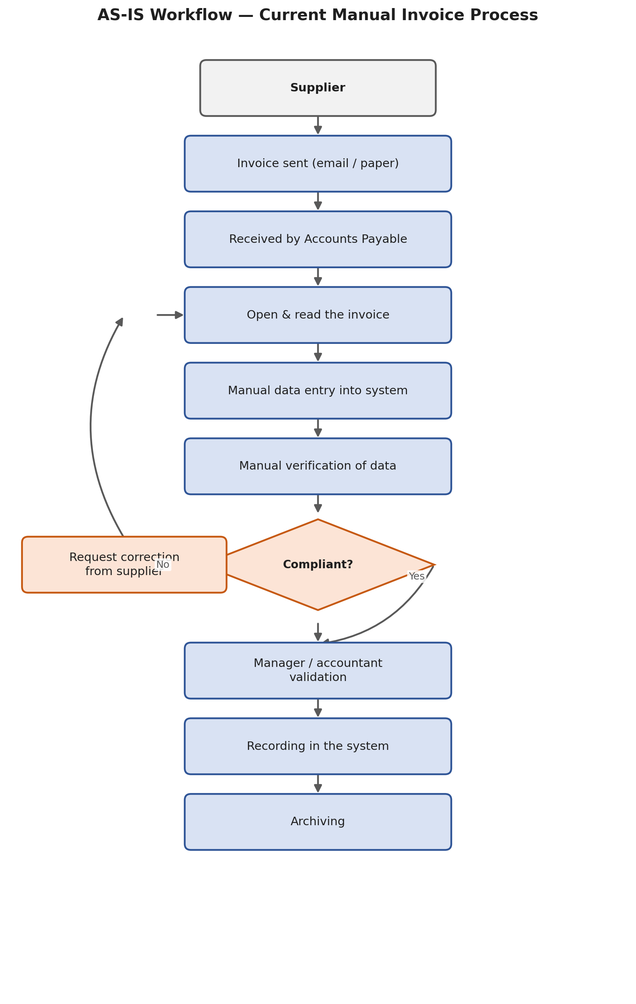
Figure 1 — AS-IS workflow: current fully manual invoice-processing process.

3. Process Analysis — What to Automate and Why
Each step of the current process is assessed for automation potential. The guiding principle: automate repetitive, predictable tasks; keep a human in the loop for decisions that require judgment.
Step | Problem | Automatable? | Justification
Reception | Manual handling of incoming emails/documents | Yes | Can be triggered automatically on email/upload
Reading the invoice | Long and repetitive manual reading | Yes | OCR / AI reads the document instantly
Data extraction | Manual keying, prone to typos | Yes | OCR + AI extract structured fields
Format verification | Repetitive rule checks done by hand | Yes | Deterministic rules can be automated
Anomaly detection | Manual cross-checking | Partial | AI + rules flag most anomalies; edge cases still need review
Validation | Business decision with financial impact | Partial | Human judgment kept for significant amounts
Anomaly correction | Requires investigation and supplier contact | Limited | Kept as accountant intervention
Recording | Repetitive data entry | Yes | Automated once data is validated
Archiving | Administrative filing task | Yes | Fully automatable

4. Optimized Process — TO-BE Workflow
The redesigned process keeps the same business outcome but automates extraction, verification and routing, while preserving human validation for anomalies and for invoices above the financial threshold.
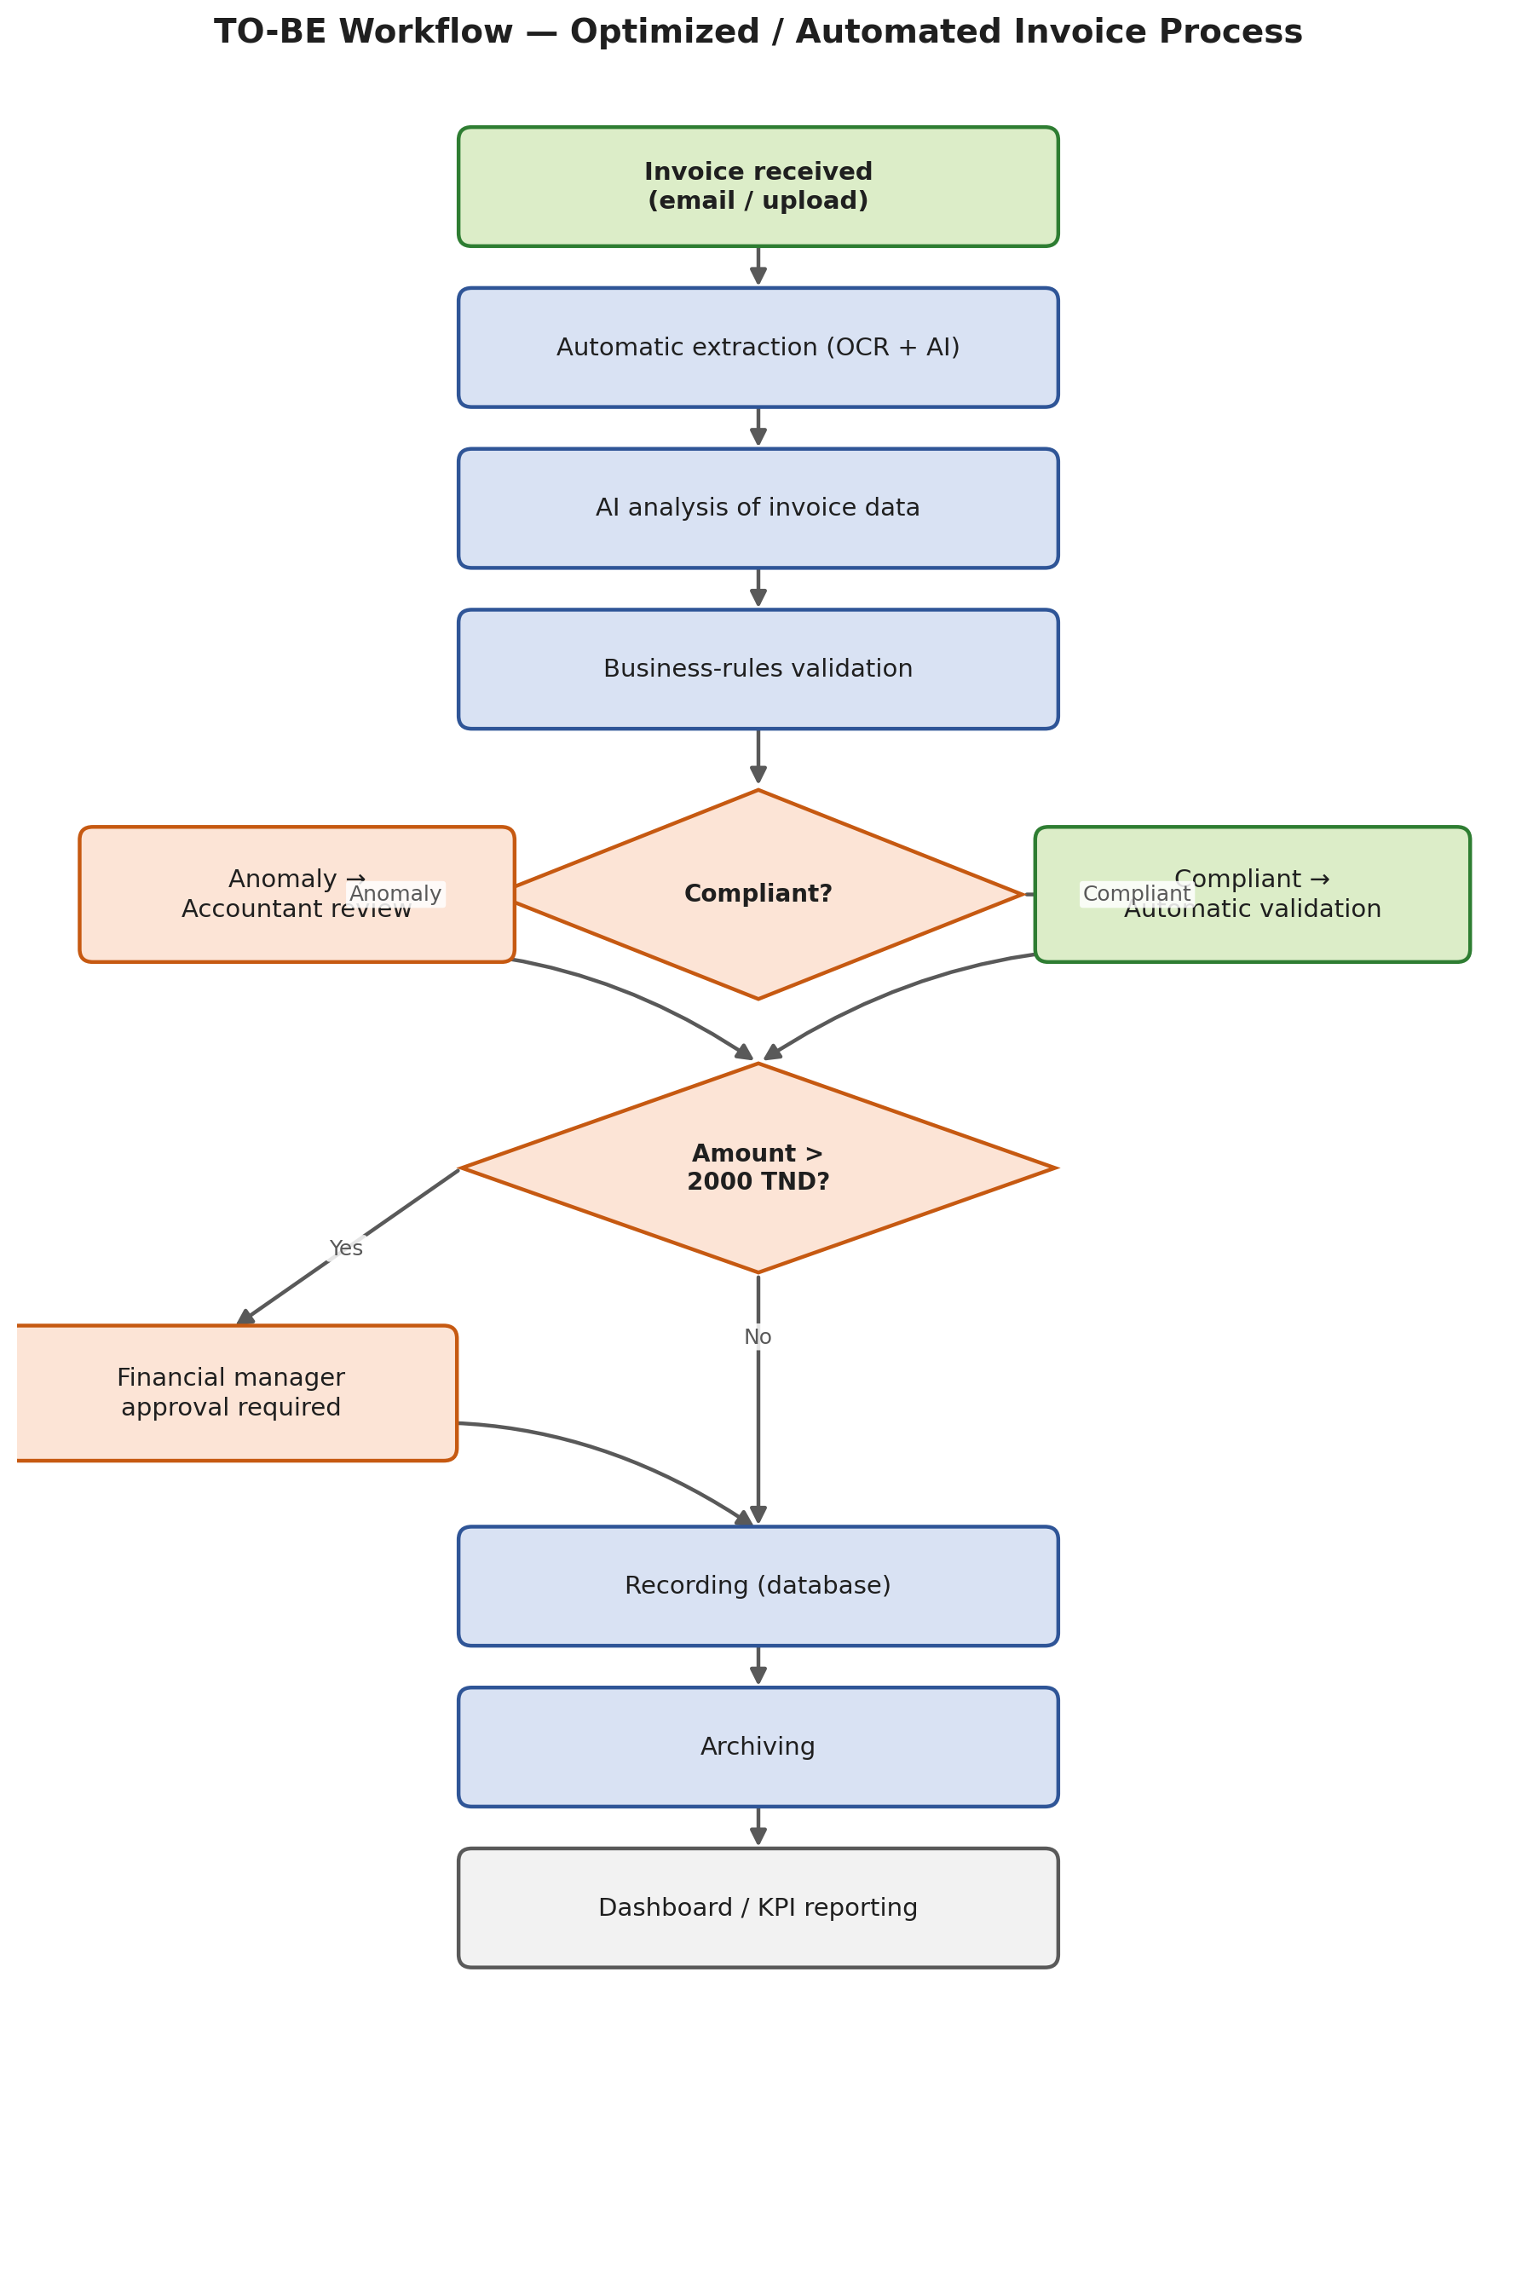
Figure 2 — TO-BE workflow: AI-assisted extraction with rule-based routing and human validation where it matters.

4.1 Automations Implemented
Automation 1 — Reception
The system automatically detects a new incoming invoice as soon as it is emailed or uploaded, removing the need for manual monitoring of a shared inbox.
Automation 2 — Extraction (OCR + AI)
OCR combined with an AI/LLM layer extracts structured data directly from the PDF or scanned image, for example: supplier name, invoice number, net amount, VAT and gross amount, without any manual keying.
Automation 3 — Verification
The system automatically checks that mandatory fields are present, that net amount + VAT equals the gross amount, that the supplier exists in the master data, that the invoice is not a duplicate, and that the purchase-order reference is valid.
Automation 4 — Routing
Based on the business rule, invoices at or below 2,000 TND are routed to the accountant for validation; invoices above 2,000 TND are routed to the Financial Manager for an additional approval.
Automation 5 — Archiving
Once validated, the invoice is written to the database and archived automatically, with no manual filing step.

5. KPIs and Justification
The business case rests on simulation hypotheses, stated explicitly: 1,000 invoices/month; 12 minutes to process one invoice manually; 4 minutes after automation; a fully-loaded labor cost of 20 TND/hour; a current error rate of 5%, reduced to 1% after automation; and an average cost of 15 TND to correct one error. Four KPI families are used to justify the automation: Time Saved, Error Reduction, Employee Satisfaction and Cost Reduction.

TIME SAVED  -66.7%  133.3 h / month | ERROR REDUCTION  -80%  40 fewer errors / month | COST REDUCTION  2,667 TND  saved per month | SATISFACTION  +1.2 pt  target, 3.0 → 4.2 / 5

5.1 KPI 1 — Time Saved
- Before: 1,000 invoices × 12 min = 12,000 min = 200 hours / month.
- After: 1,000 invoices × 4 min = 4,000 min = 66.67 hours / month.
- Time saved: 200 − 66.67 = 133.33 hours / month → about 1,600 hours saved per year.
- Relative time reduction: 66.7%.

5.2 KPI 2 — Error Reduction
- Before: 5% × 1,000 = 50 errors / month.
- After: 1% × 1,000 = 10 errors / month.
- Errors avoided: 40 / month → about 480 errors avoided per year.
- Error-rate reduction: 80%.

5.3 KPI 3 — Employee Satisfaction
Reducing headcount pressure is not the only goal — staff experience matters. Satisfaction can be tracked with a simple 1-to-5 survey administered before and after rollout.
Indicator | Before | Target after
Average satisfaction score | 3.0 / 5 | 4.2 / 5
Manual, repetitive tasks | High | Low
Time spent on data entry | High | Reduced
Target improvement: +1.2 point, i.e. roughly +40% on the relative scale. This KPI is a pilot objective and should be measured with a real survey rather than presented as an already-achieved result.

5.4 KPI 4 — Cost Reduction
Labor cost
- Manual processing cost: 200 h × 20 TND = 4,000 TND / month.
- Cost after automation: 66.67 h × 20 TND ≈ 1,333.40 TND / month.
- Labor savings: 4,000 − 1,333.40 = 2,666.60 TND / month → about 32,000 TND / year.
Error-related cost
- Before: 50 errors × 15 TND = 750 TND / month.
- After: 10 errors × 15 TND = 150 TND / month.
- Savings: 600 TND / month → about 7,200 TND / year.
Gross Annual Benefit
- Time-related savings: 32,000 TND / year.
- Error-related savings: 7,200 TND / year.
- Gross annual benefit: 32,000 + 7,200 = 39,200 TND / year.

6. Technical Feasibility
Component | Technology | Feasibility
Invoice reception | Email / Upload | High
OCR | Tesseract or a managed OCR service | High
Data extraction | LLM (AI) | High
Workflow orchestration | n8n | High
Database | PostgreSQL | High
Notifications | Email / Telegram | High
Dashboard | Grafana / Metabase | High
Real ERP integration | API (Oracle / SAP / etc.) | Moderate — more complex
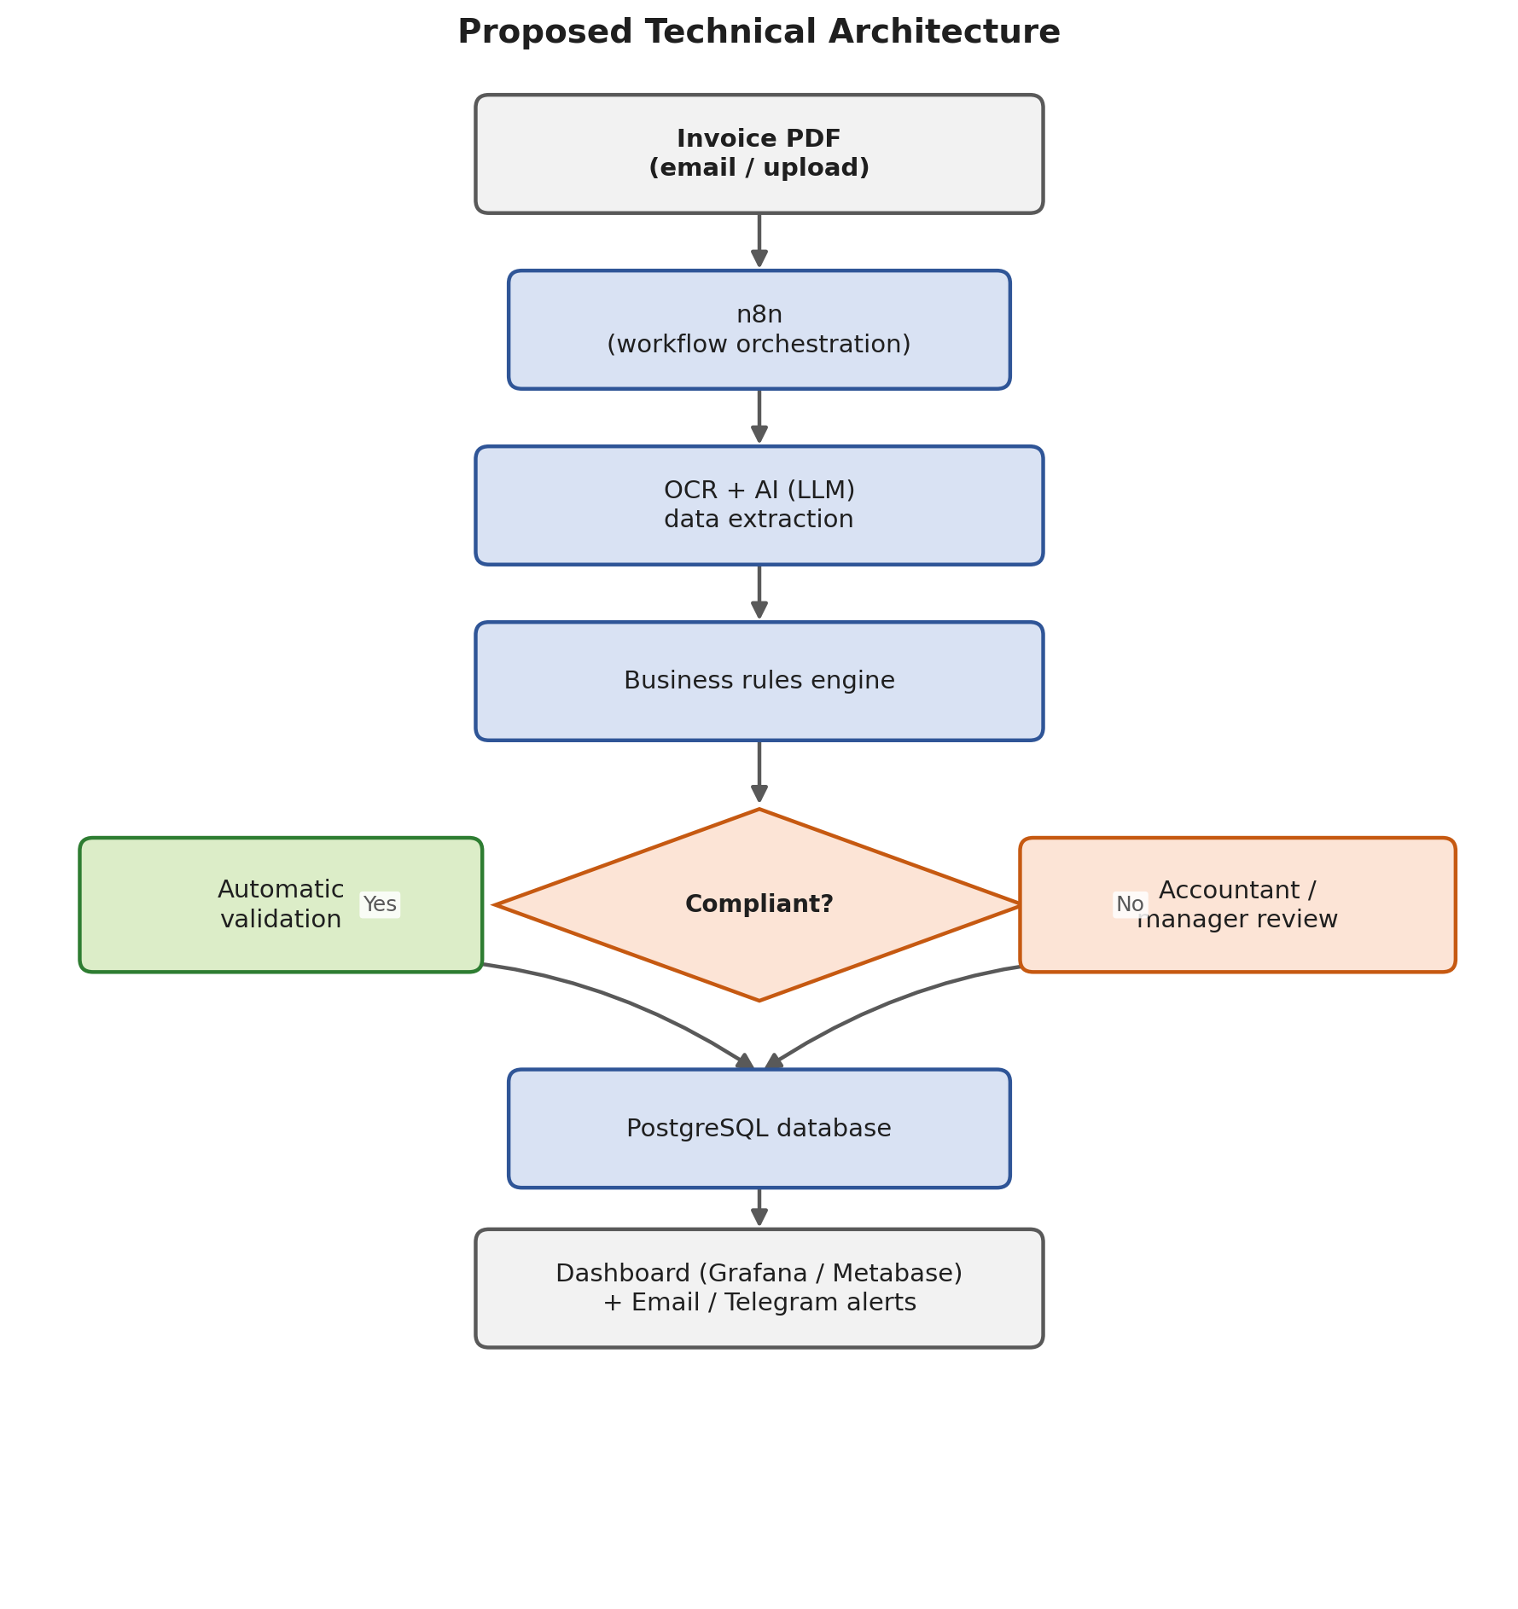
Figure 3 — Proposed technical architecture.
The prototype is technically feasible with widely available, largely open-source technologies and can be built incrementally, automation by automation. The main technical difficulty is integration with a real ERP system, since it depends on the target company's APIs, security policies and infrastructure — this is the component most likely to require additional budget and time beyond the initial prototype.

7. Financial Feasibility
For a student / prototype build, the solution relies mainly on open-source and locally-hosted components, which keeps the initial investment modest.
Initial Investment (Hypothetical)
Item | Estimated Cost
Prototype development | 3,000 TND
Configuration / integration | 1,000 TND
Testing / training | 500 TND
Initial infrastructure | 0 – 500 TND
Estimated investment range: 4,500 – 5,000 TND. For the ROI calculation below, 4,500 TND is used as the initial investment.
Annual Operating Cost
Assumed at 1,200 TND / year, covering maintenance, infrastructure and incidental services.

8. ROI and Payback Calculation
- Gross annual benefit: 39,200 TND.
- Annual operating cost: 1,200 TND.
- Net annual benefit: 39,200 − 1,200 = 38,000 TND.
Formula: ROI = (Net benefit − Investment) / Investment × 100
ROI = (38,000 − 4,500) / 4,500 × 100 ≈ 744%
Under these hypotheses, the project returns about 7.44 times the initial investment, net, within the first year.
Payback Period
- Net monthly benefit: 38,000 / 12 ≈ 3,167 TND / month.
- Payback: 4,500 / 3,167 ≈ 1.4 months.
The initial investment would be recovered in approximately 1.4 months under these assumptions — an aggressive but directionally realistic estimate given how labor-intensive the current manual process is.

9. Summary — Before vs. After
KPI | Before | After | Improvement
Time per invoice | 12 min | 4 min | -66.7%
Monthly processing time | 200 h | 66.7 h | -133.3 h
Error rate | 5% | 1% | -80%
Monthly labor cost | 4,000 TND | 1,333 TND | -2,667 TND
Satisfaction (target)* | 3.0 / 5 | 4.2 / 5 | +1.2 pt
Annual gross savings | — | — | ≈ 39,200 TND
Investment | — | 4,500 TND | —
First-year ROI | — | ≈ 744% | —
Payback period | — | ≈ 1.4 months | —
* Simulation target, to be validated through a real employee survey during the pilot.

10. Risks and Ethical Considerations
Operational risks
- OCR / AI extraction errors on low-quality scans or unusual invoice layouts, requiring a fallback to manual review.
- Over-reliance on automation could let a wrong approval slip through if thresholds or rules are misconfigured.
- Integration risk with the company's existing ERP (APIs, data mapping, security).
Data protection and security
- Invoices contain sensitive supplier and banking data; access must be role-based and traffic encrypted.
- AI providers used for extraction should not retain sensitive financial data beyond what is contractually required.
Ethical and organizational considerations
- Automation changes roles rather than only removing tasks: accountants shift from data entry toward exception handling and control — this should be communicated transparently to the team.
- Human validation is deliberately kept for financially significant or inconsistent invoices, so accountability for high-impact decisions remains with a person, not the algorithm.
- KPI targets (notably employee satisfaction) are stated as pilot hypotheses, not guaranteed outcomes, to avoid overselling the project's impact.

11. Conclusion
The proposed workflow automates the repetitive, high-volume parts of invoice processing — reception, extraction, verification, routing and archiving — while keeping human validation exactly where judgment and accountability matter: significant amounts and inconsistent data. Under the stated simulation hypotheses, the project is both technically feasible with accessible, largely open-source tools, and financially attractive, with an estimated first-year ROI of about 744% and a payback period of roughly 1.4 months. The next step would be a limited pilot — on a subset of suppliers or a single invoice category — to validate the extraction accuracy, the error-reduction assumption, and the employee-satisfaction target before a full rollout.

