# Dota2 for Newbs App

Alyza Villa

**Introduction.** The goal of this project is to design a Dota2 Guide application. Dota2 is a MMO (Massively Multiplayer Online) game that has a very high learning curve. The game involves two teams of 5 players fighting to destroy each others' towers (or defenses) in order to reach and destroy each others' ancient (or base). The first team to destroy the opposing team's ancient wins. In this game, the strategy you use is key, as well as picking the right hero for the match. There are over 100 heroes to choose from, each with their own roles, strengths, and weaknesses. This application will conveniently display a description of each hero so you can have an idea of what you are up against or what hero would suit your strategy. This application also includes a note-pad for each hero so that you can write additional notes about them.

## Primary goals:

* Create an Android application using some buttons and a gallery to allow users to pick from 10 different heroes to read up on
  + Allow users to filter heroes by categories of Strength, Agility, and Intelligence
  + Store and access each hero description from a database
  + Allow user to write additional notes for each hero
    - Store these notes in some sort of persistent storage so user can return to the notes later
  + Help button so users can find their way around the app
  + “Don’t be a NEWB” button to display general advice (i.e.: Stop auto-attacking creeps, how to deny towers, last hitting, etc.)
* Display copyright information

## Pipedream goals:

* Include a custom icon for the app
* Put characters into subcategories (i.e. Carry, Nuker, Support, etc.)
* Include all 100+ characters instead of just a select few
* Include a Splash screen

## Layout:

The app will have two activities (view controllers). One activity will contain the list of heroes, and the other displays information on that hero:

MainActivity:

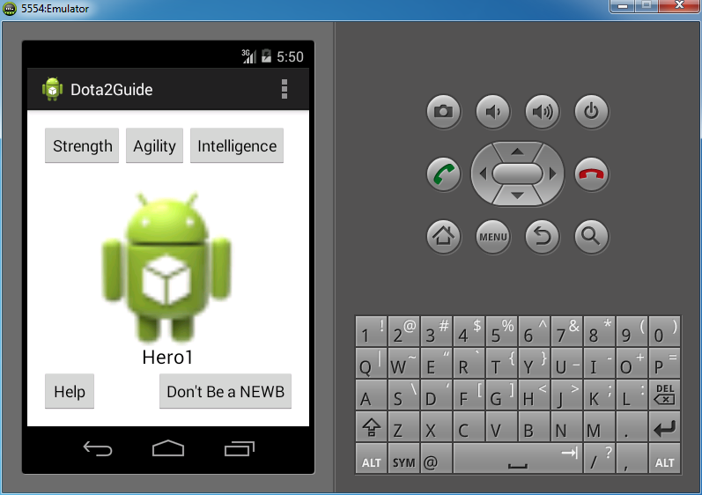

Demonstration of scrolling through gallery:

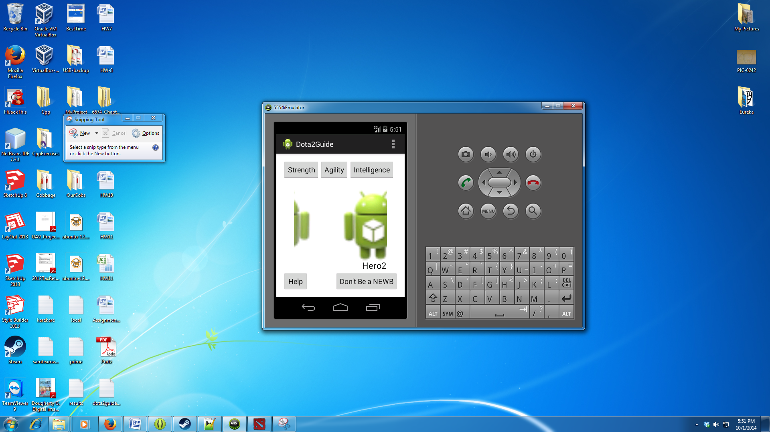

HeroActivity:

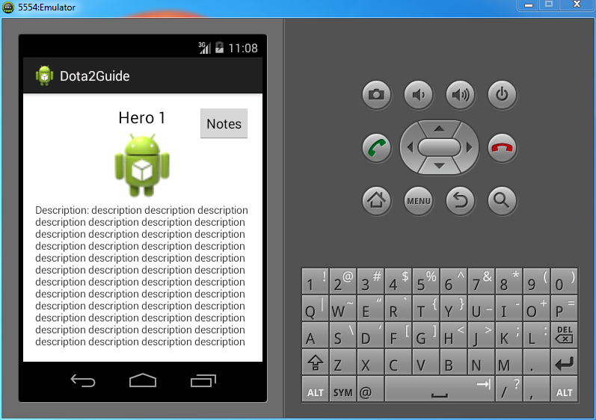

NotesActivity:

