Problem 1

▪ Run the container hello-world

▪ Check the container status



▪ Start the stopped container



▪ Remove the container



▪ Remove the image

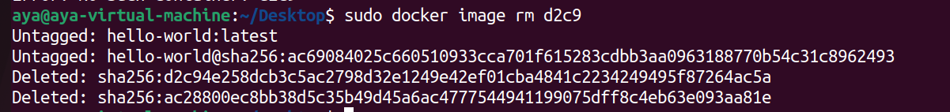

Problem 2

▪ Run container centos or ubuntu in an interactive

mode

o Run the following command in the container

“echo docker ”

o touch a file named hello-docker

▪ Stop the container and remove it.

o What is your comment about the file hello-docker?

The hello-docker file which was created within the container is deleted as well.

▪ Remove all stopped containers

Problem 3▪ Run a container nginx with name mynginx and

attach a volume to the container

o Volume for containing static html file

▪ Remove the container

▪ Run a new container with the following:

o Attach the volume that was attached to the

previous container

o Map port 80 to port 9898 on you host machine

o Access the html files from your browser



Problem 4

▪ Run a container using nginx image "without

attaching any volumes"



▪ Add html static files to the container and make

sure they are accessible



▪ Commit the container with image name "my-nginx"

▪ Run new container with the new image my-nginx

o What will happen to the static file?



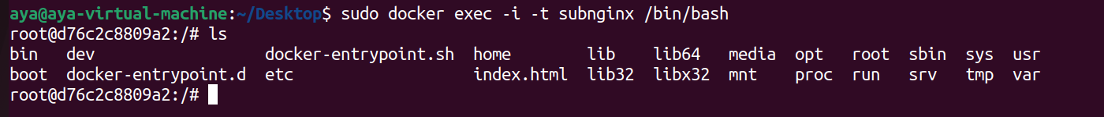

The index.html file which was created within the container of the nginx image is inside the other container that is an instance of the new image we committed.

Problem 5

▪ Create a volume called mysql_data, then deploy

a MySQL database called app-database. Use the

mysql latest image, and use the -e flag to

set MYSQL_ROOT_PASSWORD to P4sSw0rd0!.M

ount the mysql_data volume to /var/lib/mysql.

The container should run in the background.

