▪ P1: What do you know about Docker Images Tags and what is the difference

between them?

Each tag is a version of an image. When we edit an image. we build a new tag with a different name. there are some tag names which are with a meaning such as “slim” which refers to that this image is smaller than the original one

For example: If you saw ubuntu:slim means that this ubuntu only knows the basic commands and if you need to use the “ping” command, you gotta install it as you’re gonna need to run these commands first “apt-get update” then “apt-get install iputils-ping”

▪ P2: Create docker image for Python app

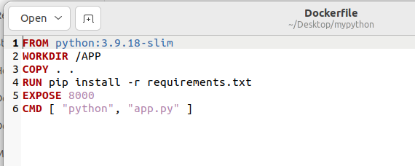

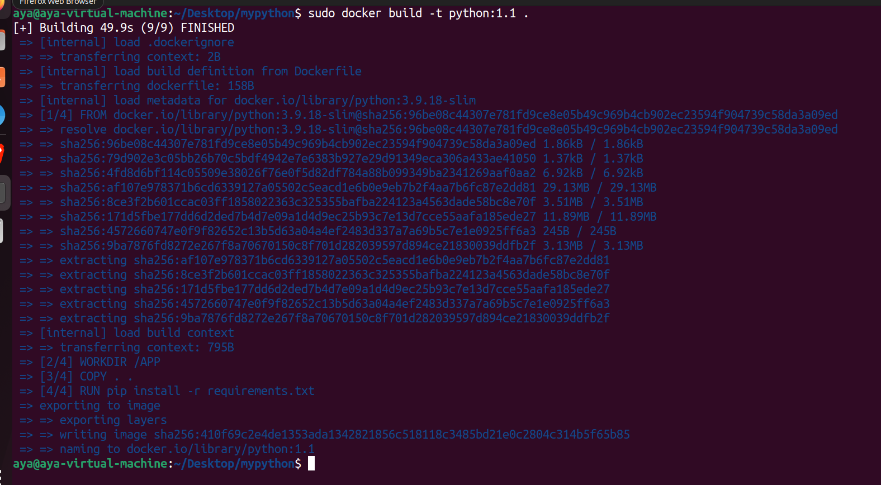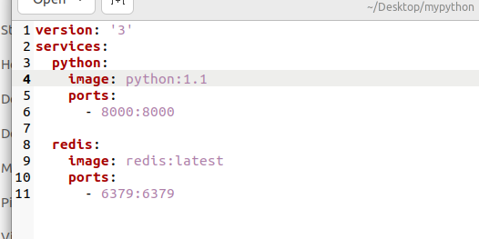

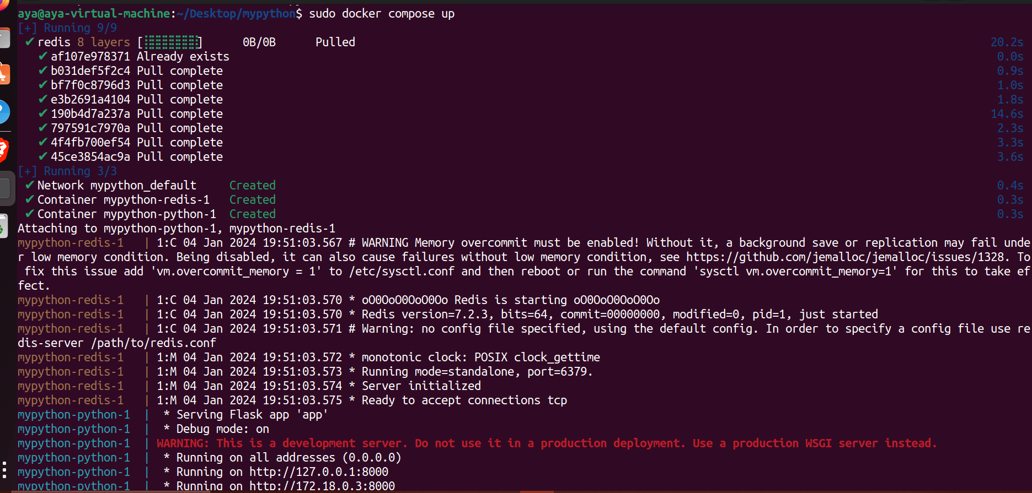

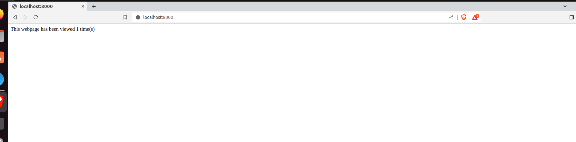

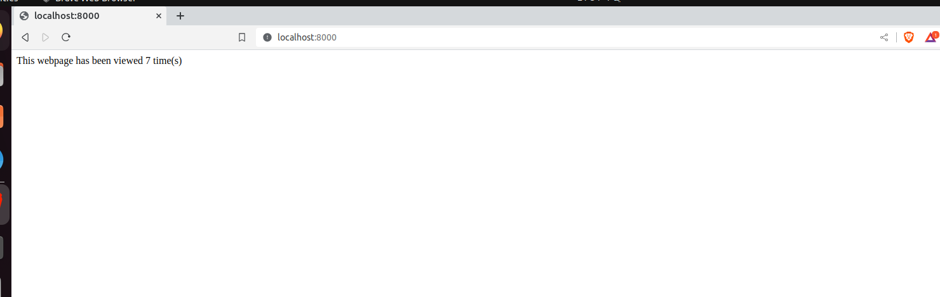

▪ P3: Create your own nginx docker image “NEVER USE FROM nginx”

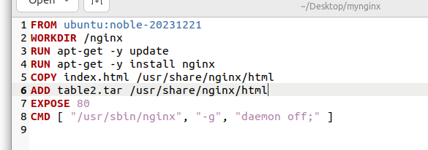

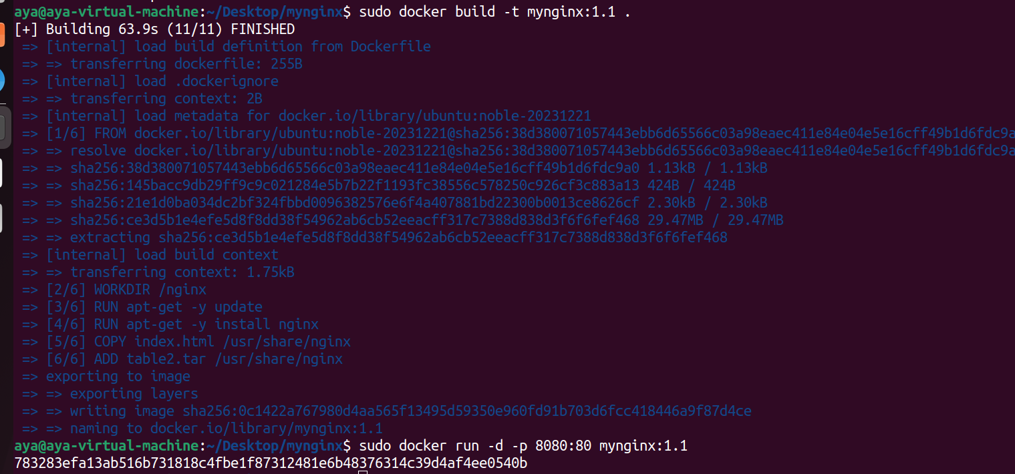

▪ P4: Create your bridge network, two containers from ubuntu image with different

names and try to ping each other using NAME





