**LAB #3**

1. Using vi write your CV in the file /tmp/mycv. Your CV should include your name, age, school, college, experience,...

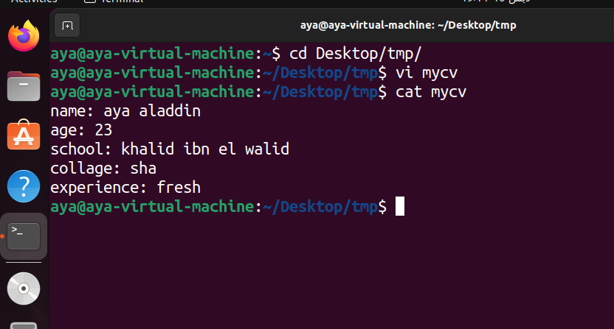

1. Open /tmp/mycv file using vi command then: Without using arrows state how to: a. Move the cursor down one line at time.

esc + j

b. Move the cursor up one line at time.

esc + k

c. Search for word age

/age

d. Step to line 5 (assuming that you are in line 1 and file is more than 5 lines).

:5

e. Delete the line you are on

dd

f. Delete line number 5.

5d

g. How to step to the end of line and change to writing mode in onestep.

shift + a

3. Create a user account with the following attribute

● username: islam

● Fullname/comment: Islam Askar

● Password: islam

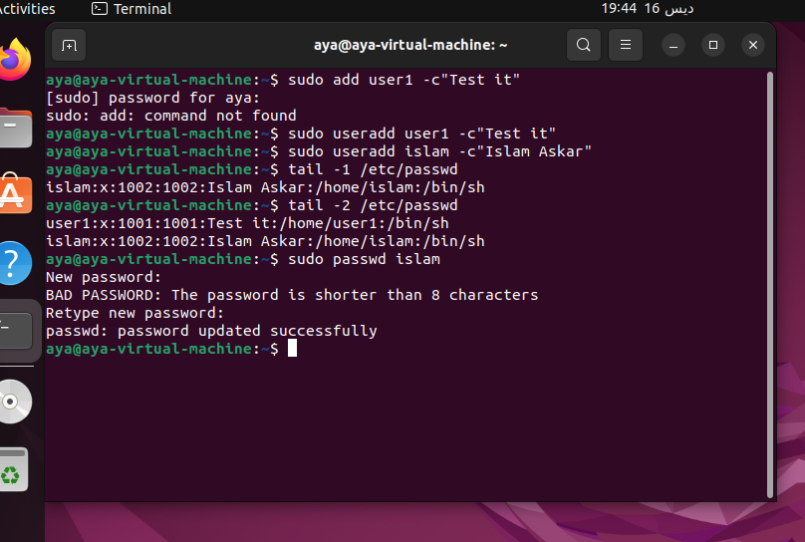

4. Create a user account with the following attribute

● Username: baduser

● Full name/comment: Bad User

● Password: baduser

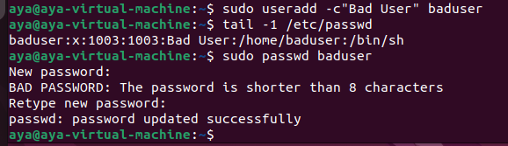

5. Create a group called pgroup with group ID of 30000

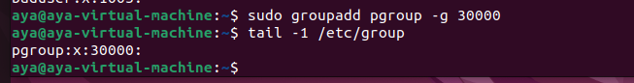

6. Create a group called badgroup

