1. Add islam user to the pgroup group as a supplementary group

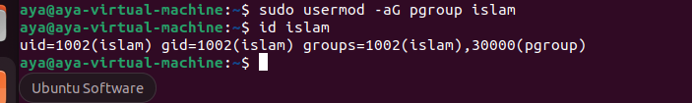

1. Log out and log in by another user

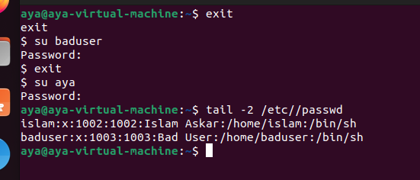

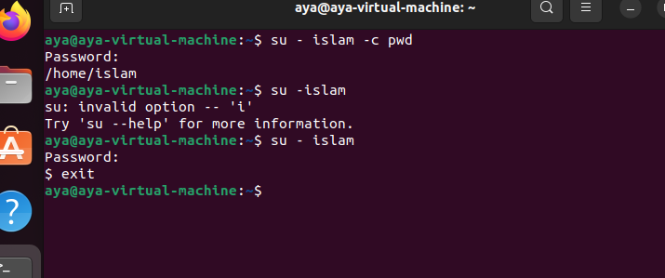

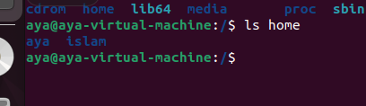

1. Modify the password of islam's account to password

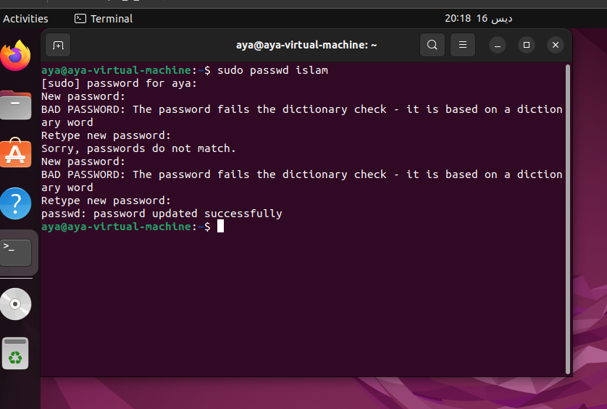

1. Modify islam's account so the password expires after 30 days

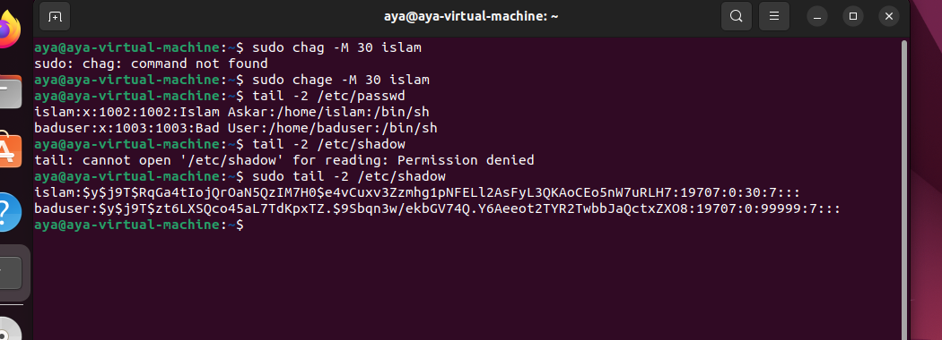

1. Lock bad user account so he can't log in

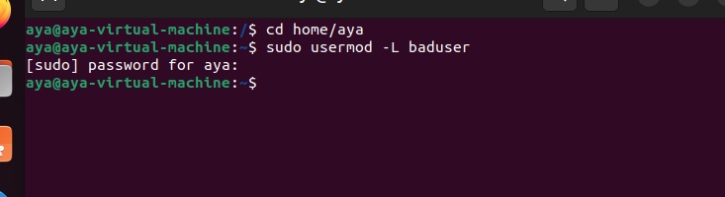

1. Delete bad user account



1. Delete the group called badgroup.

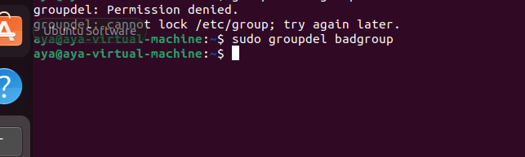

1. As you Super user, Set or change the password of root

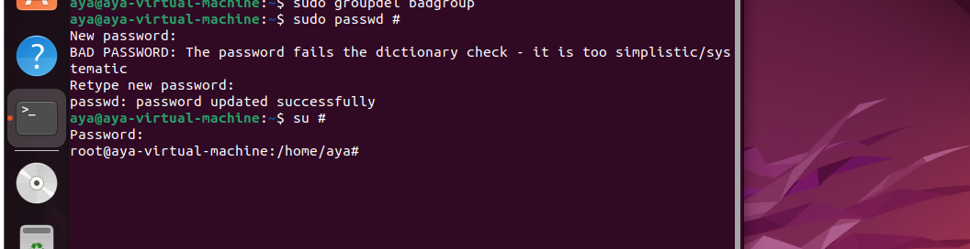

9. As you Super user, Try to remove all files in /tmp

10. Create a folder called /tmp/myteam and change its permissions to read only for the owner, and Group and Other didn’t have permission on it.

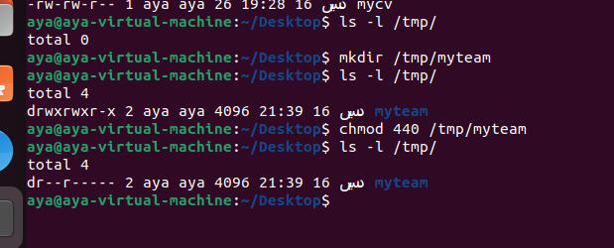

11. Log out and log in by another user

12. Try to access (by cd command) the folder (myteam)

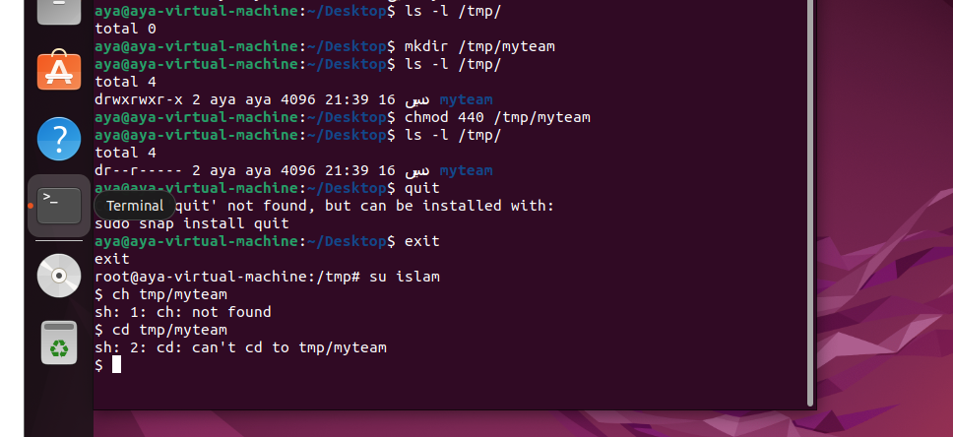

13. Change the permissions of /tmp/mycv file to give owner read and write permissions and for group write and execute and execute only for the others (using chmod in 2 different ways )



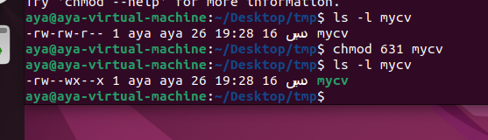

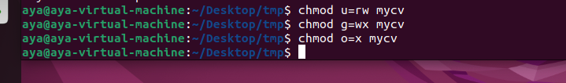

14. What are the minimum permission needed for :

a. Copy a file (permission for source file and and

permission for target parent directory)

for files (r) for dirs (w)

b. Delete a file

dir(w), no permissions needed for files

c. Change to a directory

dir(x)

d. List a directory content (ls command)

dir(r)

e. View a file content (more/cat command)

files(r)

f. Modify a file content

files(w)

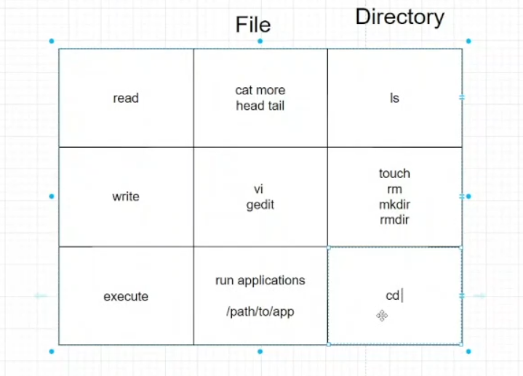

15. Create a file with permission 444 in /tmp directory. Try to edit in it and to remove it? Note what happened.

16. What is the difference between the “x” permission for a file and for a directory.

x for dirs: enter the dir

x for files: execute the executable files

17. List the All environment variables in your current shell.

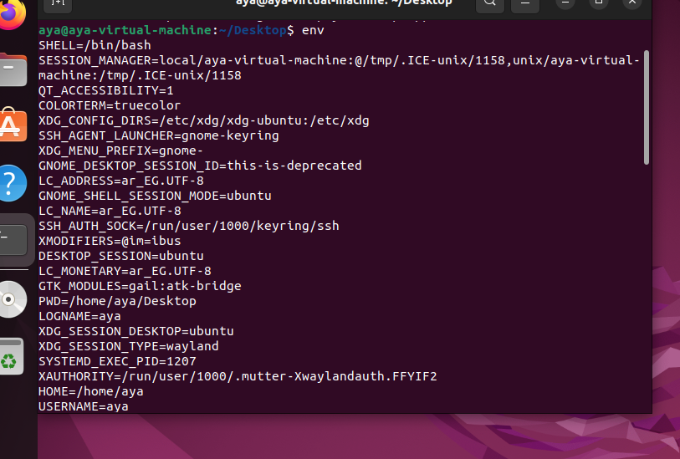

18. What are the commands that list the value of a specific variable?

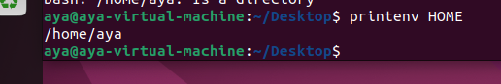

19. Display your current User name using Environment Variables.

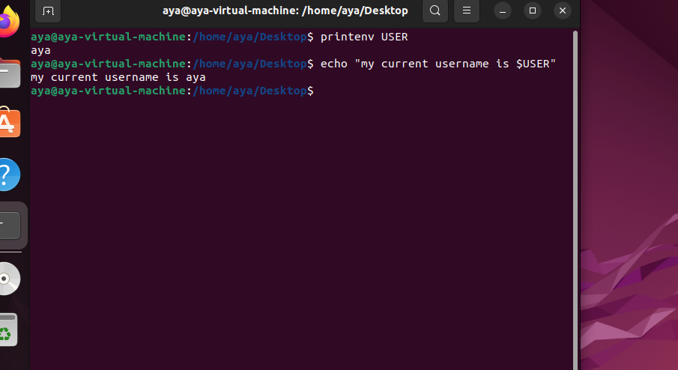

20. Create a Bash shell alias named ls for the “ls –l” command, How to bypass this alias?

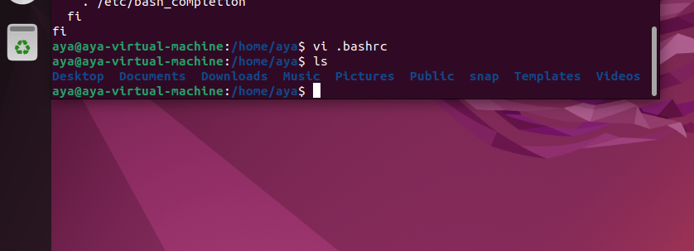

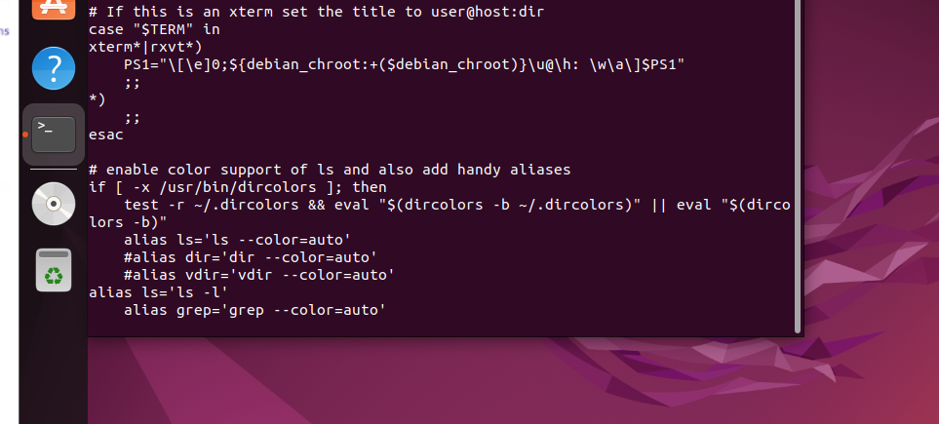

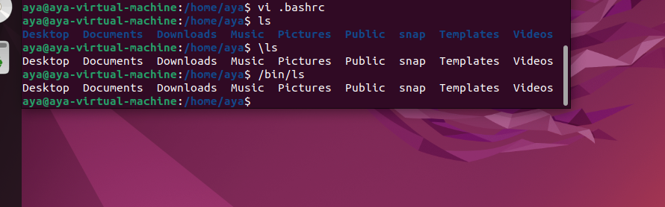

21. How to check if your internet connection is work?

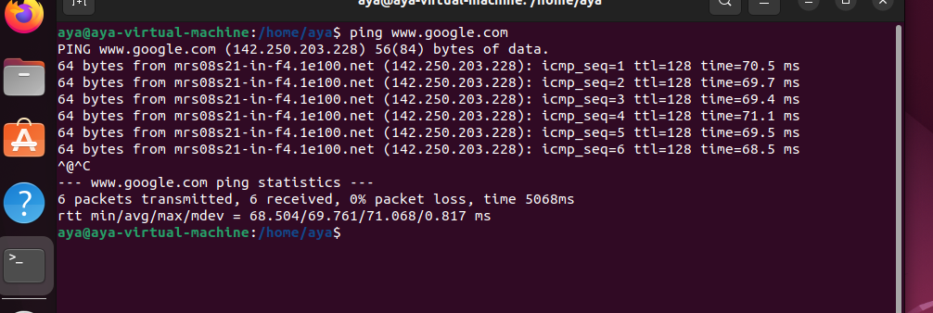

22. By editing /etc/hosts, make the URL www.iti-project-dep.com forward you to 195.10.10.2



