1. Count the number of users at your Machine

1. Search on user name “games” at your machine

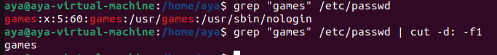

1. Get the logins names of Users.

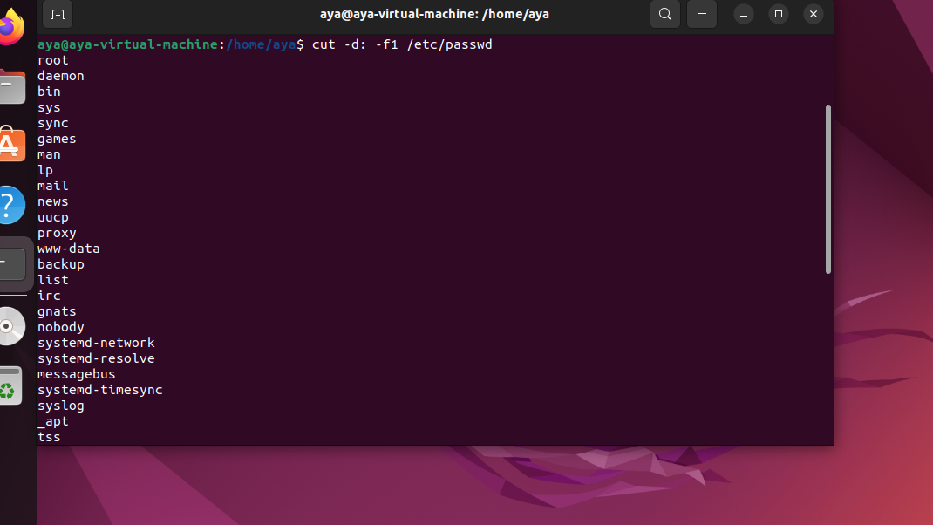

1. Get the full names (comment) of Users.

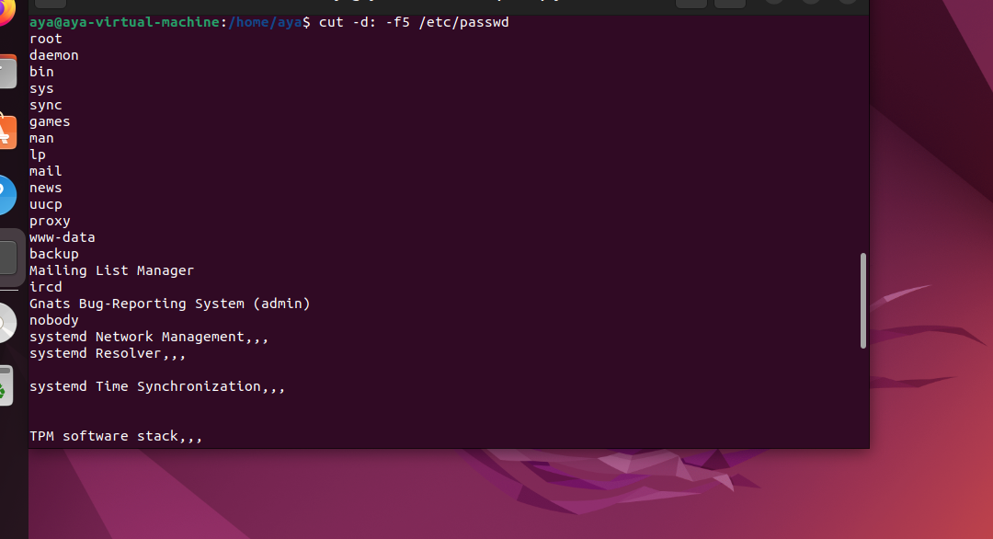

1. Issue the command sleep 100.
2. Stop the last command.

1. Resume the last command in the background
2. Issue the jobs command and see its output.

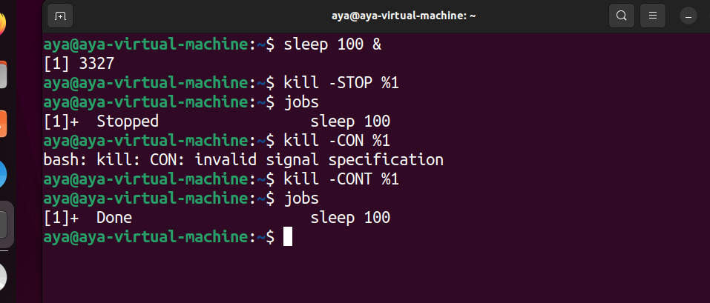

1. Send the sleep command to the foreground and send it again to the background.

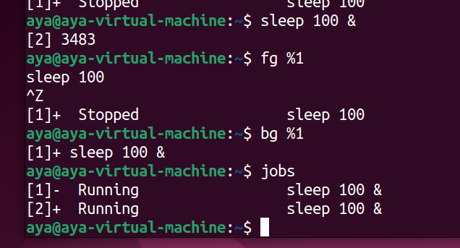

1. Kill the sleep command.

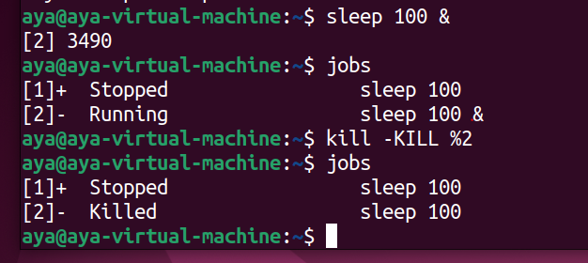

1. Display your processes only (process started by your username)

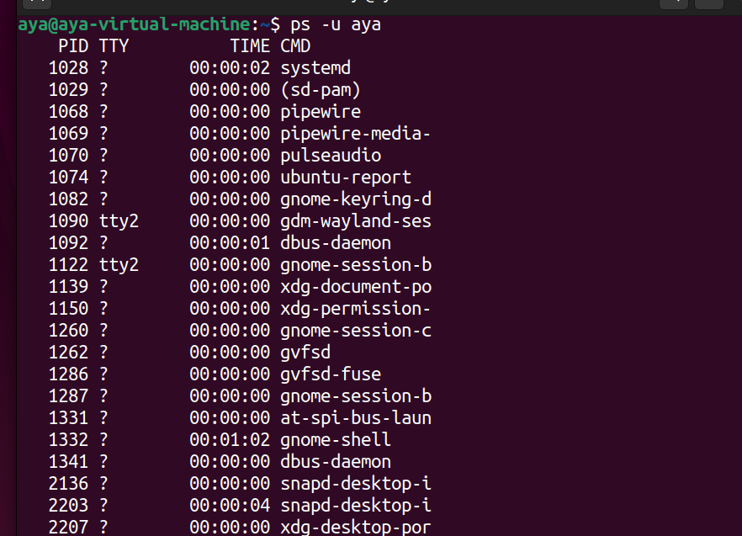

1. Use the pgrep command to list your processes only

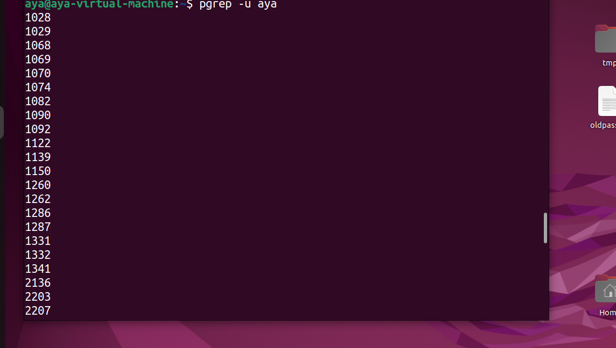

1. List the user commands(in /bin) and redirect the output to /tmp/commands.list

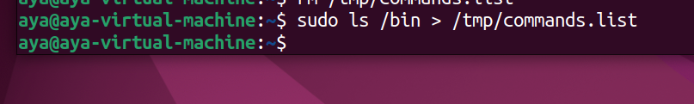

1. (based on previous Question) Count the number of user commands

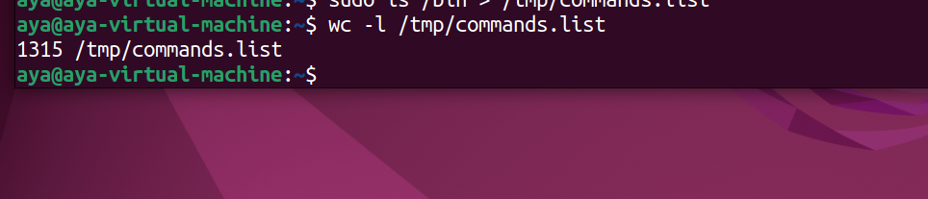

1. Start firefox application

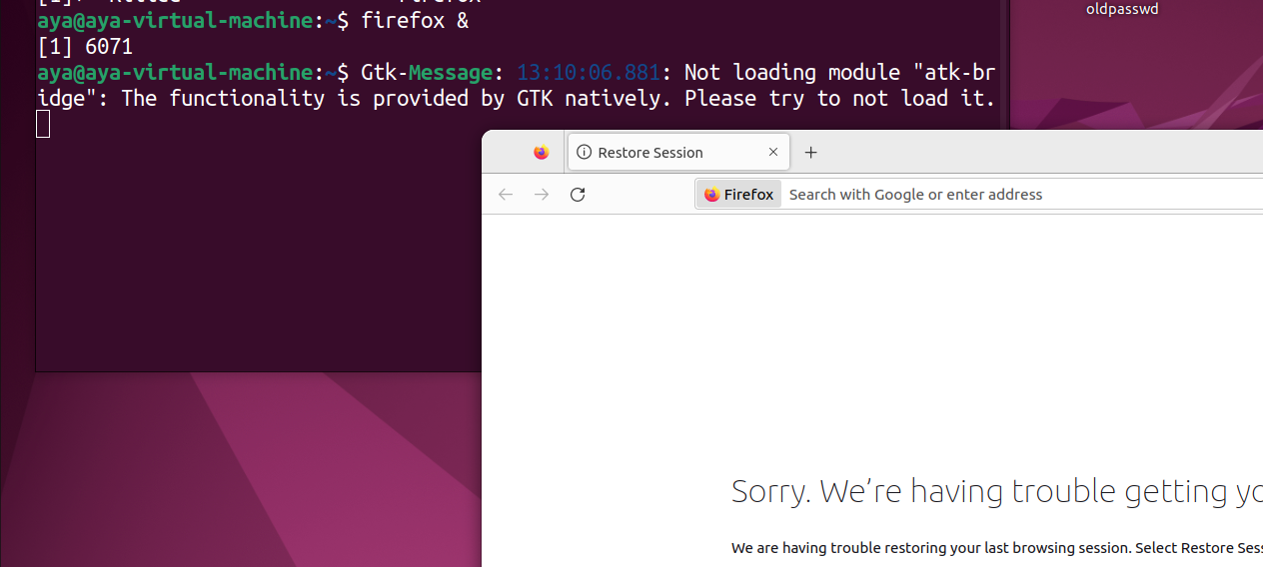

1. Send Signal kill to firefox

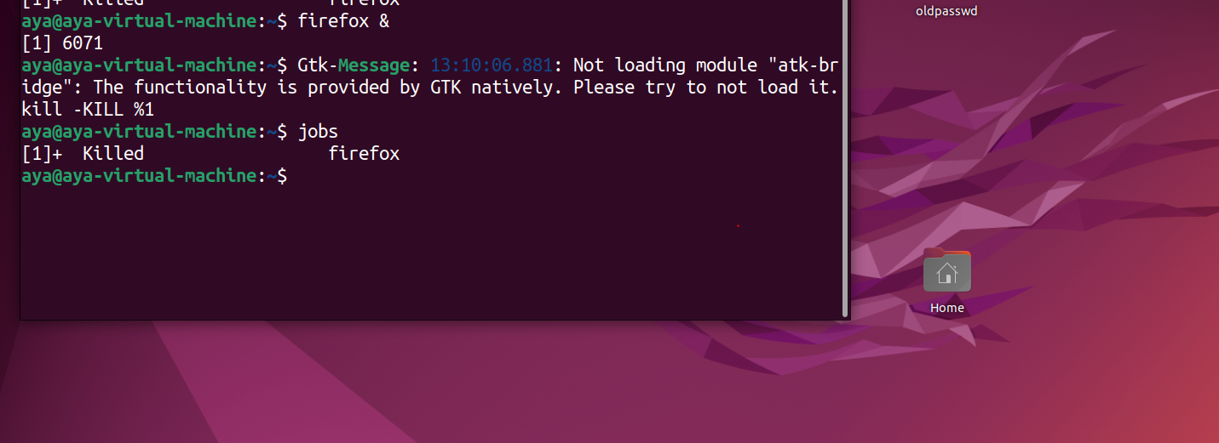

1. Get the logins name and full names (comment) of logins starts with “gu”.

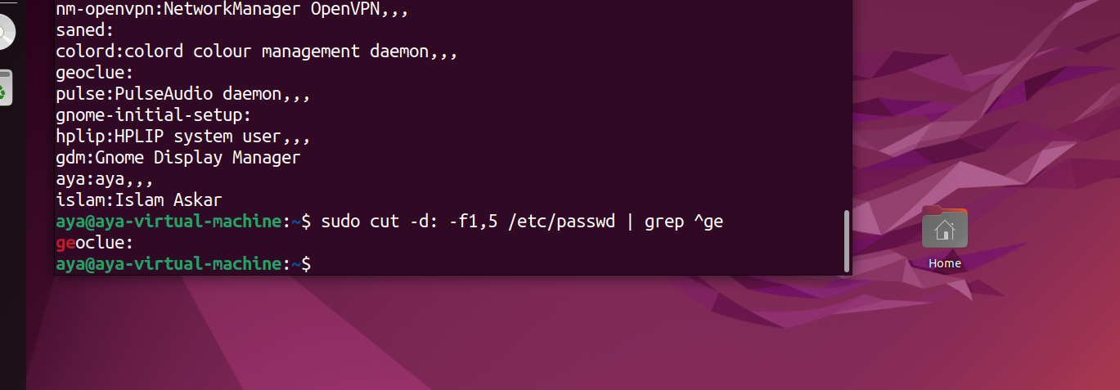

1. Display the number of users who is logged now to the system.

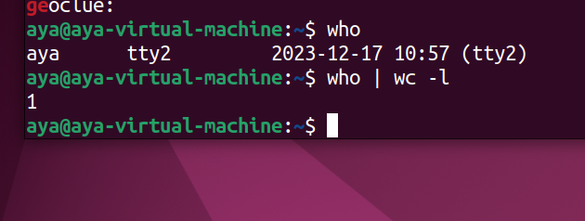

1. Display lines 7 to line 10 of /etc/passwd file

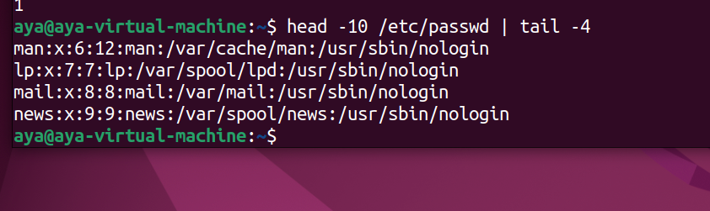

1. Search for all files on the system that named “.bash_profile” using two methods.

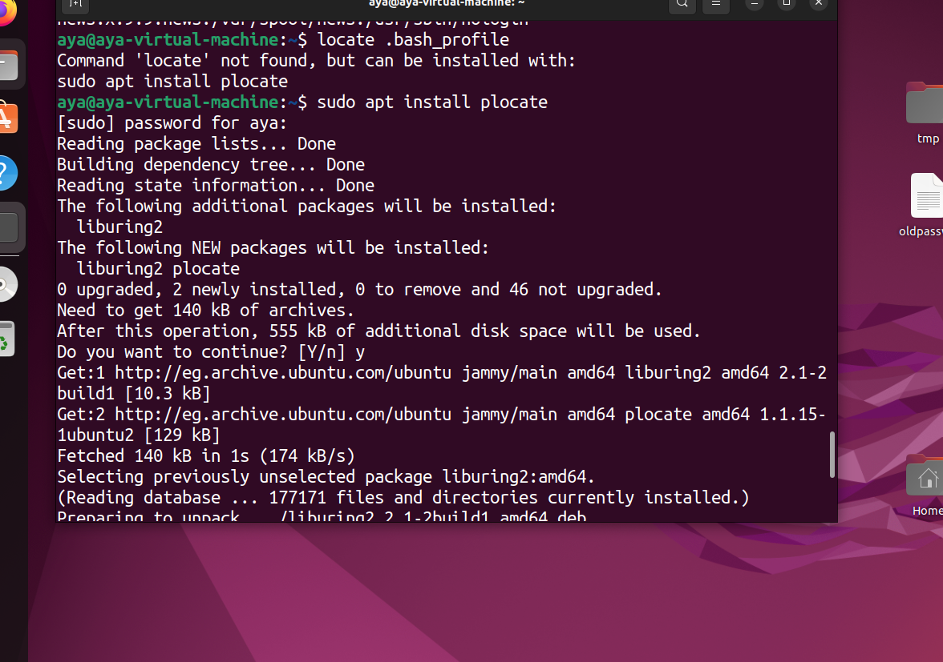

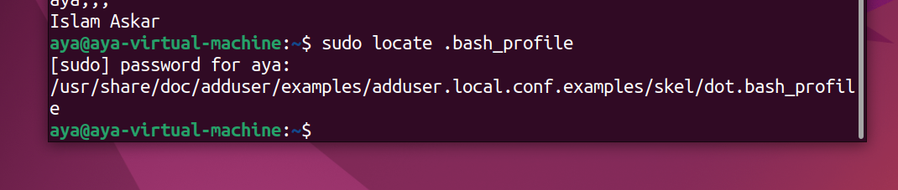

1. Install Packages called ncompress, ksh

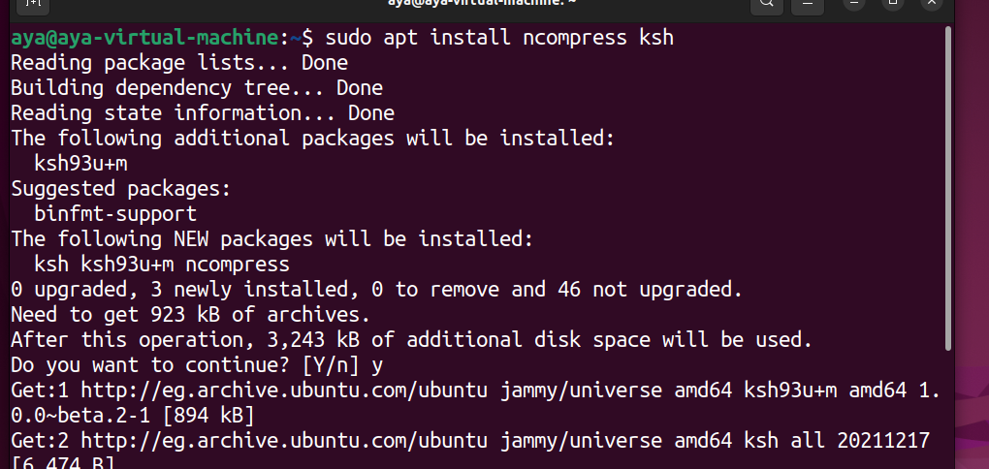

22. Kill your processes only (be care: save lab before command execution).

