1. Sort /etc/passwd based on the full names of users and save output to

external file.



2. Search for all files on the system that named “passwd” using two

methods.

Method 1

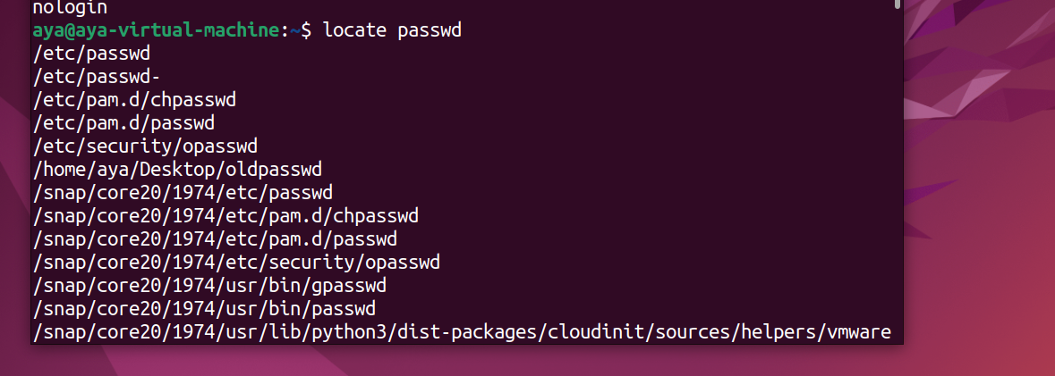

Method2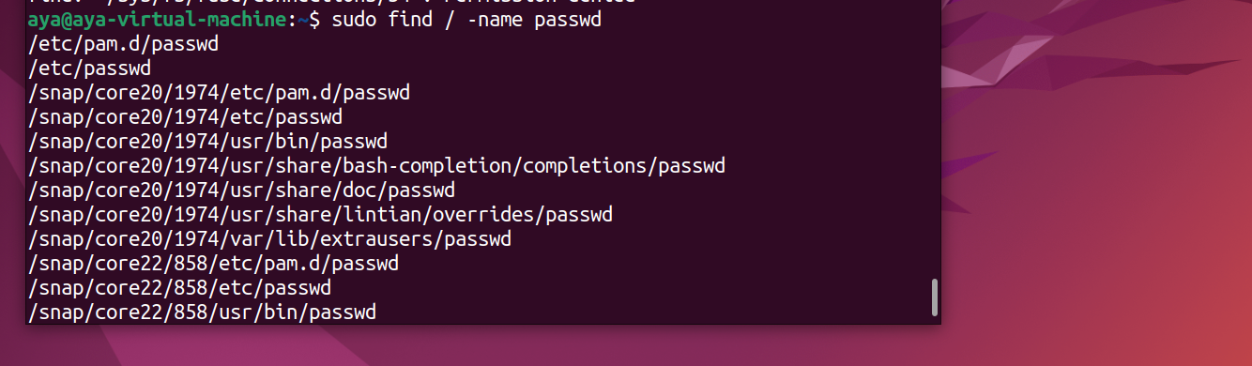

3. Install Packages called ncompress,ksh

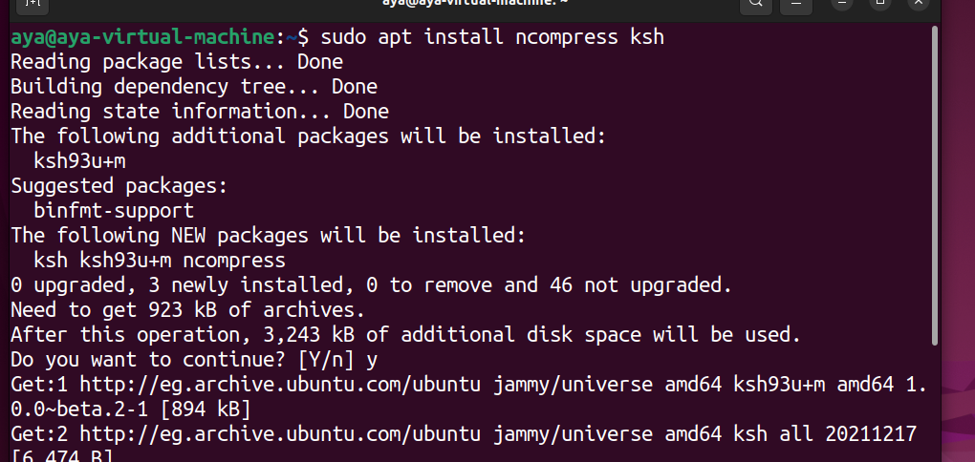

4. Compress a file by compress, bzip2 commands and decompress it again.

compress

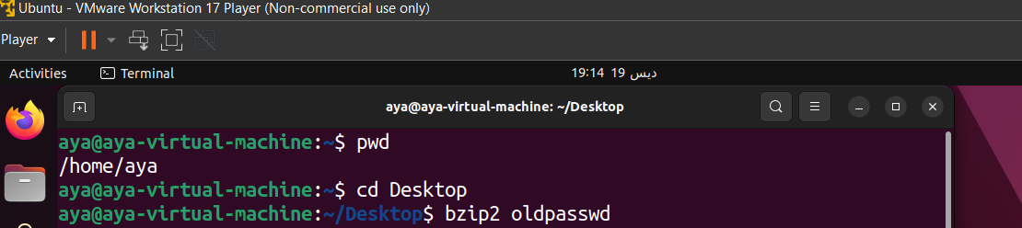

decompress

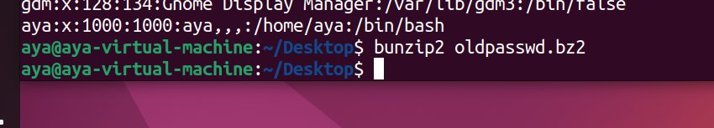

5. What is the command used to view the content of a .Z compressed file.

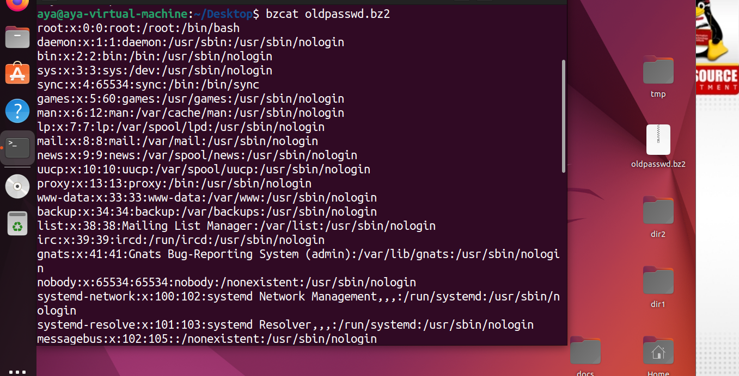

6. Backup/Archive /etc directory using tar utility.

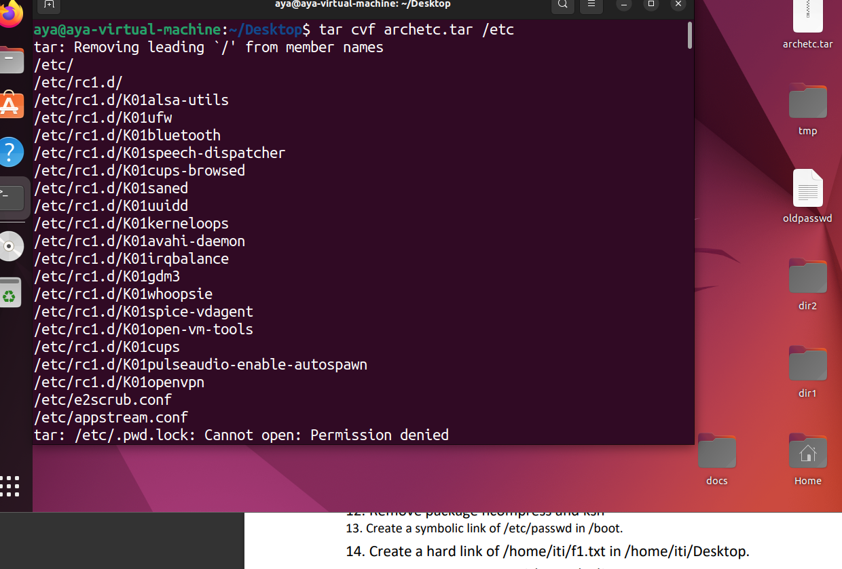

7. Starting from your home directory, find all files that were modified in the

last two day.

8. Starting from /etc, find files owned by root user.\

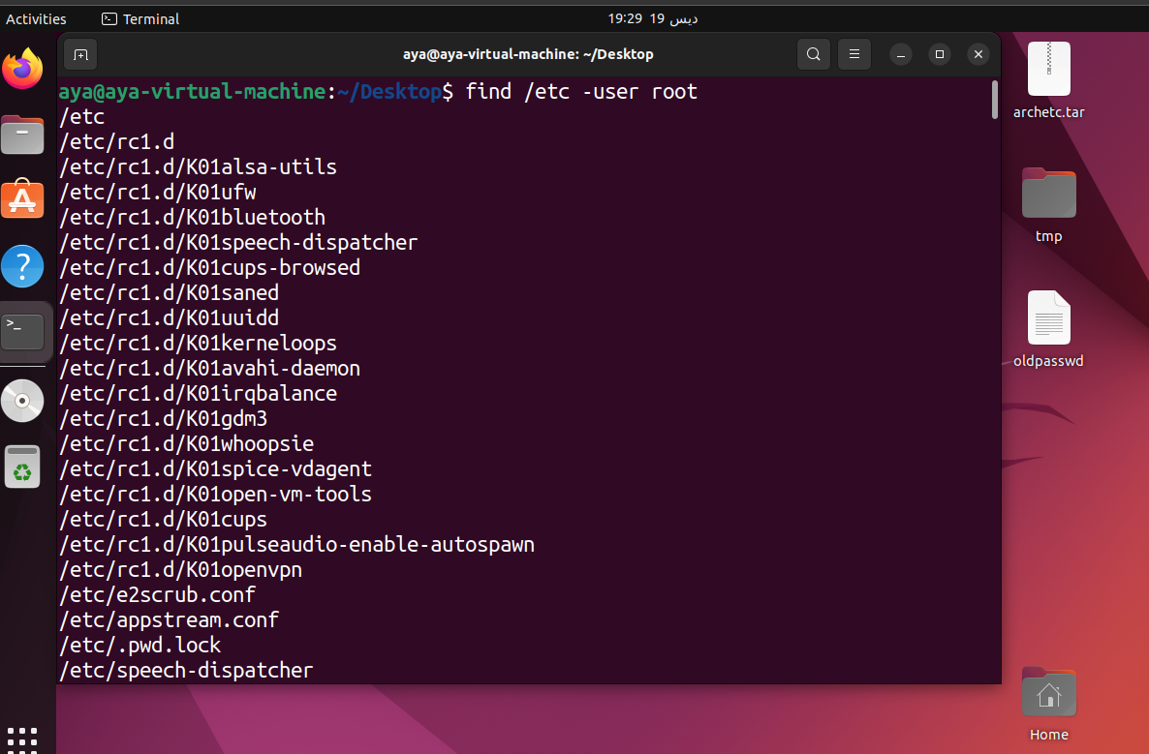

9. Find all directories in your home directory.

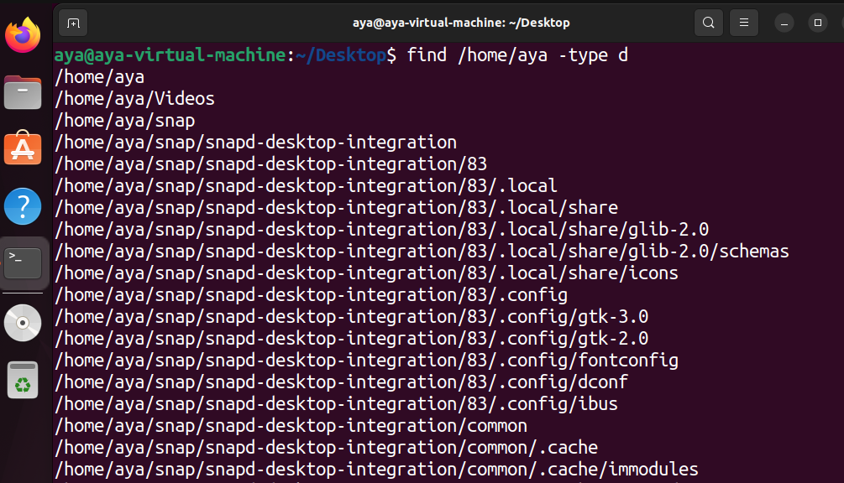

10. Write a command to search for all files on the system that, its name is

“.profile”.

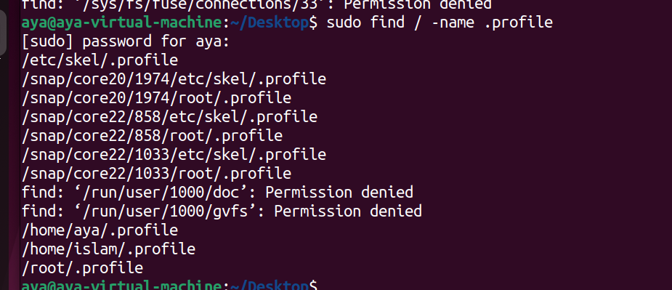

11. List the directories that have 777 Permissions in the system.

12. Remove package ncompress and ksh



13. Create a symbolic link of /etc/passwd in /boot.

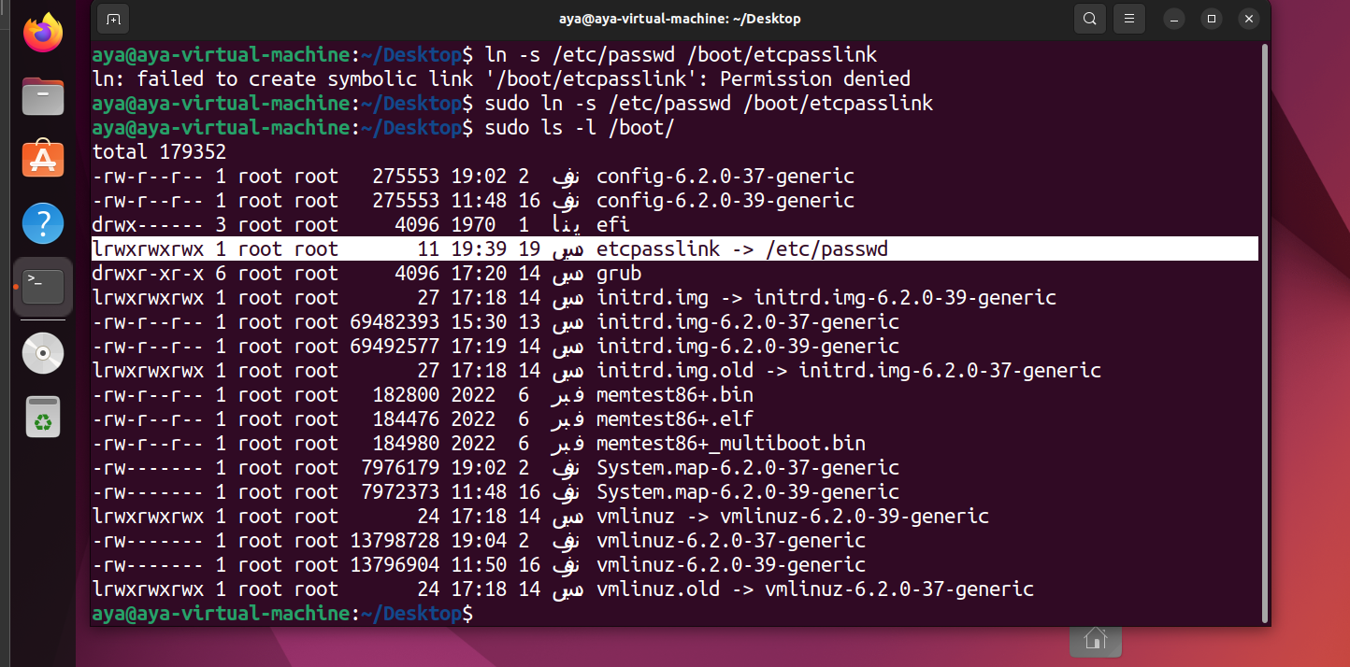

14. Create a hard link of /home/iti/f1.txt in /home/iti/Desktop.

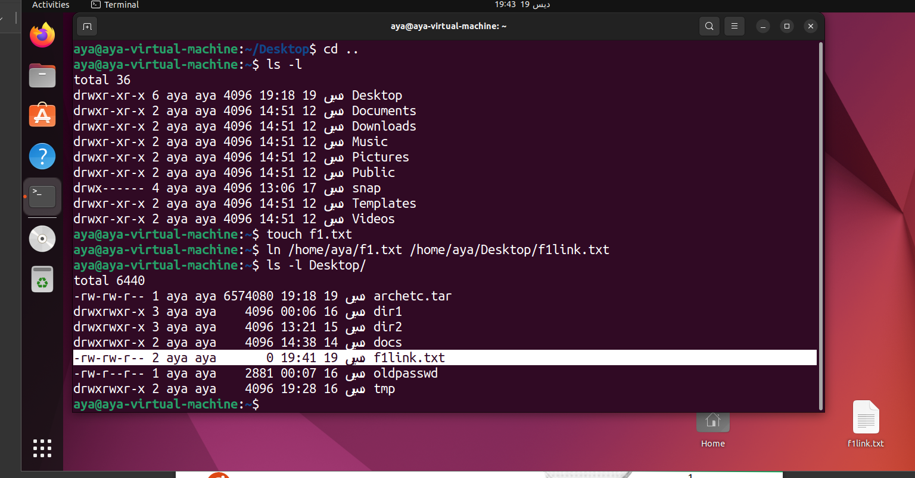

15. List the inode number of /home/iti/f1.txt

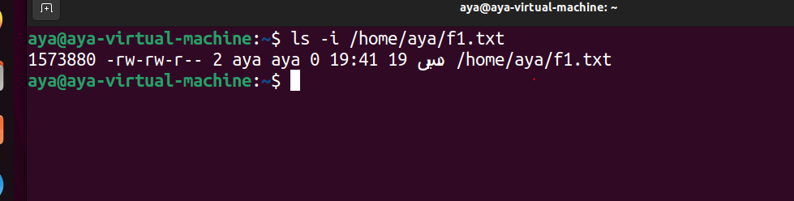

16. Copy /etc/passwd to your home directory, use the commands diff, and

Edit in the file you copied, and then use these command again, and check

the output.

