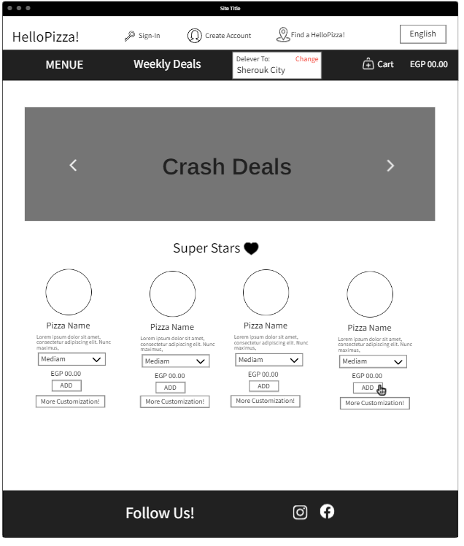

Starts with a landing page consist of nav bar and a slider of the crash deals that is always updated and doesn’t last for a long time.

The nav bar has the clear word (MENU) which is usually the word that the users always look after when visiting a web page that offers a food delivery service.

The landing page consists of the (super stars) section which shows the most popular pizzas. This is very helpful for the most customers to select from instead of going to the menu.

A floating widow (instead of a new page which takes long time when loading) opens when adding any pizza that zoom in its details and the option of adding without extra customization or the option of customizing before adding .

Each customization added the price changes. It’s super useful when buying food so that you can decide if their budget fits their adding’s.

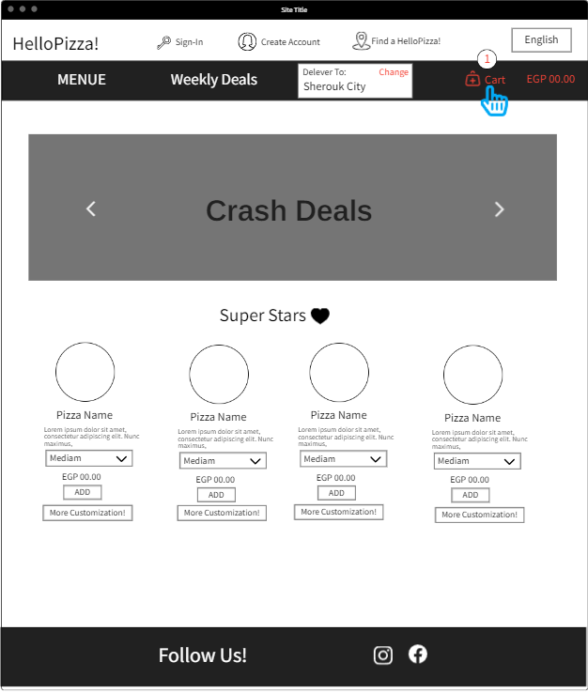

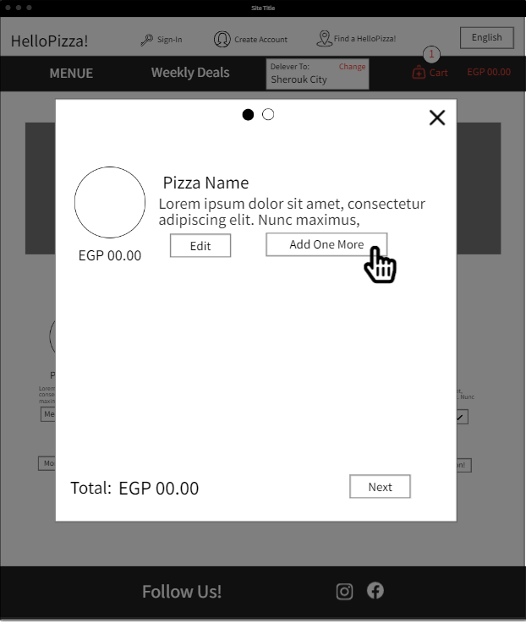after adding the item, the cart and total price turns into the red color. So helpful for users to know that the cart isn’t empty.

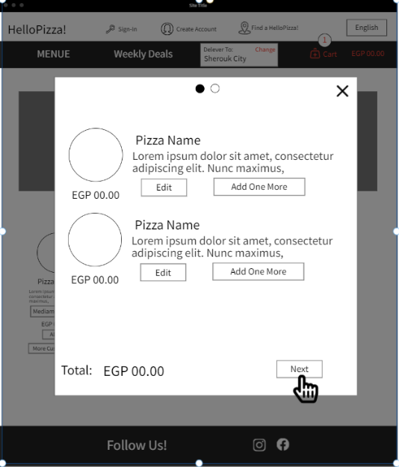When checking the cart, the user can add one more pizza with the same customization without recreating it again as he asks for the same copy.

The users can also edit that copy.

This is very useful for 2 people ordering the same pizza with the same customizations but with a slight difference which will be exhausting for the users to do the same steps again for the same pizza customization for a slight difference.

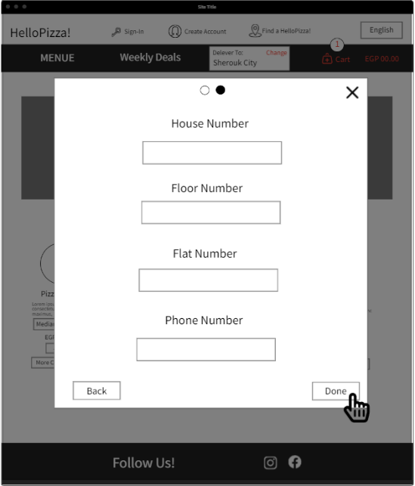

next will be the extra details needed to be added manually which cannot be known when locating the user automatically.

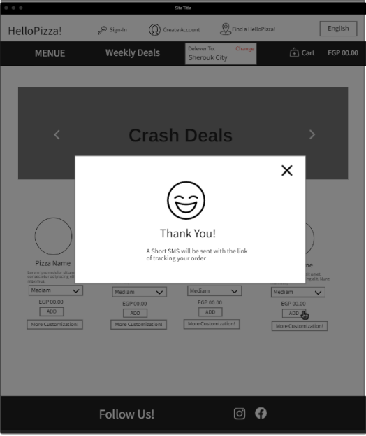

Finally, a thank you message appears to the user with a note that there will be a SMS message sent with the link for the user to track their order .

Note that we better let the scenario happens most of the time through floating windows which is better as the new pages takes longer time loading.