**ECEN452: ULTRA HIGH FREQUENCY TECHNIQUE**

**LAB08**

**SAMBONG JANG**

**DR. HUFF**

**Given:**

SUBSTRATE: FR4

Operating Frequency: 2.45GHz

Dielectric constant = 4.1

Thickness of substrate = 62 mil = 1.5748mm

**Background:**



Figure

This is S-Parameter for 4 port network with the fantastic condition where lossless and reciprocal conditions can be simultaneously met. If you consider the dot product of row 2 and 3 (using the dagger operator on row 2), we can build a relation between phase constant relationship, which is

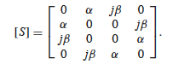

Figure

This S-Parameter is for symmetric coupler with all the terms having are in phase. Note that ,, and

are the constants for determining the power splitting into port 2 and 3. is the coupling factor between port 1 and 3. The remainder of the supplied power into port 1 will be delivered to port 2 in ideal case with the coupling factor of . The ideal case can be achieved when the port 4 is perfectly isolated.

In this lab, we are looking forward -3dB power split into port 2 and 3. The phase difference should be 90 degrees.

**Plot:**

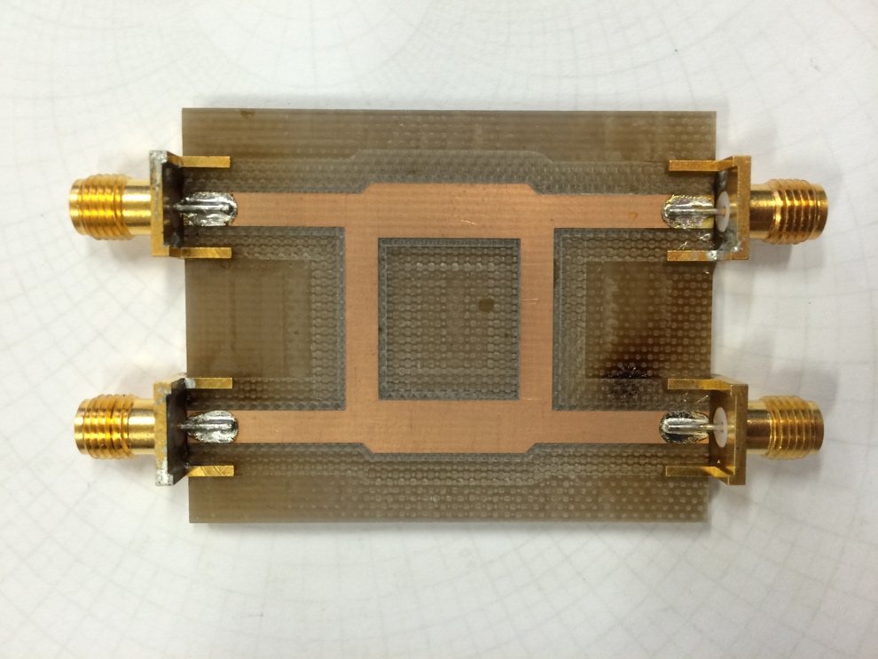

Figure

Note: This is just an example of coupler that is used in industry.

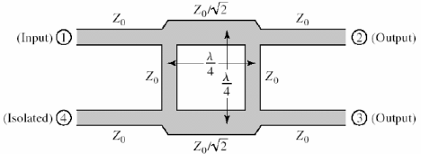

Figure

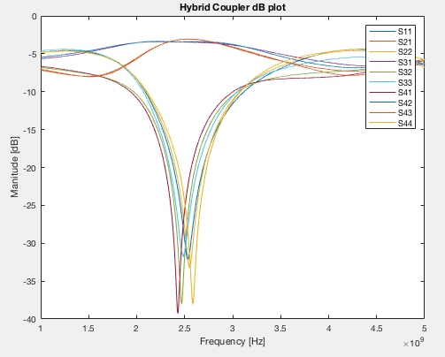

Figure

The reflection coefficients for port 2 & 4 are showing a bit off frequency than 2.45GHz. Overall, the ports are showing quite good matching. What we are expecting in this Hybrid Couple in terms of port 4 is that it should be isolated, which further means that no power entering or leaving from port 4, a total isolation from the rest of the ports. Isolation is especially significant in the Quadrature Hybrid Coupler where transmission coefficients from port 2 and 3 should be very close to -3dB in ideal case. Any further discussion should be taken place in HFSS plots.



Figure

What we need to look at this plot is the phase difference between port 2 and 3. It shows, at the operating frequency, their phase differences are 90 degrees (may not be exactly 90 degrees though).

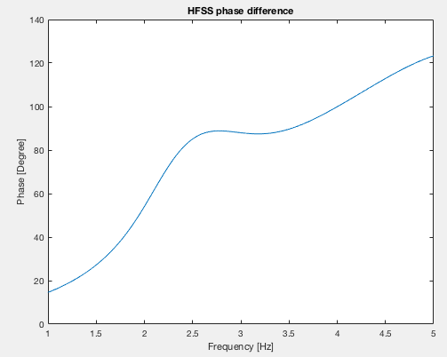

Figure. HFSS Phase Plot

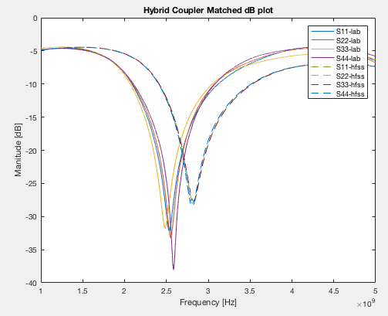

Figure

Around the operating frequency, we have a good match.

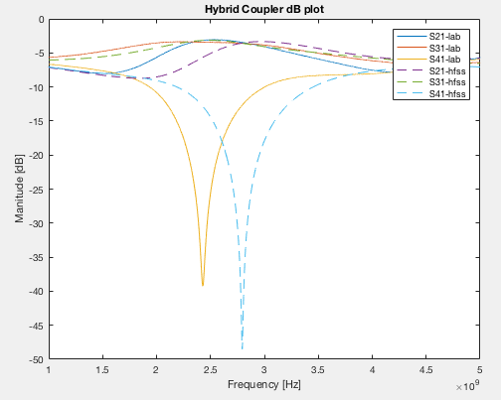

Figure

Isolation shows also good result in this plot although there’s a discrepancy between the two plots.

**HFSS Design:**

**RAT RACE COUPLER**

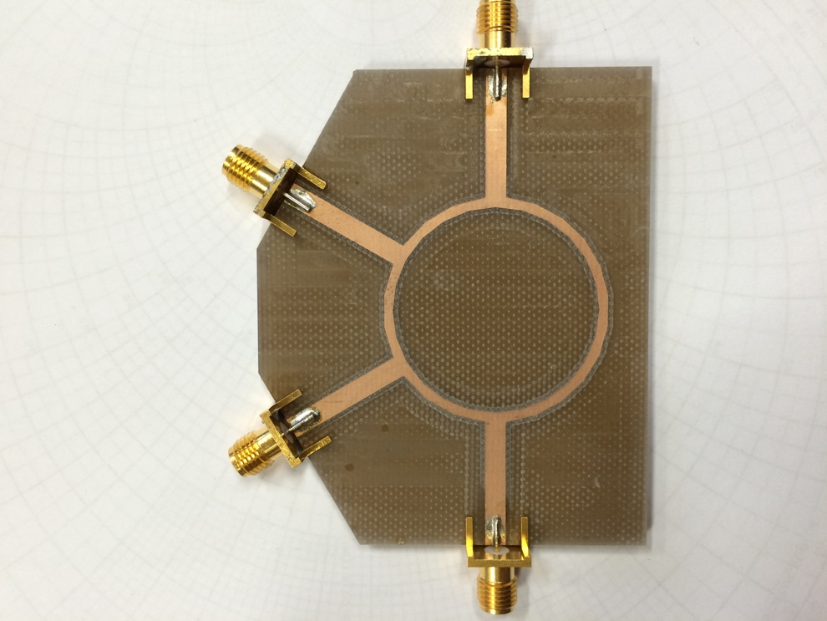

Figure

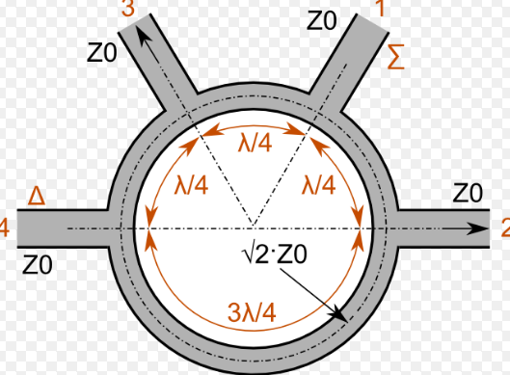

Figure

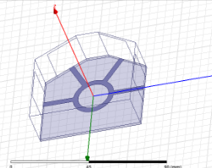

Figure. HFSS design of Rat Race Coupler

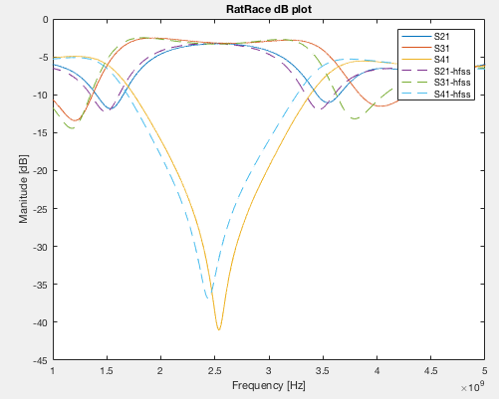

Figure

Around the operating frequency, good isolation for port 4 was obtained.

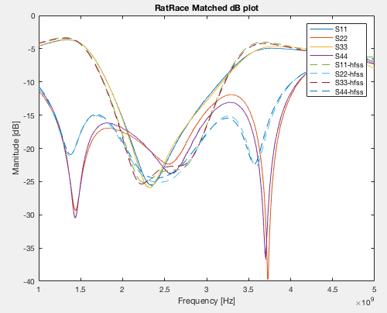

Figure

All ports around the operating frequency achieved below -20dB, which is 1% of power loss at each port.

Our goal is obtaining a phase shift of 90 degree around 2.45GHz and it seems we roughly did.



Figure

Still, the power split should be -3dB at the operating frequency and the plot displays them with the fine curve. and (excited from port 1) show the above description.



Figure

The phase difference in Rat Race Coupler should be 180 degrees between port 2 and 3. It seems, around the operating frequency, the phase difference is 180 degrees.

**References:**

[1] Microwave Engineering 4th Edition, David M. Pozar