Round Robin vs SRTF

1. Introduction
This project is a CPU scheduling simulator that compares Round Robin (RR) and Shortest Remaining Time First (SRTF)
It runs both algorithms on the same workload and shows Gantt charts, per-process metrics, and a comparison table .
2. How It Works
- The user enters processes (ID, arrival, burst) and a time quantum.
- The simulation runs entirely in the browser using HTML, CSS, and JavaScript.
- Results include Waiting Time (WT), Turnaround Time (TAT), Response Time (RT), and their averages.
- All input is validated (no negative times, no duplicates, etc.).
3. Test Scenarios and Results
Scenario A – Basic Mixed Workload
Process | Arrival | Burst
P1 | 0 | 5
P2 | 1 | 3
P3 | 2 | 8
P4 | 3 | 6
Quantum = 2
Metric | Round Robin | SRTF
Avg Waiting Time | 4.25 | 2.75
Avg Turnaround Time | 9.25 | 7.75
Avg Response Time | 1.50 | 1.00
TAT Std Deviation | 3.10 | 4.35
Observation: SRTF gives lower waiting times; RR shows fairer turnaround.

Scenario B – Quantum Sensitivity
Process | Arrival | Burst
P1 | 0 | 10
P2 | 1 | 5
P3 | 3 | 8
Quantum = 4
Metric | Round Robin | SRTF
Avg Waiting Time | 5.67 | 3.33
Avg Turnaround Time | 13.33 | 11.00
Avg Response Time | 2.67 | 1.33
TAT Std Deviation | 2.49 | 4.92
Observation: Large quantum makes RR act like FCFS, hurting short jobs.

Scenario C – Short-Job-Heavy
Process | Arrival | Burst
P1 | 0 | 2
P2 | 0 | 3
P3 | 0 | 1
P4 | 0 | 12
Quantum = 1
Metric | Round Robin | SRTF
Avg Waiting Time | 5.50 | 1.50
Avg Turnaround Time | 10.00 | 6.00
Avg Response Time | 1.25 | 0.75
TAT Std Deviation | 3.77 | 6.24
Observation: SRTF drastically reduces waiting for short jobs. RR is more balanced.

Scenario D – Interactive Fairness
Process | Arrival | Burst
P1 | 0 | 4
P2 | 1 | 2
P3 | 3 | 1
P4 | 5 | 3
Quantum = 1
Metric | Round Robin | SRTF
Avg Waiting Time | 2.00 | 1.75
Avg Turnaround Time | 4.75 | 4.50
Avg Response Time | 0.75 | 1.25
TAT Std Deviation | 1.48 | 2.17
Observation: RR gives faster first response. SRTF slightly better on waiting.

Scenario E – Validation
Tested invalid inputs:
- Negative arrival → Alert shown
- Burst = 0 → Alert shown
- Duplicate ID → Alert shown
- Letters in numbers → Alert shown
All checks work correctly.
then :
- Better waiting time: SRTF in all cases.
- Better response time: Round Robin (especially with small quantum).
- Fairer: Round Robin (smaller TAT standard deviation).
- Short jobs faster with SRTF: Yes, clearly in Scenario C.
- Effect of quantum: Small quantum = better response, more context switches. Large quantum = fewer switches but higher waiting.
- Recommendation: Use RR for interactive systems; use SRTF for batch/minimum average time.

5. Conclusion
- RR is fairer and gives better first response.
- SRTF is more efficient with lower average waiting and turnaround.
- Starvation risk exists in SRTF for long processes; RR avoids it.
- The quantum size controls the trade-off between overhead and responsiveness.
- The best algorithm depends on the system's goals.

- Screenshots
Main Interface
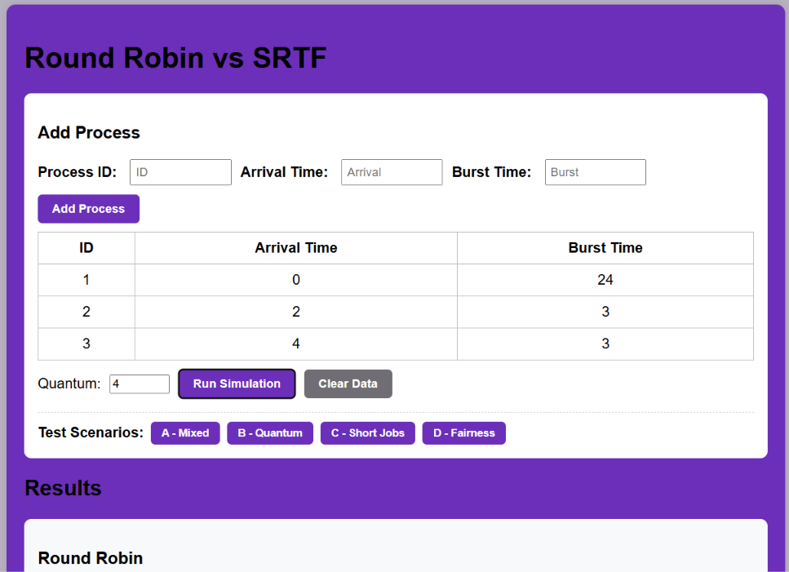

Round Robin Gantt Chart
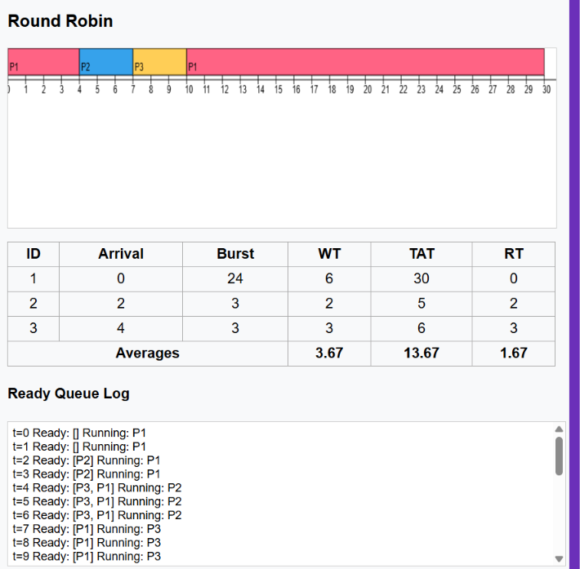

SRTF Gantt Chart
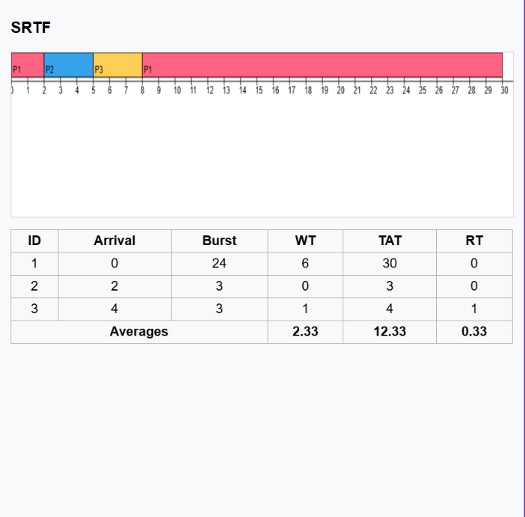

Comparison Summary

Validation Example
