***-Name : aya alam eldeen***

***-BN:3 في كشف التخلفات***

***-Emil:***

aya[195257@feng.bu.edu.eg](mailto:195257@feng.bu.edu.eg)

***13051: رقم الجلوس-***

-***Topic:***

***(Programming languages)***

**-** I am honored to discuss and explain this research from some aspects, such as its applications, uses, and its importance to society and to humans in general, and that programming language is of extreme importance as it helps us communicate with modern devices, computers or modern applications.

**-Programming languages:**

-It is a tool that helps us to make the computer and the software used our understanding. We use it to give the computer the instructions it needs to perform a particular software task, meaning the easiest way is for us to communicate with the software, computer or any particular device to tell it what we want in order to give us what we want.

***\*There are two languages\****

1. Localized programming languages:

-These languages ​​translate instructions and then convert them once into code and the programmer here is the one who has the responsibility for this process, such as C++, C and Go languages, all of which are compiled languages ​​and are used in a wide and comprehensive range.

2. Interpreted programming languages:

-These languages ​​depend on a translator or an intermediary to convert instructions into code that the device or computer understands, and the programmer is not responsible for this process, such as JavaScript and Python languages ​​are interpreted languages.

* Note: Languages ​​have been classified according to their quality, applications and number, as there are 250 classifications for them.

***-Applicationofprogramminglanguage:***

-Programming languages ​​have many and countless applications, and perhaps the most famous and most important of them are: mobile applications, desktop applications, web applications, game programs and simulation programs, calculations and simulation programs, calculations, applications, models of high-level programming languages, downloads and other applications

1- Of the languages ​​that can deal and add beautiful effects to web pages and can deal with them and are used in dealing with browsers and programming additions, for example, or Extensions and many other uses

2- Including those who can convert static web pages to a real site and add a lot of features, for example, adding articles and registering members

3-Dealing with files on the server, searching within the site, dealing with cookies

4-Obtaining data from Forms fields, controlling user access to site pages

5-Dealing with databases, encrypting data “such as passwords” and others.

6- Building websites

7- It is characterized by speed, security, information preservation and ease of completion of work

- Programming languages: Java, C, C++, Swift, Python, and other languages

***Screen shot to source code:*** 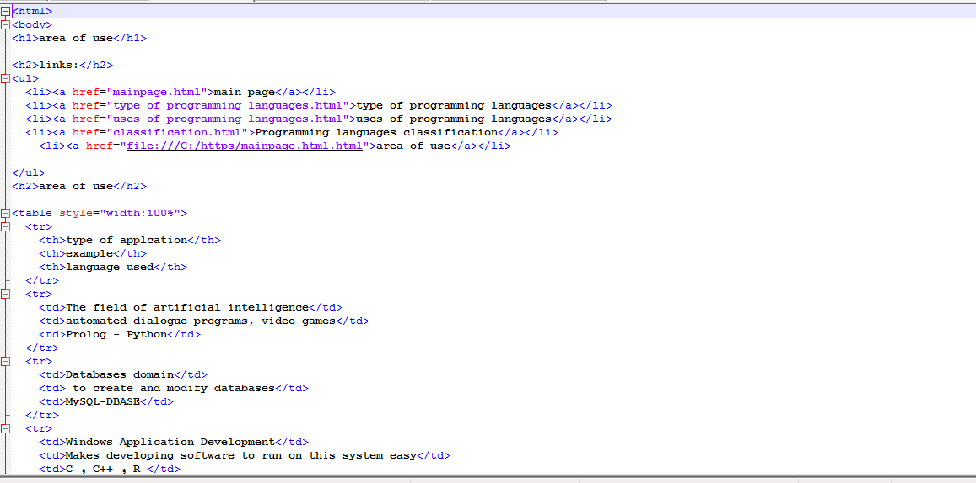

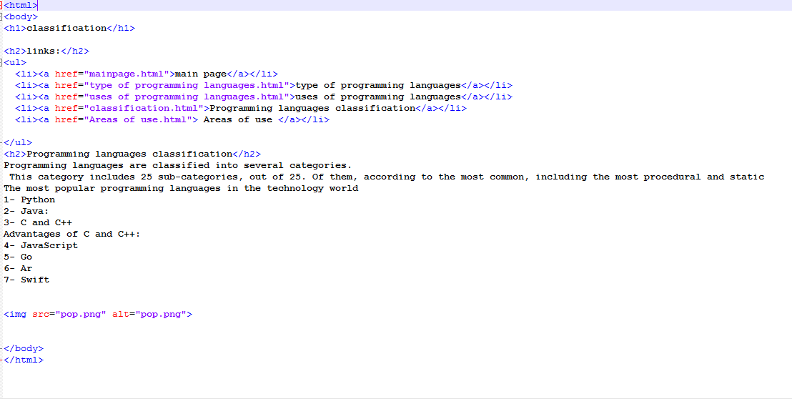

***Screen shot to page:***

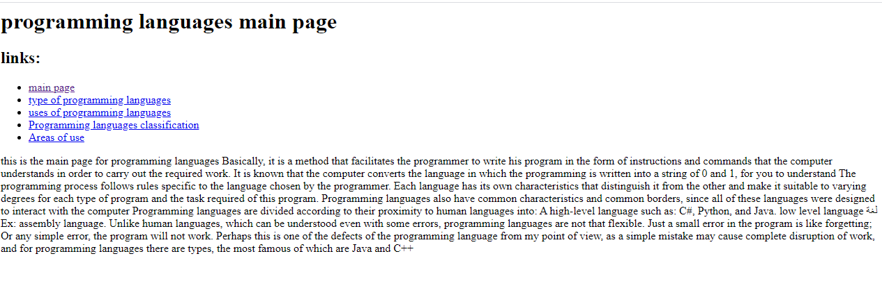

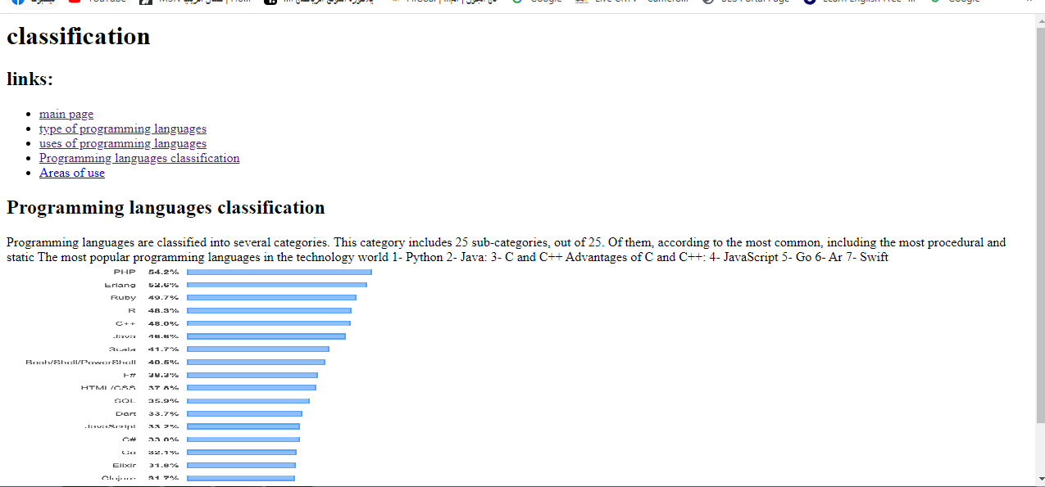

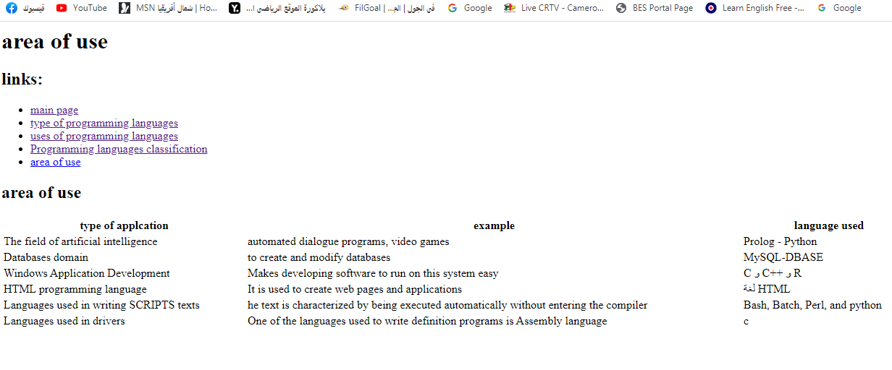

-https://github.com/aya23alam/html.project.repository/upload

-https://github.com/aya23alam/html.project.repository