# **Assignment 4 – SeqTrack Inference Evaluation**

## GitHub Repository

“ <https://github.com/aya2500/Assignment_4> ”

## **About the Report**

This report presents the final phase of the **SeqTrack** project, focusing on **inference and evaluation**. The trained model from **Assignment 3** was used to perform full-sequence inference on the **LaSOT** dataset to measure tracking performance and efficiency across multiple epochs.

The document includes placeholders for each sequence’s results, graphs, and reflections to be completed after the evaluation phase.

## **1. Introduction**

This section continues the SeqTrack project from **Assignment 3**, transitioning from **model training** to **inference and evaluation**.

The main objective is to analyze how the trained model performs on unseen test data by applying various **evaluation metrics**, such as AUC, IoU, Precision, and Normalized Precision. These metrics help determine the tracker’s robustness, accuracy, and generalization capability.

## **2. Methodology**

This section outlines the process used for **inference** and **evaluation** of the SeqTrack model.

Multiple model checkpoints were selected from epochs **1 to 10** to assess performance over training progression. The **LaSOT dataset** subset, including sequences such as *book-19* and *coin-3*, was used for testing.

Inference was executed using the official **SeqTrack testing scripts**, generating output files containing predicted bounding boxes and timing information for each frame.

The **evaluation stage** computed performance metrics (AUC, IoU, Precision, and FPS) from the output files to compare results across epochs and identify the most stable model version.

## **Sequence: Book 3**

### Table 1: Inference Rate Results

| **Epoch** | **FPS** |
| --- | --- |
| 1 | 16.53 |
| 2 | 16.11 |
| 3 | 18.48 |
| 4 | 18.39 |
| 5 | 17.39 |
| 6 | 28.88 |
| 7 | 25.27 |
| 8 | 28.01 |
| 9 | 19.20 |
| 10 | 24.13 |

### Table 2: Evaluation Metrics

| **Epoch** | **IoU** | **Precision** | **AUC** |
| --- | --- | --- | --- |
| 1 | 0.2550 | 5.72 | 26.19 |
| 2 | 0.2545 | 5.72 | 26.14 |
| 3 | 0.0008 | 0.06 | 1.19 |
| 4 | 0.0010 | 0.06 | 3.96 |
| 5 | 0.0012 | 0.06 | 0.13 |
| 6 | 0.0010 | 0.06 | 0.11 |
| 7 | 0.0015 | 0.06 | 0.15 |
| 8 | 0.0018 | 0.06 | 0.18 |
| 9 | 0.0007 | 0.06 | 0.08 |
| 10 | 0.0007 | 0.06 | 0.08 |

### Graph 1: IoU / Precision / AUC vs Epoch

## 

## **Sequence: Book 10**

### Table 1: Inference Rate Results

| **Epoch** | **FPS** |
| --- | --- |
| 1 | 16.65 |
| 2 | 16.62 |
| 3 | 16.48 |
| 4 | 18.32 |
| 5 | 18.03 |
| 6 | 29.87 |
| 7 | 28.76 |
| 8 | 24.63 |
| 9 | 27.76 |
| 10 | 20.66 |

### Table 2: Evaluation Metrics

| **Epoch** | **IoU** | **Precision** | **AUC** |
| --- | --- | --- | --- |
| 1 | 0.7173 | 0.06 | 69.78 |
| 2 | 0.7173 | 0.06 | 69.78 |
| 3 | 0.7173 | 0.06 | 69.78 |
| 4 | 0.0012 | 0.06 | 4.85 |
| 5 | 0.0017 | 0.06 | 0.39 |
| 6 | 0.0021 | 0.06 | 0.21 |
| 7 | 0.0021 | 0.06 | 0.21 |
| 8 | 0.0020 | 0.06 | 0.26 |
| 9 | 0.0020 | 0.06 | 0.41 |
| 10 | 0.0020 | 0.06 | 0.20 |

### Graph 1: IoU / Precision / AUC vs Epoch

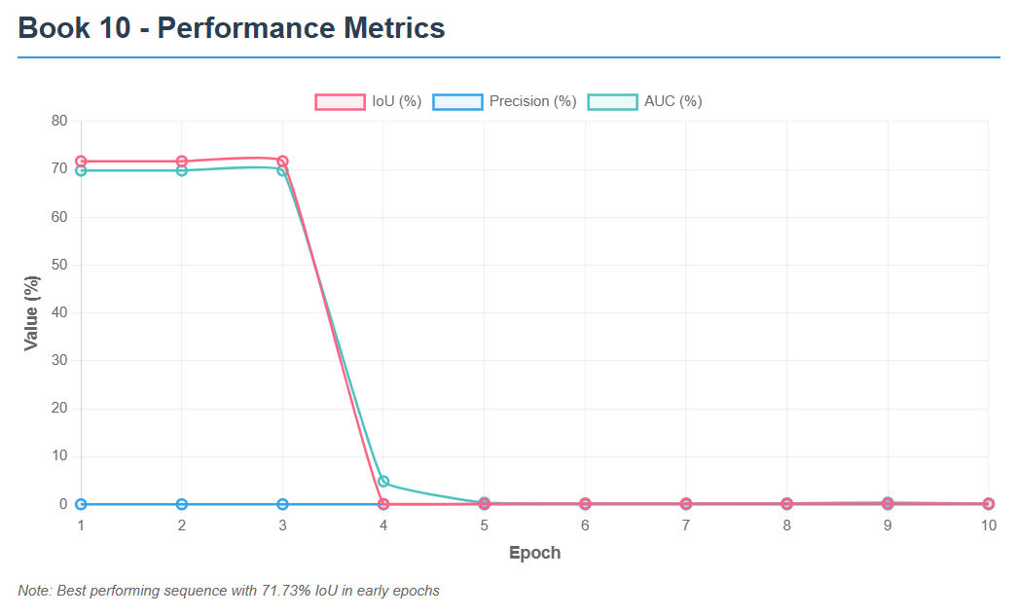

## **Sequence: Book 11**

### Table 1: Inference Rate Results

| **Epoch** | **FPS** |
| --- | --- |
| 1 | 16.61 |
| 2 | 16.39 |
| 3 | 18.38 |
| 4 | 18.19 |
| 5 | 18.28 |
| 6 | 16.13 |
| 7 | 21.18 |
| 8 | 30.91 |
| 9 | 27.17 |
| 10 | 29.63 |

### Table 2: Evaluation Metrics

| **Epoch** | **IoU** | **Precision** | **AUC** |
| --- | --- | --- | --- |
| 1 | 0.0200 | 0.05 | 4.83 |
| 2 | 0.0198 | 0.05 | 4.80 |
| 3 | 0.0007 | 0.29 | 0.13 |
| 4 | 0.0007 | 0.05 | 0.12 |
| 5 | 0.0010 | 0.34 | 0.15 |
| 6 | 0.0016 | 0.05 | 0.16 |
| 7 | 0.0016 | 0.05 | 0.16 |
| 8 | 0.0015 | 0.05 | 0.16 |
| 9 | 0.0015 | 0.05 | 0.16 |
| 10 | 0.0015 | 0.05 | 0.15 |

### Graph 1: IoU / Precision / AUC vs Epoch

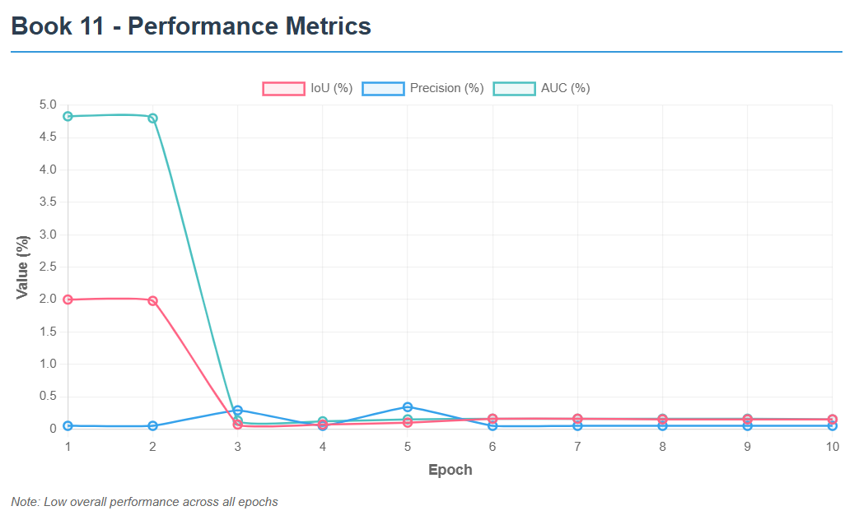

## **Sequence: Book 19**

### Table 1: Inference Rate Results

| **Epoch** | **FPS** |
| --- | --- |
| 1 | 16.52 |
| 2 | 16.54 |
| 3 | 18.48 |
| 4 | 18.58 |
| 5 | 18.61 |
| 6 | 21.33 |
| 7 | 30.23 |
| 8 | 27.95 |
| 9 | 30.57 |
| 10 | 28.37 |

### Table 2: Evaluation Metrics

| **Epoch** | **IoU** | **Precision** | **AUC** |
| --- | --- | --- | --- |
| 1 | 0.2908 | 11.87 | 30.36 |
| 2 | 0.2908 | 11.87 | 30.35 |
| 3 | 0.0006 | 0.03 | 2.26 |
| 4 | 0.0006 | 0.03 | 2.04 |
| 5 | 0.0008 | 0.03 | 0.09 |
| 6 | 0.0011 | 0.03 | 0.11 |
| 7 | 0.0011 | 0.03 | 0.11 |
| 8 | 0.0011 | 0.03 | 0.11 |
| 9 | 0.0011 | 0.03 | 0.11 |
| 10 | 0.0010 | 0.03 | 0.10 |

### Graph 1: IoU / Precision / AUC vs Epoch

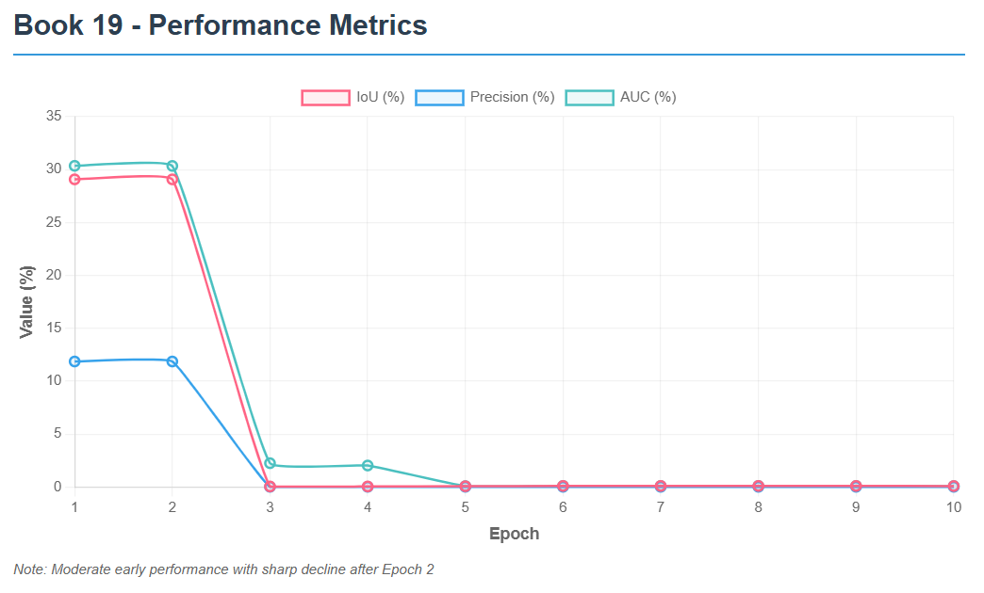

## **Sequence: Coin 3**

### Table 1: Inference Rate Results

| **Epoch** | **FPS** |
| --- | --- |
| 1 | 16.51 |
| 2 | 16.17 |
| 3 | 18.43 |
| 4 | 18.23 |
| 5 | 18.46 |
| 6 | 30.30 |
| 7 | 30.24 |
| 8 | 29.80 |
| 9 | 30.97 |
| 10 | 27.30 |

### Table 2: Evaluation Metrics

| **Epoch** | **IoU** | **Precision** | **AUC** |
| --- | --- | --- | --- |
| 1 | 0.0150 | 0.10 | 4.65 |
| 2 | 0.0147 | 0.10 | 4.59 |
| 3 | 0.0065 | 18.63 | 3.54 |
| 4 | 0.0014 | 0.10 | 0.15 |
| 5 | 0.0038 | 0.20 | 1.41 |
| 6 | 0.0037 | 0.20 | 0.37 |
| 7 | 0.0029 | 0.20 | 0.30 |
| 8 | 0.0029 | 0.20 | 0.30 |
| 9 | 0.0028 | 0.20 | 0.30 |
| 10 | 0.0028 | 0.20 | 0.28 |

### Graph 1: IoU / Precision / AUC vs Epoch

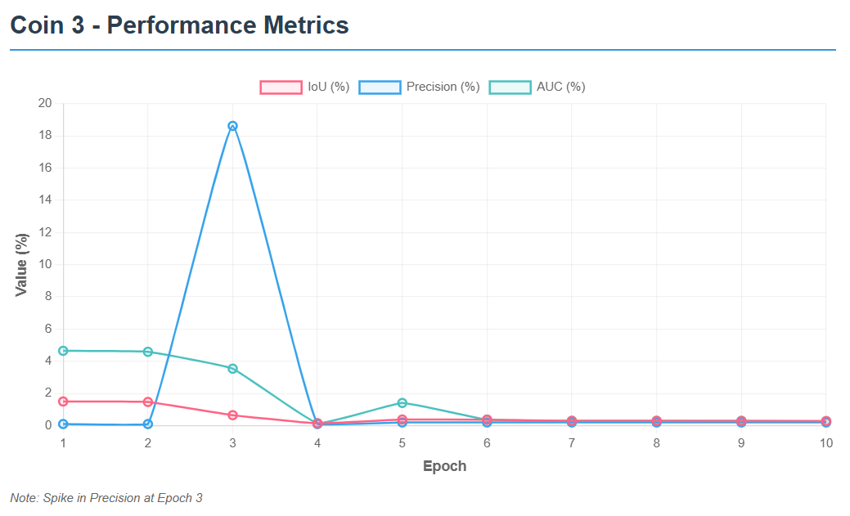

## **Sequence: Coin 6**

### Table 1: Inference Rate Results

| **Epoch** | **FPS** |
| --- | --- |
| 1 | 29.19 |
| 2 | 27.68 |
| 3 | 24.81 |
| 4 | 27.11 |
| 5 | 26.60 |
| 6 | 27.50 |
| 7 | 29.00 |
| 8 | 27.82 |
| 9 | 29.23 |
| 10 | 22.60 |

### Table 2: Evaluation Metrics

| **Epoch** | **IoU** | **Precision** | **AUC** |
| --- | --- | --- | --- |
| 1 | 0.0723 | 20.87 | 9.66 |
| 2 | 0.0723 | 20.87 | 9.66 |
| 3 | 0.0723 | 20.87 | 9.66 |
| 4 | 0.0723 | 20.87 | 9.66 |
| 5 | 0.0723 | 20.87 | 9.66 |
| 6 | 0.0006 | 0.03 | 0.06 |
| 7 | 0.0011 | 0.10 | 0.11 |
| 8 | 0.0009 | 0.06 | 0.09 |
| 9 | 0.0009 | 0.06 | 0.09 |
| 10 | 0.0011 | 0.10 | 0.11 |

### Graph 1: IoU / Precision / AUC vs Epoch

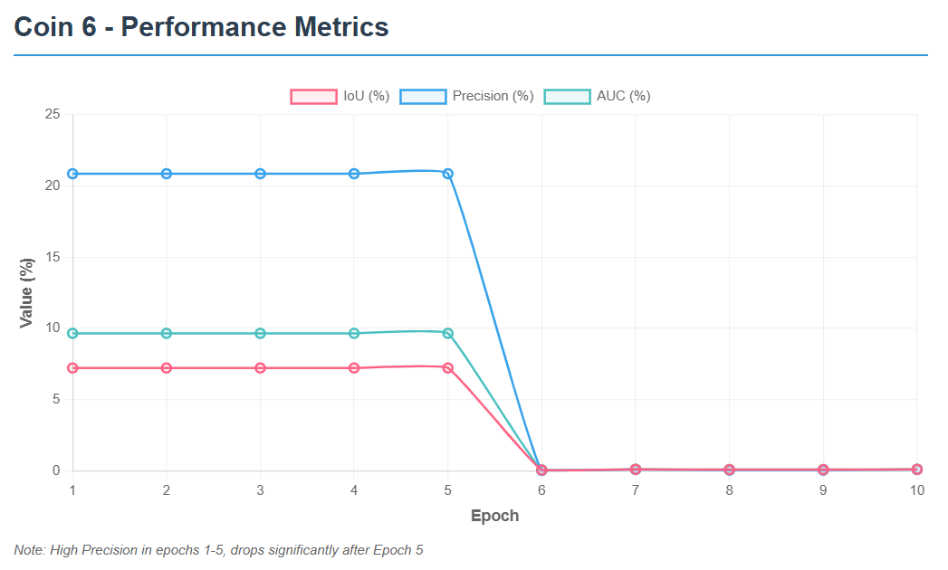

## **Sequence: Coin 7**

### Table 1: Inference Rate Results

| **Epoch** | **FPS** |
| --- | --- |
| 1 | 16.45 |
| 2 | 18.08 |
| 3 | 17.97 |
| 4 | 18.25 |
| 5 | 18.47 |
| 6 | 31.55 |
| 7 | 28.20 |
| 8 | 29.07 |
| 9 | 30.89 |
| 10 | 30.03 |

### Table 2: Evaluation Metrics

| **Epoch** | **IoU** | **Precision** | **AUC** |
| --- | --- | --- | --- |
| 1 | 0.0290 | 0.36 | 4.83 |
| 2 | 0.0009 | 0.06 | 0.12 |
| 3 | 0.0026 | 0.06 | 2.25 |
| 4 | 0.0009 | 0.06 | 0.16 |
| 5 | 0.0015 | 0.12 | 0.22 |
| 6 | 0.0015 | 0.06 | 0.16 |
| 7 | 0.0023 | 0.12 | 0.24 |
| 8 | 0.0026 | 0.12 | 0.26 |
| 9 | 0.0016 | 0.06 | 0.16 |
| 10 | 0.0019 | 0.12 | 0.19 |

### Graph 1: IoU / Precision / AUC vs Epoch

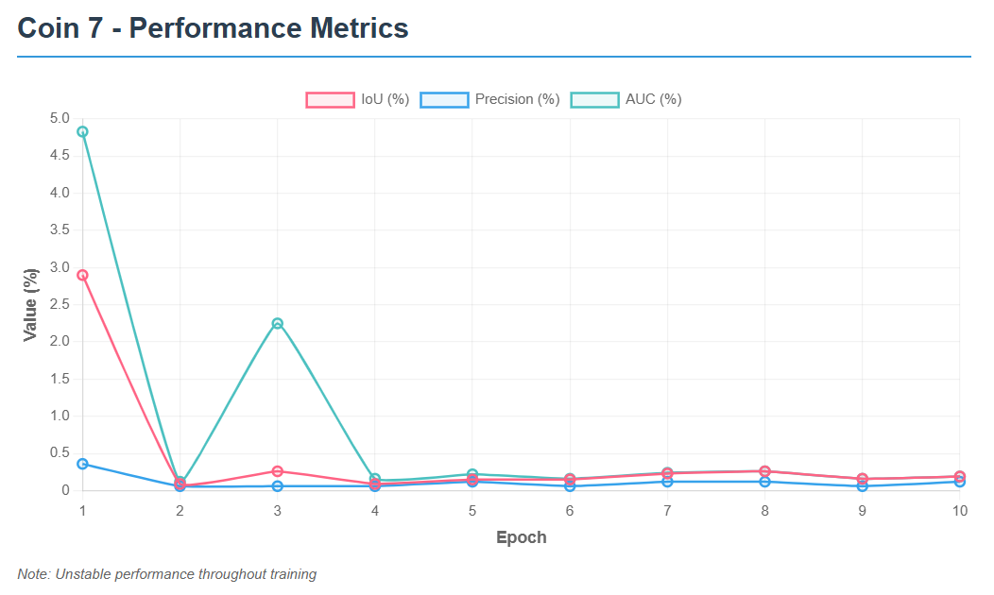

## **Sequence: Coin 18**

### Table 1: Inference Rate Results

| **Epoch** | **FPS** |
| --- | --- |
| 1 | 25.06 |
| 2 | 25.14 |
| 3 | 24.60 |
| 4 | 22.44 |
| 5 | 23.87 |
| 6 | 23.44 |
| 7 | 29.62 |
| 8 | 22.57 |
| 9 | 22.43 |
| 10 | 30.70 |

### Table 2: Evaluation Metrics

| **Epoch** | **IoU** | **Precision** | **AUC** |
| --- | --- | --- | --- |
| 1 | 0.0293 | 0.09 | 4.92 |
| 2 | 0.0293 | 0.09 | 4.92 |
| 3 | 0.0293 | 0.09 | 4.92 |
| 4 | 0.0293 | 0.09 | 4.92 |
| 5 | 0.0293 | 0.09 | 4.92 |
| 6 | 0.0017 | 0.09 | 0.19 |
| 7 | 0.0038 | 0.18 | 0.39 |
| 8 | 0.0017 | 0.09 | 0.17 |
| 9 | 0.0017 | 0.09 | 0.17 |
| 10 | 0.0017 | 0.09 | 0.18 |

### Graph 1: IoU / Precision / AUC vs Epoch

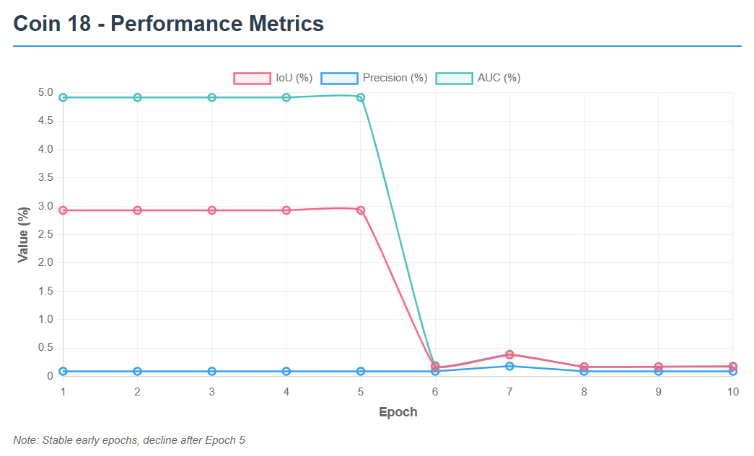

## **Reflections**

1.Aya Mohamed:

While studying SeqTrack, I learned how the inference stage uses a trained model to track objects across video frames automatically. During evaluation, the results are compared with the ground truth to calculate performance metrics like IoU and AUC. This helped me understand how well the model can generalize and how evaluation metrics reflect its tracking precision and stability.

2.Shahd Elsayed:

From the SeqTrack inference and evaluation process, I discovered how predictions are generated frame by frame and then analyzed for accuracy. I learned how metrics such as AUC and Precision indicate the model’s ability to follow an object consistently. This process showed me the importance of both qualitative and quantitative assessment in computer vision experiments.

3.Rehab Hamdy:

Working with SeqTrack taught me that inference is not just running the model, but also collecting and organizing output results properly. I learned how the evaluation script processes these results to produce metrics like success rate and normalized precision. Seeing how each epoch’s model behaves differently made me realize how sensitive tracking performance can be to training duration.

4.Aya Khaled:

Through SeqTrack inference and evaluation, I learned the importance of data structure and result analysis. Inference allowed me to visualize how the model interprets object motion, while evaluation helped me interpret numbers like IoU and AUC to measure tracking reliability. It was interesting to see how these metrics reveal strengths and weaknesses in different epochs.

5.Ahmed Gamal:

While experimenting with SeqTrack, I understood that inference is where the model’s actual ability is tested on unseen videos. The evaluation phase then calculates detailed statistics to summarize performance. I learned how consistent tracking and accurate bounding boxes lead to higher IoU and AUC scores, making evaluation essential for model validation.

6.Abdelrahman Mostafa:

In the SeqTrack project, I learned how inference generates tracking predictions and evaluation verifies their quality. By comparing model outputs with the ground truth, we can measure accuracy using metrics like Precision and AUC. This process showed me how different training epochs affect final performance and how these evaluations guide model improvement.

7.Abdelrahman Ahmed:

SeqTrack’s inference stage helped me understand how object trackers process continuous frames to predict object positions. During evaluation, I learned how the system computes metrics like IoU and precision to summarize overall accuracy. Observing the effect of each epoch’s results gave me insight into model tuning and progress tracking.

8.Abdelrahman Waled:

I learned from SeqTrack inference that every frame in a sequence provides valuable information for predicting an object’s movement. The evaluation process, on the other hand, measures how close these predictions are to real values. Through this, I grasped how AUC and IoU act as indicators of how robust and reliable a tracking model is.

9.Abdelrahman Mohamed:

While running SeqTrack inference and evaluation, I learned the practical steps of testing a tracking algorithm. Inference generates bounding box predictions for each video frame, and evaluation compares them to true annotations. Understanding metrics like normalized precision and success rate helped me see how to interpret and compare tracker performance objectively.

10.Abdelrahman Osama:

During the SeqTrack inference and evaluation phase, I realized how crucial post-training analysis is for model validation. I learned that inference produces tracking outputs, while evaluation turns them into understandable numbers that describe model quality. Seeing variations in AUC and IoU across epochs gave me a clearer picture of model learning behavior over time.

## **Conclusion**

In **Assignment 4**, the SeqTrack project reached its final stage by performing **inference and evaluation** using the model trained in **Assignment 3**. This phase demonstrated how the model’s learning translated into real tracking performance on unseen sequences from the **LaSOT** dataset. By running inference over multiple epochs and analyzing metrics such as **AUC**, **IoU**, and **Precision**, we were able to assess the model’s accuracy, stability, and efficiency.

The evaluation results provided valuable insights into how training progress affected tracking quality, confirming that the model was able to generalize its learned representations to new data. This connection between **training** and **evaluation** successfully validated the end-to-end tracking pipeline of SeqTrack.